CHAPTER III
RESEARCH METHOD

3.1 Design of Research
This research would be conducted by using class action research in the informal situation through section question answer, this change give for senior high school for prepared the student for face up their job world after graduation. In order to focus on teaching learning process happen in the class especially in the section interview. Besides that, classroom action research is one of strategies for solving problem which use real action and developing capabilities to detected and solve the problem. In this research the researcher uses partner in the classroom, she is the English teacher of SMK TKJ Istiqlal Deli Tua.
Class Action Research is a research to help teacher in overcome the problem practically faced in emergency situation and help the achievement of learning objectives. Thus, it is a classroom action research conducted by the the scientific of an activity of the class teacher, observing and reflecting action through several cycles of collaborative and participatory aims to improve or enchange the quality of the learniang process in the classroom (Istani, 2014 ). Classroom action is a method of finding out what the best way in the classroom. So that, we can improve students ability in learning process.
Tampubolon, S (2014) special pupose of classroom action research (CAR) are:
- Fix / improve the quality of practice(process) continuous learning in the classroom
- Fix / improve the quality of learning both academic aspects and non akademik
- Fixing an innovative and creative curriculum,instructional strategies,and competency-based assesment
- Improving the quality of education in instruction/school
The design of research (Kemmis & Mc Taggart in Tampubolon,2014)
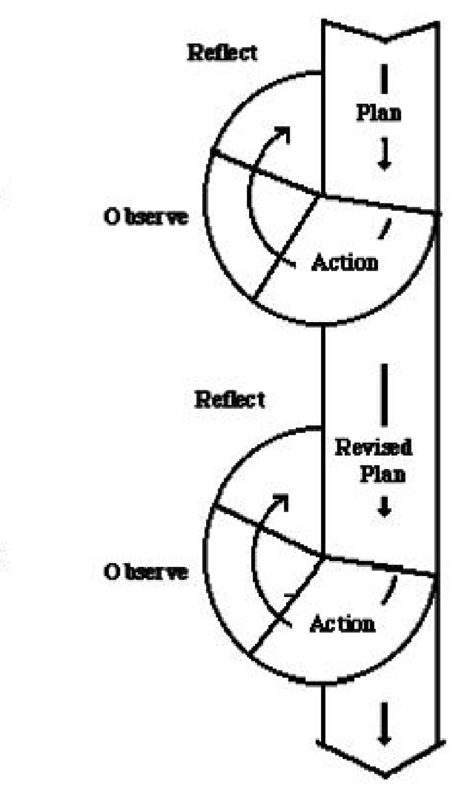
is bellow:

3.2 Procedure of Research
3.2.1 Circle I
a. Planning
Planning is arrangement for doing something. In planning the researcher prepare everything that will be needed in learning process. The following points are the specification of the planning are first cycle:
- Analyze the students’ problem in conversation
- Conducting the cycle in two meetings.
- Preparing material for conversation.
- Conducting a test of conversation with Action Learning strategy in last meeting.
- Preparing the instrument for collecting data such as questionnaire and test
b. Action
Action is process doing things, it is implementation of planning. In this step, the students will be taught how to improve conversation ability with Action Learning strategy.
  - Explain the purpose of action learning strategy in learning English.
  - Assign task to each student to write some dreams for their job plan and memorize some vocabulary that related
  - Asks the students to make a short conversation with their friend as an interviewers and answerers and they practice each other
  - Call students one by one to make section interview between the researcher and student.
Table I: Activity Cycle I
No | Action cycle I | Output
1 | Motivating students by asking the  material fraction | Increased student motivation
2 | Delivering learning objective and indicators to be achieved | Explanation of goals and indicator to be achieved
3 | Provide an explanation of the content being studied | Explanation of the content being studied
4 | To give some examples of question about the content being studied using action learning | Discuss with the student the example problem
5 | Giving students the oportunity to ask | Improving students understanding
6 | Concluded the material together with student | The student ca make the conclution
7 | Evaluating the results of the first cycle | Identifying problem
8 | Conducting any acts of reflection in cycle I throughly | The solution of the problem that had been arise

c. observation
In this stage the researcher conducted several activities as follows: Observed during the process of learning about students conversation ability and learning process using observation sheets that had been prepared.
  - To evaluate students skill of observation sheet
  - Make notes suitability study process undertaken based on indicators of conversation ability.

d. Reflection
Reflection implemented based on the analysis of data from observation and evaluation activities. Reflections conducted to determine the extent to which media can enhance students conversation ability and to know the advantages and disadvantages of the implementation of learning process which has been implemented to avoid recurrence on the second cycle and overcome obstacles that may be encountered on the second cycle.
3.2.2 Cycle II
- Planning
Activity of which is in the palnning cycle II is the same as planning to cycle I. The planning stages on the second cycle based on the result of reflection of the activity cycle I. Planning is done to avoid the shortage and obstacles that occur in the first cycle both on students and on the implementation process of learning to improve students conversation ability. In this cycle consist of two meetings. The first and second meeting on the second cycle is presented in the material daily routines.
- Action
Activities undertaken in this phase is to implement lesson plans that have been planned and developed from the implementation of the first cycle of the learning process accordance with lesson plans that have been previously design to improve students conversation ability and the learning can take well.

- Observation and evaluation
As in cycle I, observation and evaluation activities carried out to determine the changes in students speaking skill.
- Reflection
At the end of the second cycle, the observation of later researchers to find weakness and excellence in learning. Reflection include:
    - Disclosure of the result of observation about the advantages and disadvantages of learning in understanding the concept by using action learning
    - Reveal the action that have been conducted during the student learning progress poses
    - Disclose the action taken by the teacher during the learning and teaching process. The things that reflected the discussion with the class teacher concerned.

3.3 Subject of the Research
The Subject of this research is the students of SMK Istiqlal Deli Tua Medan
  - Instrument of the Research
Arikunto (2014: 265) explains that there are some methods of collecting data. There are questionnaire, test, observation, interview, and documentation. In order to collect data, the researcher use three of them by using documentation, observation, and test as an instrument.

            - Observation
According to khotari (2004: 96), observation is the most commonly used to observe the students’ activities in teaching and learning process. This way is used to monitor and record the students enhancement during the lesson. In the students’ observation sheet, there are four aspects as the focuses of the observation. Those are paying attention, activeness in asking the question, activeness in responding question, and enthusiasm in doing the test.
            - Test
In this research, the researcher used a written test. This test consist of two tests, namely pre-test to determine the ability of beginning students and post-test to determine the ability of the students after the action was performed. The test were quitionaire, The questionnaire consisted of 10 numbers of questions should be answered by student’ action and belief. The questions throungh in conversation section, its about job interview in English.
The kind of test in this research is oral test. It is done to know the students’ conversation ability involving:
- Pronunciation
- Grammar
- Vocabulary
- Fluency
            - Documentation
contained everything happens during the teaching-learning process including reflection and evaluation. All of data are collected and interpreted by research. And they also are supported by some media’s such as: photos, diary notes and video which will relate to reserch focusing.

3.5 Techiques of Collecting Data
In collecting the data needed, the researcher use quantitative data collection.
Quantitative data consist:
Test is a formal, systematic, procedure used to gather information about students’ achievement or other cognitive skill. (Based on Airasian and Russel, 2008) Test was used to measure the students’ achievement and students’ improvement during the process. In collecting the data the researcher used two tests. They were pretest and post-test. Pre-test was given in the begining of the research to know their ability in speaking English before they got treatment, then the post-test is the last test to know the students’ improvement.
              - Pre-Test
The first test is Pre-test. It is given in the first meeting to know their ability in speaking The researcher would gave the pre-test before cycle 1 in order to know the initial problem faced by students ,especially to know about the students basic in speak English before they got treatment. In pre-test session, the researcher will ask for every student to introduce him/herself in front of the class. The introduction includes name, age, address, when and where they were born and their dream jobs. The students have 3 minutes to speak up .
              - Post Test
Post-test will be conducted after treatment. This test to find out the students’ conversation ability after treatment. In this test the researcher gives some question between researcher and students that will be answered by oral test, questionnaire about job interview that consisted of 8 numbers and should be answered by students’s action and belief. The question are :
- Tell me what its your identity?
- What is your dream jobs?
- Why are you interested in this job?
- Do you can join in a team ?
- Can you working with the target?
- What is your strength?
- What is your weakness?
- What are you career goals?
- What its your preparation for your job in the future?
- What salary range were you looking for?
Scoring is given as follows:
The researcher gave the test is using oral test. The researcher will open section interviewing with the students one by one through the conversation, its about the students dream jobs. The researcher used the assesment scale for their respons in conversation to find out the mean score of students’ achievement for each cycle. The researcher will include four criteria they are Pronunciation, grammar, vocabulary and fluency maximum score is 25 for each criteria.
3.6 Technique of Data Analysis
Technique of analyzing data was the most important element in any conducted research. All collected data would be meaningless, if they were not analyzed. In this research, the researcher applied some techniques in collecting the data which consisted of qualitative data and quantitative data. The qualitative data was found by describing the situation during the teaching and learning process. In order to measure the students’ behavior, attitude, enthuasiasm, and participation during teaching and learning process, the researcher applied qualitative data.
The quantitative data was collected from the reading comprehension test. Quantitative data was found by analyzing the score of the tests done by students. Computing the scores of the reading test become the way of analyzing the quantitative data.
To know the means of the students’ score in each cycle.The researcher will measure it by using the following formula:
X = $\frac{∑x}{N}$
Where :
X = The mean of the students score
∑X = The total score
N = The member of the students
After having finished calculating the students’ individual score, the researcher then calculates the students’ mean score by applying the mean formula, as stated above. The result is categorized as follow:

Table II

The Qualification of The Result
Students’ Score | Category | Qualification
80 – 100 | A | Good to Excellent
60 – 79 | B | Average to Good
50 – 59 | C | Poor to Average
0 – 49 | D | Poor
(Modified from Heaton: 1975)
In order to categories the member of master students, the researcher used the following formula
x 100%
P=
Where:
P = The percentage of students who get the point 70
R = The number of students who get point up to 70 above
T = The total of students who do the test

