Appendix 1

The Result of Cycle I and Cycle II
NO | Name | KKM | Pre-Test | Test Cycle I | Test Cycle II | Category
1 | A D | 70 | 60 | 70 | 80 | Passed
2 | A Z | 70 | 50 | 80 | 80 | Passed
3 | A S | 70 | 40 | 70 | 90 | Passed
4 | A P | 70 | 60 | 70 | 70 | Passed
5 | B A | 70 | 50 | 60 | 80 | Passed
6 | D D | 70 | 50 | 70 | 90 | Passed
7 | E L | 70 | 60 | 80 | 90 | Passed
8 | E M | 70 | 50 | 60 | 80 | Passed
9 | E B | 70 | 60 | 80 | 90 | Passed
10 | F T | 70 | 60 | 70 | 70 | Passed
11 | F A | 70 | 70 | 80 | 90 | Passed
12 | F M | 70 | 40 | 70 | 80 | Passed
13 | F A | 70 | 50 | 70 | 70 | Passed
14 | G W | 70 | 50 | 60 | 80 | Passed
15 | J S | 70 | 60 | 70 | 80 | Passed
16 | L M | 70 | 60 | 70 | 80 | Passed
17 | L S | 70 | 60 | 70 | 90 | Passed
18 | M G | 70 | 60 | 70 | 70 | Passed
19 | M S | 70 | 50 | 70 | 80 | Passed
20 | N C | 70 | 50 | 70 | 80 | Passed
21 | N | 70 | 50 | 70 | 80 | Passed
22 | N F | 70 | 40 | 60 | 80 | Passed
23 | N I | 70 | 50 | 70 | 80 | Passed
24 | P H | 70 | 60 | 70 | 80 | Passed
25 | R A | 70 | 60 | 70 | 90 | Passed
26 | R | 70 | 50 | 90 | 90 | Passed
27 | R S | 70 | 50 | 80 | 70 | Passed
28 | R | 70 | 50 | 60 | 90 | Passed
29 | R W | 70 | 30 | 60 | 80 | Passed
30 | W S | 70 | 50 | 80 | 80 | Passed
31 | W L | 70 | 50 | 70 | 90 | Passed
32 | Y R | 70 | 50 | 60 | 70 | Passed
33 | D A | 70 | 60 | 70 | 80 | Passed
 | TOTAL SCORE |  | 1.740 | 2.320 | 2.680
 | MEAN |  | 52,72 | 70,30 | 81,21

Appendix 2
OBSERVATION SHEET
Put a checklist in column 1, 2, 3 and 4 based on your observation
1 = poor 2 = fair 3 = good 4 = very good
Focus | Topic | 1 | 2 | 3 | 4
The writer | - The teacher attracts student’s attention.  - The teacher explains teaching objective.  - The teacher prepares teaching material systematically.  - The teacher explains the lesson clearly.  - The teacher gives all the students chance to ask about the material.  - The teacher responds to students’ question.  - The teacher explains how the students write their narrative text by question answer relationship.  - The teacher gives feedback to the students.  - The teacher manages the time effectively and efficiently |  |  | √  √  √  √  √  √ | √  √  √
The students | - The students pay attention to the teachers’ explanation.  - The students ask questions to the teacher if there is something unclear.  - The students answer question that are given by the teacher.  - The students give good responds to the topic.  - The students discuss about their writing actively.  - The students feel interested in teaching learning process. |  |  | √  √  √ | √  √  √
Context | - The classroom is saving from crowded.  - The classroom is comfortable (clean, clam)  - The classroom has teaching ads (marker, whiteboard, duster, etc). |  |  | √  √  √

Appendix 3

INTERVIEW SHEET
Interview with the teacher
The researcher : How long have you been teaching English in this school?
The teacher : I have been teaching English around 15 years in this school.
The researcher : What do you think about students of this class?
The teacher : They are nice students but sometimes they make me angry.
The researcher : How do you control your students in the classroom?
The teacher : If I sould that I was angry, they will be quite or sometimes I admonished them. It’s my way to control my students.
The researcher : Do you think they like English?
The teacher : Most of them like English, just a little hate it.

Interview with the student
The Researcher : Have you ever read text in the form of narrative text in english?
Student I : Never Miss
Student II : Never miss
Student III : Never miss, but just for a moment.
The Researcher : Do you think it's difficult or easy to read the language of the text English in the form of narrative text?
Student I : It's hard to miss, I think the pronunciation and meaning is difficult miss.
Student II : It's hard to miss, I don't know what it means and it's hard to read and answer the question.
Student III : In my opinion it's a miss, it's hard to determine an idea the subject of the text.

Appendix 4
FIELD NOTE
The first meeting in cycle 1

Place : SMAS Satria Dharma
Object : Teaching Learning Process
Class : X IPA
Bell was ringing at 07.30 a. m, the first time lesson will be started. I walked to the X IPA class. I looked some students will praying to Allah. After they knew I came and I started the class by said “ Assalam’ualaikum wr wb” and the students replied “ Wa’alaikumsalam wr wb” and then I greeted to the students “Good Morning, students. How are you today?” and the students replied eagerly “ Good Morning, I’m fine and you?” and I replied “ fine thank you” and then I greeting I cheeked their attendance. For the first meeting, all of the students completed. After that, opened the lesson with gave question orally to the students’ do you know, what a narrative text is?” the situation was very noisy so that all of the students did not pay attention to the question. And the I repeated the question “ do you know what narrative text is?” but only one students could answers the question from 33 students. And then I asked “ what according to you ?” then the students replied “ boring” then I replied “why?” and the students replied “don’t understand miss” and than I gave another question “ do you like reading fairy tale ?” and 6 students could answers “ yes I do”. And another students could answer “ No” After that I explained about narrative text, generic structure and social function narrative teks . The topic of the day “ Cinderella” and I asked the asked the students to read the text and I asked four students to read two paragraphs in the text at the front of class and then I was correctly. High after that I showed the picture-story of “Cinderella” and I explained “ Cinderella” and I wrote the difficult word in the whiteboard. I asked to the students to answers questions. At the students worked their students worksheet, I monitored their activities and guided the students. Any students asked about the meaning of difficult words but I didn’t answer. The students looked for the meaning of difficulty words in to their dictionary. But many students did not bring dictionary this was make another students disturb because students who did not bring a dictionary they borrowed dictionary’s another students. Because of that I gave announcement that the next meeting, all of students must bring dictionary. Several students could finish their students worksheet. Other students could not finish their students work sheet with a reason the time for write limited. The students and I discuss and check the answers. At the moment the students explain their opinion as the result of their finding orally. I reviewed the activities at that day and give applause for the student. The students must finish their students’ worksheet at the time because time is up. Bell was ringing at 08.30 a. m the electric sounds. The students looked crowded because the class of English Lesson will be end. Then I ended the class by saying good bye and greeting. However, before closing it, I reminded the students to study hard and to memorized what has been taught to day and for the next meeting don’t forget to bring dictionary. I closed the class, “ thanks for your attention, good bye, see you later, wassalamu’alaikum Wr Wb”. When the students replied “ Wa’alaikumsalam Wr Wb “

FIELD NOTE
The Second meeting in cycle 1
Place : SMAS Satria Dharma
Object : Teaching Learning Process
Class : X IPA
I looked some students will praying to Allah. After they knew I came and I started the class by said “ Assalam’ualaikum wr wb” and the students replied “ Wa’alaikumsalam wr wb” and then I greeted to the students “Good Morning, students. How are you today?” and the students replied eagerly “ Good Morning, I’m fine and you?” and I replied “ fine thank you” and then I greeting I cheeked their attendance. I asked the students to answer the question in the worksheet. Having finishing the task then I asked one of the students to answer the question. Actually they had difficult in translating some words from Indonesia to English. I reviewed the activities at that day and give applause for the students and I asked to work group for home work, the students to search the example of narrative text and analyzing it based on purpose, generic structure. Bell was ringing at 08.30 a. m. I ended the class by giving the students chance to ask question., saying good bye and greeting. Before I closed the lesson, I gave the students chance to ask question by saying, “ Any question” one students replied , “ No miss”. I reminded the students to study hard and to memorize what has been taught today. I closed the class, “thank you your attention, good bye, and see you later, assala’mualaikum Wr. Wb”. The students replied “Wa’alaikumsalam Wr.Wb.
FIELD NOTE
The Third Meeting in cycle 1
Place : SMAS Satria Dharma
Object : Teaching Learning Process
Class : X IPA
After they knew I came and I started the class by said “ Assalam’ualaikum wr wb” and the students replied “ Wa’alaikumsalam wr wb” and then I greeted to the students “Good Morning, students. How are you today?” and the students replied eagerly “ Good Morning, I’m fine and you?” and I replied “ fine thank you” and then I greeting I cheeked their attendance. After that, I gave instruction that there was test. All of the students completely were no absent. The instruction given as follows: prepare yourself, for this day we will do examine! The students must answer the question from the paper and the students prepared their selves to do examine. The time is 08.30 WIB. The electric bell sound was ringing. The students looked crowded because the class of English lesson will be end. I said to the students that they must assemble their test in front of class. And I closed their post-test for the day and said “thanks for you attention, good bye, and see you later, Assala’mualaikum Wr Wb” the students replied “wa’alaikumsalam Wr Wb”

FIELD NOTE
The first meeting in Cycle 2
Place : SMAS Satria Dharma
Object : Teaching Learning Process
Class : X IPA
I walked to the X IPA class. And I started the class by said “Assala’mualaikum WrWb” and the students replied “Wa’alaikumsalam Wr Wb and then I greeted to the students “ good morning, students. How are you today?” and the students replied eagerly “ good morning, I’m fine and you?” and I replied “ fine thank you” and then after I greeting I checked their attendance. And then I gave question orally to the students. “Do you still remember about narrative text” the students answered “yes miss”. I explained about narrative text and then given a text about narrative text the title “ Nikini the Little Girl” to students one by one, and then students identified the text of narrative from purpose, generic structure. And the students identified the narrative text individually. After the students finished identify the text. I gave students worksheet and I asked to read the text about “Nikini, the Little Girl” after I explain the text. After finished to explain I asked the students to answer question and then students discuss the question,. I asked the students to answer the question in the worksheet. Having finishing the task one of the students explain their opinion as the result of their finding orally. I reviewed the activities at that day and give applause for the students and I asked to work group for home work to discuss a paragraph “Daffodelia” of narrative text with the free theme and analyzing the text based on orientation, complication, and resolution. Time was up, bell was ringing at 08.30 WIB. I ended the class by giving the student chance to ask question, saying good bye and greeting. Before I closed the lesson, I gave the students chance to ask question by saying “any question” one of the students replied, “ No, miss”. I reminded the students to study hard and to memorize what has been taught today. I closed the class, “ thanks for your attention, good bye, and see you later, Assala’mualaikum Wr Wb. The students replied Wa’alaikumsalam Wr Wb

FIELD NOTE
The second meeting in Cycle 2
Place : SMAS Satria Dharma
Object : Teaching Learning Process
Class : X IPA
I started the class by said “Assala’mualaikum Wr Wb” and the students replied “Wa’alaikumsalam Wr Wb and then I greeted to the students “ good morning, students. How are you today?” and the students replied eagerly “ good morning, I’m fine and you?” and I replied “fine thank you” and then after I greeting I checked their attendance. Before the lesson began, I asked the student “ did you still remember the meting lesson?” the student answer “ yes miss” Before the lesson began, I and the student discussed the home work. Every group read the answer orally. Then I corrected the answer. I gave student worksheet to the students one by one. The topic of the day “Daffodelia” and after that I asked the students to read the text. The students opened their dictionary to look for the meaning difficult words. Then I asked the students to answer from the text and they answered the question. After that I and the student discussed the question. Different with the previous meeting, the situation became better. The students were more active than previous meeting. Without I asked the students to write the answer in the whiteboard, the students forward their selves to write their answer in the whiteboard. Bell was ringing at 08.30 WIB I asked the class by giving the students chance to ask question, saying good bye, and greeting. Before I closed the lesson, I gave the students reminded to asks question by saying, “any question” one for student replied “ no, miss” I reminded the students to study hard and to memorize what has been taught today. I closed the class, “ thanks for your attention, good bye, and see you later, Assala’mualaikum Wr Wb “. The students replied “wa’alaikumsalam Wr Wb.

FIELD NOTE
The third meeting in Cycle 2
Place : SMAS Satria Dharma
Object : Teaching Learning Process
Class : X IPA
After they knew I came and I started the class by said “ Assalam’ualaikum wr wb” and the students replied “ Wa’alaikumsalam wr wb” and then I greeted to the students “Good Morning, students. How are you today?” and the students replied eagerly “ Good Morning, I’m fine and you?” and I replied “ fine thank you” and then I greeting I cheeked their attendance. For the first meeting, all of the students completed. After that, I gave instruction that there was test. All of the students completely were no absent. The instruction given as follows: prepare yourself, for this day we will do examine! The students must answer the question from the paper and the students prepared their selves to do examine. The time is 08.30 WIB. The electric bell sound was ringing. The students looked crowded because the class of English lesson will be end. I said to the students that they must assemble their test in front of class. And I closed their post-test for the day and said “thanks for you attention, good bye, and see you later, Assala’mualaikum Wr Wb” the students replied “wa’alaikumsalam Wr Wb”

Appendix 5
LESSON PLAN
(Meeting I of Cycle I)
- IDENTITAS
Satuan Pendidikan : SMAS Satria Dharma
Mata pelajaran : Bahasa Inggris
Kelas/Semester : X/2
Aspek/Skill : Reading
Alokasi Waktu : 2 x 40 menit
Jenis Teks : Narrative
Tahun Pelajaran : 2019/2020

- STANDAR KOMPETENSI
Membaca
Memahami makna dalam esei pendek sederhana berbentuk narrative dan untuk berinteraksi dengan lingkungan sekitar.

- KOMPETENSI DASAR
Membaca
Merespon makna dan langkah retorika dalam esei pendek sederhana secara akurat, lancar dan berterima yang berkaitan dengan lingkungan sekitar dalam teks berbentuk narrative.

- INDIKATOR
Membaca dan memahami teks naratif dengan cara:
1. Menemukan gagasan dalam teks seperti:
- Main ideas
- Supporting details
- Informasi faktual
2. Menentukan language features, grammatical features, dan structure dari teks naratif.
3. Menentukan makna dalam teks.

- MATERI POKOK
Duck and Turtle
Two ducks that lived in a big lake had a friend that was a turtle. One year there was a very little rain and the lake began to dry up. One of the ducks said to the other, "Soon, there'll be no water in this lake. Let's go and look for lake."
"Yes, answered the second duck, "But first let's say good bye to our friend, the turtle." When they told the turtle they were going to leave, he said, "I'll die here without arry water and without any friends. Take me with you."
"The ducks answered, "'We can't. We are going to fly, and you have no wings." "The turtle thought for a minute and then said, "please wait here.
" Then he went away and found a strong, straight stick. He brought it back to his friends, put the middle of it in his mouth and said, 'Now if each of you takes me one end of the stick in his mouth, you can |ift me up and caffyme with you."
"That is dangerous," said the ducks, "if you try to talk while we're carrying you through the air, you won't be able to hold the stick, so you'll fall down along way and break your shell."
"All right," answered the turtle, "I promise not to talk while we're in the air. So the ducks took the stick and flew away, with the turtle between them. A11 went well until they were flyrng over a town. Then some people saw them and shouted, 'ol,ook, those ducks are carrying a cat!"The turtle got very angry,"A cat? I'm not ..." he said, but he did not get any further, because when he opened his mouth, the stick came out of his mouth and the poor turtle fell to the ground.
- METODE PEMBELAJARAN
Direct Method.

VII. LANGKAII-LANGKAH KEGIATAN
- Kegiatan Pendahuluan '
- Greeting (member salam dan tegur sapa)
- Tanya jawab hal terkait kondisi siswa
- Mengabsen siswa.
- Memberi motivasi kepada siswa
- Menjelaskan materi yang akan dibahas
b. Kegiatan Inti
- Guru membagi siswa ke dalam kelompok; satu kelompok terdiri dari 5 atau 6 orang yang beragam dalam hal ras,jenis kelamin, dan kemampuan akademik. Materi diberikan dalam bentuk teks naratif' dan masing-masing siswa rnempelajari materi berdasarkan porsinya' Kemudian, setelah siswa selesai mempelajari materi dalam tim expert, mereka kembali kepada kelompoknya semula (tim,, home',) dan masing-masing siswa menerangkan pemahaman yang telah diperoleh dari tim expert.
- Brainstorm: guru memberikan materi kepada siswa berupa teks naratif. Sebelum para siswa membahas materi tersebut, guru meminta siswa untuk membaca teks tanpa suara. setelah itu, siswa dipersilakan membahas isi teks tersebut bersama dengan tim expertnya, kemudian siswa dipersilakan kembali ke tim home-nya untuk bersama-sama menyelesaikan latihan soal berdasarkan teks yang sudah dibaca sebelumnya. Guru dan siswa mendiskusikan tentang jawaban pertanyaan dan mengadakan refleksi terhadap kegiatan belajar mengajar yang sudah dilakukan.

C. Kegiatan Penutup
- Menyimpulkan materi Pelajaran
- Menanyakan kesulitan siswa selama KBM
- Memberikan saran untuk mengatasi kesulitan dalamKBM

VIII. SUMBER BELAJAR
- http://www.isdaryanto.com/definition-of-narrative-text,
- Kamus
IX. PENILAIAN
a. Teknik : Tes tertulis
b. Bentuk : Tertulis

Medan. March 2020
Mahasiswa

Nur Amanah Rizka

LESSON PLAN
(Meeting 2 of Cycle 1)
- IDENTITAS
Satuan Pendidikan : SMAS Satria Dharma
Mata pelajaran : Bahasa Inggris
Kelas/Semester : X/2
Aspek/Skill : Reading
Alokasi Waktu : 2 x 40 menit
Jenis Teks : Narrative
Tahun Pelajaran : 2019/2020

- STANDAR KOMPETENSI
Membaca
Memahami makna dalam esei pendek sederhana berbentuk narrative dan untuk berinteraksi dengan lingkungan sekitar.

- KOMPETENSI DASAR
Membaca
Merespon makna dan langkah retorika dalam esei pendek sederhana secara akurat, lancar dan berterima yang berkaitan dengan lingkungan sekitar dalam teks berbentuk narrative.

- INDIKATOR
Membaca dan memahami teks naratif dengan cara:
1. Menemukan gagasan dalam teks seperti:
- Main ideas
- Supporting details
- Informasi faktual
2. Menentukan language features, grammatical features, dan structure dari teks naratif.
3. Menentukan makna dalam teks.

- MATERI POKOK
Jonah
Once upon a time there was a village in North Israel. All the people lived peacefully there. One of them was Jonah. Jonah lived with his parents. They loved him verymuch.
In the north of Israel was Syria. It had powerful knights. They were very cruel and liked to invade other countries.
One night when the people of Jonah's village were sleeping, the Syrian knights attacked his village. They burned down the houses. One of therrr'threw a torch into Jonah's house. Jonah's house was on fire.
Jonah and his parents avoided the fire buming their house. They saved themselves by climbing a ladder to the upstairs. It was too high for them to jump down to the ground from the upstairs. Jonah's father took a rope to get down from the stairs to the ground. They escaped to another village. Jonah and his parents lived in a fishermen village. -l'hey became fishermen.
One day, when they were fishing in the sea, Jonah fell into the sea. Jonah was drawn into the sea. A whale came closer to him. He tried to swim avoiding the whale as fast as possible but he failed and at last the whale swallowed him. Jonah was still alive in the stomach of the whale. He prayed to God to be released from the stomach of the whale. Fortunately God granted his prayer. The whale came closer to an island. It opened its mouth and Jonah came out from its stomach.

- METODE PEMBELAJARAN
Direct Method.

VII. LANGKAII-LANGKAH KEGIATAN
- Kegiatan Pendahuluan
- Greeting (member salam dan tegur sapa)
- Tanya jawab hal terkait kondisi siswa
- Mengabsen siswa.
- Memberi motivasi kepada siswa
- Menjelaskan materi yang akan dibahas
b. Kegiatan Inti
- Guru membagi siswa ke dalam kelompok; satu kelompok terdiri dari 5 atau 6 orang yang beragam dalam hal ras,jenis kelamin, dan kemampuan akademik. Materi diberikan dalam bentuk teks naratif' dan masing-masing siswa rnempelajari materi berdasarkan porsinya' Kemudian, setelah siswa selesai mempelajari materi dalam tim expert, mereka kembali kepada kelompoknya semula (tim,, home',) dan masing-masing siswa menerangkan pemahaman yang telah diperoleh dari tim expert.
- Guru memberikan materi kepada siswa berupa teks naratif. Siswa dipersilakan membahas isi teks tersebut bersama dengan tim expertnya, kemudian siswa dipersilakan kembali ke tim home-nya.
- Guru memberikan pertanyaan seputar teks naratif yang sedang dibahas.
- Siswa menyimpulkan dan mengambil intisari dari teks tersebut.
C. Kegiatan Penutup
- Menyimpulkan materi Pelajaran
- Guru menanyakan kesulitan siswa selama KBM.
- Guru memberikan saran untuk mengatasi kesulitan dalam KBM.
- Guru memberikan post test kepada siswa. (pertemuan selanjutnya).
VIII. SUMBER BELAJAR
a.http://www.isdaryanto.com/definition-of-narrative-text,
b.Kamus

IX. PENILAIAN
a. Teknik : Tes tertulis
b. Bentuk : Tertulis
Medan. March 2020
Mahasiswa

Nur Amanah Rizka

LESSON PLAN
(Meeting I of Cycle 2)
- IDENTITAS
Satuan Pendidikan : SMAS Satria Dharma
Mata pelajaran : Bahasa Inggris
Kelas/Semester : X/2
Aspek/Skill : Reading
Alokasi Waktu : 2 x 40 menit
Jenis Teks : Narrative
Tahun Pelajaran : 2019/2020

- STANDAR KOMPETENSI
Membaca
Memahami makna dalam esei pendek sederhana berbentuk narrative dan untuk berinteraksi dengan lingkungan sekitar.

- KOMPETENSI DASAR
Membaca
Merespon makna dan langkah retorika dalam esei pendek sederhana secara akurat, lancar dan berterima yang berkaitan dengan lingkungan sekitar dalam teks berbentuk narrative.

- INDIKATOR
Membaca dan memahami teks naratif dengan cara:
1. Menemukan gagasan dalam teks seperti:
- Main ideas
- Supporting details
- Informasi faktual
2. Menentukan language features, grammatical features, dan structure dari teks naratif.
3. Menentukan makna dalam teks.

- MATERI POKOK
Duck and Turtle
Two ducks that lived in a big lake had a friend that was a turtle. One year there was a very little rain and the lake began to dry up. One of the ducks said to the other, "Soon, there'll be no water in this lake. Let's go and look for lake."
"Yes, answered the second duck, "But first let's say good bye to our friend, the turtle." When they told the turtle they were going to leave, he said, "I'll die here without arry water and without any friends. Take me with you."
"The ducks answered, "'We can't. We are going to fly, and you have no wings." "The turtle thought for a minute and then said, "please wait here.
" Then he went away and found a strong, straight stick. He brought it back to his friends, put the middle of it in his mouth and said, 'Now if each of you takes me one end of the stick in his mouth, you can |ift me up and caffyme with you."
"That is dangerous," said the ducks, "if you try to talk while we're carrying you through the air, you won't be able to hold the stick, so you'll fall down along way and break your shell."
"All right," answered the turtle, "I promise not to talk while we're in the air. So the ducks took the stick and flew away, with the turtle between them. A11 went well until they were flyrng over a town. Then some people saw them and shouted, 'ol,ook, those ducks are carrying a cat!"The turtle got very angry,"A cat? I'm not ..." he said, but he did not get any further, because when he opened his mouth, the stick came out of his mouth and the poor turtle fell to the ground.

- METODE PEMBELAJARAN
Direct Method.

VII. LANGKAII-LANGKAH KEGIATAN
- Kegiatan Pendahuluan '
- Greeting (member salam dan tegur sapa)
- Tanya jawab hal terkait kondisi siswa
- Mengabsen siswa.
- Memberi motivasi kepada siswa
- Menjelaskan materi yang akan dibahas
b. Kegiatan Inti
- Guru membagi siswa ke dalam kelompok; satu kelompok terdiri dari 5 atau 6 orang yang beragam dalam hal ras,jenis kelamin, dan kemampuan akademik. Materi diberikan dalam bentuk teks naratif' dan masing-masing siswa rnempelajari materi berdasarkan porsinya' Kemudian, setelah siswa selesai mempelajari materi dalam tim expert, mereka kembali kepada kelompoknya semula (tim,, home',) dan masing-masing siswa menerangkan pemahaman yang telah diperoleh dari tim expert.
- Guru memberikan materi kepada siswa berupa teks naratif. Siswa dipersilakan membahas isi teks tersebut bersama dengan tim expertnya, kemudian siswa dipersilakan kernbali ke tim home-nya
- Guru memberikan pertanyaan seputar teks naratif yang sedang dibahas.
- Siswa menyelesaikan soal-soal yang diberikan guru secara berkelompok.
- Siswa menyimpulkan dan mengambil intisari dari teks tersebut
C. Kegiatan Penutup
- Menyimpulkan materi Pelajaran
- Menanyakan kesulitan siswa selama KBM
- Memberikan saran untuk mengatasi kesulitan dalamKBM

VIII. SUMBER BELAJAR
- http://www.isdaryanto.com/definition-of-narrative-text,
- Kamus
IX. PENILAIAN
a. Teknik : Tes tertulis
b. Bentuk : Tertulis

Medan. March 2020
Mahasiswa

Nur Amanah Rizka

LESSON PLAN
(Meeting 2 of Cycle 2)
- IDENTITAS
Satuan Pendidikan : SMAS Satria Dharma
Mata pelajaran : Bahasa Inggris
Kelas/Semester : X/2
Aspek/Skill : Reading
Alokasi Waktu : 2 x 40 menit
Jenis Teks : Narrative
Tahun Pelajaran : 2019/2020

- STANDAR KOMPETENSI
Membaca
Memahami makna dalam esei pendek sederhana berbentuk narrative dan untuk berinteraksi dengan lingkungan sekitar.

- KOMPETENSI DASAR
Membaca
Merespon makna dan langkah retorika dalam esei pendek sederhana secara akurat, lancar dan berterima yang berkaitan dengan lingkungan sekitar dalam teks berbentuk narrative.

- INDIKATOR
Membaca dan memahami teks naratif dengan cara:
1. Menemukan gagasan dalam teks seperti:
- Main ideas
- Supporting details
- Informasi faktual
2. Menentukan language features, grammatical features, dan structure dari teks naratif.
3. Menentukan makna dalam teks.

- MATERI POKOK
Rabbit and Bear
once upon a time, there lived as neighbors, b bear and a rabbit. The rabbit is a good shot. In contrary, the bear is always clumsy ad could not use the arrow to good advantage.
One day, the bear called over the rabbit and asked the rabbit to take his bow and arrows and came with bear to the other side of the hill. The rabbit feared to arouse the bear's anger so he could not refuse it. He consented and went with the bear and shot enough buffalo to satisfy the hungry family. Indeed he shot and killed so many that there was lots of meat left after the bear and his family had loaded themselves and packed all they could carry home.
The bear was very gluttonous and did not want the rabbit to get any of the meat. The rabbit could not even taste the blood from the butchering as the bear woutrd throw earth on the blood and dry it up. The poor rabbit rvould have to go home hungry after his hard day's work' The bear was the father of five children. The youngest child was very kind to the rabbit. He was very hearty eater. The mother bear always gave him an extra large piece of meat but the youngest child did not eat it. He would take it outside with him and pretended to play ball with the meat. He kicked toward the rabbit's house and when he got close to the door he would give the meat with such a great kick. The meat would fly into the rabbit's house. In this way, the poor rabbit would get his meal unknown to the papa bear.

- METODE PEMBELAJARAN
Direct Method.

VII. LANGKAII-LANGKAH KEGIATAN
- Kegiatan Pendahuluan '
- Greeting (member salam dan tegur sapa)
- Tanya jawab hal terkait kondisi siswa
- Mengabsen siswa.
- Memberi motivasi kepada siswa
- Menjelaskan materi yang akan dibahas
b. Kegiatan Inti
- Guru membagi siswa ke dalam kelompok; satu kelompok terdiri dari 5 atau 6 orang yang beragam dalam hal ras,jenis kelamin, dan kemampuan akademik. Materi diberikan dalam bentuk teks naratif' dan masing-masing siswa rnempelajari materi berdasarkan porsinya' Kemudian, setelah siswa selesai mempelajari materi dalam tim expert, mereka kembali kepada kelompoknya semula (tim,, home',) dan masing-masing siswa menerangkan pemahaman yang telah diperoleh dari tim expert.
- Guru memberikan materi kepada siswa berupa teks naratif. Siswa dipersilakan membahas isi teks tersebut bersama dengan tim expertnya, kemudian siswa dipersilakan kembali ke tim home-nya.
- Guru memberikan pertanyaan seputar teks naratif yang sedang dibahas.
- Sisrwa menyelesaikan soal-soal yang diberikan guru secara berkelompok.
- Siswa menyimpulkan dan mengambil intisari dari teks tersebut.
b. Kegiatan Penutup
- Menyimpulkan materi pelajaran.
- Menanyakan kesulitan siswa selarna KBM.
- Guru memberikan post-test kepada siswa.

VIII. SUMBER BELAJAR
- http://www.isdaryanto.com/definition-of-narrative-text,
- Kamus

IX. PENILAIAN
a. Teknik : Tes tertulis
b. Bentuk : Tertulis

Medan. March 2020
Mahasiswa

Nur Amanah Rizka

Appendix 6
Pre-Test
The Smartest Parrot
A man in Puerto Rico had a wonderful parrot. There was no another parrot like it. It was very, very smart. This parrot would say any word-except one. He would not say the name of the town where he was born. The name of the town was Catano.
The man tried to teach the parrot to say Catano. But the bird would not say the word. At first the man was very nice, but then he got angry. “You are a stupid bird! Why can‟t you say the word? Sat Catano, or I will kill you!” but the parrot would not say it. Then the man got to so angry that the shouted over and over, “Say Catano, or I‟ll kill you!” but the bird would not talk.
One day after trying for many hours to make the bird say Catano, the man got very angry. He picked up the bird and threw him into the chicken house. “You are more stupid than the chickens. Soon I will eat them, and I will eat you, too.
” In the chicken house there are four old chickens. They were for Sunday‟s dinner. The man put the parrot in the chicken house and left.
The next day the man came back to the chicken house. He opened the door and stopped. He was very surprised at what he saw! He saw three dead chickens on the floor. The parrot was screaming at the fourth chicken, “Say Catano, or I‟ll kill you!
1. Where does the story take place?
A. London B. Puerto Rico C. Prancis D. Buenos Aires
2. What is the word that the parrot cannot say?
A. Catano B. Tacano C. Canato D. Nacato
3. How often did the owner teach the bird how to say the word?
A. Always B. Everyday C.Many times D. Every second
4. Which statement is true according to the text?
A. The parrot could say Catano B. At last the parrot could say Catano
C. Catano was the name at the parrot D. The man never got angry at the parrot
5. What does the man do to the bird because the bird cannot say the name of a place.
A. The man ate the bird. B. The sold the bird.
C. The man killed the bird. D. The man taught the bird.
6. It is most likely that ….
A. The bird killed the three chickens. B. The three chickens killed the bird.
C. The bird played with the chicken. D. The bird killed one of the three chickens.
7. What is the story about?
A. A parrot and a cat B. A parrot and a chicken
C. A parrot and the owner D. A parrot, the owner, and chickens
8. “It was very, very smart” The underlined word refers to ….
A. The man B. The bird C. The chicken D. Puerto Rico
9. “The parrot was very, very smart” The word „smart‟ means ….
A. Stupid B. Clever C. Stubborn D. Beautiful
10. “The parrot was screaming at the fourth chickens” What does the underlined word mean?
A. Smiling B. Crying C. Shouting D. Laugh
The Crow and the Oyster
One hot day, an ant was searching for some water. After walking around for some time, he came to a spring.
To reach the springs he had to climb up a blade of grass. White making her way up, she slipped and fell into the water.
She could have drowned if a dove a nearby tree had hot helped her. Seeing that the ant was in trouble, the dove quickly plucked leaf and drooped it into the water near the struggling ant. The ant moved towards the leaf and climbed u there soon, it carried her safely to dry ground. Just as at the time, hunter nearby was throwing out his net towards the dove, hoping to trap it. Guessing what he was about to do, the ant quickly bit him on the heel. Feeling the pain, the hunter drooped his net. Quickly, the dove field away to safety.
(Source: my favorite fables-Kuala Lumpur)
- The type of the text above is?
a. Description b. Narration c. Announcement d. Genre
12. What did the dove do to save the ant
a. It climbed the nearby tree b. It saw the ant struggling c. It dropped a leaf d. It carried the ant to dry ground
13. What did the hunter do to the above ?
a. He was hoping to eat it b. He was trying to trap it
c. He was trying to shoot it d. He was running towards it
14. Which statement is TRUE according to the text?
a. The dove bit the hunter on the heel b. Both animals were finally safe
c. The hunter killed the dove d. The ant bit the dove
15. What is the purpose of the text?
a. To inform the readers about an ant b. To describe the job of a hunter
c. To entertain the readers d. To describe a dove

Rearrange the jumbled letters to become meaningful words!
Example : a-l-e-t = tale
16. N-O-M-O
17. K-A-L-W
18. T-A-B-C-R-E-L-E-E
19. O-M-H-T-E-R
20. G-T-F-I

Appendix 7
Post-Test 1
The Lion and The Mouse
Once when a lion was asleep, a little mouse began running up and down upon him; this soon awoke the lion, who placed his huge paw upon him, and open his big jaws to swallow him. “Pardon, king,” cried the little mouse, “Forgive me this time, I shall never forget it; perhaps I may be able to do you a good turn some of these days.” The lion was so tickled at the idea of the mouse being able to help him. Then, he lifted up his paw and let him go.
Sometime after, the lion was caught in a trap. Some hunters, who wanted to carry him alive to the King, tied him to a tree while they went in search of a wagon to carry him in. Just then, the little mouse happened to pass by and see the sad plight in which the lion was. The little mouse went up to him and soon gnawed away the ropes that bounded the king of the beasts. Soon after the little mouse had finished gnawing away the ropes, he asked the lion to run away.
1. What is the purpose of the text?
a. To entertains the readers b. To persuade the readers that something should not be the case
c. To informs the readers about the events of the day which are considered newsworthy
d. To present at least two point of view about an issue
2. What is the moral value of the text?
a. Don‟t look at someone because of his clothes b. It is best for prepare for the days of necessity c. Common people may prove great ones d.United we stand, divided we fall
3. Paragraph three mainly tells us that ……
a. The little mouse asked for forgiveness b. The hunters carried the lion alive to the King
c. The lion was tied to a tree by the hunters d. The little mouse could prove that he could help the lion
4. What did the little mouse do to prove his words?
a. He would never forget the lion b. He tried hard to help the lion free
c. He ran up and down upon the lion d. He asked for apology to the king of the beast
5. The complication is showed on paragraph ?
a. One b. Two c. Three d. Four
The two friends and the bear
One day, two young friends, Hans and Adam, decided to go to exploring together. Before they set out they promised that if they met with any danger they would face it together, they went deep into a deserted part of the forest. Suddenly a bear came out from the bushes towards them. Hans quickly climbed the nearest tree. Adam saw that he did not have time to escape. So he lay down on the ground and pretended to be dead. The bear growled as it came closer and closer.
It sniffed around Adam and went close to his ear. Adam held his breath and kept very still. A short later, the bear grunted and went away. It is known that some bears will not touch you if you play dead. Hans came down from the tree and asked, “why did the bear put its mouth to your ear? did say something to you? did it say something to you? “yes” Adam replied, “ the bear told me not to make friends with people who run away and leave others to face danger by themselves!
6. The type of the text above is?
a. Description b. Narration c. Announcement d. Genre
7. The social function of the text is?
a. To tell about a friendship b. To entertains the readers
c. To explain how to make a friend d. To describe about a danger situation
8. The message of the story is ?
a. Don‟t trust a friend who is not ready to help in times of need
b. Don‟t ask for the impossible, know you limit c. Never judge our enemy‟s strength by the size
d. Those who lie and boast may end up in trouble
9. The complication is showed on paragraph ?
a. One b. Two c. Three d. Four
10. “Hans quickly climbed the nearest”. The synonym of the underlined word is.
a. Slowly b. Fast c. Quietly d. Carefully

The Grasshopper and the Ants
One summer, a grasshopper spent his days merrily singing and dancing. He hopped everywhere, while ants were busy gathering grains of wheat and corn. He laughed at the ants and said. “How dull!” why don‟t you sing and dance with me instead of working under the hot sun?”
“ we are storing away food for the winter, “ they explained, “ you should do the same”
The grasshopper laughed and replied, ”why sorry about the winter? I have plenty to eat for now.” And he hopped away to look for now.” And he hopped away to look for someone to play with.
But when the winter came, the grasshopper could find no more food. Shivering, he knocked at the ants” door. “ Can you spare me some seeds?” he begged. I‟m cold and hungry!”
“We worked hard all summer to store away food, “ they answered. “ What were are you doing?”
“I was busy singing and dancing.” He said.
“ Then sing and dance for us now! They told him. “it‟s time you work for you dinner.”
(Source: My favorite Fables- Kuala Lumpur )
11. The grasshopper laughed at the ants because…
a. The ants were very funny b. The ants made some jokes
c. He thought the ants were dull d. The ants danced and sang song
12. What is the moral value of the story?
a. Eating seeds is very important b. We must sing and dance a lot
c. We must be greedy to safe our lives d. It is wise to plan ahead for hard time
13. What did the ants wants the grasshopper to do for his dinner ?
a. To hop away b. To sing and dance c. To collect the food d. To knock at the door
14. What happened when the winter came?
a. It was hard for the grasshopper to find food b. It was a beautiful season for the grasshopper c. It was not easy for the grasshopper to find‟s a shelter d. It was hard for the grasshopper to find someone to play with
15. The type of the passage above is a/an ?
a. Procedure b. Descriptive c. Recount d. Narrative
Rearrange the jumbled letters to become meaningful words!
Example : a-l-e-t = tale
16. U-B-S-H
17. L-E-A-P
18. O-L-R-E-F-W
19. B-L-A-R-E-Y
20. O-M-C-P-A-N-Y

Appendix 8
Post- Test 2
Bawang Merah and Bawang Putih
There were a girl named Bawang Putih, she lived her step mother and her step sister namedBawang Merah. Bawang Putih‟s life was sad. Her step mother and her step sister treated Bawang Putih badly always asked her to do all the household chores.
One morning, Bawang Putih was washing some clothes in a river. Accidentally, her mother‟s clothes fell down to the river. Finally she met an old woman. The old women returned the clothes. She also gave Bawang Putih a small pumpkin. At home, Suddenly Bawang Putih and her step mother and step sister were surprised. Inside the pumpkin they found jewelries. “Bawang Merah, hurry up Go to the river when then found the old woman and took big pumpkin. They were screaming. There were a lot of snakes inside the pumpkin!
Finally both of them realized of mistakes the apologized and Bawang Putih forgave them.
1. What is the story about?
a. Malin Kundang b. Bawang Putih & Bawang Merah c. Sangkuriang d. Tangkuban Perahu
2. What kind of text the story above?
a. Recount b. Descriptive c. Procedure d. Narrative
3. Who is Bawang Merah?
a. Bawang Putih‟s mother b. Bawang Putih‟s step sister
c. The old woman d. The pumpkin‟s owner
4. Why were Bawang Merah and mother Screaming?
a. They found jewelries b. Mother‟s clothes fell down to the river
c. Both of them realized their mistake d. There were a lot of snakes inside the pumpkin
5. Why did Bawang Merah and mother say apologize to Bawang Putih?
a. They found jewelries b. Mother‟s clothes fell down to the river
c. Both of them realized their mistakes d. There were a lot of snakes inside the pumpkin
Ali Baba
Once upon the time were 40 thieves who put their stolen money and treasure in a cave saying to the care entrance, “Open Sesame!”. A poor person saw them while they were doing that, so he heard the opening word. After they left. He went towards the cave and opened it. Suddenly he found a very large quantity of money and golden treasure. He took some of it and went back home.
After that he become a rich man and his brother wanted to know how become rich. Once day his brother followed him so solve that mistery. Next day the brother when get back to the cave and opened. He found a lot of money but when he tired to get out he could not. After a minutes the thieves came in and saw the brother. The boss asked him how he knew about the cave so he told them story. Theory killed the brother and when to find Ali Baba‟s house
Next morning the thieves hide in big jar and went to Ali Baba‟s invited them to lunch. After lunch they took a rest. The house maid out and found 40 thieves in the jars, so she boiled hot oil and poured it on their to kill them. After that Ali Baba lived in happiness for ever.
6. The type of the passage above is a/an?
a. Procedure b. Descriptive c. Recount d. Narrative
7. Where the thieves save their stolen money and treasure?
a. In the Ali Baba‟s house b. In the cave c. In the brother‟s house d. In the boss house
8. The word it in paragraph 1line 3 refers to..?
a. The cave b. The thieves c. The money d. Ali Baba
9. What happened when the house maid found the thieves in the jar?
a. She boiled hot oil and poured it on their to kill them b. She creamed and asked for help
c. She afraid of the thieves and run d. She killed by the thieves
10. What is the story about?
a. Sangkuriang b. Malin Kundang c. Ali Baba d. Tangkuban Perahu

The Rats and The Elephants

Once upon a time there lived a group of mice under a tree in peace. However, a group of elephants crossing the jungle unknowingly destroyed the homes of all the rats. Many of them were even crushed to death. Then taking of rats decided to approach the elephant's chief and request him to guide his herd through another route. On hearing the sad story, the elephant's king apologized and agreed to take another route. And so the lives of the rats were saved.
One day elephant-hunters came to the jungle and trapped a group of elephants in huge nets. Then the elephant king suddenly remembered the king of the rats. He summoned on of the elephants of his herd, which had not been trapped, to go seek help from the king and told him about the trapped elephants. The rat's king immediately took his entire group of rats and they cut open the nets which had trapped the elephant's herd. The elephant herd was totally set free. They danced with joy and thank the rats.
- What type of text is the above text? It is …
- a narrative text b. a description text c. a recount text d. an anecdote text

- What destroyed the homes of all rats?
- a group of mice did b.the hunter did c. elephant-hunter did d. a group of elephant did

- What helped the elephant's herd free?
- the elephant-hunter did b. the hunters did
- c. the trapped elephants did d. entire group of rats did

- What is generic structure of "once upon a time there lived a group of mice under a tree in peace"?
- Identification b. Orientation c. Complication d. Resolution

- At the end of the story, how was the elephant's herd?
- Angry b. sad c. happy d. dead
Rearrange the jumbled letters to become meaningful words!
Example : a-l-e-t = tale
- P-l-s-e-e
- F-r-a-t-h-e
- L-v-e-o
- S-l-l-a-m
- L-p-a-y
Appendix 9

Answer of Pre-Test and Post-Test

Pre-Test

- B
- A
- A
- B
- C
- A
- C
- B
- B
- C
- B
- D
- C
- B
- C
- Moon
- Walk
- Celebrate
- Mother
- Gift

Post-Test I
- A
- A
- D
- B
- B
- B
- B
- A
- B
- B
- C
- D
- B
- A
- D
- Bush
- Pale
- Flower
- Barely
- Company

Post-test 2
- B
- D
- B
- D
- C
- D
- B
- A
- B
- C
- A
- D
- D
- B
- C
- Sleep
- Father
- Love
- Small
- Play

Appendix 10
DOCUMENTATION
PRE-TEST

Students are working on a tests
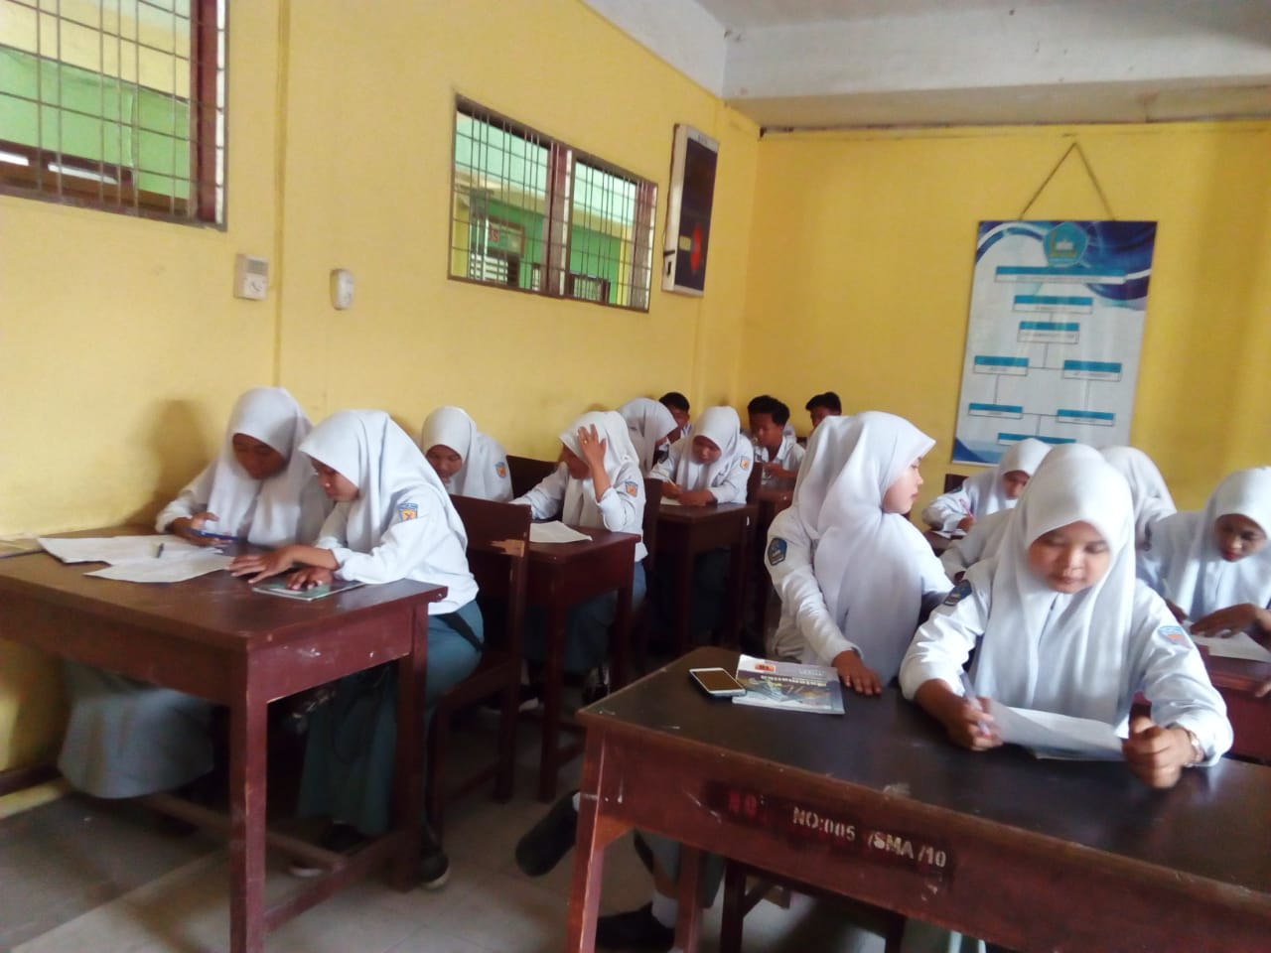
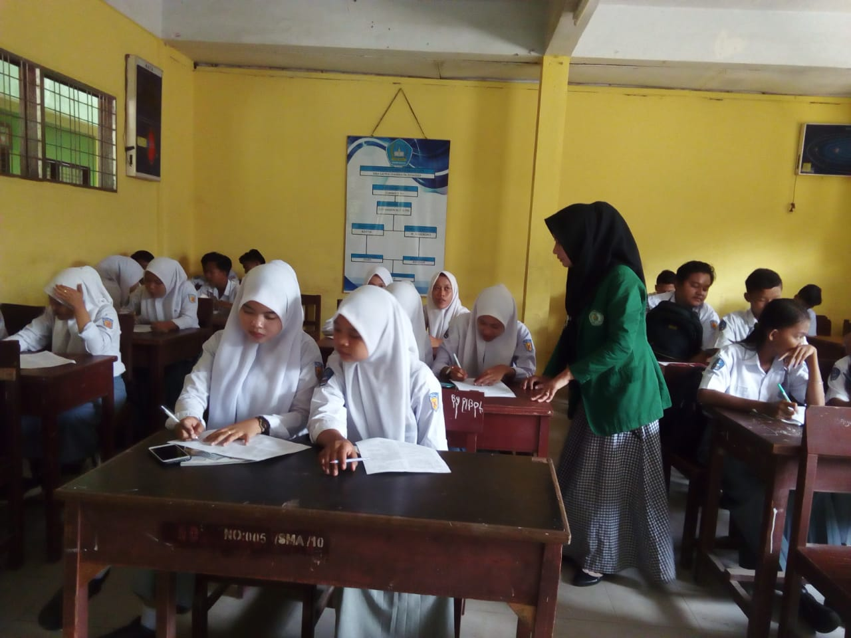

Observation in the classroom
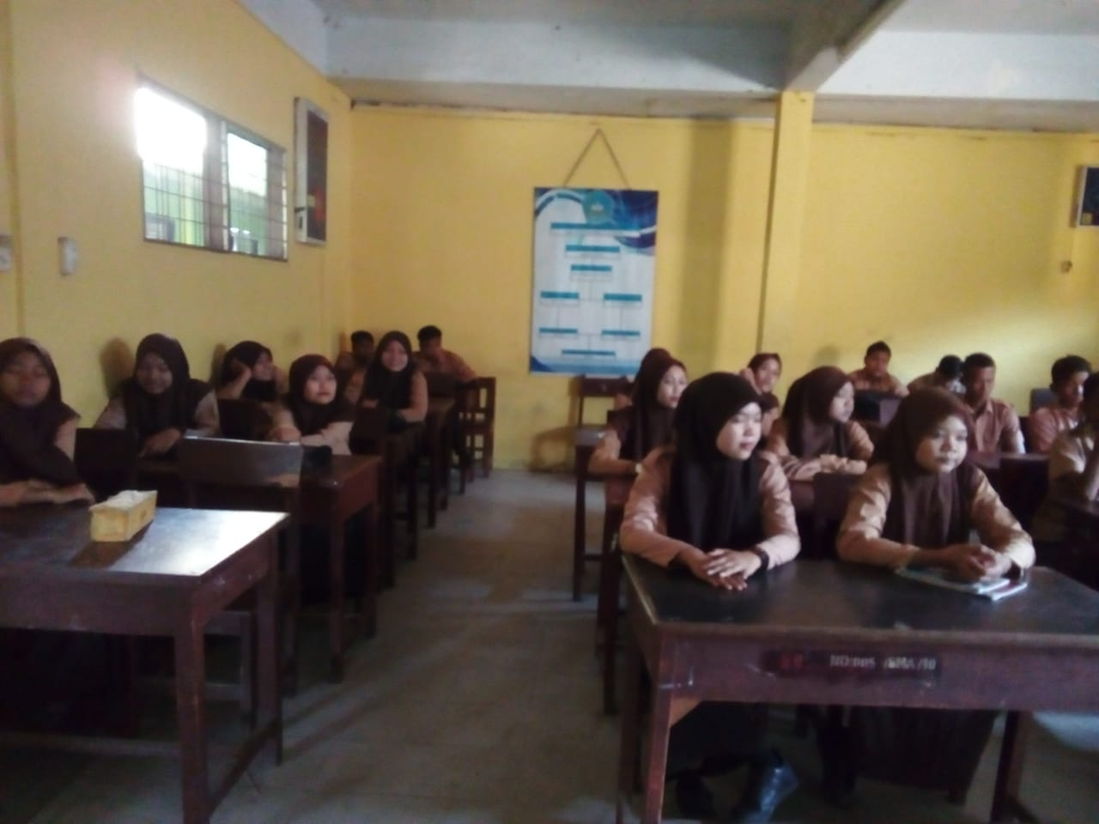
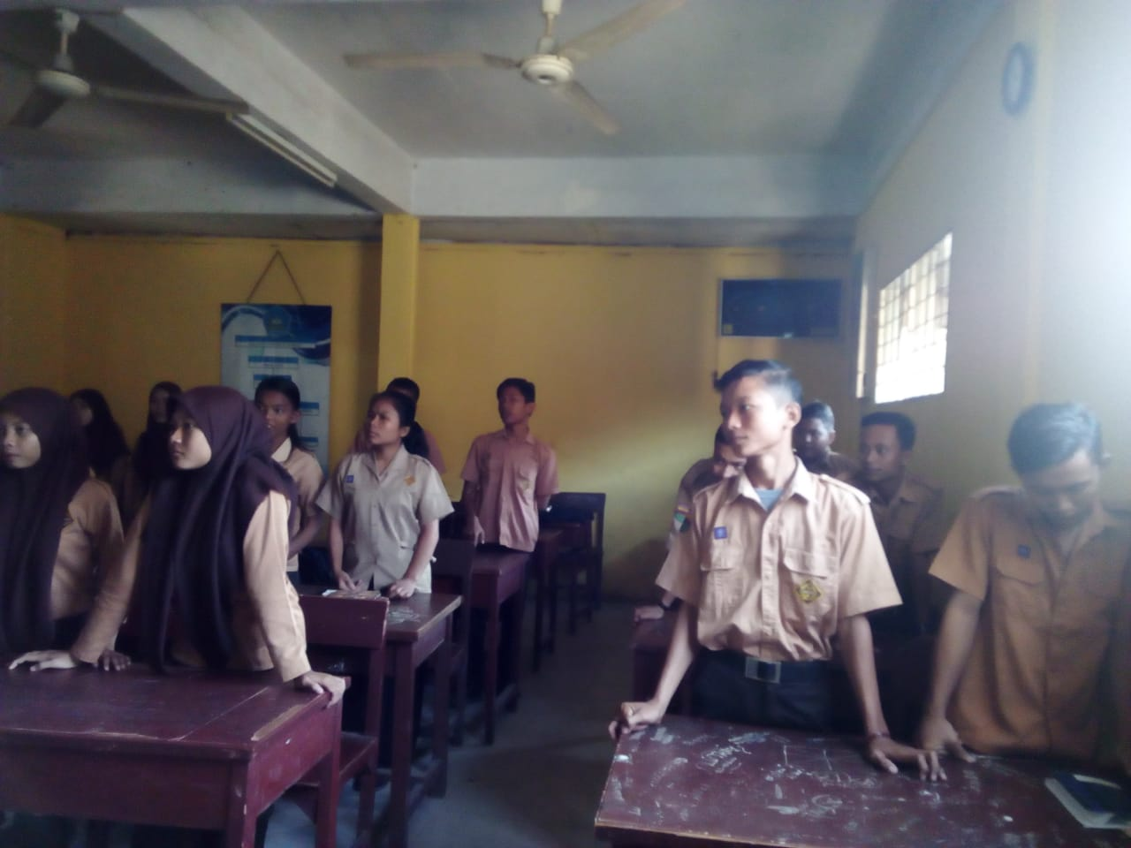

Interview with the teacher
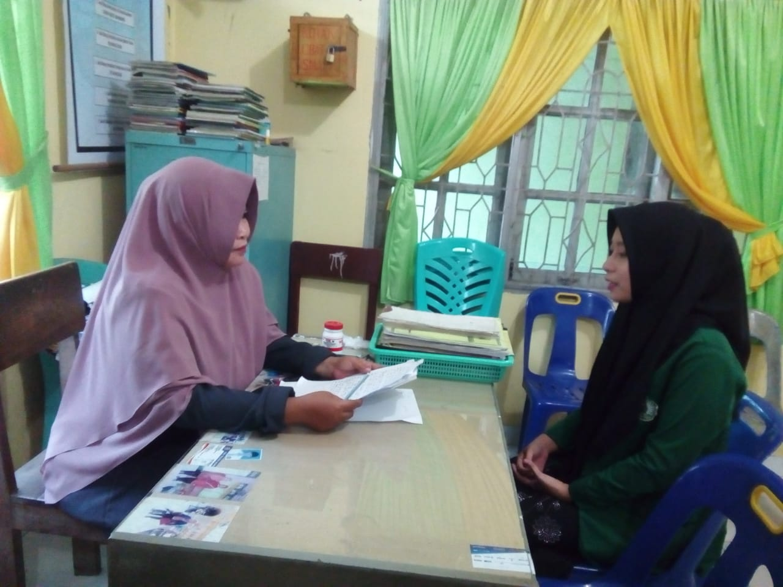
Interview with the students’
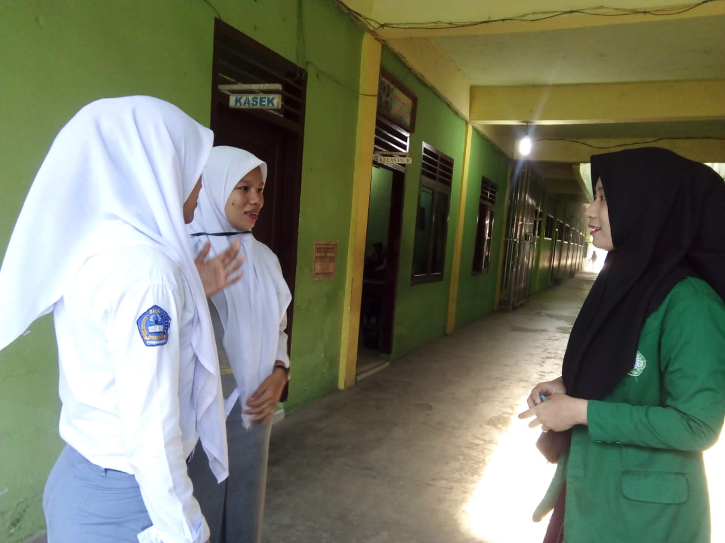

POST TEST
(Cycle I)
Students paid attention to the teachers’ explanation
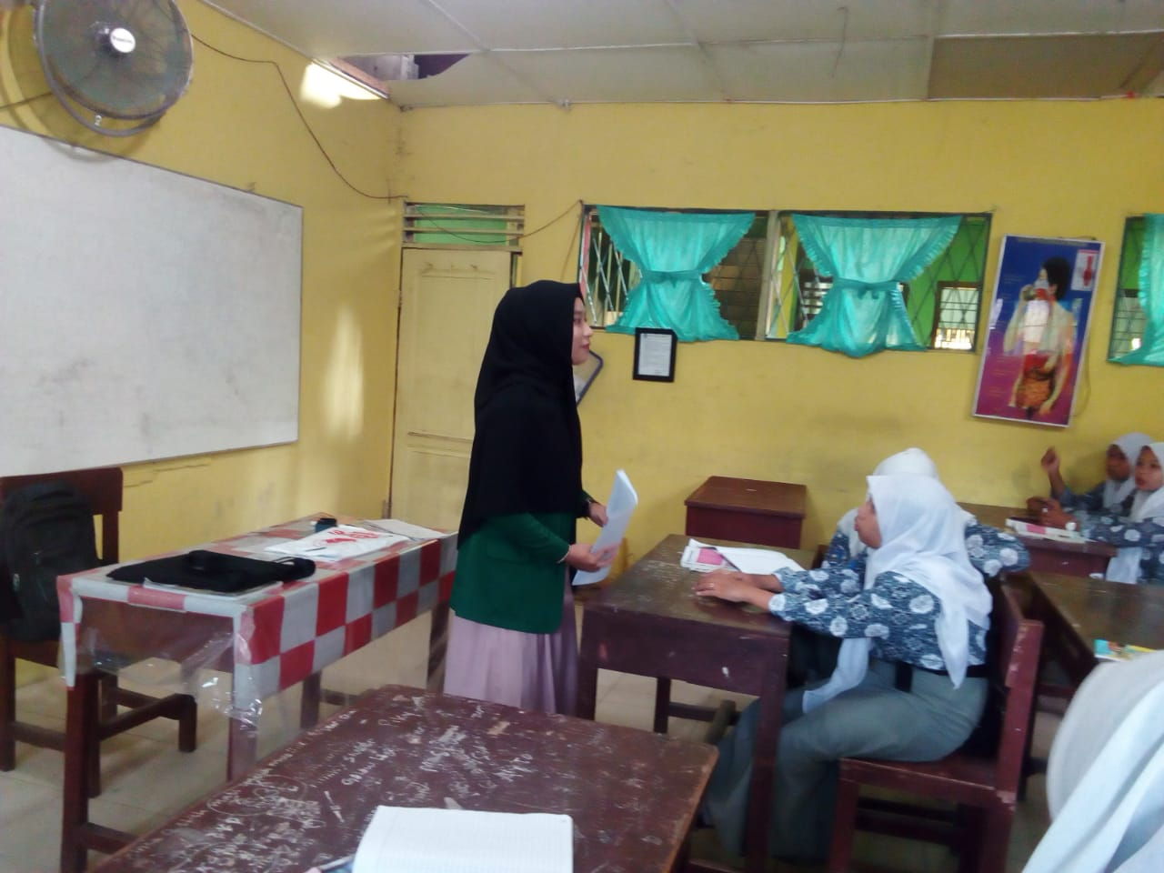
Teacher gave guidance to the students’
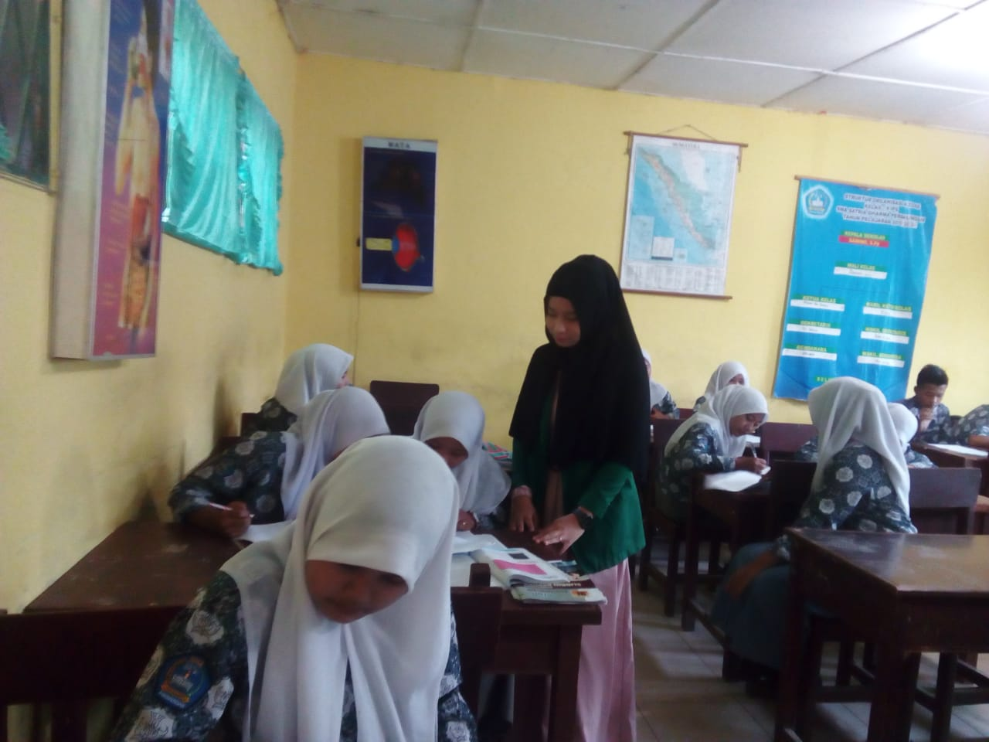

Students are working on a tests
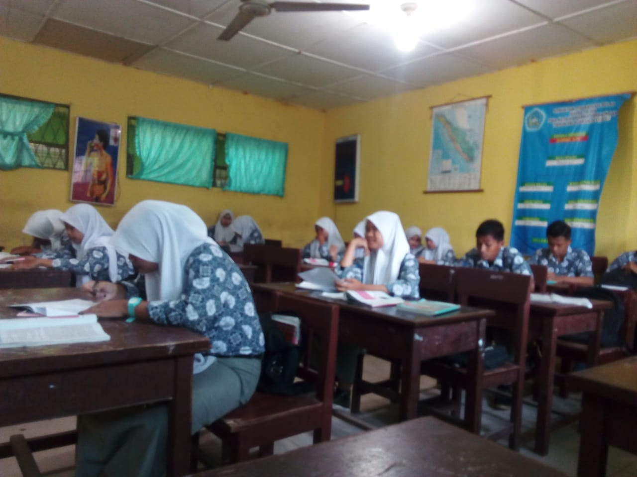

(Cycle II)
Students paid attention to the teacher’s explanation
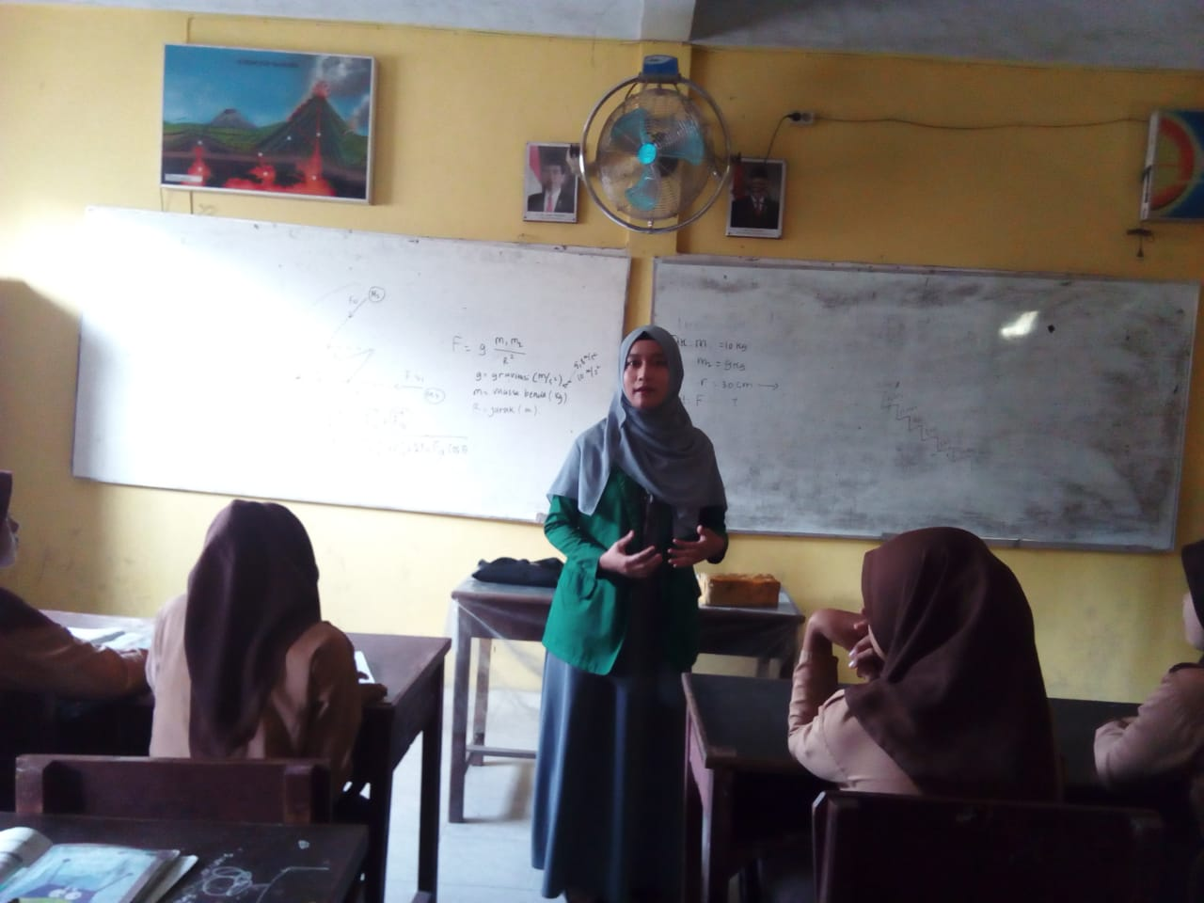

Teacher gave guidance to the students’
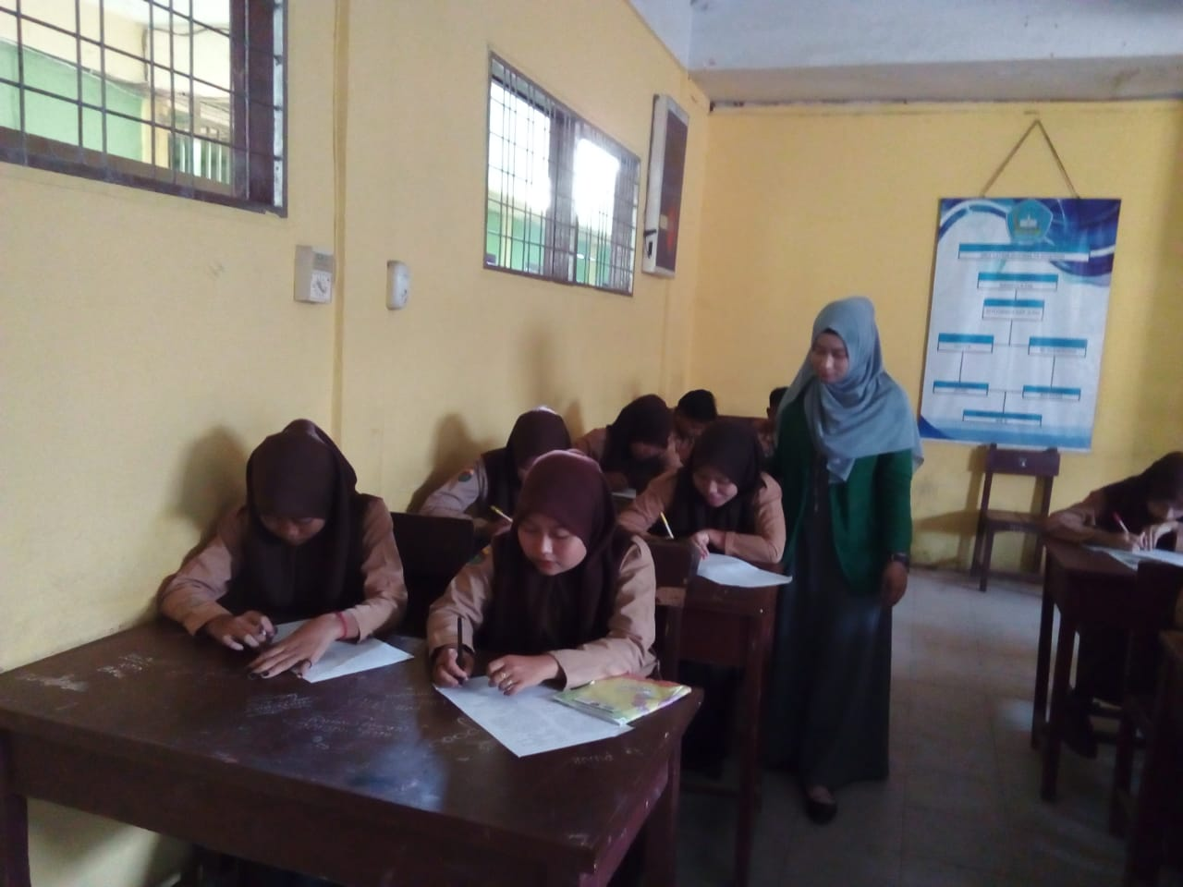
Students are working on a tests
