REFERENCES

Alifiyanti Nugrahani and Fernando, (2006). Language To Use English. (Jakarta: Piranti Drama Kalokatama).
Al-Khresheh, Mohammad Hamad. 2016. A Review Study of Error Analysis Theory. International Journal of Humanities and Social Science Research. 2016 Vol. 2.
Bodgan & Biklen. 2007. Qualitative Research for Education: an Introduction to Theory and Method 5th edition. Boston: Pearson Education Inc.
Brown, H. Douglas. 2000. Principle of Language Learning and Teaching 4th edition. London: Longman
Camara, Jackson & Drummon. 2007. What is Qualitative Research?. Routledege, Vol. 8, No. 1, 2007.
Dismuke & Martin. 2016. What about Writing? : A National Study of Writing Instruction in Teacher Preparation Programs, Boise State University.
Dulay, H., Burt, M., & Krashen, S. (1982). Language Two. New York: Oxford University Press.
Eli Hinkel, Teaching Academic ESL Writing, (London: Lawrence Erlbaum Associates Publisher, 2004).
Erdogan, Vacide. 2005. Contribution of Error Analysis to Foreign Language Teaching. Mersin University Journal of the Faculty of Education, Vol. 1, Issue 2.
Fraenkel, J. R., Wallen, N. E., & Hyun, H. H. (2011). How to Design and Evaluate Research in Education. New York: Longman.
Heldin Manurung, Simplified English Grammar, (Bekasi Timur: Kesaint Blanv, 2007).
Huddlestone & Pullum. 2016. The Cambridge Grammar of the English Language. Cambridge: Cambridge University Press.
Jabeen, Aqsa. 2015. The Role of Error Analysis in Teaching and Learning of Second and Foreign Language. Education and Linguistics Research 2015, Vol. 1, No. 2.
Joyce, H & Feez S. (2000). Writing skills: Narrative and non-fiction text types. (Sydney: Phoenix Education Pty Ltd)
43

Oshima & Hogue. 2007. Introduction to Academic Writing 3rd edition. New York: Pearson Education.
Pardiyono. 2016. Genre: Mastering English through Context. Yogyakarta : C.V Andi Offset.
Pratyasto, Putut. 2011. Jenis Teks Bahasa Inggris. Jakarta: PT. Pustaka Pitaloka.
Riyanto, Leila & Emilia. 2010. Essentials of English Grammar for Fluent. Yogyakarta: Pustaka Pelajar.
Rod Ellis, The Study of Second Language Acquisition, 2nd edition, (New York: Oxford University Press, 2008)
Septari, Ayu Rizky. 2016. The Use of Personal Pronouns by Students in Writing Narrative Text At Sman 1 Sungai Beremas, Pasaman Barat, STKIP PGRI Sumatera Utara.
Sudjono, Anas;. (2007). Pengantar Statistik Pendidikan. Jakarta: PT. Raja Grafindo Persada.
Sugiono. (2009). Metode Penelitian Pendidikan. Yogyakarta: CV. Alfabeta.
Thomas E. Payne, Understanding English Grammar A Linguistic Introduction. (New York: Cambridge University Press, 2011).
Wijayanto, Aru. 2012. Error Analysis in the Use of Personal Pronouns Made by Eleventh Graders in Writing, State University of Surabaya.
William, James D. 2005. The Teacher’s Grammar Book 2nd edition. New Jersey: Lawrence Erlbaum Associates.
Yuli, Aknis Monica Sandra. 2017. An Error Analysis on Using Personal Pronouns in Writing Recount Paragraph Made by the Eight Grade Students Of Smp Negeri 1 Prambon In Academic Year 2015/2016. University of Nusantara PGRI Kediri.

Appendix A
INSTRUMENT
WRITING TEST
AT SMP Cerdas Murni Tembung

Subject : English Writing
Time allocation : 60 minutes

Based on instruction below!
- Every students choose their own title about narrative text.
- Write your name, class, on the piece of paper.

Appendix B
Students’ Writing
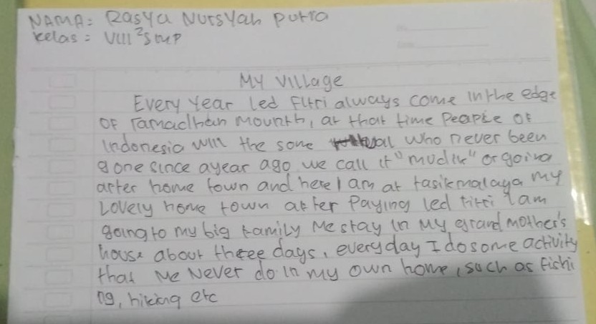
Appendix C
Students’ Writing
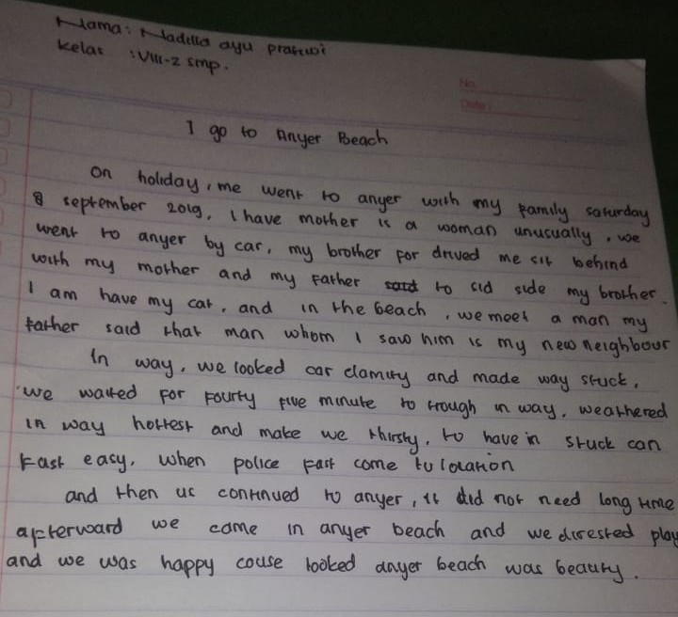

Appendix D
Students’ Writing
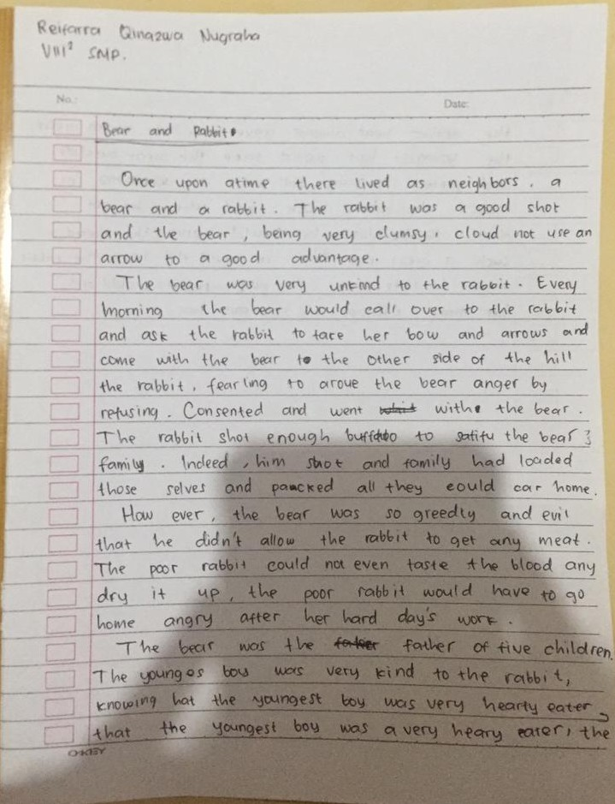
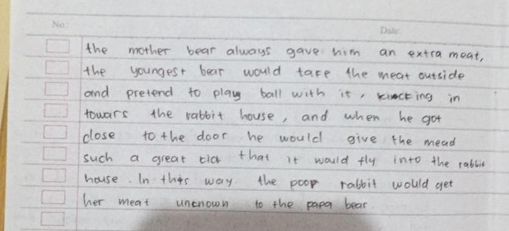

Appendix E
Students’ Writing
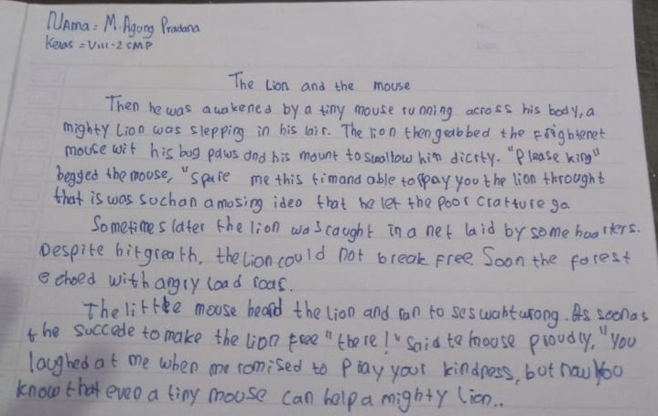
Appendix F
Students’ Writing
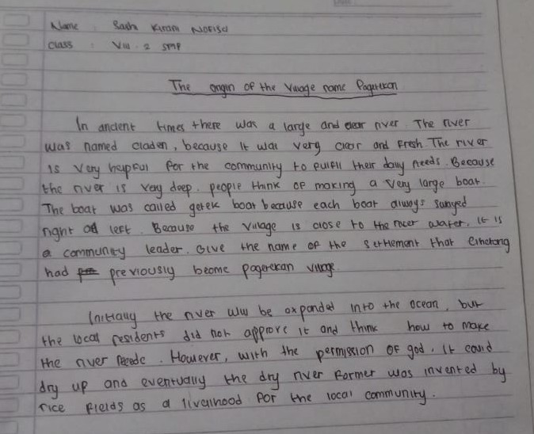

Appendix G
Students’ Writing
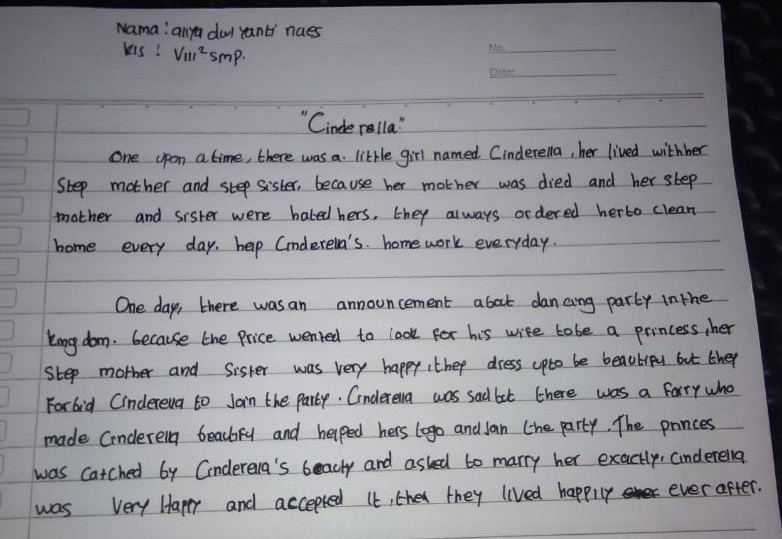
Appendix H
Students’ Writing
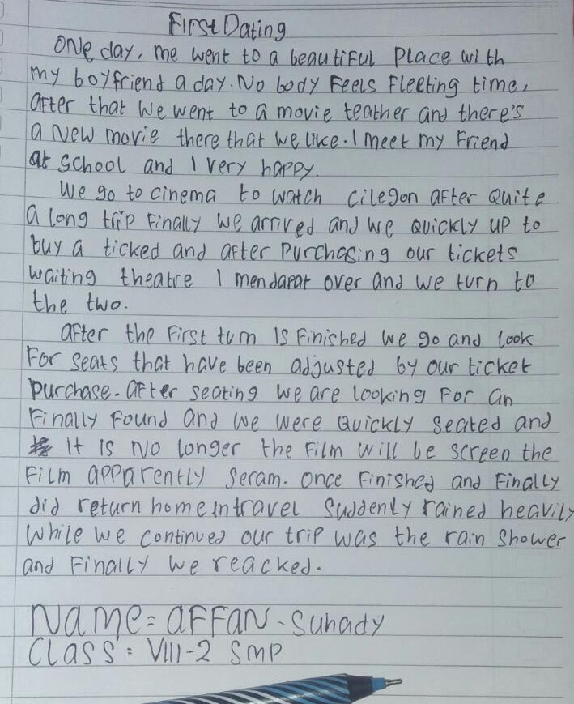
Appendix I
Students’ Writing
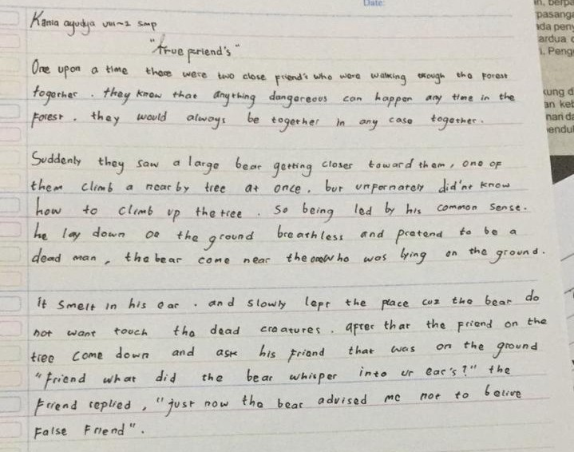
Appendix J
Students’ Writing
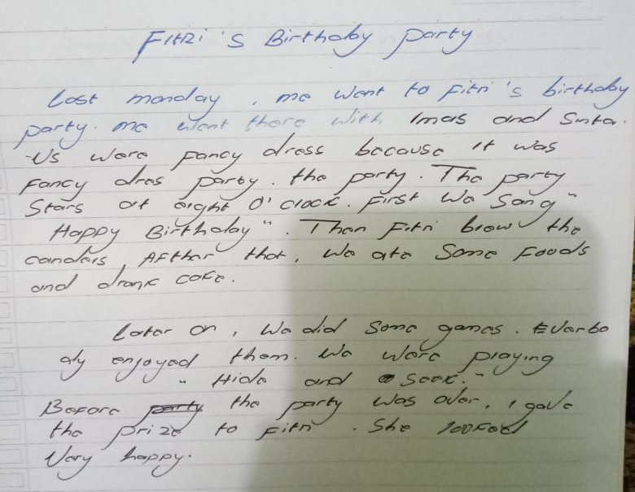
Appendix K
Students’ Writing
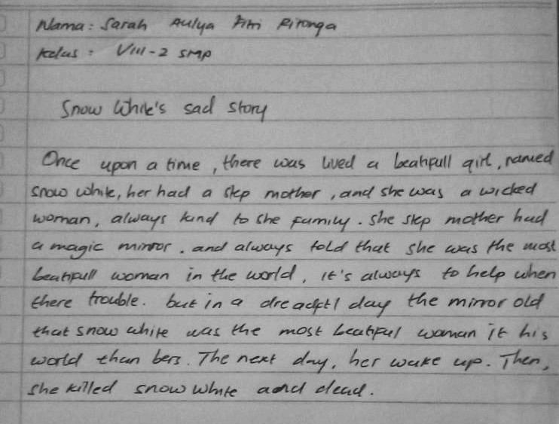
Appendix L
Students’ Writing
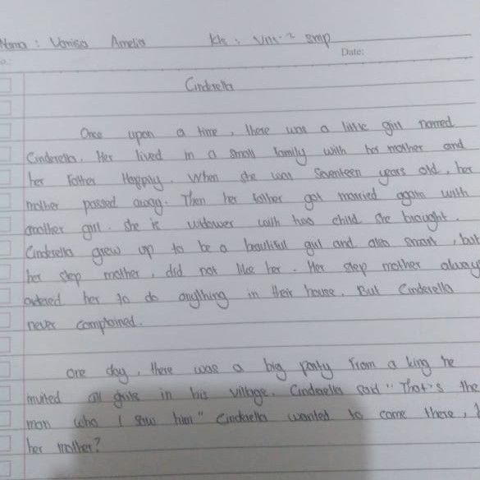

Appendix M
Students’ Writing
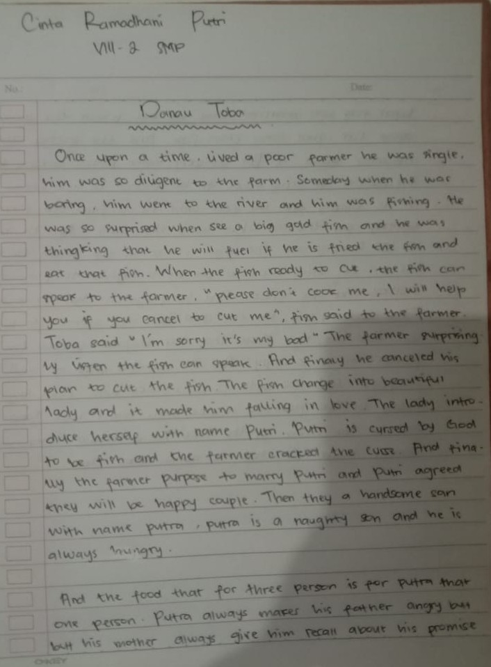

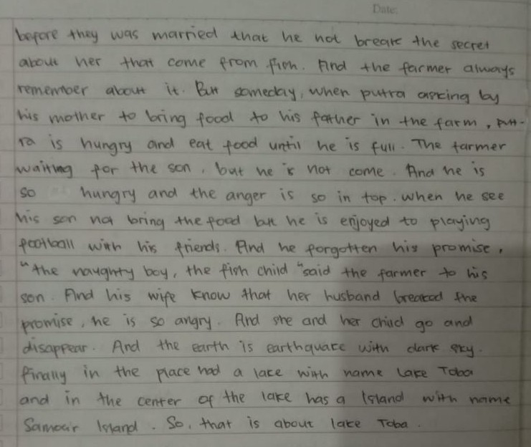
Appendix N
Students’ Writing
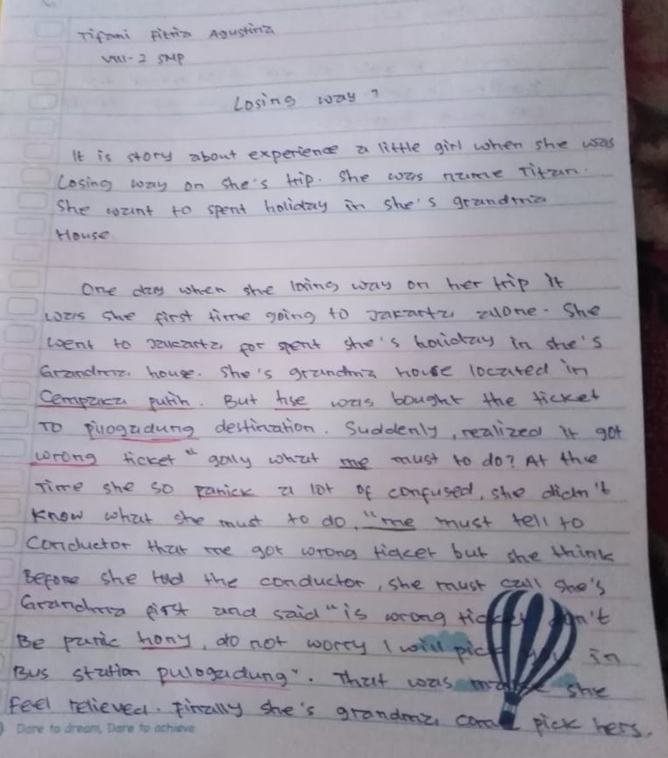

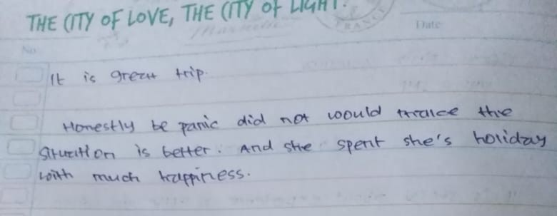
Appendix O
Students’ Writing
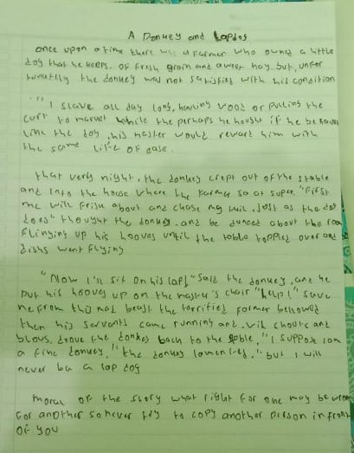
Appendix P
Students’ Writing
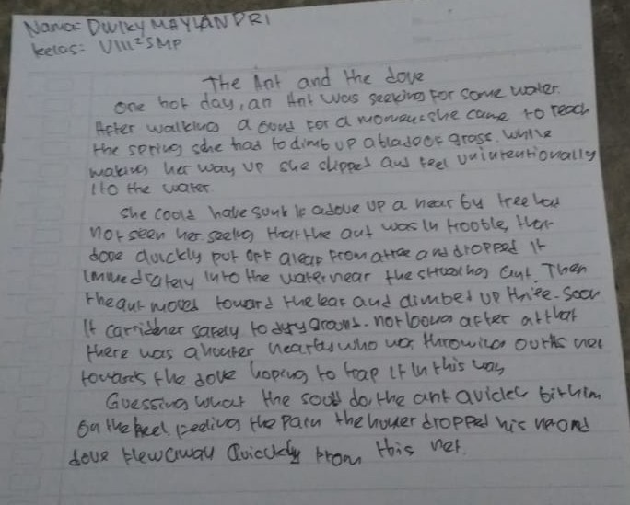
Appendix Q
Name of Students and Initial Name
No | Name of Students | Initial Name
1 | Affan Suhady | AS
2 | Al-Fathir Dafa BB | ADB
3 | Anya Dwi Yanti | ADY
4 | Cinta Ramdhani Putri | CRP
5 | Dwiky Maylandry | DM
6 | Kana Ayudya | KA
7 | Kirani Nafisa | KN
8 | M. Agung Pradana | MAP
9 | Nadia Zahra | NZ
10 | Nadilla Ayu Pratiwi | NAP
11 | Qinazwa Nugraha | QN
12 | Rasya Nursya Putra | RNP
13 | Sarah Aulia Fitri Ritonga | SAF
14 | Tifani Fitria Agustina | TFA
15 | Vanisa Amelia | VA

Appendix R
Documentation
