THE EFFECT OF BLINDFOLD GAME IN IMPROVING STUDENTS’ SPEAKING SKILL

A THESIS

BY

ANGGUN SILVIA
NPM 161244110

FAKULTAS KEGURUAN DAN ILMU PENDIDIKAN
UNIVERSITAS MUSLIM NUSANTARA AL WASHLIYAH
MEDAN
2020
THE EFFECT OF BLINDFOLD GAME IN IMPROVING STUDENTS’ SPEAKING SKILL

A Thesis

Submitted to the Department of English Language Education In Partial Fulfillment of the Requirements for the Degree of
Bachelor of Education

BY

ANGGUN SILVIA
NPM 161244104

FAKULTAS KEGURUAN DAN ILMU PENDIDIKAN
UNIVERSITAS MUSLIM NUSANTARA AL WASHLIYAH
MEDAN
2020

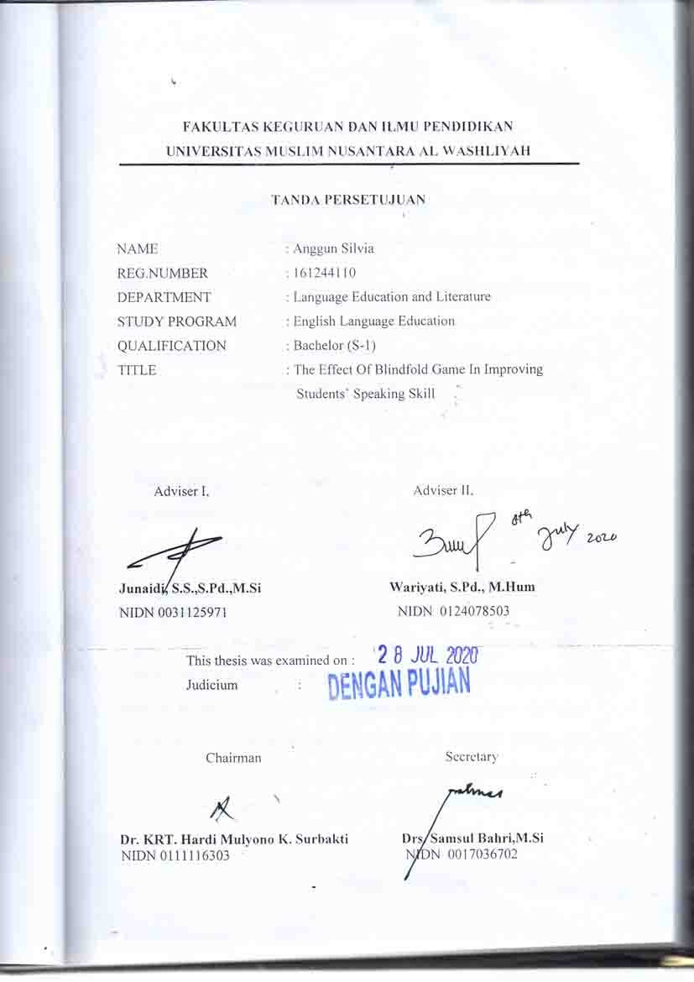

ABSTRACT

THE EFFECT OF BLINDFOLD GAME IN IMPROVING STUDENTS’ SPEAKING SKILL

ANGGUN SILVIA

The objectiveof this research was to investigate the students’ speaking skill through Blindfold Game. This observation was taken 7 Days which started from Thursday, 20th February to 28 February 2020. The Quantitave Research Method was used in this research. The subject of this research were tenth grade students of SMA Swasta Jaya Krama Beringin academic year 2019-2020. The population from this research were the whole students in the class tenth grade A and B.

Technique of collecting data used was pre – test and post-test data, test,observation and documentation. The result of this research showed that there was improving of students’ speaking skill. The findings showed that the students’ speaking skill was improved.the researcher found that the result of the t-testformula was0,007. The value of the degree of freedom (Df) is 52. The researcher made the conclusion of the hypothesis that $t_{0}$ is bigger than t-test namely 0,007> 1,70. It means that the Alternative Hypothesis (Ha) was accepted and Null Hypothesis (Ho) was rejected.There was an improvement of students’ speaking skill significant effect of using blindfold game. It means that Blindfold Game was able to improve the students’ speaking skill.

Keywords: Speaking skill, Blindfold Game, Quanitative research.

ABSTRAK

PENGARUH PEMAINAN BLINDFOLD DALAM MENINGKATKAN KEMAMPUAN BERBICARA SISWA
ANGGUN SILVIA

Tujuandaripenelitianiniadalahuntukmenyelidikiketerampilanberbicarasiswamelaluipermainan Blindfold.Pengamataninidiambil 7 Hari yang dimulaidariKamis, 20 Februarihingga 28 Februari 2020.MetodePenelitiankuantitatifdigunakandalampenelitianini.Subjekpenelitianiniadalahsiswakelas X SMA Swasta Jaya KramaBeringintahunakademik 2019-2020.Populasidaripenelitianiniadalahseluruhsiswakelas X danAkelas B.
Teknikpengumpulan data yang digunakanadalah data pre-test dan post-test, tes, observasidandokumentasi. Hasilpenelitianinimenunjukkanbahwaadapeningkatanketerampilanberbicarasiswa.Temuanmenunjukkanbahwaketerampilanberbicarasiswameningkat.Penelitimenemukanbahwahasildari t-testformula adalah 0,007.Nilaiderajatkebebasan (Df) adalah 52. Penelitimembuatkesimpulandarihipotesisbahwa t_0 lebihbesardari t-test yaitu 0,007> 1,70. IniberartibahwaHipotesisAlternatif (Ha) diterimadan Null Hipotesis (Ho) ditolak.Terdapatpeningkatanketerampilanberbicarasiswa yang berpengaruhsignifikanmenggunakanpermainanBlindfold.IniberartibahwapermainanBlindfold dapatmeningkatkanketerampilanberbicarasiswa.

Kata kunci: KeterampilanBerbicara, PermainanBlindfold, PenelitianQuanitatif.

