ACKNOWLEDGMENT

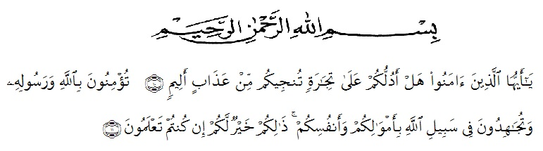
Meaning:
"O believers, do you like me to show you a trade that can save you from painful punishment? (10). (Namely) you believe in Allah and His Messenger and strive in the way of Allah with your wealth and soul. That's better for you, if you know. (11)’’.(QS.ash-Shaff: 10-12)’.
Al- hamdulillahi rabbi lil’alamin. First, and foremost, the writer dedicates this thesis to Allah SWT, Without blessing the writer woudn’t have the ultimate power and motivation to accomplish the completion of her thesis a partial fulfillment of the requirements to achieve the degree SrajanaPendidikan from the English Department of the Faculty of Language and Arts of the University of Muslim Nusantara Al Washliyah Medan. The writer also like to express her praise and gratitude to The Holy Prophet Muhammad SAW who has brought the human race out of the darkness into the light.
During the writing process, the writer has receive help, support and encouragement from a great number of people without whom the writer would not be able to finish her thesis. Here by she would like to express her sincere gratitude to following individuals:
- Dr.KRT.HardiMulyonoK.Surbakti, Rector of University of Moslem Nusantara Alwashliyah Medan.
- The Dean of FKIP UMN Al Wasliyah Medan and his staffs for guidance and assistance during her study at the university.
- Dra.Nurjannah, M.Si, the Head of the English Education Study Program of the English Department.
- Nurhafni, SPd.,M.Hum, she first consultant, who has given she a lot of valuable suggestions, comments and acricism for completing this research.
- NazrianiLubis, SPd.,MHum, she second consultant, who has never stopped helping she in guiding correcting the pattern of this research.
6. The librarian FKIP UMN Al Washliyah Medan, for the books needed in conducting this research.
7. The lecture of the English Department at UMN Al Washliyah Medan for their nice and valuable discussing to enrich the writer’s knowledge.
8. Her beloved family – Her parents whose love, prayers, hard work, and endless motivation, her brother and sister who have supported her to finish this research : support she will never be able to repay them all.
9. Thank you to the women of KAMMI UMN who have supported and prayed for me in my thesis from beginning to end.
10. All Classmates and friends who have encouraged her in finishing this research.

Medan, Juli 2020
The writer’

Ika Ramayadani

