ACKNOWLEDGEMENT
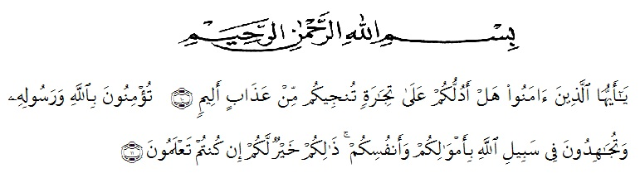
Artinya :
Wahai orang-orang yang beriman! Maukah kamu Aku tunjukkan suatu perdagangan yang dapat menyelamatkan kamu dari azab yang pedih? (10), (Yaitu) kamu beriman kepada Allah dan Rasul-Nya dan berjihad di jalan Allah dengan harta dan jiwamu. Itulah yang lebih baik bagi kamu jika kamu mengetahui (11). (Q.S As-Shaf : 10-11)
The researcher wishes to express her great thanks to the God the beneficent, the merciful. Shalawat and Salam go to the Noble Prophet Mohammad SAW with his followers.
In completing this research, the researcher got suggestions assistance, critics and guidance from many people. The researcher, therefore, would like to express her thanks to:
- The Rector of UMN Al Washliyah Medan as the leader of the University who has received the researcher as the student of the university.
- The Dean of FKIP UMN Al Washliyah Medan and his staffs for facilities given to her during the studies in the Faculty.
- Junaidi, SS.,S.Pd.,M.Si the first adviser, who has given her a lot of valuable suggestions, comments and criticism for completing this research.
- Zulfitri, SS.,MA, her second adviser, who has never stopped helping her in guiding and correcting the pattern of this research.
- The Headmaster of SMK SWASTA AL WASHLIYAH 12 SEI RAMPAH, for facilities given to her in conducting this research.
- The librarian of FKIP UMN Al Washliyah Medan, for the books needed in writing this research.
- The lecturers of the English section in language Department FKIP UMN Al Washliyah Medan for their nice and valuable discussing to enrich the writer’s knowledge.
- The writer’s parents, who have supported her financially and morally during her academic years at FKIP UMN Al Washliyah Medan.
- Her close friends who have encouraged her in planning, drafting and finishing the research.

Medan, 28th July 2020
The Researcher,

Sri Wahyu Jasmin Pratiwi

