APPENDIX A
CRITICAL VALUE T-TABLE
Titik Persentase Distribusi t (df = 1 – 40)

Pr | 0.25 | 0.10 | 0.05 | 0.025 | 0.01 | 0.005 | 0.001
df | 0.50 | 0.20 | 0.10 | 0.050 | 0.02 | 0.010 | 0.002
1 | 1.00000 | 3.07768 | 6.31375 | 12.70620 | 31.82052 | 63.65674 | 318.3084
2 | 0.81650 | 1.88562 | 2.91999 | 4.30265 | 6.96456 | 9.92484 | 22.32712
3 | 0.76489 | 1.63774 | 2.35336 | 3.18245 | 4.54070 | 5.84091 | 10.21453
4 | 0.74070 | 1.53321 | 2.13185 | 2.77645 | 3.74695 | 4.60409 | 7.17318
5 | 0.72669 | 1.47588 | 2.01505 | 2.57058 | 3.36493 | 4.03214 | 5.89343
6 | 0.71756 | 1.43976 | 1.94318 | 2.44691 | 3.14267 | 3.70743 | 5.20763
7 | 0.71114 | 1.41492 | 1.89458 | 2.36462 | 2.99795 | 3.49948 | 4.78529
8 | 0.70639 | 1.39682 | 1.85955 | 2.30600 | 2.89646 | 3.35539 | 4.50079
9 | 0.70272 | 1.38303 | 1.83311 | 2.26216 | 2.82144 | 3.24984 | 4.29681
10 | 0.69981 | 1.37218 | 1.81246 | 2.22814 | 2.76377 | 3.16927 | 4.14370
11 | 0.69745 | 1.36343 | 1.79588 | 2.20099 | 2.71808 | 3.10581 | 4.02470
12 | 0.69548 | 1.35622 | 1.78229 | 2.17881 | 2.68100 | 3.05454 | 3.92963
13 | 0.69383 | 1.35017 | 1.77093 | 2.16037 | 2.65031 | 3.01228 | 3.85198
14 | 0.69242 | 1.34503 | 1.76131 | 2.14479 | 2.62449 | 2.97684 | 3.78739
15 | 0.69120 | 1.34061 | 1.75305 | 2.13145 | 2.60248 | 2.94671 | 3.73283
16 | 0.69013 | 1.33676 | 1.74588 | 2.11991 | 2.58349 | 2.92078 | 3.68615
17 | 0.68920 | 1.33338 | 1.73961 | 2.10982 | 2.56693 | 2.89823 | 3.64577
18 | 0.68836 | 1.33039 | 1.73406 | 2.10092 | 2.55238 | 2.87844 | 3.61048
19 | 0.68762 | 1.32773 | 1.72913 | 2.09302 | 2.53948 | 2.86093 | 3.57940
20 | 0.68695 | 1.32534 | 1.72472 | 2.08596 | 2.52798 | 2.84534 | 3.55181
21 | 0.68635 | 1.32319 | 1.72074 | 2.07961 | 2.51765 | 2.83136 | 3.52715
22 | 0.68581 | 1.32124 | 1.71714 | 2.07387 | 2.50832 | 2.81876 | 3.50499
23 | 0.68531 | 1.31946 | 1.71387 | 2.06866 | 2.49987 | 2.80734 | 3.48496
24 | 0.68485 | 1.31784 | 1.71088 | 2.06390 | 2.49216 | 2.79694 | 3.46678
25 | 0.68443 | 1.31635 | 1.70814 | 2.05954 | 2.48511 | 2.78744 | 3.45019
26 | 0.68404 | 1.31497 | 1.70562 | 2.05553 | 2.47863 | 2.77871 | 3.43500
27 | 0.68368 | 1.31370 | 1.70329 | 2.05183 | 2.47266 | 2.77068 | 3.42103
28 | 0.68335 | 1.31253 | 1.70113 | 2.04841 | 2.46714 | 2.76326 | 3.40816
29 | 0.68304 | 1.31143 | 1.69913 | 2.04523 | 2.46202 | 2.75639 | 3.39624
30 | 0.68276 | 1.31042 | 1.69726 | 2.04227 | 2.45726 | 2.75000 | 3.38518
31 | 0.68249 | 1.30946 | 1.69552 | 2.03951 | 2.45282 | 2.74404 | 3.37490
32 | 0.68223 | 1.30857 | 1.69389 | 2.03693 | 2.44868 | 2.73848 | 3.36531
33 | 0.68200 | 1.30774 | 1.69236 | 2.03452 | 2.44479 | 2.73328 | 3.35634
34 | 0.68177 | 1.30695 | 1.69092 | 2.03224 | 2.44115 | 2.72839 | 3.34793
35 | 0.68156 | 1.30621 | 1.68957 | 2.03011 | 2.43772 | 2.72381 | 3.34005
36 | 0.68137 | 1.30551 | 1.68830 | 2.02809 | 2.43449 | 2.71948 | 3.33262
37 | 0.68118 | 1.30485 | 1.68709 | 2.02619 | 2.43145 | 2.71541 | 3.32563
38 | 0.68100 | 1.30423 | 1.68595 | 2.02439 | 2.42857 | 2.71156 | 3.31903
39 | 0.68083 | 1.30364 | 1.68488 | 2.02269 | 2.42584 | 2.70791 | 3.31279
40 | 0.68067 | 1.30308 | 1.68385 | 2.02108 | 2.42326 | 2.70446 | 3.30688

Titik Persentase Distribusi t (df = 41 – 80)
Pr | 0.25 | 0.10 | 0.05 | 0.025 | 0.01 | 0.005 | 0.001
df | 0.50 | 0.20 | 0.10 | 0.050 | 0.02 | 0.010 | 0.002
41 | 0.68052 | 1.30254 | 1.68288 | 2.01954 | 2.42080 | 2.70118 | 3.30127
42 | 0.68038 | 1.30204 | 1.68195 | 2.01808 | 2.41847 | 2.69807 | 3.29595
43 | 0.68024 | 1.30155 | 1.68107 | 2.01669 | 2.41625 | 2.69510 | 3.29089
44 | 0.68011 | 1.30109 | 1.68023 | 2.01537 | 2.41413 | 2.69228 | 3.28607
45 | 0.67998 | 1.30065 | 1.67943 | 2.01410 | 2.41212 | 2.68959 | 3.28148
46 | 0.67986 | 1.30023 | 1.67866 | 2.01290 | 2.41019 | 2.68701 | 3.27710
47 | 0.67975 | 1.29982 | 1.67793 | 2.01174 | 2.40835 | 2.68456 | 3.27291
48 | 0.67964 | 1.29944 | 1.67722 | 2.01063 | 2.40658 | 2.68220 | 3.26891
49 | 0.67953 | 1.29907 | 1.67655 | 2.00958 | 2.40489 | 2.67995 | 3.26508
50 | 0.67943 | 1.29871 | 1.67591 | 2.00856 | 2.40327 | 2.67779 | 3.26141
51 | 0.67933 | 1.29837 | 1.67528 | 2.00758 | 2.40172 | 2.67572 | 3.25789
52 | 0.67924 | 1.29805 | 1.67469 | 2.00665 | 2.40022 | 2.67373 | 3.25451
53 | 0.67915 | 1.29773 | 1.67412 | 2.00575 | 2.39879 | 2.67182 | 3.25127
54 | 0.67906 | 1.29743 | 1.67356 | 2.00488 | 2.39741 | 2.66998 | 3.24815
55 | 0.67898 | 1.29713 | 1.67303 | 2.00404 | 2.39608 | 2.66822 | 3.24515
56 | 0.67890 | 1.29685 | 1.67252 | 2.00324 | 2.39480 | 2.66651 | 3.24226
57 | 0.67882 | 1.29658 | 1.67203 | 2.00247 | 2.39357 | 2.66487 | 3.23948
58 | 0.67874 | 1.29632 | 1.67155 | 2.00172 | 2.39238 | 2.66329 | 3.23680
59 | 0.67867 | 1.29607 | 1.67109 | 2.00100 | 2.39123 | 2.66176 | 3.23421
60 | 0.67860 | 1.29582 | 1.67065 | 2.00030 | 2.39012 | 2.66028 | 3.23171
61 | 0.67853 | 1.29558 | 1.67022 | 1.99962 | 2.38905 | 2.65886 | 3.22930
62 | 0.67847 | 1.29536 | 1.66980 | 1.99897 | 2.38801 | 2.65748 | 3.22696
63 | 0.67840 | 1.29513 | 1.66940 | 1.99834 | 2.38701 | 2.65615 | 3.22471
64 | 0.67834 | 1.29492 | 1.66901 | 1.99773 | 2.38604 | 2.65485 | 3.22253
65 | 0.67828 | 1.29471 | 1.66864 | 1.99714 | 2.38510 | 2.65360 | 3.22041
66 | 0.67823 | 1.29451 | 1.66827 | 1.99656 | 2.38419 | 2.65239 | 3.21837
67 | 0.67817 | 1.29432 | 1.66792 | 1.99601 | 2.38330 | 2.65122 | 3.21639
68 | 0.67811 | 1.29413 | 1.66757 | 1.99547 | 2.38245 | 2.65008 | 3.21446
69 | 0.67806 | 1.29394 | 1.66724 | 1.99495 | 2.38161 | 2.64898 | 3.21260
70 | 0.67801 | 1.29376 | 1.66691 | 1.99444 | 2.38081 | 2.64790 | 3.21079
71 | 0.67796 | 1.29359 | 1.66660 | 1.99394 | 2.38002 | 2.64686 | 3.20903
72 | 0.67791 | 1.29342 | 1.66629 | 1.99346 | 2.37926 | 2.64585 | 3.20733
73 | 0.67787 | 1.29326 | 1.66600 | 1.99300 | 2.37852 | 2.64487 | 3.20567
74 | 0.67782 | 1.29310 | 1.66571 | 1.99254 | 2.37780 | 2.64391 | 3.20406
75 | 0.67778 | 1.29294 | 1.66543 | 1.99210 | 2.37710 | 2.64298 | 3.20249
76 | 0.67773 | 1.29279 | 1.66515 | 1.99167 | 2.37642 | 2.64208 | 3.20096
77 | 0.67769 | 1.29264 | 1.66488 | 1.99125 | 2.37576 | 2.64120 | 3.19948
78 | 0.67765 | 1.29250 | 1.66462 | 1.99085 | 2.37511 | 2.64034 | 3.19804
79 | 0.67761 | 1.29236 | 1.66437 | 1.99045 | 2.37448 | 2.63950 | 3.19663
80 | 0.67757 | 1.29222 | 1.66412 | 1.99006 | 2.37387 | 2.63869 | 3.19526

Titik Persentase Distribusi t (df = 81 –120)
Pr | 0.25 | 0.10 | 0.05 | 0.025 | 0.01 | 0.005 | 0.001
df | 0.50 | 0.20 | 0.10 | 0.050 | 0.02 | 0.010 | 0.002
81 | 0.67753 | 1.29209 | 1.66388 | 1.98969 | 2.37327 | 2.63790 | 3.19392
82 | 0.67749 | 1.29196 | 1.66365 | 1.98932 | 2.37269 | 2.63712 | 3.19262
83 | 0.67746 | 1.29183 | 1.66342 | 1.98896 | 2.37212 | 2.63637 | 3.19135
84 | 0.67742 | 1.29171 | 1.66320 | 1.98861 | 2.37156 | 2.63563 | 3.19011
85 | 0.67739 | 1.29159 | 1.66298 | 1.98827 | 2.37102 | 2.63491 | 3.18890
86 | 0.67735 | 1.29147 | 1.66277 | 1.98793 | 2.37049 | 2.63421 | 3.18772
87 | 0.67732 | 1.29136 | 1.66256 | 1.98761 | 2.36998 | 2.63353 | 3.18657
88 | 0.67729 | 1.29125 | 1.66235 | 1.98729 | 2.36947 | 2.63286 | 3.18544
89 | 0.67726 | 1.29114 | 1.66216 | 1.98698 | 2.36898 | 2.63220 | 3.18434
90 | 0.67723 | 1.29103 | 1.66196 | 1.98667 | 2.36850 | 2.63157 | 3.18327
91 | 0.67720 | 1.29092 | 1.66177 | 1.98638 | 2.36803 | 2.63094 | 3.18222
92 | 0.67717 | 1.29082 | 1.66159 | 1.98609 | 2.36757 | 2.63033 | 3.18119
93 | 0.67714 | 1.29072 | 1.66140 | 1.98580 | 2.36712 | 2.62973 | 3.18019
94 | 0.67711 | 1.29062 | 1.66123 | 1.98552 | 2.36667 | 2.62915 | 3.17921
95 | 0.67708 | 1.29053 | 1.66105 | 1.98525 | 2.36624 | 2.62858 | 3.17825
96 | 0.67705 | 1.29043 | 1.66088 | 1.98498 | 2.36582 | 2.62802 | 3.17731
97 | 0.67703 | 1.29034 | 1.66071 | 1.98472 | 2.36541 | 2.62747 | 3.17639
98 | 0.67700 | 1.29025 | 1.66055 | 1.98447 | 2.36500 | 2.62693 | 3.17549
99 | 0.67698 | 1.29016 | 1.66039 | 1.98422 | 2.36461 | 2.62641 | 3.17460
100 | 0.67695 | 1.29007 | 1.66023 | 1.98397 | 2.36422 | 2.62589 | 3.17374
101 | 0.67693 | 1.28999 | 1.66008 | 1.98373 | 2.36384 | 2.62539 | 3.17289
102 | 0.67690 | 1.28991 | 1.65993 | 1.98350 | 2.36346 | 2.62489 | 3.17206
103 | 0.67688 | 1.28982 | 1.65978 | 1.98326 | 2.36310 | 2.62441 | 3.17125
104 | 0.67686 | 1.28974 | 1.65964 | 1.98304 | 2.36274 | 2.62393 | 3.17045
105 | 0.67683 | 1.28967 | 1.65950 | 1.98282 | 2.36239 | 2.62347 | 3.16967
106 | 0.67681 | 1.28959 | 1.65936 | 1.98260 | 2.36204 | 2.62301 | 3.16890
107 | 0.67679 | 1.28951 | 1.65922 | 1.98238 | 2.36170 | 2.62256 | 3.16815
108 | 0.67677 | 1.28944 | 1.65909 | 1.98217 | 2.36137 | 2.62212 | 3.16741
109 | 0.67675 | 1.28937 | 1.65895 | 1.98197 | 2.36105 | 2.62169 | 3.16669
110 | 0.67673 | 1.28930 | 1.65882 | 1.98177 | 2.36073 | 2.62126 | 3.16598
111 | 0.67671 | 1.28922 | 1.65870 | 1.98157 | 2.36041 | 2.62085 | 3.16528
112 | 0.67669 | 1.28916 | 1.65857 | 1.98137 | 2.36010 | 2.62044 | 3.16460
113 | 0.67667 | 1.28909 | 1.65845 | 1.98118 | 2.35980 | 2.62004 | 3.16392
114 | 0.67665 | 1.28902 | 1.65833 | 1.98099 | 2.35950 | 2.61964 | 3.16326
115 | 0.67663 | 1.28896 | 1.65821 | 1.98081 | 2.35921 | 2.61926 | 3.16262
116 | 0.67661 | 1.28889 | 1.65810 | 1.98063 | 2.35892 | 2.61888 | 3.16198
117 | 0.67659 | 1.28883 | 1.65798 | 1.98045 | 2.35864 | 2.61850 | 3.16135
118 | 0.67657 | 1.28877 | 1.65787 | 1.98027 | 2.35837 | 2.61814 | 3.16074
119 | 0.67656 | 1.28871 | 1.65776 | 1.98010 | 2.35809 | 2.61778 | 3.16013
120 | 0.67654 | 1.28865 | 1.65765 | 1.97993 | 2.35782 | 2.61742 | 3.15954

Titik Persentase Distribusi t (df = 121 –160)
Pr | 0.25 | 0.10 | 0.05 | 0.025 | 0.01 | 0.005 | 0.001
df | 0.50 | 0.20 | 0.10 | 0.050 | 0.02 | 0.010 | 0.002
121 | 0.67652 | 1.28859 | 1.65754 | 1.97976 | 2.35756 | 2.61707 | 3.15895
122 | 0.67651 | 1.28853 | 1.65744 | 1.97960 | 2.35730 | 2.61673 | 3.15838
123 | 0.67649 | 1.28847 | 1.65734 | 1.97944 | 2.35705 | 2.61639 | 3.15781
124 | 0.67647 | 1.28842 | 1.65723 | 1.97928 | 2.35680 | 2.61606 | 3.15726
125 | 0.67646 | 1.28836 | 1.65714 | 1.97912 | 2.35655 | 2.61573 | 3.15671
126 | 0.67644 | 1.28831 | 1.65704 | 1.97897 | 2.35631 | 2.61541 | 3.15617
127 | 0.67643 | 1.28825 | 1.65694 | 1.97882 | 2.35607 | 2.61510 | 3.15565
128 | 0.67641 | 1.28820 | 1.65685 | 1.97867 | 2.35583 | 2.61478 | 3.15512
129 | 0.67640 | 1.28815 | 1.65675 | 1.97852 | 2.35560 | 2.61448 | 3.15461
130 | 0.67638 | 1.28810 | 1.65666 | 1.97838 | 2.35537 | 2.61418 | 3.15411
131 | 0.67637 | 1.28805 | 1.65657 | 1.97824 | 2.35515 | 2.61388 | 3.15361
132 | 0.67635 | 1.28800 | 1.65648 | 1.97810 | 2.35493 | 2.61359 | 3.15312
133 | 0.67634 | 1.28795 | 1.65639 | 1.97796 | 2.35471 | 2.61330 | 3.15264
134 | 0.67633 | 1.28790 | 1.65630 | 1.97783 | 2.35450 | 2.61302 | 3.15217
135 | 0.67631 | 1.28785 | 1.65622 | 1.97769 | 2.35429 | 2.61274 | 3.15170
136 | 0.67630 | 1.28781 | 1.65613 | 1.97756 | 2.35408 | 2.61246 | 3.15124
137 | 0.67628 | 1.28776 | 1.65605 | 1.97743 | 2.35387 | 2.61219 | 3.15079
138 | 0.67627 | 1.28772 | 1.65597 | 1.97730 | 2.35367 | 2.61193 | 3.15034
139 | 0.67626 | 1.28767 | 1.65589 | 1.97718 | 2.35347 | 2.61166 | 3.14990
140 | 0.67625 | 1.28763 | 1.65581 | 1.97705 | 2.35328 | 2.61140 | 3.14947
141 | 0.67623 | 1.28758 | 1.65573 | 1.97693 | 2.35309 | 2.61115 | 3.14904
142 | 0.67622 | 1.28754 | 1.65566 | 1.97681 | 2.35289 | 2.61090 | 3.14862
143 | 0.67621 | 1.28750 | 1.65558 | 1.97669 | 2.35271 | 2.61065 | 3.14820
144 | 0.67620 | 1.28746 | 1.65550 | 1.97658 | 2.35252 | 2.61040 | 3.14779
145 | 0.67619 | 1.28742 | 1.65543 | 1.97646 | 2.35234 | 2.61016 | 3.14739
146 | 0.67617 | 1.28738 | 1.65536 | 1.97635 | 2.35216 | 2.60992 | 3.14699
147 | 0.67616 | 1.28734 | 1.65529 | 1.97623 | 2.35198 | 2.60969 | 3.14660
148 | 0.67615 | 1.28730 | 1.65521 | 1.97612 | 2.35181 | 2.60946 | 3.14621
149 | 0.67614 | 1.28726 | 1.65514 | 1.97601 | 2.35163 | 2.60923 | 3.14583
150 | 0.67613 | 1.28722 | 1.65508 | 1.97591 | 2.35146 | 2.60900 | 3.14545
151 | 0.67612 | 1.28718 | 1.65501 | 1.97580 | 2.35130 | 2.60878 | 3.14508
152 | 0.67611 | 1.28715 | 1.65494 | 1.97569 | 2.35113 | 2.60856 | 3.14471
153 | 0.67610 | 1.28711 | 1.65487 | 1.97559 | 2.35097 | 2.60834 | 3.14435
154 | 0.67609 | 1.28707 | 1.65481 | 1.97549 | 2.35081 | 2.60813 | 3.14400
155 | 0.67608 | 1.28704 | 1.65474 | 1.97539 | 2.35065 | 2.60792 | 3.14364
156 | 0.67607 | 1.28700 | 1.65468 | 1.97529 | 2.35049 | 2.60771 | 3.14330
157 | 0.67606 | 1.28697 | 1.65462 | 1.97519 | 2.35033 | 2.60751 | 3.14295
158 | 0.67605 | 1.28693 | 1.65455 | 1.97509 | 2.35018 | 2.60730 | 3.14261
159 | 0.67604 | 1.28690 | 1.65449 | 1.97500 | 2.35003 | 2.60710 | 3.14228

Titik Persentase Distribusi t (df = 161 –200)
Pr | 0.25 | 0.10 | 0.05 | 0.025 | 0.01 | 0.005 | 0.001
df | 0.50 | 0.20 | 0.10 | 0.050 | 0.02 | 0.010 | 0.002
161 | 0.67602 | 1.28683 | 1.65437 | 1.97481 | 2.34973 | 2.60671 | 3.14162
162 | 0.67601 | 1.28680 | 1.65431 | 1.97472 | 2.34959 | 2.60652 | 3.14130
163 | 0.67600 | 1.28677 | 1.65426 | 1.97462 | 2.34944 | 2.60633 | 3.14098
164 | 0.67599 | 1.28673 | 1.65420 | 1.97453 | 2.34930 | 2.60614 | 3.14067
165 | 0.67598 | 1.28670 | 1.65414 | 1.97445 | 2.34916 | 2.60595 | 3.14036
166 | 0.67597 | 1.28667 | 1.65408 | 1.97436 | 2.34902 | 2.60577 | 3.14005
167 | 0.67596 | 1.28664 | 1.65403 | 1.97427 | 2.34888 | 2.60559 | 3.13975
168 | 0.67595 | 1.28661 | 1.65397 | 1.97419 | 2.34875 | 2.60541 | 3.13945
169 | 0.67594 | 1.28658 | 1.65392 | 1.97410 | 2.34862 | 2.60523 | 3.13915
170 | 0.67594 | 1.28655 | 1.65387 | 1.97402 | 2.34848 | 2.60506 | 3.13886
171 | 0.67593 | 1.28652 | 1.65381 | 1.97393 | 2.34835 | 2.60489 | 3.13857
172 | 0.67592 | 1.28649 | 1.65376 | 1.97385 | 2.34822 | 2.60471 | 3.13829
173 | 0.67591 | 1.28646 | 1.65371 | 1.97377 | 2.34810 | 2.60455 | 3.13801
174 | 0.67590 | 1.28644 | 1.65366 | 1.97369 | 2.34797 | 2.60438 | 3.13773
175 | 0.67589 | 1.28641 | 1.65361 | 1.97361 | 2.34784 | 2.60421 | 3.13745
176 | 0.67589 | 1.28638 | 1.65356 | 1.97353 | 2.34772 | 2.60405 | 3.13718
177 | 0.67588 | 1.28635 | 1.65351 | 1.97346 | 2.34760 | 2.60389 | 3.13691
178 | 0.67587 | 1.28633 | 1.65346 | 1.97338 | 2.34748 | 2.60373 | 3.13665
179 | 0.67586 | 1.28630 | 1.65341 | 1.97331 | 2.34736 | 2.60357 | 3.13638
180 | 0.67586 | 1.28627 | 1.65336 | 1.97323 | 2.34724 | 2.60342 | 3.13612
181 | 0.67585 | 1.28625 | 1.65332 | 1.97316 | 2.34713 | 2.60326 | 3.13587
182 | 0.67584 | 1.28622 | 1.65327 | 1.97308 | 2.34701 | 2.60311 | 3.13561
183 | 0.67583 | 1.28619 | 1.65322 | 1.97301 | 2.34690 | 2.60296 | 3.13536
184 | 0.67583 | 1.28617 | 1.65318 | 1.97294 | 2.34678 | 2.60281 | 3.13511
185 | 0.67582 | 1.28614 | 1.65313 | 1.97287 | 2.34667 | 2.60267 | 3.13487
186 | 0.67581 | 1.28612 | 1.65309 | 1.97280 | 2.34656 | 2.60252 | 3.13463
187 | 0.67580 | 1.28610 | 1.65304 | 1.97273 | 2.34645 | 2.60238 | 3.13438
188 | 0.67580 | 1.28607 | 1.65300 | 1.97266 | 2.34635 | 2.60223 | 3.13415
189 | 0.67579 | 1.28605 | 1.65296 | 1.97260 | 2.34624 | 2.60209 | 3.13391
190 | 0.67578 | 1.28602 | 1.65291 | 1.97253 | 2.34613 | 2.60195 | 3.13368
191 | 0.67578 | 1.28600 | 1.65287 | 1.97246 | 2.34603 | 2.60181 | 3.13345
192 | 0.67577 | 1.28598 | 1.65283 | 1.97240 | 2.34593 | 2.60168 | 3.13322
193 | 0.67576 | 1.28595 | 1.65279 | 1.97233 | 2.34582 | 2.60154 | 3.13299
194 | 0.67576 | 1.28593 | 1.65275 | 1.97227 | 2.34572 | 2.60141 | 3.13277
195 | 0.67575 | 1.28591 | 1.65271 | 1.97220 | 2.34562 | 2.60128 | 3.13255
196 | 0.67574 | 1.28589 | 1.65267 | 1.97214 | 2.34552 | 2.60115 | 3.13233
197 | 0.67574 | 1.28586 | 1.65263 | 1.97208 | 2.34543 | 2.60102 | 3.13212
198 | 0.67573 | 1.28584 | 1.65259 | 1.97202 | 2.34533 | 2.60089 | 3.13190
199 | 0.67572 | 1.28582 | 1.65255 | 1.97196 | 2.34523 | 2.60076 | 3.13169
200 | 0.67572 | 1.28580 | 1.65251 | 1.97190 | 2.34514 | 2.60063 | 3.13148

APPENDIX B
LESSON PLAN
Nama Sekolah : MTSS Lab Ikip Al Washliyah Medan
Mata Pelajaran : Bahasa Inggris
Kelas/ Semester : VIII/ Ganjil
Alokasi Waktu : 2 x 45
- Kompetensi Inti
KI 1 : Menghayati dan mengamalkan ajaran agama yang dianutnya.
KI 2 : Menghayati dan mengamalkan perilaku jujur, disiplin, tanggungjawab, peduli ( gotong royong, kerjasama, toleran, damai ), santun , responsif dan pro-aktif dan menunjukan sikap sebagai bagian dari solusi atas berbagaii permasalahan dalam berinteraksi secara efektif dengan lingkungan sosial dan alam serta dalam menempatkan diri sebagai cerminan bangsa dan pergaulan dunia.
KI 3 : Memahami, menerapkan, menganalisis pengetahuan faktual, konseptual, prosedural berdasarkan rasas ingin tahunya tentang ilmu pengetahuan, teknologi, seni, budaya, dan humanioradengan wawasan kemanusiaan, kebangsaan, kenegaraan, dan peradaban terkait penyebab fenomena dan kejadian, serta menerapkan pengetahuan prosedural pada bidang kajian yang spesifik sesuai dengan bakat dan minatnya untuk memecahkan masalah.
KI 4 : Mengolah, menalar, dan menyaji dalam ramah konkret dan ramah abstrak terkait dengan pengembangan dari yang dipelajarinya di sekolah secara mandiri, dan mampu menggunakan metode sesuai kaidah keilmuan.
- Kompetensi Dasar dan Indikator
  - Mensyukuri kesempatan dapat mempelajari bahasa inggris sebagai bahasa pengantar komunikasi international yang diwujudkan dalam semangat belajar.
    - Menghargai bahasa inggris sebagai pengantar komunikasi international.
2.1 Menunjukan perilaku santun dan peduli dalam melakukan komunikasi interpersonal dengan guru dan teman
2.1.1 Memiliki perilaku santun dan peduli dalam berkomunikasi dengan lingkungan sosial.
2.3 Menunjukan perilaku tanggung jawab, peduli, kerjasama, dan cinta damai, dalam melaksanakan komunikasi fungsional.
2.3.1 Memiliki perilaku jujur dan santun dalam berinteraksi secara efektif dengan lingkungan sosial.
3.7 Menganalisis fungsi sosial, struktur teks, dan unsur kebahasaan pada teks deskriptif sedrhana tentang seseorang, tempat wisata, dan bangunan bersejarah terkenal, sesuai dengan penggunaanya.
3.9.1 Mengidentifikasi fungsi sosial atau tujuan penulisan teks deskriptif.
3.9.2 mengidentifikasi struktur teks atau generic structure teks deskriptif.
3.9.3 Mengidentifikasi unsur kebahasaan dalam teks deskriptif.
4.8 Menangkap makna dalam teks deskriptif tulisan sederhana, tentang seseorang, atau gambar hewan dan benda- benda.
4.13.1 Merespon makna dalam kalimat teks deskriptif lisan dan tulisan.
4.13.2 Mengidentidikasi kebahasan/ grammar dalam teks deskriptif.
4.13.3 Menganalisa unsur kebahasan dalam teks deskriptif yang telah dibuat.
4.9 Menyunting teks deskriptif tulis sederhana, tentang seseorang, hewan dan benda, dengan memperhatikan fungsi sosial, struktur teks, dan unsur kebahasaan, secara benar dan sesuai dengan konteks.
4.9.1 menyusun teks deskriptif dalam bentuk paragraph yang benar.
4.10 Menyusun teks deskriptif tulis sederhana, tentang seseorang, hewan dan benda, dengan memperhatikan fungsi sosial, struktur teks, dan unsur kebahasaan, secara benar dan sesuai dengan konteks.
4.14.1 Menyusun teks deskriptif tentang seseorang.
4.14.2 Mengidentifikasikan struktur teks deskriptif yang telah dibuat.
4.14.3 Menganalisa unsur kebahasaan dalam teks deskriptif yang telah dibuat.
C. Tujuan Pembelajaran
Setelah mempelajari materi ini, siswa diharapkan mampu:
- Menunjukan kesungguhan belajar bahsa inggris terkait teks deskriptif sederhana tentang seseorang.
- Menunjukan perilaku peduli, percaya diri, dan tanggung jawab dalam melaksanakan komunikasi terkait teks deskriptif sederhana tentang seseorang, hewan dan benda.
- Mengidentifikasi fungsi sosial, struktur teks, dan unsur kebahasaan pada teks deskriptif sederhana tentang seseorang.
- Merespon makna dalam teks deskriptif, tulis dan guru, sederhana tentang seseorang, hewan dan benda.
- Menyunting teks deskriptif tulis tentang seseorang, hewan dan benda.
- Menyusun teks deskriptif tulis sederhana tentang seseorang, hewan dan benda.
D. Materi Pembelajaran
- Teks deskriptif sederhana tulis.
Descriptive text is a text which say what a person or a thing is like.
- Funsi sosial
The purpose of descriptif text to describe and reveal a particular person, place, animal or thing.
- Language feature
Using attributive and indetifying process. Using adjective and classifiers in nominal group. Using simple present tense.
- The generic structure of descriptive text has structure as below:
- Identification : identifying the phenomenon to be described.
- Description : describing the phenomenon in parts, qualities, or/and characteristics.

E. Metode Pembelajaran
- Pendekatan : Scientific Approach
- Model : Interactive Learning
- Teknik : The use of messenger
F. Media, Alat, dan Sumber Pembelajaran
- Media : Messenger
- Alat : Papan Tulis
G. Langkah – Langkah Pembelajaran
Kegiatan Awal ( 10’)
- Mengucapkan salam dengan ramah kepada siswa ketika memasuki ruang kelas ( nilai yang ditanamkan: santun, peduli).
- Mengecek kehadiran siswa ( nilai yang ditanamkan: disiplin, rajin).
- Mengaitykan materi/ kompetensi yang akan dipelajari denagn karakter.
- Dengan merujuk pada silabus, rpp, dan bahan ajar, menyampaikan butir karakter yang hendak dikembangakan selain yang terkait dengan SK/KD.
- Siswa berdiskusi mengenai gambar yang akan di deskripsikan di dalam tulisan.
Kegiatan Inti (70’)
Eksplorasi
Dalam kegiatan eksplorasi guru:
- Memberikan stimulus berupa pemberian materi gambar untuk di deskripsikan.
- Mendiskusikan materi gambar bersama kelompok yang terdiri dari 4-5 siswa dalam 1 kelompok.
Elaborasi
Dalam kegiatan elaborasi guru:
- Membiasakan siswa membuat sebuah paragraph : berbentuk descriptive.
- Memfasilitasi siswa melalui pemberian gambar sebagai tugas mendeskripsikan gambar tersebut untuk di apliksikan dalam tulisan.
Konfirmasi
Dalam kegiatan konfirmasi guru:
- Memberikan umpan balik pada siswa dengan memberi penguatan dalam bentuk lisan pada siswa yang telah dapat menyelesaikan tugas.
- Memberi konfirmasi pada hasil pekerjaan yang sudah dikerjakan oleh siswa.
- Memfasilitasi siswa melakukan refleksi untuk memperoleh pengalaman belajar yang sudah dilakukan.
- Memberikan motivasi kepada siswa yang kurang dan belum bisa mnegikuti dalam materi text berbentuk descriptive.
Kegiatan Akhir (10’)
- siswa dan guru melakukan refleksi terhadap kegiatan yang sudah dilaksanakan.
- Siswa diberikan pekerjaan rumah (pr) berkaitan dengan materi text berbentuk descriptive.
- Menyampaikan rencana pembelajaran pada pertemuan berikutnya.
H. Penilaian Hasil Pembelajaran
1. Jenis/Teknik Penilaian.
- Test tulis dan test kinerja.
Penilaian proses berlangsung selama pembelajaran berlangsung yang dimulai sejak aktivitas mengamati, mananya, mengeksplorasi, mengasosiasi hingga mengkomunikasi.
Sikap
- Guru mengobservasi dan mencatat perilaku siswa yang mencakupi sikap dan keterampilan.
Pengetahuan
- Pengetahuan siswa tentang stuktur teks, kebahasaan dievaluasi dengan menggunakan tes tulis.
Keterampilan
- Unjuk kerja/ praktik.

- Pedoman Penilaian
ASPEK YANG DINILAI
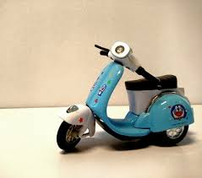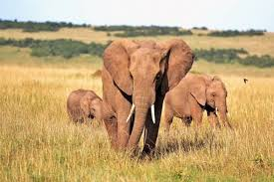
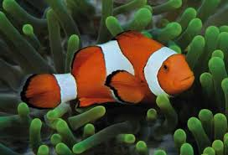

RUBRIC ANALITICAL SCORING
Aspect | Score | Performance Description | Weighting
Content | 4 | The topic is complete and clear and the details are relating to the topic
20% | 3 | The topic complete and clear but the details are not almost relating to the topic | 2 x
- Topic | 2 | The topic is complete and clear but the details are not relating the topic
- Details | 1 | The topic is not clear and the details are not relating to the topic
Organization | 4 | Identification is complete and descriptions are arranged with proper connectves
20% | 3 | Identification is almost complete and decriptions are arranged with almost proper connectives | 2 x
-identification | 2 | Identification is not complete and descriptions are arranged with few mususe of connectives
-description | 1 | Identification is not complete and descriptions are arranged with missue of connectives
Grammar | 4 | Very few grammatical or aggreement inaccuracies
20% | 3 | Few grammatical or gramatical or agreement inaccuracies but not affecton meaning | 2 x
-use present tense | 2 | Numerous grammatical or agreement inaccuracies
-agreement | 1 | Frequent grammatical or agreement inaccuracies
Vocabulary | 4 | Effective choice of vocabularies, words and word forms
20% | 3 | Few misuse of vocabularies, word forms, but not change the meaning | 2 x
 | 2 | Limited range confusing words and word form
 | 1 | Very poor knowledge of words, word forms, and not understand able
Mechanics | 4 | It uses correct spelling, punctuation, and capitalization
20% | 3 | It has occasional errors of spelling, punctuation, and capitalization | 2 x
-spelling | 2 | It has frequent errors of spelling, punctuation, and capitalization
-punctuation  -capitalization | 1 | It is dominated by errors of spelling, punctuation, and capitalization

ANALYTICAL SCORING
Aspect | score
Organization | 20
Content | 20
Grammar | 20
Mechanics | 20
Vocabulary | 20
Total | 100

Nilai maksimal = 100
Nilai siswa = jumlah score = .......
LEMBAR PENGAMATAN SIKAP
Pengamatan ( observations ):
Bukan penilaian fromal seperti tes, tetapi untuk tujuan memberi balikan. Sasaran penilaian.
- Berperilaku tanggung jawab, peduli, kerjasama, dan cinta damai, dalam melakukan komunikasi.
- Kesungguhan siswa dalam proses pembelajaran disetiap tahapan.
 |  |  |  | Aspek
 |  |  |  | pengamatan
No | Nama |  |  |  |  |  | Jumlah
 | Siswa | Tanggung | Peduli | Kerjasama | Cinta |  |  | Nilai
 |  |  |  |  |  | keaktifan | Skor
 |  | jawab |  |  | damai
1.
2.
...
Dst.

Keterangan skor :
Masing-masing kolom diisi dengan kriteria.
4 = baik sekali
3 = baik
2 = cukup
1 = kurang

Nilai = $\frac{\sum{skor perolehan}}{skor maksimal (30)}x 100$

APPENDIX C

INSTRUMENT OF THE RESEARCH
Pre- Test
Name :
Class :
Subject :

Write down about messenger that you know

Post-Test
Name :
Class :
Subject :

Write down the conversation you usually have in messenger

Pre-Test
Name :
Class :
Subject :

Choose one of conversation with your friends.
My friend

Post –Test
Name :
Class :
Subject :

Write down daily conversation you usually have

APPENDIX D
DOCUMENTATIONS OF TEACHING PRACTICE AND STUDENTS TEST
- EKSPERIMENTAL GROUP

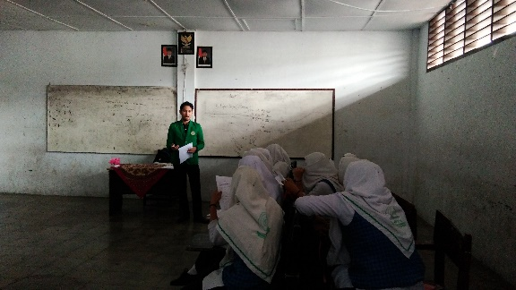
Pre –test to measure the students’ understanding in using messenger to mastering writing skill.

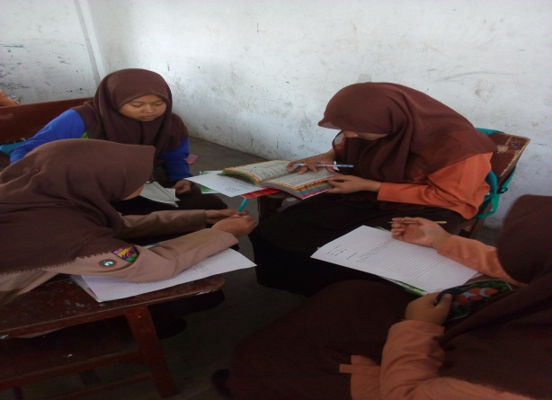
Students are writing a text based on the given topic

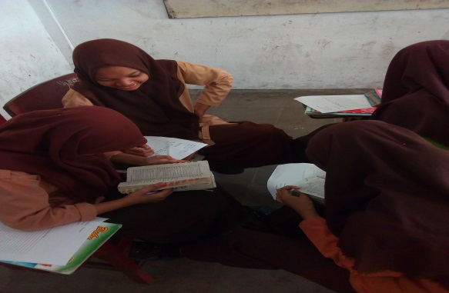
In the post-test, students try to remind about text and write them on the paper.

- CONTROL GROUP

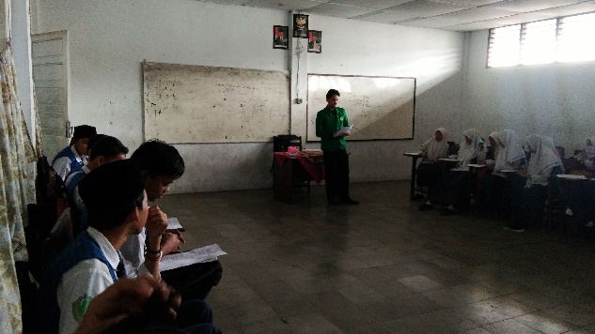
Students are writing a daily conversation text based on the give topic

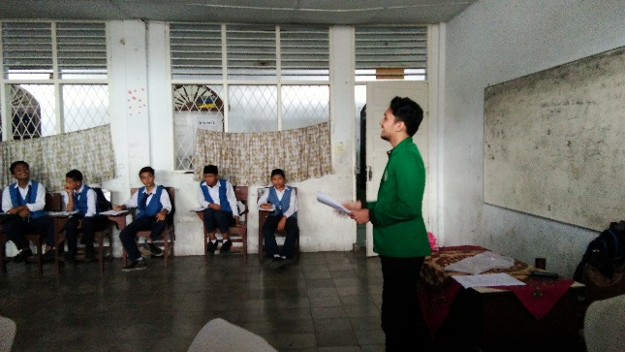
Treatment test that will be given to the control class

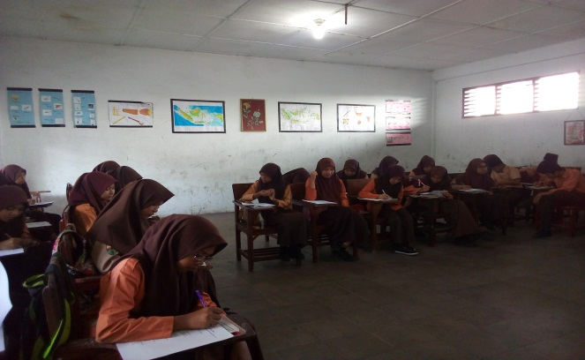
The students are trying to remind and write what they memorized.

