ACKNOWLEDGEMENT
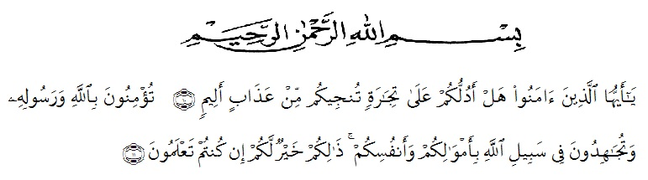

Artinya : “ Hai orang –orang yang beriman, sukakah kamu aku tunjukkan suatu perniagaan yang dapat menyelamatkanmu dari azab yang pedih? ( 10) (yaitu) kamu yang beriman kepada allah dan rasulnya dan berjihad di jalan allah dengan harta dan jiwamu. Itulah yang lebih baik bagimu, jika kamu mengetahui. (11) (as-shaff ayat 10-11).
The writter whises to express her great thank to Allah Swt. The Most Gracious and the Most Merciful. The writer also wants to present sholawat and salam to the prophet Muhammad SAW. Hopefully the writer will get intercession from him in here after later.
In completing this research, the writer got suggestions, criticisms, and guidance from some people. Therefore, the writer would like to express him thanks to:
- H. Hardi Mulyono, SE, M.AP., as the Rector of UMN Al Washliyah.
- Drs. Mhd. Ayyub Lubis, M.Pd, Ph. D., as the Dean of FKIP UMN Al Washliyah.
- Junaidi, SS, S.Pd, M.Si., as the Head of the English Education Study Program.
- Prof. Dr. H. Ahmad Laut Hsb., M.Pd, as the frist advisor who has given him a lot of valuable suggestions, comment, and critisms for completing this research.
- Harianto, SS, MS, Ph.D, as the second advisor who never stopped helping him in guiding and correcting the pattern of this research.
- Lectures and staffs of FKIP UMN al Washliyah Medan.
- The Headmaster of Mtss Lab Ikip Al Washliyah Medan in giving the facilities to research.
- The librarian of UMN Al Washliyah for the needed books in writing this research.
- The lecturers of English Education Study Program of FKIP UMN Al Washliyah Medan for sharing their nice and valuable ideas to enrich the writer’s knowledge.
- The writer’s beloved parents ( Hanif S.H dan Yusnani Lubis), Mam Rita Susana and Sir Ahmad Sahlin, as second parents for writer who has given every affection, prayer and endless support, and strunggle and sacrifice which has been done for the writer so far.
- The writer’s little brother (Bagas Fatur Rahman), little sisters (Adinda Nifta Rosifah and Namira Suci Shafira), grand mother and her husband (Roslaini Pane and Drs. Muhammad Yunus Lubis) for support, attention, and affection so much that they were able to complete this thesis.
- The writer’s big family aunts, uncles, cousins (Rina Safitri Lubis, Wira Utama Lubis, Amar Makruf Lubis, Muhammad Ihsan Lubis, Mirza Alvaro Siregar) who have given prayer, encourangement, and support.
- To close friends (Ani Septiyani, Agita Mutiara Panjaitan, Saskia Rizki Putri, Darminta Br Surbakti, Wilda Rahmadani) and best friends (Muhammad Affan, Yunita Maharani, Safrida Novita) for their support, prayer, enthusiasm, and accompanying the writer while working on this thesis.
- The writer classmate reguler B education in 2015, which extraordinary, thank you for the join strunggle in several semesters.
Hopefully, this thesis gives many benefits for the writer and the readers.

Medan, 30 Deember 2019

The writer,

