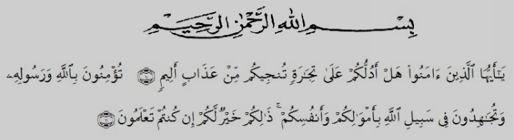
Meaning: “Oh, you who have believed shall I guide you to a transaction that will save you from a painful punishment? {10} [It is that] you believe in Allah and his Messenger and strive in the cause of Allah with your wealth and your lives. That is best for you. If you should know {11}”. (Surah As-Saff 10-11)
First of all the researcher would like to express her greatest thanks to Allah Subhanahu wa ta’ala for blessing that has been given to her especially health and luck until this skripsi could be complete and also shalawat and salam to our prophet Muhammad Shallallahu ‘alaihi wa sallam.
In the process of completing the skripsi the researcher has received a lot of assistance from many people, she obtains a lot of valuable suggestions and comments from many people whom she can not mention one by one, but she deserves her very special gratitude to:
- Dr. KRT. Hardi Mulyono K. Surbakti as the rector of University of Muslim Nusantara Al-Washliyah Medan.
- Drs. Samsul Bahri, M. Si as the dean of FKIP UMN Al-Washliyah Medan.
- Junaidi, SS, S. Pd., M. Si as the head of English Departement.
- Diana Sopha, S.S., M. Hum as the first adviser who has contributed his time, knowledge, suggestion and comments to help the writer on supervising the draft writing this skripsi.
- Reni Sapitri, S.Pd., M. Hum as the second adviser who has contributed her time, knowledge, suggestion and comments to help the writer on supervising the draft writing this skripsi.
- All lectures at the English Departement who have dedicated their valuable knowledge for her during the academic year at UMN Al-Washliyah Medan.
- Her beloved parents, Rasidin, S.Pd and Radinah who always give their love, motivation, and support to the researcher to finish her study, your services cannot be countered, only prayers that are able to be provided in prostration. May Allah give you a blessed age in this world and hereafter.
- Her beloved siblings, Wira Hadi Darmawan, Firman Iswandi, Riswan Hadi, Aldi Hidayat who always support the researcher.
- Her best friends (Muslimah Squad), Siti Sarah, Diah Mitha Viranis, Irma Nelpianti, Nur Afifah and Nur Amanah Rizka who has encouraging one another and praying because of Allah.
- Headmaster and teachers of SMK NEGERI 1 PATUMBAK. That school have helped provide research permission at the school.
- Her best team in organization overall the members of LDK Raudhatul Jannah UMN Al Washliyah, and all of friends of English Department C 2016, who has helped a lot in providing motivation, direction, advice and input that is very useful for the researcher.
- Her best friends in basecamp, Meli Handayani Pardede, Siti Nurhalizah, Sahranita, Nur Hidayah, Rahmayani Nasution, Ayu Syahfitri Sihombing, Putri Riskiyana Pohan, Nur Asiah, Elapinia Tanjung and Wenny Della who has helped and support the researcher.

Medan, August 2020
The Researcher

Dina Sartika

