LESSON PLAN

School : SMA PAB PATUMBAK
Grade/ Semester : XI/ II
Subject : English
Topic : Descriptive Text
Time Allocation : 2x 45 minutes/ meeting
- Core Competence
KI 1 : Living and practicing religious teachings which is embraced.
KI 2 : Realizing and practicing honest, disciplined, responsible, caring (peasant, cooperative, tolerant, peaceful) behavior, polite, responsive and pro-active and showing attitude as part of the solution to problems in interacting effectively with the social and natural environment and in placing ourselves as a reflection of the nation in the association of the world.
KI 3 :Understanding, applying, analyzing factual, conceptual, procedural knowledge based on his knowledge of science, technology, art, culture, and humanities with the insights of humanity, nationality, state and civilization on the causes of phenomena and events, and applying procedural knowledge to the field of study specific in accordance with his talents and interests to solve problems.
K1 4 : Processing, reasoning and chanting in the realm of concrete and abstract spheres is related to the development of the self-study in schools independently, and capable of using methods according to scientific rules.
- Basic Competence and Indicator
NO | BASIC COMPETENCE | INDICATOR
1 | - Thankful for the opportunity to learn English as the language of international communication that is manifested in the spirit of learning.
2 | - Demonstrate polite and caring behavior in carrying out interpersonal communication with teachers and friends.  - Shows honest, disciplined,confident, and responsible behavior in carrying out transactional communication with the teacher and friends.  - Shows the behavior of responsibility, caring, cooperation, and love of peace, in carrying out functional Communication | - Shows courteous and caring attitude in doing the task of learning English.  - Demonstrate honest, disciplined, and responsible attitude in doing the tasks of learning English.  - Demonstrate an active attitude of inquiring and arguing in discussions and presentations.
3 | - Analyzing social functions, text structures, and linguistic elements in the text of an analytical exposition of topics that are warmly spoken publicly, in the context of their use. | - Identify characteristics of desvriptive text.  - Explain the text format of the descriptive text.  - Explain the function of an descriptive text  - Explain the linguistic element in the text of the descriptive text.
4 | - Capturing the meaning in the text of a descriptive text of topics that are warmly spoken of publicly | - Answering questions based on the text they read.  - Present the information obtained in the text of the descriptive text.  - Develope descriptive text.

- Learning Objective
- Through discussion activities students can show the attitude of cooperation, mutual cooperation, responsibility and honest.
- Through observation, students can analyze the social function, text structure, and linguistic elements in the text of a descriptive of topics that are warmly spoken of publicly.
- Through discussions, students can analyze social functions, text structures, and linguistic elements to carry out the social function of an descriptive text on a commonly discussed topic.
- Through individual work and observation of other literary sources, students can compose texts of descriptive text by taking into account the correct and contextual function of the social, textual structure, and linguistic elements.
- Through presentation, students can grasp meaning in the text of a descriptive text.

- Learning Material
Descriptive Text
Descriptive text is a text that describe what an object or person is like.
- Social Function: to describe and reveal a particular person, place, or thing.
- Generic Structure of Descriptive Text
- Identification
Identifying phenomenon that will be decribed.
- Description
Describing the phenomenon in parts, qualities, and characteristic
- Language Feature :
- Using attributive and identifying process.
- Using adjective words.
- Using simplepresent tense.

- Linguistic Element
- Words and standard grammar .
- Spelling and handwriting and print are clear and neat.
- Use Simple Present
- Conditional Clauses
- Teaching Method
Approach : Communicative Learning
Learning Model : Using Talking Chips Technique

- Media, Tools and Learning Resource
- Media : Picture, Powerpoint
- Tools : Marker, Whiteboard, Laptop, Projector
- Learning Resource :
1.2. Picture
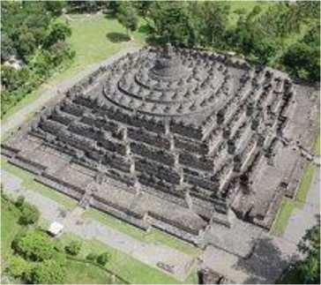

Borobudur is Hindu Budhist temple. It was build in the nineth century under Sailendra dynasty of ancient Mataram kingdom. Borobudur is located in Magelang, Central Java, Indonesia. Borobudur is well-known all over the world. Its construction is influenced by the Gupta architecture of India. The temple is constructed on a hill 46 m high and consist of eight step like stone terrace. The first five terrace are square and surrounded by walls adorned with Budist sculpture in bas-relief. The upper three are circular. Each of them is with a circle of bell shape-stupa. The entire edifice is crowned by a large stupa at the centre at the centre of the top circle. The way to the summit extends through some 4.8 km of passage. The design of borobudur which symbolizes the structure of universe influences temples at Angkor, Cambodia.
- Learning Activity
No | Learning Activity |  | Time  Allocation
 | Teacher's  Activity | Students' Activity
 | Preliminary  - Orientation  - Teacher starts the learning by greeting, prayer and checking student attendance.  - The teacher focuses the student's attention on the material to be learned.  - Apperception  - Teacher gives the students early perception about the material that will be taught  - Motivation  - The teacher provides an overview of the benefits of learning the material to be taught  - Teacher provides encouragement or motivation that can arouse learners' learning interests.  - Reference  - Teacher gives science study to be studied.  - Teacher explains the subject matter and description of the subject matter in outline  - Teacher explains the method of learning  - Teacher explains the mechanism of implementation of the learning experience (in accordance with the plan of learning steps)  - Teacher delivers KD and learning objectives  Core Activity Phase 1  Teacher explains descriptive text to the students  - Teachers gives example of descriptive text to the students  - Teacher explains about the generic structure and language feature of descriptive text  - Teacher asks students to find out the generic structure and language feature in the text given  Phase 2  - Teacher explains about Four Square Writing Method, the procedure of FSMW from the beginning until the final step of the method  - Teacher explain about Wordless Picture  Phase 3  - Teacher gives the students a topic of descriptive text.  Phase 4  - Teacher asks the students to write descriptive text by using FSWM based on topic that is given  Phase 5  - Teacher monitors the students when they are writing the text. | - Students respond the teacher to greetingand pray  - Students focus on their attention to the material that will be taught. -Students listen and pay attention to the teacher about material perception that will be taught.  - Students listen and prepare the material that will be taught.  - Students have the spirit and motivation to learn about the material that will be taught.  - Students record the study of science that will be taught.  - Students listen and record teacher explanation.  - Students discuss the method to be used.  - Students follow the teacher's instructions.  - Students record it and understand it  Students pay attention toward teacher's explanation  - Students pay attention to the teacher  - Students pay attention to the teacher and ak questions related to the generic structure and language feature  - Students find out the generic structure and language feature of descriptive text given by the teacher  - Students pay attention to the teacher explanation  - Students accept the topic that is given  - Students write a descriptive text by using FSWM through Wordless Picture based on topic that is given  - Students write the descriptive text | 10  Minutes  10 Minutes  - Minutes  10 Minutes  15 Minutes

3. | Closing  - Teacher collects the students' work  - Teacher asks the the students to make a summary based on the investigation they have made  Teacher together learners do Prayers  - The teacher closes the lesson to say good bye | - Students collect their work to the teacher  - Students make summary based on the investigation they have made  - Students pray together  - Students say goodbye | 10 Minutes

- Evaluation
- Technique and Instrument
Technique | Instrument
Attitude Observation | Form of Attitude  Observation
Test for work 1 | Form of Test for work 1
Test for work 2 | Form of Test for work 2

  - Attitude Observation Format
No | Aspect Observed | 3 | 2 | 1 | Note
1 | Shows a cooperative attitude in the learning process
2 | Show an attitude of responsibility in individual and group learning activities
Max Score | 6

  - Attitude Observation Column
No | Aspect Observed |  | Rubric
1 | Shows the attitude of cooperation in the learning process |  | - Demonstrate a great cooperative attitude by actively participating in the learning process  - Show less cooperation attitude but only actively participate when pushed  - Does not show a cooperative attitude in learning by not participating actively despite being pushed
2 | Show responsibility and discipline  in working in groups |  | - Show responsibility and discipline in working as well as possible  - Shows less responsibility in work but does not show maximum discipline  - Shows no responsibility and discipline in working in groups

  - Form Observation Test For Work (Individual)
 | No |  | Criteria to be assesed |  | Low performance |  | Good performance |  | Very good performance | Score
 | 1 |  | Text  Organization |  | Doesn't use the  correct  organization  of |  | Use the correct text  organization |  | Use the correct text  organization
descriptive  text |  | but has not elaborated  the idea |  | and with elaborated idea
2 |  | Sentence  Formation |  | Use simple sentences |  | Begin to very simple sentences  and compound  sentences |  | Use simple sentences, compound sentences, and complex sentences  correctly
3 |  | Grammar |  | Too many mistake |  | 6 until 10 mistakes |  | Under 5 mistaakes
4 |  | Vocabulary |  | Basic  Vocaabulary  less precise |  | Developed  vocabulary |  | Purposefully  chosen vocabulary
5 |  | Mechanic |  | Some errors spelling  punctuation |  | Mostly effective used of mechanics, errors do not detrect from meaning |  | Effective use of capitalization,  punctuation  and spelling
6 |  | Tidiness and  dead line |  | Write awkwardly, unreadable, submit late than  3 days from the  dead line |  | Write quite neatly, quiet clear font, submit late days from the dead line |  | Write neatly, clear font,  submit the work on time
Total Score
Final Score
= Total
Score : 6

  - Form Observation Test For Work (Group)
No | Criteria to be assed | Low performance | Good performanced | Very Good performance | Score
1 | Pronunciation | Too many mistake | With 2 until 5 mistakes | Perfect pronunciation
2 | Intonation | Monotonous | Begins to vary the intonation | Accurate  intonation
3 | Grammar | Too many mistakes | With 2 until 5 mistakes | No mistakes  in grammar
4 | Content | Plain simple | Begins to add some | Add more personal

  - Speaking Rubric
No | Aspects
A | Grammar
B | vocabulary
C | Comprehension
D | Fluency
E | Pronunciation

Teacher Class Reseacher

Rosmaida Nasution, S.Pd Weny Sulistiawaty

PRE-TEST
Name :
Class :
With your partner, make dialogues based on the situations below. Use expression of giving suggestions and instructions including the responses. Then, practice the dialogues.
Your friend, Lisa, is a lazy student. Ask her to study hard for the upcoming test. Suggest that she:
join your study club
go to the library

ANSWER KEY
PRE TEST
Join to your study club
me : I suggest that you have to join with our study club because your score of
your test was low.
Lisa : That's a good idea. I will join to your study club.
go to the library
me : I'd like to suggest that you have to go to the library to study together with us because your score of your test was low.
Lisa : That's a good idea. I will go to the library to study together with you
POST TEST
Name :
Class :
With your partner, make dialogues based on the situations below. Use expression of giving suggestions and instructions including the responses. Then, practice the dialogues.
- Jack's condition is not well. He is sick. Suggest him to see a doctor.
- Rudy is looking for a new flat. Suggest that he find a cheap and comfortable flat, and tell him what he should do to rent it.

ANSWER KEY
POST TEST
Jack's condition is not well. He is sick. Suggest him to see a doctor.
Me : I suggest that you have to see a doctor because your condition is not well Jack : Yes, you're right. I will go to see a doctor now.
Rudy is looking for a new flat. Suggest that he find a cheap and comfortable flat, and tell him what he should do to rent it.
Me : I'd like to suggest that you have to find a cheap and comfortable flat. You
have to save your money from now to rent a new flat.
Rudy : That's a good idea. I will find a cheap and comfortable flat and save
money to rent it.
Observation Sheet of Students' Activity
OBSERVATION SHEET
The observation sheet of Students' Activity
NO | Activity | Meeting of I | Average | Description
1 | 2
1 | All of the students come on time | 4 | 4 | 4 | Very  good
2 | The students pay attention to the teachers's explanation | 4 | 4 | 4 | Very  good
3 | The students are active in joining the learning process | 4 | 4 | 4 | Very  good
4 | The students ask question to the teacher if there is something unclear | 4 | 4 | 4 | Very  good
5 | The students can answer the question from the teacher | 3 | 4 | 3.5 | Good
6 | The students can follow the rule of  Talking Chips Technique | 4 | 4 | 4 | Very  good
7 | The students can improve their speaking ability | 3 | 4 | 3.5 | Good
Total of average | 27
Note :
1 = Bad 2 = Enough 3 = Good 4 = Very good
Interview sheet with the students

Before Implementing Talking Chips Technique
The researcher : Good morning everyone ..
The students : Good morning Miss
The reseacher : Ok, before I asking you, how do you think about English, especially when you talk or tell a text, especially learning
Descriptive Text?
The students I : In my opinion, English is difficult, Miss
The students II : In my opinion Miss, it's a little bit difficult Miss The students III : Sometimes confused about how to speaking, afraid of being wrong

Interview sheet with the students
After Implementing Talking Chips Technique
(I)
The researcher : Good morning Alfiyah
The students I : Good morning Miss
The reseacher : Ok now, Miss want to ask you .what do you think after we learn the English language by using Talking Chips Technique?
The students I : I think the lesson is so fun
The researcher : Next, does This Talking Chips Technique motivating you to speak in Descriptive Text?
The students I : If l do Miss, because by Using Talking Chips Technique I will understand more about Descriptive text

The researcher : the last question, do you think the Talking Chips
Technique makes the classroom environment active or what?
The students I : yes make the class active Miss because talking chips technique can express our ability to speak

(II)
The researcher : Good morning Elisabeth nainggolan
The students I : Good morning Miss
The reseacher : Ok now I want to ask you,what is your opinion after we learn the English language by using Talking Chips
Technique ?
The students II : in my opinion very exciting, because it makes me spirit to speak
Miss
The researcher : Next, does Talking Chips Technique motivating you to speak
Descriptive Text?
The students II : yes Miss, because we are required to be active students, especially in speaking describing images
The researcher : The last question, do you think the Talking Chips
Technique makes the classroom environment active or what?
The students II : Active Miss, we enjoy learning speaking

(III)
The researcher : Good morning M.ismail
The students III : Good morning Miss
The reseacher : Ok now I want to ask you, what do you think after we learn the
English language using the talking chips technique?
The students III : good. because we have to describes images that you give, so we can understand in learning speaking
The researcher : Next, does Talking Chips Technique motivating you to speak in Descriptive Text?
The students III: Yes Miss.it is motivates us to speak well and correctly, because
better the way the pronunciation will get a good rating .
The researcher : The last question, do you think the Talking Chips
Technique makes the classroom environment active or what?
The students III : We become more active in Miss because we speak Miss, so we are more confident in speaking

LEARNING PROCESS SITUATION BY USING
TALKING CHIPS TECHNIQUE

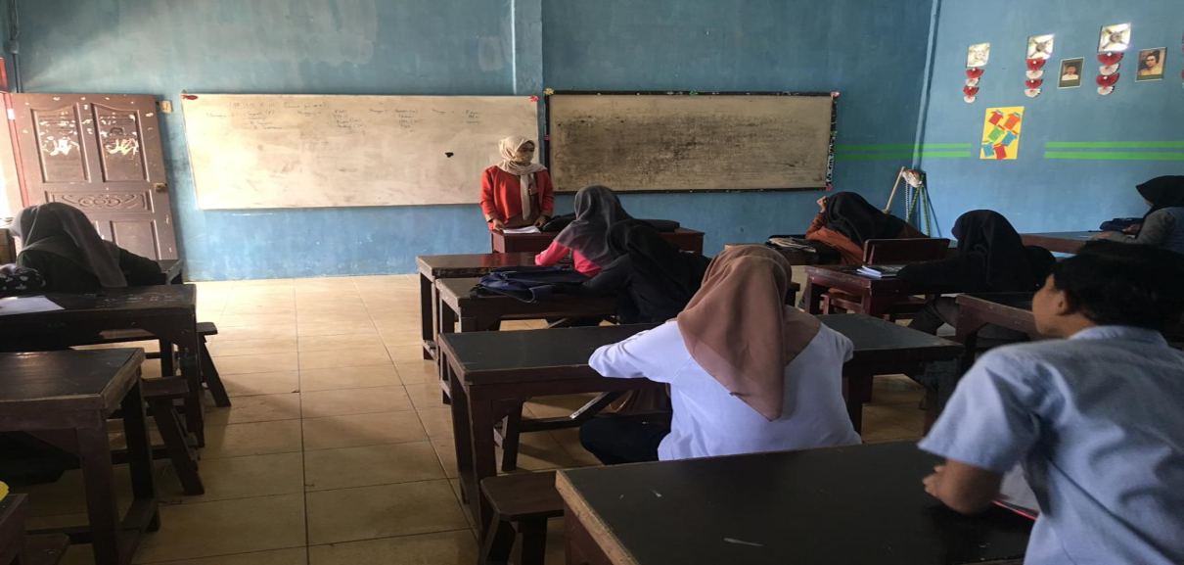
Based on the picture above, we can see together that the writer explained to the students first about materials that would be tought by the teacher (researcher) , what they would do and what the purpose of learning using talking chips technique.
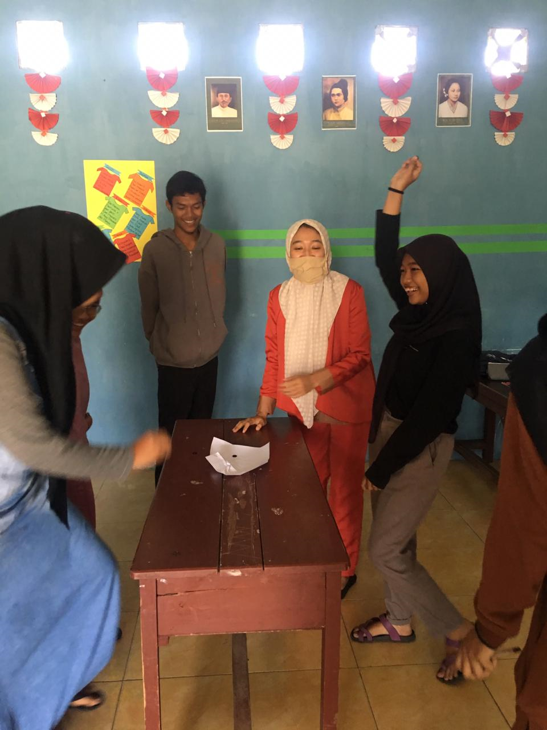
Each member of a group got different chips that they must use whenever they want to speak. Through using talking chips technique, it can be seen that the students are very fun, active and happy in learning Descriptive Text. In this technique, students place one of these chips on their desks before speaking. When they finish speaking, the other members think of different ways to respond and continue the discussion.
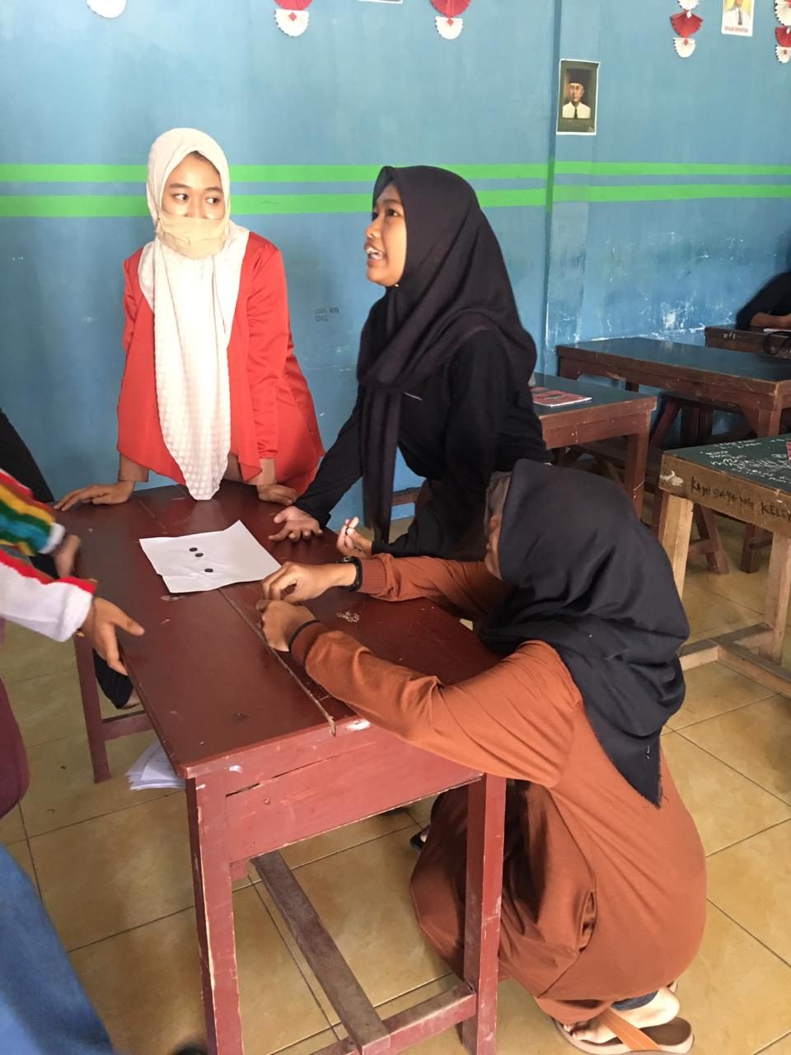
There are some difficulties faced by the students when they were learning in speaking, one of them is the students still difficult to speak English because the students didn’t master well of English vocabularies. But the teacher (researcher) helped them to speak English to deliver their ideas.
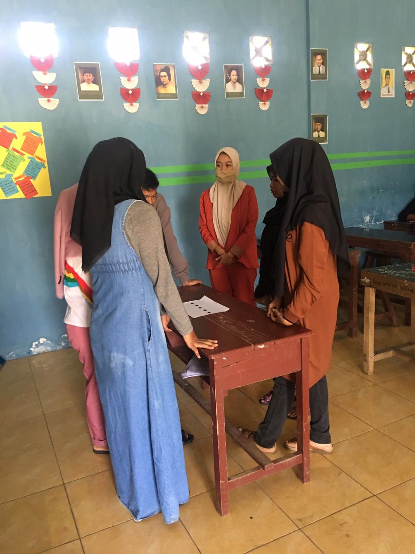
And finally, all the students can spend their chips through communication actively. Talking chips technique created fun learning situation for them and they are hoped can implement and their English communication skill in their daily life.

