ACKNOWLEDGMENT
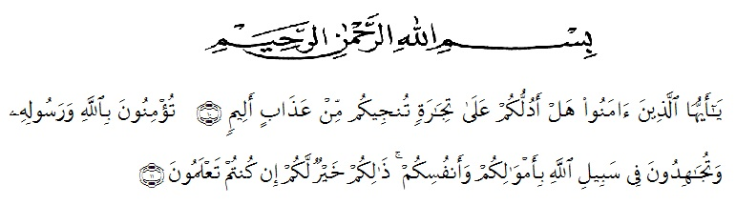
All praises and gratitude for the presence of Allah SWT for His blessings, mercy and guidance that are always abundant to the author, so that he can finish the thesis proposal with the title “An Analysis of Students’ Self-confidence on Conversation Practice”. This thesis proposal was prepared as one of the requirements for working on a thesis in Bachelor (S-1) program in the English Language Education, The Faculty of Teachers’ Training and Education, Universitas Muslim Nusantara Al Washliyah Medan.
The author realizes in the preparation of thesis proposal will not be completed without the help various parties. Therefore on the occasion i would like to thanks:
- The research can not be separated from guidance, support both science and morale and assistence from various parties around the research. Therefore, at this opportunity with all humality and respect, the research would like to express her thanks to Dr. KRT Hardi Mulyono K. Surbakti the Rector of Universitas Muslim Nusantara Al- Washliyah Medan.
- Drs. Samsul Bahri, M.Si, as the dean of faculty of Teachers’ Training and Education of Universitas Muslim Nusantara Al washliyah.
- Junaidi, SS., S.Pd., M.Si who has agreed to the tilte of this thesis. Without his approval, this thesis would certainly not be able to run.
- Prof. Dr. H. A. Laut Hasibuan, M.Pd as the adviser I, who provides guidance in writing his thesis.
- Rosmita Ambarita S.Pd, M.Hum as the adviser II, who is willing to direct and guide the writer during the preparation of this thesis and provide additional knowledge as well as solutions in completing this thesis.
- Beloved parents Soetarno and Burnelis who always accompany, provide moral and material support and prayers that are always offered to Allah Swt so that the author can complete this thesis proposal
- for unforgettable friends and executive class 2016 buddies that I cannot write down his name one by one who pray and give motivation to the author in improving this thesis.
The author realizes that this thesis is far from being perfect. All constructive criticism and suggestions are certainly very necessary in the perfection of writing this thesis, with the hope that this thesis is useful and help us all. Aamiin.

Medan, July, 2020.
Researcher

Weny Sulistiawaty

