**AKNOWLEDGEMENTS**

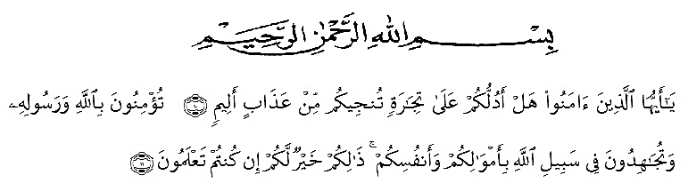

Artinya:

Hai orang-orang yang beriman, sukakah kamu aku tunjukkan suatu perniagaan yang dapat menyelamatkanmu dari azab yang pedih? (Yaitu) kamu beriman kepada Allah dan RasulNya dan berjihad di jalan Allah dengan harta dan jiwamu. Itulah yang lebih baik bagimu, jika kamu mengetahuinya. (QS. Ash-Shaff : 10-11)

The writer got suggestions and comments from some persons in completing this research. Therefore, the writer would naturally feel obliged to express her gratitude to all of them.

1. H.Hardi Mulyono Surbakti, SE,MAP as the Rector of UMN Al Washliyah, Medan who has given facilitiesa to her during her study at the university.
2. Drs. Samsul Bahri, M.Si as The Dekan of FKIP UMN Alwashliyah Medan and his staffs for guidance and counseling during the study.
3. Dra. Nurjannah, M.Si, the head of English Department UMN Al washliyah Medan.
4. Junaidi, S.S, S.Pd.,M.Si, the first consultant, who has given her a lot of valuable suggestions, comments and cristicsm for completing this research.
5. Syahran Yusuf, M.Pd, and Yulia Sari Harahap, S.Pd,M.Hum her second consultant, who has never stopped helping her in guiding and correcting the pattern of this research so that this research is complete and perfect.
6. The headmaster of SMA NURHASANAH Medan for the facilities given to her in conducting this research.
7. The librarian of FKIP UMNAlwashliayah Medan, for the books needed in conducting this research.
8. My beloved parents, my brother evriN andikaand my sister enia syahfitri that always support his unconditionally.
9. My friends Cantik Handayani Harahap, Riski Ardi, Sastra Buana Ginting, Eli Candra Barus, Takla Titi Gulo, Nona Jilenta Pinem, Windy arianty, Riska Cut Nadya, Harita Mulia ,Rendi Hasbi Yoga and class 8d that always support to makes this tesis.
10. The lectures of the English section of language Department FKIP UMN Medan for their nice and valuable discussing to enrich the write’s knowledge.

Finally, she realizes that she could not recompense the contribution of those people mentioned above. She prays upon God, may the Almighty bless them all in here after.

Medan, juli 2020

The writer

**ENDANG RAHMADINA**