**Appendix**

**Appendix A Name of Students of Experimental Group**

|  |  |  |
| --- | --- | --- |
|  | **Name of Students** | **Class** |
| 1 | Shopia | **X1** |
| 2 | Abdul Halim | **X1** |
| 3 | Juliana widyawati sitompul | **X1** |
| 4 | Alfia Syahmadina | **X1** |
| 5 | Mirna Karina | **X1** |
| 6 | Ahmad Ridho | **X1** |
| 7 | Aulia Nurhaliza | **X1** |
| 8 | Muhammad Reyhan | **X1** |
| 9 | Nina Novika | **X1** |
| 10 | Destira Dita Sitompul | **X1** |
| 11 | Cyndia Mutia | **X1** |
| 12 | Amelia Desfianti | **X1** |
| 13 | Annisa Husna Tarigan | **X1** |
| 14 | Budi Sudjatmoko | **X1** |
| 15 | Gilang Akbar Putra | **X1** |
| 16 | Putri Khairunnisa | **X1** |
| 17 | Alfi Satiawan | **X1** |
| 18 | Sandrina Melvi | **X1** |
| 19 | Dandi | **X1** |
| 20 | Rahmad Rinaldi | **X1** |
| 21 | Aulia Rahmadhani | **X1** |
| 22 | Agel Maulana | **X1** |
| 23 | Muhammad Rizky | **X1** |
| 24 | Rahmad Rinaldi | **X1** |

**Appendix B Name of Control Group**

|  |  |  |
| --- | --- | --- |
| **No** | **Name of Students** | **Class** |
| 1 | Rifandi | X2 |
| 2 | Nadia putrid | **X2** |
| 3 | Ikhsan | **X2** |
| 4 | Dini Sari | X2 |
| 5 | Cur Annisa Putri | **X2** |
| 6 | Merry | **X2** |
| 7 | Putri ismaliyah Harahap | X2 |
| 8 | Alravi Ramadhan | **X2** |
| 9 | Syafira Indri Ramadhani | **X2** |
| 10 | Annisa Ulfadilah | X2 |
| 11 | Fikri Zuazosovik Ritonga | **X2** |
| 12 | Cinta Putri Ananda | **X2** |
| 13 | Feby Adelia | X2 |
| 14 | Fitria Nurhaliza | **X2** |
| 15 | Ayunda Syafi Azra | **X2** |
| 16 | Annisa Ramadhani | X2 |
| 17 | Muhammad Ridwan | **X2** |
| 18 | Annisya Putri | **X2** |
| 19 | Disya | X2 |
| 20 | Nabila Putri | **X2** |
| 21 | Ali Tarmidzi | **X2** |
| 22 | Muhammad arif | X2 |
| 23 | Diky Pratama | **X2** |
| 24 | Rinaldi Putra | X2 |

**Appendix C**

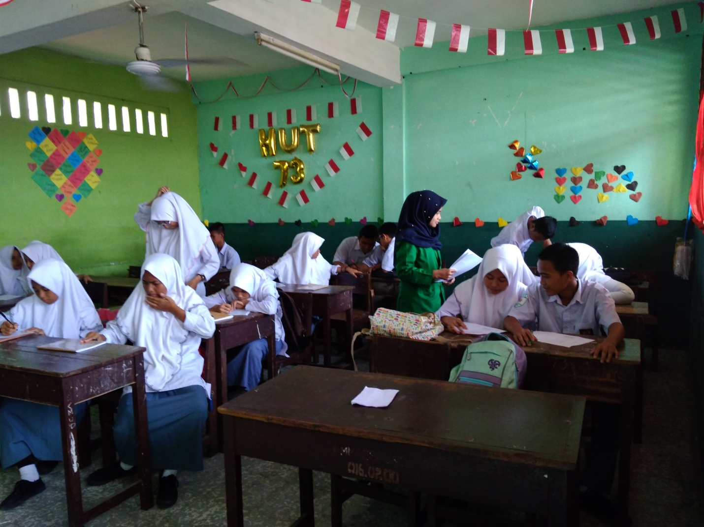

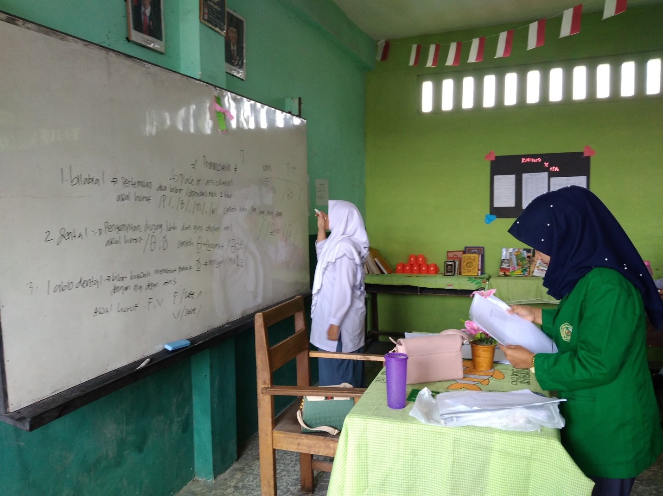

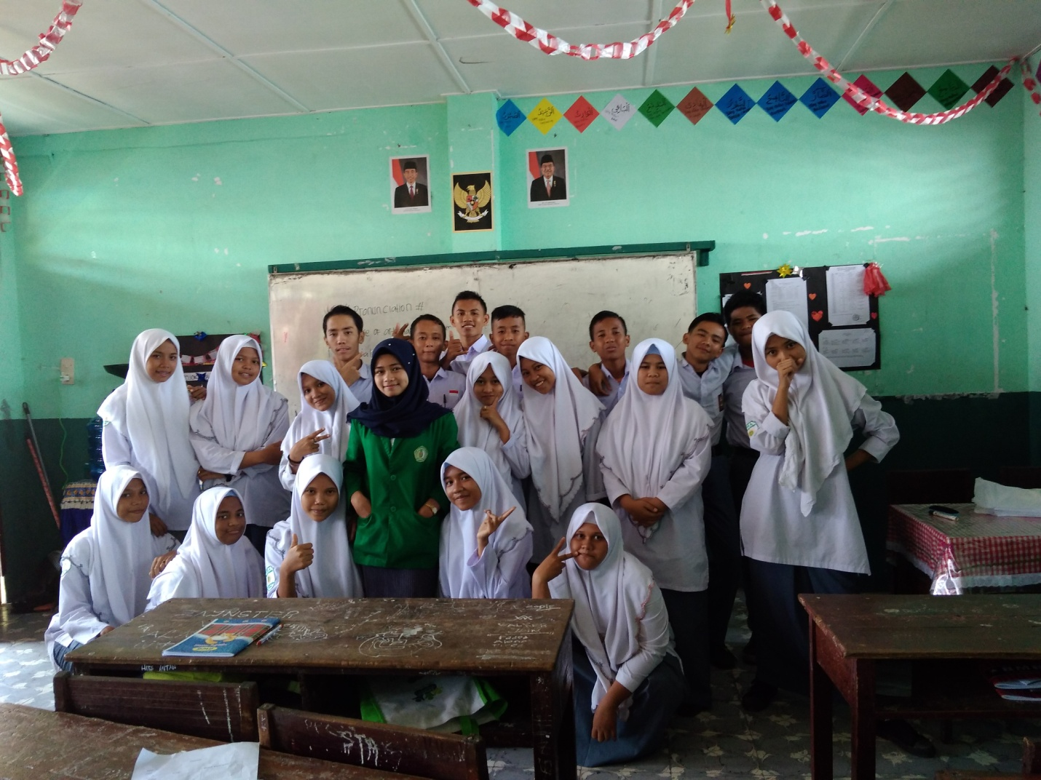

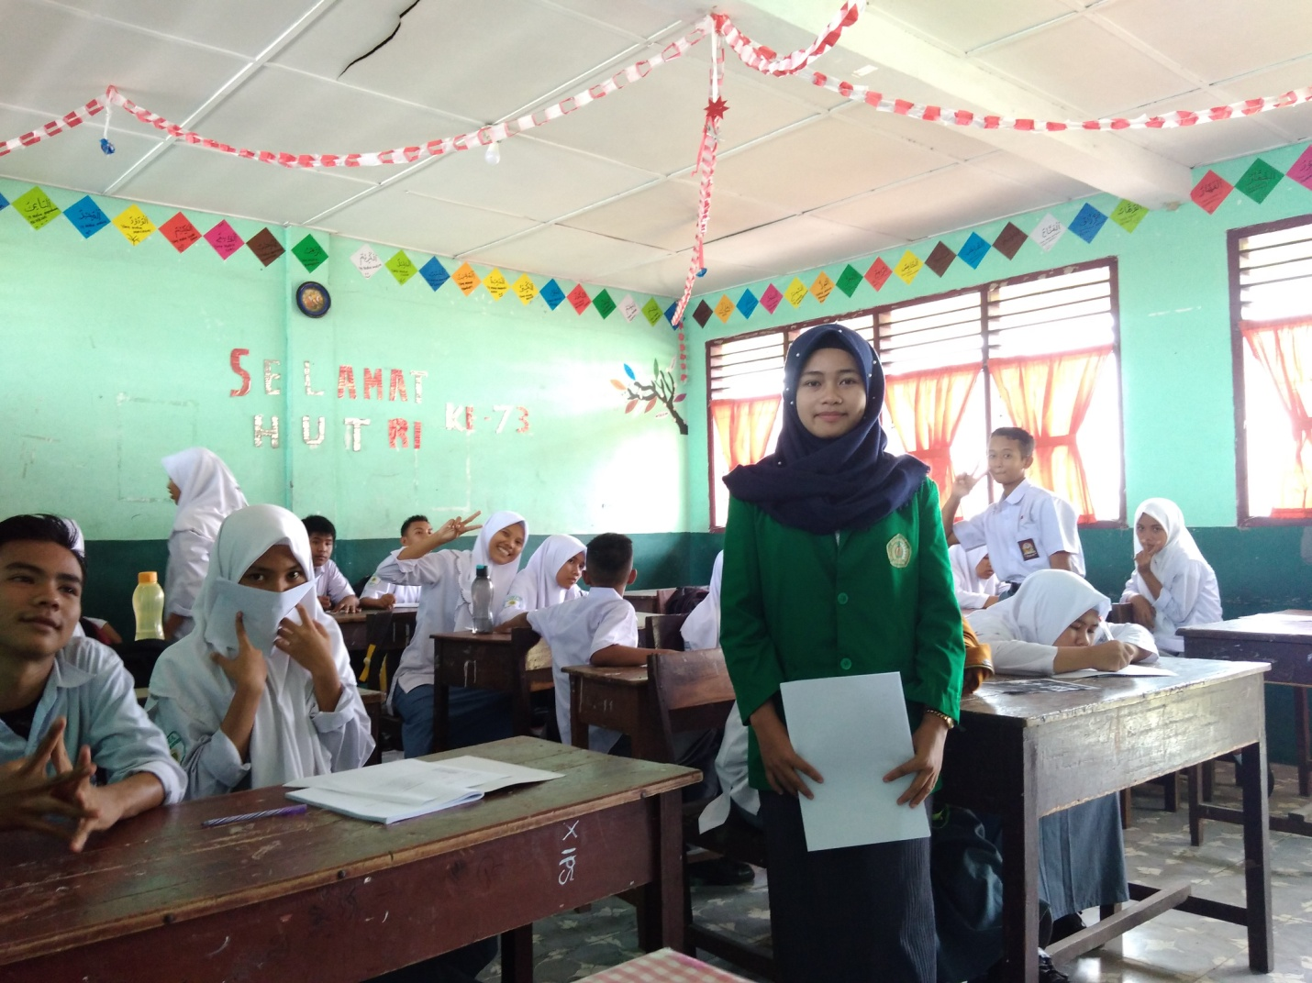

**Syllabus**

**School : SMA**

**Subject Lesson : English**