**ACKNOWLEDGEMENTS**

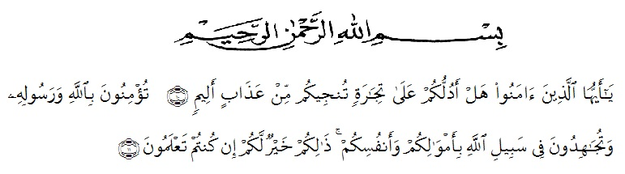.

**Artinya** : “Hai orang-orang yang beriman, sukakah kamu aku tunjukkan suatu perniagaan yang dapat menyelamatkanmu dari azab yang pedih?(10). (yaitu) kamu beriman kepada llah dan RasulNya dan berjihad di jalan Allah dengan harta dan jiwamu. Itulah yang lebih baik bagimu, jika kamu mengetahui.(11) ( As-Shaff ayat 10-11)”

First and foremost, the writer would praise and thanks to Allah SWT, because of his blessing she is able to completes this research. She got suggestion, criticism and guidance from many people.

She would like to extent her sincere and special thanks to:

(1). H. Hardi Mulyono, SE, MAP. As the Rector of FKIP UMN Al Washliyah Medan,

(2). Drs. M. Ayyub Lubis M.Pd, Ph.D, as the Dekan of FKIP UMN Al Washliayh Medan and his staffs for facilities given to her during studies in the faculty,

(3). Drs. H. M. Khalid, M.Hum, as the head of English Department of UMN Al Washliyah Medan,

(4). Dr. H. Muhizar Muchtar, M.S, as the first consultant, who has given her a lot of valuable suggestions, comments and criticism,

(5). Dra. Hamidah Sidabalok, M.Hum as the second consultant, who has never stop helping her in guiding and correcting the pattern of this research,

(6). The Lecturers of English Department of FKIP UMN Al Washliyah Medan, who have taught her motivation,

(7). The Headmaster of SMA Nurul Islam Indonesia Medan, and all of the English teachers for the facilities given to her in conducting this research,

(8). The Librarians of FKIP UMN Al Washliyah Medan for the books needed in writng this research,

(9). Her beloved parents, Yakub Hasibuan and Nur Hawani Harahap who always support and motivate her financial, moral and for their endless love and their pray in finishing her study at FKIP UMN Al Washliayh Medan,

(10). Her beloved brothers, Wilman Zahri Hasibuan, and Indra Huddin Hasibuan and her sisters, Yulis Fitriani Hasibuan, S.Pd and Tri Pina Warti Hasibuan, S.Pd, and young sisrters, Sefti Aisyah Hasibuan, who always gives motivation and support,

(11). Her classmates VIII D, especially her beloved friend, Dosma Gabena Harahap, who always give motivation and support,

(12). Her beloved friends, especially all of friends her classmate VIII D, who always give suggestion and support,

Finally, she hopes this thesis give benefit for all reader, it is able to increase the development education in Indonesia.

Medan, October 2018

The Writer

Nova Indriani