AN ANALYSIS OF TEACHER’S MOTIVATION ON IMPROVING STUDENTS’ ENGLISH WRITING SKILL AT
SMA NEGERI 1 SIBOLANGIT

A THESIS

BY:

OKNARIA SITOPU
Registration Number: 131244201

FAKULTAS KEGURUAN DAN ILMU PENDIDIKAN
UNIVERSITAS MUSLIM NUSANTARA
AL WASHLIYAH
MEDAN
2020

AN ANALYSIS OF TEACHER’S MOTIVATION ON IMPROVING STUDENTS’ ENGLISH WRITING SKILL AT
SMA NEGERI 1 SIBOLANGIT

A THESIS

Submitted to the Faculty of Teachers Training and Educations Science
University of Muslim Nusantara Al Washliyah in Partial Fulfillment
of the Requirements for English Language Education Study Program

BY:

OKNARIA SITOPU
Registration Number: 131244201

FACULTY OF TEACHER TRAINING AND EDUCATION
UNIVERSITAS MUSLIM NUSANTARA AL WASHLIYAH
MEDAN
2020

FACULTY OF TEACHER TRAINING AND EDUCATION UNIVERSITAS MUSLIM NUSANTARA AL WASHLIYAH

LETTER OF APPROVAL

NAME : Oknaria Sitopu
REG. NUMBER : 131244201
DEPARTMENT : Language Education and Literature
STUDY PROGRAME : English Language Education
QUALIFICATION : Bachelor (S-1)
TITLE : AN ANALYSIS OF TEACHER’S MOTIVATION ON IMPROVING STUDENTS’ ENGLISH WRITING SKILL AT SMA NEGERI 1 SIBOLANGIT

Adviser I, Adviser II,

Junaidi, S.S., S.Pd., M.Si Yugi Diraga Prawiyata, S.Pd., M.Hum

This thesis was examined on :
Judicium :

Chairman,  H. Hardi Mulyono, S.E., M.AP. | Secretary,  Drs. Samsul Bahri, M.Pd.

ACKNOWLEDGEMENT
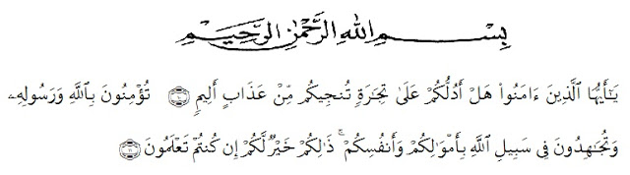
Artinya:
“Hai orang orang yang beriman, sukakah kamu aku tunjukkan suatu perniagaan yang dapat menyelamatkanmu dari azab yang pedih?¹⁰ (Yaitu) kamu beriman kepada Allah dan Rasul Nya dan berjihad dijalan Allah dengan harta dan jiwamu. Itulah yang lebih baik bagimu, jika kamu mengetahuinya¹¹.” (QS.Ash-Shaff:10-11).
In the name of the God of Fathers, Sons, and Holy Spirits, the researcher expresses his highest gratitude to God for blessing, love, opportunity, health, and mercy to complete this undergraduate thesis. This undergraduate thesis entitled “An Analysis of Teacher’s Motivation on Improving Students’ English Writing Skill at SMA Negeri 1 Sibolangit” is submitted as the final requirement in accomplishing undergraduate degree at Universitas Muslim Nusantara Al Washliyah Medan.
In arranging this thesis, a lot of people have provided motivation, advice, and support for the researcher. In this valuable chance, the researcher intended to express his gratitude and appreciation to:
- Dr. KRT. Hardi Mulyono K. Surbakti, as the Rector Universitas Muslim Nusantara Al Washliyah Medan.
- Drs. Samsul Bahri, M.Pd. The Dean of Faculty of Teacher Training and Education.
- Dra. Zulfitri, S.S., M.A. The Head of Department of English Education.
- All lectures of Department of English Education who have taught and education the researcher during her study at Universitas Muslim Nusantara Al Washliyah Medan.
- Mr Bindu Sembiring as the Headmaster of SMA Swasta Budisatrya, who has permitted to the researcher to carry out the research at the school she leads
- Furthermore, she is grateful to her beloved parents, Jhan Wisman Sitopu and Hotma Uhur br Silalahi for all their affections and encouragements all the time. They always support the witer to keep studying hard and finishing this paper. They are the best motivator for the writer in order to be patient and strong to face many barriers when he was working on this duty.
- For her big family thank you for your praying and supporting the researcher. Especially for witer’s brother Yakob Berutu, Rizki Ardiansyah, S.Pd who always helped the writer whenever the writer’s is.
- To her best friends Sahara, Tirta, Lady and Afrida who shared a lot of things when it comes to Writing this thesis.

- The last to everyone whom she has not mention yet, thank you very much for all of your support.

Medan, August, 27th, 2020

Oknaria Sitopu

TABLE OF CONTENTS

ACKNOWLEDGEMENT i
TABLE OF CONTENTS iv
LIST OF TABLES vii
LIST OF APPENDICES viii
ABSTRACT ix
ABSTRAK x
CHAPTER I INTRODUCTION 1
1.1 Background of the Research 1
1.2 Identification of the Problem 2
1.3 Limitation of the Problem 2
1.4 Formulation of the Problem 3
1.5 Objective of the Research 3
1.6 Significance of the Research 3
1.7 Hypothesis 4
CHAPTER II REVIEW OF RELATED LITERATURE 5
2.1 Motivation 5
2.1.1 Definition of Motivation 5
2.1.2 Types of Motivation 6
2.1.2.1 Extrinsic Motivation 6
2.1.2.2 Intrinsic Motivation 7
2.1.3 Students’ Motivation Towards Learning English 8
2.2 Writing 8
2.2.1 The Definition of Writing 8
2.2.2 The Purposes of Writing 9
2.2.3 The Process of Writing 11
2.2.3.1 Planning 11
2.2.3.2 Drafting 12
2.2.3.3 Editing (Reflecting and Revising) 12
2.2.3.4 Final version 12
2.2.4 Teaching Writing 13
2.2.4.1 Principles for Teaching Writing 13
2.2.4.2 Teaching Writing for Senior High School 14
2.2.4.3 Writing Assessment Scorong Rubric 16
2.5 Approach 21
2.5.1 Definition of Approach 21
2.5.2 Types of Approach 21
2.5.3 Approaches to Motivate Students in Learning 22
2.6 Learning Language 23
2.7 Previous Research 23

CHAPTER III METHODOLOGY OF RESEARCH 24

3.1 Design of the Research 24

3.2 Subject of the Research 24
3.3 Instruments of Collecting Data 25

3.4 Technique of Collecting Data 26

3.5 Technique of Analyzing Data 27

CHAPTER IV THE DATA AND DATA ANALYSIS 28

4.1 The Data Analysis 28
4.2 Research Implementation 3
4.2.1 Cycle 1 31
CHAPTER V CONCLUSION AND SUGGESTION 35
5.1 Conclusion 35
5.1.1 Implication 37
5.2 Suggestion 38
REFERENCES 40

LIST OF TABLES

Table I Observation Sheet of SMA N 1 Students’ Writing Skill Through Class 16
Table II Observation Sheet of SMA N 1 Teacher’s Writing Skill Through Class 25
Tabel III Jacobs et al.’s Scoring Rubric on Writing Aspects of Writing. 26
Table IV Process of the Research 28
Table V Pre-Test Result 29

LIST OF APPENDICES

APPENDIX A Field Notes 43

APPENDIX B Interview Transcripts 55

APPENDIX C Questionnaire Before 61

APPENDIX D List of the Stusents 67

APPENDIX E Syllabus 69
APPENDIX F Lesson Plan 71

ABSTRACT

AN ANALYSIS OF TEACHER’S MOTIVATION ON IMPROVING STUDENTS’ ENGLISH WRITING SKILL AT
SMA NEGERI 1 SIBOLANGIT

By:

OKNARIA SITOPU
NPM:131244201

The purpose of this study is to investigate student motivation and achievement in English and its relationship to teacher motivation and the use of strategies in the classroom. The study participants were 4 teachers in 1 High School, Sibolangit and 384 students in their class. The unit of analysis is the English class,on 2016-2017 Education year.
Our results show that teacher motivation is related to the use of strategies to motivate teachers, which in turn is related to student motivation and English Achievement. As such, any changes in the education system that promote a higher level of teacher motivation must result in an increase in the level of student education.

Key words: Teacher’s motivation, students’ motivation, motivating strategy use, achievement.

ABSTRAK

ANALISIS MOTIVASI GURU UNTUK MENINGKATKAN KETERAMPILAN MENULIS SISWA BAHASA INGGRIS
SMA SMA I SIBOLANGIT

Oleh:

OKNARIA SITOPU
NPM:131244201

Tujuan dari studi ini adalah untuk menyelidiki motivasi siswa dan pencapaian dalam bahasa inggris dan hubungannya dengan motivasi guru dan penggunaan strategi di kelas. Peserta studi adalah 4 guru di 1 sma, Sibolangit dan 384 siswa di kelas mereka.
Unit analisa adalah kelas bahasa inggris. Di tahun pendidikan 2016-2017.
Hasil kami menunjukkan bahwa motivasi guru berhubungan dengan penggunaan trategies untuk memotivasi guru. Yang dalam turm berhubungan dengan motivasi mahasiswa dan pencapaian inggris. Dengan demikian, perubahan apa pun dalam sistem pendidikan yang meningkatkan motivasi guru yang lebih tinggi harus menghasilkan peningkatan dalam tingkat pendidikan siswa.

Kata kunci: Motivasi guru, motivasi siswa, memotivasi penggunaan strategi, pencapaian

CHAPTER I
INTRODUCTION

  - Background of the Research
Research on teacher motivation has developed and expanded since the late 1990s, and the past decade has witnessed a marked increase in literature in the area of teacher motivation research across various social cultural contexts. A significant step forward was the release of the special issue on motivation for teaching by Learning and Instruction in 2008 with the focus on relating the current motivational theories to the domain of teaching which has been called a “Zeitgeist of interest” by Watt and Richardson (2008). As a big contribution to the application of motivational theories in the new research domain of teachers in their career choice, education studies and professional commitment, the special issue was an important impetus to setting the agenda for future teacher motivation research.
The need to address teacher motivation also derives from teacher shortage reported by many western countries including the US, Australia and some other European countries like the UK, Germany and Norway (e.g. Kyriacou & Kunc, 2007: Weiss, 1999). A renewed research interest in teachers’ motivation to teach and to remain teaching in the past decade has highlighted possible causes of the existing and potential teacher shortages as early teacher attrition, teaching force ageing, imbalance of high demand with less reward, limited career opportunities, less job security and low prestige (OECD, 2005: Richardson & Watt, 2005, 2006; Sinclair, 2008; Sinclair, Dowson, & Mc Inerney, 2006: Watt & Richardson, 2007: Watt et al, 2012). The significance of teacher motivation research is also self-evident as it is a crucial factor closely related to a number of variables in education such as student motivation, educational reform, teaching practice and teachers’ psychological fulfillment and well-being. Therefore, it is helpful for administrators to determine how to attract potential teachers and how to retain them in teaching.

  - Identification of the Problem
The problem can be identified as follows:
- Student cannot write English correctly
- Student are lazy in learning English
- They are not interested in learning English because the teacher is not attractive.

  - Limitation of the Problem
In line with problem identification, the focus of research is on the Teacher for how to teach using the writing “Approach” technique. Decisions are taken by considering the importance of the Approach technique as one of the Cooperative Learning strategies that is useful for increasing students' intention to learn English. The author assumes that there must be some appropriate techniques in teaching English that can motivate students to learn and read all English texts so that they can understand the information.
  - Formulation of the Problem
Based on the problem limitation above, the researcher formulates the research problem as follows:
            - How is the english teacher’s motivation in improving students’ english learning ?

  - Objective of the Research
Based on the above problem formulation, the research objectives are as follows:
- To investigate English teacher’s motivation in improving students’ english learning.

1.6 Significance of the Research
The benefits of this research are as follows:
- For students:
This research intends to increase students' desire to learn English. Students can optimize their abilities and be more motivated in learning English.
- For teachers:
The results are expected to be of benefit to the authors themselves and to all English teachers who might use this technique when they teach. Teachers must plan their teaching programs, so as to create comfort in the teaching process.

- For SMA N 1, Sibolangit:
Schools must provide media and also equip facilities to make better progress in English and make teaching and learning more effective.

1.7 Hypothesis
Based on the problem in action research entitled ‘The Effect of Motivating Teachers and Teaching to improve student learning achievement in English" In SMA N 1, Sibolangit is conducted by researchers, the following hypotheses can be formulated:
- Through the Teaching Technique "Approach" Students can be more interested in learning English.
- Through this "Approach" Technique Students can feel comfortable learning English which will certainly improve their Learning Achievement
- Through this "Approach" Technique Teachers can be more comfortable in the process of teaching English with the material provided

CHAPTER II
REVIEW OF RELATED LITERATURE

This chapter consists of previous theoretical research framework and study framework. This will give some beforehand studies that have almost the same topic as this research and several theories that resulted in this research.
  - Motivation
2.1.1 Definition of Motivation
Spring (1993) said, “Motivation is a cognitive state passion that provokes 'the decision to act' as a result of existing intellectual and/or physical sustainability efforts "so that the person can achieve some" predetermined Motivational goals are several types of internal movers encourage someone to do something to achieve something”. This definition is introduced in several theories, the most widely known are motivation to study, work, and get achievements. What will be analyzed in this study is motivation for study, it is a kind of internal and external drive encourage students who are learning something Improve their attitude, generally influenced by several people supporting factors, namely:
- Desire to success
- There is pushing of study
- There are necessities in study
- There is expectation in future
- Appreciation in the learning process
- There are attractive activities in the teaching learning process
- Good learning environment
Motivation is one of the important factors affect learning achievement in English. Maintain a high level of motivation during the language period learning is one of the best ways to make the whole process more success. Because every student is motivated in differences way, the teacher must find the right balance of incentives to succeed and disincentives to failure, encouragement, and the right environment for learning.

2.1.2 Types of Motivation
There are two types of motivation. They are extrinsic motivation and intrinsic motivation.
2.1.2.1 Extrinsic Motivation
Lens and Deci (2006) Extrinsic motivation is a learning activity occurs from the urges and needs of a person which is completely unrelated to their own learning activities. This is caused by an external number the factors. For example: the need to pass an exam, financial awards, good grades, etc. Some opinions state that the concept is intrinsic motivation occurs when extrinsic motivation is fulfilled. Extrinsic motivation itself is basically a behavior that is driven by external forces individual. Individuals are extrinsically motivated if those individuals choose tasks that are easy, routine, and simple predictably, work to get a prize, depending on help others are lacking the confidence to express their opinions, and use external criteria in determining success and failure.
2.1.2.2 Intrinsic Motivation
Intrinsic motivation is an activity initiated and continue learning, based on appreciate ion of needs and encouragement that is absolutely related to activation of learning. Important intrinsic factor motivation is the pleasure shown when doing their duty without coercion. It comes from the individual himself. For example: enjoyment the learning process makes them feels better. The existence of intrinsic motivation is influenced by several factors, they are:
- Challenges
People are most motivated when they work towards personally meaningful goals whose achievements need optimal activity continuously (intermediate level) difficulty level.
- Recognition
Learners feel satisfaction when others recognize and appreciate their achievements.
- Curiosity
Something in the physical environment is interesting student attention or there is an optimal level the difference between current knowledge and skills what can this be if students are involved in several the activities.
- Control
People have a basic tendency to want to control what happened to them.
2.1.3 Students’ Motivation towards learning English
Based on the Oxford Advanced Learners Dictionary, students are defined as people who study in college, polytechnic or university; men or women attending school; anyone who studies or who devotes himself to knowledge acquisition. Zamakhsari Dhofier (1994), is defined Santri as learners who study classical books with clerics. From the above definition it can be concluded that the santri and students have the same thing. Both of them fight for get knowledge.
The theory of hope, formulated by vroom (1960s), suggests that high motivations when workers believe high levels of effort leads to high performance and high performance lead to desired achievement. Hope theory is one of the motivational working theories, and this theory focuses on all three parts of the motivational equation: input, performance and results. The theory of hope identifies three major factors that determine a person's motivation: hope, intercession, and valence.

2.2 Writing
2.2.1 The Definition of Writing
In studying English as a foreign language, writing is one of the productive language skills. It is like speaking. The difference between writing and speaking mainly lies on the product. In speaking, the product is a spoken text may be in the form of monologue or dialogue. On the other hand, in writing, the main product is a written text. Spratt, Pulvernes, and Williams (2005:26) states that writing is one of the productive language sk According to (Harmer, 2004:11) writing is a way to produce language and express ideas, feelings, and opinions. Furthermore, he states that writing is a process that what people write is often heavily influenced by the constraints of genres, and then these elements have to be presented in learning activities. From the ideas above, the the researcher concludes that writing is a complex process for conveying or delivering ideas, thoughts, opinions and feelings using combination of letters in written language that other people can understand. It is complex because we have to consider the grammar, spelling accurately, punctuation meaningfully, linking ideas and information across sentences to develop a topic, etc. It means that the writer has to organize the sentences unto a coherent text whole which is as possible and complete in it, so that we are able to communicate successfully with the readers through the medium of writing.

2.2.2 The Purposes of Writing
When teaching “writing for wtiting” we need to make sure that our students‟ have some writing aims. Effective writers usually have a purpose in mind and construct their writing with a view to achieving that purpose. The most effective learning of writing skills is likely to take place when students are writing real messages for real audiences, or at least when they are performing tasks which they are likely to have to do in their out-of-class life. The choice of writing tasks will depend, therefore, on why students are studying english. There are three main categories of learning which are worth considering, namely:
- English as a Second Language (ESL) – this term is normally used to describe students who are living in the target language community and who need english to function in that community on a day-today basis. Recent immigrants and refugess, for example, will have specific writing needs such as the ability to fill in a range of forms, or write particular kinds of letters (depending upon their exact needs and circumstances), alongside the need for general English development.
- English for Specific Purpose (ESP) – many students study english for a particular (or specific) purpose. People who are going to work as nurses in Britain or the USA, for example, will study medical English. Those who are going to study at an English-medium university need to concentrate on English for Academic Purpose (EAP). Business students will concentrate on the language of management and commerce, and so on.
- English as a Foreign Language (EFL) – this is generally taken to apply to students who are studying general English at school and institutes in their own country or as transitory visitors in a targetlanguage country. Their needs are often not nearly so easy to pin down as the two categories we have mentionned above (Jeremy Harmer, 2004:39).

2.2.3 The Process of Writing
The writing process that is the stages a writer goes through in order to produce something in its final written form. This process may, of course, be affected by the content (subject matter) of the writing, the type of writing (shopping lists, letters, essays, reports, or novels), and the medium it is written in (pen and paper, computer word files, live chat, etc.). But in all of these cases it is suggested that the process has four main elements;
2.2.3.1 Planning
Experienced writers plan what they are going to write. Before starting to write or type, they try and decide what they are going to say. For some writers this may involve making detailed notes. For other a few jotted words may be enough. Still others may not actually write down any preliminary notes at all since thay may do all their planning in their heads. When planning, writers have to think about there main issue. In the first place they have to consider the purpose of their writing since this will influence (amongst other things) not only the type of text they wish to produce, but also the language they use, and the information they choose to includes. Secondly, experienced writers think of the audience they are writing for, since this will influence not only the shape of the writing (how it is laid out, how the paragraphs are structured, etc.), but also the choice of language – whether, for examples, it is formal or informal in tone. Thirdly. Writers have to consider the content structure of the piece – that is, how best to sequence the fact, ideas, or arguments which they have decided to include.
2.2.3.2 Drafting
We can refer to the first version of a piece of writing as a draft. This first‟go‟ at a text is often done on the assumption that it will be amended later. As the writing process proceeds into editing, a number of drafts may be producted on the way to the final version.
2.2.3.3 Editing (reflecting and revising)
Once writers have produced a draft they then, usually, read through what they have written to see where it works and where it doesn‟t. perhaps the order of the information is not clear. Perhaps the way something is wrotten is ambiguous or confusing. They may then move paragraphs around or write a new introduction. They may use a differents form of words for a particular sentences. More skilled writers tend to look at issue of general meaning and overall structure before concretating on detailed features such as individual words and grammatical accuracy. The latter two are, of coures, important and are often dealt with later in the process. Reflecting and revising are often helped by other readers (or editors) who comment and make suggestions. Another reader‟s reaction to a piece of writingwill help the author to make appropriate revisions.
2.2.3.4 Final version
Once writers have edited their draft, making the changes they consider to be necessary, they produce their final version. This may look considerably differents from both the original plan and the first draft, because things have changed in the editing process. But the writer is now ready to send the written text to its intended audience (Harmer, 2004: 4-5).

2.2.4 Teaching Writing
2.2.4.1 Principles for Teaching Writing
The following are a few principles that every teacher should consider while planning a course, whether it is a writing course, or a course in which writing will play a part. These principles can be adapted to the many different learning situations (David, 2003:92-96).
- Understand the students‟ reasons for writing The greatest dissatisfaction with writing instruction comes when the teacher‟s goals do not match the student‟s, or when the teacher‟s goals do not match those of the school or institution in which the student work. It is important to understand both and to convey goals to students in ways that make sense to them.
- Provide many opportunities for students to write Writing almost always improves with practice. Writing is a part of physical activities that requires practice. Practice writing should provide students with different types of writing as well. Short responses to a reading, journal entries, letter writing, summaries, poetry, or any type of useful writing should be practiced in class. So the teacher should provide many opportunities for students to write in order to the students will become more comfortable with the act of writing.
- Make feedback helpful and meaningful Students need feedback on their writing.
If the teacher write comments on students‟ papers, make sure that the students understand the vocabulary or symbols used. Take time to discuss them in class. The teacher should be cautious about the tone of comments. The comments or feedbacks should be helpful and meaningful for the students‟ writing.
- Clarify for yourself, and for your students, how their writing will beevaluated. Students often feel that the evaluation of their writing is completely subjective. Students can help to form a rubric as well. Take class time to ask them what they value in writing. Ask them what features make writing enjoyable to read and what features distract from that enjoyable. This kind of discussion has two benefits: it not only gives students a voice in the evaluation of their own work, it also provides a common vocabulary with which the entire class can discuss their writing and the writing of others.
2.2.4.2 Teaching Writing for Senior High School
Understanding the students‟ characteristics is important for the teacher because it is the key in the success of learning any subjects. The students‟ characteristics influence the teaching and learning process. So, the relationship between the teacher and the students in the teaching and learning process in class is very strong. Before the teacher handles the teaching and learning process, the teacher has to know the students‟ characteristics, their habit in school or daily life, and their ability in academic field. They are needed for the teacher to know the development of the students‟ ability.
In the teaching and learning process of writing, the teachers are expected to have creativity in delivering the lesson, because writing is one of the four skills with difficulties in structure, contexts, and content. Teachers of middle grades students need to be knowledgeable of the varied developmental characteristics of young adolescents so that they can design instruction and classroom management strategies that address these ongoing changes and support on these characteristics.
To improve the creativity in the English teaching and learning process of writing, Feez and Joyce (1998:123) state that there are some strategies in writing, namely:
- Using a model.
- Writing down words spelled aloud.
- Using appropriate sentence structure to represent intended meaning. d. Seeking assistance from others.
- Approximating the spelling of unfamiliar words.
- Using a range of spelling strategies (including visual memory, word patterns, morphemic knowledge, phonic knowledge, mnemonics, fluent and fast script).
- Using dictionaries to check spelling.
- Using a fluent and consistent script.
- Accurately copying written language.
Those strategies above can be applied by the teacher as a step in delivering the writing lesson by consedering the students’ characteristics.
2.2.4.3 Writing Assessment Scorong Rubric
TABEL I
JACOBS ET AL.’S SCORING RUBRIC ON WRITING ASPECTS OF WRITING
Aspects of Writing | Level | Score | Criteria
Content | Excellent to very Good | 30-27 | Knowledgeable, substantive, thorough development of thesis, relevant to assigned topic.
 | Good to Average | 26-22 | Some knowledge of subject, adequate range, limited development of thesis, mostly relevant to topic, but lacks of detail.
 | Fair poor | 21-17 | Limited knowledge of subject, little substance, inadequate development of topic
 | Very Poor | 16-13 | Does not show knowledge of subject, non substantive, not pertinent, not enough to Evaluate.
Organization | Excellent to Very Good | 20 -18 | Fluent expressions, ideas clearly stated/supported, succinct, well - organized, logical sequencing, cohesive
 | Good to Average | 17 -14 | Somewhat choppy, loosely organized but main ideas stand out, limited support, logical but incomplete sequencing.
 | Fair to Poor | 13 -10 | Ideas confused or disconnected, lacks logical sequencing and development.
 | Very Poor | 9 - 7 | Does not communicate, no organization, not enough to evaluate.
Vocabublary | Excellent to Very Good | 20 -18 | Sophisticated range, effective words/idiom choice and usage, word form mastery, appropriate register.
 | Good to Average. | 17 -14 | Adequate range, occasional errors of words/idiom form, choice, usage, but meaning not obscured.
 | Fair to Poor | 13 -10 | Limited range, frequent errors of words/idiom form choices/usage, meaning confused or obscured.
 | Very Poor | 9 - 7 | Essentially translation, little knowledge of English vocabulary, idioms, word form, not enough to evaluate.
 | Excellent to Very Good | 25 -22 | Effective complex construction, few error of agreement, tense, number, word order/function, articles, pronouns, prepositions, but meaning seldom obscured
 | Good to Average | 21 -18 | Effective but simple construction, minor problem in complex construction, several errors of agreement, tense, number, word order/function, articles, pronoun, preposition, but meaning seldom obscured.
 | Fair to Poor | 17 -11 | Major patterns in simple/complex construction, Mechanics frequent error of negation, agreement, tense, number, word order/function, articles, pronoun, preposition and/or fragments, run on, deletions
 | Very Poor | 10-5 | Virtually no mastery of sentence construction rules, dominated by errors does not communicate, not enough to evaluate.
Mechanics | Excellent to Very Good | 5 | Demonstrate mastery of convention, few errors of spelling, punctuation, capitalization, Paragraphing
 | Good to Average | 4 | Occasional errors of spelling, punctuation, capitalization, paragraphing but meaning not Obscured
 | Fair to Poor | 3 | Occasional errors of spelling, punctuation, capitalization, paragraphing, poor hand writing, meaning confused or obscured.
 | Very Poor | 2 | No mastery of convention, dominated by errors of spelling, punctuation, capitalization, paragraphing, hand writing illegible.

2.5 Approach
2.5.1 Definition of Approach
Wahjoedi (1999) said, “Approach can be interpreted as a starting point or our perspective on the learning process”. The teacher-centered approach reduces direct learning strategies, deductive learning or expository learning. Meanwhile, student-centered learning approaches reduce discovery and inquiry learning strategies and inductive learning strategies

2.5.2 Types of Approach
Semi (1993) stated, “There are many types of approaches that can be applied by teacher in teaching English”. The author categorizes it into five types of approaches, as follows:
- Constructivism Approach The constructivism approach is a learning approach that emphasizes the level of student creativity in channeling new ideas that can be needed for student self-development based on knowledge.
- Deductive Approach
A deductive approach is an approach that uses logic to draw one or more conclusions based on a set of premises given. A deductive approach is a process of reasoning that starts from a general state to a particular situation, as a teaching approach that starts with presenting rules, general principles and is followed by specific examples or applying rules, general principles to specific circumstances.
- Process Approach
The process approach is a teaching approach that gives students the opportunity to appreciate the process of finding or constructing concepts as process skills. In this approach students are expected to really master the process. This approach is important to train the mind power or develop thinking skills and train students psychomotor. In the process approach students must also be able to illustrate or model and even conduct experiments.

2.5.3 Approaches to Motivate Students in Learning
Learning approach according to Sagala (1999) “ is a path that will be taken by teachers and students in achieving learning objectives, the learning approach is the teacher's activity in choosing learning activities, whether the teacher will explain a teaching with subject matter that has been arranged in a certain order, or by using material which are related to each other at different depths, or even integrated material in multi-disciplinary units”. This learning approach is an explanation that makes it easy for teachers to provide learning services and also makes it easier for students to understand the teaching material delivered by the teacher, by maintaining a pleasant learning atmosphere.

2.6 Learning Language
Language is a communication tool. Every human being in this world needs language to communicate the other. Language is the main means of communication thoughts from one person to another. Based on Crow and Crow's (1989) statement, language is an expression tool for people. People really need language as a means to interact one to another. Moreover, language has several characteristics. First, the characteristics of language systematically and arbitrary. Second, language is symbolized by having vowels and visual. Third, the conventional meanings that they are referring to. Fourth, language as a communication tool. Fifth, operate language in a speech community or culture. Sixth, basically humans though might not be limited to humans. And the last, Language as a universal thing, obtained by all people in Indonesia same way.

2.7 Previous Research
Related to this research, the researcher chose literature about previous research that is relevant to research.
Approach as a medium of teaching in Classes and also English courses. Written by Zamzami Zainuddin, Alumnus UIN Ar-Raniry Aceh, works as an education researcher at the Faculty of Education, Malaya University, Kuala Lumpur. He said the approach was translated into methods containing techniques with a series of procedures.

CHAPTER III

METHODOLOGY OF RESEARCH

3.1 Design of the Research
In order to achieve the objectives of the research, Qualitative Research Method was used. Descriptive Qualitative Research is research intended to investigate the circumstances, conditions or other terms that was mentioned, the results were presented in the form of research reports (Arikunto, 2010:307). The writer analyzes the data that get by concerning the writer’s observation about the contribution of material of student achievement in writing skill.

3.2 Subject of the Research
The researcher will conduct research on the effectiveness of genre-based approaches in SMA N 1 Sibolangit. The author will apply it to the tenth grade students of SMA 1 Sibolangit. She will take two classes where the first class will be the experimental group and the second will be the control group. She will treat them both in different ways. In the experimental class, she will apply a genre-based approach to the teaching process but in the control class, she will treat in another way. And to find out the effectiveness of the genre-based approach, he will compare the results of student composition using the t-test mentioned above in the post data analysis method.
By this above the researcher is confident to collect the data. The first, the researcher will hold the pretest to both groups in order to know the ability of students before treatments. After holding the pretest toward both groups, the writer will treat the genre based approach to the experimental group and another way to the control group, but his treatments toward both groups are not difference significantly; such as method of teaching, time of learning, learning atmosphere, etc. Finally the writer will hold the posttest as the final term to seek the truth whether the genre based approach is effective or no in improving students’ writing skill.

3.3 Instruments of Collecting Data
Research instrument was a device used by researcher while collecting data to make her work become easier and to get better result, complete, and systematic in order to make the data to be processed (Arikunto, 2003: 136). The research were did by used observation sheet. So, the instruments used were observation sheet, video recorder, mobile phone, paper and pen.
The observation sheet was used in this research has some indicator achieve which will be adopted from the theory of Edward (2010). Clearly the example of observation sheet as shown as follows:
TABLE II
OBSERVATION SHEET OF SMA N 1 STUDENTS’ WRITING SKILL THROUGH CLASS
No. | Indicator Achieved | Explanation | Scores
 |  |  | 50 | 75 | 90
 | Content | 23.04
 | Text Organization | 14.00
 | Vocabulary | 12.29
 | Language Use/Grammar | 11.71
 | Mechanic | 4.95

TABLE III
OBSERVATION SHEET OF SMA N 1 TEACHER’S WRITING SKILL THROUGH CLASS
No. | Indicator Achieved | Explanation | Scores
 |  |  | 50 | 75 | 90
1 | How to teach, techniques | 23.04
2 | How to deliver lessons | 14.00
3 | The language used in teaching | 12.29
4 | Syle of Teaching | 11.71
5 | Reward | 4.95

3.4 Technique of Collecting Data
There searcher starts this research by doing a direct method. Observation includes the observation activity of an object by using all the sense (Arikunto, 2010: 199). The researcher observe the student directly by using paper sheet while the student in the debate subject. The test of speaking scored as a whole on the basis of the following elements (carol, 2001).
- The researcher would following the Writing subject in the classroom
- Entry to the class and have a sit on the back of the class
- Prepare for the observation sheet for 21 student that have been choosen before and prepare for the video recorder.
- Fill the paper of observation sheet

3.5 Technique of Analyzing Data
Technique of analyzing data based on Sugiyono (2006) technique of analysis data is inductive, which an analysis based on the data is obtained, then the developed a pattern of certain relation or become a hypothesis.
- The writer gave a question toward the student and record the student’s answer
- The writer analysis the student’s answer based on the theory of the effectiveness of writing skill by Edward (2010) which had 5 indicator there are active listening, asking question, writing clarifying and summarizing, developing trust and rapport and being empathetic.
- To get the score of 5 indicators, every indicator had 3 categories as the rating of score.

CHAPTER IV

THE DATA AND DATA ANALYSIS

4.1 The Data Analysis
The research findings are obtained from the beginning until the last of teaching and learning process. In this classroom action research, the researcher is an active participant as a teacher and an observer. The researcher conducts the action research into two steps. First, the researcher does the observation and interview. Then, the second, the researcher conducts the action research.
Table IV
PROCESS OF THE RESEARCH
No | Date | Activities | Description
1 | August | Observation | Identifying the problems during the teaching-learning process.
2 | August | Interview | Identifying and confirming teacher and the students‟ difficulties in the teaching learning process
3 | September, 5 th | Planning | Choosing the teaching materials, preparing materials, lesson plans, worksheets, students‟ attendance list, and everything related to the researcher.
4 | September, 6 th | 1st Meeting | Conducting pre-test to identify the students‟ abilities in writing narrative text.
5 | September, 10th | 2 nd Meeting | The researcher implemented pre-writing activity treatment, brainstorming, vocabularies, social function, part of narrative text, verb pattern, and language features in narrative text.
6 | September, 13th
7 | September, 17th | 4th Meeting | The researcher implemented the 2nd treatment, and explained the example of narrative text using pictures series.
8 | September, 20th | 5th Meeting | Conducting the post test to know the progress of students writing ability in writing narrative text after implementing the 2nd treatment.
9 | September, 24th 3 rd Meeting | Analyzing the result | Scoring the result of pre test 1, post test 1, and post test 2.

The researcher gave the pre-test to know the students‟ writing skills in narrative text. The more detailed result of the pre test score can be seen from the following table:
Table V
PRE-TEST RESULT.
No. | Name | I | II | III | IV | V | Total
1 | Alisa Nur Fadillah | 13 | 10 | 6 | 6 | 4 | 39
2 | Dania Asima Istihbar | 13 | 9 | 5 | 7 | 3 | 37
3 | Fayra Diza Berlian | 22 | 15 | 7 | 7 | 5 | 56
4 | Syarifah Mar‟atus S. | 21 | 10 | 14 | 9 | 4 | 58
5 | Hana Rahmaningtyas H | 19 | 10 | 16 | 7 | 4 | 56
6 | Frida Ayu Salma Antari | 12 | 10 | 7 | 6 | 3 | 38
7 | Erika Hendratama Putri | 15 | 10 | 15 | 10 | 6 | 56
8 | Ismi Wafda Maulidya | 13 | 6 | 14 | 7 | 6 | 46
9 | Amanda Zerlinda | 13 | 7 | 13 | 6 | 5 | 44
10 | Rima Nurlabansa | 20 | 10 | 12 | 9 | 6 | 57
11 | Haidar Daffa Aulia | 21 | 12 | 10 | 9 | 6 | 58
12 | Salsa Amalia Husna | 15 | 9 | 10 | 8 | 5 | 47
13 | M. Fawwas Yumna F. | 13 | 10 | 8 | 7 | 4 | 42
14 | M. Habib Hari Moekti | 13 | 8 | 8 | 5 | 4 | 38
15 | M. Majid Athaillah | 12 | 8 | 7 | 7 | 5 | 39
16 | Faqih Alamsyahari | 15 | 7 | 8 | 7 | 4 | 41
17 | Andi Setiawan | 15 | 8 | 8 | 6 | 4 | 41
18 | M. Taufik Awarisga | 17 | 8 | 9 | 8 | 5 | 47
19 | Yusuf Maulana | 20 | 10 | 9 | 9 | 6 | 54
20 | Faiq Fajar Satri Tama | 15 | 7 | 6 | 8 | 5 | 41
21 | M. Hamdan Yuwari | 13 | 7 | 7 | 8 | 4 | 39
 | Total Score |  |  |  |  |  | 974
 | Mean Score = $\frac{974}{21}$ |  |  |  |  |  | 46,38

The result of the pre-test shows that the writing skills of the students were still low. Students writing scores of pre-test were between 38 – 58. It is still lower than the minimum standard score. The minimum standard score of English is 70. None student who got score more than 60. It means that all of the students got scores under the minimum standard. The highest score in pretest was 58, and the lowest score was 38. So, the result of pre-test above shows that the students writing skills were needed to be improved. The researcher decided to improve it using picture series.

4.2 Research Implementation
Based on explanation above, the researcher started to give the treatment into two cycles, every cycle consists of some series of steps namely identifying the problems, planning the action, implementing the action, observing the action, and reflecting the result of the observation.

4.2.1 Cycle 1
- Planning Based on the result of pre research and pre test, the researcher arranged the plan for the treatment. The researcher prepared everything that was needed in the treatment such as lesson plan, teaching material, and other material that supported the action. The researcher used picture series as a technique for improving students writing skills in narrative task. The researcher used three phase technique, comprising opening, main activity and closing. The researcher took the material from the Internet and English book for the students (English on the Sky). The material was associated with competence standard (SK) and basic competence (KD). The materials of narrative text include the example, the function, the generic structures, language features of narrative text and soon.
- Implementing the Action In this action, the researcher played a role as a teacher. The teacher did the teaching-learning process in three phases; reactivity, main-activity, and post activity. The pre-activity phase covered all the thing done as the opening such as greeting, checking the student’s attendance, and giving motivation for students to learn English and practice more. Then, the researcher did the brainstorming or gives some questions to simulate student’s participation in the lesson. The duration of each cycle was 40 minutes long. Each meeting can be described as follows:
- First Meeting The first meeting was conducted on Tuesday, September 6th 2016. There were 21 students in the X mia class, consisting of 10 male and 11 female students. Pre-test was given in the first meeting to know the student’s writing skills before giving the treatment.
- Opening the researcher was only given about 40 minutes for each meeting by the teacher. The opening session was given 5 minutes to start with greeting and checking the attendance.
- Main Activity Before main activity, the researcher asked the students whether they knew or not about narrative before, and the students answered knew. After that, the researcher conducted pre-test to the students. The researcher wanted to know the students‟ abilities in writing narrative text by doing the pre-test before doing the treatment. The researcher gave an answer sheet to every student. The answer sheet of pre-test contained of making a simple narrative story entitled The Lion and The Mouse.
- Closing In this session, the researcher asked the students whether they had difficulties or not. The students faced difficulty when they made a narrative story. The researcher asked the students to prepare the materials for the next meeting. Then, the researcher closed the meeting and suggested the students to study hard. Finally, the researcher closed the class by saying salam.
- Second Meeting The second meeting was held on Saturday, 10th 2016. The meeting started at 07.00 p.m.
- Opening In the opening session, the researcher expressed the greeting to the students and asked their condition. Then, the researcher checked the attendance and asked who did not came that day.
- Main Activity After opening session, the researcher gave a sheet material about narrative text and explained to the students about its components such as generic structure, language features, and key features. After that, the researcher discussed pre-test yesterday’s. Then, the researcher gave them a picture series entitle “Jack and The Beanstalk” with jumbled picture then the students to arranged the picture after that the researcher and the students explain together about the picture. They were so enthusiastic on identifying them. They were also very attracted to the picture series because it was the first time they got this medium in their writing class.
- Closing After giving the treatment, the researcher reviewed again the material and remembered the students to study hard at home. The researcher said 1st post test would be conducted in next meeting and asked the students to study hard at home. The researcher closed teaching and learning process by saying salam.
- Third Meeting The third meeting was held on Tuesday, September 13th 2016. The meeting started at 08.20 p.m.
- Opening the researcher started the class by expressed greeting and checking the students‟ attendance and asked who did not come that day.
- Main Activity After giving a pre-test and treatment to know the students writing skill in narrative. The researcher gave a post-test to know whether the technique could improve students writing skill or not. The researcher gave a task for students to make a narrative story based on picture series. The title of the story is Jack and The Beanstalk and the students should make a text at least three paragraphs. Every paragraph at least consisted of three sentences. The story should also include generic structure of narrative text such as orientation, complication, and resolution. Besides, the researcher gave a vocabulary to make it easier for students to write. The researcher also reminded the students to give more attention about the composition of writing such as; vocabulary, grammar, spelling and punctuation. After finishing their task, the researcher asked the students to submit their task. After that the researcher asked the students to explain the other of the stories and almost all of the students had understood.
- Closing After giving a post-test the researcher reviewed again the materials and also reminded the students to study hard at home. The researcher also gave motivation to the students. Finally, the researcher closed teaching and learning process by saying salam.
- Observing
To observe the result of the first cycle, the researcher used some techniques, such as; tests, interviews, and observation.

CHAPTER V
CONCLUSION AND SUGGESTION

5.1 Conclusion
Based on the research findings, it was indicated that the writing ability of grade X students of SMA Negeri 1 Sibolangit improved after the implementation of picture series in writing narrative texts. The teaching writing using picture series could improve the students‟ skills in writing narrative text. The response of the students‟ about the implementation of picture series were they enjoyed in the writing class.
The research was conducted in two cycles. First cycle consisted of three meetings and the second cycle consisted two meetings. In every cycle, some research steps namely planning, action and observation, and reflection were included. In cycle I, the researcher implemented picture-series and some other actions, such as giving a model of narrative text and listing difficult words and giving rewards. Some picture based activities such as sequencing jumbled pictures and sequencing jumbled paragraphs were also implemented in order to make the learning situation not monotonous. Pair work and group work activities were also done. In addition, the students also wrote narrative texts individually. In cycle II, two sets of picture series were provided. The students got the opportunity to write two narrative texts based on the pictures. The process of writing namely drafting, revising, and producing the final product were successfully done by the students.
The researcher also conducted interview with one of the students after the implementation of picture series technique to know their responses about the implementation of picture series. The result of the interview was that they enjoyed the writing class. The students also said their self-confidence built and increased and that pictures could help them to make a narrative text because the story would be more lively and the story’s description was clear. The use of picture series accompanied by picture based activities, worksheets, and giving feedback brought some significant improvements to the students‟ writings especially in the aspect of contents, organization, language use, vocabulary, and mechanics. The students made a quite much improvement in the aspect of content. Picture series could help the students to stimulate the ideas about what they had to write.
As the result, they could develop their ideas into long paragraphs. They also could write fluently. Furthermore, in the aspect of organization, picture series could help the students organize their ideas. By studying some series of pictures, the students could understand the sequence of the ideas. The students could arrange the ideas based on the generic structure of narrative text. As the result, the students‟ writings were well written. Picture series could also improve the students‟ vocabulary mastery. By looking at the pictures, the students knew the vocabulary that they wanted to use and then they checked in the dictionary to find the words in English. The worksheets also provided some key words to help the students write. In addition, the students‟ writing skills also improved in the aspect of language use. By the explanation and worksheet given by the teacher the students had a better mastery of the use of simple past tense in writing narrative texts. They could produce simple but meaningful sentences. In addition, during the whole class discussions the students corrected each other so they could realize their mistakes. The research findings also indicated that the students‟ mean scores in writing increased cycle by cycle. The increase of the students writing skill was also supported by the result of the test scores. The mean scores of pre-test was only 46,38, it improved to 68,52 and in the final test, it increased 77,00. It can be concluded that the use of picture series in narrative text does improve the students‟ writing skill.
5.1.1 Implication
- The implementation of picture series could improve students’ skills in writing narrative texts. It is because the use of picture series in the materials and writing practice could generate students’ ideas. Picture series provided an image that the students could easily follow. By seeing the series of picture, they could easily generate ideas into a chronological order. Besides, the pictures were colorful. Thus, the students loved it. It implies that the English teacher needs to use picture series in order to improve students’ skills in writing.
- The implementation of picture series and other accompanying actions such as giving a model, listing the difficult words and giving rewards were effective to improve students’ writing skills. It could be seen from the improvements of students‟ writing scores in the pre-test and post-test. The mean score were improved from 46,38 to 68,52 to 77,00. It implies that the teacher needs to use picture series in teaching writing.
- The implementation of picture series could promote the students positive attitude toward the teaching-learning process. Most of the students actively involved in the teaching and learning process. They became enthusiastic to do the writing task. They also enjoyed the learning process. The teaching strategies of using picture series increased the students‟ enthusiasm in the teaching and learning process of writing. It implies that the teachers need to implement picture series in their teaching and learning process of writing. However, the teacher must be creative to design the activities with various media because it can attract student’s attention in learning writing.

5.2 Suggestion
After drawing the conclusions and telling the implications of the research, some suggestions for the English teacher, the students, and the next researchers on this subject can be proposed. Those suggestions are presented as follows:
- For the English Teacher It is suggested for the English teachers to use picture series in teaching writing narrative texts since the result of the research show that picture series were useful to help students in generating the ideas. The students could write the narrative texts in good order. Besides, the use of picture series also promoted the students‟ positive behavior during the teaching and learning process. The learning using picture series was able to enhance the students‟ interests and preference to do writing activities.
- For the Students the students should manage themselves to always have positive attitudes towards English. They also should have motivation in learning for their own benefits. It is important for them to always practice writing so that they could improve their skills. In addition, they should always actively participate in the process of teaching and learning and do the tasks given by the teacher. They should also manage themselves to work in pairs, in groups, or individually.
- For the other Researchers This research is only a small study in improving students‟ writing skill. This study was done by implementing picture series as the technique in teaching-learning process. It is expected for the other researchers that this study can be used as additional reference in the future in order to create better teaching learning process, especially for writing skill.

REFERENCES

Arikunto, Suharsimi. 2002. Prosedur Penelitian Suatu Pendekatan Praktik. Jakarta: PT. Rineka Cipta
Allyn and Bacon.Instructional Planning. USA: Florida State University
Ary, Donald, et al. 2002. Introduction to Research in Education (Sixth Edition). USA: Wadsworth Thompson Learning
Brown, H. Douglas. 2000. The Principles of Language Learning Teaching -4^{t h}Edition.USA: Wadsworth Thompson Learning
Brown, H. Douglas. 2001. Teaching by Principles –Second Edition. London: Longman Group Ltd.
Cazden, C. (1991). Classroom Discourse: The Language of Teaching and Learning. Barcelona: Paidós-MEC.
Cohen, Andrew D., et. al. 1996.The Impact of Strategies-Based Instruction on Speaking A Foreign Language. Minnesota: University of Minnesota
Harmer, Jeremy. 2001. The Practice of English Language Teaching (3rdEdition). London: Longman Group Ltd.
Harmer, Jeremy. 2007. The practice of English Language Teaching. Pearson: Longman.
Hartley, L. and Sporing, M. 1999. Teaching Communicatively: Assessing Communicatively. Language Learning Journal
Heaton, J.B. 1977.Writing English Language Tests. London: Longman Group Ltd.
Hughes, Arthur. 1989. Testing for Language Teachers: Second Edition. Cambridge: Cambridge University Press.
Maghfiroh, IkaMuntadzirotul. 2013.ADescriptive Study on Teachers’ Strategies in Teaching Speaking for The Second Grade Students at MAN 2 Tulungagung. Tulungagung: IAIN Tulunagung
Maulida, Nazmi. 2013 Speaking Assessment Techniques in TEYL Using Project-Based Learning (A Descriptive Qualitative Research at One of Elementary Schools in Bandung). Bandung: Universitas Pendidikan Indonesia
Moleong, Lexy. J. 2006. MetodologiPenelitianKualitatif: EdisiRevisi. Bandung: PT Remaja Rosda Karya
Nunan, David. 1989. Designing Tasks for the Communicative Classroom. University of Cambridge: Cambridge University Press
Nunan, David. 2003. Practical English Language Teaching. England: McGrawhill Publishing
Nurgiantoro, Burhan. 1995. PenilaianDalamPengajaranBahasadanSartra. Yogyakarta: BPFE
O‟Sullivan, Barry. 2008. Notes on Assessing Speaking. Kings College: The University of London.
Richards, Jack C and Renandya, Willy A. 2002. Methodology in Language Teaching: An Anthology of Current Practice. University of Cambridge: Cambridge University Press

APPENDIX

APPENDIX A
A FIELD NOTES

FIELD NOTES

No. : FN.01
Hari,Tanggal : Sabtu, 20 Agustus 2016
Jam : 10.00 a.m.
Tempat : SMA N 1 SIBOLANGIT (Ruang Kepala sekolah)
Kegiatan : Meminta ijin penelitian
Responden : P : Peneliti
KS : Kepala Sekolah

P datang ke sekolah pada pukul 09.00 kemudian bertemu dengan SS. P mengutarakan bahwa P ingin bertemu dengan KS. SS menerima dan menyuruh P untuk menunggu di ruang tamu. SS menyuruh P untuk masuk ke ruangan KS. KS menyambut P dengan sangat baik. P kemudian menyampaikan maksud kedatangannya untuk meminta ijin melakukan penelitian di SMP Ta‟mirul Islam Surakarta. P mengutarakan bahwa sebelumnya P ingin melakukan observasi terlebih dahulu. KS menjelaskan bahwa P dapat melaksanakan observasi dan penelitian di kelas VII dan VIII saja. Hal ini disebabkan kelas IX sedang mempersiapkan UN. KS memberitahukan prosedur penelitian yang harus P penuhi. KS memberikan izin untuk P melaksanakan penelitian. KS memperkenalkan P kepada GBI. P berterima kasih dan berpamitan dengan KS.

FIELD NOTES

No. : FN.02
Hari,Tanggal : Senin, 22 Agustus 2016
Jam : 09.00 a.m.
Tempat : Ruang Kepala Sekolah, Ruang Guru
Kegiatan : Meminta ijin penelitian
Responden : P : Peneliti
GBI : Guru Bahasa Inggris
KS : Kepala Sekolah
SS : Staf Sekolah

P sampai di sekolah dan langsung bertemu dengan SS. P menyatakan maksudnya untuk bertemu kembali dengan KS. SS langsung mengantar P bertemu dengan KS. KS mempersilahkan P untuk duduk di runag tunggu. KS menyuruh P untuk menunggu sejenak. Kemudian GBI datang dan KS memperkenalkan saya dengan GBI. KS memberitahukan bahwa P akan melakukan penelitian di sekolah. KS menyerahkan P kepada GBI untuk lebih lanjutnya. GBI dan P berpamitan dengan KS dan beranjak ke ruang guru. GBI dan P berdikusi untuk menentukan kelas yang cocok untuk P melakukan penelitian. GBI menyarankan P untuk melakukan penelitian di kelas X. GBI menyatakan bahwa anak-anak kelas X masih kesulitan dalam belajar bahasa inggris. Terutama dalam hal kosa kata yang masih kurang dan penggunaan tenses. GBI menjelaskan bahwa anak-anak masih lemah dalam menulis dibanding berbicara. GBI menjelaskan bahwa anak-anak kesulitan dalam mengembangkan idenya, menyusun kalimat serta kosa kata yang sedikit. P meminta izin untuk melakukan observasi serta melakukan intereview kepada anak-anak. GBI menyarankan P untuk melakukan observasi pada hari rabu. P berterima kasih dan pamit kepada GBI.

FIELD NOTES

No. : FN.03
Hari,Tanggal : Rabu, 24 Agustus 2016
Jam : 07.00 a.m
Tempat : Ruang Guru Kegiatan
Observasi Responden : P : Peneliti
GBI : Guru Bahasa Inggris

P sampai di sekolah pukul 06.45. P langsung menuju ruang guru dan bertemu dengan GBI. Bel berbunyi tanda siswa akan memulai pelajaran. GBI dan P berjalan menuju kelas X. GBI membuka kelas dengan mengucapkan salam. Hanya beberapa siswa yang menjawab salam GBI. GBI menyuruh anak-anak untuk mendengarkan dan memperkenalkan P kepada siswa. GBI mempersilahkan P untuk duduk di belakang untuk mengamati proses pembelajaran. GBI menanyakan apa ada tugas. Anak-anak menjawab tidak ada. GBI melanjutkan menyuruh anak-anak untuk membuka LKS. GBI menyuruh siswa untuk mempelajari contoh dari teks narrative. Lalu GBI menyuruh seorang siswa untuk membaca teks tersebut dengan nyaring, sedangkan siswa yang lain mendengarkan. Namun, hanya beberapa siswa yang memperhatikan instruksi GBI. P melihat banyak siswa berisik ketika temennya sedang membaca teks. GBI menyuruh seorang siswa untuk membaca sebuah text dan menyuruh anak-anak yang lain untuk mendengarkannya. Ketika GBI menjelaskan teks tersebut terlihat beberapa siswa mengobrol dengan temannya dan melakukan sesuatu hal yang mengganggu teman lainnya. Dalam menjelaskan materi GBI tidak menggunakan media yang menarik. Banyak siswa yang tidak memperhatikan penjelasan GBI. Siswa terlihat bosan saat pelajaran. Hal ini dapat dilihat dari adanya siswa yang meletakan kepalanya di atas meja, mengobrol dengan siswa lainnya dan ada pula yang mengerjakan tugas lain. Oleh karen itu, pada saat guru menanyakan beberapa pertanyaan terkait teks tersebut, siswa terlihat bingung. Hanya beberapa yang mencoba untuk menjawab sementara yang lainnya hanya diam. Setelah menyanyakan beberapa pertanyaan kepada siswa, GBI menulis beberapa kosa kata di papan tulis. Kemudian GBI menyuruh siwa untuk mencatatnya di buku. Setelah siswa selesai mencatat, GBI mengucapkan dan menyuruh siswa untuk mengikuti ucapannya. Setelah itu, GBI menyuruh siswa untuk menghafal kosa kata yang diberikan sebagai PR untuk pertemuan berikutnya. Setelah itu GBI meminta siswa untuk mengerjakan latihan di LKS dan menulis jawaban mereka di papan tulis. Beberapa siswa terlihat bingung saat mengerjakan latihan tersebut. Hal ini dapat dilihat dari hasil latihan dan situasi saat siswa mengerjakan latihan. P melihat banyak siswa yang mencontek pekerjaan temannya. Hasil tulisan mereka kurang baik. Banyak siswa melakukan kesalahan terutama dalam generic structure dari narrative text. P melihat banyak dari siswa yang masih menggunakan bahasa indonesia. Bel berbunyi, waktu untuk pelajaran bahasa inggris telah selesai. Sebelum meninggalkan kelas GBI mengingatkan siswa kembali untuk menghapal kosa kata yang telah diberikan sebagai PR di pertemuan berikutnya. GBI mengakhiri pelajaran dengan mengucapakan salam.

FIELD NOTES

No. : FN. 04
Hari, tanggal : Rabu, 24 Agustus 2016
Jam : 09.00 a.m.
Tempat : Ruang kelas X
Kegiatan : Observasi
Responden : P : Peneliti
GBI : Guru Bahasa Inggris S : Siswa

Setelah bel istirahat berbunyi, P bertemu dengan GBI di ruang guru. P kemudian berdiskusi dengan GBI tentang solusi yang tepat untuk menanggulangi masalah siswa dalam menulis. P menjelaskan tentang hasil observasi dan memaparkan masalah-masalah selama proses belajar mengajar P berterima kasih dan berpamitan pulang.

FIELD NOTES

No. : FN. 05
Hari, tanggal : Sabtu, 27 Agustus 2016
Jam : 07.00 a.m.
Tempat : SMA N 1 SIBOLANGIT
Kegiatan : Menyerahkan surat penelitian Responden : P : Peneliti
GBI : Guru Bahasa Inggris

P sampai di sekolah pukul 08.00 dan langsung meminta izin untuk bertemu dengan KS. KS mempersilahkan duduk. P menjelaskan kepada KS bahwa P akan melakukan penelitian di kelas VIII bedasarkan hasil observasi dan diskusi dengan GBI. P memberikan surat izin penelitian dari kampus dan memberikan proposal penelitian kepada KS. P mengucapkan terima kasih dan pamit kepada KS. Kemudian P bertemu dengan GBI di ruang guru. P menyerahkan RPP untuk Cycle 1 kepada GBI untuk diteliti. GBI memberitahukan bahwa P sudah bisa melakukan penelitian pada hari selasa. P menyampaikan bahwa sebelum memulai penelitian. P akan memberikan pre-test. GBI menyetujui hal tersebut. P mengucapkan terima kasih dan berpamitan dengan GBI.

FIELD NOTES

No. : FN. 06
Hari, tanggal : Selasa, 6 September 2016
Jam : 08.20 a.m
Tempat : Ruang kelas X
Kegiatan : Pre-test (pertemuan pertama / cycle 1)
Responden : P : Peneliti
S : Siswa

P sampai sekolah pukul 07.40 dan langsung bertemu dengan GBI untuk memberikan contoh pre-test yang akan diberikan kepada siswa. Setelah bel berbunyi, P menuju kelas VIII B untuk memberikan pretest. P memberikan salam dan menyapa siswa. P memperkenalkan diri kepada siswa dan menjelaskan apa yang akan dilakukan. P mengecek kehadiran siswa P menyuruh salah satu siswa untuk membagikan lembar pre-test. Salah satu siswa membagikan lembar pre-test. P memberikan instruksi tentang apa yang harus dilakukan oleh siswa. Siswa terlihat kesulitan dalam memulai untuk menulis. Mereka terlihat bingung. Saat P berkeliling menuju tempat duduk siswa, beberapa siswa meminta P untuk membantu mengartikan kata dalam bahasa inggris seperti “Miss bahasa inggrisnya jaring apa? Setelah selesai, siswa menyerahkan hasil tulisan kepada P. P melakukan interview dengan beberapa siswa di sisa waktu tentang kesulitan yang dialami saat menulis. Bel berbunyi waktu pelajaran habis, P menutup pelajaran dengan mengucapkan terima kasih dan salam. P kembali menuju ruang guru. P berpamitan dan berterima kasih kepada GBI.

FIELD NOTES
No : FN. 07
Hari, tanggal : Sabtu, 10 September 2016
Jam : 07.00 a.m.
Tempat : Kelas X
Kegiatan : Pertemuan kedua
Responden : P : Peneliti

P datang ke sekolah pukul 06.45 kemudian P ke ruang guru untuk menemui GBI. GBI bertanya kepada P tentang kesiapan P menghadapi siswa di kelas nanti. P masuk ke kelas pada pukul 07.00. P kemudian menyapa siswa, menanyakan kehadiran siswa dan meminta salah satu siswa memimpin doa. Semua siswa hadir. P memberikan handout kepada siswa. P menyuruh siswa untuk melihat gambar yang ada di handout. Salah satu siswa berbicara “ Wah, the lion and the mouse miss”. Beberapa siswa terlihat antusias melihat gambar-gambar yang P berikan. P kemudian bertanya “ what do you think about the picture ? what is it ?”. Beberapa siswa menjawab “cerita tentang buncis ajaib miss”. Terlihat siswa-siswi antusias dalam menjawab pertanyaan yang P berikan. “apa kalian ada yang tahu cerita nya ?” Salah satu siswa menjawab “ya ya ya, Miss”. P menanyakan kepada siswa “do you know what narrative text is?”. “cerita, dongeng, Miss”. “yes, that‟s right”. P menjelaskan tentang social function dari teks narrative dan membahas tentang pre-test kemaren dan tentang picture series. P tidak lupa untuk mengingatkan untuk pertemuan yang akan datang masih menulis teks naarative tapi dengan picture series. Bel berbunyi dan pelajaran ditutup dengan salam.

FIELD NOTES

No : FN. 08
Hari, tanggal : Selasa, 13 September 2016
Jam : 08.20 a.m.
Tempat : Kelas X
Kegiatan : Pertemuan ketiga ( 1st post-test )
Responden : P : Peneliti

P datang ke sekolah pukul 07.45 kemudian P ke ruang guru untuk menemui GBI. GBI bertanya kepada P tentang kesiapan P menghadapi siswa di kelas nanti. P masuk ke kelas pada pukul 08.20. P kemudian menyapa siswa, menanyakan kehadiran siswa. P menjelasakan sedikit tentang narative teks untuk sekedar mengingatkan. P memberikan sesuah handout berisikan picture series yang berjudul “ Jack and The Beanstalk”. P meminta kepada siswa untuk mengerjakan teks naarative dengan gambar tersebut. Siswa pun mulai mengerjakan dan P meminta siswa untuk membuka kamus jika tidak mengetahui tentang kata dalam bahasa inggris atau dapat menannyakan langsung ke pada P. Setelah selesai P meminta untuk mengumpulkan handout tersebut dan kemudian P menannyakan “apa ada kesulitan ?” ” tidak miss”. Bel berbunyi dan P mengakhiri pelajaran pada hari itu dan tak lupa P untuk menginatkan kembali bahwa pertemuan yang akan datang masih tentang naarative teks, P menutup dengan berterimakasih dan salam.

FIELD NOTES

No : FN. 09
Hari, tanggal : Sabtu, 17 September 2016
Jam : 07.00 a.m.
Tempat : Kelas X
Kegiatan : Pertemuan keempat
Responden : P: Peneliti

P datang ke sekolah pukul 06.45 kemudian P ke ruang guru untuk menemui GBI. GBI bertanya kepada P tentang kesiapan P menghadapi siswa di kelas nanti. P masuk ke kelas pada pukul 07.00. P kemudian menyapa siswa, menanyakan kehadiran siswa dan meminta salah satu siswa memimpin doa. P memulai pelajaran dengan menjelaskan kembali apa itu naarative teks dan social function of narrative text. P memberikan penjelasan lagi tentang picture series dan simple past tense. P memberikan sedikit soal untuk siswa dan yang dapat menjawab mendapatkan sedikit hadiah dari P. pertannyaan masih seputar tentang narrative teks dan picture series. Siswa mengikuti pembelajaran dengan sangat antusias. Bel berbunyi dan p menutup pelajaran dan tak lupa P mengingatkan untuk belajar lagi tentang narrative teks untuk pertemuan selanjutnya. P menutup dengan berterimakasih dan salam.

FIELD NOTES

No : FN. 10
Hari, tanggal : Selasa, 20 September 2016
Jam : 08.20 a.m.
Tempat : Kelas X mia
Kegiatan : Pertemuan kelima ( 2nd Post-test )
Responden : P : Peneliti

P datang ke sekolah pukul 07.45 kemudian P ke ruang guru untuk menemui GBI. GBI bertanya kepada P tentang kesiapan P menghadapi siswa di kelas nanti. P masuk ke kelas pada pukul 08.20. P kemudian menyapa siswa, menanyakan kehadiran siswa. P memberitahukan bahwa ini pertemuan terakhir. P meminta siswa untuk membuat teks narrative teks dengan picture series bertemakan “cinderella”. Siswa sangat berantusias tentang gambar yang Perikan. Siswa mengerjakan soal dengan tenang dan hikmat. Setelah selesai P meminta handoutnya untuk dikumpulkan dan P meminta pamit dan mengucapkan terimakasih dan salam. Setelah selesai pelajaran P bertemu kepada GBI untuk pamit dan berterimakasih karna telah mengizinkan P untuk menggunakan kelasnya.

APPENDIX B
INTERVIEW TRANSCRIPTS

PRE-RESEARCH INTERVIEW

Hari, Tanggal : Rabu, 24 Agustus 2016
Jam : 09.00 a.m
Tempat : Ruang guru
Kegiatan : Interview

Reseaecher : Assalamu‟alaikum miss Tina, saya Agustina dan Dewi yang mau penelitian disini miss.
Teacher : Waalaikum salam mbak, oh iya mbak. Silakan duduk, gimana apa yang dapat saya bantu ?
Reseaecher : Iya miss Tina, begini miss, sebelum penelitian bertanya miss, tentang masalah-masalah dan kesulitan-kesulitan yang dihadapi siswa serta miss sebagai Guru Bahasa Inggris itu seperti apa ?
Teacher : Saya mengampu 4 kelas, terdiri dari kelas XII A, XII B dan X A, X B. Kalau masalah kesulitan setiap kelas memiliki masalah yang berbeda-beda mbak.
Researcher : Oh begitu ya miss, kalau secara umum bagaimana miss ? seperti yang kita tahu bahasa Inggris itu terdir dari 4 skill, listening, reading, writing, dan speaking. Menurut miss secara umum kesulitan siswa di skill yang mana miss ?
Teacher : Kalau kebanyakan, kesulitan siswa itu ada pada speaking dan writingnya. Hal ini dikarenakan dalam bahasa Inggris pengucapan katanya berbeda dengan tulisan. Siswa sulit dalam membaca atau mengucapkan sebuak kata. Terkadang mereka membaca sesuai dengan tulisan.
Researcher : Maaf miss sebelumnya, dari kelas X yang ibu ampu kelas mana yang paling rendah kemampuan writingnya ?
Teacher : Sebenarnya hampir setiap kelas mempuanyai masalah dalam writing tapi yang cukup terlihat itu kelas X B mbak, selain itu kalau dibanding kelas yang lain kelas X B jumlah siswanya hanya 21 orang.
Researcher : Oh begitu ya miss, kalau kesulitan-kesulitan seperti apa yang biasanya dihadapi oleh siswa-siswi di kelas X B ini miss ?
Teacher : Banyak mbak tapi kalau dalam writing itu ya, kemauan siswa dalam menulis itu sangat rendah jadi mereka mau menulis jawaban aja itu sudah Alhamdulilah meskipun masih banyak kekurangan.
Researcher : Kalau dalam vocab, tanda baca, sama grammarnya bagaimana miss ?
Teacher : Kalau masalah vocab itu kendalanya siswa malas menulis mbak. Kalau bacaan-bacaan dengan banyak kata sukar sementara anak jarang membaca dan malas mengartikan itu yang menyebabkan kesulitan mereka. Makanya saya banyak memberi tugas untuk mereka dan tugas saya mengharuskan mereka untuk menulis baik itu pertannyaan maupun jawaban sehingga mau tidak mau siswa harus membaca dan menulis. Sedangkan mereka sangat kurang dalam penggunaan tanda baca karena disepelekan. Kalau grammarnya untuk kelas X B ini ya kebanyakan sudah lupa jadi harus terus di ulang lagi dan lagi.
Researcher : Mengenai metode pengajaran yang biasa miss gunakan itu itu seperti apa miss ?
Teacher : Kalau masalah metode yang digunakan itu bermaam-macam mbak, ada yang saya suruh nulis vocab setiap hari beberapa kaliyang harus mereka hafalkan, terkadang juga saya menulis sebuah kata dipapan tulis yang saya ajarkan mereka membaca dua tiga kali kemudian saya hapus kemudian saya suruh mereka mengulang. Kalau tidak ya saya suruh mengerjakan soal dalam buku pegangan siswa kemudian dipertemuan berikutnya dibahas bersama-sama. Saya juga sengaja memberi mereka tugas rumah atau PR tujuannya agar mereka belajar, setidaknya satu malam sebelum pelajaran mereka membuka buku untuk megerjakan PR.
Researcher : Kalau buku pegangannya itu terdiri dari apa aja miss ?
Teacher : Sebenarnya kalau masalah buku pegangaan ini relatif masih kurang. Tapi insyaAllah semua siswa punya masing-masing buku pendamping dan buku pegangan siswa yang berisi soal-soal dan latihan-latihan. Nanti bisa dipinjam dan difoto copy. Disitu sudah ada soal dan latihan writing juga. Nanti kalau kebetulan dibutuhkan.
Researcher : Kalau kurikulumnya sekolah ini menggunakan kurikulum apa miss ?
Teacher : Kalau kurikulumnya masih menggunakan kurikulum KTSP, oh iya mbak nanti kalau didalam kelas caranya handel siswa-siswi biar gak rame sendiri itu dicari biangnya ramai dan disuruh maju atau disuruh mengerjakan tugas sendiri supaya teman-temannya yang lain gak ikut- ikutan dan KBMnya juga tidak terganggu.
Researcher : Iya miss terimakasih banyak atas informasinya. Kalau begitu saya permisi dulu. Assalamu‟alaikum Wr.Wb.
Teacher : Waalaikum salam Mbak, hati-hati pulangnya dan semoga sukses ya mbak.
Reseahcer : Iya miss terimakasih.

PRE-RESEARCH INTERVIEW

Hari, Tanggal : Rabu, 24 Agustus 2016
Jam : 10.00 a.m
Tempat : Ruang guru
Kegiatan : Interview
Responden : Faqih Almasyahari

Researcher : Assalamu‟alaikum Wr. Wb.
Interviewer : Waalaikum salam Wr.Wb.
Researcher : Lagi istirahat ya dek ?
Interviewer : Iya mbak, baru keluar dari kelas. Ada apa ya mbak ?
Researcher : Ini dek mumpung lagi istirahat mbak mau tannya-tanya sama kamu, boleh ya ?
Interviewer : Oh mau nanya apa dulu mbak, boleh kok.
Researcher : Oh iya kenalin dulu, namaku Oknaria dari UMN medan
Interviewer : Mahasiswa to mbak ?
Researcher : Iya dek, gak kelihatan ya kalau mahasiswa ya ?
Interviewer : Hehe ngak kok mbak, kaya pernah denger UMN , itu dimana sih mbak ?
Researcher : Waduh gak tau to dek, itu lo dek deket simpang amplas
Interviewer : Oh disitu to, tau kalau itu mbak.
Researcher : Kamu namanya siapa ?
Interviewer : F aqih mbak. Lenkapnya Faqih Almasyahari.
Researcher : Wah. Bagus ya namanya. Dek Faqih mbak mau tanya tentang pelajaran bahasa inggris. Kira-kira menurut kamu susah gak belajar bahasa Inggris ?
Interviewer : Wah susah banget mbak, gak mudeng mumet mbak.
Researcher : Emangnya susahnya dimana dek ?
Interviewer : Ya banyak mbak gak tau artinya.
Researcher : Ya kalau itu sih standar, semua temen kamu mesti juga kaya gitu.biasanya kalau pelajaran bahasa Inggris suruh ngapain ?
Interviewer : Ngerjain soal di buku pegangan, sama disuruh hafalin kata-kata gitu, kadang juga suruh nulis pake bahasa Inggris.
Researcher : Susah gak nulis pake bahasa Inggris ?
Interviewer : Ya sama aja mbak susah, kadang udah nulis tapi masih salah kata-katane.
Researcher : Oh iya kamu kelas berapa ?
Interviewer : Kelas X B mbak.
Researcher : Guru bahasa Inggris mu Miss Okta Handayani yaa ?
Interviewer : Iya mbak, namanya sama dengan mbak hehe, kog tau mbak ?
Researcher : Tadi udah ketemu sama miss oktaa katanya beliau juga ngajar di kelas X B. Kalau menurut kamu miss Tina ngajarnya gimana ?
Interviewer : Ya biasa sih mbak, suruh baca dibuku pegangan sambil dijelaskan, habis itu suruh ngerjain soal, kadang juga suruh hafalin kata-kata atau disuruh nulis.
Researcher : Oh gitu ya dek, makasih ya dek udah bantu mbak. Mulai besok mbak mau penelitian ngajar disini soalnya.
Interviewer : Oh ngajar di kelasku ya mbak ?
Researcher : Iya dek tadi udah ijin sama Miss. Okta, yaudah kamu lanjutin istirahatnya. Makasih banyak ya dek.
Interviwee : Iya mbak sama-sama.

APPENDIX C
QUESTIONNAIRE BEFORE
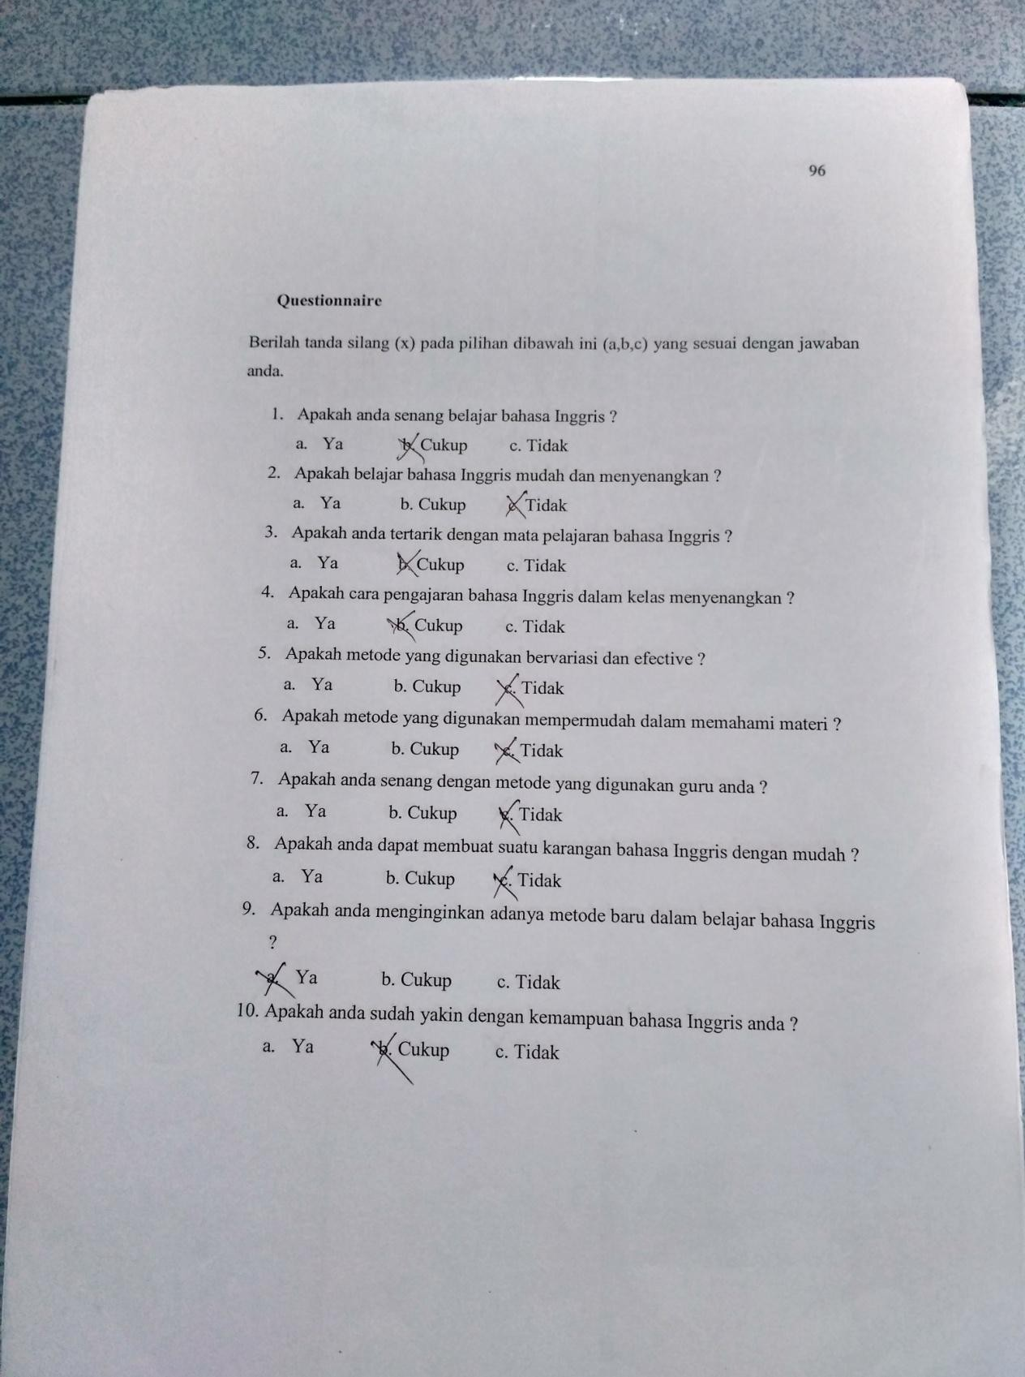
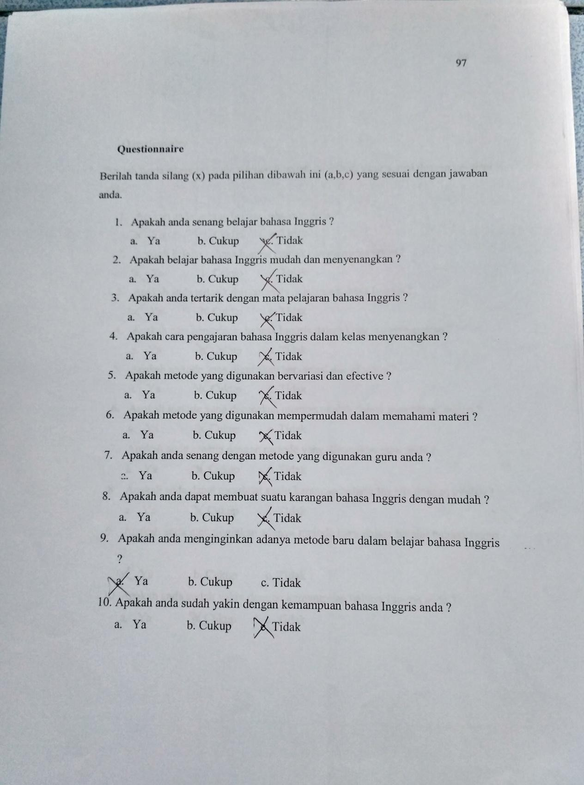
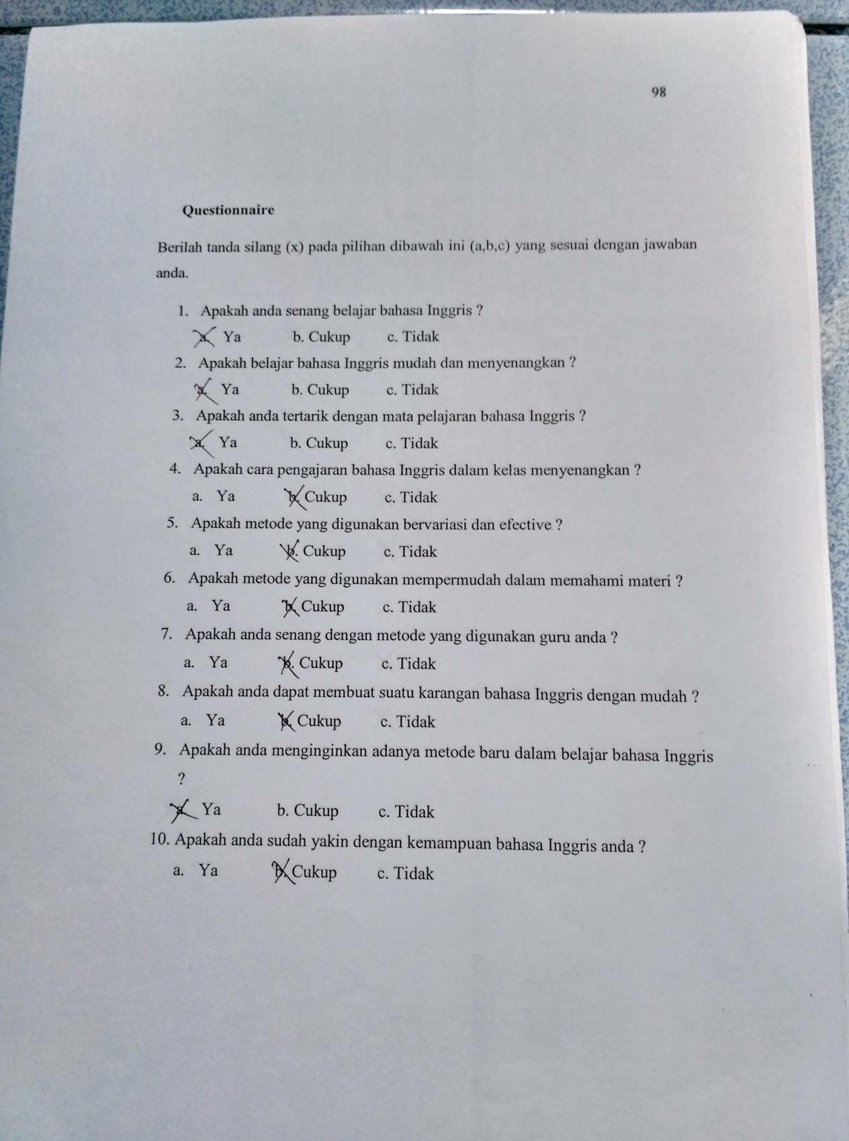
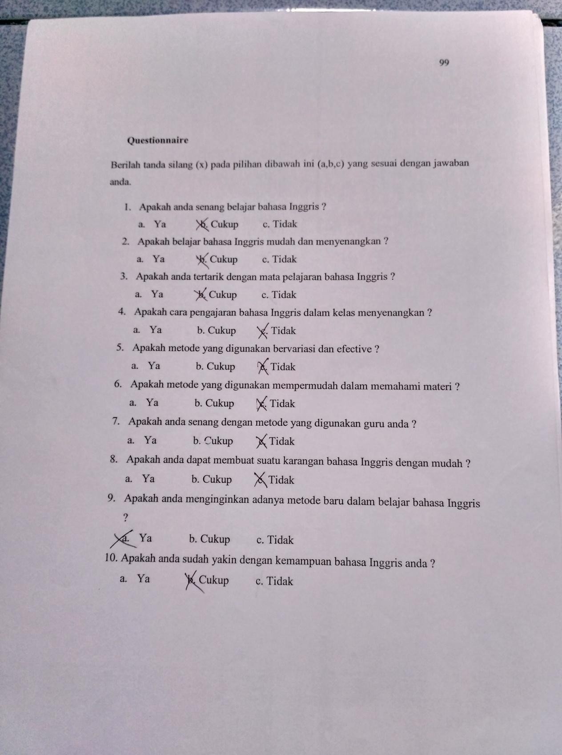
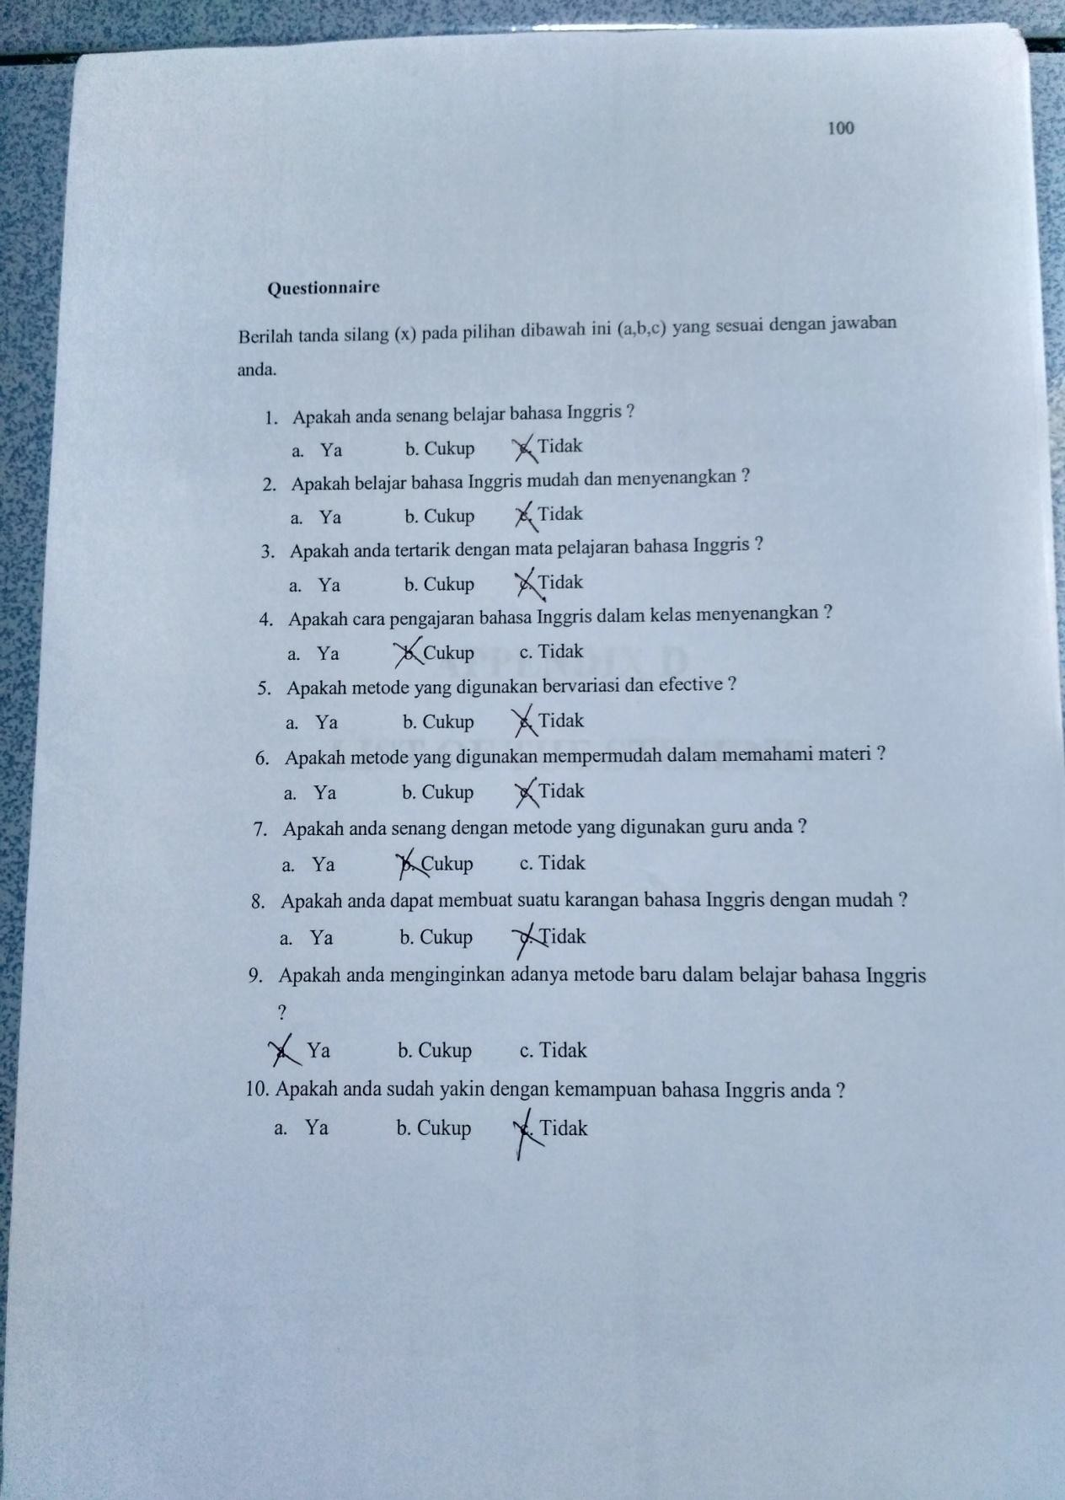

APPENDIX D
LIST OF THE STUSENTS

List Of The Stusents

No. | Name | Jenis kelamin
1 | Alisa Nur Fadillah |  | P
2 | Dania Asima Istihbar |  | P
3 | Fayra Diza Berlian |  | P
4 | Syarifah Mar‟atus S. |  | P
5 | Hana Rahmaningtyas H |  | P
6 | Frida Ayu Salma Antari |  | P
7 | Erika Hendratama Putri |  | P
8 | Ismi Wafda Maulidya |  | P
9 | Amanda Zerlinda |  | P
10 | Rima Nurlabansa |  | P
11 | Haidar Daffa Aulia | L
12 | Salsa Amalia Husna |  | P
13 | M. Fawwas Yumna F. | L
14 | M. Habib Hari Moekti | L
15 | M. Majid Athaillah | L
16 | Faqih Alamsyahari | L
17 | Andi Setiawan | L
18 | M. Taufik Awarisga | L
19 | Yusuf Maulana | L
20 | Faiq Fajar Satri Tama | L
21 | M. Hamdan Yuwari | L

APPENDIX E
SYLLABUS

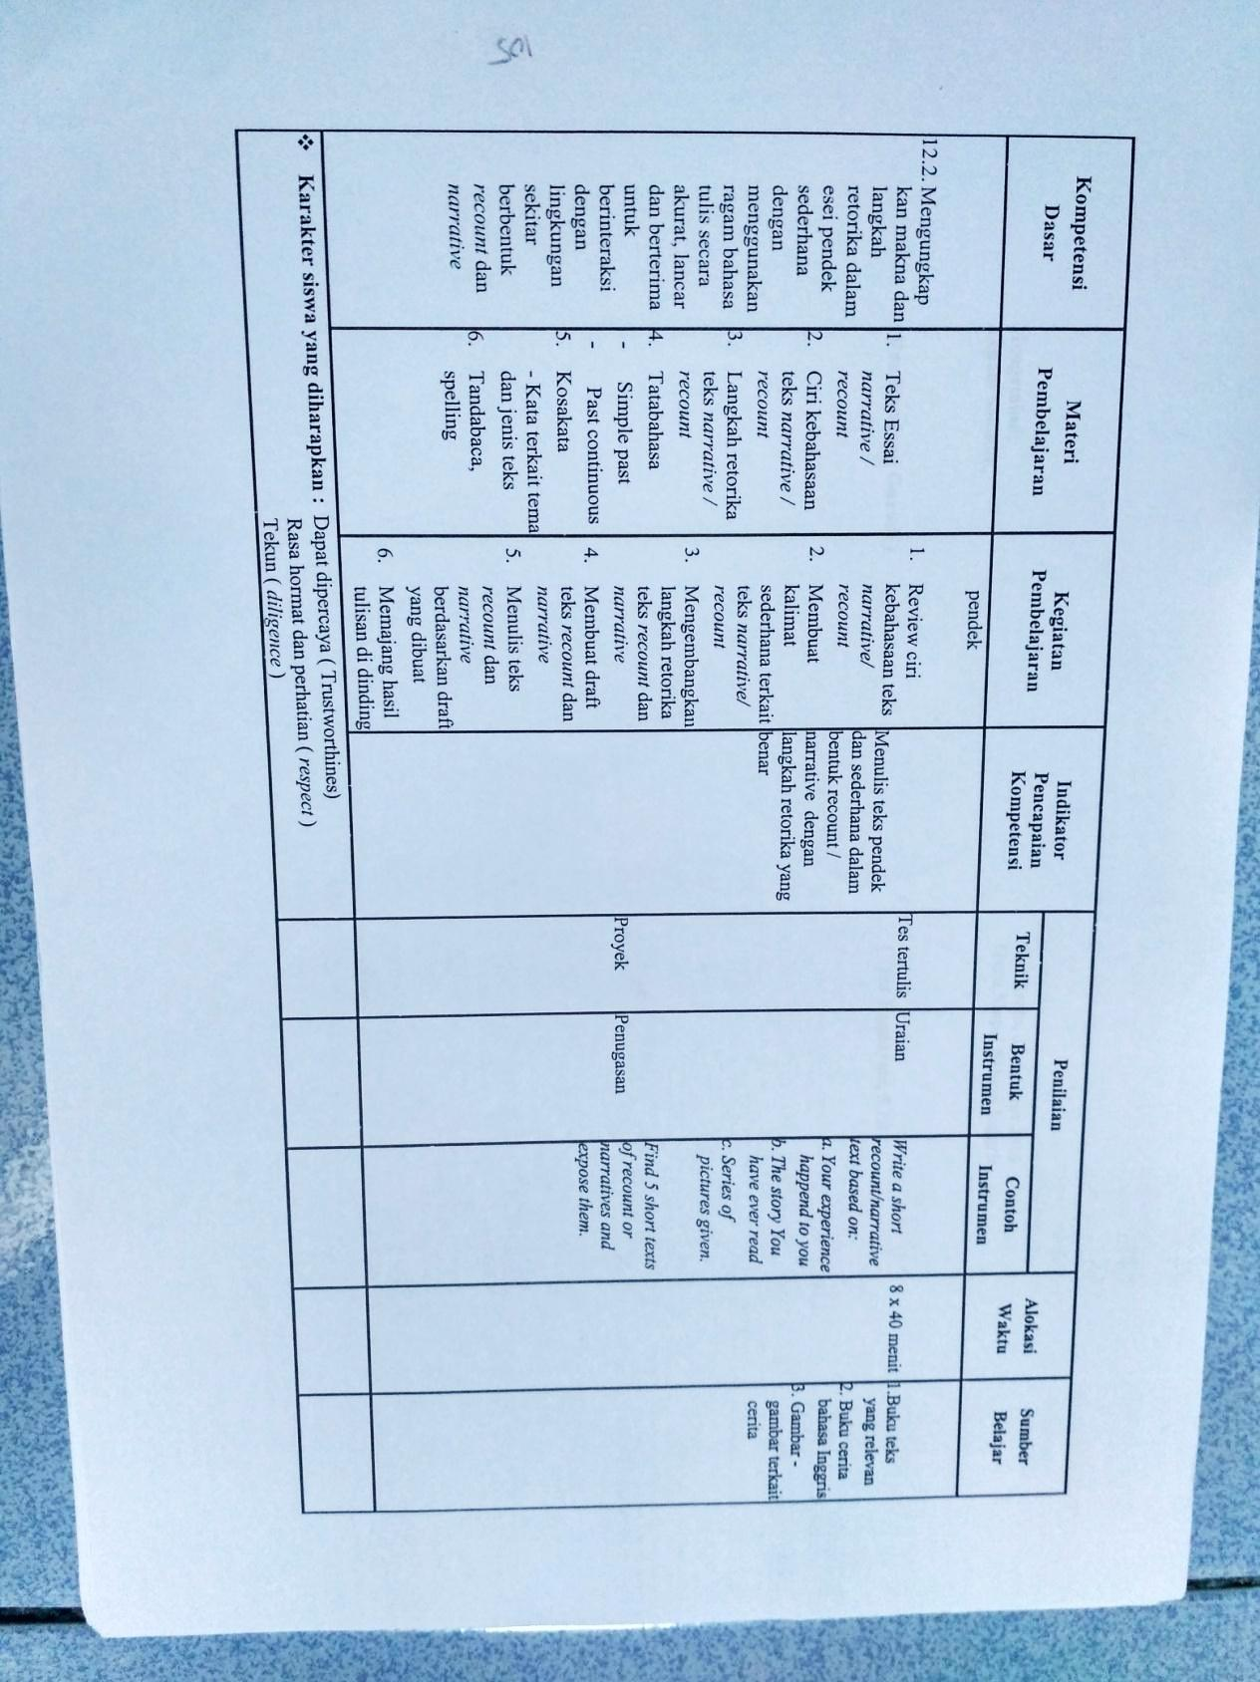

APPENDIX F
LESSON PLAN

RENCANA PELAKSANAAN PEMBELAJARAN (RPP)

- Identitas
Nama Sekolah : SMA N SIBOLANGIT
Mata Pelajaran : Bahasa inggris
Kelasn / Semester : X / 1
Jenis Teks : Transaksional / interpersonal
Skill : Writing
Waktu : 2 x 20 menit

Standar Kompetensi

Menulis

12. Mengungkapkan makna dalam teks tulis fungsional dan esei pendek sederhana berbentuk narrative untuk berinteraksi dengan lingkungan sekitar.

Kompetensi Dasar

Mengungkapkan makna dalam bentuk teks tulis fungsional pendek sederhana dengan menggunakan ragam bahasa tulis secara akurat, lancar dan berterima untuk berinteraksi dengan lingkungan sekitar.

Mengungkap kan makna dan langkah retorika dalam esei pendek sederhana dengan menggunakan ragam bahasa tulis secara akurat, lancar dan berterima untuk berinteraksi dengan lingkungan sekitar berbentuk narrative.

Indikator

Mengidentifikasi berbagai informasi dalam teks narrative.

Mengidentifikasi tujuan komunikatif teks narrative.

Membuat teks narrative.

Muatan Nilai-nilai Karakter
- Dapat dipercaya ( Trustworthines )
- Rasa hormat dan perhatian ( Respect )
- Berani ( Courage )

- Tujuan Pembelajaran
- Pada akhir pembelajaran siswa dapat:
- Mengidentifikasi berbagai informasi dalam teks narrative.
- Mengidentifikasi tujuan komunikatif teks narrative.
- Membuat teks narrative.

Materi Pembelajaran
Narrative Text
- Narrative text is an imagination or a complicated event which direct to a crisis that find a solution at last.
- The purpose of narrative text is to entertain or amaze the readers through a story.
- Generic structure of narrative text:

Orientation:

The beginning of the story has the function of introducing the characters of the story, where and when the story occurred.

Complication:

How the problem starts until its crisis point (climax) of the problem, in which the character(s) have to face.

Resolution:

How the problem is solved or ended.

Reoriontation:

The ending of the story which may consist of closing remark to the story.

Coda:

The change that the character has and moral value the readers can take.

Reoriontation and coda are optional. You may or may not find them in the story.
- Language Feature
- Use of particular nouns to refer to or describe the particular people, animals and thing that the story is about;
- Use of adjectives to build noun groups to describe the people, animals or things in the story;
- Use of time connectives and conjunctions to sequence events through time;
- Use of adverbs and adverbial phrases to locate the particular incidents or events;
- Use of past tense action verbs to indicate the actions in a narrative;
- Use of saying and thinking verbs to indicate what characters are feeling, thinking or saying.

Metode Pembelajaran: Three Phase Technique
Three phase technique adalah tehnik atau metode pengajaran menggunakan tiga tahapan yaitu sebelum saat pelaksanaan dan setelah pelaksanaan. Tehnik ini semula dipakai untuk pengajaran writing, kemudian tehnik ini dikembangkan untuk semua skill dalam bahasa Inggris seperti dalam writing dan lisrening. Dalam listening tehnik ini terdiri dari pre-listening, whilst-listening phase, and post-listening phase. Prosedure pelaksanaan three-phases listening techniques.
- In the pre-listening phase, tahap ini ketika para siswa belum mendengarkan guru membuka pelajaran kemudian mengenalkan topic yang akan dibahas sehingga siswa mempunyai gambaran tentang apa yang akan dipelajari. Pada tahap ini guru juga bisa mengarahkan siswa kemungkinan kosa kata yang akan muncul.
- In the whilst-listening phase, tahap ini guru mengajak siswa untuk mendengarkan baik-baik apa yang akan diperdengarkan.
- In the post-listening phase, pada tahap ini guru meminta siswa untuk mendiskusikan hasil dengaranya, mwreview kembali dan menemukan jawabannya.

- Kegiatan Pembelajaran
- Kegiatan Awal
- Pertama, Membuka pelajaran dengan salam dan dilanjutkan berdoa.
- Mengabsen siswa.
- Mengecek keadaan kelas (kebersihan dan kerapian).
- Kegiatan Inti
  - Eksplorasi
    - Guru menanyakan kepada siswa tentang sebuah cerita; siapa yang suka mendengarkan cerita ? membaca cerita ? dan menulis cerita ?
  - Elaborasi
    - Guru meminta siswa untuk mendengarkan penjelasan tentang teks narrative.
    - Guru meminta siswa untuk menceritakan sebuah gambar berseri atau apa isi dari gamabar itu.
    - Guru meminta siswa untuk menuliskan teks narrative dengan media gambar.
- Konfirmasi
    - Menanyakan kesulitan yang dihadapi oleh siswa tentang materi yang telah diberikan.
    - Guru bersama siswa menyimpulkan materi yang telah dibahas.
- Kegiatan Penutup
  - Guru meminta siswa untuk menyebutkan sebuah kalimat atau satu kata yang berkaitan tentang mateti, di mulai dari belakang.
  - Guru menutup pelajaran dan salam.

Sumber Belajar
Wardiman, Artono, dkk.2008.English in focus:for grade IX Juniour High School(SMA Sederajat).Jakarta:Pusat Perbukuan, Departemen Pendidikan Nasional.

Media Pembelajarn
- Lembar Kerja Siswa
- White board
- Board maker
- Picture series

- Penilaian

Indikator penilaian | Teknik Penilaian | Instrumen penilaian | IIndikator Penilaian
Mengidentifikasi alur cerita beserta generic structure dan language feature dari teks naratif. | Tes Tertulis | Look at the pictures and learn the story. Decide which pictures will be the orientation, complication, and resolution.
Menemukan makna kosakata sukar dari cerita naratif. | Tes tertulis | Look up the meaning of these words by using the dictionary.
Menulis sebuah teks naratif berdasarkan picture series. | Tes tertulis | Write a story of Cinderella by making a many  sentences based on picture series.

- Rubrik Penilaian
Diambil dari rubrik penilaian dari Jacob et.al dalam Weigle (2002), terlampir.
Score | Categorization
87.5–100 | Excellent
75–87.4 | Very good
62.5–74.9 | Good
50–62.4 | Fair
37.5–49.9 | Poor
25–37.4 | Very poor

Nilai tertinggi = 100

- Instruments
Look at The Picture Series and Make a Story !

1 |  | 2 |  | 3 | 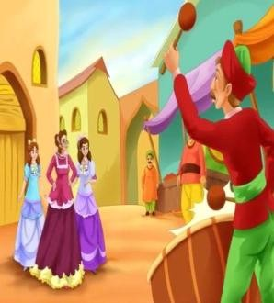
4 | 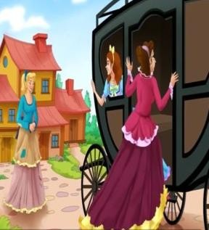 | 5 |  | 6
7 |  | 8 |  | 9
10 | 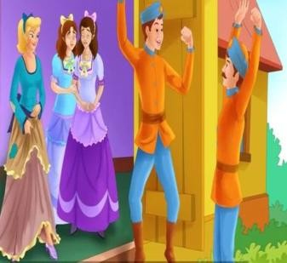 | 11 |  | 12

- Kunci Jawaban: I.
Orientation:
Cinderella
Once upon a time, there was a beautiful girl named Cinderella. She lived with her wicked stepmother and two stepsisters. They treated Cinderella very badly.

Complication:
One day, they were invited for a grand ball in the king‟s palace. But Cinderella‟s stepmother would not let her go. Cinderella felt very sad and began to cry. Suddenly, a fairy godmother appeared and said, “Don‟t cry, Cinderella! I will send you to the ball!” But Cinderella was sad. She said, “I don‟t have a gown to wear for the ball!”

Resolution:
The fairy godmother waved her magic wand and changed Cinderella‟s old clothes into a beautiful new gown. The fairy godmother then touched Cinderella‟s feet with the magic wand. She had beautiful glass slippers. The fairy godmother found six mice playing near a pumpkin, in the kitchen. She touched them with her magic wand and the mice became four shiny black horses and two coachmen and the pumpkin turned into a golden coach. Cinderella was overjoyed and set off for the ball in the coach drawn by the six black horses. Before leaving thefairy godmother said, “Cinderella, this magic will only last until midnight! You must reach home by then. The handsome prince also saw her and fell in love with Cinderella. He went to her and asked, “Do you want to dance?” And Cinderella said, “Yes!” At the last moment, Cinderella remembered her fairy godmother‟s words and she rushed to go home. One of her glass slippers came off but Cinderella did not turn back for it. The prince had fallen in love with Cinderella and wanted to find out who the beautiful girl was, but he did not even know her name. He found the glass slipper that had come off Cinderella‟s foot as she ran home. The next day, the prince and his servants took the glass slipper and went to all the houses in the kingdom. They wanted to find the lady whose feet would fit in the slipper. Cinderella‟s stepmother would not let her try the slipper on, but the prince saw her and said, “Let her also try on the slipper!” The slipper fit her perfectly. The prince recognized her from the ball. He married Cinderella and together they lived happily ever after.

Praktikan
Sibolangit, 22 September 2016

Bindu Sembiring S,Pd,M.Si

