ACKNOWLEDGEMENT
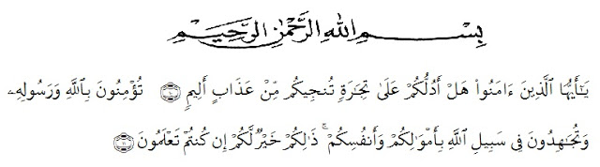
Artinya:
“Hai orang orang yang beriman, sukakah kamu aku tunjukkan suatu perniagaan yang dapat menyelamatkanmu dari azab yang pedih?¹⁰ (Yaitu) kamu beriman kepada Allah dan Rasul Nya dan berjihad dijalan Allah dengan harta dan jiwamu. Itulah yang lebih baik bagimu, jika kamu mengetahuinya¹¹.” (QS.Ash-Shaff:10-11).
In the name of the God of Fathers, Sons, and Holy Spirits, the researcher expresses his highest gratitude to God for blessing, love, opportunity, health, and mercy to complete this undergraduate thesis. This undergraduate thesis entitled “An Analysis of Teacher’s Motivation on Improving Students’ English Writing Skill at SMA Negeri 1 Sibolangit” is submitted as the final requirement in accomplishing undergraduate degree at Universitas Muslim Nusantara Al Washliyah Medan.
In arranging this thesis, a lot of people have provided motivation, advice, and support for the researcher. In this valuable chance, the researcher intended to express his gratitude and appreciation to:
- Dr. KRT. Hardi Mulyono K. Surbakti, as the Rector Universitas Muslim Nusantara Al Washliyah Medan.
- Drs. Samsul Bahri, M.Pd. The Dean of Faculty of Teacher Training and Education.
- Dra. Zulfitri, S.S., M.A. The Head of Department of English Education.
- All lectures of Department of English Education who have taught and education the researcher during her study at Universitas Muslim Nusantara Al Washliyah Medan.
- Mr Bindu Sembiring as the Headmaster of SMA Swasta Budisatrya, who has permitted to the researcher to carry out the research at the school she leads
- Furthermore, she is grateful to her beloved parents, Jhan Wisman Sitopu and Hotma Uhur br Silalahi for all their affections and encouragements all the time. They always support the witer to keep studying hard and finishing this paper. They are the best motivator for the writer in order to be patient and strong to face many barriers when he was working on this duty.
- For her big family thank you for your praying and supporting the researcher. Especially for witer’s brother Yakob Berutu, Rizki Ardiansyah, S.Pd who always helped the writer whenever the writer’s is.
- To her best friends Sahara, Tirta, Lady and Afrida who shared a lot of things when it comes to Writing this thesis.

- The last to everyone whom she has not mention yet, thank you very much for all of your support.

Medan, August, 27th, 2020

Oknaria Sitopu

