, ACKNOWLEDGEMENT

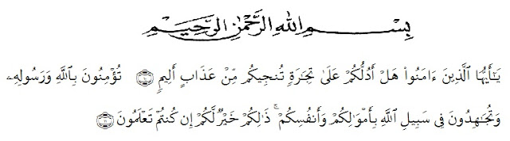

*Artinya:*“Hai orang-orang yang beriman, sukakah kamu aku tunjukkan suatu perniagaan yang dapat menyelamatkan mu dari azab yang pedih?(10). (Yaitu) kamu beriman kepada Allah dan Rasul-Nya dan berjihad di jalan Allah dengan harta dan jiwamu. Itulah yang lebih baik bagimu, jika kamu mengetahui.(11) (As-Shaff : 10-11)”

First of all, Alhamdulillah the researcher wishes to express her great thank to Allah SWT, the most gracious and the most merciful. The writer also wants to present Sholawat and Salam to The Prophet Muhammad SAW.

In completing this skripsi, the researcher got suggestion, critics, comments and support from many persons. Therefore, the researcher would like to express her greatest thank to the following persons, especially to:

1. H. Hardi Mulyono, SE., MAP., the rector Universitas Muslim Nusantara Al Washliyah Medan as the leader of the university.
2. Drs. Samsul Bahri, M.Si,. as the Dean of FKIP UMN Al Washliyah Medan his staffs for guidance and facilities given to the writer during studies in the faculty.
3. Dra.Hj.Nurjannah,.M.Si., as the Head of English Department in University Muslim Nusantara Al Washliyah Medan.
4. Nurhafni Siregar S.Pd.,M.Hum as the first consultant who has given the researcher a lot of valuable suggestions, comments and criticism for completing this research.
5. Yugi Diraga Prawiyata S.Pd.,M.Hum as the second consultant who has never stopped helping guiding and correcting the pattern of this research.
6. All the lectures of FKIP UMN Al Washliyah Medan especially of English Department who have taught the research during in UMN Al Washliyah.
7. Drs. Sadiman, M.Si as the headmaster of SDS Al-Wardah who has given permission and help the researcher the author to conducting this reseach
8. Maya Demiyati, S.Pdas the English teacher of the second grade students of SDS Al-Wardah Medan Tembung for his kindness to allow the researcher to do the research in these classes.
9. My parents, Ari Afandi and Erna Wati .brother and sister, Fadli Ashari and Tri Wulandari who have given support and motivation to conducting this research.
10. My boyfriend, Rudi Faridindika S.Kom, who have offered prayers, advice,guidance mainly spirit, the outhors thanks for the motivational support, help and always there in happiness and sadness, time and affection as long as the researcher complited this thesis.

.

1. My beloved friends, Eliska Youlanda, Suryani, Nora Elida, Risky Paujiah, Rani butar-butar. Thanks to supporting each other and strengthen eah other in the preparation of this thesis.
2. The second grade students of SDS AL-WARDAH Medan Tembung for their participants and support during the research
3. All researchers' friends that researcher cannot mention all for the help.The researcher realizes that this thesis is still far from being perfect. Thus, the researcher accepts for every criticisms and suggestion. Finally, the researcher expects that this thesis will be beneficial for people who read it.

Finally, her realizes that could not recompense the contribution of those people mentioned above, her pray upon Allah, may the almighty bless them all in here after.

Medan, june 2020

The researcher

Dwi Anggraini

NPM: 161244128