APPENDIX
57

APPENDIX 1 (RPP)
LESSON PLAN
(RPP)

Education units | SMP
Subjects | English
Class / Semester | IX / 1
Subject matter
Time Allocation | 4JP (2xmeeting)
- CORE COMPETENCY
KI 1 | Respect and appreciate the teachings of the religion they profess
KI 2 | Respect and appreciate honest habits, discipline, responsibility, caring, polite, confident, in relationships with the social environment and the environment in association and support it
KI 3 | Understanding knowledge (factual, conceptual, and procedural) based on curiosity about science, technology, art, cultural-related phenomena and eye-sighting events
KI 4 | Trying, processing, and presenting in the realm of concrete (using, unraveling, composing, composing, creating) and abstract domains (writing, reading, calculating, drawing and composing) in accordance with what is learned in school and other sources in the same perspective / theory  58

B. BASIC COMPETENCIES

1.1. | Grateful for the opportunity to speak English as a language of communication for international communication which is manifested in the spirit of learning.
2.3 | Relating to responsibility, attention, cooperation, and peace in carrying out functional communication.
3.15 | Understanding social functions and not linguistics in songs.
4.17 | Capture the meaning of the song.
1. INDICATOR
1.1.1 | Have fun during the learning process.
2.3.1 | Respond to responsibility for the tasks given by the group
2.3.2 | Relating to commitments in assignments given by groups
3.15.1 | Determine the social function of a given song
4.17.1 | Find the moral value of a given song
1. MATERIAL
First Meeting:
59

- Que Sera Sera song
- Social functions: Appreciate senior work that contains songs, entertain and teach positive values
- Language elements:
(1) Vocabulary
(2) Speech, pressure and intonation
(3) Spelling and punctuation
(4) Handwriting
Second meeting :
- Social Functions: Appreciate senior work that contains songs, entertain and teach positive values (optimistically challenges the future)
- Language elements:
(5) Vocabulary
(6) Speech, pressure and intonation
(7) Spelling and punctuation
(8) Handwriting
- Song: You Raise Me Up (Josh Groban)

60
C. LEARNING STEPS

Meeting 1
Activity | Time Allocation
Preliminary  1) The teacher gives greetings (greetings);  2) The teacher accepts student participation;  3) Teachers who accept psychic and physical students to follow the learning process;  4) The teacher motivates student learning according to the benefits and application of teaching material in daily life, by providing examples and local, national and international participation;  5) The teacher agrees about prior knowledge with the material to be learned;  6) The teacher explains the learning objectives or basic competencies to be achieved;  7) The teacher conveys material and activities that are in accordance with the syllabus. | (10 minutes)
Core activities  1. Observing  • Listen to the song through the video played by the teacher  • Imitate a song from a video played by the teacher  61  2. Ask  • Give students the opportunity to ask questions about various things they want to know  3. Gather information / try  • Divide students into groups  • Copying songs given by the teacher  • Look for the meaning of words that are not yet known by students and their respective groups  4. Reasoning / associating  • Complete information related to the song provided  • Determine the social function of the song given by answering some questions given by the teacher. (Attached)  • Convey the moral message in the song given.  5. Communicating  • Sing a song that has been given in front of the class with the group | (60 minutes)
Closing  1) Students and teachers reflect on learning activities and their benefits.  2) Students and teachers provide feedback on the process and learning outcomes.  3) Students accept individual assignments to search for the lyrics to the song "You Raise Me Up (Josh Groban) from various sources *  4) Learners pay attention to information about planned learning activities for the next meeting.  5) Students and teachers are approved in closing remarks.  62 | (10 minutes)

Meeting 2
 | Activity | Time Allocation
 | Preliminary  1). The teacher gives greetings (greetings);  2). Student Admission  3). The teacher accepts psychic and physical students to follow the learning process;  4). The teacher motivates student learning according to the benefits and application of teaching materials in daily life.  5). The agreed teacher is discussed between prior knowledge and the material to be studied;  6). The teacher explains about the learning objectives or basic competencies to be achieved;  7). The teacher welcomes materials and descriptions according to the activity syllabus.  63 | (10 minutes)
 | Core activities  Observe  • Students watch the video of the song "You Raise Me Up (Josh Groban)" played by the teacher while playing the song lyrics that the students have received as assignments from the previous meeting.  • Students imitate the song played by the teacher  Ask  • Give students the opportunity to ask questions about various things they want to know from the song.  Gather information / try  • Divide students into groups  • Look for the meaning of words that are not yet known by students and their respective groups  Reasoning / associating  • Determine the social function of the song by answering some questions given by the teacher. (Attached)  64  • Convey the moral message contained in the song  • Determine rhyming words at the last word in each feed in the song  Communicating  • Sing the song You Raise Me Up with the right pronunciation and intonation together. | (60 minutes)
 | Closing  1). Students and teachers reflect on learning activities and their benefits.  2). Students and teachers provide feedback and conclusions on the learning process and outcomes.  3). Learners accept assignments consisting of 4 students to search English-language songs that have social functions and moral values from various source.  4). Participants listen to the lyrics of the song and determine social functions and resolve the moral values implicit in the song as a portfolio task.  65  5). Learners pay attention to information about planned learning activities for the next meeting.  6). Students and teachers agree to the closing greeting. | (10 minutes)
D. ASSESSMENT

1. Attitude:
2. Knowledge:
a. A. Material: The song "You Raise Me Up".
b. Assessment Technique: Written Test
c. Instrument Form: Question Fields.
d. Grilles:

Not | Indicator | Instrument Bullet  66
 | An optimistic-themed song "About a person's life" is played with a sentence missing from the lyrics, students can complete the song's lyrics correctly. | 1 – 15
e. Knowledge Competency Assessment Instrument.
3. Skills
An Assessment Technique: Performance
b. Instrument Form: Reading and Training Skills Test
c. Grilles:

Not | Skills / Indicator | Instrument Bullet
Reading and listening
SEBUAH | Presented a theme song optimism students can convey the moral message of the song correctly | Song

d. Instrument :
E. MEDIA, MATERIALS AND LEARNING RESOURCES
67

Media | : Song Video
Material | :Whiteboard,speaker, and Infokus
Learning Resources | 1. Book Package  2. Internet  3. Dictionary

Medan, 07 July 2020
Teacher

Eliska Youlanda
161244164

APPENDIX 2 (Pre Test)
68

Name :
Class :
Group : Experimental Group

- What is music ?
- So, what is vocabulary ?
- What do you think about your life ?

APPENDIX 3 (Post Test)

Name :
Class :
Group : Control Group

When I am ..., and, oh, my soul, so weary
When ... come, and my heart burdened be
Then, I am still and ... here in the ....
..... you ..... and sit awhile with me
You raise me up, so I can .... on mountains
You raise me up to .... on stormy seas
I am ..... when I am .... your ......
You raise me up to ...as
I am strong when I am on your shoulders
You raise me up to more than I .... be
Answer Down,troubles,wait,silence,until,come,stand,walk,strong,on,shoulders,more,raise,stormy,can.
69

APPENDIX 4 (Doing Research)
70
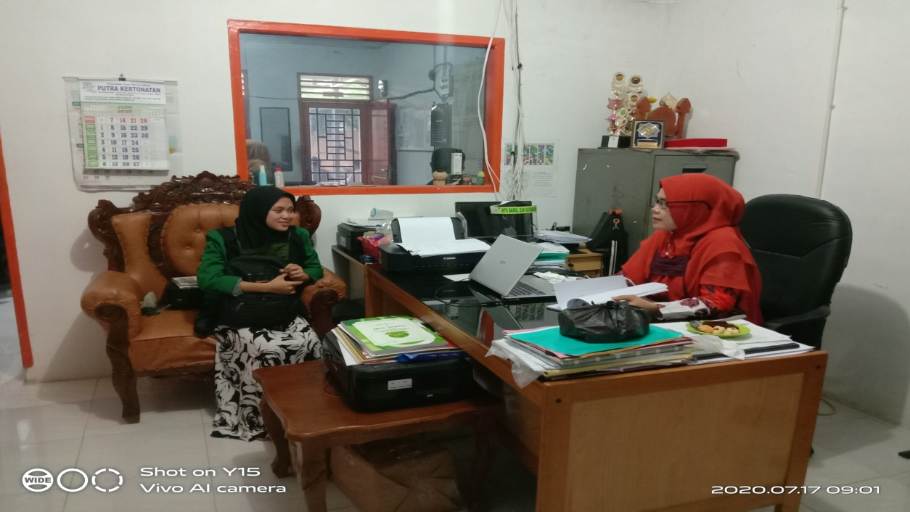
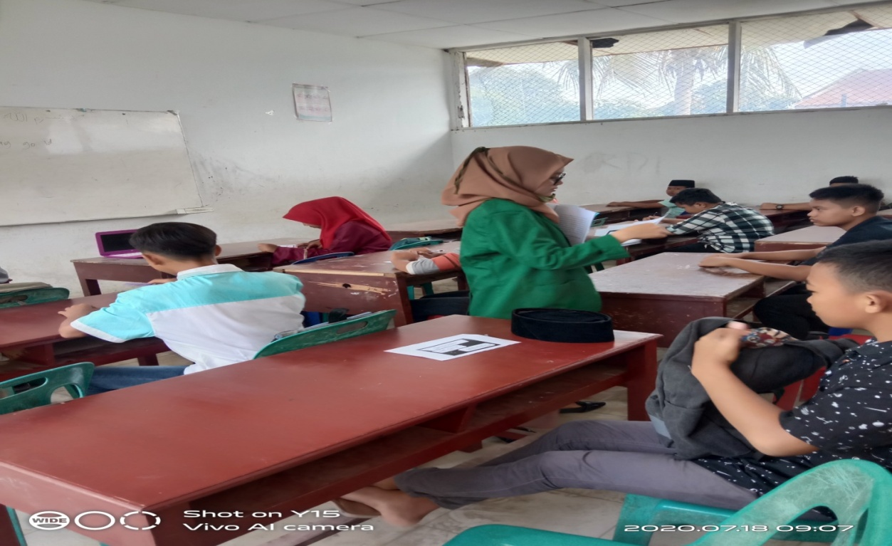
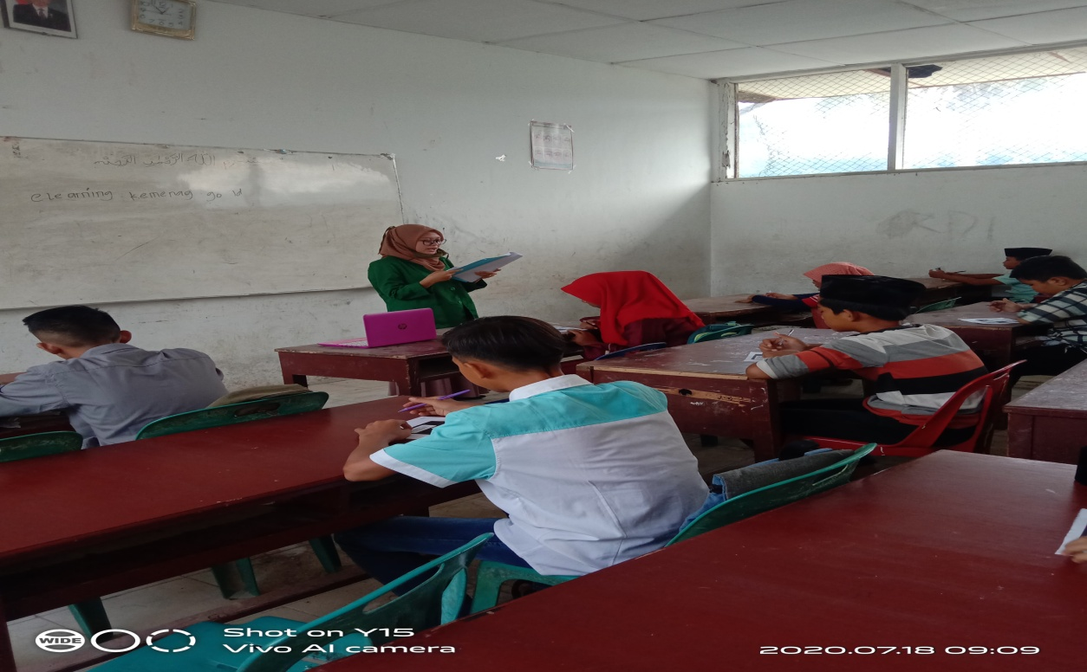
71
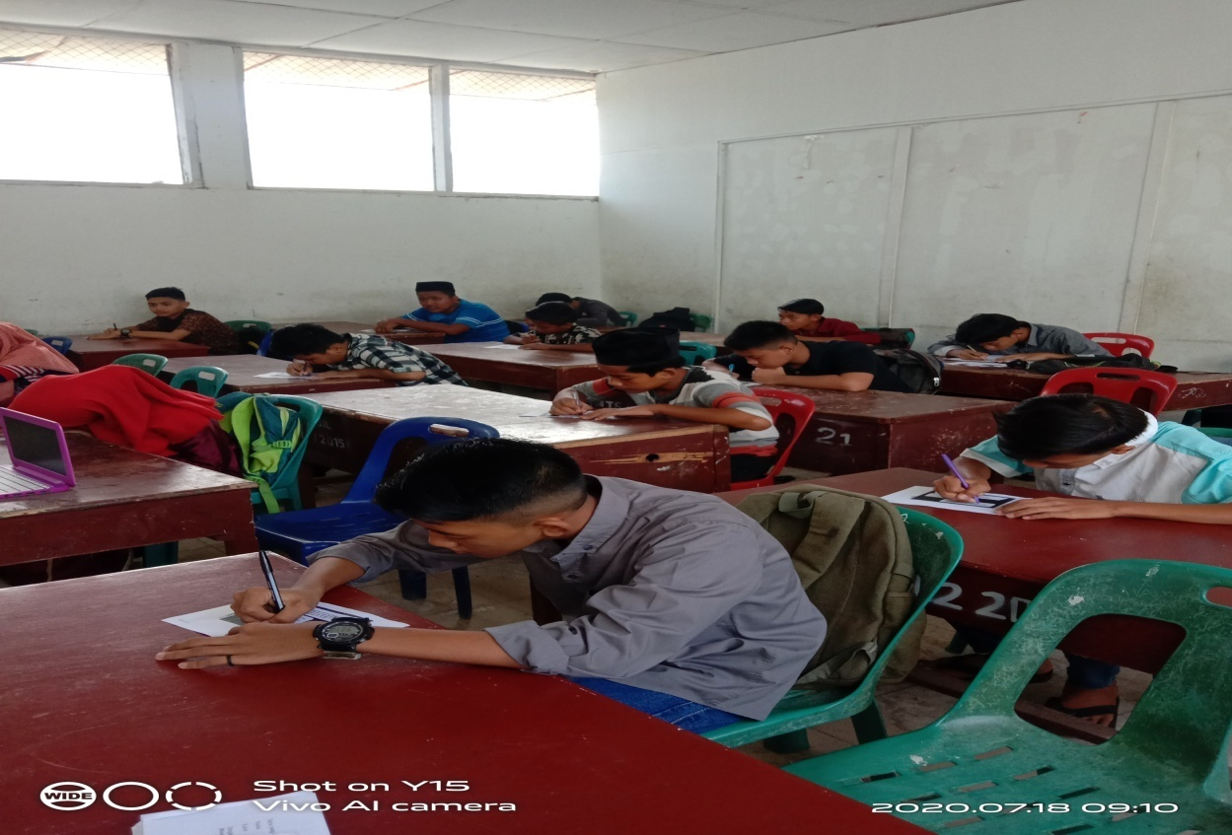
72
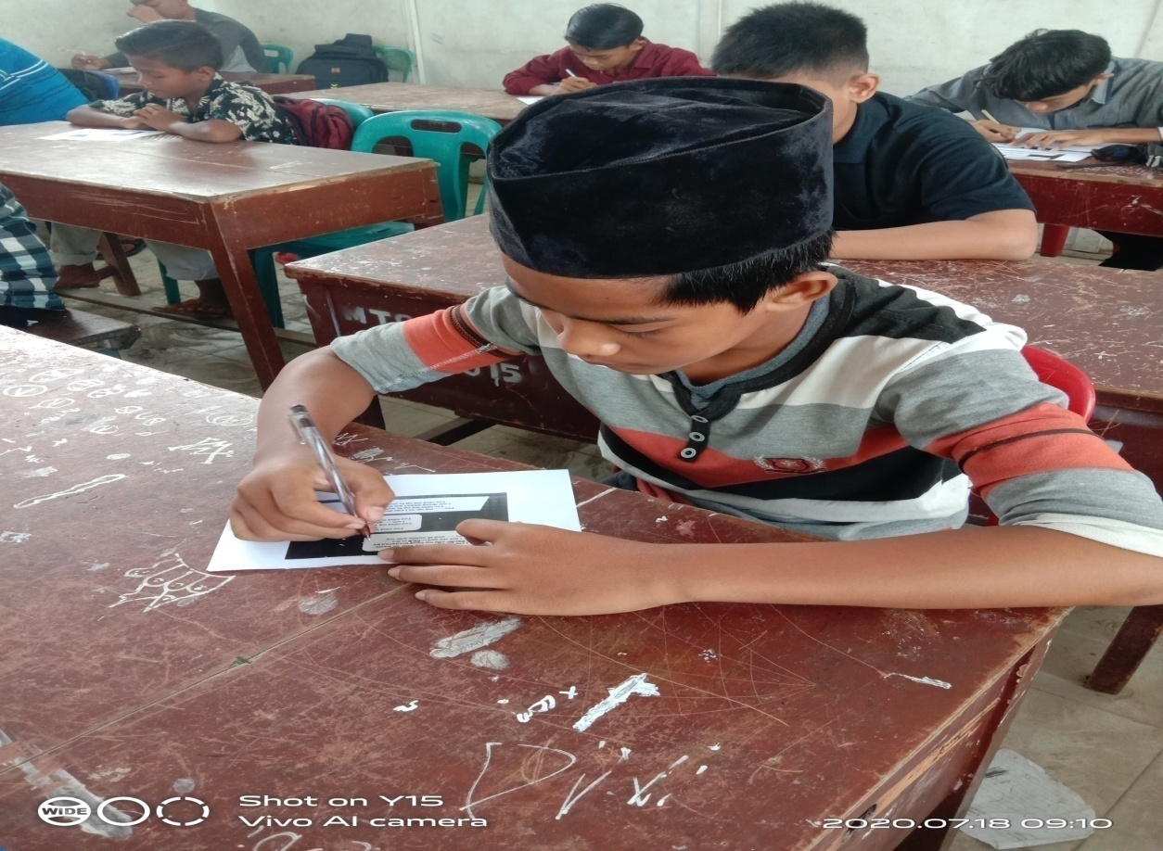
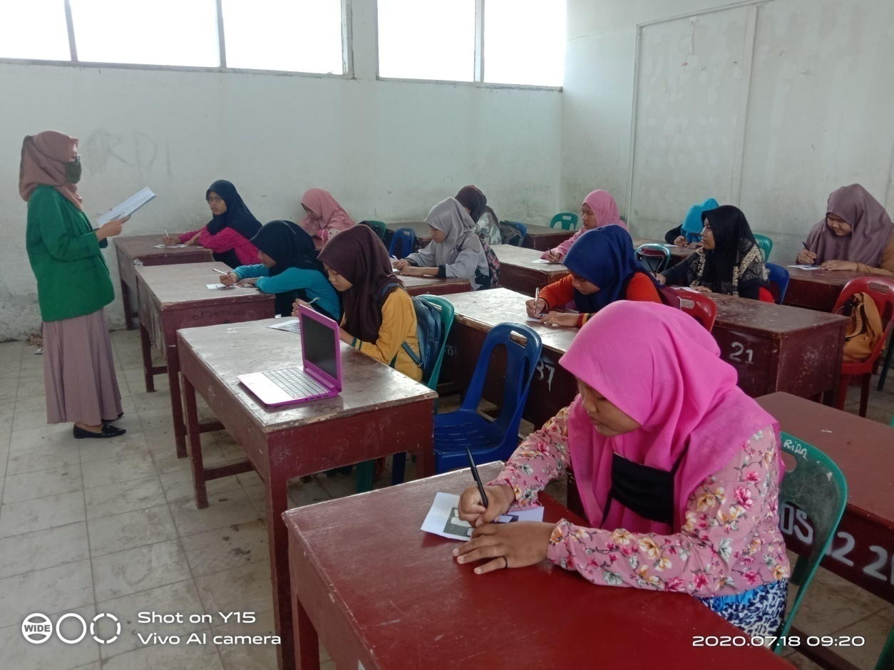
73
