ACKNOWLEDGEMENT
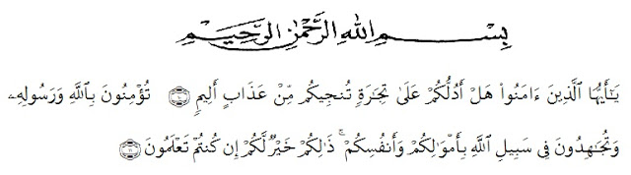
Artinya:“Hai orang-orang yang beriman, sukakah kamu aku tunjukkan suatu perniagaan yang dapat menyelamatkan mu dari azab yang pedih?(10). (Yaitu) kamu beriman kepada Allah dan Rasul-Nya dan berjihad di jalan Allah dengan harta dan jiwamu. Itulah yang lebih baik bagimu, jika kamu mengetahui.(11) (As-Shaff : 10-11)”
First of all, Alhamdulillah the researcherwishes to express my great thank to Allah SWT, the most gracious and the most merciful. The writer also wants to present Sholawat and Salam to The Prophet Muhammad SAW.
In completing this skripsi, the researcher got suggestion, critics, comments and support from many persons. Therefore, the researcher would like to express her greatest thank to the following persons, especially to:
- Dr. KRT Hardi Mulyono K Surbakti the rector Universitas Muslim Nusantara Al Washliyah Medan as the leader of the university.
- Drs. Samsul Bahri, M.Si,. as the Dean of FKIP UMN Al Washliyah Medan his staffs for guidance and facilities given to the writer during studies in the faculty.
- Dra.Hj.Nurjannah,.M.Si., as the Head of English Department in University Muslim Nusantara Al Washliyah Medan.
i
- Dr.Salamuddin Selian, M.Hum, as the first consultant who has given the writer a lot of valuable suggestions, comments and criticism for completing this research.
- Wariyati, S.Pd., M.Hum, as the second consultant who has never stopped helping guiding and correcting the pattern of this research.
- All the lectures of FKIP UMN Al Washliyah Medan especially of English Department who have taught the research during in UMN Al Washliyah.
- Rini Daraini, S.Si,. M.Pd., as the head of MTS SWASTA DARUL ILMI BATANG KUIS who has given permission and help the writer the author to conducting this reseach
- Erli Murnita, S.Pd as the teacher of the nine grade of MTs DARUL ILMI BATANG KUIS for his kindness to allow the researcher to do the reaserch in these classes.
- Special gratitude for my beloved father Mr. Lisno and her dearest mother Mrs. Eka Susilawati who have offered prayers, advice, guidance mainly spirit, material support and everything for my life until I can finish study from university.
- Boy friend beloved Muhammad Haqqy Annazily., who have offered prayers, advice, guidance mainly spirit, the outhors thanks for the motivational support, help and always there in happiness and sadness, time and affection as long as the writer complited this thesis.
- My beloved Family, brothers of Rehan Fajarianda Syahputra, of sisters Riana Yuli Erliza S.Farm, Rifka Fitri Anggina S.Pd, Frida Gusti Ningrum S.Pd, Grandfather and Grandmother they have offered prayers, advice, material support whole heartedly to the author, .
ii
- My beloved friends Dwi Anggraini, Suryani, Nora, Rani Butar-Butar, Nurul Azizah.. Thanks to supporting each other and strengthen eah other in the preparation of this thesis.
- Seniors and Juniors who have provided a lot of motivation in completing this thesis, both within and outside the UMN AL-Washliyah Medan
Finally, My realizes that could not recompense the contribution of those people mentioned above, my pray upon Allah, may the almighty bless them all in here after.
Medan, july 2020
The researcher

Eliska Youlanda
NPM: 161244164

iii

