ACKNOWLEGDEMENTS
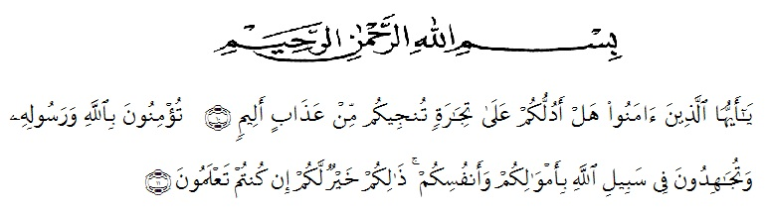
In the name of Allah, the beneficent, the merciful. All praises be to ALLAH for the mercy and blessing, who has given the health and strength to the writer in completing this thesis as a particular instance of which is that this research is now finally in our hands. Then, may ALLAH’s peace and blessing be upon the final prophet and messenger, Muhammad, her family and her companions.
In writing and finishing this thesis, many people have provided their motivation, advice, and even remark that helped the researcher. Therefore the researcher would like to express her appreciation to all of them.
The writer would like to dedicate the best thank to :
- The Rector of University of Muslim Nusantara Al – Washliyah Medan, Dr. KRT. Hardi Mulyono K. Surbakti
- The Dean of Faculty of Letters, Dr. Hj. Risnawaty, M.Hum
- The Head of English Letters of University of Muslim Nusantara Al- Washliyah Medan for giving her knowledge and enlightenment to the writer during the academic years as well.
- The writer’s gratitude due to her supervisors, Dr. Susy Deliani M.Hum. As the first concultant and Dra. Nurhaida Harahap M.Hum. as the second consultant for their generous support, advise, constructive, suggestions and precious time they have given during the completion of this research.
- The writer’s special gratitude for her beloved parents, Sudarmanto and Rabaisyah, who have patiently given their moral value, financial support, nice and good advice for their children. God bless you.
- The researcher would like to express her appreciate to her close friends, billion thanks to you for all the things that you have given to her. Your kindness would not be end in her mind until the last of her breath.
- The deepest appreciation individually and collectively most profound thanks to English Literature Student 2016. Thank you for your sisterhood, friendship, kindness and suggestion for long time we gathered in the class.
Finally, this thesis is still far from perfectness, the positive advice, suggestion and critics for the completion of this thesis will be much appreciated.
The writer believes that Allah SWT blesses us and shows us the right way of life. Aamiin.
Medan, 13 July 2020

Opy Desya Masita

