ACKNOWLEDGEMENT
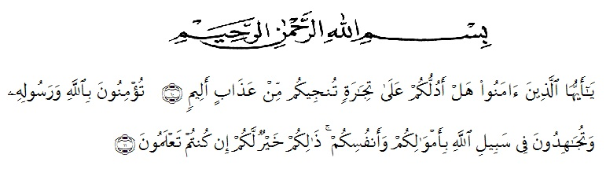
"O ye who believe ! Shall I show you a commerce that will save you from a painful doom? Ye should believe in Allah and His messenger, and should strive for the cause of Allah with your wealth and your lives. That is better for you, if ye did but know. (As-Shaff 10-11)"
Alhamdulillahi Rabbil ‘Alamin, first of all the researcher would like to express his deepest praise and gratitude to Allah SWT who has given the blessing and merciful to complete the script. Salawat and Salam addressed to Muhammad SAW as the final chosen religious messenger.
This thesis entitled “AN ANALYSIS OF INEQUALITY AS REFLECTED IN THE ADVENTURES OF TOM SAWYER’S NOVEL” is presented to the Faculty of Letters in University of Muslim Nusantara Al- Washliyah Medan (UMN) as one of the requirements for bachelor degree of letters.
However, this success would not be achieved without support, advice, guidance, help and encouragement from the people and intuition. It’s an appropriate moment for the writer to say her deepest gratitude for:
- Dr. KRT. Hardi Mulyono K. Surbakti, Rector of University of Muslim Nusantara Al-Washliyah Medan.
- Dr. Hj. Risnawaty, M.Hum, Dean of Faculty of Letters.
- Rezky Khoirina Tarihoran, S.S, M.A. My first consultant who has educated, supported and given me countless advice, suggestion and solution in writing this script. I really thanks also for his patience to guide me until I have finished this thesis.
- The Vice Dean and as my second consultant, Harianto, S.S, M.S, Ph.D who has educated and giving me the advice and suggestion to improve my ability to speak English.
- Dewi Nurmala, SS, M.Hum as the Head of Department who never tired in facing up me, and all lectures of the faculty of Letters.
- For my family and for all my friends in Faculty of Letters 2016 thank you for togetherness and thank you for being pleasure for helping me. May Allah always be with us and gives us the power and guidance in our life.
Eventually, this thesis is expected to be able to provide useful knowledge and information for all readers. The writer is pleased to accept more contribution and suggestion for the improvement of this graduating paper.

Medan, August 2020

Risa Tiara Difa

