ACKNOWLEDGEMENTS
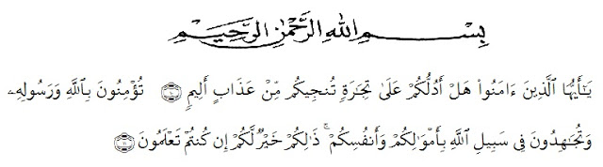
Translation : O you who had believed! Sall I guide you a transaction that will save you from a painful punishment?(10) You should believe in Allah and His messenger and should strive for the cause of Allah with your wealth and your lives. That is better for you, if you should know. (11) (As-Shaff: 10-11).
Alhamdulillah, in the name of Allah SWT the most Gracious, thw mos Merciful. all praises be to Allah SWT, king of the king, the Lord of the world, and the master of the day after who has giving me health, opportunities and blessings every day, and the prophet Muhammad SAW as the messenger of Allah SWT, so that the author can complete this thesis. This thesis is entitled The Existence of Magic Powers in American The industrial revolution is reflected in A Wrinkle in Time novel by Madelein L'Engle's is presented to the faculty of Letters in University of Muslim Nusantara Al – Washliyah Medan (UMN) as one of requitments for sarjana Sastra at the faculty of Letters
In writing this thesis, the author gets a motivation, advice and support in research. In this case, the author would like to express her gratitude to :
- Allah SWT who has given me health and blessings so that I can complete this thesis
- Hardi Mulyono Surbakti, SE. MAP. As a Rector at University of Muslim Nusantara Al-Wasliyah Medan.
- Dr. Hj. Risnawati M.Hum as the Dean of Faculty of Letters, The University of Muslim Nusantara Al-Wasliyah Medan.
- Dewi Nurmala SS.M.Hum as the Head of the English Department of the Faculty of Letters, The University of Muslim Nusantara Al-Wasliyah Medan.
- Harianto, S.S., M.S.Ph.D and Rezky Khoirina Tarihoran, M.Hum, as my consultant who have educated, supported, directed and given me countless advice, suggestion and recommendation writing this thesis from beginning until the end. Thanks for patient and guidance.
- All Lecturers of Faculty of Letters University of Muslim Nusantara Al-Wasliyah Medan. The writer gives thanks to them for the valuable knowledge and guidance during her study at English Literature.
- My big beloved family especially for my father the late Burhansyah, my mother Hj. Saminem, my sisters Lisa, Rara, Ella, Titha, my brother Akbar, and my younger Mia, Wina, Fajar.
- Thanks for my classmate and all friends, especially my close friends Khairunnisa Arridha, Fittri Yanti Ritonga, and Luthfi Arfianti who always support all my time.

The author realizes that this thesis is still far from perfect. Therefore, the writer will be glad to receive any recommendation and constructive criticism to make this thesis better. The author is also expected this thesis to be able to provide usefull knowladge and information for all readers.

Medan, 2020

Vika Hamima

