AN ANALYSIS OF CODE MIXING IN MASTERCHEF INDONESIA THROUGH RCTI PROGRAMS

A THESIS

BY
KHAIRUNNISA AYU WIRDANI PANE
NPM: 166224017

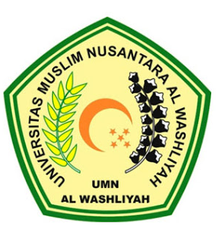

THE FACULTY OF LETTERS
UNIVERSITAS MUSLIM NUSANTARA AL – WASHLIYAH
MEDAN
2020

