ACKNOWLEDGEMENT
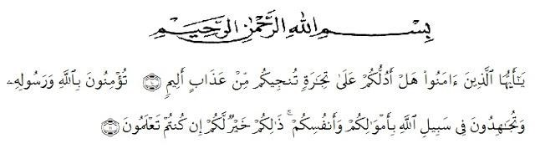
meaning: O you who have believed, shall I guide you to a transaction that will save you from a painful punishment? (10), [It is that] you believe in Allah and His Messenger and strive in the cause of Allah with your wealth and your lives. That is best for you, if you should know. (11). (As-Shaff: 10-11)
Alhamdulillah, in the Name of Allah, the most Gracious, the most Merciful All praises be to Allah, king of the king, the Lord of the world, and the master of the day after, who has given us blessing and guidance. Because of His graciousness and mercifulness the writer can write well. This thesis entitled “AN ANALYSIS OF CODE MIXING IN MASTERCHEF INDONESIA THROUGH RCTI PROGRAMS” is presented to the Faculty of Letters in University of Muslim Nusantara Al-washliyah Medan (UMN) as one of requirements for sarjana sastra at the Faculty of Letters.
In arranging this thesis, a lot of people have provided motivation, advice, and support for the researcher. In this valuable chance, the researcher intended to express her gratitude and appreciation to :
- Dr. KRT. Hardi Mulyono K. Surbakti, As a Rector at University of
Muslim Nusantara Al-Wasliyah Medan.
- Dr. Hj. Risnawaty M.Hum as the Dean of Faculty of letters, The University of Muslim Nusantara Al-Wasliyah Medan.
- Harianto S.S, M.S, Ph. D. as vice Dean of Faculty of letters, The University of Muslim Nusantara Al-Wasliyah Medan.
- Dewi Nurmala S.S, M.Hum as the Head of the English Department of the Faculty of Leters, The University of Muslim Nusantara Al-Wasliyah Medan.
- Dewi Nurmala S.S, M.Hum and Diana Sopha, S.S. M.Hum as my consultant who have educated, supported, directed and given me countless advice, suggestion and recommendation writing this thesis from beginning until the end. Thanks for patient and guidance.
- All lecturers of Faculty Of English Literature The University of Muslim Nusantara Al- Wasliyah Medan. The writer gives thanks to them for the valuable knowledge and guidance during her study at English Literature.
- My big beloved family especially for my lovely father Alm. M. Yusuf Pane , my lovely Mother Yusnaini nasution, and also my younger sister Rosa Nauli Hasanah Pane and my mood booster M. Daffa Al Fattah pane as my little brother, also my grandfather Mahyaruddin Nasution and my grandmother Nurlan Tobing, and then Thanks for all my family, I do love you more than you know.
- And thanks for my classmate and all friends who always support all my time.
- Thanks for my best friends ever I have Imraini, Putri Amalia Ramdhani, and Faramitha Lubis, and then my lovely bestfriends Risma Lonjong, Aini Kecil, and Tika Chane which supporting me in all situation, thankyou so much guys I love all of you.

This thesis is still far from perfect. Therefore, the writer will be glad to receive any recommendation and constructive criticism to make this thesis better. And the writer hope this thesis could be one of the reference for the next study especially in term of Code Mixing. May Allah bless us and our knowledge.

Medan, 08 September 2020

Khairunnisa Ayu Wirdani Pane

