Lampiran Dokumentasi Penelitian
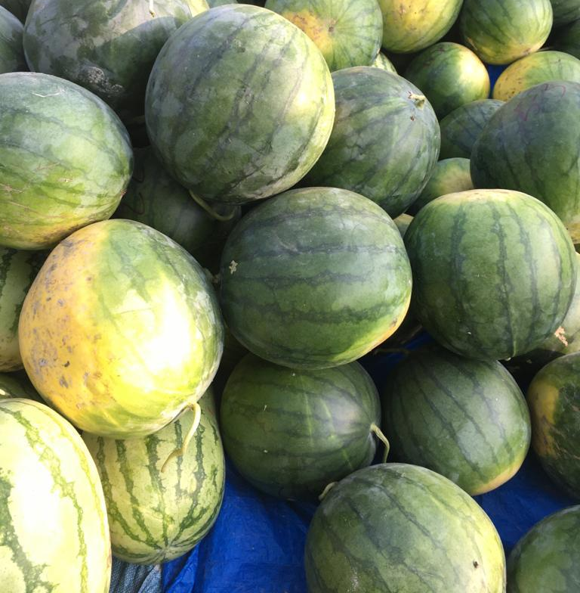

Foto Semangka di Kecamatan Pantai Cermin, Kabupaten Serdang Bedagai
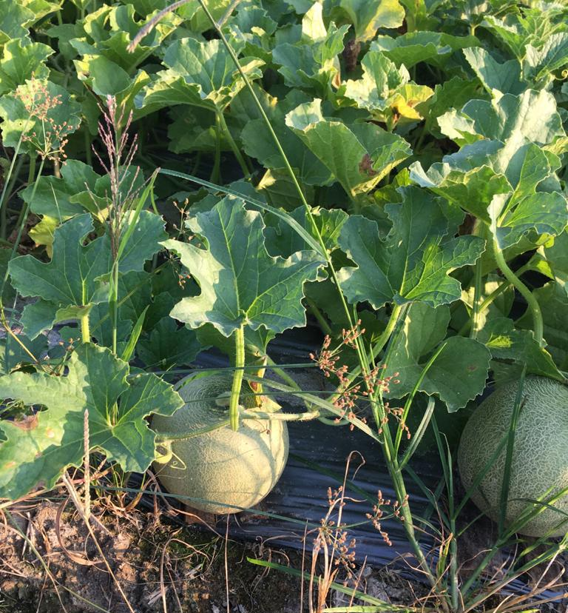

Foto Melon di Kecamatan Pantai Cermin, Kabupaten Serdang Bedagai

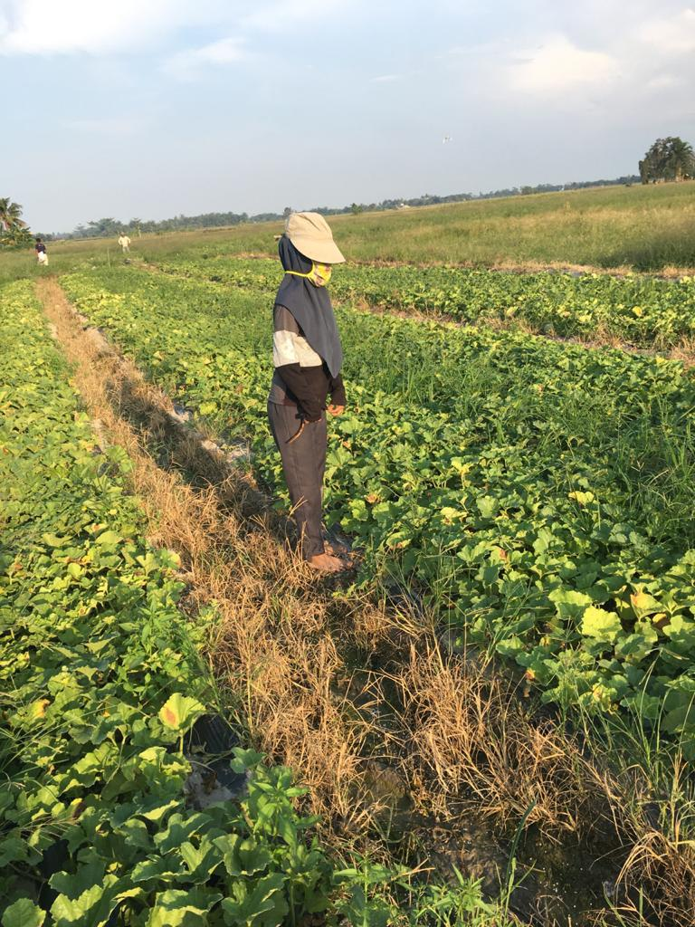

Foto Petani Semangka dan Melon di Kecamatan Pantai Cermin, Kabupaten Serdang Bedagai

LEMBAR KUESIONER

ANALISIS PERBANDINGAN FAKTOR-FAKTOR YANG MEMPENGARUHI PENDAPATAN PETANI MELON DAN SEMANGKA DI KECAMATAN
PANTAI CERMIN KABUPATEN
SERDANG BEDAGAI

- Daftar Pertanyaan
No. Sampel :
Nama :
Umur :
Jenis Kelamin :
Pendidikan :
- Tidak Pernah Sekolah
- SD
- SMP
- SMA
- Akademik
- Perguruan Tinggi
Agama :
Suku :
Jumlah Tanggungan :
No | Nama | Status | Umur | Jenis Kelamin | Pendidikan Formal | Pendidikan Informal
1
2
3
4
5
Keterangan : KK (kepala keluarga), I (istri), A (anak), L( lainnya: kakek, nenek,dll)
Jenis Kelamin : LK (Laki-laki), PR (Perempuan)

- Analisis Biaya Produksi Usahatani Melon
- Biaya Sewa Lahan
No | Luas Lahan | Harga (Rp) | Jumlah (Rp)
1
2

- Biaya Tenaga Kerja
No | Jenis Pekerjaan | Jumlah Tenaga Kerja (Orang) | Upah (Rp/Hari)
1 | Pemeliharaan
2 | Pemupukan/Penyemprotan
4 | Pemanenan

- Biaya Pupuk
No | Jenis Pupuk | Jumlah | Harga (Rp) | Jumlah
1
2

- Biaya Pestisida
No | Jenis Pestisida | Jumah (Botol) | Harga (Rp) | Jumlah (Rp)
1
2

- Biaya Bibit
No | Jenis Bibit | Jumlah | Harga (Rp) | Jumlah
1
2

Lampiran 17. Hasil Regresi Melon

REGRESSION
/MISSING LISTWISE
/STATISTICS COEFF OUTS R ANOVA
/CRITERIA=PIN(.05) POUT(.10)
/NOORIGIN
/DEPENDENT Ln_Y
/METHOD=ENTER Ln_X1 Ln_X2 Ln_X3 Ln_X4 Ln_X5
/SCATTERPLOT=(*ZRESID ,*ZPRED)
/RESIDUALS DURBIN HISTOGRAM(ZRESID) NORMPROB(ZRESID)
/CASEWISE PLOT(ZRESID) ALL
/SAVE RESID.

Regression

Notes
Output Created |  | 16-JUL-2020 06:13:45
Comments
Input | Active Dataset | DataSet0
 | Filter | <none>
 | Weight | <none>
 | Split File | <none>
 | N of Rows in Working Data File | 30
Missing Value Handling | Definition of Missing | User-defined missing values are treated as missing.
 | Cases Used | Statistics are based on cases with no missing values for any variable used.
Syntax |  | REGRESSION  /MISSING LISTWISE  /STATISTICS COEFF OUTS R ANOVA  /CRITERIA=PIN(.05) POUT(.10)  /NOORIGIN  /DEPENDENT Ln_Y  /METHOD=ENTER Ln_X1 Ln_X2 Ln_X3 Ln_X4 Ln_X5  /SCATTERPLOT=(*ZRESID ,*ZPRED)  /RESIDUALS DURBIN HISTOGRAM(ZRESID) NORMPROB(ZRESID)  /CASEWISE PLOT(ZRESID) ALL  /SAVE RESID.
Resources | Processor Time | 00:00:00.75
 | Elapsed Time | 00:00:00.72
 | Memory Required | 2684 bytes
 | Additional Memory Required for Residual Plots | 880 bytes
Variables Created or Modified | RES_1 | Unstandardized Residual

[DataSet0]

Variables Entered/Removedª
Model | Variables Entered | Variables Removed | Method
1 | Biaya Bibit, Biaya Tenaga Kerja, Luas Lahan^{b} | . | Enter
a. Dependent Variable: Pendaptan
b. Tolerance = .000 limits reached.

Model Summary^{b}
Model | R | R Square | Adjusted R Square | Std. Error of the Estimate | Durbin-Watson
1 | .999ª | .998 | .997 | .03286448 | 1.726
a. Predictors: (Constant), Biaya Bibit, Biaya Tenaga Kerja, Luas Lahan
b. Dependent Variable: Pendaptan

ANOVAª
Model |  | Sum of Squares | df | Mean Square | F | Sig.
1 | Regression | 11.613 | 3 | 3.871 | 3584.097 | .000^{b}
 | Residual | .028 | 26 | .001
 | Total | 11.641 | 29
a. Dependent Variable: Pendaptan
b. Predictors: (Constant), Biaya Bibit, Biaya Tenaga Kerja, Luas Lahan

Coefficientsª
Model |  | Unstandardized Coefficients |  | Standardized Coefficients | t | Sig.
 |  | B | Std. Error | Beta
1 | (Constant) | 5.349 | .704 |  | 7.603 | .000
 | Luas Lahan | 1.633 | .029 | 1.239 | 56.238 | .000
 | Biaya Tenaga Kerja  Biaya Pupuk  Biaya Pestisida | -.119  1.302  -.010 | .890  .039  .234 | -.025  .988  -.008 | -.134  32.995  -.040 | .894  .000  .969
 | Biaya Bibit | 1.159 | .148 | .828 | 7.807 | .000
a. Dependent Variable: Pendapatan

Charts

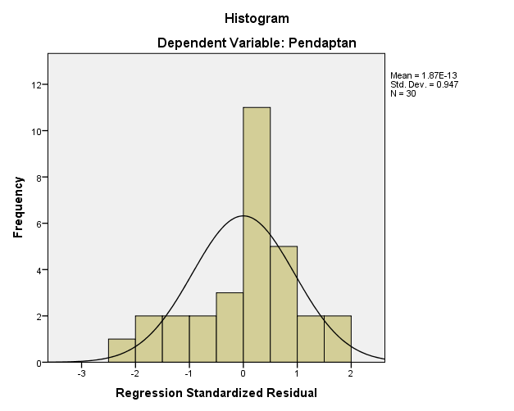

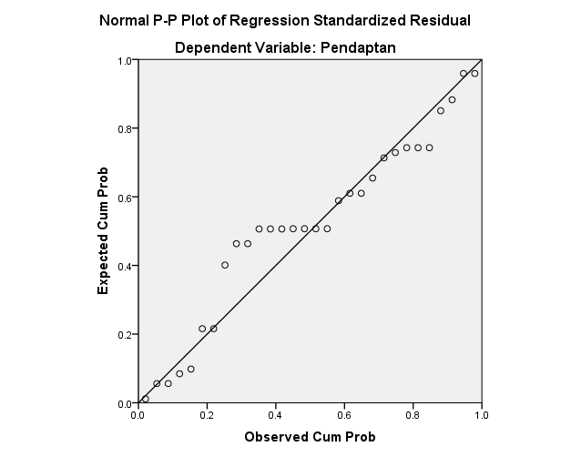

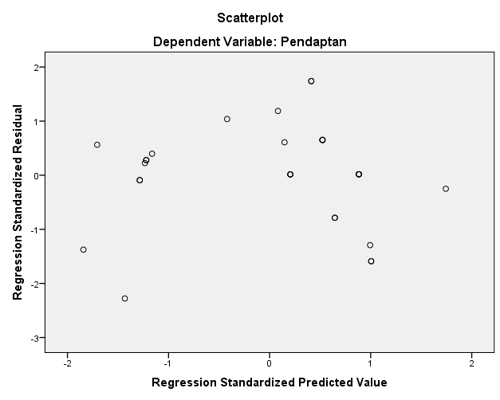

Lampiran 18. Hasil Regresi Semangka

REGRESSION
/MISSING LISTWISE
/STATISTICS COEFF OUTS R ANOVA
/CRITERIA=PIN(.05) POUT(.10)
/NOORIGIN
/DEPENDENT Ln_Y
/METHOD=ENTER Ln_X1 Ln_X2 Ln_X3 Ln_X4 Ln_X5
/SCATTERPLOT=(*ZRESID ,*ZPRED)
/RESIDUALS DURBIN HISTOGRAM(ZRESID) NORMPROB(ZRESID)
/CASEWISE PLOT(ZRESID) ALL
/SAVE RESID.

Regression

Notes
Output Created |  | 16-JUL-2020 06:31:27
Comments
Input | Active Dataset | DataSet1
 | Filter | <none>
 | Weight | <none>
 | Split File | <none>
 | N of Rows in Working Data File | 30
Missing Value Handling | Definition of Missing | User-defined missing values are treated as missing.
 | Cases Used | Statistics are based on cases with no missing values for any variable used.
Syntax |  | REGRESSION  /MISSING LISTWISE  /STATISTICS COEFF OUTS R ANOVA  /CRITERIA=PIN(.05) POUT(.10)  /NOORIGIN  /DEPENDENT Ln_Y  /METHOD=ENTER Ln_X1 Ln_X2 Ln_X3 Ln_X4 Ln_X5  /SCATTERPLOT=(*ZRESID ,*ZPRED)  /RESIDUALS DURBIN HISTOGRAM(ZRESID) NORMPROB(ZRESID)  /CASEWISE PLOT(ZRESID) ALL  /SAVE RESID.
Resources | Processor Time | 00:00:00.64
 | Elapsed Time | 00:00:00.64
 | Memory Required | 2708 bytes
 | Additional Memory Required for Residual Plots | 880 bytes
Variables Created or Modified | RES_2 | Unstandardized Residual

[DataSet1]

Variables Entered/Removedª
Model | Variables Entered | Variables Removed | Method
1 | Luas Lahan, Biaya, Pestisida, Biaya Bibit, Biaya Tenaga Kerja, Biaya Pupuk^{b} | . | Enter
a. Dependent Variable: Pendapatan
b. Tolerance = .000 limits reached.

Model Summary^{b}
Model | R | R Square | Adjusted R Square | Std. Error of the Estimate | Durbin-Watson
1 | .999ª | .998 | .998 | .03427935 | 2.177
a. Predictors: (Constant), Biaya Bibit, Biaya Tenaga Kerja, Biaya Pupuk
b. Dependent Variable: Pendapatan

ANOVAª
Model |  | Sum of Squares | df | Mean Square | F | Sig.
1 | Regression | 13.856 | 3 | 4.619 | 3930.463 | .000^{b}
 | Residual | .031 | 26 | .001
 | Total | 13.886 | 29
a. Dependent Variable: Pendapatan
b. Predictors: (Constant), Biaya Bibit, Biaya Tenaga Kerja, Biaya Pupuk

Coefficientsª
Model |  | Unstandardized Coefficients |  | Standardized Coefficients | t | Sig.
 |  | B | Std. Error | Beta
1 | (Constant) | 7.701 | 1.488 |  | 5.174 | .000
 | Luas Lahan  Biaya Tenaga Kerja | 1.389  4.352 | .071  .519 | .965  .845 | 19.465  8.378 | .013  .025
 | Biaya Pupuk  Biaya Pestisida | .936  -0.356 | .106  .025 | .857  -.745 | 8.792  -.673 | .046  .765
 | Biaya Bibit | 1.328 | .054 | 1.965 | 52.845 | .000
a. Dependent Variable: Pendapatan

Charts

