ACKNOWLEDGEMENTS

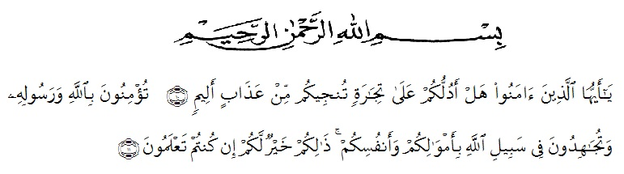

10. O ye who believe! Shall I show you a commerce that will save you from a painful doom? 11. Ye should believe in Allah and His messenger, and should strive for the cause of Allah with your wealth and your lives. That is better for you, if ye did but know.
As praise of thanks to Allah SWT, most gracious and most merciful, Firstly, I would like to thanks to the Almighty Allah SWT for all the blessing that gave to me for finishing this proposal.
Secondly, i also give my thanks because of blessing and peace be upon our Prophet Muhammad SAW, who has brought human being from the foolish era to the science era as we be held today, in completing of research, Many people given their participation such as their academic support. I realizes this thesis would not have been completed without support by family, lectures, friends and people around him while give great contibution. Therefore, in this research would like to delivery the writer’s thanks to :
- Rektor H. Hardi Mulyono, SE., M.A.P., as a Rector of Muslim Nusantara University Al Washliyah Medan.
- Drs. Samsul Bahri, M.Si., as the Dekan of the Teachers’ Training and Education Faculty of Muslim Nusantara University Al Washliyah Medan.
- Junaidi, S.Pd., M.Si., the head of the English Education Department of Muslim Nusantara University Al Washliyah Medan.
- H. Asnawi ,S.p.d, M.hum., the first consultant who give the command, critic and suggestion toward the writer in finishing the thesis.
- Wariyati, S.Pd., M.Hum., the second consultant who give the command, critic and suggestion toward the writer in finishing the thesis
- All of the lecturers of the English Education Department of Muslim Nusantara University Al Washliyah Medan.
- All of the Academic Administration Staffs of Muslim Nusantara University Al Washliyah Medan.
- All of the Librarians of Muslim Nusantara University Al Washliyah Medan.
- All her colleagues at the English department who always make her happy and many memories.
- Her dearest parents wahyono and yarni that give her spirit, support, motivation who she loves them forever and sister adelia wahyuni , young brother rahmat bintoro who give her support.

Finally, she admits that this thesis is still far from being perfect, therefore she would like to invite the readers to give some suggestions, comments, and criticism for the improvement of this thesis in the future. Furthermore, she expects it has meaningful contribution for teachers, students, and the readers.

Medan, juli 2020
The researcher

Laila Fitria

