LAMPIRAN I
Lampiran : Kuesioner
Kepada
Yth. Bapak/Ibu
Dengan hormat,

Nama saya Syakila Rama Hazlina, mahasiswa program S1 Jurusan Agribisnis Fakultas Pertanian Universitas Muslim Nuasantara Al-WASHLIYAH Medan, yang saat ini sedang menyelesaikan program skripsi. Judul penelitian saya adalah “ANALISIS PERMINTAAN DAN DISTRIBUSI PENJUALAN DAGING AYAM RAS PEDAGING (BROILER) TERHADAP PENDAPATAN PEDAGANG DI PASAR TRADISIONAL KOTA BINJAI SUMATERA UTARA”.
Penelitian ini merupakan salah satu syarat kelulusan pada jenjang S1. Berdasarkan dengan hal tersebut, saya memohon kesediaan Bapak/Ibu untuk meluangkan waktu mengisi kuesioner ini. Atas kesediannya saya ucapkan terimakasih.

Hormat Saya,

Syakila Rama Hazlina

DAFTAR PERTANYAAN KUESIONER
Bersama ini, saya mohon kesediaan Saudara/Saudari, Bapak/Ibu untuk mengisi kuesioner yang saya berikan. Informasi yang Anda berikan merupakan bantuan yang sangat berarti dalam menyelesaikan penelitian ini. Atas bantuan dan perhatian Anda berikan, saya ucapkan terima kasih.
- Data Responden
Nama :
Jenis Kelamin :
Umur :
Kuantitas Kunjungan (sebulan) :
- Pilihlah jawaban dengan memberi tanda checklist (√ ) pada salah satu jawaban yang paling sesuai menurut saudara. Adapun makna tanda tersebut adalah sebagai berikut:
- SS (Sangat Setuju) : 5 skor
- S (Setuju), : 4 skor
- CS (Cukup setuju) : 3 skor
- TS (Tidak Setuju) : 2 skor
- STS (Sangat Tidak Setuju) : 1 skor

Permintaan (X₁)
NO | PERNYATAAN | SS | S | CS | TS | STS | Ket
1. | Permintaan daging ayam di Pasar ini sangat bagus
2. | Permintaan daging ayam RAS pedaging terus meningkat
3. | Masyarakat membeli daging ayam RAS pedaging di Pasar Tradisonal Kota Binjai
4. | Permintaan daging ayam RAS pedaging sangat banyak di Pasar Tradisional Kota Binjai
5. | Konsumen membeli Ayam Ras Pedaging dengan jumlah yang banyak.

Distribusi Penjualan (X₂)
NO | PERNYATAAN | SS | S | CS | TS | STS | Ket
1. | Pedagang menjual Ayam Ras Pedaging ke semua kalangan
2. | Pasar Tradisional memiliki akses yang mudah dijangkau
3. | Kondisi jalan menuju pasar sangat baik
4. | Penjualan Ayam Ras Pedaging mengalami peningkatan.
5. | Pedagang menjual langsung ayam ras pedaging ke konsumen

Pendapatan Pedagang (Y)
NO | PERNYATAAN | SS | S | CS | TS | STS | Ket
1. | Pendapatan pedagang ayam ras pedaging mengalami peningkatan
2. | Jumlah pendapatan pedagang cukup memenuhi kebutuhan sehari-hari
3. | Jumlah rata-rata pendapatan pedagang ayam ras pedaging > 1.000.000
4. | Kisaran harga ayam ras pedaging Rp. 25.000-Rp. 30.000/Kg
5. | Pedagang mudah mendapat keuntungan dari penjualan Ayam Ras Pedaging

LAMPIRAN II

Tabulasi Data Variabel Permintaan (X₁)
No Responden | Nomor Item Peryataan |  |  |  |  | Total X₁
 | 1 | 2 | 3 | 4 | 5
1 | 4 | 4 | 4 | 5 | 4 | 21
2 | 5 | 2 | 5 | 5 | 5 | 22
3 | 4 | 3 | 3 | 4 | 4 | 18
4 | 5 | 4 | 5 | 5 | 5 | 24
5 | 5 | 4 | 5 | 4 | 4 | 22
6 | 5 | 5 | 5 | 4 | 5 | 24
7 | 4 | 3 | 3 | 3 | 5 | 18
8 | 4 | 4 | 4 | 4 | 4 | 20
9 | 5 | 5 | 5 | 5 | 5 | 25
10 | 3 | 2 | 5 | 4 | 5 | 19
11 | 4 | 4 | 5 | 5 | 4 | 22
12 | 4 | 5 | 4 | 4 | 4 | 21
13 | 4 | 4 | 4 | 4 | 5 | 21
14 | 4 | 4 | 4 | 4 | 4 | 20
15 | 5 | 5 | 5 | 5 | 5 | 25
16 | 4 | 4 | 4 | 4 | 5 | 21
17 | 3 | 4 | 4 | 4 | 4 | 19
18 | 5 | 5 | 5 | 5 | 5 | 25
19 | 4 | 4 | 5 | 5 | 5 | 23
20 | 5 | 4 | 4 | 5 | 5 | 23
21 | 4 | 4 | 4 | 4 | 4 | 20
22 | 4 | 4 | 3 | 4 | 4 | 19
23 | 5 | 5 | 4 | 5 | 4 | 23
24 | 4 | 4 | 4 | 5 | 5 | 22
25 | 5 | 5 | 3 | 5 | 4 | 22
26 | 4 | 4 | 4 | 5 | 4 | 21
27 | 5 | 4 | 3 | 4 | 5 | 21
28 | 4 | 4 | 4 | 4 | 5 | 21
29 | 4 | 4 | 4 | 4 | 4 | 20
30 | 4 | 5 | 3 | 5 | 5 | 22
31 | 5 | 5 | 5 | 4 | 3 | 22
32 | 4 | 3 | 5 | 5 | 5 | 22
33 | 4 | 4 | 5 | 4 | 4 | 21
34 | 5 | 4 | 5 | 4 | 4 | 22
35 | 4 | 4 | 4 | 3 | 5 | 20
36 | 5 | 3 | 4 | 5 | 5 | 22
37 | 5 | 5 | 5 | 5 | 4 | 24
38 | 5 | 3 | 5 | 3 | 5 | 21
39 | 4 | 4 | 5 | 3 | 4 | 20
40 | 4 | 5 | 4 | 5 | 4 | 22
41 | 4 | 4 | 4 | 5 | 4 | 21
42 | 5 | 5 | 5 | 5 | 5 | 25
43 | 4 | 3 | 4 | 3 | 3 | 17
44 | 4 | 4 | 4 | 4 | 4 | 20
 | ∑X₁ |  |  |  |  | 943

Tabulasi Data Variabel Distribusi (X₂)
No Responden | Nomor Item Peryataan |  |  |  |  | Total X₂
 | 1 | 2 | 3 | 4 | 5
1 | 4 | 4 | 3 | 5 | 5 | 21
2 | 5 | 4 | 4 | 4 | 4 | 21
3 | 5 | 5 | 3 | 4 | 4 | 21
4 | 5 | 5 | 5 | 5 | 5 | 25
5 | 5 | 4 | 4 | 4 | 4 | 21
6 | 5 | 5 | 5 | 5 | 4 | 24
7 | 4 | 4 | 3 | 3 | 3 | 17
8 | 3 | 4 | 4 | 3 | 3 | 17
9 | 5 | 4 | 4 | 4 | 4 | 21
10 | 4 | 4 | 4 | 3 | 3 | 18
11 | 5 | 5 | 5 | 4 | 4 | 23
12 | 4 | 4 | 4 | 5 | 4 | 21
13 | 5 | 5 | 4 | 4 | 4 | 22
14 | 4 | 4 | 4 | 5 | 4 | 21
15 | 5 | 5 | 5 | 5 | 5 | 25
16 | 4 | 4 | 3 | 4 | 4 | 19
17 | 4 | 4 | 4 | 4 | 4 | 20
18 | 5 | 4 | 4 | 5 | 5 | 23
19 | 4 | 4 | 4 | 4 | 4 | 20
20 | 4 | 5 | 4 | 4 | 4 | 21
21 | 5 | 4 | 4 | 4 | 4 | 21
22 | 5 | 4 | 4 | 4 | 4 | 21
23 | 5 | 5 | 4 | 5 | 5 | 24
24 | 5 | 4 | 4 | 4 | 4 | 21
25 | 5 | 5 | 5 | 4 | 4 | 23
26 | 4 | 4 | 4 | 4 | 4 | 20
27 | 5 | 4 | 4 | 4 | 4 | 21
28 | 5 | 5 | 4 | 4 | 4 | 22
29 | 4 | 4 | 4 | 4 | 4 | 20
30 | 5 | 4 | 4 | 5 | 5 | 23
31 | 5 | 5 | 4 | 5 | 5 | 24
32 | 5 | 4 | 3 | 5 | 5 | 22
33 | 4 | 5 | 4 | 5 | 5 | 23
34 | 4 | 5 | 4 | 4 | 4 | 21
35 | 4 | 3 | 3 | 5 | 5 | 20
36 | 5 | 4 | 4 | 5 | 4 | 22
37 | 5 | 4 | 5 | 4 | 5 | 23
38 | 5 | 4 | 5 | 4 | 5 | 23
39 | 5 | 4 | 4 | 5 | 5 | 23
40 | 4 | 4 | 4 | 4 | 4 | 20
41 | 4 | 3 | 4 | 5 | 5 | 21
42 | 5 | 5 | 4 | 4 | 4 | 22
43 | 4 | 5 | 4 | 4 | 5 | 22
44 | 5 | 4 | 4 | 4 | 4 | 21
 | ∑X₂ |  |  |  |  | 944

Tabulasi Data Variabel Pendapatan (Y)
No Responden | Nomor Item Peryataan |  |  |  |  | Total Y
 | 1 | 2 | 3 | 4 | 5
1 | 4 | 4 | 3 | 5 | 5 | 21
2 | 5 | 5 | 5 | 5 | 5 | 25
3 | 4 | 5 | 3 | 5 | 4 | 21
4 | 5 | 5 | 5 | 5 | 5 | 25
5 | 5 | 5 | 4 | 4 | 4 | 22
6 | 5 | 5 | 5 | 5 | 5 | 25
7 | 5 | 3 | 3 | 3 | 4 | 18
8 | 4 | 4 | 5 | 4 | 3 | 20
9 | 5 | 5 | 5 | 5 | 5 | 25
10 | 4 | 5 | 3 | 4 | 4 | 20
11 | 5 | 5 | 3 | 5 | 5 | 23
12 | 5 | 5 | 3 | 5 | 4 | 22
13 | 5 | 5 | 4 | 5 | 4 | 23
14 | 5 | 5 | 3 | 4 | 4 | 21
15 | 5 | 5 | 5 | 5 | 5 | 25
16 | 4 | 5 | 5 | 4 | 4 | 22
17 | 4 | 3 | 5 | 5 | 4 | 21
18 | 5 | 5 | 5 | 5 | 5 | 25
19 | 5 | 5 | 5 | 4 | 4 | 23
20 | 5 | 4 | 4 | 5 | 5 | 23
21 | 4 | 5 | 5 | 4 | 4 | 22
22 | 4 | 5 | 4 | 5 | 3 | 21
23 | 5 | 4 | 5 | 5 | 5 | 24
24 | 5 | 4 | 4 | 5 | 4 | 22
25 | 5 | 5 | 5 | 4 | 4 | 23
26 | 5 | 5 | 4 | 4 | 4 | 22
27 | 4 | 5 | 5 | 4 | 4 | 22
28 | 5 | 5 | 5 | 4 | 5 | 24
29 | 4 | 4 | 4 | 4 | 4 | 20
30 | 5 | 3 | 5 | 5 | 5 | 23
31 | 5 | 5 | 5 | 5 | 5 | 25
32 | 5 | 5 | 5 | 4 | 4 | 23
33 | 4 | 5 | 5 | 5 | 4 | 23
34 | 5 | 5 | 4 | 5 | 4 | 23
35 | 3 | 5 | 3 | 5 | 4 | 20
36 | 4 | 5 | 5 | 3 | 5 | 22
37 | 5 | 5 | 5 | 5 | 5 | 25
38 | 5 | 5 | 5 | 4 | 4 | 23
39 | 5 | 5 | 5 | 5 | 4 | 24
40 | 5 | 5 | 4 | 5 | 4 | 23
41 | 5 | 5 | 5 | 3 | 4 | 22
42 | 5 | 5 | 5 | 5 | 5 | 25
43 | 5 | 4 | 5 | 4 | 5 | 23
44 | 4 | 4 | 5 | 5 | 4 | 22
 | ∑Y |  |  |  |  | 996

LAMPIRAN III
Profil Pedagang Pengecer Ayam Broiler
No. | Nama | Jenis kelamin | Umur | Pendidikan | Pengalaman usaha (tahun)
1 | Bambang | P | 35 | SMA | 5
2 | Dewi | W | 32 | SD | 5
3 | Dedi Siregar | P | 33 | SMA | 5
4 | Ade Rizky | P | 30 | SMA | 3
5 | Sori | P | 35 | SD | 4
6 | Syafitri | W | 34 | SMA | 12
7 | Agus | P | 35 | SMP | 11
8 | M Rusli | P | 34 | SMA | 10
9 | Fitri | W | 31 | SMP | 20
10 | Sahyuti | P | 33 | SMA | 7
11 | Darmadi | P | 33 | SMA | 9
12 | Dini | W | 32 | SMP | 8
13 | Darwin | P | 34 | SMP | 6
14 | Wulan | W | 34 | SMA | 7
15 | Ardina | W | 49 | SMP | 13
16 | Maulana | P | 52 | SMA | 18
17 | Amrizal | P | 49 | SMP | 9
18 | Suri | W | 39 | SMA | 6
19 | Arman | P | 35 | SMA | 5
20 | Rina | W | 33 | SMA | 5
21 | Riko Regar | P | 37 | SMP | 5
22 | Suherman | P | 48 | SMP | 12
23 | Indah | W | 43 | SMA | 11
24 | Sulastri | W | 50 | SD | 20
25 | Srimurni | W | 47 | SMP | 12
26 | Riswanda | P | 51 | SMP | 19
27 | Faisal Darma | P | 39 | SMA | 8
28 | Romlah | W | 46 | SD | 12
29 | Andre | P | 47 | SMP | 11
30 | Sukarman | P | 49 | SMA | 10
31 | Asril | P | 47 | SMA | 9
32 | Ahyar Nst | P | 42 | SMP | 10
33 | Sri Murni | W | 43 | SMA | 10
34 | Sabrina | W | 38 | SMA | 6
35 | Ameliarosa | W | 27 | SMA | 8
36 | Desi Astuti | W | 52 | SMP | 17
37 | Ardiansyah | P | 50 | SMP | 19
38 | Amhar | W | 36 | SMA | 8
39 | Muh.Hasan | P | 39 | SMA | 12
40 | Adi | P | 27 | SMA | 10
41 | Suri | W | 42 | SMA | 12
42 | Anto | W | 28 | SMP | 20
43 | Mutia | W | 43 | SMP | 20
44 | Rima | P | 30 | SMA | 12

LAMPIRAN IV

Regression

Notes
Output Created |  | 02-AUG-2020 21:29:47
Comments
Input | Active Dataset | DataSet0
 | Filter | <none>
 | Weight | <none>
 | Split File | <none>
 | N of Rows in Working Data File | 95
Missing Value Handling | Definition of Missing | User-defined missing values are treated as missing.
 | Cases Used | Statistics are based on cases with no missing values for any variable used.
Syntax |  | REGRESSION  /DESCRIPTIVES MEAN STDDEV CORR SIG N  /MISSING LISTWISE  /STATISTICS COEFF OUTS R ANOVA COLLIN TOL CHANGE ZPP  /CRITERIA=PIN(.05) POUT(.10)  /NOORIGIN  /DEPENDENT Y  /METHOD=ENTER X1 X2  /SCATTERPLOT=(*ZRESID ,*ZPRED)  /RESIDUALS DURBIN HISTOGRAM(ZRESID) NORMPROB(ZRESID)  /CASEWISE PLOT(ZRESID) ALL  /SAVE RESID.
Resources | Processor Time | 00:00:01.89
 | Elapsed Time | 00:00:13.37
 | Memory Required | 1644 bytes
 | Additional Memory Required for Residual Plots | 904 bytes
Variables Created or Modified | RES_1 | Unstandardized Residual

[DataSet0]

Descriptive Statistics
 | Mean | Std. Deviation | N
Pendapatan | 32.99 | 9.803 | 95
Permintaan | 30.89 | 9.044 | 95
Distribusi | 31.36 | 9.436 | 95

Correlations
 |  | Pendapatan | Permintaan | Distribusi
Pearson Correlation | Pendapatan | 1.000 | .984 | .989
 | Permintaan | .984 | 1.000 | .972
 | Distribusi | .989 | .972 | 1.000
Sig. (1-tailed) | Pendapatan | . | .000 | .000
 | Permintaan | .000 | . | .000
 | Distribusi | .000 | .000 | .
N | Pendapatan | 95 | 95 | 95
 | Permintaan | 95 | 95 | 95
 | Distribusi | 95 | 95 | 95

Variables Entered/Removedª
Model | Variables Entered | Variables Removed | Method
1 | Distribusi, Permintaan^{b} | . | Enter
a. Dependent Variable: Pendapatan
b. All requested variables entered.

Model Summary^{b}
Model | R | R Square | Adjusted R Square | Std. Error of the Estimate | Change Statistics |  |  |  |  | Durbin-Watson
 |  |  |  |  | R Square Change | F Change | df1 | df2 | Sig. F Change
1 | .993ª | .987 | .987 | 1.134 | .987 | 3465.448 | 2 | 92 | .000 | 2.414
a. Predictors: (Constant), Distribusi, Permintaan
b. Dependent Variable: Pendapatan

ANOVAª
Model |  | Sum of Squares | df | Mean Square | F | Sig.
1 | Regression | 8914.657 | 2 | 4457.329 | 3465.448 | .000^{b}
 | Residual | 118.332 | 92 | 1.286
 | Total | 9032.989 | 94
a. Dependent Variable: Pendapatan
b. Predictors: (Constant), Distribusi, Permintaan

Coefficientsª
Model |  | Unstandardized Coefficients |  | Standardized Coefficients | t | Sig. | Correlations |  |  | Collinearity Statistics
 |  | B | Std. Error | Beta |  |  | Zero-order | Partial | Part | Tolerance | VIF
1 | (Constant) | .028 | .416 |  | .067 | .947
 | Permintaan | .450 | .055 | .415 | 8.160 | .000 | .984 | .648 | .097 | .055 | 18.193
 | Distribusi | .608 | .053 | .585 | 11.492 | .000 | .989 | .768 | .137 | .055 | 18.193
a. Dependent Variable: Pendapatan

Collinearity Diagnosticsª
Model | Dimension | Eigenvalue | Condition Index | Variance Proportions
 |  |  |  | (Constant) | Permintaan | Distribusi
1 | 1 | 2.944 | 1.000 | .01 | .00 | .00
 | 2 | .054 | 7.401 | .98 | .01 | .01
 | 3 | .002 | 36.310 | .01 | .99 | .98
a. Dependent Variable: Pendapatan

Casewise Diagnosticsª
Case Number | Std. Residual | Pendapatan | Predicted Value | Residual
1 | -1.095 | 21 | 22.24 | -1.242
2 | 2.035 | 25 | 22.69 | 2.308
3 | .096 | 21 | 20.89 | .109
4 | -.902 | 25 | 26.02 | -1.023
5 | -.610 | 22 | 22.69 | -.692
6 | -.366 | 25 | 25.41 | -.415
7 | -.406 | 18 | 18.46 | -.461
8 | .564 | 20 | 19.36 | .639
9 | .845 | 25 | 24.04 | .958
10 | .425 | 20 | 19.52 | .482
11 | -.800 | 23 | 23.91 | -.907
12 | -.213 | 22 | 22.24 | -.242
13 | .133 | 23 | 22.85 | .151
14 | -.698 | 21 | 21.79 | -.791
15 | -1.299 | 25 | 26.47 | -1.473
16 | .859 | 22 | 21.03 | .974
17 | .235 | 21 | 20.73 | .266
18 | -.227 | 25 | 25.26 | -.257
19 | .411 | 23 | 22.53 | .466
20 | -.125 | 23 | 23.14 | -.142
21 | .184 | 22 | 21.79 | .209
22 | -.301 | 21 | 21.34 | -.341
23 | -.851 | 24 | 24.96 | -.965
24 | -.610 | 22 | 22.69 | -.692
25 | -.800 | 23 | 23.91 | -.907
26 | .323 | 22 | 21.63 | .366
27 | -.213 | 22 | 22.24 | -.242
28 | 1.015 | 24 | 22.85 | 1.151
29 | -1.044 | 20 | 21.18 | -1.184
30 | -.800 | 23 | 23.91 | -.907
31 | .428 | 25 | 24.51 | .485
32 | -.264 | 23 | 23.30 | -.299
33 | -.403 | 23 | 23.46 | -.457
34 | .272 | 23 | 22.69 | .308
35 | -1.044 | 20 | 21.18 | -1.184
36 | -1.146 | 22 | 23.30 | -1.299
37 | .170 | 25 | 24.81 | .193
38 | -.403 | 23 | 23.46 | -.457
39 | .876 | 24 | 23.01 | .993
40 | .808 | 23 | 22.08 | .916
41 | -.213 | 22 | 22.24 | -.242
42 | .309 | 25 | 24.65 | .350
43 | 1.721 | 23 | 21.05 | 1.951
44 | .184 | 22 | 21.79 | .209
45 | -.160 | 42 | 42.18 | -.182
46 | 1.654 | 43 | 41.12 | 1.876
47 | -1.473 | 44 | 45.67 | -1.670
48 | 2.017 | 46 | 43.71 | 2.288
49 | -.041 | 42 | 42.05 | -.047
50 | .702 | 43 | 42.20 | .796
51 | 1.793 | 43 | 40.97 | 2.033
52 | .375 | 42 | 41.57 | .426
53 | -.784 | 41 | 41.89 | -.889
54 | -.059 | 40 | 40.07 | -.066
55 | .273 | 44 | 43.69 | .310
56 | -1.907 | 42 | 44.16 | -2.162
57 | -.092 | 43 | 43.10 | -.105
58 | .236 | 42 | 41.73 | .268
59 | -1.975 | 41 | 43.24 | -2.240
60 | -.798 | 44 | 44.91 | -.905
61 | .356 | 42 | 41.60 | .403
62 | -.696 | 42 | 42.79 | -.790
63 | .979 | 43 | 41.89 | 1.111
64 | -1.025 | 43 | 44.16 | -1.162
65 | -.631 | 38 | 38.72 | -.716
66 | .135 | 44 | 43.85 | .153
67 | -.645 | 41 | 41.73 | -.732
68 | 2.726 | 43 | 39.91 | 3.091
69 | -1.371 | 42 | 43.55 | -1.555
70 | 2.309 | 43 | 40.38 | 2.619
71 | .010 | 41 | 40.99 | .011
72 | -.438 | 42 | 42.50 | -.497
73 | -.628 | 43 | 43.71 | -.712
74 | 1.844 | 42 | 39.91 | 2.091
75 | -.299 | 42 | 42.34 | -.339
76 | 2.567 | 43 | 40.09 | 2.911
77 | -.631 | 38 | 38.72 | -.716
78 | 1.824 | 42 | 39.93 | 2.069
79 | -.631 | 38 | 38.72 | -.716
80 | .061 | 40 | 39.93 | .069
81 | -.784 | 41 | 41.89 | -.889
82 | -.594 | 40 | 40.67 | -.674
83 | 1.427 | 42 | 40.38 | 1.619
84 | .582 | 43 | 42.34 | .661
85 | 1.081 | 41 | 39.77 | 1.226
86 | -1.578 | 41 | 42.79 | -1.790
87 | -.336 | 40 | 40.38 | -.381
88 | .149 | 41 | 40.83 | .168
89 | -1.578 | 41 | 42.79 | -1.790
90 | -.438 | 42 | 42.50 | -.497
91 | -1.578 | 41 | 42.79 | -1.790
92 | .651 | 44 | 43.26 | .738
93 | -.248 | 41 | 41.28 | -.282
94 | .305 | 43 | 42.65 | .346
95 | .305 | 43 | 42.65 | .346
a. Dependent Variable: Pendapatan

Residuals Statisticsª
 | Minimum | Maximum | Mean | Std. Deviation | N
Predicted Value | 18.46 | 45.67 | 32.99 | 9.738 | 95
Residual | -2.240 | 3.091 | .000 | 1.122 | 95
Std. Predicted Value | -1.492 | 1.302 | .000 | 1.000 | 95
Std. Residual | -1.975 | 2.726 | .000 | .989 | 95
a. Dependent Variable: Pendapatan

Charts

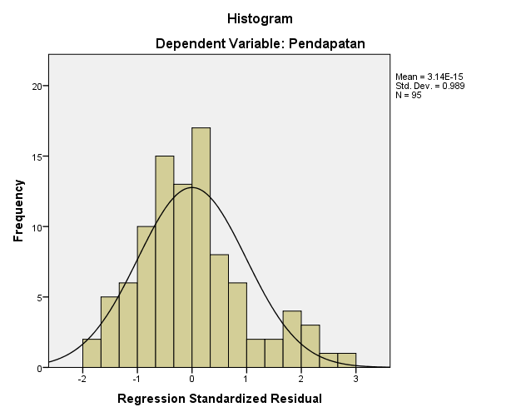

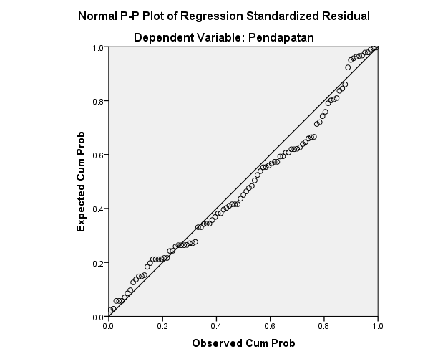

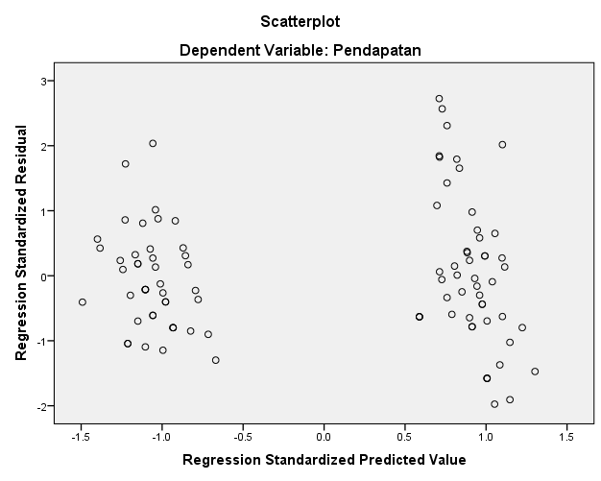

REGRESSION
/DESCRIPTIVES MEAN STDDEV CORR SIG N
/MISSING LISTWISE
/STATISTICS COEFF OUTS R ANOVA COLLIN TOL CHANGE ZPP
/CRITERIA=PIN(.05) POUT(.10)
/NOORIGIN
/DEPENDENT Y
/METHOD=ENTER X1 X2
/SCATTERPLOT=(*ZRESID ,*ZPRED)
/RESIDUALS DURBIN HISTOGRAM(ZRESID) NORMPROB(ZRESID)
/CASEWISE PLOT(ZRESID) ALL
/SAVE RESID.

