**LAMPIRAN I**

**DAFTAR PERTANYAAN KUESIONER**

**Petunjuk Pengisian**

Pertanyaan terdiri dari 2 tipe, yaitu pertanyaan A dan B. Pertanyaan A merupakan pertanyaan umum. Bapak /Ibu dapat mengisi titik-titik yang telah disediakan, Pertanyaan B merupakan pertanyaan khusus dimana telah diberikan 5 macam pilihan jawaban yaitu;

1. SS (Sangat Setuju) : 5 skor
2. S (Setuju), : 4 skor
3. CS (Cukup setuju) : 3 skor
4. TS (Tidak Setuju) : 2 skor
5. STS (Sangat Tidak Setuju) : 1 skor

Berilah tanda silang (X) pada kolom jawaban yang Bapak/Ibu anggap paling tepat.

1. **Identitas Petani**
2. Nama :
3. Umur :
4. Alamat :
5. Kelompok Tani :
6. Pendidikan :
7. Pekerjaan utama :
8. Jumlah keluarga :
9. Pengalaman bertani :
10. Mulai menjadi anggota :

1. **Pertanyaan Khusus**
2. **Variabel Persepsi Petani (Petani)|**

|  |  |  |  |  |  |  |  |
| --- | --- | --- | --- | --- | --- | --- | --- |
| **No** | **PERTANYAAN** | **SS** | **S** | **CS** | **TS** | **STS** | **Ket** |
|  |  |  |  |  |  |  |  |
| **Individu Bersangkutan** | |  |  |  |  |  |  |
| 1. | Petani puas dengan kegiatan yang dilakukan oleh Gapoktan |  |  |  |  |  |  |
| 2. | Petani sangat terbantu dengan adanya Gapoktan |  |  |  |  |  |  |
| 3. | Petani senang dengan gapoktan yang dijalankan |  |  |  |  |  |  |
| **Sarana Dari Persepsi** | |  |  |  |  |  |  |
| 4. | Petani sangat terbantu dengan sarana yang disediakan |  |  |  |  |  |  |
| 5. | Petani selalu menggunakan sarana yang disediakan Gapoktan |  |  |  |  |  |  |
| **Pelayanan** | |  |  |  |  |  |  |
| 6. | Petani puas dengan pelayanan yang diberikan |  |  |  |  |  |  |
| 7. | Petani berniat untuk membantu mengembangkan pelayanan gapoktan agar terus berkembang. |  |  |  |  |  |  |
| **Situasi** | |  |  |  |  |  |  |
| 8. | Petani berharap kerjasama kepada Koperasi/Gapoktan bisa bejalan dengan baik |  |  |  |  |  |  |
| 9. | Petani memahami situasi yang hadapi Gapoktan |  |  |  |  |  |  |
| 10. | Petani memanfaatkan situasi untuk menambah ilmu dengan adanya gapoktan. |  |  |  |  |  |  |

1. **Gapoktan (Y)**

|  |  |  |  |  |  |  |  |
| --- | --- | --- | --- | --- | --- | --- | --- |
| **No** | **PERTANYAAN** | **SS** | **S** | **CS** | **TS** | **STS** | **Ket** |
|  |  |  |  |  |  |  |  |
| **Unit Usaha Distribusi** | |  |  |  |  |  |  |
| 1. | Gapoktan sangat membantu petani dalam melakukan usaha distribusi |  |  |  |  |  |  |
| 2. | Pupuk subsidi terdistribusi dengan baik |  |  |  |  |  |  |
| 3. | Petani terbantu mendistribusikan hasil usaha taninya dengan adanya gapoktan |  |  |  |  |  |  |
| **Unit Usaha Pengolahan** | |  |  |  |  |  |  |
| 4. | Usaha tani di olah dengan baik oleh gapoktan. |  |  |  |  |  |  |
| 5. | Uni usaha pengolahan gapoktan sangat membantu petani |  |  |  |  |  |  |
| 6. | Unit usaha gapoktan dapat membantu petani dalam mengolah hasil produksinya. |  |  |  |  |  |  |
| **Unit Pengelola Cadangan Pangan** | |  |  |  |  |  |  |
| 7 | Unit Pengelola Gapoktan membantu menyimpan cadangan hasil panen petani agar tidak terjadi kekurangan pangan di Desa Panji Sibura Bura Batang Beru Kecamatan Sidikalang Kabupaten Dairi. |  |  |  |  |  |  |
| 8 | Unit Pengelola Gapoktan sangat membantu petani. |  |  |  |  |  |  |
| **Sentra Produksi Pangan** | |  |  |  |  |  |  |
| 9 | Petani terbantu dengan adanya lembaga distribusi dalam penyediaan pupuk subsidi |  |  |  |  |  |  |
| 10 | Gapoktan sangat berperan aktif dalam mengelola hasil produksi petani. |  |  |  |  |  |  |

Terima kasih atas segala bantuan yang Bapak /Ibu berikan.

**Lampiran 2. Hasil Regresi**

REGRESSION

/DESCRIPTIVES MEAN STDDEV CORR SIG N

/MISSING LISTWISE

/STATISTICS COEFF OUTS R ANOVA COLLIN TOL CHANGE ZPP

/CRITERIA=PIN(.05) POUT(.10)

/NOORIGIN

/DEPENDENT Y

/METHOD=ENTER X

/SCATTERPLOT=(*ZRESID ,*ZPRED)

/RESIDUALS DURBIN HISTOGRAM(ZRESID) NORMPROB(ZRESID)

/CASEWISE PLOT(ZRESID) ALL

/SAVE RESID.

**Regression**

|  |  |  |
| --- | --- | --- |
| **Notes** | | |
| Output Created | | 11-JUL-2020 21:49:48 |
| Comments | |  |
| Input | Active Dataset | DataSet0 |
| Filter | <none> |
| Weight | <none> |
| Split File | <none> |
| N of Rows in Working Data File | 30 |
| Missing Value Handling | Definition of Missing | User-defined missing values are treated as missing. |
| Cases Used | Statistics are based on cases with no missing values for any variable used. |
| Syntax | | REGRESSION  /DESCRIPTIVES MEAN STDDEV CORR SIG N  /MISSING LISTWISE  /STATISTICS COEFF OUTS R ANOVA COLLIN TOL CHANGE ZPP  /CRITERIA=PIN(.05) POUT(.10)  /NOORIGIN  /DEPENDENT Y  /METHOD=ENTER X  /SCATTERPLOT=(*ZRESID ,*ZPRED)  /RESIDUALS DURBIN HISTOGRAM(ZRESID) NORMPROB(ZRESID)  /CASEWISE PLOT(ZRESID) ALL  /SAVE RESID. |
| Resources | Processor Time | 00:00:02.40 |
| Elapsed Time | 00:00:02.31 |
| Memory Required | 1356 bytes |
| Additional Memory Required for Residual Plots | 912 bytes |
| Variables Created or Modified | RES_1 | Unstandardized Residual |

[DataSet0]

|  |  |  |  |
| --- | --- | --- | --- |
| **Descriptive Statistics** | | | |
|  | Mean | Std. Deviation | N |
| Gakpoktan | 42.63 | 6.662 | 30 |
| Persepsi Petani | 40.37 | 8.028 | 30 |

|  |  |  |  |
| --- | --- | --- | --- |
| **Correlations** | | | |
|  | | Gakpoktan | Persepsi Petani |
| Pearson Correlation | Gakpoktan | 1.000 | .661 |
| Persepsi Petani | .661 | 1.000 |
| Sig. (1-tailed) | Gakpoktan | . | .000 |
| Persepsi Petani | .000 | . |
| N | Gakpoktan | 30 | 30 |
| Persepsi Petani | 30 | 30 |

|  |  |  |  |
| --- | --- | --- | --- |
| **Variables Entered/Removeda** | | | |
| Model | Variables Entered | Variables Removed | Method |
| 1 | Persepsi Petanib | . | Enter |
| a. Dependent Variable: Gakpoktan | | | |
| b. All requested variables entered. | | | |

|  |  |  |  |  |
| --- | --- | --- | --- | --- |
| **Model Summaryb** | | | | |
| Model | R | R Square | Adjusted R Square | Std. Error of the Estimate | |
|
| 1 | .661a | .437 | .417 | 5.088 | |
| a. Predictors: (Constant), Persepsi Petani | | | | |
| b. Dependent Variable: Gakpoktan | | | | |

|  |  |  |  |  |  |  |
| --- | --- | --- | --- | --- | --- | --- |
| **ANOVAa** | | | | | | |
| Model | | Sum of Squares | df | Mean Square | F | Sig. |
| 1 | Regression | 562.179 | 1 | 562.179 | 21.718 | .000b |
| Residual | 724.788 | 28 | 25.885 |  |  |
| Total | 1286.967 | 29 |  |  |  |
| a. Dependent Variable: Gakpoktan | | | | | | |
| b. Predictors: (Constant), Persepsi Petani | | | | | | |

|  |  |  |  |  |  |  |
| --- | --- | --- | --- | --- | --- | --- |
| **Coefficientsa** | | | | | | |
| Model | | Unstandardized Coefficients | | Standardized Coefficients | t | Sig. | |
| B | Std. Error | Beta |
| 1 | (Constant) | 20.494 | 4.841 |  | 4.234 | .000 | |
| Persepsi Petani | .548 | .118 | .661 | 4.660 | .000 | |
| a. Dependent Variable: Gakpoktan | | | | | | |

|  |  |  |  |  |  |
| --- | --- | --- | --- | --- | --- |
| **Collinearity Diagnosticsa** | | | | | |
| Model | Dimension | Eigenvalue | Condition Index | Variance Proportions | |
| (Constant) | Persepsi Petani |
| 1 | 1 | 1.981 | 1.000 | .01 | .01 |
| 2 | .019 | 10.325 | .99 | .99 |
| a. Dependent Variable: Gakpoktan | | | | | |

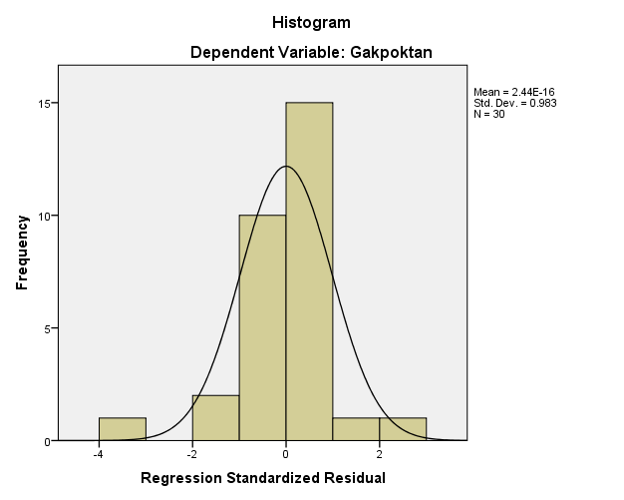

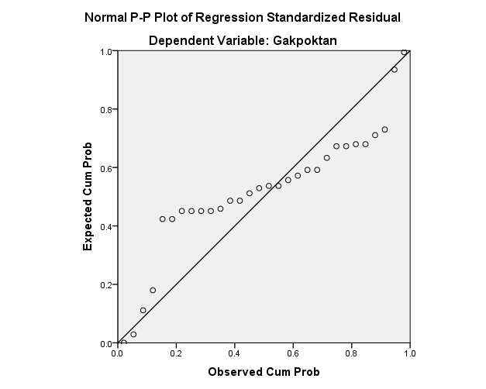

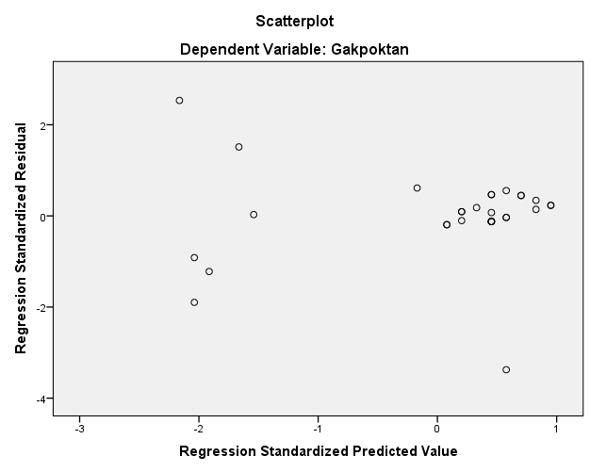

**Lampiran 3. Tabulasi Penelitian**

**Tabulasi Data Variabel Persepsi Petani (X)**

|  |  |  |  |  |  |  |  |  |  |  |  |
| --- | --- | --- | --- | --- | --- | --- | --- | --- | --- | --- | --- |
| **No Responden** | **Nomor Item Pernyataan** | | | | | | | | | | **Jumlah** |
| 1 | 2 | 3 | 4 | 5 | 6 | 7 | 8 | 9 | 10 |
| 1 | 4 | 5 | 4 | 5 | 5 | 4 | 5 | 5 | 4 | 4 | 45 |
| 2 | 4 | 4 | 5 | 5 | 4 | 5 | 4 | 5 | 4 | 4 | 44 |
| 3 | 3 | 3 | 3 | 2 | 2 | 2 | 2 | 2 | 2 | 2 | 23 |
| 4 | 4 | 5 | 5 | 5 | 5 | 5 | 5 | 5 | 4 | 5 | 48 |
| 5 | 5 | 4 | 4 | 5 | 4 | 5 | 5 | 5 | 4 | 4 | 45 |
| 6 | 5 | 4 | 5 | 4 | 5 | 4 | 5 | 5 | 5 | 5 | 47 |
| 7 | 3 | 2 | 3 | 3 | 3 | 2 | 3 | 2 | 2 | 2 | 25 |
| 8 | 4 | 5 | 5 | 4 | 5 | 5 | 4 | 5 | 4 | 5 | 46 |
| 9 | 5 | 4 | 4 | 4 | 5 | 5 | 5 | 4 | 5 | 4 | 45 |
| 10 | 4 | 4 | 4 | 5 | 4 | 4 | 5 | 4 | 4 | 5 | 43 |
| 11 | 2 | 2 | 2 | 3 | 2 | 2 | 3 | 3 | 3 | 2 | 24 |
| 12 | 2 | 2 | 3 | 3 | 3 | 3 | 2 | 2 | 2 | 2 | 24 |
| 13 | 4 | 5 | 4 | 5 | 4 | 4 | 4 | 5 | 5 | 4 | 44 |
| 14 | 4 | 5 | 4 | 4 | 5 | 5 | 5 | 5 | 4 | 5 | 46 |
| 15 | 5 | 5 | 5 | 4 | 4 | 5 | 5 | 4 | 5 | 5 | 47 |
| 16 | 5 | 4 | 4 | 4 | 3 | 4 | 5 | 5 | 5 | 3 | 42 |
| 17 | 4 | 2 | 4 | 5 | 5 | 2 | 5 | 4 | 4 | 4 | 39 |
| 18 | 5 | 5 | 5 | 4 | 5 | 5 | 4 | 5 | 5 | 5 | 48 |
| 19 | 4 | 5 | 4 | 4 | 4 | 5 | 4 | 5 | 5 | 4 | 44 |
| 20 | 3 | 2 | 3 | 3 | 3 | 3 | 2 | 3 | 3 | 3 | 28 |
| 21 | 5 | 5 | 4 | 4 | 4 | 5 | 4 | 4 | 5 | 4 | 44 |
| 22 | 4 | 5 | 5 | 4 | 4 | 4 | 4 | 5 | 4 | 5 | 44 |
| 23 | 4 | 5 | 4 | 4 | 4 | 5 | 4 | 5 | 5 | 4 | 44 |
| 24 | 4 | 4 | 4 | 5 | 4 | 4 | 5 | 4 | 3 | 5 | 42 |
| 25 | 4 | 5 | 5 | 4 | 4 | 4 | 3 | 5 | 4 | 3 | 41 |
| 26 | 4 | 5 | 2 | 5 | 4 | 5 | 5 | 2 | 5 | 5 | 42 |
| 27 | 5 | 4 | 4 | 5 | 4 | 4 | 5 | 5 | 4 | 4 | 44 |
| 28 | 3 | 2 | 3 | 3 | 3 | 2 | 3 | 3 | 3 | 2 | 27 |
| 29 | 4 | 4 | 5 | 5 | 5 | 5 | 4 | 5 | 4 | 4 | 45 |
| 30 | 5 | 5 | 3 | 4 | 4 | 3 | 5 | 3 | 5 | 4 | 41 |
|  | ∑X | | | | | | | | | | 1211 |

Sumber : Data Penelitian Diolah (2021)

**Tabulasi Data Variabel Gapoktan (Y)**

|  |  |  |  |  |  |  |  |  |  |  |  |
| --- | --- | --- | --- | --- | --- | --- | --- | --- | --- | --- | --- |
| **No Responden** | **Nomor Item Pernyataan** | | | | | | | | | | **Jumlah** |
| 1 | 2 | 3 | 4 | 5 | 6 | 7 | 8 | 9 | 10 |
| 1 | 5 | 5 | 4 | 5 | 5 | 5 | 4 | 5 | 5 | 5 | 48 |
| 2 | 5 | 4 | 5 | 5 | 5 | 5 | 5 | 4 | 5 | 4 | 47 |
| 3 | 4 | 4 | 5 | 4 | 5 | 5 | 5 | 4 | 5 | 5 | 46 |
| 4 | 5 | 5 | 4 | 5 | 4 | 5 | 5 | 5 | 5 | 5 | 48 |
| 5 | 3 | 3 | 2 | 2 | 3 | 3 | 4 | 4 | 2 | 2 | 28 |
| 6 | 4 | 5 | 5 | 5 | 5 | 5 | 4 | 5 | 5 | 5 | 48 |
| 7 | 3 | 2 | 3 | 3 | 3 | 3 | 2 | 3 | 3 | 3 | 28 |
| 8 | 5 | 5 | 5 | 5 | 4 | 5 | 5 | 5 | 4 | 5 | 48 |
| 9 | 5 | 5 | 5 | 4 | 5 | 5 | 5 | 4 | 3 | 4 | 45 |
| 10 | 4 | 5 | 5 | 5 | 4 | 4 | 5 | 5 | 5 | 3 | 45 |
| 11 | 3 | 3 | 2 | 3 | 3 | 2 | 2 | 2 | 2 | 2 | 24 |
| 12 | 3 | 2 | 3 | 3 | 3 | 3 | 3 | 3 | 3 | 3 | 29 |
| 13 | 4 | 5 | 5 | 5 | 5 | 5 | 5 | 5 | 4 | 4 | 47 |
| 14 | 4 | 5 | 5 | 5 | 5 | 5 | 5 | 4 | 5 | 5 | 48 |
| 15 | 5 | 5 | 5 | 5 | 5 | 5 | 4 | 5 | 4 | 4 | 47 |
| 16 | 5 | 5 | 4 | 2 | 4 | 5 | 5 | 5 | 5 | 3 | 43 |
| 17 | 4 | 5 | 5 | 5 | 5 | 5 | 3 | 4 | 5 | 4 | 45 |
| 18 | 5 | 4 | 5 | 5 | 4 | 5 | 5 | 5 | 5 | 5 | 48 |
| 19 | 5 | 5 | 5 | 3 | 5 | 5 | 5 | 5 | 3 | 4 | 45 |
| 20 | 2 | 2 | 3 | 5 | 3 | 5 | 3 | 3 | 5 | 5 | 36 |
| 21 | 5 | 5 | 5 | 5 | 5 | 5 | 2 | 4 | 5 | 3 | 44 |
| 22 | 5 | 4 | 5 | 5 | 5 | 4 | 5 | 4 | 3 | 4 | 44 |
| 23 | 5 | 4 | 5 | 4 | 5 | 5 | 3 | 5 | 5 | 3 | 44 |
| 24 | 4 | 3 | 5 | 3 | 5 | 5 | 4 | 5 | 5 | 5 | 44 |
| 25 | 5 | 5 | 5 | 5 | 3 | 5 | 2 | 5 | 3 | 4 | 42 |
| 26 | 5 | 4 | 4 | 2 | 5 | 5 | 5 | 4 | 5 | 5 | 44 |
| 27 | 4 | 5 | 5 | 4 | 4 | 3 | 5 | 5 | 5 | 4 | 44 |
| 28 | 4 | 5 | 3 | 5 | 5 | 5 | 4 | 5 | 3 | 4 | 43 |
| 29 | 5 | 5 | 4 | 4 | 4 | 5 | 5 | 3 | 5 | 5 | 45 |
| 30 | 3 | 5 | 5 | 5 | 5 | 5 | 3 | 4 | 3 | 4 | 42 |
|  | ∑Y | | | | | | | | | | 1279 |

Sumber : Data Penelitian Diolah (2021)