Lampiran 1. Hasil Identifikasi Tanaman Daun Afrika
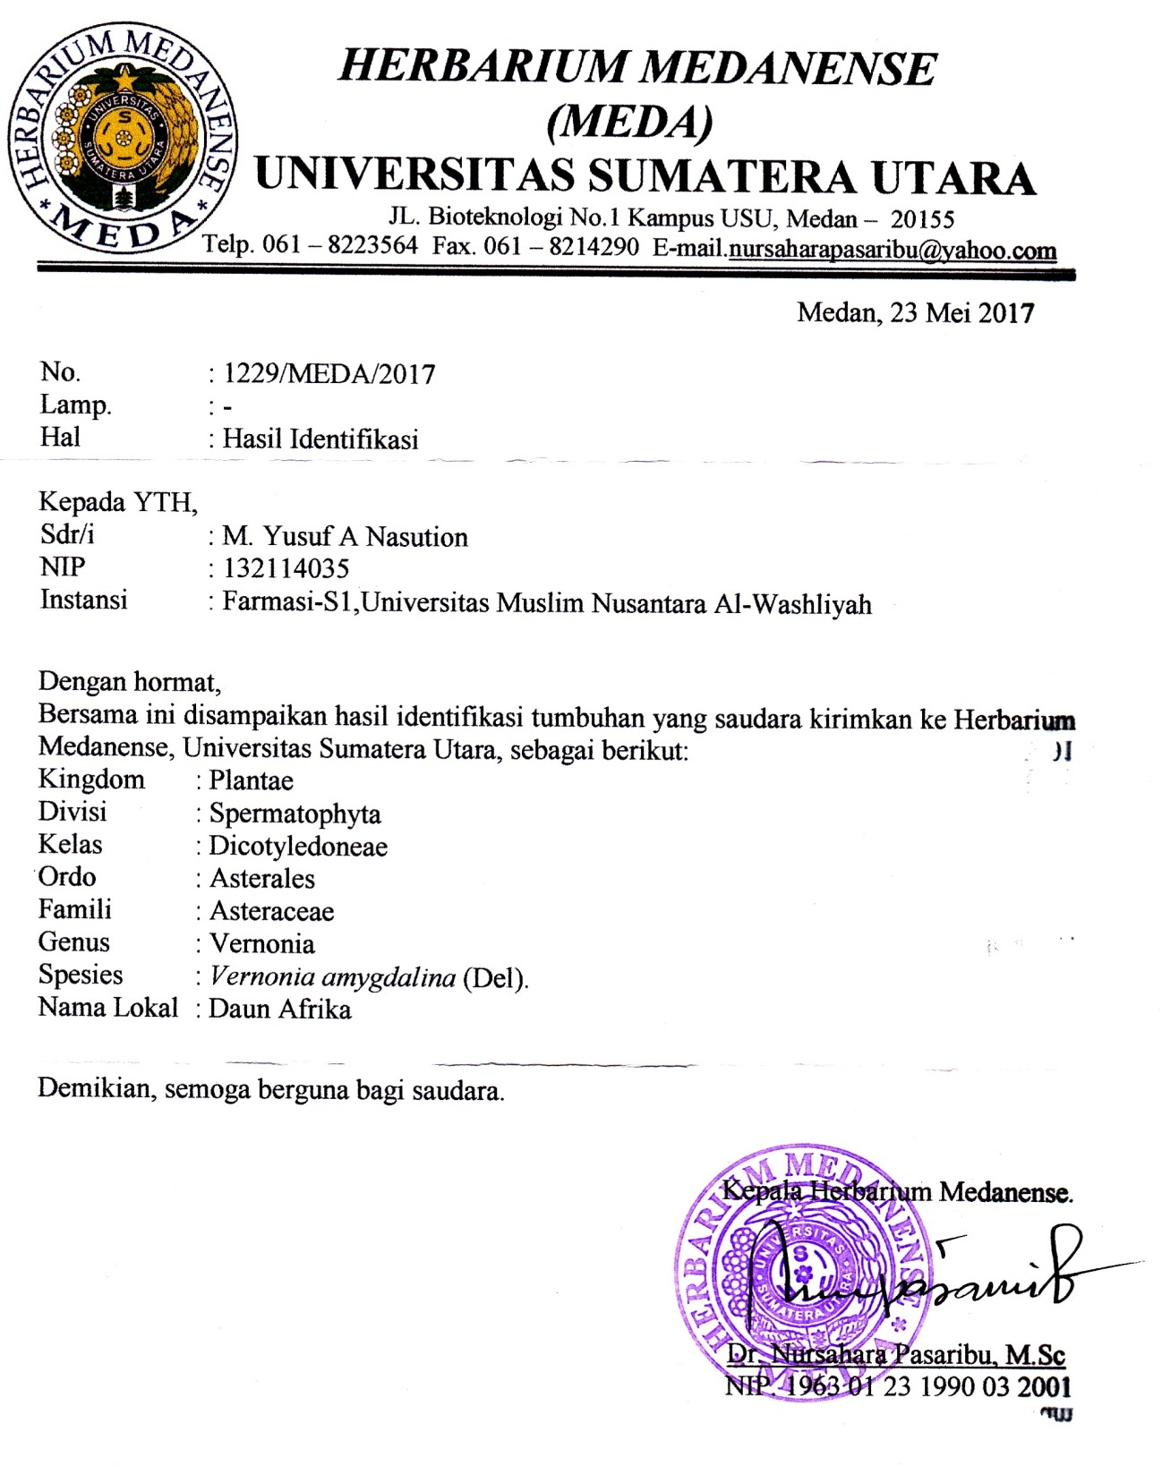

Lampiran 2. Bagan Alir Penelitian
Dibersihkan
Daun Afrika
Dirajang
Ditimbang
3kg Daun Afrika segar

Dikeringkan
1,2 kg simplisia kering

Dihaluskan
Ditimbang
560 g serbuk simplisia

Dimaserasi dengan etanol pro analis
Pemeriksaan & karakterisasi
Skrining fitokimia :
1. alkaloid
2. flavonoid
3. saponin
4. glikosida
5.steroid/triterpenoid
1. makroskopik
2. mikroskopik
3. penetapan kadar air
4. penetapan kadar sari larut dalam air
5. penetapan kadar sari larut etanol
6. kadar abu total
7. kadar abu tidak larut dalam asam
Maserat
Dirotari
Ekstrak kental 100 gram
eks
Dibuat gel
Gel konsentrasi 5% dan dasar gel

Pengujian efek gel terhadap luka bakar
Pemeriksaan gel
Lampiran 3. Sampel yang digunakan dalam penelitian
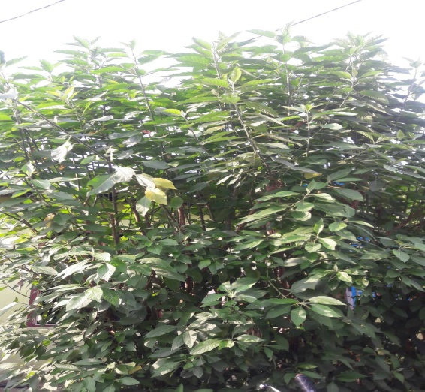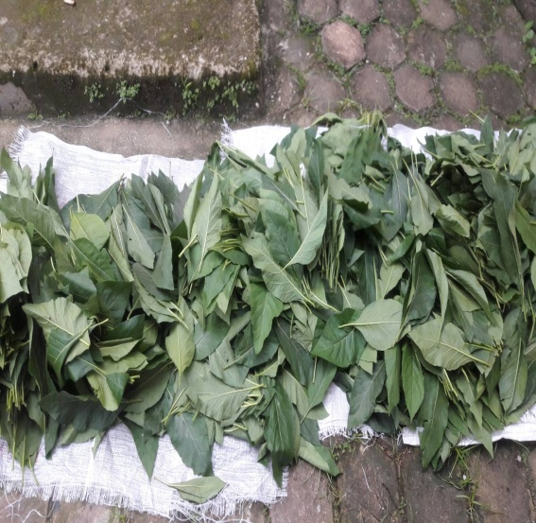
A. Tanaman Daun Afrika B. Daun Afrika
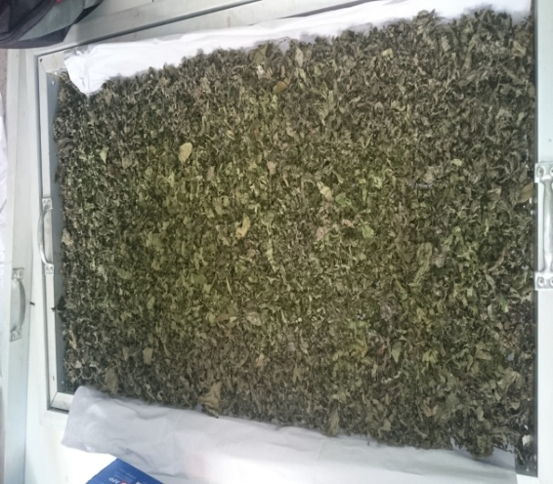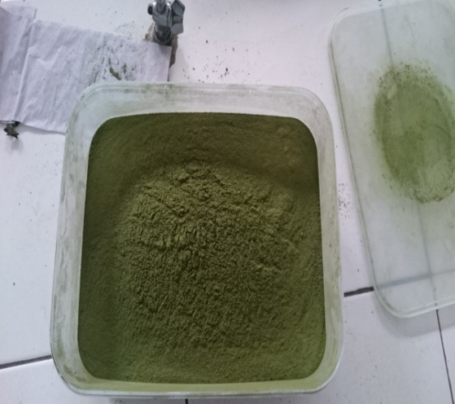
C. Simplisia Kering Daun Afrika D. Serbuk Simplisia Daun Afrika
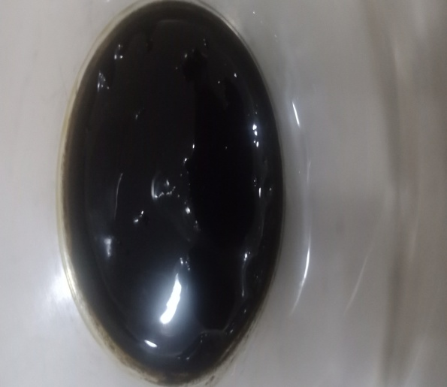
E. Ekstrak Etanol Daun Afrika
Lampiran 4. Gel-gel Ekstrak Etanol Daun Afrika dengan berbagai konsentrasi

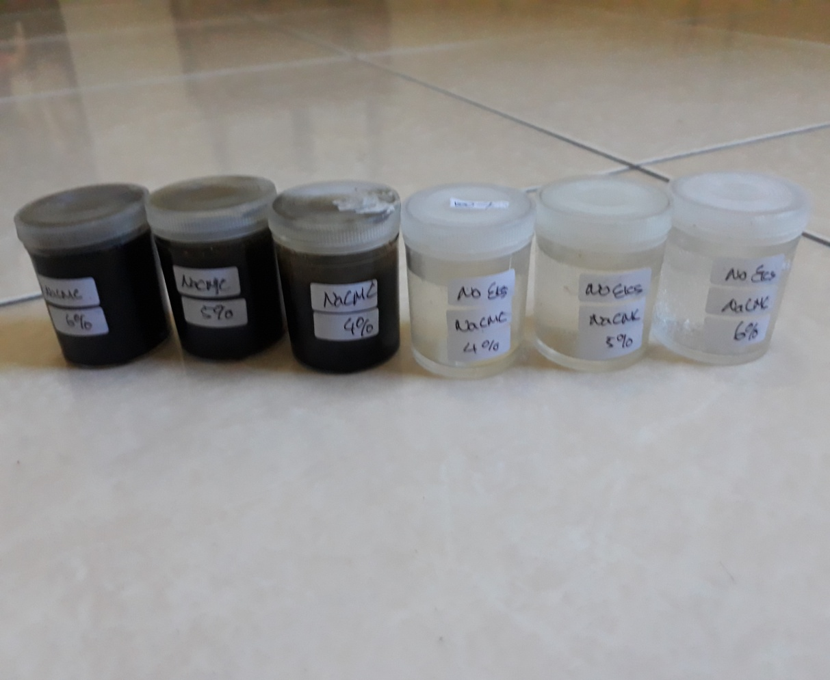

Lampiran 5. Perubahan Diameter Luka Bakar Pengobatan EEDA 5% dengan Na CMC 6%

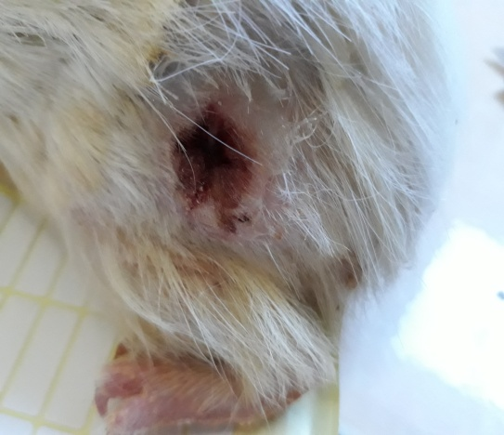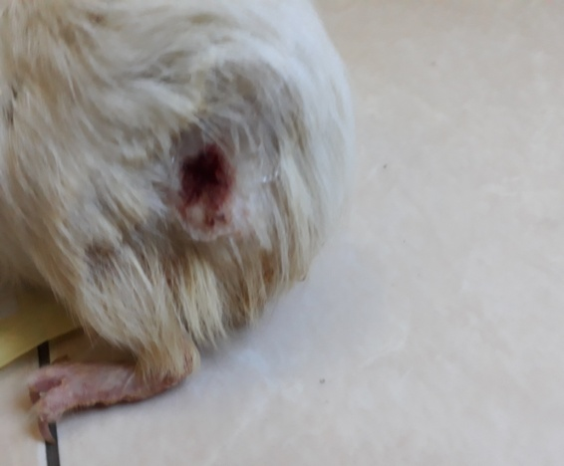
Hari Ke 1 Hari ke 4
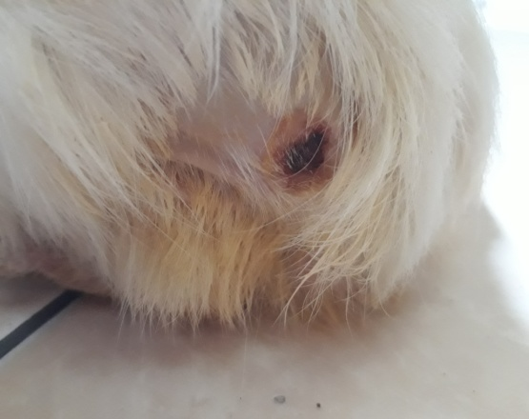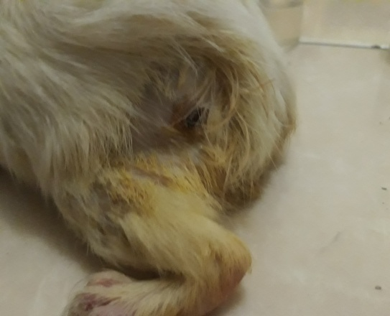
Hari Ke 7 Hari Ke 10
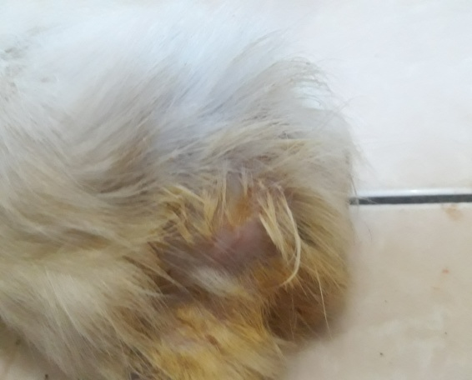
Hari ke 13

Lampiran 6. Perubahan Diameter Luka Bakar Pengobatan EEDA 5% dengan Na CMC 5%

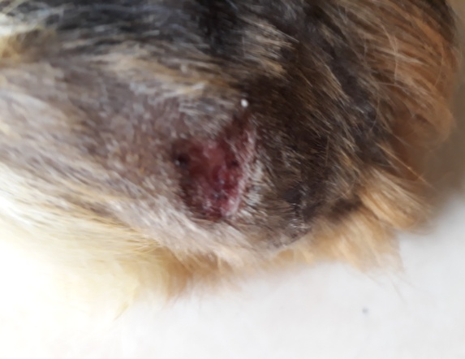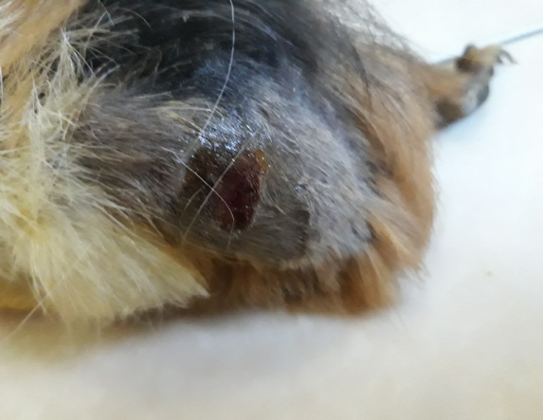
Hari ke 1 Hari ke 4
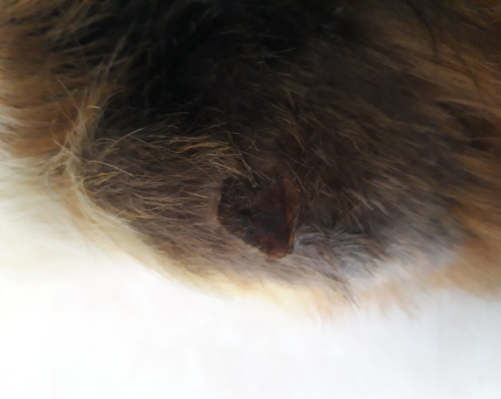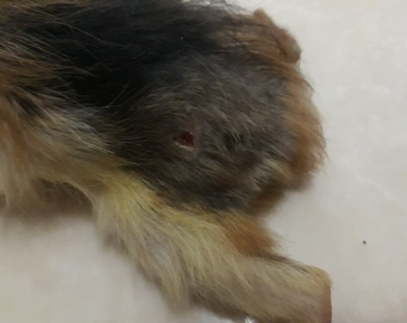
Hari ke 7 Hari ke 10
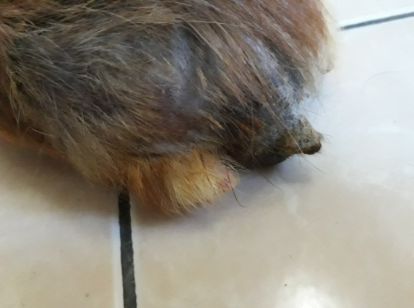
Hari ke 13

Lampiran 7. Perubahan Diameter Luka Bakar Pengobatan EEDA 5% dengan Na CMC 4%

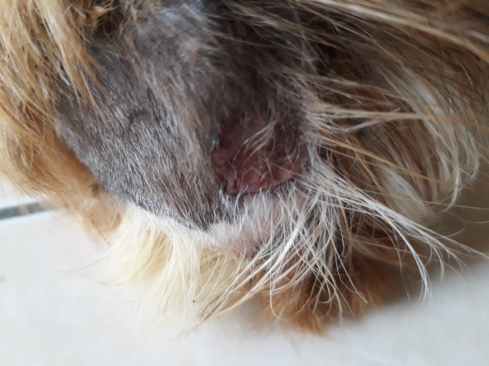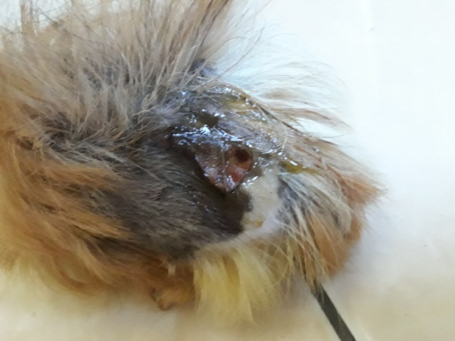
Hari Ke-1 Hari Ke-4
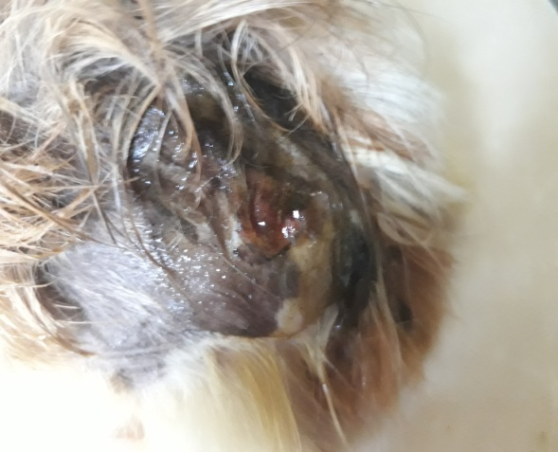
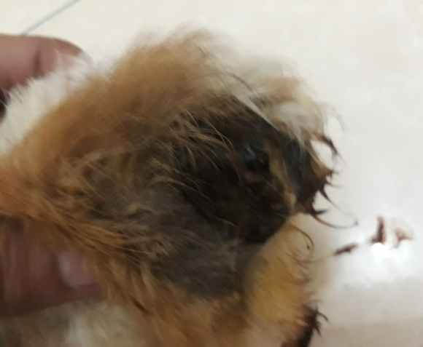
Hari Ke-7 Hari ke-10
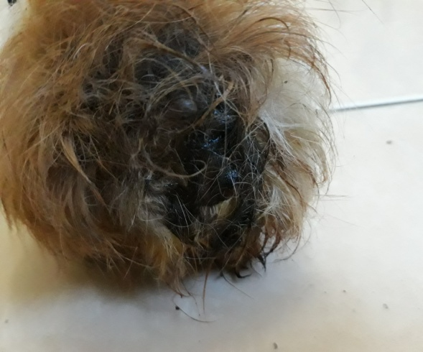

Lampiran 8. Perubahan Diameter Luka Bakar Pengobatan non ekstrak dengan Na CMC 6%

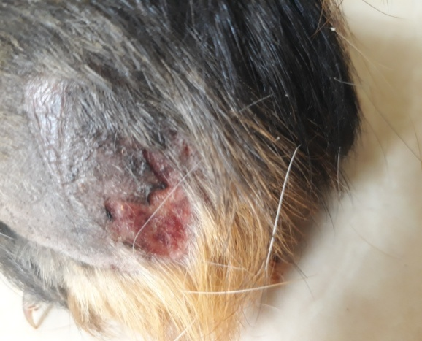 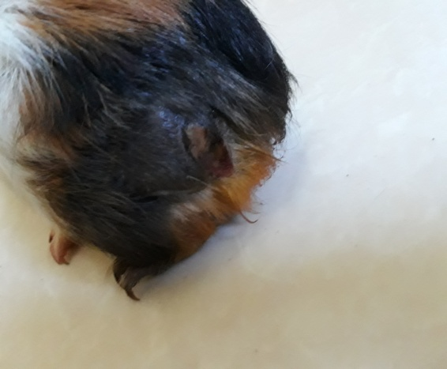
Hari Ke-1 Hari Ke-4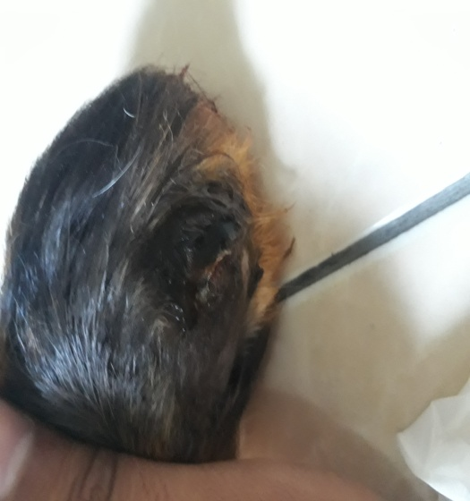 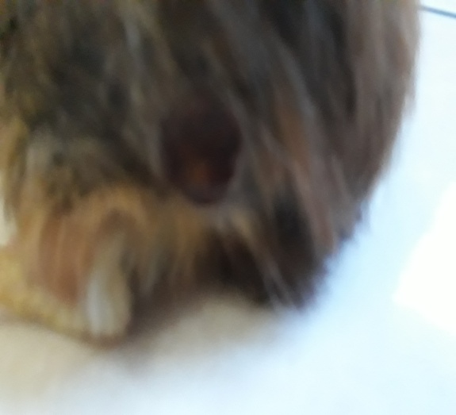
Hari Ke-7 Hari Ke-10
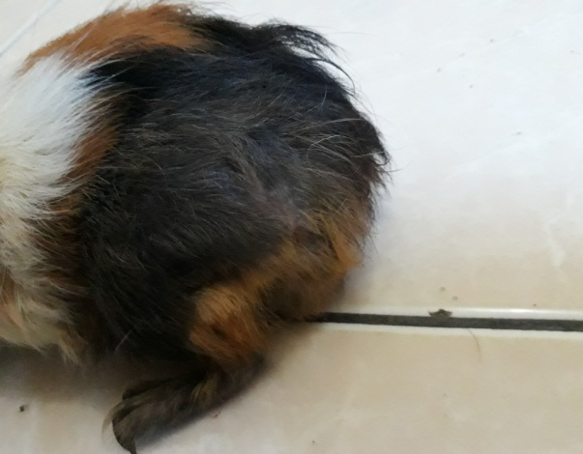
Hari Ke-13
Lampitan 9. Perubahan Diameter Luka Bakar Pengobatan non ekstrak dengan Na CMC 5%

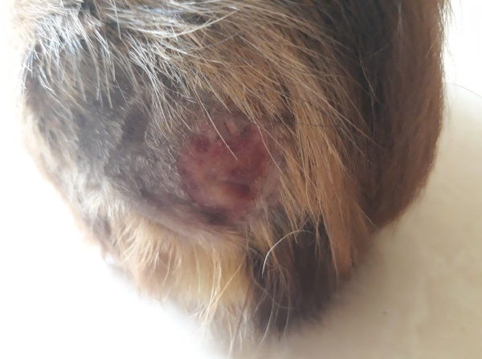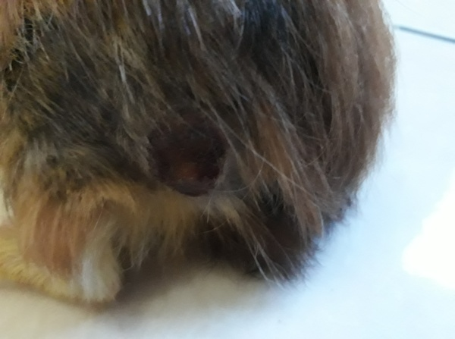
Hari Ke-1 Hari Ke-4
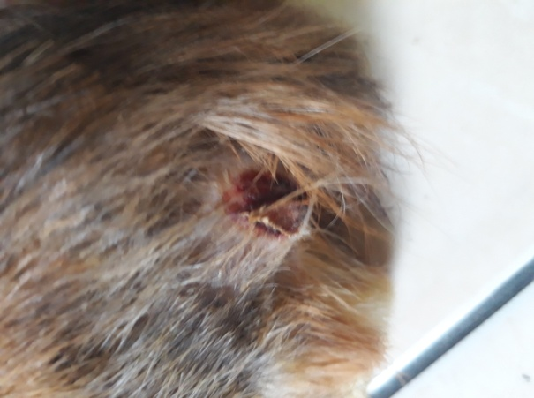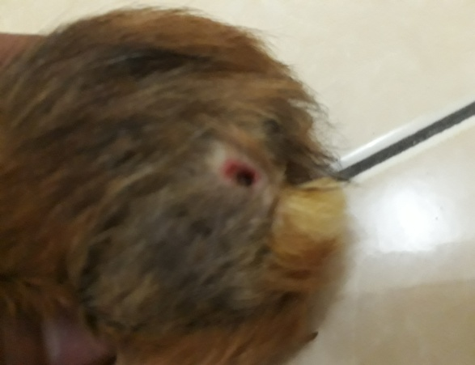
Hari Ke-7 Hari Ke-10
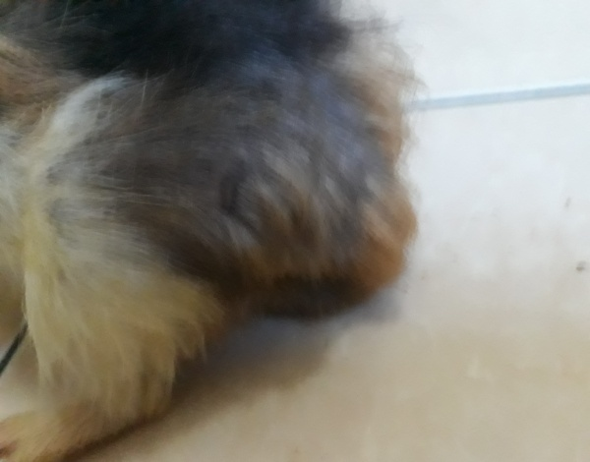
Hari Ke-13

Lampiran 10. Perubahan Diameter Luka Bakar Pengobatan non ekstrak dengan Na CMC 4%

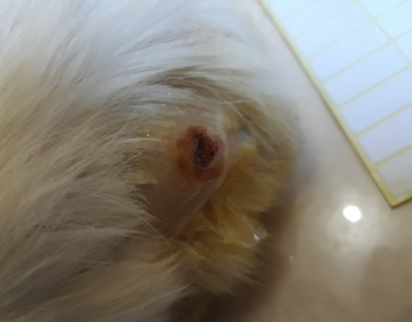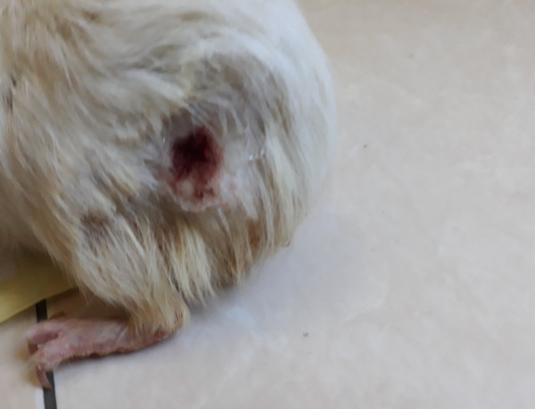
Hari Ke-1 Hari Ke-4
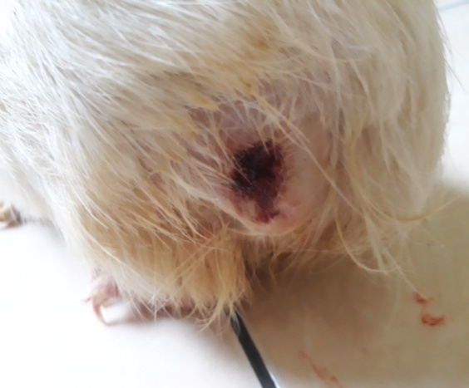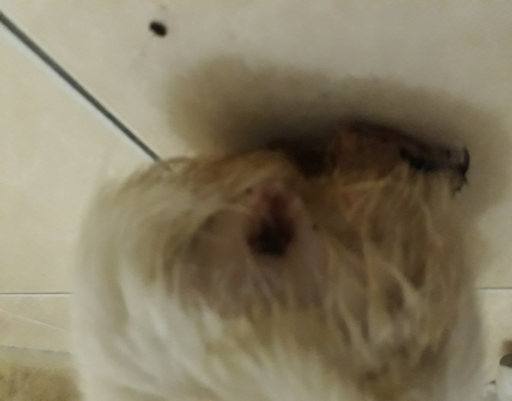
Hari Ke-7 Hari Ke-10
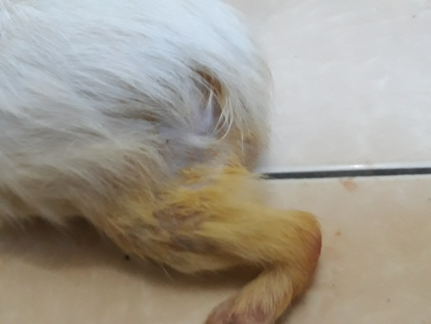
Hari ke 13

Lampiran11. Hasil Analisis Variasi dan Uji Duncan.
- Hasil Uji Diameter Luka Bakar Hari ke-4

ANOVA
Diameter Luka Bakar H-4 (cm)
 | Sum of Squares | Df | Mean Square | F | Sig.
Between Groups | ,280 | 5 | ,056 | 8,400 | ,001
Within Groups | ,080 | 12 | ,007
Total | ,360 | 17

Diameter Luka Bakar H-4 (cm)
Ducanª
Sediaan | N | Subset for alpha = 0.05
 |  | 1 | 2 | 3
Ekstrak EDA 5% dengan Na-CMC 4% | 3 | 1,400
Ekstrak EDA 5% dengan Na-CMC 5% | 3 | 1,467 | 1,467
Ekstrak EDA 5% dengan Na-CMC 4% | 3 | 1,500 | 1,500
Tanpa Ekstrak EDA dengan Na-CMC 6% | 3 | 1,600 | 1,600 | 1,600
Tanpa Ekstrak EDA dengan Na-CMC 5% | 3 |  | 1,667 | 1,667
Tanpa Ekstrak EDA dengan Na-CMC 4% | 3 |  |  | 1,767
Sig. |  | ,091 | ,091 | ,198
Means for groups in homogeneous subsets are displayed.
a. Uses Harmonic Mean Sample Size = 3,000.

Lampiran 11. (lanjutan)
- Hasil Uji Diameter Luka Bakar Hari ke-7

ANOVA
Diameter Luka Bakar H-7 (cm)
 | Sum of Squares | Df | Mean Square | F | Sig.
Between Groups | ,704 | 5 | ,141 | 19,508 | ,000
Within Groups | ,087 | 12 | ,007
Total | ,791 | 17

Diameter Luka Bakar H-7 (cm)
Ducan ª
Sediaan | N | Subset for alpha = 0.05
 |  | 1 | 2 | 3 | 4
Ekstrak EDA 5% dengan Na-CMC 4% | 3 | ,667
Ekstrak EDA 5% dengan Na-CMC 5% | 3 | ,800 | ,800
Ekstrak EDA 5% dengan Na-CMC 4% | 3 |  | ,967 | ,967
Tanpa Ekstrak EDA dengan Na-CMC 5% | 3 |  |  | 1,067 | 1,067
Tanpa Ekstrak EDA dengan Na-CMC 6% | 3 |  |  | 1,100 | 1,100
Tanpa Ekstrak EDA dengan Na-CMC 4% | 3 |  |  |  | 1,267
Sig. |  | ,435 | ,229 | ,435 | ,110
Means for groups in homogeneous subsets are displayed.
a. Uses Harmonic Mean Sample Size = 3,000.

Lampiran 11. (lanjutan)
- Hasil Uji Diameter Luka Bakar Hari ke-10

ANOVA
Diameter Luka Bakar H-10 (cm)
 | Sum of Squares | df | Mean Square | F | Sig.
Between Groups | ,449 | 5 | ,090 | 20,225 | ,000
Within Groups | ,053 | 12 | ,004
Total | ,503 | 17

Diameter Luka Bakar H-10(cm)
Ducan ª
Sediaan | N | Subset for alpha = 0.05
 |  | 1 | 2 | 3 | 4
Ekstrak EDA 5% dengan Na-CMC 4% | 3 | ,167
Ekstrak EDA 5% dengan Na-CMC 5% | 3 | ,233 | ,233
Ekstrak EDA 5% dengan Na-CMC 4% | 3 | ,267 | ,267
Tanpa Ekstrak EDA dengan Na-CMC 6% | 3 |  | ,400 | ,400
Tanpa Ekstrak EDA dengan Na-CMC 5% | 3 |  |  | ,467 | ,467
Tanpa Ekstrak EDA dengan Na-CMC 4% | 3 |  |  |  | ,633
Sig. |  | ,480 | ,082 | ,817 | ,082
Means for groups in homogeneous subsets are displayed.
a. Uses Harmonic Mean Sample Size = 3,000.

Lampiran 11. (lanjutan)
- Hasil Uji Diameter Luka Bakar Hari ke-13

ANOVA
Diameter Luka Bakar H-13 (cm)
 | Sum of Squares | df | Mean Square | F | Sig.
Between Groups | ,127 | 5 | ,025 | 22,800 | ,000
Within Groups | ,013 | 12 | ,001
Total | ,140 | 17

Diameter Luka Bakar H-13(cm)
Ducan ª
Sediaan | N | Subset for alpha = 0.05
 |  | 1 | 2 | 3
Ekstrak EDA 5% dengan Na-CMC 4% | 3 | ,000
Ekstrak EDA 5% dengan Na-CMC 5% | 3 | ,000
Ekstrak EDA 5% dengan Na-CMC 4% | 3 | ,000
Tanpa Ekstrak EDA dengan Na-CMC 6% | 3 | ,067 | ,067
Tanpa Ekstrak EDA dengan Na-CMC 5% | 3 |  | ,100
Tanpa Ekstrak EDA dengan Na-CMC 4% | 3 |  |  | ,233
Sig. |  | ,214 | ,817 | 1,000
Means for groups in homogeneous subsets are displayed.
a. Uses Harmonic Mean Sample Size = 3,000.

Lampiran 12. Perhitugan Karakterisasi
1. Penetapan Kadar Air
$$Kadar Air =\frac{Berat Abu}{Berat sampel} x 100\%$$
Sampel I
Berat Sampel = 5,0027 gr
Volume I = 1,4 ml
Volume II = 1,8 ml
$$Kadar air =\frac{1,8ml-1,4ml}{5,0027 g} x 100\%=7,99$$Sampel II
Berat Sampel = 5,0031 gr
Volume I = 1,3 ml
Volume II = 1,7 ml
$$Kadar air =\frac{1,7ml-1,3ml}{5,0031 g} x 100\%=7,99$$
Sampel III
Berat Sampel = 5,0021 gr
Volume I = 1,4 ml
Volume II = 1,7 ml
$$Kadar air =\frac{1,7ml-1,4ml}{5,0021 g} x 100\%=5,99\%$$
$$Kadar air rata-rata =\frac{7,99+7,99+5,99}{3}=7,32$$

Lampiran 12 (Lanjutan).
2. penetapan Kadar Abu Total
$$Kadar Abu Total =\frac{Berat Abu}{Berat sampel} x 100\%$$
Sampel I
Berat serbuk = 2,0001 g
Berat cawan = 69,9668 g
Berat cawan + abu = 70,1654 g
Berat abu = 0,1986 g
$$Kadar abu total =\frac{0,1986 g}{2,0001 g} x 100\%=9,92\%$$
Sampel II
Berat serbuk = 2,0004 g
Berat cawan = 69,9668 g
Berat cawan + abu = 70,1440 g
Berat abu = 0,1772 g
$$Kadar abu total =\frac{0,1772 g}{2,0004 g} x 100\%=8,55\%$$
Sampel III
Berat serbuk = 2,0008 g
Berat cawan = 69,9668 g
Berat cawan + abu = 70,1625 g
Berat abu = 0,1957 g
Lampiran 12 (Lanjutan).
$$Kadar abu total =\frac{0,1957 g}{2,0065 g} x 100\%=9,78\%$$
$$Kadar abu total rata-rata =\frac{9,92+8,85+9,78}{3}=9,52\%$$
3. penetapan Kadar Abu Tidak Larut Dalam Asam
$$Kadar Abu Tidak Larut Dalam Asam =\frac{Berat Abu}{Berat sampel} x 100\%$$
Sampel I
Berat serbuk = 2,0001 g
Berat cawan = 69,9668 g
Berat cawan + abu = 69,9932 g
Berat abu = 0,0264 g
$$Kadar abu tidak larut dalam asam =\frac{0,0264 g}{2,0001 g} x 100\%=1,30\%$$
Sampel II
Berat serbuk = 2,0004 g
Berat cawan = 69,9668 g
Berat cawan + abu = 69,9918 g
Berat abu = 0,0250 g
$$Kadar abu tidak larut dalam asam =\frac{0,0250 g}{2,0004 g} x 100\%=1,24\%$$
Sampel III
Berat serbuk = 2,0008 g
Lampiran 12 (Lanjutan).
Berat cawan = 69,9668 g
Berat cawan + abu = 69,9882 g
Berat abu = 0,0214 g
$$Kadar abu tidak larut dalam asam =\frac{0,0214 g}{2,0008 g} x 100\%=1,06\%$$
$$Kadar abu tidak larut dalam asam rata-rata=\frac{1,30\%+1,24\%+1,06\%}{3}$$
$=1,20\%$
4. Penetapan Kadar Sari Larut Dalam Air
$$Kadar Sari Larut Dalam Air =\frac{Berat Sari x 100}{Berat sampel x 20} x 100\%$$
Sampel I
Berat sampel = 5,0300 g
Berat cawan = 121,9239 g
Berat cawan + sari = 121,1122 g
Berat sari = 0,1883 g
$$Kadar sari larut dalam air =\frac{0,1883 g x 100}{5,0300 g x 20} x 100\%=18,70\%$$
Sampel II
Berat sampel = 5,0255 g
Berat cawan = 121,9239 g
Berat cawan + sari = 121,1328 g
Berat sari = 0,2089 g
Lampiran 12 (Lanjutan).
$$Kadar sari larut dalam air =\frac{0,2089 g x 100}{5,0255 g x 20} x 100\%=20,75\%$$
Sampel III
Berat sampel = 5,0412 g
Berat cawan = 121,9239 g
Berat cawan + sari = 121,1425 g
Berat sari = 0,2186 g
$$Kadar sari larut dalam air =\frac{0,2186 g x 100}{5,0412 g x 20} x 100\%=21,65\%$$
$$Kadar sari larut dalam air rata-rata=\frac{18,70\%+20,75+21,65}{3} =20,36\%$$
5. Penetapan Kadar Sari Larut Dalam Etanol
$$Kadar Sari Larut Dalam Etanol =\frac{Berat Sari x 100}{Berat sampel x 20} x 100\%$$
Sampel I
Berat sampel = 5,0077 g
Berat cawan = 111,6925 g
Berat cawan + sari = 111,8575 g
Berat sari = 0,1650 g
$$Kadar sari larut dalam etanol =\frac{0,1650 g x 100}{5,0077 g x 20} x 100\%=16,45\%$$
Sampel II
Berat sampel = 5,0112 g
Lampiran 12 (Lanjutan).
Berat cawan = 111,6925 g
Berat cawan + sari = 111,8689 g
Berat sari = 0,1764 g
$$Kadar sari larut dalam etanol =\frac{0,1764 g x 100}{5,00112 g x 20} x 100\%=11,95\%$$
Sampel III
Berat sampel = 5,0216 g
Berat cawan = 111,6925 g
Berat cawan + sari = 111,8886 g
Berat sari = 0,1961 g
$$Kadar sari larut dalam etanol =\frac{0,1961 g x 100}{5,0216 g x 20} x 100\%=19,50\%$$
$$Kadar sari larut dalam etanol rata-rata=\frac{16,45\%+17,60\%+19,50\%}{3}$$
$=17,85\%$

