APPENDIX A
Critical Value T-Table (df = 1 – 40)
Pr | 0.25 | 0.10 | 0.05 | 0.025 | 0.01 | 0.005 | 0.001
df | 0.50 | 0.20 | 0.10 | 0.050 | 0.02 | 0.010 | 0.002
1 | 1.00000 | 3.07768 | 6.31375 | 12.70620 | 31.82052 | 63.65674 | 318.3084
2 | 0.81650 | 1.88562 | 2.91999 | 4.30265 | 6.96456 | 9.92484 | 22.32712
3 | 0.76489 | 1.63774 | 2.35336 | 3.18245 | 4.54070 | 5.84091 | 10.21453
4 | 0.74070 | 1.53321 | 2.13185 | 2.77645 | 3.74695 | 4.60409 | 7.17318
5 | 0.72669 | 1.47588 | 2.01505 | 2.57058 | 3.36493 | 4.03214 | 5.89343
6 | 0.71756 | 1.43976 | 1.94318 | 2.44691 | 3.14267 | 3.70743 | 5.20763
7 | 0.71114 | 1.41492 | 1.89458 | 2.36462 | 2.99795 | 3.49948 | 4.78529
8 | 0.70639 | 1.39682 | 1.85955 | 2.30600 | 2.89646 | 3.35539 | 4.50079
9 | 0.70272 | 1.38303 | 1.83311 | 2.26216 | 2.82144 | 3.24984 | 4.29681
10 | 0.69981 | 1.37218 | 1.81246 | 2.22814 | 2.76377 | 3.16927 | 4.14370
11 | 0.69745 | 1.36343 | 1.79588 | 2.20099 | 2.71808 | 3.10581 | 4.02470
12 | 0.69548 | 1.35622 | 1.78229 | 2.17881 | 2.68100 | 3.05454 | 3.92963
13 | 0.69383 | 1.35017 | 1.77093 | 2.16037 | 2.65031 | 3.01228 | 3.85198
14 | 0.69242 | 1.34503 | 1.76131 | 2.14479 | 2.62449 | 2.97684 | 3.78739
15 | 0.69120 | 1.34061 | 1.75305 | 2.13145 | 2.60248 | 2.94671 | 3.73283
16 | 0.69013 | 1.33676 | 1.74588 | 2.11991 | 2.58349 | 2.92078 | 3.68615
17 | 0.68920 | 1.33338 | 1.73961 | 2.10982 | 2.56693 | 2.89823 | 3.64577
18 | 0.68836 | 1.33039 | 1.73406 | 2.10092 | 2.55238 | 2.87844 | 3.61048
19 | 0.68762 | 1.32773 | 1.72913 | 2.09302 | 2.53948 | 2.86093 | 3.57940
20 | 0.68695 | 1.32534 | 1.72472 | 2.08596 | 2.52798 | 2.84534 | 3.55181
21 | 0.68635 | 1.32319 | 1.72074 | 2.07961 | 2.51765 | 2.83136 | 3.52715
22 | 0.68581 | 1.32124 | 1.71714 | 2.07387 | 2.50832 | 2.81876 | 3.50499
23 | 0.68531 | 1.31946 | 1.71387 | 2.06866 | 2.49987 | 2.80734 | 3.48496
24 | 0.68485 | 1.31784 | 1.71088 | 2.06390 | 2.49216 | 2.79694 | 3.46678
25 | 0.68443 | 1.31635 | 1.70814 | 2.05954 | 2.48511 | 2.78744 | 3.45019
26 | 0.68404 | 1.31497 | 1.70562 | 2.05553 | 2.47863 | 2.77871 | 3.43500
27 | 0.68368 | 1.31370 | 1.70329 | 2.05183 | 2.47266 | 2.77068 | 3.42103
28 | 0.68335 | 1.31253 | 1.70113 | 2.04841 | 2.46714 | 2.76326 | 3.40816
29 | 0.68304 | 1.31143 | 1.69913 | 2.04523 | 2.46202 | 2.75639 | 3.39624
30 | 0.68276 | 1.31042 | 1.69726 | 2.04227 | 2.45726 | 2.75000 | 3.38518
31 | 0.68249 | 1.30946 | 1.69552 | 2.03951 | 2.45282 | 2.74404 | 3.37490
32 | 0.68223 | 1.30857 | 1.69389 | 2.03693 | 2.44868 | 2.73848 | 3.36531
33 | 0.68200 | 1.30774 | 1.69236 | 2.03452 | 2.44479 | 2.73328 | 3.35634
34 | 0.68177 | 1.30695 | 1.69092 | 2.03224 | 2.44115 | 2.72839 | 3.34793
35 | 0.68156 | 1.30621 | 1.68957 | 2.03011 | 2.43772 | 2.72381 | 3.34005
36 | 0.68137 | 1.30551 | 1.68830 | 2.02809 | 2.43449 | 2.71948 | 3.33262
37 | 0.68118 | 1.30485 | 1.68709 | 2.02619 | 2.43145 | 2.71541 | 3.32563
38 | 0.68100 | 1.30423 | 1.68595 | 2.02439 | 2.42857 | 2.71156 | 3.31903
39 | 0.68083 | 1.30364 | 1.68488 | 2.02269 | 2.42584 | 2.70791 | 3.31279
40 | 0.68067 | 1.30308 | 1.68385 | 2.02108 | 2.42326 | 2.70446 | 3.30688

Critical Value T-Table t (df = 41 – 80)
Pr | 0.25 | 0.10 | 0.05 | 0.025 | 0.01 | 0.005 | 0.001
df | 0.50 | 0.20 | 0.10 | 0.050 | 0.02 | 0.010 | 0.002
41 | 0.68052 | 1.30254 | 1.68288 | 2.01954 | 2.42080 | 2.70118 | 3.30127
42 | 0.68038 | 1.30204 | 1.68195 | 2.01808 | 2.41847 | 2.69807 | 3.29595
43 | 0.68024 | 1.30155 | 1.68107 | 2.01669 | 2.41625 | 2.69510 | 3.29089
44 | 0.68011 | 1.30109 | 1.68023 | 2.01537 | 2.41413 | 2.69228 | 3.28607
45 | 0.67998 | 1.30065 | 1.67943 | 2.01410 | 2.41212 | 2.68959 | 3.28148
46 | 0.67986 | 1.30023 | 1.67866 | 2.01290 | 2.41019 | 2.68701 | 3.27710
47 | 0.67975 | 1.29982 | 1.67793 | 2.01174 | 2.40835 | 2.68456 | 3.27291
48 | 0.67964 | 1.29944 | 1.67722 | 2.01063 | 2.40658 | 2.68220 | 3.26891
49 | 0.67953 | 1.29907 | 1.67655 | 2.00958 | 2.40489 | 2.67995 | 3.26508
50 | 0.67943 | 1.29871 | 1.67591 | 2.00856 | 2.40327 | 2.67779 | 3.26141
51 | 0.67933 | 1.29837 | 1.67528 | 2.00758 | 2.40172 | 2.67572 | 3.25789
52 | 0.67924 | 1.29805 | 1.67469 | 2.00665 | 2.40022 | 2.67373 | 3.25451
53 | 0.67915 | 1.29773 | 1.67412 | 2.00575 | 2.39879 | 2.67182 | 3.25127
54 | 0.67906 | 1.29743 | 1.67356 | 2.00488 | 2.39741 | 2.66998 | 3.24815
55 | 0.67898 | 1.29713 | 1.67303 | 2.00404 | 2.39608 | 2.66822 | 3.24515
56 | 0.67890 | 1.29685 | 1.67252 | 2.00324 | 2.39480 | 2.66651 | 3.24226
57 | 0.67882 | 1.29658 | 1.67203 | 2.00247 | 2.39357 | 2.66487 | 3.23948
58 | 0.67874 | 1.29632 | 1.67155 | 2.00172 | 2.39238 | 2.66329 | 3.23680
59 | 0.67867 | 1.29607 | 1.67109 | 2.00100 | 2.39123 | 2.66176 | 3.23421
60 | 0.67860 | 1.29582 | 1.67065 | 2.00030 | 2.39012 | 2.66028 | 3.23171
61 | 0.67853 | 1.29558 | 1.67022 | 1.99962 | 2.38905 | 2.65886 | 3.22930
62 | 0.67847 | 1.29536 | 1.66980 | 1.99897 | 2.38801 | 2.65748 | 3.22696
63 | 0.67840 | 1.29513 | 1.66940 | 1.99834 | 2.38701 | 2.65615 | 3.22471
64 | 0.67834 | 1.29492 | 1.66901 | 1.99773 | 2.38604 | 2.65485 | 3.22253
65 | 0.67828 | 1.29471 | 1.66864 | 1.99714 | 2.38510 | 2.65360 | 3.22041
66 | 0.67823 | 1.29451 | 1.66827 | 1.99656 | 2.38419 | 2.65239 | 3.21837
67 | 0.67817 | 1.29432 | 1.66792 | 1.99601 | 2.38330 | 2.65122 | 3.21639
68 | 0.67811 | 1.29413 | 1.66757 | 1.99547 | 2.38245 | 2.65008 | 3.21446
69 | 0.67806 | 1.29394 | 1.66724 | 1.99495 | 2.38161 | 2.64898 | 3.21260
70 | 0.67801 | 1.29376 | 1.66691 | 1.99444 | 2.38081 | 2.64790 | 3.21079
71 | 0.67796 | 1.29359 | 1.66660 | 1.99394 | 2.38002 | 2.64686 | 3.20903
72 | 0.67791 | 1.29342 | 1.66629 | 1.99346 | 2.37926 | 2.64585 | 3.20733
73 | 0.67787 | 1.29326 | 1.66600 | 1.99300 | 2.37852 | 2.64487 | 3.20567
74 | 0.67782 | 1.29310 | 1.66571 | 1.99254 | 2.37780 | 2.64391 | 3.20406
75 | 0.67778 | 1.29294 | 1.66543 | 1.99210 | 2.37710 | 2.64298 | 3.20249
76 | 0.67773 | 1.29279 | 1.66515 | 1.99167 | 2.37642 | 2.64208 | 3.20096
77 | 0.67769 | 1.29264 | 1.66488 | 1.99125 | 2.37576 | 2.64120 | 3.19948
78 | 0.67765 | 1.29250 | 1.66462 | 1.99085 | 2.37511 | 2.64034 | 3.19804
79 | 0.67761 | 1.29236 | 1.66437 | 1.99045 | 2.37448 | 2.63950 | 3.19663
80 | 0.67757 | 1.29222 | 1.66412 | 1.99006 | 2.37387 | 2.63869 | 3.19526

APPENDIX B
LESSON PLAN
Nama Sekolah : SMK AKP GALANG
Mata Pelajaran : Bahasa Inggris
Kelas/ Semester : XI/2
Alokasi Waktu : 2 x 45
- Standar Kompetensi
1 : Membuat makna teks tertulis fungsional dan esai pendek sederhana berbentuk narrative text.
- Kompetensi Dasar
- Membaca nyaring dengan bermakna teks tertulis fungsional dan esai pendek sederhana berbentuk narative text dengan ucapan, tekanan dan intonasi.
- Indikator Pencapaian
- Siswa dapat menangkap makna lebih mendalam mengenai teks narative
- Siswa dapat mengidentifikasi makna dan gagasan dalam teks narative
- Siswa dapat mengidentifikasi aspek-aspek yang ada pada teks narrative

- Karakter:
- Dapat dipercaya (Trustworties)
- Berani (Courage)
- Tekun (Diligent)
- Tanggung jawab (Responsible)
- Peduli lingkungan dan sosial
- Tujuan Pembelajaran
- Siswa dapat menangkap makna lebih mendalam mengenai teks narrative
- Siswa dapat mengidentifikasi makna dan gagasan dalam teks narrative
- Siswa dapat mengidentifikasi aspek-aspek yang ada pada teks narrative
- Materi Pembelajaran
Terlampir
- Metode Pembelajaran
- Pendekatan : Scientific Approach
- Model : Interactive Learning
- Teknik : small group discussion
F. Media, Alat, dan Sumber Pembelajaran
- Media/ Alat : Papan tulis, board marker
G. Langkah – Langkah Pembelajaran
Pendahuluan ( 10’)
- Guru menyiapkan siswa secara psikis dan fisik untuk mengikuti proses pembelajaran dengan memberi salam, mengajak siswa untuk merapikan kelas dan penampilan mereka, mengajak peserta didikuntuk mengawali kegiatan dengan berdoa.
- Guru memberi salam dan menyapa siswa
- Mengecek kehadiran siswa ( nilai yang ditanamkan: disiplin, rajin).
- Mengaitkan materi/ kompetensi yang akan dipelajari denagn karakter.
- Dengan merujuk pada rpp, dan bahan ajar, guru menyampaikan butir karakter yang hendak dikembangakan.
Kegiatan Inti (60’)
Eksplorasi
- Mengamati
- Memberikan penjelasan mengenai narative text
- Memberikan stimulus mengenai materi yang bersangkutan

- Menanya
- Dengan bimbingan dan arahan guru, peserta didik dibagi kedalam beberapa kelompok yang berjumlah 4/5 orang.
- Kelompok pasangan diminta untuk membaca teks narative
- Memfasilitasi peserta didik melalui pemberian kunci dasar mengenai narative teks
- Mengumpulkan Data atau Informasi
- Dengan bimbingan guru, siswa mempertanyakan tentang bagaimana menemukan makna dalam teks narative
- Siswa dapat menemukan informasi mengenai teks narative tersebut.
- Mengasosiasi
- Secara berpasangan siswa mendiskusikan makna atau kata-kata sulit yang digunakan pada teks narative yang diberikan oleh guru.
- Masih secara berpasangan, siswa mengidentifikasi struktur narative teks.
- Mengasosiasi
- Setiap kelompok membacakan hasil diskusi didepan kelas mengenai teks narative yang diberikan oleh guru.
- Guru memberikan umpan balik pada siswa dengan memberi penguatan dalam bentuk lisan pada siswa yang telah dapat menyelesaikan tugas.
- Memberi konfirmasi pada hasil pekerjaan yang sudah dikerjakan oleh siswa.
- Memfasilitasi siswa melakukan refleksi untuk memperoleh pengalaman belajar yang sudah dilakukan.
- Memberikan motivasi kepada siswa yang kurang dan belum bisa mnegikuti dalam materi text berbentuk narative
Kegiatan Akhir (10’)
- siswa dan guru melakukan refleksi terhadap kegiatan yang sudah dilaksanakan.
- Siswa diberikan pekerjaan rumah (pr) berkaitan dengan materi text berbentuk narative
- Menyampaikan rencana pembelajaran pada pertemuan berikutnya.
H. Penilaian Hasil Pembelajaran
1. Jenis/Teknik Penilaian.
- Test tulis: Guru memberikan beberapa topik tentang narative text dalam bentuk pilihan berganda.
Nilai maksimal = 100
Nilai siswa = jumlah score = .......

APPENDIX 3
Instrument of the Research Pre-Test & Post Test

UNIVERSITAS MUSLIM NUSANTARA AL WASHLIYAH
MEDAN

Pre Test
Name : Class :

Long, long ago, when the gods and goddesses used to mingle in the affairs of mortals, there was a small kingdom on the slope of Mount Wayang in West Java. The King, named Sang Prabu, was a wise man. He had an only daughter, called Princess Teja Nirmala, who was famous for her beauty but she was not married. One day Sang Prabu made up his mind to settle the matter by a show of strength. After that, Prince of Blambangan, named Raden Begawan had won the competition. Unfortunately, the wicked fairy, Princess Segara fell in love with Raden Begawan and used magic power to render him unconscious and he forgot his wedding. When Sang Prabu was searching, Raden Begawan saw him and soon realized that he had been enchanted by the wicked fairy. The fairy could not accept this, so she killed Raden Begawan. When Princess Teja Nirmala heard this, she was very sad. So a nice fairy took her to the Kahyangan.
1. Which one of the following statements is false about Sang Prabu?
A. Sang Prabu was a father of his only daughter
B. Sang Prabu was a king of a kingdom in West Java
C. Sang Prabu was taken to Kahyangan by a wicked fairy
D. Sang Prabu was a wise man
E. Sang Prabu didn’t have a son
2. Why the wicked fairy did used her magic to make Raden Begawan unconscious?
A. She didn’t like Raden Begawan
B. She didn’t want Raden Prabu marry the princess
C. She wanted Teja Nirmala to forget about her wedding
D. She didn’t want the prince of Blambangan marry the princess
E. She didn’t want the prince of Blambangan feel love with her
3. What do you think will happen if gods or goddesses cannot mingle in the affairs of people in the earth at that time?
A. Princess Segara will have married with Raden Begawan
B. Sang Prabu will not hold strength competition
C. Raden Begawan will not die
D. Teja Nirmala will stay in the Kahyangan
E. Wicked Fairy will not take Raden Begawan’s life
4. So a nice fairy took her to the Kahyangan. (Paragraph 2) The word her in the sentence refers to…
A. The wicked fairy
B. The nice fairy
C. Princess Nirmala
D. Prince Teja
E. The prince of Blambangan
5. The similarity between fairy and human according to the text.
A. The place they live
B. The jealousy that they posses
C. The way they don’t feel a love
D. The strength they have
E. Their life that is immortal
A long time ago, there lived on the island of Bali a giant-like creature named Kbo Iwo. The people of Bali used to say that Kbo Iwo was everything, a destroyer as well as a creator. He was satisfied with the meal, but this meant for the Balinese people enough food for a thousand men. Difficulties arose when for the first time the barns were almost empty and the new harvest was still a long way off. This made Kbo Iwo wild with great anger. In his hunger, he destroyed all the houses and even all the temples. It made the Balinese turn to rage. So, they came together to plan steps to oppose this powerful giant by using his stupidity. They asked Kbo Iwo to build them a very deep well, and rebuild all the houses and temples he had destroyed. After they fed Kbo Iwo, he began to dig a deep hole. One day he had eaten too much, he fell asleep in the hole. The oldest man in the village gave a sign, and the villagers began to throw the limestone they had collected before into the hole. The limestone made the water inside the hole boiling . Kbo Iwo was buried alive. Then the water in the well rose higher and higher until at last it overflowed and formed Lake Batur. The mound of earth dug from the well by Kbo Iwo is known as Mount Batur.
6. Which the following fact is true about Kbo Iwo?
A. Kebo Iwo ate a little amount of meat
B. Kebo Iwo is a destroyer that cannot make anything
C. Kebo Iwo was angry because his food was stolen by Balinese people
D. Kebo Iwo destroyed all the house but not the temple
E. Kebo eat food was equal for food of thousand people
7. Why did Kbo Iwo feel angry to the Balinese people?
A. Because Balinese people ate his meal
B. Because Balinese people took his food so his barns was empty
C. Because Balinese people didn’t give him food
D. Because Balinese people were in hunger
E. Because Balinese people turned to rage
8. According to the story, if Kbo Iwa is never existed in Bali island, what do you think will happen?
A. There will be no Bali island
B. Bali People will never be angry
C. All Bali people will live in a prosperous way
D. We are not able see the beauty of Lake Batur
E. Mount Batur will not be a sacred place now
9. “So, they came together to plan steps to oppose this powerful giant……”(Paragraph 3). The antonym of the word “oppose “ is….
A. Support
B. Defeat
C. Turn Against
D. Beat
E. Change
10. What is mount batur?
A. A lake build by Kbo Iwa
B. A well dug by Kbo iwa
C. The mountain build by Kbo Iwa
D. A mound of earth dug from the well by Kbo iwa
E. A home build by Balinese people to Kbo Iwa

The Lion and The mouse
Once when a lion was asleep, a little mouse began up and down upon him; this soon awoke the lion, who placed his huge paw upon the mouse, and opened his big jaws to swallow him.
“Pardon, O King “cried the little mouse “forgive me this time. I shall never forget it: who knows I may be able to do you a good turn some of these days? ”. The lion was so tickled at the idea of the mouse being able to help him. Then he lifted up his paw and let him go.
On day the lion was caught in a trap. Some hunters who to carry him alive to the king, tied him to a tree while they went in search of a wagon to carry him in. Just then the little mouse happened to pass by and see the sad plight in which the lion was. The little mouse went up to him and soon gnawed away the ropes that bound the king of the beats. Soon the little mouse had finished growing away the ropes, he asked the lion to run away.

- What is the moral lesson from the text?
- Don’t look at someone because of his clothes
- It is best to prepare for the days of necessity
- Common people may prove great ones
- United we stand, divided we fall
- Honesty begins at home.

- Paragraph three mainly tells that….
- The little mouse asked forgiveness
- The hunters carried the lion alive to the king
- The lion was tied to a tree by the hunters
- The little mouse could prove that he could help the lion
- From the first, the lion believed in what the little mouse said

- What did the little mouse do to prove his words?
- He would never forget the lion.
- He tried hard to help the lion free.
- He ran up and down upon the lion
- He asked for apology to the king of the beast
- He tied the lion to the tree so that the hunters could carry him

- The word “huge” (p.1) means very…..
- old B. large C. tall D. Tiny E. giant

Once upon a time there was a girl name Cindrella. She lived with her bad step-mother and two step-sisters. She had to do all the household chores.
One day the king invited all the ladies in the kingdom to go to a ball (pesta dansa) in the palace. He wanted to find the Crown Prince a wife.
The step sisters went to the ball that night with their mother. Cindrella was left alone. She cried because she actually wanted to go to the ball, too.
Just then a fairy godmother came. With her magic wand, she gave Cindrella a coach (kereta), two horses and footmen. She also gave Cindrella a lovely dress to wear the ball and a pair of glass slippers. She told Cindrella to come home before midnight.
At the ball, Cindrella danced all night with the Prince. The Prince fell in love with her. At midnight, Cindrella ran home. Unfortunately, one of her slippers slipped off at the door. She did not have time to put it back on. The Prince was sad as he could not find Cindrella again that night.
The next day, the Prince and his men brought along the glass slipper. They went all over the Kingdom to search for the owner.
After searching for along time, finally, they came to Cindrella’s house. The slipper fit her. The prince was very happy to find Cindrella again. They got married and lived ever after.

15. | What is the purpose of the text above?
 | A. | To tell us how to write a story
 | B. | To inform what happened in the past
 | C. | To give a description of a beautiful girl
 | D. | To retell about Cindrella’s experience/memory
 | E. | To entertain readers with an actual, or vicarious experience
16. | What was there at the palace one day?
 | A. | A game | C. | A birthday party |  |  |  |  | E. | Glass slippers
 | B. | A ball | D. | Crown part
17. | Why did the king hold the event at his palace?
 | A. | To celebrate his birthday |  |  | D. | To entertain his people
 | B. | To celebrate his wedding |  |  | E. | To show give amusement to his guests.
 | C. | To find his crown prince a wife
18. | How was the end of the story?
 | A. | The prince married Cindrella. |  |  |  |  | D. | The king gave the kingdom to Cindrella.
 | B. | Cindrella was killed by her step mother . |  |  |  |  | E. | Cindrella was betrayed by the king.
 | C. | The prince turned into a horse forever.
19. | “She also gave Cindrella a lovely dress….” (Paragraph 4). The underlined word has the same meaning with …..
 | A. | Boring | C. | Polite |  |  |  |  | E. | Pretty
 | B. | Honest | D. | Loyal
20. How is the feeling cindrella in ending story?
A. Sad B. Happy C. Angry D. Hungry E. Scare
Kunci Jawaban
C E A B
D C D C
E D B A
C A B E
D D E B
APPENDIX D

Documentations of Teaching Practice

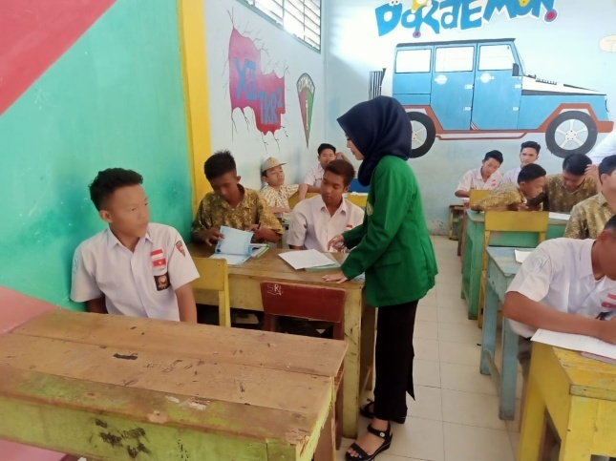
The teacher is making a group in the class
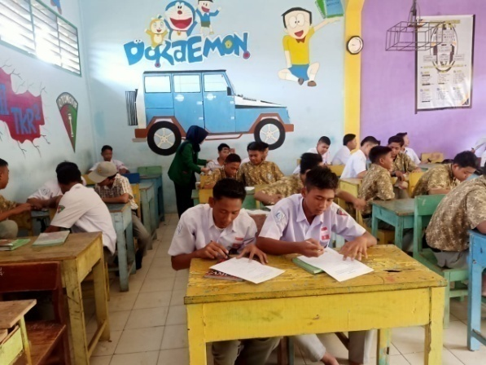
The students are doing treatment to read the topic

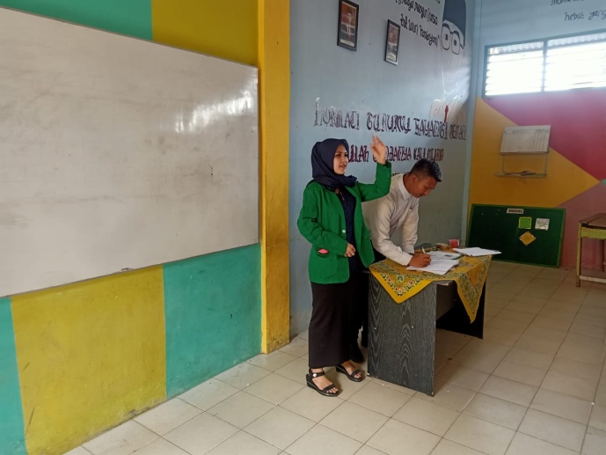
The teacher is asking the students to present their result infront of the class

APPENDIX E
The Score of Students’ Test

- Experimental Class
- Pre-Test
Highest Score
Lowest Score.

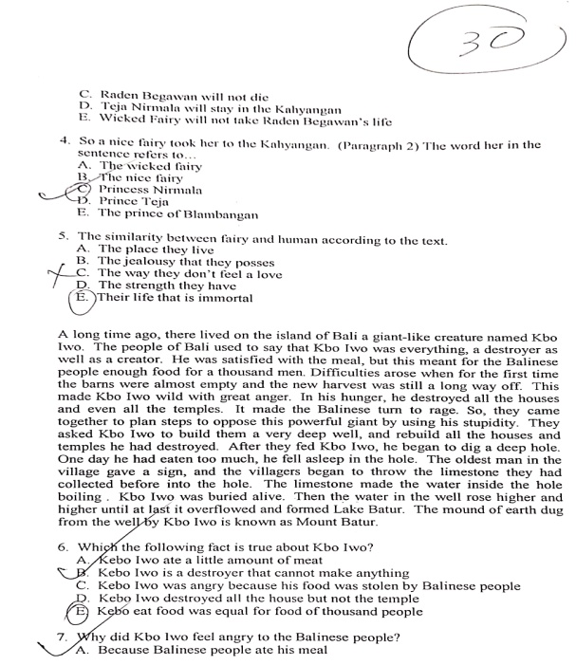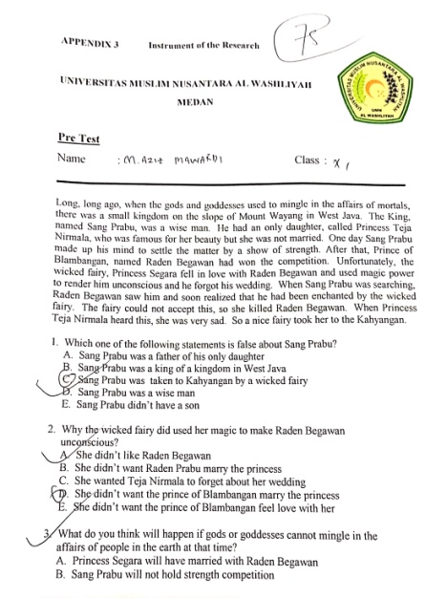

b. Post-Test
Highest Score.
Lowest Score.

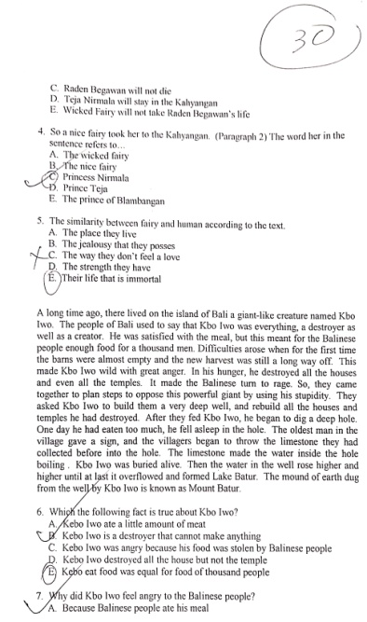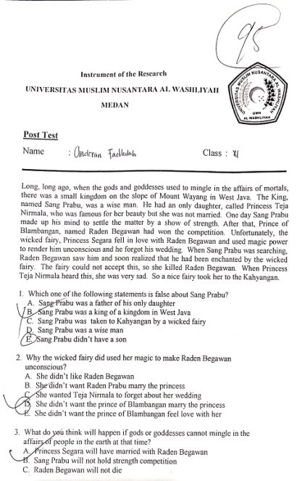
- Control Class

- Pre-Test
highest Score.
Lowest Score.
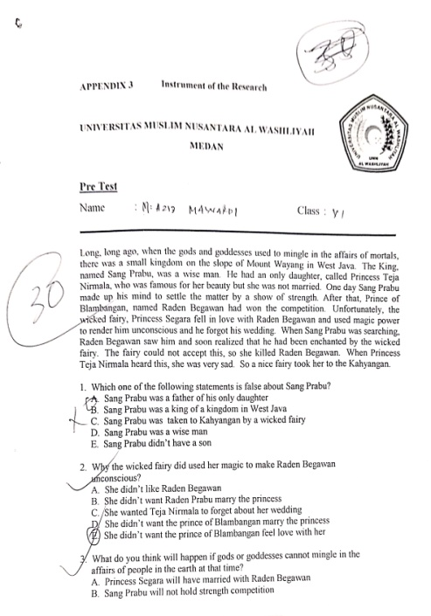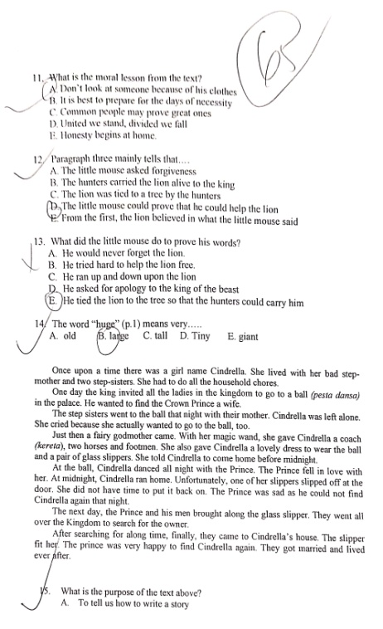

- Post-Test
Lowest Score.
Highest Score.
