IMPROVING STUDENTS’ VOCABULARY MASTERY THROUGH CROSSWORD TOWARD SEVENTH GRADE OF SMP SWASTA
BINA BERSAUDARA MEDAN

A Thesis

By

RIKA SURIANI
NPM : 171224076

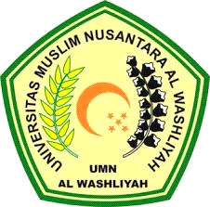

ENGLISH EDUCATION DEPARTMENT FACULTY OF TEACHER TRAINING AND EDUCATION UNIVERSITAS MUSLIM NUSANTARA AL WASHLIYAH
MEDAN
2021
IMPROVING STUDENTS’ VOCABULARY MASTERY THROUGH CROSSWORD TOWARD SEVENTH GRADE OF SMP SWASTA BINA BERSAUDARA MEDAN

A Thesis

Submitted to the Department of English Language Education in
Partial Fulfillment of the Requirements for the Degree of
Sarjana Pendidikan

By

RIKA SURIANI
NPM : 171224076

ENGLISH EDUCATION DEPARTMENT FACULTY OF TEACHER TRAINING AND EDUCATION UNIVERSITAS MUSLIM NUSANTARA AL WASHLIYAH
MEDAN
2021

