Lampiran 1. Hasil Determinasi Tumbuhan

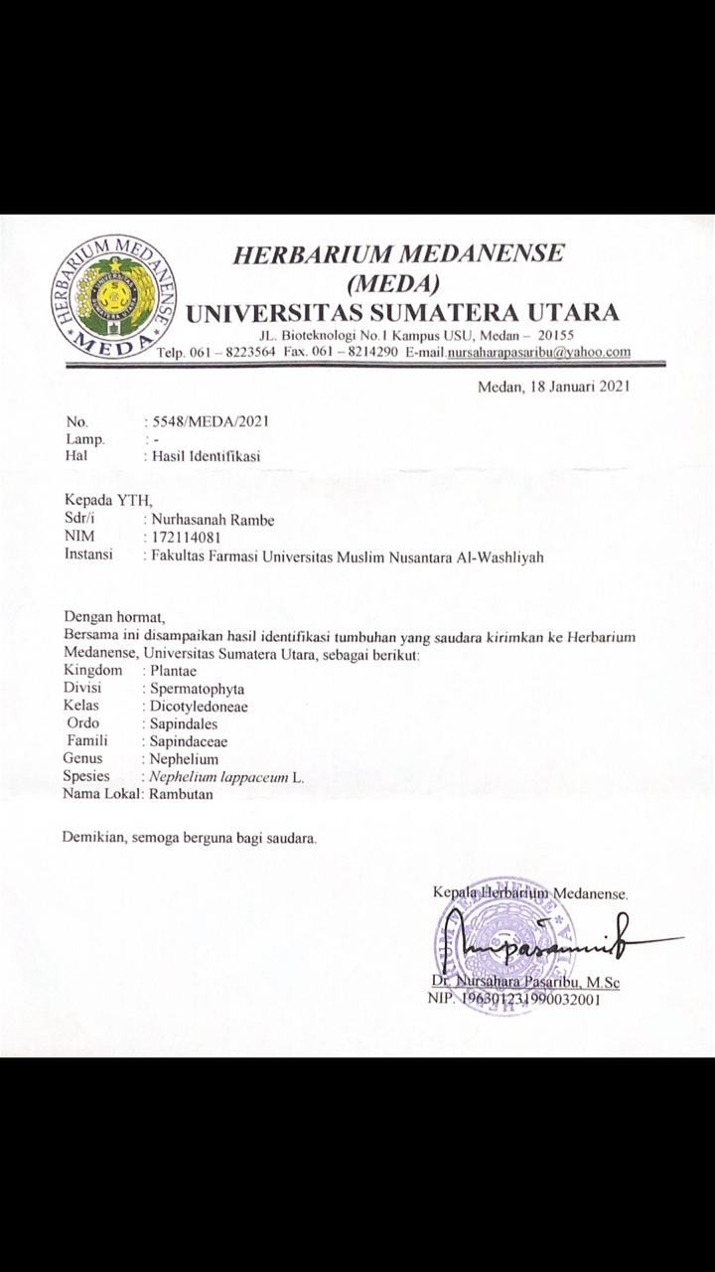

Lampiran 2. Ethical Clearance

Lampiran 3. Daun rambutan, makroskopik daun rambutan dan serbuk daun rambutan
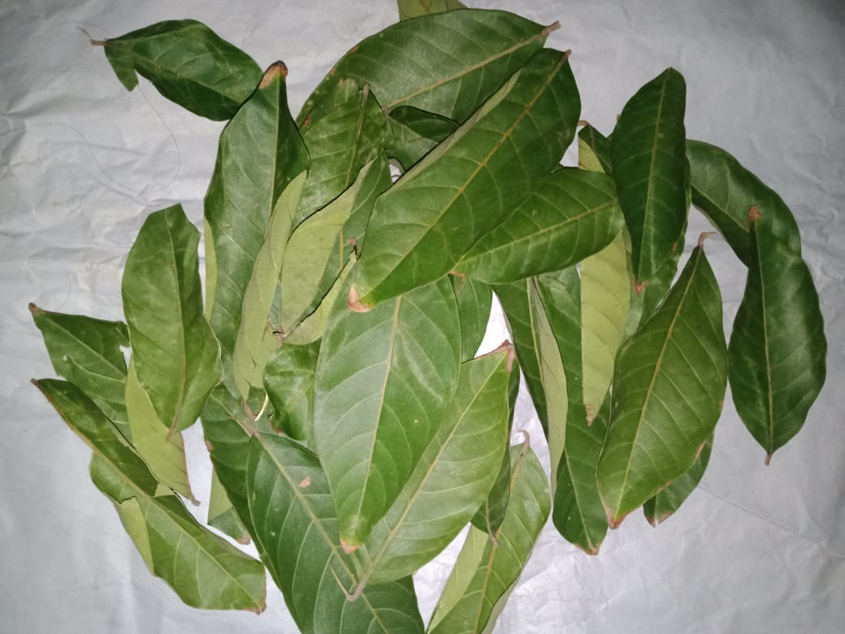

Simplisia Daun Rambutan

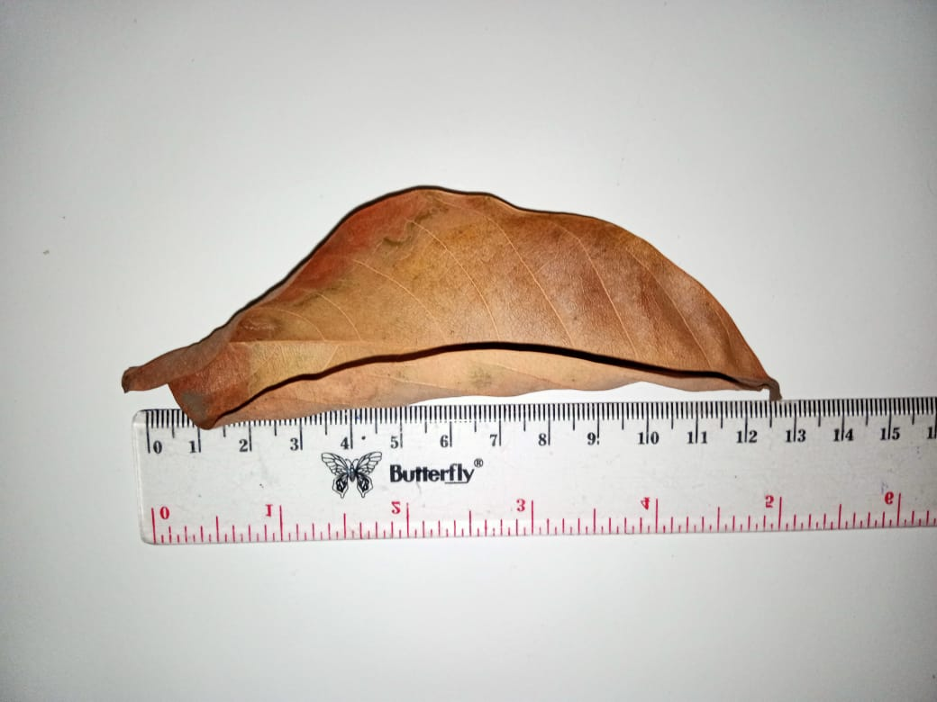

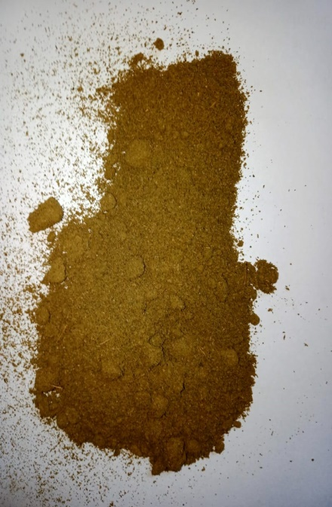
Makroskopik Simplisia Daun Rambutan

Serbuk Simplisia daun rambutan

Lampiran 4. Hasil Meserasi, Ekstrak Rambutan dan rotary

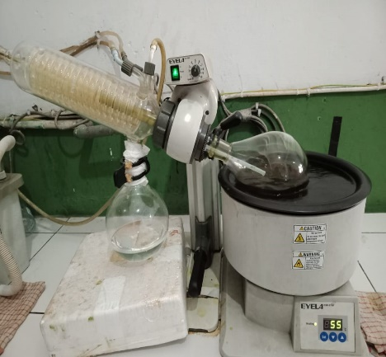

Proses Dalam Pembuatan Ekstrak (Rotary)

Maserat Daun Rambutan Ekstrak Etanol Daun Rambutan

Lampiran 5. Vaksin DPT HB (Penginduksi), Paracetamol Dan Termometer

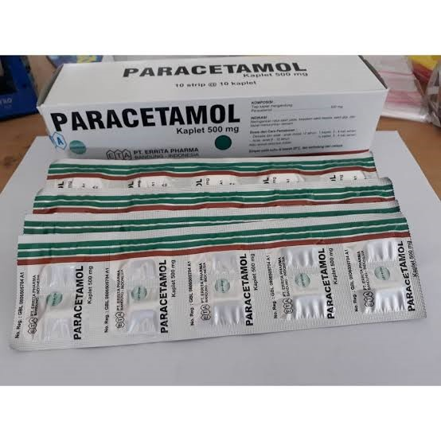
Vaksin DPT HB

Paracetamol

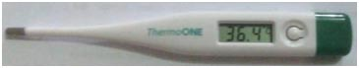

Termometer

Lampiran 6. Hasil Pemeriksaan Mikroskopik Daun Rambutan

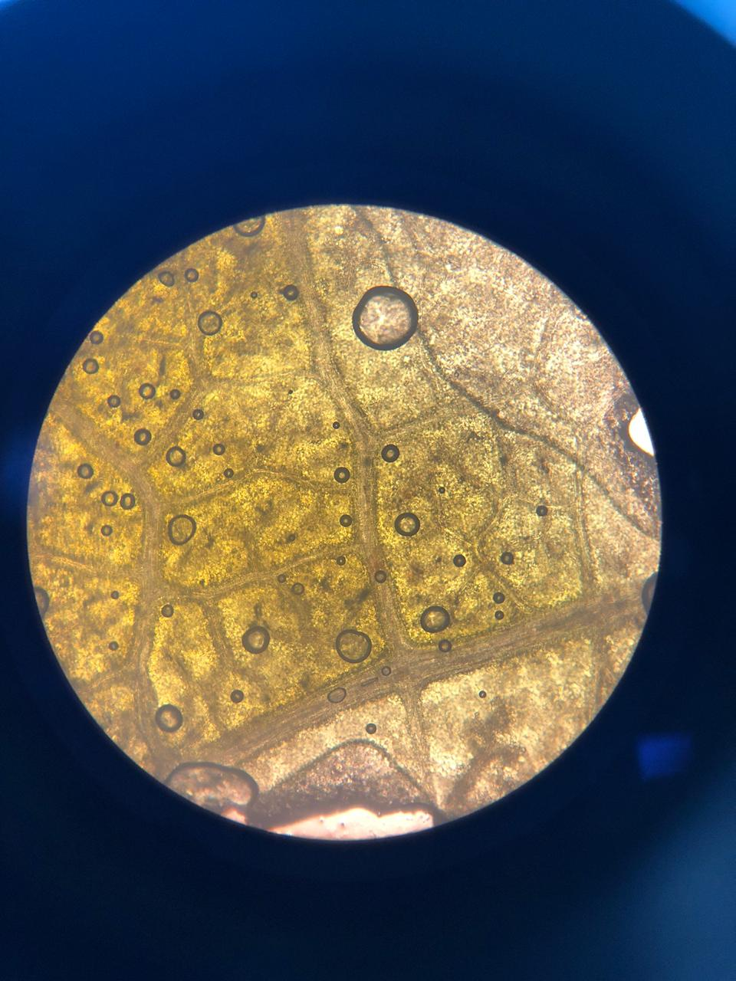

A

Mikroskopik Daun Rambutan
Keterangan

A : Sel epidermis Daun Rambutan

Lampiran 7. Penetapan Karakterisasi Simplisia
- Perhitungan penetapan kadar air simplisia
Berat sampel | Volume awal | Volume akhir
5 g | 1,6 ml | 1,8 ml
5 g | 1.6 ml | 1,9 ml
5 g | 1,5 ml | 1,8 ml
% Kadar air simplisia = $\frac{Volume akhir-Volume awal}{Berat sampel}$ x 100%

- Berat simplisia I = 5 g
% Kadar air = $\frac{1,8ml-1,6ml}{5 g}$ x 100% = 5%
- Berat simplisia II = 5 g
% Kadar air = $\frac{1,9ml-1,6ml}{5 g}$ x 100% = 6%
- Berat simplisia III = 5 g
% Kadar air = $\frac{1,8ml-1,5ml}{5 g}$ x 100% = 6%
% Kadar air rata-rata = $\frac{5\%+ 6\%+6\%}{ 3}$ = 5,6 %

Lampiran 7. (Lanjutan)
- Penetapan kadar sari larut dalam air
Berat sampel | Berat cawan kosong | Berat cawan berisi
5 g | 36,802 g | 36.994 g
5 g | 33,047 g | 33.235 g
5 g | 32.150 g | 32.335 g
% Kadar sari larut dalam air = berat cawan isi- berat cawan kosong x 100 X 100%
Berat sampel (g) 20

- Berat simplisia I = 5 g
% Kadar sari larut dalam air = 36,994 g – 36,802 g x 100 x 100% = 19 %
5 20
- Berat simplisia I I = 5 g
% Kadar sari larut dalam air = 33,235 g – 33,047 g x 100 x 100% = 18 %
5 20
- Berat simplisia I II = 5 g
% Kadar sari larut dalam air = 32,335 g – 32,150 g x 100 x 100% = 18 %
5 20
% Kadar sari rata-rata = $\frac{ 19 \%+18 \%+18 \%}{3}$ = 18,333 %

Lampiran 7. (Lanjutan)
- Penetapan kadar sari larut dalam etanol
Berat sampel | Berat cawan kosong | Berat cawan berisi
5 g | 35,623 g | 35,758 g
5 g | 33,150 g | 33,305 g
5 g | 34,022 g | 34,221 g
% Kadar sari larut dalam etanol = $\frac{\left(Berat cawan berisi - Berat cawan kosong\right) x 5}{Berat sampel}$ x 100%

- Berat simplisia I = 5 g
% Kadar sari larut etanol = $\frac{\left(35,758 g-35,623 g\right) x 5}{5 g}$ x 100% = 13 %

- Berat simplisia I I = 5 g
% Kadar sari larut etanol = $\frac{\left(33,305 g-33,150 g\right) x 5}{ 5 g}$ x 100% = 15%

- Berat simplisia I II = 5 g
% Kadar sari larut etanol = $\frac{\left(34.221 g-34.022 g\right) x 5}{5 g}$ x 100% = 19 %
% Kadar sari larut etanol rata-rata = $\frac{ 13 \%+15 \%+19 \%}{3}$ = 15` %

Lampiran 7. (Lanjutan)
- Penetapan kadar abu total
Berat sampel | Berat cawan kosong | Berat cawan berisi
2g | 58,23 g | 58,29 g
2g | 57,30 g | 57,34 g
2g | 59,50 g | 59,54 g

% Kadar abu total = $\frac{\left(Berat cawan berisi - Berat cawan kosong\right)}{Berat sampel}$ x 100%

- Berat simplisia I = 2 g
% Kadar abu total = $\frac{58,29g-58,23 g}{2 g}$ x 100% = 3 %

- Berat simplisia I I = 2 g
% Kadar abu total = $\frac{57,34g-57,30 g}{2 g}$ x 100% = 2 %

- Berat simplisia I II = 2 g
% Kadar abu total = $\frac{59,54g-59,50g}{2 g}$ x 100% = 2 %
% Kadar abu total rata-rata = $\frac{ 3 \% + 2\% + 2 \%}{3}$ = 2,3 %

Lampiran 7. (Lanjutan)
- Penetapan kadar abu tidak larut dalam asam
Berat sampel | Berat cawan kosong | Berat cawan berisi
2.5 g | 63,13 g | 63,18 g
2.5 g | 65,08 g | 65,12 g
2 .5 g | 60,26 g | 60,30 g

% Kadar abu tidak larut asam = $\frac{\left(Berat cawan berisi - Berat cawan kosong\right)}{Berat sampel}$ x 100%

- Berat simplisia I = 2 g
% Kadar abu tidak larut asam = $\frac{63,18g-63,13 g}{2 g}$ x 100% = 2,5 %

- Berat simplisia I I = 2 g
% Kadar abu tidak larut asam = $\frac{65,12g-65,08 g}{2 g}$ x 100% = 2 %

- Berat simplisia I II = 2 g
% Kadar abu tidak larut asam = $\frac{67,30g-60,26 g}{2 g}$ x 100% = 2 %
% Kadar abu tidak larut asam rata-rata = $\frac{ 2,5 \% + 2 \% + 2\%}{3}$ = 2,16 %

Lampiran 8. Skrining fitokimia serbuk simplisia
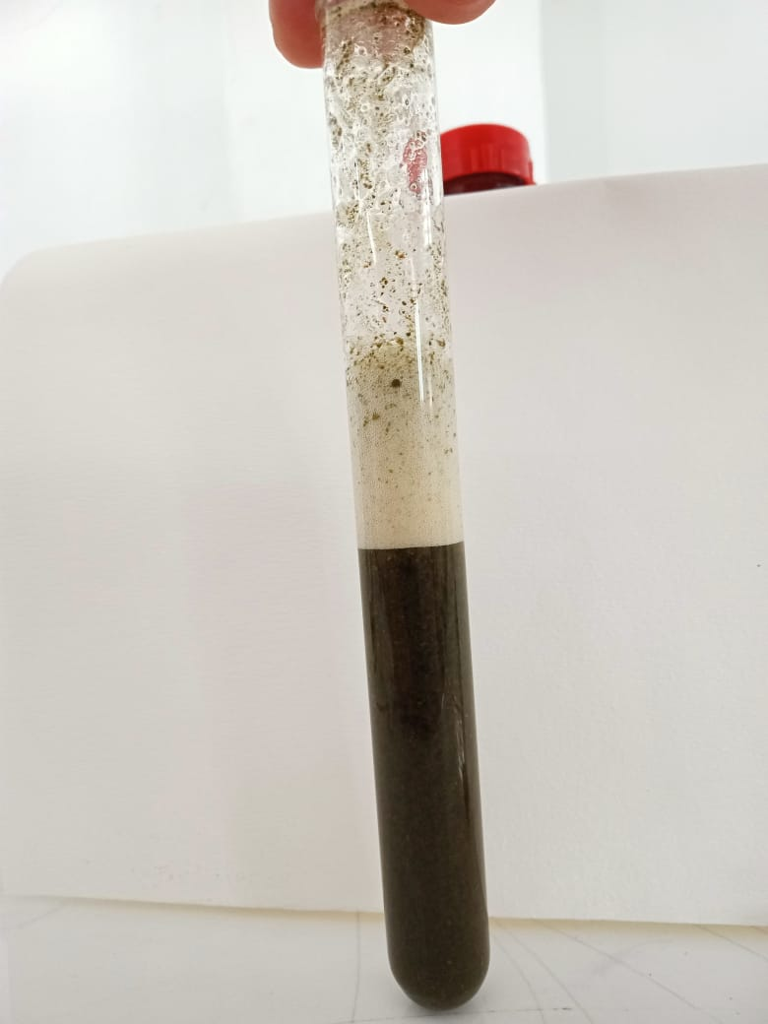
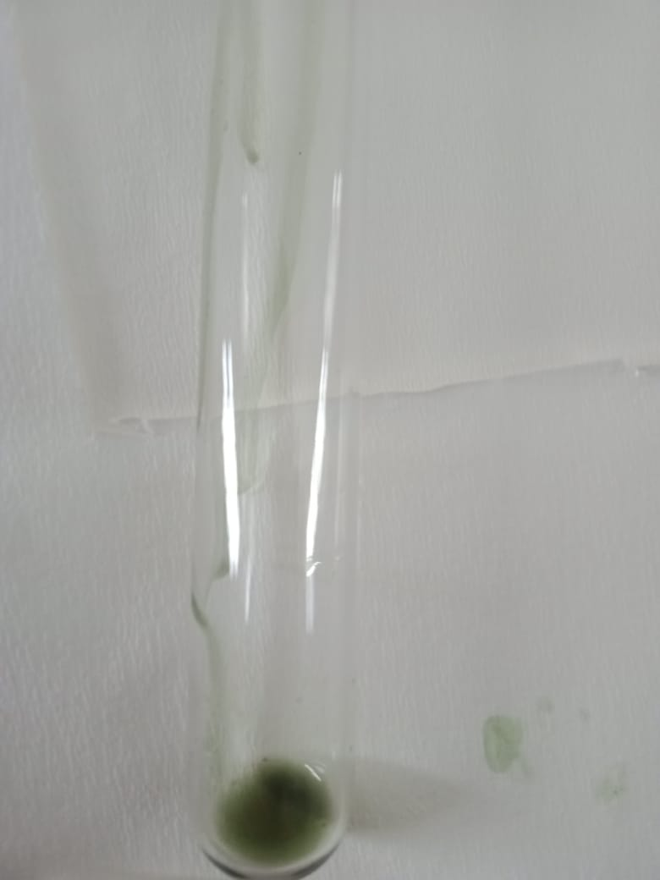

Saponin Tanin Steroid/Triterpernoid

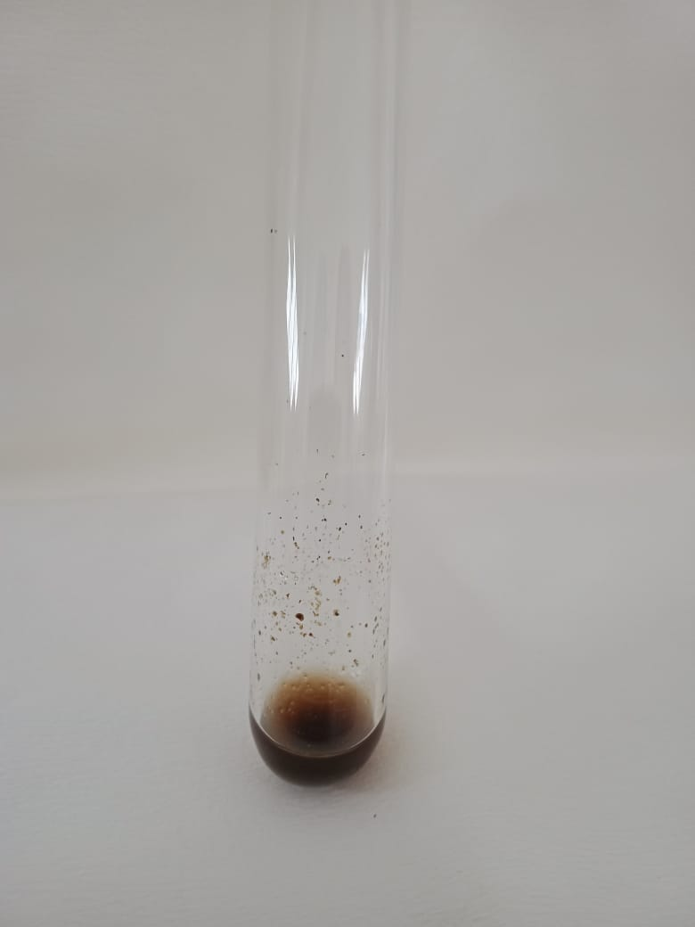
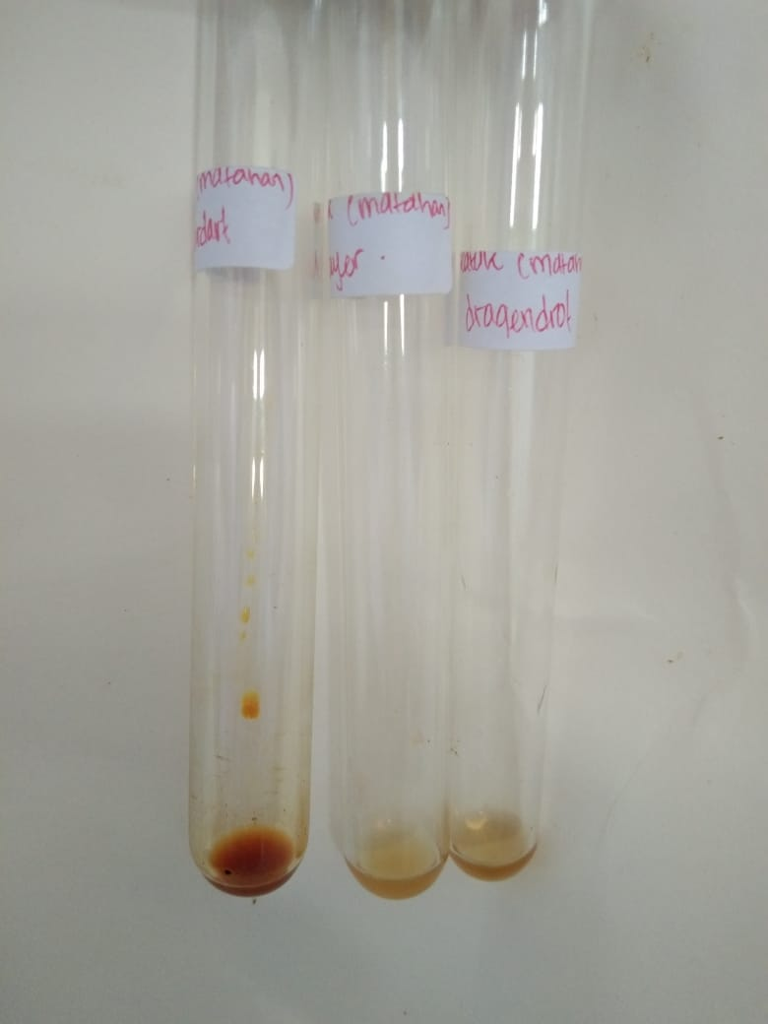

Flavanoid Alkaloid

Lampiran 9. Skrining fitokimia ekstrak simplisia

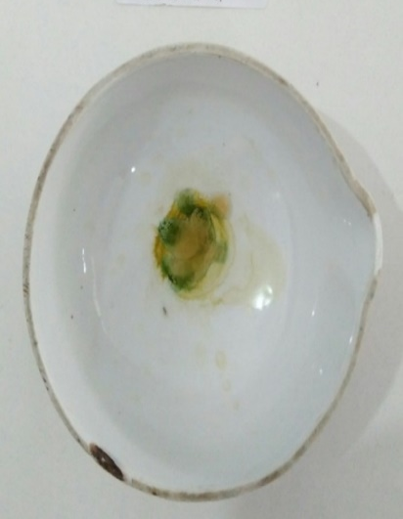
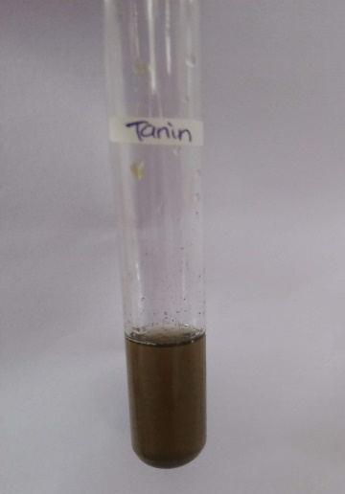
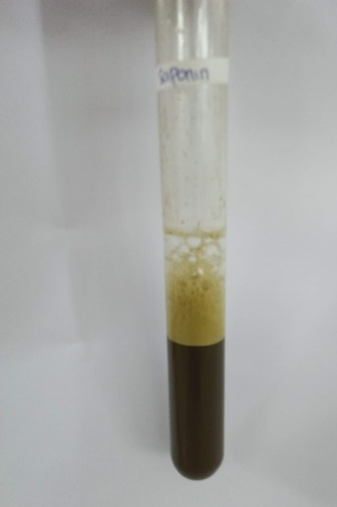

Saponin tanin steroid

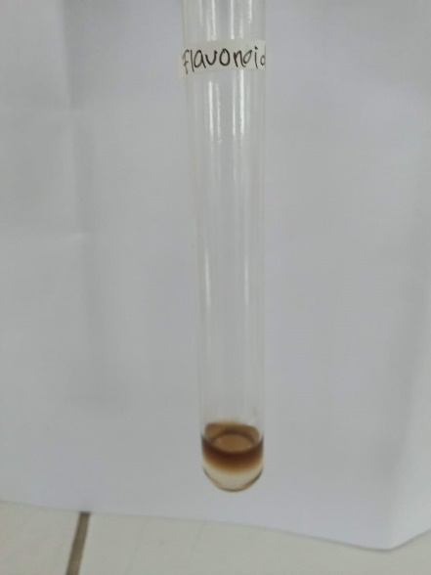

Flavonoid alkaloid

Lampiran 10. Bagan alir penelitian, bagan pembutan simplisia, bagan alir pembuatan ekstrak dan bagan alir uji efektivitas antipiretik

- Bagan alir penelitian
Daun Rambutan Segar
Daun Rambutan
Simplisia
Serbuk simplisia
Karakterisasi Simplisia
Meserasi Simplisia
Maserat
Ekstrak kental
- Penetapan kadar air
- Penetapan kadar abu
- Penetapan kadar abu tidak larut asam
- Penetapan kadar sari larut dalam air
- Penetapan kadar sari larut dalam etanol
Skrining fitokimia
Suspensi ekstrak
Rambutan
- Alkaloid
- Flavonoid
- Steroid/Triterpenoid
- Saponin
- Tanin
- Tannin
Uji efektivitas antipiretik pada tikus putih jantan
Dibersihkan dari pengotor
Dicuci bersih dan ditiriskan
Diangin-anginkan
Ditimbang

Dikeringkan pada suhu 40ºC
Ditimbang

Dihaluskan
Ditimbang

Direndam dengan etanol 96%

Diuapkan dengan rotary evaporator

Lampiran 10. (lanjutan)
2.Bagan alir pembuatan simplisia

Daun Rambutan

Disortasi Basah
Dicuci dengan air mengalir
Ditiriskan
Diangin-anginkan
Dirajang
Ditimbang

Berat Daun Rambutan setelah dirajang

Dikeringkan di dalam lemari pengering pada suhu ± 40ºC
Disortasi kering
Ditimbang

Berat simplisia 5.000 kg

Dihaluskan menggunakan blender
Ditimbang
Berat serbuk simplisia 700 g

Dimasukkan kedalam wadah tertutup rapat
Serbuk simplisia

Lampiran 10. (lanjutan)
3.Bagan alir pembuatan ekstrak
500 g Serbuk Simplisia Daun Rambutan

Diekstraksi dengan cara dimaserasi menggunakan pelarut etanol

Ekstrak kental
Karakterisasi simplisia
1.Makroskopik
2.Mikroskopik
3.PK Air
4.PK sari larut dalam etanol
5.PK sari larut dalam air
6.PK abu total
7.PK tidak larut dalam asam

4.PK
Pengujian efektivitas antipiretik terhadap tikus putih jantan

Skrining fitokimia
- Alkaloid
- Flavonoid
- Saponin
- Tanin
- Steroid/triterpenoid
Suspensi EEDR
Lampiran 10. (lanjutan)
4.Bagan alir pengujian farmakologi
25 ekor tikus putih jantan

Dipuasakan ± 18 jam
Kelompok 2
( 5 ekor )
Kelompok 5
( 5 ekor )
Pengukuran suhu awal
Kelompok 1
(5 ekor )
Kelompok 4
( 5 ekor )
Kelompok 3
( 5 ekor )
Pengukuran suhu awal 1 jam setelah pemberian vaksin DTP-HB
Diberi EEDR 50 mg/kg BB
Kontrol negatif diberi suspensi CMC 0,5%
Diberi EEDR 100 mg/kg BB
Analisis data

Diberi EEDR 200 mg/kg BB
kontrol positif diberi suspensi parasetamol 0,5%

Pengukuran suhu rektak dilakukan setiap 30 menit selama 3 jam

Lampiran 11. Perhitungan dosis
- Perhitungan dosis CMC 0,5%
CMC 0,5% = jumlah cmc / volume suspensi
= 0,5 g / 100 ml
= 500 mg / 100 ml
= 5 mg / ml
Perhitungan CMC 0,5% pada tikus dengan BB = 200 g
50
= X 200 g
100
= 1 ml

- Perhitungan dosis parasetamol
Konversi dosis parasetamol dari manusia (70 kg) ke tikus (200 g) = 0,018
Dosis parasetamol untuk manusia dewasa dengan BB (70 kg) = 500 mg
Maka dosis parasetamol pada tikus = dosis terapi manusia x 0,018
= 500 mg x 0,018
= 9 ml
Tikus 200 g 0,2 kg
9 mg
=
0,2 kg
= 45 mg / kg BB

Konsentrasi suspensi parasetamol
Suspensi parasetamol 0,5% = jumlah parasetamol / volume suspensi
= 5 g / 100 ml
= 500 mg / 100 ml
= 5 mg / ml

Lampiran 11. (lanjutan)
Dosis untuk tikus = Dosis parasetamol X BB tikus
= 45 mg x 0,2 kg
= 9 ml

Volume suspense yang diambil = dosis parasetamol untuk tikus

Konsentrasi suspense parasetamol
= 9 mg

5 mg / ml
= 1,8 ml

3.Perhitungan dosis EEDR 50 mg/kg
- Konsentrasi suspense EEDR
Konsentrasi EEDR 5% = jumlah EEDR / volume suspense
= 5000 mg /100 ml
= 50 mg/ml
- BB tikus 200 g atau 0,2 kg
- Perhitungan dosis 50 mg/kg BB
= 50
X 200 g
1000
= 10 mg
Volume suspensi yang diberikan = Dosis EEDR

Konsentrasi
= 10 mg

50 mg/ml
= 0,2
Lampiran 11. (lanjutan)
4.Perhitungan dosis EEDR 100 mg/kg BB
- Konsentrasi suspensi EEDR
Konsentrasi EEDR 5% = jumlah EEDR / volume suspense
= 5000 mg / 100 ml
= 50 mg/ml
- BB tikus 200 g atau 0,2 kg
- Perhitungan dosis 100 mg/kg BB
= 100 mg
X 200 g
1000 g
= 20 mg
- Volume suspensi yang diberikan = Dosis EEDR
Konsentrasi
= 20 mg
50 mg/ml
= 0,4 ml
- Perhitungan dosis EEDR 200 mg/kg BB
- Konsentrasi suspensi EEDR
Konsentrasi EEDR 5% = jumlah EEDG / volume suspensi
= 5000 mg / 100 ml
= 50 mg/ml
- BB tikus 200 g atau 0,2 kg
- Perhitungan dosis 200 mg/kg BB
= 20mg
Volume suspensi yang diberikan = dosis EEDR
Konsentrasi
40 mg
50 mg/ml = 0,8 ml
Lampiran 12. Data perlakuan hewan
Perlakuan | Hewan | Suhu awal | Suhu demam | Suhu rektal tikus (⁰C) selang 30 menit
 |  |  |  | 30 | 60 | 90 | 120 | 150 | 180
Kontrol Negatif CMC 0,5% | 1 | 36,8 | 38,3 | 38,2 | 38,2 | 38,1 | 38 | 38 | 38
 | 2 | 36,9 | 38,1 | 38,1 | 38,1 | 38 | 37,9 | 37,8 | 37,7
 | 3 | 37 | 38,2 | 38 | 38 | 37,9 | 37,7 | 37,7 | 37,6
 | 4 | 36,9 | 38,3 | 38,2 | 38,2 | 38 | 38 | 37,9 | 37,9
 | 5 | 37 | 38 | 37,9 | 37,9 | 37,8 | 37,6 | 37,6 | 37,5
Kontrol positif parasetamol | 1 | 36,7 | 38,2 | 37,7 | 37,5 | 37,4 | 37,1 | 37 | 36,7
 | 2 | 36,8 | 38 | 37,7 | 37,5 | 37,4 | 37,2 | 37 | 36,8
 | 3 | 37 | 38,3 | 38 | 37,8 | 37,7 | 37,5 | 37,2 | 36,9
 | 4 | 36,9 | 38,1 | 37,9 | 37,7 | 37,5 | 37,4 | 37,2 | 37
 | 5 | 36,9 | 38 | 37,8 | 37,5 | 37,4 | 37,3 | 37,1 | 36,8
EEDR 50 mg/kg BB | 1 | 36,8 | 38 | 37,9 | 37,7 | 37,6 | 37,5 | 37,4 | 37,2
 | 2 | 36,7 | 38,4 | 38,2 | 37,9 | 37,8 | 37,7 | 37,5 | 37,4
 | 3 | 37 | 38,1 | 37,9 | 37,6 | 37,5 | 37,4 | 37,3 | 37,1
 | 4 | 36,6 | 38,2 | 38 | 37,8 | 37,7 | 37,5 | 37,3 | 37,2
 | 5 | 36,9 | 38,3 | 38,1 | 37,9 | 37,8 | 37,6 | 37,5 | 37,3
EEDR 100 mg/kg BB | 1 | 36,5 | 38,1 | 37,8 | 37,7 | 37,6 | 37,5 | 37,4 | 37,2
 | 2 | 36,6 | 38,2 | 38 | 37,8 | 37,6 | 37,4 | 37,2 | 37
 | 3 | 37 | 38,2 | 37,7 | 37,6 | 37,5 | 37,4 | 37,2 | 37
 | 4 | 36,8 | 38,3 | 38 | 37,9 | 37,7 | 37,5 | 37,3 | 37,2
 | 5 | 36,7 | 38 | 37,8 | 37,7 | 37,6 | 37,5 | 37,4 | 37,1
EEDR 200 mg/kg BB | 1 | 36,6 | 38 | 37,7 | 37,5 | 37,4 | 37,2 | 37,1 | 36,8
 | 2 | 36,9 | 38,1 | 37,9 | 37,6 | 37,5 | 37,4 | 37,3 | 36,6
 | 3 | 36,8 | 38,1 | 38 | 37,7 | 37,6 | 37,2 | 36,8 | 36,5
 | 4 | 36,7 | 38,2 | 37,6 | 37,4 | 37,4 | 37,3 | 37,2 | 37
 | 5 | 36,5 | 38,3 | 37 | 37,2 | 37 | 36,8 | 36,6 | 36,5

Lampiran 13. Tabel konversi dosis (g).
Konvensi | Mencit  20 g | Tikus  200 g | Marmut  400 g | Kelinci  1,5 kg | Kucing  1,5 kg | Kera  4 kg | Anjing  12 kg | Manusia  70 kg
Mencit  20 g | 1,0 | 7,0 | 12,23 | 27,80 | 29,70 | 64,10 | 124,20 | 387,9
Tikus  200 g | 0,14 | 1,0 | 1,74 | 3,90 | 4,20 | 9,20 | 17,80 | 56,0
Marmut  400 g | 0,08 | 0,57 | 1,0 | 2,25 | 2,40 | 5,20 | 10,20 | 31,50
Kelinci  1,5 g | 0,04 | 0,25 | 0,44 | 1,0 | 1,08 | 2,40 | 4,50 | 14,20
Kucing  1,5 g | 0,03 | 0,23 | 0,41 | 0,92 | 1,0 | 2,20 | 4,10 | 13,0
Kera  4 kg | 0,016 | 0,11 | 0,19 | 0,42 | 0,43 | 0,1 | 1,9 | 6,1
Anjing  12 kg | 0,008 | 0,06 | 0,10 | 0,22 | 1,24 | 0,52 | 1,0 | 3,10
Manusia  70 kg | 0,0026 | 0,018 | 0,031 | 0,07 | 0,076 | 0,16 | 0,32 | 1,0

Lampiran 14. Tabel volume maksimum lambung pada hewan (ml)
Jenis hewan  Uji | Volume maksimum ( ml) sesuai jalur pemberian
 | i.v | i.m | i.p | s.c | p.o
Mencit  (20-30 g) | 0,5 | 0,05 | 1,0 | 0,5-1,0 | 1,0
Tikus  (200 g) | 1,0 | 0,1 | 2-5 | 2-5 | 5,0
Hamster  (50 g) | - | 0,1 | 1-2 | 2,5 | 2,5
Marmut  (250 g) | - | 0,25 | 2-5 | 5,0 | 10,0
Kelinci  (3 kg) | 5-10 | 0,5 | 10-20 | 5-10 | 20,0
Kucing  (3kg) | 5-10 | 1,0 | 10-20 | 5-10 | 50,0
Anjing  (5 kg) | 10-20 | 5,0 | 20-50 | 10,0 | 100,0
Lampiran 15. Hasil SPSS,ANOVA, Dan DUNCAN
Descriptives
 |  |  | Mean | Std. Deviation | Std. Error | 95% Confidence Interval for Mean |  | Minimum | Maximum
 |  |  |  |  |  | Lower Bound | Upper Bound
suhu_awal | CMC 0,5% | 5 | 36,9200 | ,08367 | ,03742 | 36,8161 | 37,0239 | 36,80 | 37,00
 | PCT | 5 | 36,8600 | ,11402 | ,05099 | 36,7184 | 37,0016 | 36,70 | 37,00
 | EEDR50 Mg/kg BB | 5 | 36,8000 | ,15811 | ,07071 | 36,6037 | 36,9963 | 36,60 | 37,00
 | EEDR100 Mg/kg BB | 5 | 36,7200 | ,19235 | ,08602 | 36,4812 | 36,9588 | 36,50 | 37,00
 | EEDR200 Mg/kg BB | 5 | 36,7000 | ,15811 | ,07071 | 36,5037 | 36,8963 | 36,50 | 36,90
 | Total | 25 | 36,8000 | ,15811 | ,03162 | 36,7347 | 36,8653 | 36,50 | 37,00
suhu_demam | CMC 0,5% | 5 | 37,8800 | ,61400 | ,27459 | 37,1176 | 38,6424 | 36,80 | 38,30
 | PCT | 5 | 38,1200 | ,13038 | ,05831 | 37,9581 | 38,2819 | 38,00 | 38,30
 | EEDR50 Mg/kg BB | 5 | 38,2000 | ,15811 | ,07071 | 38,0037 | 38,3963 | 38,00 | 38,40
 | EEDR100 Mg/kg BB | 5 | 38,1600 | ,11402 | ,05099 | 38,0184 | 38,3016 | 38,00 | 38,30
 | EEDR200 Mg/kg BB | 5 | 38,1400 | ,11402 | ,05099 | 37,9984 | 38,2816 | 38,00 | 38,30
 | Total | 25 | 38,1000 | ,29580 | ,05916 | 37,9779 | 38,2221 | 36,80 | 38,40
menit30 | CMC 0,5% | 5 | 38,0800 | ,13038 | ,05831 | 37,9181 | 38,2419 | 37,90 | 38,20
 | PCT | 5 | 37,8200 | ,13038 | ,05831 | 37,6581 | 37,9819 | 37,70 | 38,00
 | EEDR50 Mg/kg BB | 5 | 38,0200 | ,13038 | ,05831 | 37,8581 | 38,1819 | 37,90 | 38,20
 | EEDR100 Mg/kg BB | 5 | 37,8600 | ,13416 | ,06000 | 37,6934 | 38,0266 | 37,70 | 38,00
 | EEDR200 Mg/kg BB | 5 | 37,6400 | ,39115 | ,17493 | 37,1543 | 38,1257 | 37,00 | 38,00
 | Total | 25 | 37,8840 | ,24947 | ,04989 | 37,7810 | 37,9870 | 37,00 | 38,20
menit60 | CMC 0,5% | 5 | 38,0800 | ,13038 | ,05831 | 37,9181 | 38,2419 | 37,90 | 38,20
 | PCT | 5 | 37,6000 | ,14142 | ,06325 | 37,4244 | 37,7756 | 37,50 | 37,80
 | EEDR50 Mg/kg BB | 5 | 37,7800 | ,13038 | ,05831 | 37,6181 | 37,9419 | 37,60 | 37,90
 | EEDR100 Mg/kg BB | 5 | 37,7400 | ,11402 | ,05099 | 37,5984 | 37,8816 | 37,60 | 37,90
 | EEDR200 Mg/kg BB | 5 | 37,4800 | ,19235 | ,08602 | 37,2412 | 37,7188 | 37,20 | 37,70
 | Total | 25 | 37,7360 | ,24474 | ,04895 | 37,6350 | 37,8370 | 37,20 | 38,20
menit90 | CMC 0,5% | 5 | 37,9600 | ,11402 | ,05099 | 37,8184 | 38,1016 | 37,80 | 38,10
 | PCT | 5 | 37,4800 | ,13038 | ,05831 | 37,3181 | 37,6419 | 37,40 | 37,70
 | EEDR50 Mg/kg BB | 5 | 37,6800 | ,13038 | ,05831 | 37,5181 | 37,8419 | 37,50 | 37,80
 | EEDR100 Mg/kg BB | 5 | 37,6000 | ,07071 | ,03162 | 37,5122 | 37,6878 | 37,50 | 37,70
 | EEDR200 Mg/kg BB | 5 | 37,3800 | ,22804 | ,10198 | 37,0969 | 37,6631 | 37,00 | 37,60
 | Total | 25 | 37,6200 | ,24152 | ,04830 | 37,5203 | 37,7197 | 37,00 | 38,10
menit120 | CMC 0,5% | 5 | 37,8400 | ,18166 | ,08124 | 37,6144 | 38,0656 | 37,60 | 38,00
 | PCT | 5 | 37,3000 | ,15811 | ,07071 | 37,1037 | 37,4963 | 37,10 | 37,50
 | EEDR50 Mg/kg BB | 5 | 37,5400 | ,11402 | ,05099 | 37,3984 | 37,6816 | 37,40 | 37,70
 | EEDR100 Mg/kg BB | 5 | 37,4600 | ,05477 | ,02449 | 37,3920 | 37,5280 | 37,40 | 37,50
 | EEDR200 Mg/kg BB | 5 | 37,1800 | ,22804 | ,10198 | 36,8969 | 37,4631 | 36,80 | 37,40
 | Total | 25 | 37,4640 | ,27215 | ,05443 | 37,3517 | 37,5763 | 36,80 | 38,00
menit150 | CMC 0,5% | 5 | 37,8000 | ,15811 | ,07071 | 37,6037 | 37,9963 | 37,60 | 38,00
 | PCT | 5 | 37,1000 | ,10000 | ,04472 | 36,9758 | 37,2242 | 37,00 | 37,20
 | EEDR50 Mg/kg BB | 5 | 37,4000 | ,10000 | ,04472 | 37,2758 | 37,5242 | 37,30 | 37,50
 | EEDR100 Mg/kg BB | 5 | 37,3000 | ,10000 | ,04472 | 37,1758 | 37,4242 | 37,20 | 37,40
 | EEDR200 Mg/kg BB | 5 | 37,0000 | ,29155 | ,13038 | 36,6380 | 37,3620 | 36,60 | 37,30
 | Total | 25 | 37,3200 | ,32275 | ,06455 | 37,1868 | 37,4532 | 36,60 | 38,00
menit180 | CMC 0,5% | 5 | 37,7400 | ,20736 | ,09274 | 37,4825 | 37,9975 | 37,50 | 38,00
 | PCT | 5 | 36,8400 | ,11402 | ,05099 | 36,6984 | 36,9816 | 36,70 | 37,00
 | EEDR50 Mg/kg BB | 5 | 37,2400 | ,11402 | ,05099 | 37,0984 | 37,3816 | 37,10 | 37,40
 | EEDR100 Mg/kg BB | 5 | 37,1000 | ,10000 | ,04472 | 36,9758 | 37,2242 | 37,00 | 37,20
 | EEDR200 Mg/kg BB | 5 | 36,6800 | ,21679 | ,09695 | 36,4108 | 36,9492 | 36,50 | 37,00
 | Total | 25 | 37,1200 | ,40104 | ,08021 | 36,9545 | 37,2855 | 36,50 | 38,00

Tests of Normality
 | perlakuan | Kolmogorov-Smirnovª |  |  | Shapiro-Wilk
 |  | Statistic | df | Sig. | Statistic | df | Sig.
suhu_awal | CMC 0,5% | ,231 | 5 | ,200* | ,881 | 5 | ,314
 | PCT | ,237 | 5 | ,200* | ,961 | 5 | ,814
 | EEDR50 Mg/kg BB | ,136 | 5 | ,200* | ,987 | 5 | ,967
 | EEDR100 Mg/kg BB | ,141 | 5 | ,200* | ,979 | 5 | ,928
 | EEDR200 Mg/kg BB | ,136 | 5 | ,200* | ,987 | 5 | ,967
suhu_demam | CMC 0,5% | ,377 | 5 | ,019 | ,724 | 5 | ,017
 | PCT | ,221 | 5 | ,200* | ,902 | 5 | ,421
 | EEDR50 Mg/kg BB | ,136 | 5 | ,200* | ,987 | 5 | ,967
 | EEDR100 Mg/kg BB | ,237 | 5 | ,200* | ,961 | 5 | ,814
 | EEDR200 Mg/kg BB | ,237 | 5 | ,200* | ,961 | 5 | ,814
menit30 | CMC 0,5% | ,221 | 5 | ,200* | ,902 | 5 | ,421
 | PCT | ,221 | 5 | ,200* | ,902 | 5 | ,421
 | EEDR50 Mg/kg BB | ,221 | 5 | ,200* | ,902 | 5 | ,421
 | EEDR100 Mg/kg BB | ,273 | 5 | ,200* | ,852 | 5 | ,201
 | EEDR200 Mg/kg BB | ,259 | 5 | ,200* | ,888 | 5 | ,345
menit60 | CMC 0,5% | ,221 | 5 | ,200* | ,902 | 5 | ,421
 | PCT | ,360 | 5 | ,033 | ,767 | 5 | ,042
 | EEDR50 Mg/kg BB | ,221 | 5 | ,200* | ,902 | 5 | ,421
 | EEDR100 Mg/kg BB | ,237 | 5 | ,200* | ,961 | 5 | ,814
 | EEDR200 Mg/kg BB | ,141 | 5 | ,200* | ,979 | 5 | ,928
menit90 | CMC 0,5% | ,237 | 5 | ,200* | ,961 | 5 | ,814
 | PCT | ,330 | 5 | ,079 | ,735 | 5 | ,021
 | EEDR50 Mg/kg BB | ,221 | 5 | ,200* | ,902 | 5 | ,421
 | EEDR100 Mg/kg BB | ,300 | 5 | ,161 | ,883 | 5 | ,325
 | EEDR200 Mg/kg BB | ,335 | 5 | ,069 | ,860 | 5 | ,228
menit120 | CMC 0,5% | ,229 | 5 | ,200* | ,867 | 5 | ,254
 | PCT | ,136 | 5 | ,200* | ,987 | 5 | ,967
 | EEDR50 Mg/kg BB | ,237 | 5 | ,200* | ,961 | 5 | ,814
 | EEDR100 Mg/kg BB | ,367 | 5 | ,026 | ,684 | 5 | ,006
 | EEDR200 Mg/kg BB | ,335 | 5 | ,069 | ,860 | 5 | ,228
menit150 | CMC 0,5% | ,136 | 5 | ,200* | ,987 | 5 | ,967
 | PCT | ,241 | 5 | ,200* | ,821 | 5 | ,119
 | EEDR50 Mg/kg BB | ,241 | 5 | ,200* | ,821 | 5 | ,119
 | EEDR100 Mg/kg BB | ,241 | 5 | ,200* | ,821 | 5 | ,119
 | EEDR200 Mg/kg BB | ,234 | 5 | ,200* | ,928 | 5 | ,585
menit180 | CMC 0,5% | ,180 | 5 | ,200* | ,952 | 5 | ,754
 | PCT | ,237 | 5 | ,200* | ,961 | 5 | ,814
 | EEDR50 Mg/kg BB | ,237 | 5 | ,200* | ,961 | 5 | ,814
 | EEDR100 Mg/kg BB | ,241 | 5 | ,200* | ,821 | 5 | ,119
 | EEDR200 Mg/kg BB | ,244 | 5 | ,200* | ,871 | 5 | ,272
*. This is a lower bound of the true significance.
a. Lilliefors Significance Correction

Test of Homogeneity of Variances
 | Levene Statistic | df1 | df2 | Sig.
suhu_awal | ,808 | 4 | 20 | ,534
suhu_demam | 3,454 | 4 | 20 | ,027
menit30 | 1,884 | 4 | 20 | ,153
menit60 | ,479 | 4 | 20 | ,750
menit90 | 1,042 | 4 | 20 | ,411
menit120 | 1,316 | 4 | 20 | ,298
menit150 | 4,615 | 4 | 20 | ,008
menit180 | 2,305 | 4 | 20 | ,094

ANOVA
 |  | Sum of Squares | df | Mean Square | F | Sig.
suhu_awal | Between Groups | ,172 | 4 | ,043 | 2,009 | ,132
 | Within Groups | ,428 | 20 | ,021
 | Total | ,600 | 24
suhu_demam | Between Groups | ,320 | 4 | ,080 | ,899 | ,483
 | Within Groups | 1,780 | 20 | ,089
 | Total | 2,100 | 24
menit30 | Between Groups | ,606 | 4 | ,151 | 3,410 | ,028
 | Within Groups | ,888 | 20 | ,044
 | Total | 1,494 | 24
menit60 | Between Groups | 1,022 | 4 | ,255 | 12,279 | ,000
 | Within Groups | ,416 | 20 | ,021
 | Total | 1,438 | 24
menit90 | Between Groups | ,984 | 4 | ,246 | 11,827 | ,000
 | Within Groups | ,416 | 20 | ,021
 | Total | 1,400 | 24
menit120 | Between Groups | 1,274 | 4 | ,318 | 12,635 | ,000
 | Within Groups | ,504 | 20 | ,025
 | Total | 1,778 | 24
menit150 | Between Groups | 1,940 | 4 | ,485 | 17,321 | ,000
 | Within Groups | ,560 | 20 | ,028
 | Total | 2,500 | 24
menit180 | Between Groups | 3,356 | 4 | ,839 | 33,294 | ,000
 | Within Groups | ,504 | 20 | ,025
 | Total | 3,860 | 24

suhu_awal
Duncan
perlakuan | N | Subset for alpha = 0.05
 |  | 1 | 2
EEDR200 Mg/kg BB | 5 | 36,7000
EEDR100 Mg/kg BB | 5 | 36,7200 | 36,7200
EEDR50 Mg/kg BB | 5 | 36,8000 | 36,8000
PCT | 5 | 36,8600 | 36,8600
CMC 0,5% | 5 |  | 36,9200
Sig. |  | ,127 | ,060
Means for groups in homogeneous subsets are displayed.
a. Uses Harmonic Mean Sample Size = 5,000.

suhu_demam
Duncan
perlakuan | N | Subset for alpha = 0.05
 |  | 1
CMC 0,5% | 5 | 37,8800
PCT | 5 | 38,1200
EEDR200 Mg/kg BB | 5 | 38,1400
EEDR100 Mg/kg BB | 5 | 38,1600
EEDR50 Mg/kg BB | 5 | 38,2000
Sig. |  | ,142
Means for groups in homogeneous subsets are displayed.
a. Uses Harmonic Mean Sample Size = 5,000.

menit30
Duncan
perlakuan | N | Subset for alpha = 0.05
 |  | 1 | 2
EEDR200 Mg/kg BB | 5 | 37,6400
PCT | 5 | 37,8200 | 37,8200
EEDR100 Mg/kg BB | 5 | 37,8600 | 37,8600
EEDR50 Mg/kg BB | 5 |  | 38,0200
CMC 0,5% | 5 |  | 38,0800
Sig. |  | ,133 | ,087
Means for groups in homogeneous subsets are displayed.
a. Uses Harmonic Mean Sample Size = 5,000.

menit60
Duncan
perlakuan | N | Subset for alpha = 0.05
 |  | 1 | 2 | 3
EEDR200 Mg/kg BB | 5 | 37,4800
PCT | 5 | 37,6000 | 37,6000
EEDR100 Mg/kg BB | 5 |  | 37,7400
EEDR50 Mg/kg BB | 5 |  | 37,7800
CMC 0,5% | 5 |  |  | 38,0800
Sig. |  | ,203 | ,075 | 1,000
Means for groups in homogeneous subsets are displayed.
a. Uses Harmonic Mean Sample Size = 5,000.

menit90
Duncan
perlakuan | N | Subset for alpha = 0.05
 |  | 1 | 2 | 3 | 4
EEDR200 Mg/kg BB | 5 | 37,3800
PCT | 5 | 37,4800 | 37,4800
EEDR100 Mg/kg BB | 5 |  | 37,6000 | 37,6000
EEDR50 Mg/kg BB | 5 |  |  | 37,6800
CMC 0,5% | 5 |  |  |  | 37,9600
Sig. |  | ,286 | ,203 | ,391 | 1,000
Means for groups in homogeneous subsets are displayed.
menit120
Duncan
perlakuan | N | Subset for alpha = 0.05
 |  | 1 | 2 | 3 | 4
EEDR200 Mg/kg BB | 5 | 37,1800
PCT | 5 | 37,3000 | 37,3000
EEDR100 Mg/kg BB | 5 |  | 37,4600 | 37,4600
EEDR50 Mg/kg BB | 5 |  |  | 37,5400
CMC 0,5% | 5 |  |  |  | 37,8400
Sig. |  | ,246 | ,127 | ,435 | 1,000
Means for groups in homogeneous subsets are displayed.
a. Uses Harmonic Mean Sample Size = 5,000.

menit90
Duncan
perlakuan | N | Subset for alpha = 0.05
 |  | 1 | 2 | 3 | 4
EEDR200 Mg/kg BB | 5 | 37,3800
PCT | 5 | 37,4800 | 37,4800
EEDR100 Mg/kg BB | 5 |  | 37,6000 | 37,6000
EEDR50 Mg/kg BB | 5 |  |  | 37,6800
CMC 0,5% | 5 |  |  |  | 37,9600
Sig. |  | ,286 | ,203 | ,391 | 1,000
Means for groups in homogeneous subsets are displayed.
menit120
Duncan
perlakuan | N | Subset for alpha = 0.05
 |  | 1 | 2 | 3 | 4
EEDR200 Mg/kg BB | 5 | 37,1800
PCT | 5 | 37,3000 | 37,3000
EEDR100 Mg/kg BB | 5 |  | 37,4600 | 37,4600
EEDR50 Mg/kg BB | 5 |  |  | 37,5400
CMC 0,5% | 5 |  |  |  | 37,8400
Sig. |  | ,246 | ,127 | ,435 | 1,000
Means for groups in homogeneous subsets are displayed.
a. Uses Harmonic Mean Sample Size = 5,000.

a. Uses Harmonic Mean Sample Size = 5,000.

menit150
Duncan
perlakuan | N | Subset for alpha = 0.05
 |  | 1 | 2 | 3 | 4
EEDR200 Mg/kg BB | 5 | 37,0000
PCT | 5 | 37,1000 | 37,1000
EEDR100 Mg/kg BB | 5 |  | 37,3000 | 37,3000
EEDR50 Mg/kg BB | 5 |  |  | 37,4000
CMC 0,5% | 5 |  |  |  | 37,8000
Sig. |  | ,356 | ,073 | ,356 | 1,000
Means for groups in homogeneous subsets are displayed.
a. Uses Harmonic Mean Sample Size = 5,000.

menit180
Duncan
perlakuan | N | Subset for alpha = 0.05
 |  | 1 | 2 | 3
EEDR200 Mg/kg BB | 5 | 36,6800
PCT | 5 | 36,8400
EEDR100 Mg/kg BB | 5 |  | 37,1000
EEDR50 Mg/kg BB | 5 |  | 37,2400
CMC 0,5% | 5 |  |  | 37,7400
Sig. |  | ,127 | ,178 | 1,000
Means for groups in homogeneous subsets are displayed.
a. Uses Harmonic Mean Sample Size = 5,000.

