Lampiran 1. Surat Determinasi Tumbuhan
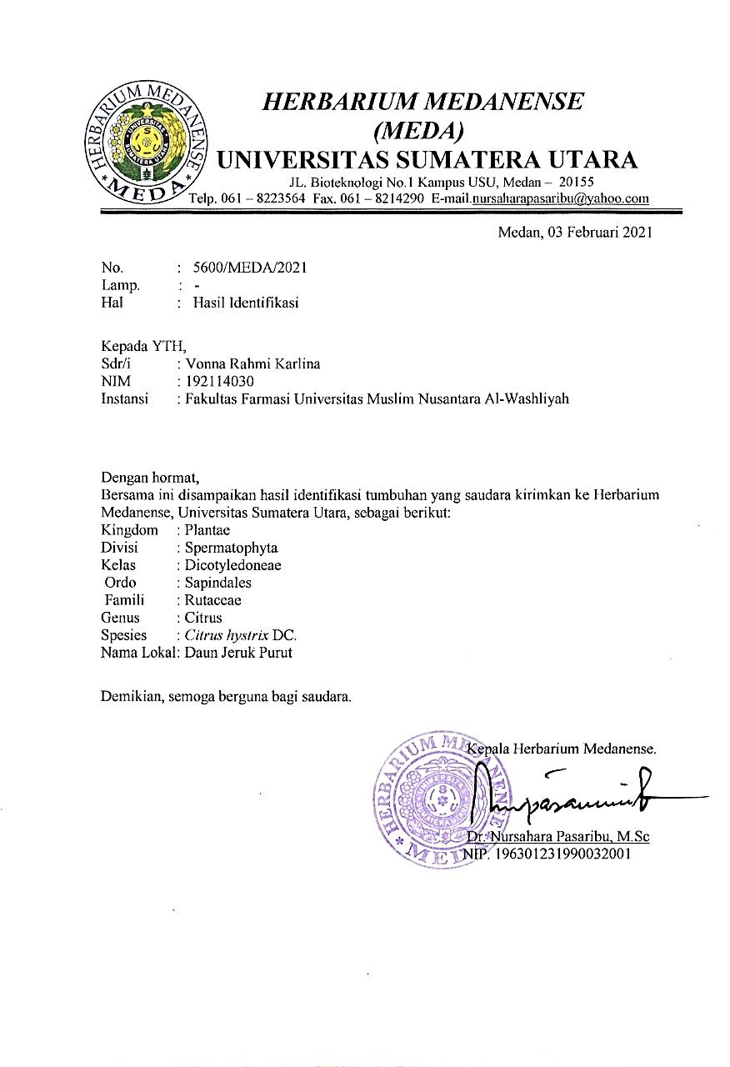

Lampiran 2. Bagan Alir Penelitian Pembuatan Serbuk Simplisia Daun Jeruk Purut (Citrus hystrix DC)

Daun jeruk Purut segar

Disortasi basah
Dicuci dengan air yang mengalir
Ditiriskan
6 kg daun
Jeruk purut basah

Dikeringkan

1,8 kg daun
Jeruk purut kering

Sortasi kering
1,5 kg daun
Jeruk purut kering

Dihaluskan dengan menggunakan blender
Disaring dengan ayakan
Dimasukkan dalam wadah tertutup
1,4 kg serbuk
daun jeruk purut

Lampiran 3. Tumbuhan Daun Jeruk Purut ( Citrus hystrix DC)

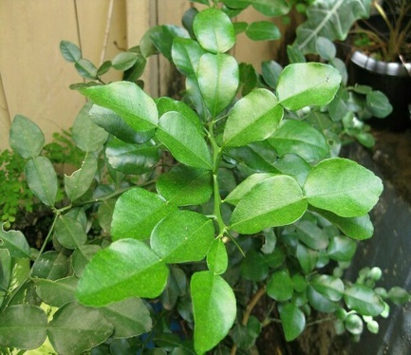
Daun Jeruk Purut Segar
Daun Jeruk Purut Segar

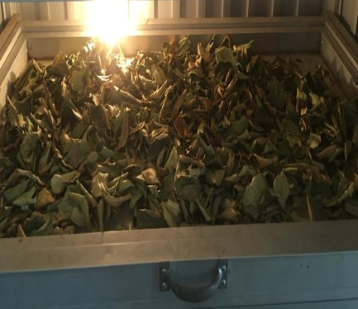
Pengeringan Daun Jeruk Purut

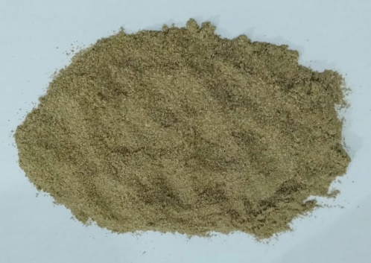
Serbuk Simplisia Daun Jeruk Purut

Lampiran 4. Lampiran Makroskopik dan Mikroskopik Daun Jeruk Purut
A. Gambar Makroskopik Simplisia Daun Jeruk Purut

Lampiran 4. (Lanjutan)
B. Gambar Mikroskopik Serbuk Simplisia Daun Jeruk Purut

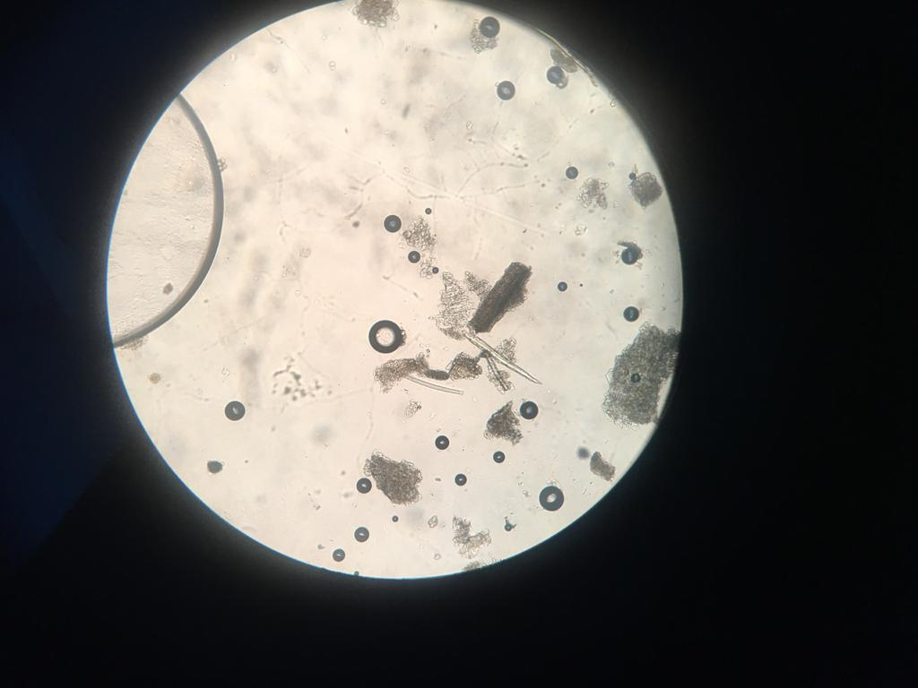
A
C
DD
B

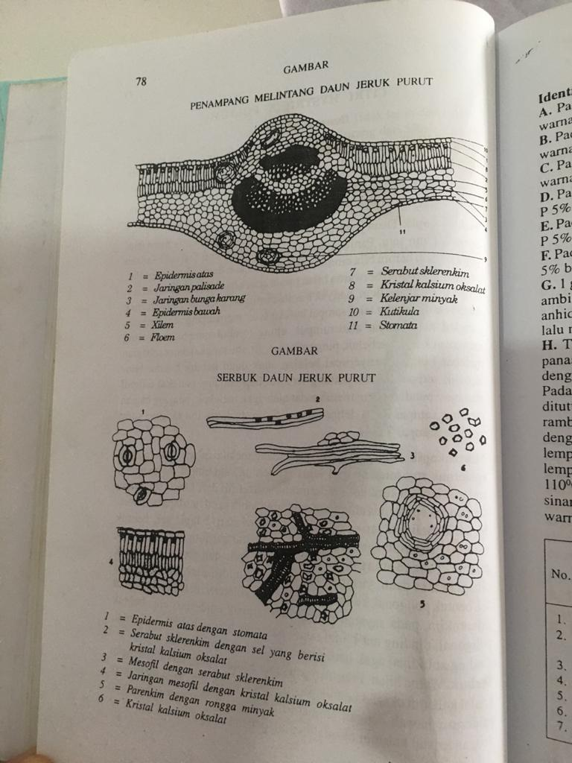
(MMI-VI, 1995)
Keterangan :
A=Kristal kalsium oksalat
B=Mesofil dengan serabut sklerenkim
C=Epidermis dengan stomata
D= Jaringan mesofil dengan kristal kalsium oksalat

Lampiran 5. Pengujian Karakteristik
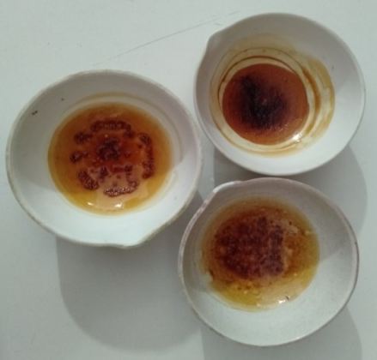
Kadar sari larut air

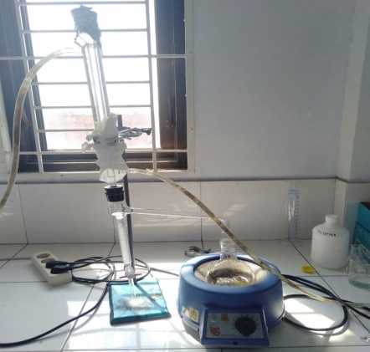
Penetapan kadar air

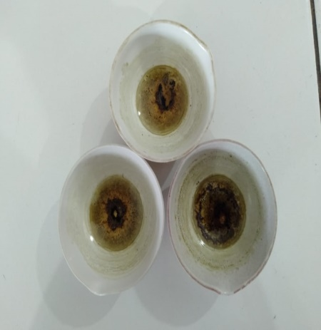
Penetapan kadar sari larut etanol

Lampiran 5. (Lanjutan)
Penetapan kadar sari larut asam

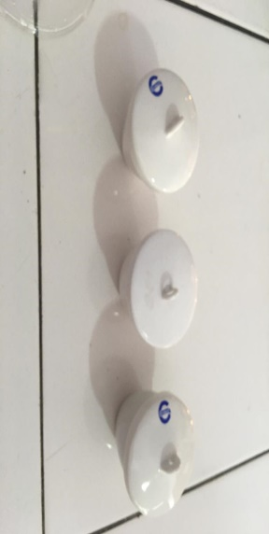
Penetapan kadar abu total

Lampiran 6. Bagan Alir Pembuatan Ekstrak Etanol Daun Jeruk Purut Dengan Metode Maserasi
500 g serbuk simplisia daun jeruk purut

Skrining fitokimia
1. Alkaloid
2. Tanin
3. Flavonoid
4. Saponin
5.Steroid/Triterpenoid
6. Glikosida

Diekstraksi dengan cara maserasi menggunakan pelarut etanol 80%

Dipekatkan dengan alat rotary evaparator
Ekstrak kental 71,9309 gram
Pengujian aktivitas terhadap bakteri Staphylococcus aureus dan Escherichia coli
- Makroskopis
- Mikroskopis
- Kadar air
- Kadar sari larut air
- Kadar sari larut etanol
- Kadar abu total
- Kadar abu tidak larut asam

Pemeriksaan dan karakterisasi
Lampiran 7. Maserasi Daun Jeruk Purut Dan Ekstrak Etanol
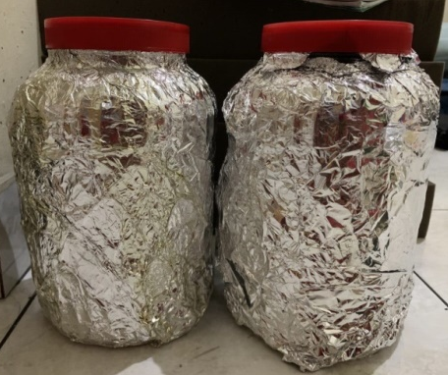
Maserasi daun jeruk Purut

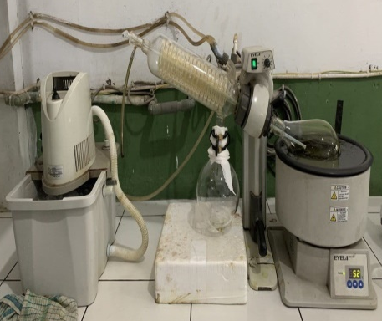
Rotary evaporator

Ekstrak daun Jeruk Purut

Lampiran 8. Skrining Fitokimia

1. Serbuk daun jeruk purut (Citrus hystrix DC)

Flavonoid (+)
Alkaloid (+)

Saponin (+) Steroid/Triterpenoid (+)

Glikosida (-)
Tanin (+)

Lampiran 8. (Lanjutan)
2. Ekstrak Etanol daun jeruk purut (Citrus hystrix DC)

Flavonoid (+)
Alkaloid (+)

Steroid/Triterpenoid (+)
Saponin (+)

Tanin (+) Glikosida (-)

Lampiran 9. Bagan Alir Pengujian Antibakteri
Biakan murni

Diambil 1 ose steril Diambil 1 ose steril
Bakteri Staphylococcus aureus

Bakteri Escherichia coli
Ditanam pada media Na Ditanam pada media Na
Diinkubasi pada suhu 37ºc Diinkubasi pada suhu
Stok kultur bakteri
37ºc
Diambil dengan jarum ose steril Disuspensikan dalam 10 mL
NaCl 0,9% steril
Dihomogenkan sampai kekeruhan
yang sama dengan Mc. Farland Dipipet 0,1 mL ke tabung reaksi Ditambahkan 9,9 mL NaCl 0,9 %
Suspensi bakteri 10⁸ CFU/mL
steril dan homogenkan Digoreskan ke permukaan media MHA yang telah memadat
Suspensi bakteri 10⁶ CFU/mL
menggunakan swab steril
Dimasukkan kertas cakram yang telah ditetesi ekstrak etanol daun
Jeruk purut
Diinkubasi pada suhu 35-36ºC
selama 18-24 jam
Hasil inkubasi
Diukur diameter zona hambat
Diameter zona hambat bakteri
Lampiran 10. Hasil Uji Aktivitas Antibakteri Daya Hambat Ekstrak Etanol Daun Jeruk Purut Terhadap Bakteri Staphylococcus aures dan Escherichia coli

A. Bakteri Staphylococcus aureus
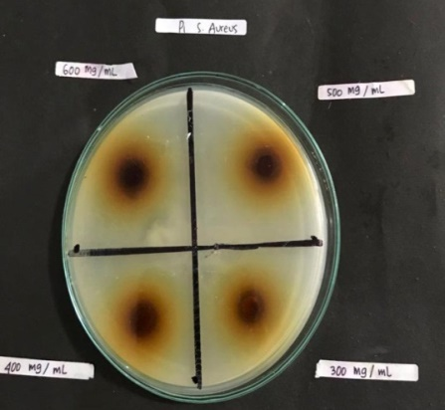
Pengulangan 1 :

B
A

D
C

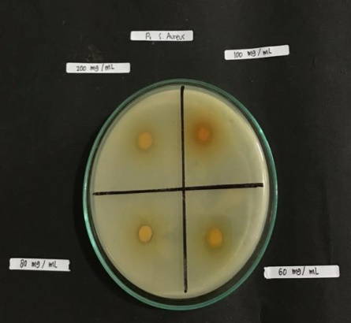

F
E

H
G

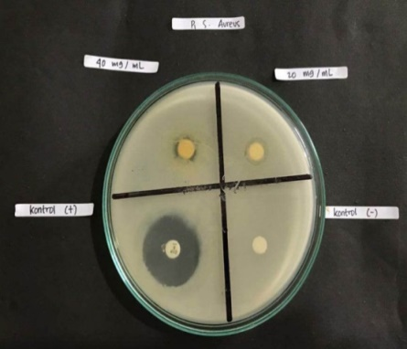

J
I

-
+

Keterangan :
A= 600 mg/mL F= 100 mg/mL
B= 500 mg/mL G= 80 mg/mL
C= 400 mg/mL H= 60 mg/mL
D= 300 mg/mL I= 40 mg/mL
E= 200 mg/mL J= 20 mg/mL
Kontrol (+) = Siproflaksasin Kontrol (-) = Etanol 80%
Lampiran 10. (Lanjutan)
Pengulangan 2 :
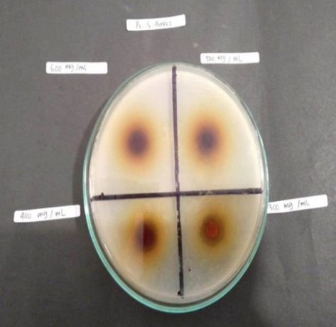

A
B

C
D

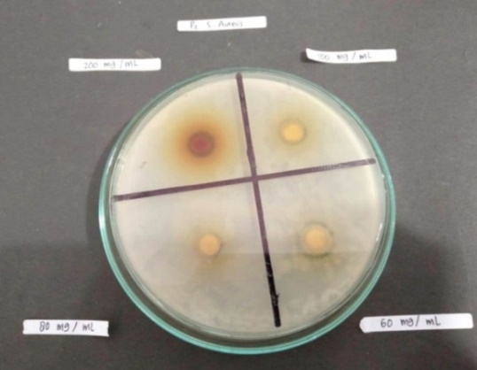

F
E

H
G

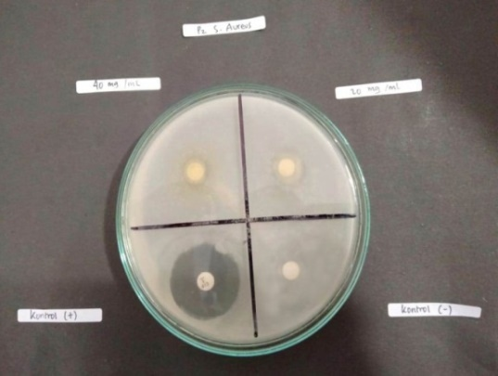

J
I
-
+

Keterangan :
A= 600 mg/mL F= 100 mg/mL
B= 500 mg/mL G= 80 mg/mL
C= 400 mg/mL H= 60 mg/mL
D= 300 mg/mL I= 40 mg/mL
E= 200 mg/mL J= 20 mg/mL
Kontrol (+) = Siproflaksasin Kontrol (-) = Etanol 80%
Lampiran 10. (Lanjutan)
Pengulangan 3:
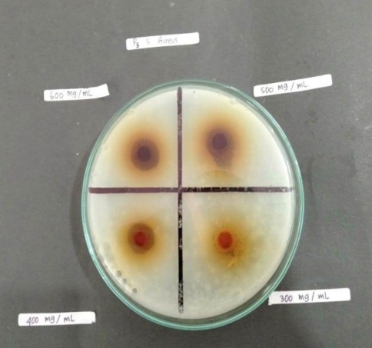

B
A

D
C

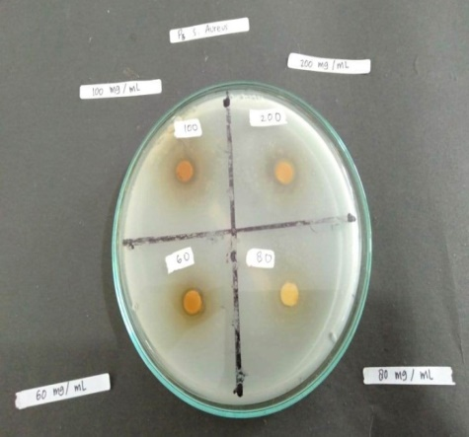

F
E

H
G

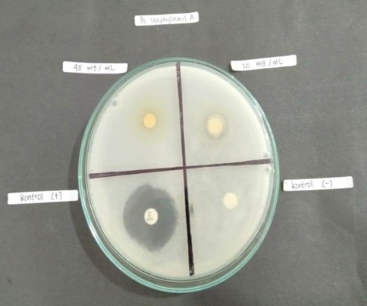

I
J

+
-

Keterangan :
A= 600 mg/mL F= 100 mg/mL
B= 500 mg/mL G= 80 mg/mL
C= 400 mg/mL H= 60 mg/mL
D= 300 mg/mL I= 40 mg/mL
E= 200 mg/mL J= 20 mg/mL
Kontrol (+) = Siproflaksasin Kontrol (-) = Etanol 80%
Lampiran 10. (Lanjutan)
B. Bakteri Escherichia coli
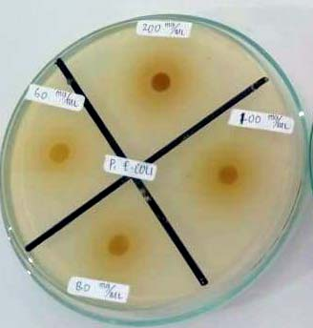
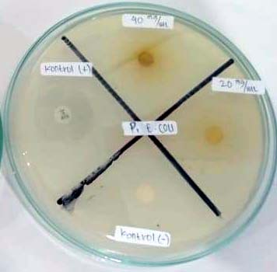
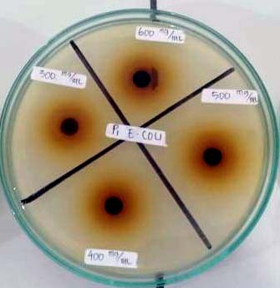
Pengulangan 1.

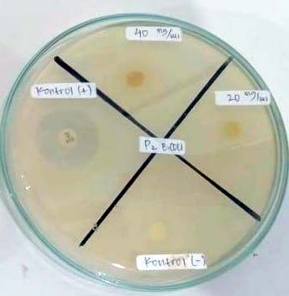
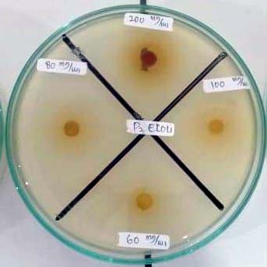
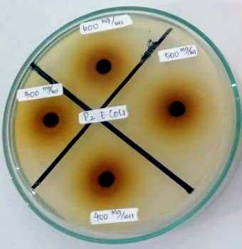
Pengulangan 2.

Pengulangan 3.
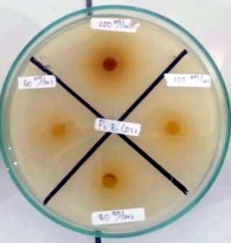
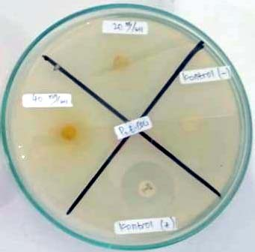
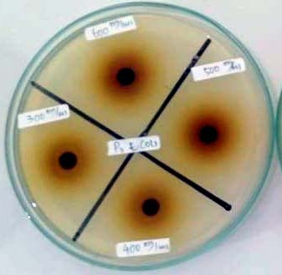

Keterangan :
A= 600 mg/mL F= 100 mg/mL
B= 500 mg/mL G= 80 mg/mL
C= 400 mg/mL H= 60 mg/mL
D= 300 mg/mL I= 40 mg/mL
E= 200 mg/mL J= 20 mg/mL
Kontrol (+) = Siproflaksasin Kontrol (-) = Etanol 80%
Lampiran 11. Pengujian Antibakteri

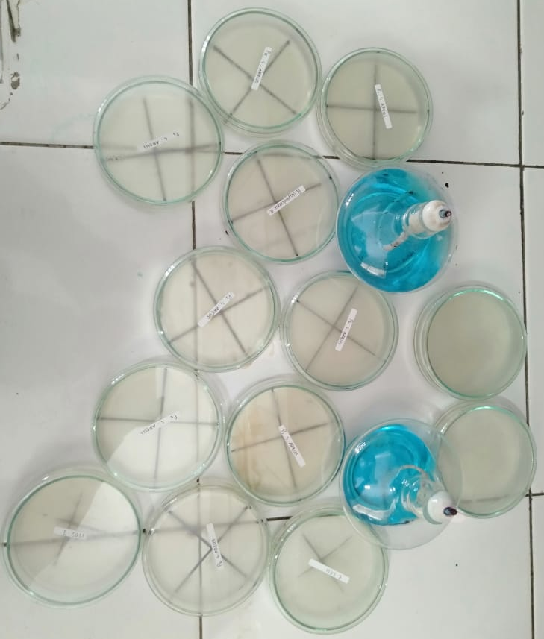
Uji daya hambat bakteri

Suspensi Staphylococcus aureus

Suspensi Escherichia coli

Lampiran 12. Hasil SPSS.
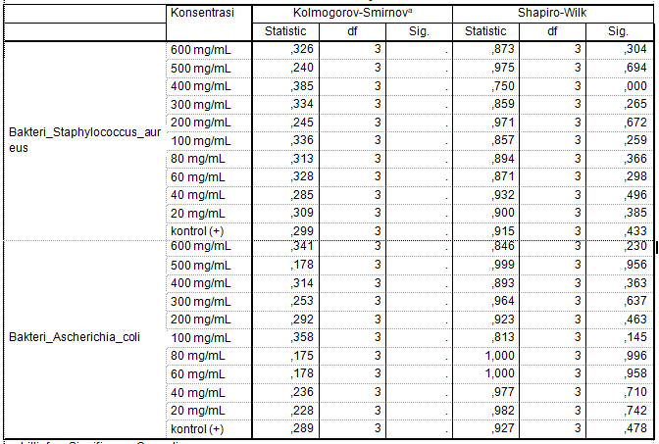

Lampiran 12. (Lanjutan)
Descriptives
 |  |  | N | Mean | Std. Deviation |  | Std. Error |  | 95% Confidence Interval for Mean |  |  | Minimum |  |  | Maximum
 |  |  |  |  |  |  |  |  | Lower Bound |  | Upper Bound
Bakteri_Staphylococcus_aureus | 600 mg/mL |  | 3 | 12,1500 | 1,57877 |  | ,91150 |  | 8,2281 |  | 16,0719 | 11,00 |  |  | 13,95
 | 500 mg/mL |  | 3 | 12,0500 | 1,89934 |  | 1,09659 |  | 7,3318 |  | 16,7682 | 10,00 |  |  | 13,75
 | 400 mg/mL |  | 3 | 11,7733 | ,04619 |  | ,02667 |  | 11,6586 |  | 11,8881 | 11,72 |  |  | 11,80
 | 300 mg/mL |  | 3 | 11,5333 | 1,80716 |  | 1,04337 |  | 7,0441 |  | 16,0226 | 10,25 |  |  | 13,60
 | 200 mg/mL |  | 3 | 11,2700 | ,50744 |  | ,29297 |  | 10,0094 |  | 12,5306 | 10,72 |  |  | 11,72
 | 100 mg/mL |  | 3 | 11,1133 | 1,40433 |  | ,81079 |  | 7,6248 |  | 14,6019 | 10,12 |  |  | 12,72
 | 80 mg/mL |  | 3 | 10,2133 | 1,44383 |  | ,83359 |  | 6,6267 |  | 13,8000 | 9,12 |  |  | 11,85
 | 60 mg/mL |  | 3 | 10,1833 | ,16073 |  | ,09280 |  | 9,7841 |  | 10,5826 | 10,00 |  |  | 10,30
 | 40 mg/mL |  | 3 | 9,8267 | 1,43977 |  | ,83125 |  | 6,2501 |  | 13,4032 | 8,22 |  |  | 11,00
 | 20 mg/mL |  | 3 | 9,4367 | 1,04892 |  | ,60559 |  | 6,8310 |  | 12,0423 | 8,25 |  |  | 10,24
 | kontrol (+) |  | 3 | 18,7500 | 2,22205 |  | 1,28290 |  | 13,2301 |  | 24,2699 | 17,00 |  |  | 21,25
 | kontrol (-) |  | 3 | ,0000 | ,00000 |  | ,00000 |  | ,0000 |  | ,0000 | ,00 |  |  | ,00
 | Total |  | 36 | 10,6917 | 4,17099 |  | ,69517 |  | 9,2804 |  | 12,1029 | ,00 |  |  | 21,25
Bakteri_Ascherichia_coli | 600 mg/mL |  | 3 | 12,9167 | 3,12583 |  | 1,80470 |  | 5,1517 |  | 20,6817 | 10,75 |  |  | 16,50
 | 500 mg/mL |  | 3 | 12,5833 | 3,12583 |  | 1,80470 |  | 4,8183 |  | 20,3483 | 9,50 |  |  | 15,75
 | 400 mg/mL |  | 3 | 12,0000 | 2,64575 |  | 1,52753 |  | 5,4276 |  | 18,5724 | 10,00 |  |  | 15,00
 | 300 mg/mL |  | 3 | 11,6667 | 1,52753 |  | ,88192 |  | 7,8721 |  | 15,4612 | 10,00 |  |  | 13,00
 | 200 mg/mL |  | 3 | 10,6667 | 1,04083 |  | ,60093 |  | 8,0811 |  | 13,2522 | 9,50 |  |  | 11,50
 | 100 mg/mL |  | 3 | 10,4000 | 6,60076 |  | 3,81095 |  | -5,9972 |  | 26,7972 | 6,10 |  |  | 18,00
 | 80 mg/mL |  | 3 | 9,4767 | 1,52500 |  | ,88046 |  | 5,6883 |  | 13,2650 | 7,95 |  |  | 11,00
 | 60 mg/mL |  | 3 | 7,4767 | 1,04026 |  | ,60059 |  | 4,8925 |  | 10,0608 | 6,45 |  |  | 8,53
 | 40 mg/mL |  | 3 | 6,9167 | 1,23929 |  | ,71550 |  | 3,8381 |  | 9,9952 | 5,80 |  |  | 8,25
 | 20 mg/mL |  | 3 | 6,5333 | 1,71561 |  | ,99051 |  | 2,2715 |  | 10,7952 | 4,70 |  |  | 8,10
 | kontrol (+) |  | 3 | 17,5833 | 4,54377 |  | 2,62335 |  | 6,2960 |  | 28,8707 | 12,50 |  |  | 21,25
 | kontrol (-) |  | 3 | ,0000 | ,00000 |  | ,00000 |  | ,0000 |  | ,0000 | ,00 |  |  | ,00
 | Total |  | 36 | 9,8517 | 4,86397 |  | ,81066 |  | 8,2059 |  | 11,4974 | ,00 |  |  | 21,25
Lampiran 12. (Lanjutan)

Anova

 |  |  |  |  |  | Sum of Squares |  | Df |  | Mean Square |  |  | F | Sig.
Bakteri_Staphylococcus_aureus |  | Between Groups |  |  |  | 565,264 |  | 11 |  | 51,388 |  |  | 28,262 | ,000
 |  | Within Groups |  |  |  | 43,637 |  | 24 |  | 1,818
 |  | Total |  |  |  | 608,902 |  | 35
Bakteri_Ascherichia_coli |  | Between Groups |  |  |  | 623,915 |  | 11 |  | 56,720 |  |  | 6,669 | ,000
 |  | Within Groups |  |  |  | 204,122 |  | 24 |  | 8,505
 |  | Total |  |  |  | 828,037 |  | 35

Lampiran 12. (Lanjutan)

Bakteri_Staphylococcus_aureus
Duncanª
Konsentrasi | N | Subset for alpha = 0.05
 |  | 1 | 2 | 3 | 4
kontrol (-) | 3 | ,0000
20 mg/mL | 3 |  | 9,4367
40 mg/mL | 3 |  | 9,8267 | 9,8267
60 mg/mL | 3 |  | 10,1833 | 10,1833
80 mg/mL | 3 |  | 10,2133 | 10,2133
100 mg/mL | 3 |  | 11,1133 | 11,1133
200 mg/mL | 3 |  | 11,2700 | 11,2700
300 mg/mL | 3 |  | 11,5333 | 11,5333
400 mg/mL | 3 |  | 11,7733 | 11,7733
500 mg/mL | 3 |  | 12,0500 | 12,0500
600 mg/mL | 3 |  |  | 12,1500
kontrol (+) | 3 |  |  |  | 18,7500
Sig. |  | 1,000 | ,051 | ,081 | 1,000
Means for groups in homogeneous subsets are displayed.
a. Uses Harmonic Mean Sample Size = 3,000.

Bakteri_Ascherichia_coli
Duncanª
Konsentrasi | N | Subset for alpha = 0.05
 |  | 1 | 2 | 3 | 4
kontrol (-) | 3 | ,0000
20 mg/mL | 3 |  | 6,5333
40 mg/mL | 3 |  | 6,9167
60 mg/mL | 3 |  | 7,4767 | 7,4767
80 mg/mL | 3 |  | 9,4767 | 9,4767
100 mg/mL | 3 |  | 10,4000 | 10,4000
200 mg/mL | 3 |  | 10,6667 | 10,6667
300 mg/mL | 3 |  | 11,6667 | 11,6667
400 mg/mL | 3 |  | 12,0000 | 12,0000
500 mg/mL | 3 |  |  | 12,5833 | 12,5833
600 mg/mL | 3 |  |  | 12,9167 | 12,9167
kontrol (+) | 3 |  |  |  | 17,5833
Sig. |  | 1,000 | ,057 | ,058 | ,057
Means for groups in homogeneous subsets are displayed.
a. Uses Harmonic Mean Sample Size = 3,000.

