Lampiran 1. Hasil Determinasi Tumbuhan
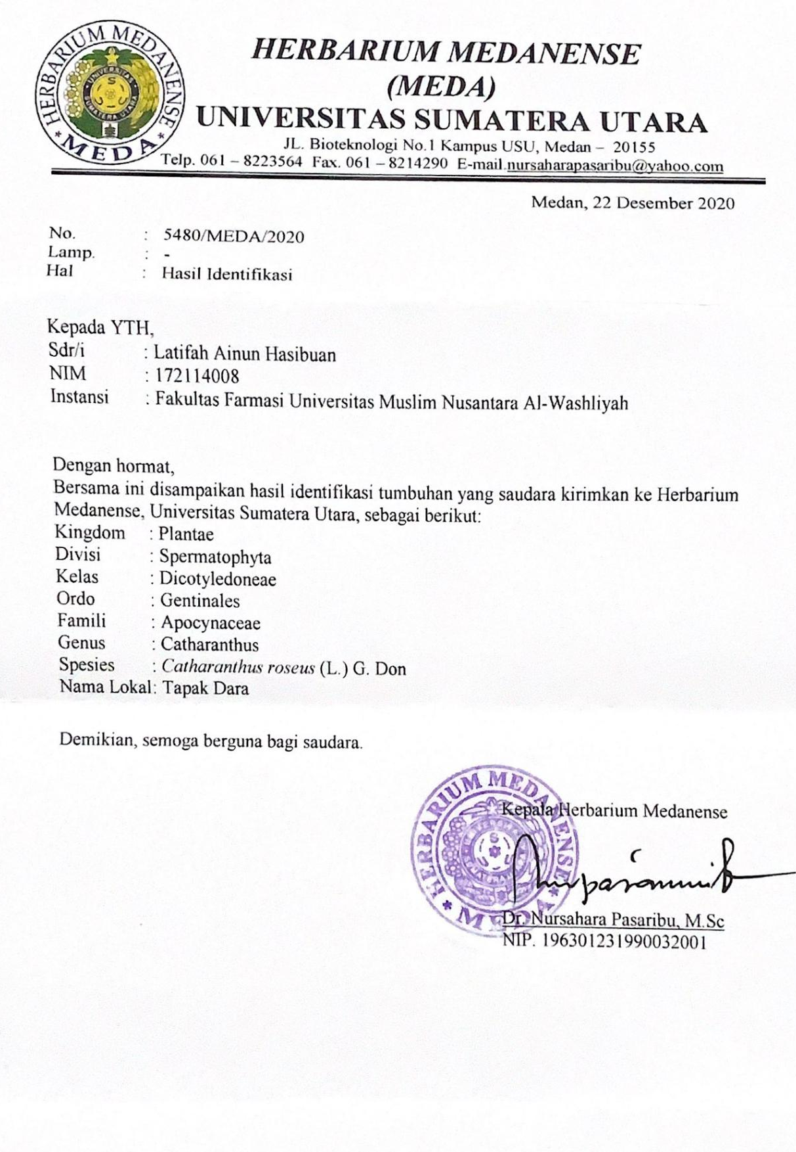

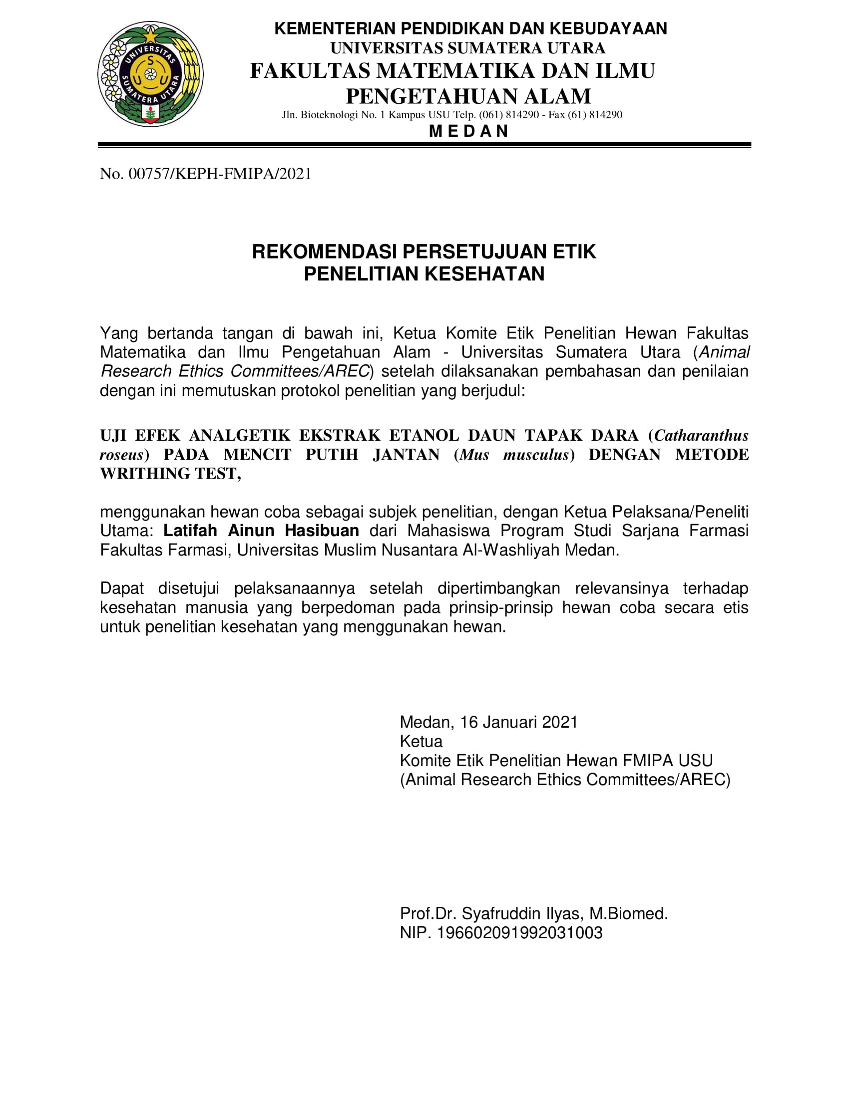
Lampiran 2. Rekomendasi Persetujuan Etik penelitian Kesehatan

Lampiran 3. Bagan Alir Pembuatan Simplisia
Daun Tapak Dara 5 kg

Dicuci bersih

Ditiriskan

Berat basah 5 kg

Dikeringkan dilemari pengering

Disortasi kering
Berat kering 1 kg

Dihaluskan dengan menggunakan blender
Serbuk simplisia ekstrak daun tapak dara 840 gr

Lampiran 4. Bagan Alir Pembuatan Ekstrak Etanol Daun Tapak Dara
Serbuk Simplisia 500 gr

Dimasukkan dalam bejana
Dituangkan dengan 75 bagian etanol 96%
Ditutup dan dibiarkan selama 5 hari sambil diaduk-aduk sesekali
Setelah 5 hari disaring dan ampasnya diperas
Maserat I

Ampas

Dicuci dengan 25 bagian etanol 96%
Maserat II

Maserat I + Maserat II

Dienaptuangkan kedalam bejana tertutup, dibiarkan selama 2 hari dan disaring
Dipekatkan dengan Rotary Evaporator
Ekstrak Etanol Kental 55 g
Rendemen Ekstrak : 5,5%

Lampiran 5. Bagan Alir Skrining Fitokimia dan Karakterisasi
Serbuk Simplisia Daun Tapak dara

- Pemeriksaan Alkaloida
- Pemeriksaan Flavonoida
- Pemeriksaan Tanin
- Pemeriksaan Saponin
- Pemeriksaan Steroida/Triterpenoid
- Makroskopik
- Mikroskopik
- Penetapan Kadar Air
- Penetapan Kadar Sari Larut Air
- Penetapan Kadar Sari Larut Etanol
- Penetapan Kadar Abu Total
- Penetapan Kadar Abu Tidak Larut dalam Asam
- Pemeriksaan Alkaloida
- Pemeriksaan Flavonoida
- Pemeriksaan Tanin
- Pemeriksaan Saponin
- Pemeriksaan Steroida/Triterpenoid
Skrining Fitokimia
Dimaserasi Dan Dipekatkan Dengan Rotary Evaporator
Karakterisasi

Ekstrak Etanol Daun Tapak Dara

Uji Farmakologi

Lampiran 6. Bagan Alir Analgetik
Mencit

Diaklimatisasi selama 1-2 minggu
Dipuasakan selama 18 jam
Ditimbang berat badan
Dikelompokkan secara acak menjadi 5 kelompok masing-masing kelompok 6 ekor mencit
Diinduksi dengan Asam Asetat 0,5% hewan secara intraperitoneal
Mencit Nyeri

Dihitung jumlah geliat tiap 5 menit sampai menit ke 10
Setelah 10 menit diamati, setiap kelompok setiap kelompok diberi perlakuan secara peroral :
Kelompok 1 : CMC 0,5%
Kelompok 2 : Methampiron 2%
Kelompok 3 : EEDTD 150 mg/kgBB
Kelompok 4 : EEDTD 200 mg/kgBB
Kelompok 5 : EEDTD 300 mg/kgBB
Diamati geliatnya dan dihitung jumlah geliat tiap 5 menit sampai menit ke 60
Jumlah Geliat

Lampiran 7. Tumbuhan Tapak Dara
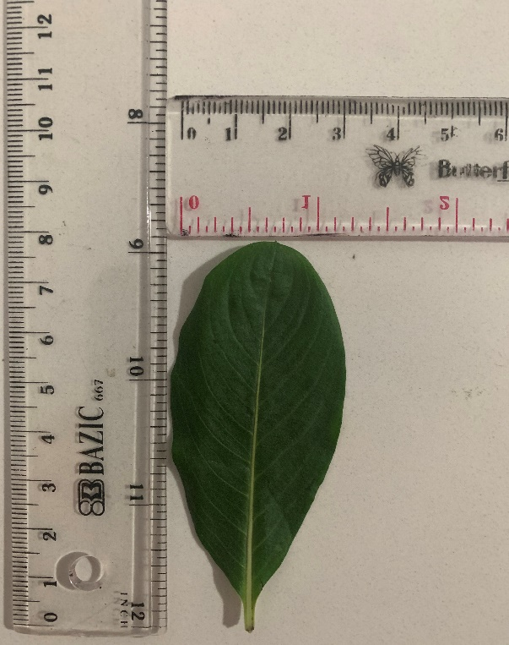
Daun Tapak Dara
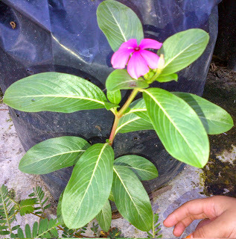
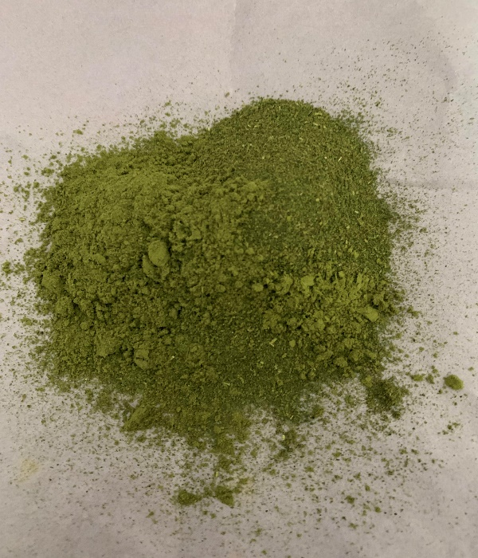
Serbuk Simplisia Daun Tapak Dara

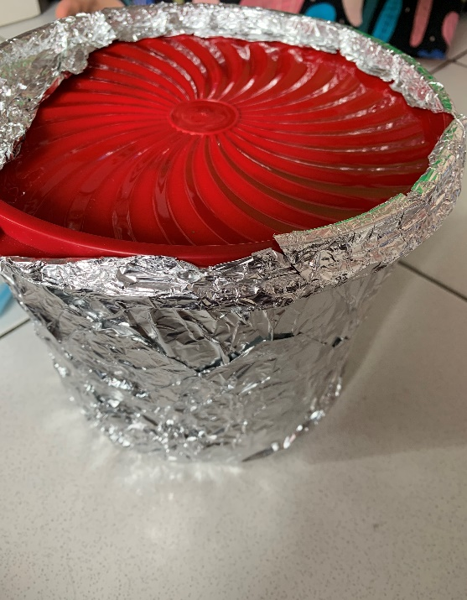
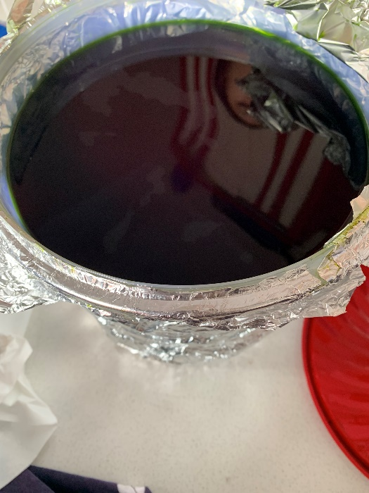
Lampiran 8. Maserasi Dan Ekstrak Etanol Daun Tapak Dara
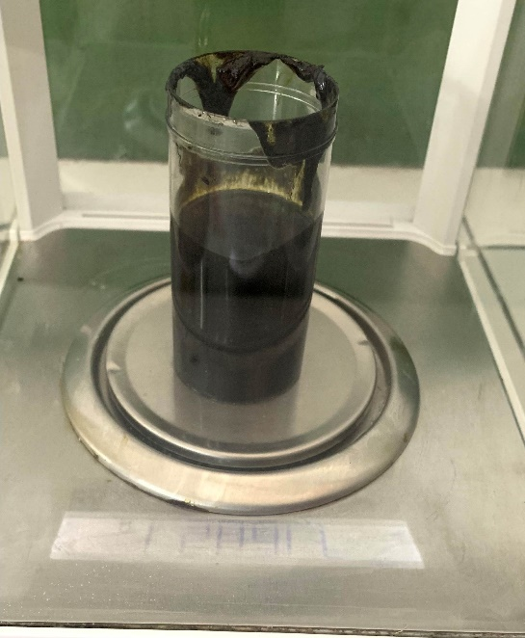
Maserasi Daun Tapak dara
Ekstrak Etanol Daun Tapak Dara

Lampiran 9. Mikroskopik

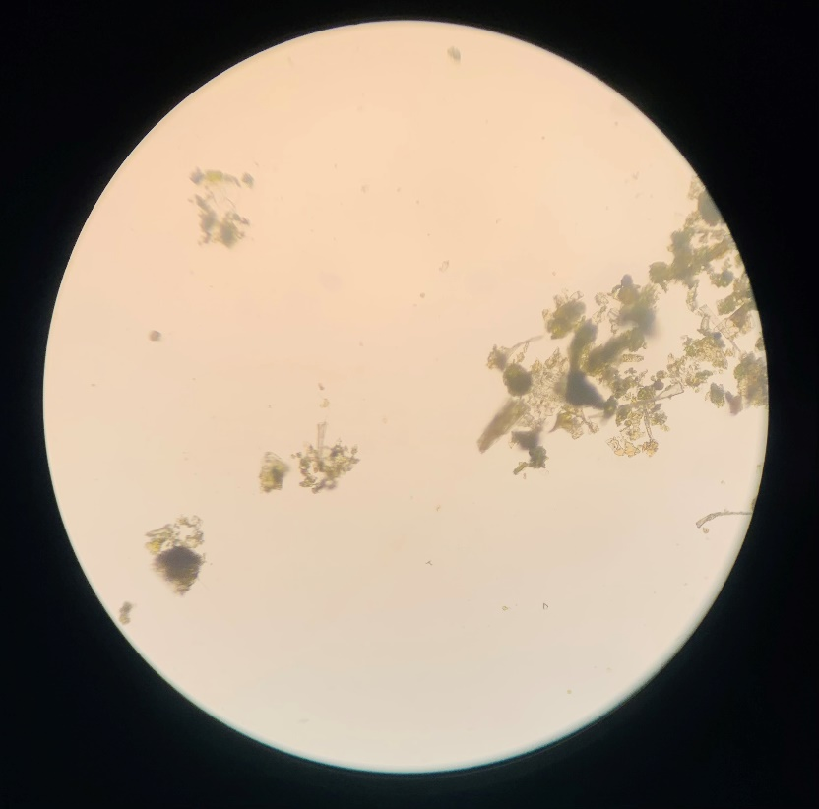
Rambut Penutup

Keterangan:
Rambut penutup

Lampiran 10. Alat Rotary Evaporator Dan Alat Azeotrop
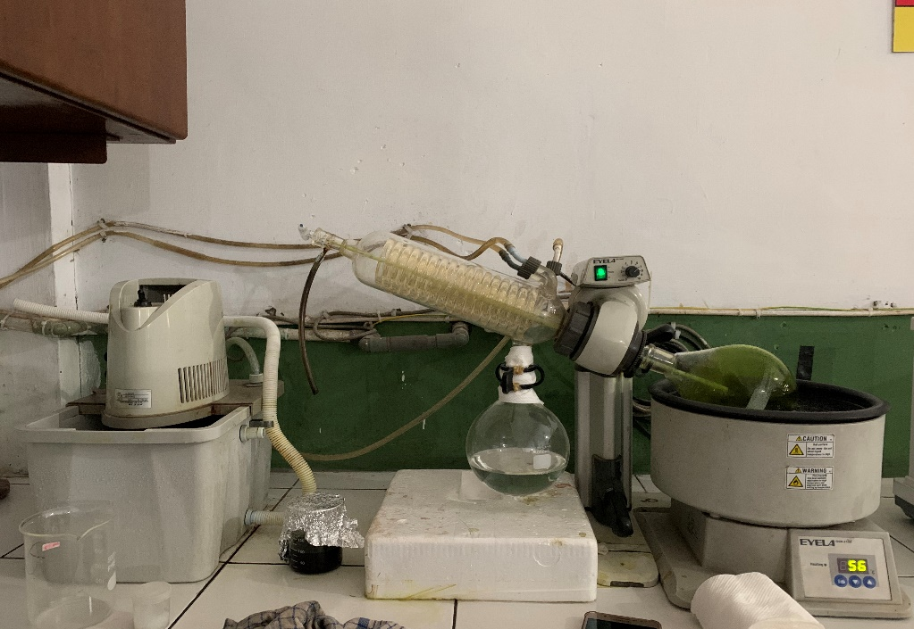

Alat Rotary Evaporator

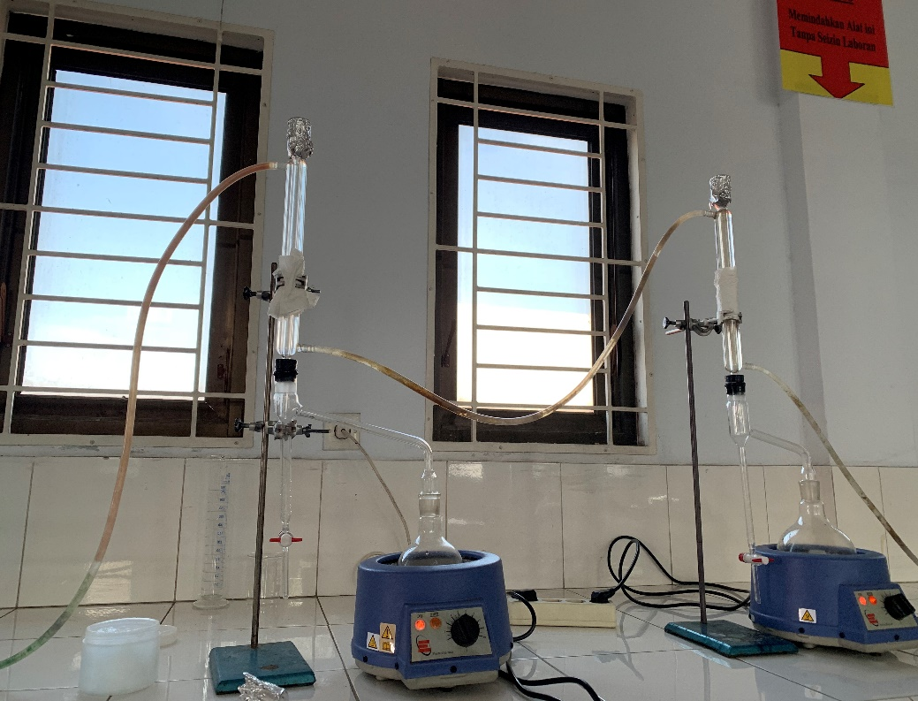

Alat Azeotrop

Lampiran 11. Perlakuan Dengan Mencit

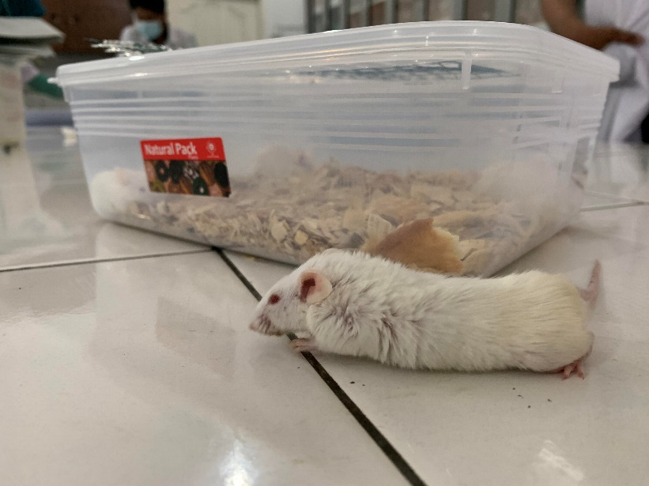

Geliat Mencit
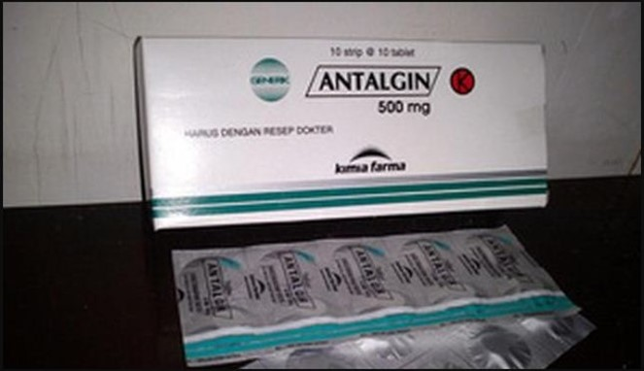

Obat Metampiron (Antalgin)

Lampiran 12. Tabel Konversi Dosis Dan Tabel Volume Maksimum Lambung Pada Hewan
 | Mencit  20 g | Tikus  200 g | Marmut  400 g | Kelinci  1,5 Kg | Kera  4 Kg | Anjing  12 Kg | Manusia  70 Kg
Mencit  20 g | 1,0 | 7,0 | 12,25 | 27,80 | 64,10 | 124,3 | 787,9
Tikus  200 g | 0,14 | 1,0 | 1,74 | 3,90 | 9,20 | 17,80 | 56,0
Marmut  400 g | 0,08 | 0,57 | 1,0 | 2,25 | 5,20 | 10,20 | 31,50
Kelinci  1,5 Kg | 0,04 | 0,25 | 0,44 | 1,0 | 2,40 | 4,50 | 14,20
Kera  4 Kg | 0,016 | 0,11 | 0,19 | 0,92 | 0,1 | 1,9 | 6,1
Anjing  12 Kg | 0,008 | 0,6 | 0,10 | 0,42 | 0,52 | 1,0 | 3,10
Manusia  70 Kg | 0,0026 | 0,018 | 0,031 | 0,07 | 0,16 | 0,32 | 1,0

Lampiran 13. Tabel Volume Maksimum lambung pada hewan (ml)
Jenis Hewan Uji | Volume maksimum (ml) sesuai jalur pemberian
 | i.v | i.m | i.p | s.c | p.o
Mencit(20-30 g) | 0,05 | 0,05 | 1,0 | 0,5-1,0 | 1,0
Tikus(200 g) | 0,1 | 0,1 | 2-5 | 2-5 | 5,0
Hamster(50 g) | 0,1 | 0,1 | 1-2 | 2,5 | 2,5
Marmut (250 g) | 0,25 | 0,25 | 2-5 | 5,0 | 10,0
Kelinci ( 3 kg) | 0,5 | 0,5 | 10-20 | 5-10 | 20.0
Kucing (3 kg) | 1,0 | 1,0 | 10-20 | 5-10 | 50,0
Anjing (5 kg) | 5,0 | 5,0 | 20-50 | 10,0 | 100,0

Lampiran 14. Data Karakterisasi Serbuk Simplisia Daun Tapak Dara
- Perhitungan Hasil Penetapan Kadar Air (Tidak lebih dari 10 %).
$$Kadar Air :\frac{volume II-Volume I}{Berat Sampel}×100 \%$$

Sampel I
Berat sampel : 5 g
Volume I : 1,8 ml
Volume II : 2,2 ml
= $\frac{2,2 ml-1,8 ml}{5 g}×100 \%$
= $\frac{0,4 ml}{5 g}×100 \%=8 \%$
Sampel II
Berat sampel : 5 g
Volume I : 1,7 ml
Volume II : 2 ml
= $\frac{2 ml-1,7 ml}{5 g}×100 \%$
= $\frac{0,3 ml}{5 g}×100 \%=6 \%$
Sampel III
Berat sampel : 5 g
Volume I : 2,2 ml
Volume II : 2,6 ml
= $\frac{2,6 ml-2,2 ml}{5 g}×100 \%$
= $\frac{0,4}{5 g}×100 \%=8 \%$
Kadar air rata-rata: = $\frac{8 \%+6 \%+8 \%}{3}$ = 7 %

Kadar air pada daun tapak dara memenuhi syarat yaitu 7 %, tidak lebih dari 10%.

Lampiran 14. (lanjutan)
- Perhitungan Kadar Sari Larut dalam Air (≤6 %).
$$Kadar Sari Larut Air=\frac{Berat cawan x Faktor pengenceran}{Berat sampel}×100\%$$

Sampel 1
Berat sampel : 5 g
Berat cawan kosong : 45,68 g
Berat cawan$+$sampel : 46,01 g
=$\frac{\left(46,01 g-45,68 g\right)×5}{5 g}×100 \%$
= 33 %
Sampel II
Berat sampel : 5 g
Berat cawan kosong : 59,86 g
Beratcawan$+$ sampel : 60,12 g
= $\frac{\left(60,12g-59,86 g \right)×5}{5 g}100 \%$
= 26 %
Sampel III
Berat sampel : 5 g
Berat cawan kosong : 45,70 g
Berat cawan$+$sampel : 45,98 g
= $\frac{(45,98 g-45,70 g)}{5 g}×100 \%$
= 28 %
Kadar sari larut dalam air rata-rata: = $\frac{33\%+26 \%+28 \%}{3}$ = 29 %
Kadar sari larut dalam air pada daun tapak dara memenuhi syarat yaitu 29 %, tidak kurang dari 6%.

Lampiran 14. (lanjutan)
- Perhitungan Kadar Sari Larut dalam Etanol ( ≤2,5%)
Kadar Sari Larut Dalam Etanol = $\frac{Berat Cawan+sampel (g)}{Berat sampel (g)}×100 \%$

Sampel I
Berat sampel : 5 g
Berat cawan kosong : 45,63 g
Berat cawan$+$sampel : 45,86 g
= $\frac{(45,86 g-45,63 g ×5}{5 g}×100$= 23 %
Sampel II
Berat sampel : 5 g
Berat cawan kosong : 41,36 g
Berat cawan$+$ sampel : 41,54 g
= $\frac{\left(41,54 g-41,36 g\right)×5}{5 g}×100 \%$ = 18 %
Sampel III
Berat sampel : 5 g
Berat cawan kosong : 61,20 g
Berat cawan$+$ sampel : 61,45 g
= $\frac{\left(61,45g-61,20 g\right)×5}{5 g}×100 \%$ = 25 %

Kadar sari larut dalam etanol rata-rata: = $\frac{23\%+18\%+25\%}{3}$= 22 %

Kadar sari larut dalam etanol pada daun tapak dara memenuhi syarat yaitu 22% tidak kurang dari 2,5%.

Lampiran 14.(lanjutan)
- Perhitungan Penetapan Kadar Abu Total (≥11,5 %)

Kadar Abu = $\frac{Berat abu (g)}{Berat sampel (g)}×100 \%$

Sampel I
Berat sampel : 2 g
Berat Abu : 0,07 g

Kadar abu total = $\frac{0,07 g}{2 g}×100 \%$ = 3,5 %

Sampel II
Berat sampel : 2 g
Berat Abu : 0,06 g

Kadar abu total = $\frac{0,06 g}{2 g}×100 \%$ = 3 %
Sampel III
Berat sampel : 2 g
Berat Abu : 0,09 g

Kadar abu total = $\frac{0,09 g}{2 g}×100 \%$= 4,5 %
Kadar abu total rata-rata =$\frac{3,5+3 \% +4,5 \%}{3}$= 3,67 %

Kadar abu total pada daun tapak dara memenuhi syarat yaitu 3,67 %, tidak lebih dari 11,5 %.

Lampiran 14.(lanjutan)
- Perhitungan Kadar Abu tidak Larut dalam Asam (≥1 %).
Kadar abu tidak larut asam = $\frac{Berat abu larut asam (g)}{Berat sampel}×100 \%$

Sampel I
Berat sampel : 2 g
Berat Abu : 0,01 g
= $\frac{0,01 g}{2 g}×100 \%$ = 0,5 %

Sampel ll
Berat sampel : 2 g
Berat Abu : 0,02
= $\frac{0,02 g}{2g}×100 \%=1 \%$

Sampel III
Berat sampel : 2 g
Berat Abu : 0,01 g
= $\frac{0,01 g}{2 g}×100 \%$ = 0,5 %
Kadar abu tidak larut dalam asam rata-rata:= $\frac{0,5 \% +1\% +0,5 \% }{3}$ = 0,67 %
Kadar abu tidak larut dalam asam pada daun tapak dara memenuhi syarat yaitu 0,67 %, tidak lebih dari 1 %.

Lampiran 15. Data hasil pengamatan geliat mencit jantan setelah perlakuan suspensi CMC 0,5%, suspensi metampiron 2%, suspensi EEDTD dosis 150mg/kgBB, dosis 200 mg/kgBB, dosis 300 mg/kgBB

Mencit ke | CMC 0,5% volume pemberian sebanyak 0,5ml  Menit ke - |  |  |  |  |  |  |  |  |  |  |  |  | Jumlah geliat
 | 5 | 10 | Setelah diberikan suspensi CMC 0,5% | 15 | 20 | 25 | 30 | 35 | 40 | 45 | 50 | 55 | 60
1 | 14 | 29 |  | 27 | 25 | 23 | 20 | 17 | 15 | 14 | 10 | 8 | 6 | 208
2 | 14 | 27 |  | 25 | 26 | 20 | 18 | 16 | 14 | 12 | 11 | 9 | 7 | 199
3 | 16 | 30 |  | 28 | 25 | 21 | 18 | 17 | 15 | 13 | 11 | 10 | 6 | 210
4 | 15 | 28 |  | 26 | 25 | 23 | 20 | 18 | 15 | 13 | 10 | 9 | 7 | 209
5 | 16 | 29 |  | 27 | 26 | 23 | 20 | 18 | 16 | 15 | 10 | 12 | 8 | 220
6 | 15 | 26 |  | 25 | 26 | 21 | 19 | 16 | 14 | 13 | 11 | 9 | 7 | 202
Rata-rata | 15 | 28.1 |  | 26.3 | 25.5 | 21.8 | 19.1 | 17 | 14.8 | 13.3 | 10.5 | 9.5 | 6.8 | 208
Mencit ke | Metampiron 2% volume pemberian sebanyak 0,1 ml  Menit ke - |  |  |  |  |  |  |  |  |  |  |  |  | Jumlah geliat
 | 5 | 10 | Setelah diberikan suspensi metampiron 2% | 15 | 20 | 25 | 30 | 35 | 40 | 45 | 50 | 55 | 60
1 | 13 | 16 |  | 15 | 12 | 10 | 7 | 5 | 4 | 3 | 1 | 0 | 0 | 86
2 | 13 | 15 |  | 14 | 12 | 10 | 8 | 5 | 4 | 3 | 1 | 1 | 0 | 86
3 | 12 | 14 |  | 13 | 11 | 9 | 7 | 6 | 4 | 2 | 1 | 0 | 0 | 79
4 | 14 | 15 |  | 14 | 13 | 10 | 8 | 7 | 5 | 3 | 1 | 1 | 0 | 91
5 | 12 | 16 |  | 13 | 10 | 9 | 6 | 5 | 3 | 2 | 1 | 0 | 0 | 77
6 | 14 | 15 |  | 13 | 10 | 9 | 10 | 7 | 6 | 4 | 1 | 1 | 0 | 90
Rata-rata | 13 | 15,1 |  | 13,6 | 11,3 | 9,5 | 7,6 | 5,8 | 4,3 | 2,8 | 1 | 0,5 | 0 | 84,8

Mencit ke | EEDTD 150 mg volume pemberian sebanyak 0.15 ml  Menit ke - |  |  |  |  |  |  |  |  |  |  |  |  | Jumlah geliat
 | 5 | 10 | Setelah diberikan suspensi EEDTD 150 mg | 15 | 20 | 25 | 30 | 35 | 40 | 45 | 50 | 55 | 60
1 | 12 | 18 |  | 20 | 16 | 15 | 13 | 10 | 9 | 7 | 4 | 3 | 3 | 130
2 | 13 | 19 |  | 19 | 16 | 13 | 11 | 9 | 8 | 6 | 5 | 4 | 2 | 125
3 | 13 | 19 |  | 21 | 17 | 14 | 12 | 10 | 9 | 7 | 5 | 4 | 3 | 134
4 | 14 | 17 |  | 19 | 17 | 13 | 11 | 9 | 8 | 7 | 4 | 3 | 2 | 123
5 | 13 | 17 |  | 20 | 16 | 14 | 11 | 9 | 8 | 6 | 6 | 4 | 3 | 127
6 | 12 | 18 |  | 21 | 18 | 15 | 12 | 11 | 10 | 8 | 6 | 3 | 2 | 136
Rata-rata | 12,8 | 18 |  | 20 | 16,6 | 14 | 11,6 | 9,6 | 8,6 | 6,8 | 5 | 3,3 | 2,5 | 129,1
Mencit ke | EEDTD 200 mg volume pemberian sebanyak 0.2 ml  Menit ke - |  |  |  |  |  |  |  |  |  |  |  |  | Jumlah geliat
 | 5 | 10 | Setelah diberikan suspensi EEDTD 200 mg | 15 | 20 | 25 | 30 | 35 | 40 | 45 | 50 | 55 | 60
1 | 14 | 17 |  | 18 | 15 | 11 | 10 | 8 | 6 | 4 | 2 | 1 | 1 | 107
2 | 14 | 16 |  | 19 | 16 | 13 | 11 | 9 | 7 | 5 | 4 | 3 | 2 | 120
3 | 12 | 18 |  | 18 | 15 | 12 | 11 | 9 | 7 | 5 | 3 | 2 | 1 | 113
4 | 13 | 16 |  | 18 | 15 | 12 | 10 | 8 | 6 | 4 | 3 | 2 | 2 | 109
5 | 13 | 19 |  | 20 | 16 | 13 | 11 | 9 | 7 | 6 | 5 | 3 | 2 | 125
6 | 12 | 17 |  | 19 | 16 | 12 | 10 | 8 | 6 | 5 | 4 | 1 | 1 | 111
Rata-rata | 13 | 17,1 |  | 18,6 | 15,5 | 12,1 | 10,5 | 8,5 | 6,5 | 4,8 | 3,5 | 2 | 1,5 | 114,1
Mencit ke | EEDTD 300 mg volume pemberian sebanyak 0.3 ml  Menit ke - |  |  |  |  |  |  |  |  |  |  |  |  | Jumlah geliat
 | 5 | 10 | Setelah diberikan suspensi EEDTD 300 mg | 15 | 20 | 25 | 30 | 35 | 40 | 45 | 50 | 55 | 60
1 | 14 | 16 |  | 16 | 13 | 10 | 8 | 7 | 6 | 4 | 3 | 2 | 2 | 104
2 | 14 | 17 |  | 14 | 14 | 11 | 9 | 7 | 7 | 5 | 3 | 2 | 1 | 105
3 | 13 | 16 |  | 15 | 14 | 12 | 10 | 8 | 6 | 5 | 4 | 3 | 2 | 97
4 | 12 | 17 |  | 18 | 15 | 12 | 10 | 9 | 5 | 3 | 2 | 1 | 1 | 107
5 | 13 | 15 |  | 16 | 14 | 10 | 9 | 8 | 5 | 4 | 3 | 1 | 1 | 94
6 | 12 | 15 |  | 18 | 15 | 12 | 10 | 7 | 4 | 4 | 2 | 2 | 0 | 109
Rata-rata | 13 | 16 |  | 17 | 13,8 | 11,5 | 9,6 | 7,5 | 5,5 | 3,5 | 2,5 | 1,6 | 1 | 102,6

Lampiran 16. Perhitungan Dosis
1. Perhitungan Konversi Dosis Metampiron
Dosis terapi Metampiron pada manusia adalah 500 mg
Dosis sekali minum : 500 mg
Dosis tiga kali minum : 1500 mg
Konversi dosis manusia (70 kg) ke mencit (20 g) : 0,0026
Dosis antalgin pada mencit : 500 mg x 0,0026 = 1,3 mg
Maka :
Mencit (20 g) = $\frac{1,3 mg}{0,02 kg}$ = 65 mg/kgBB
Dosis = $\frac{65 mg}{1000 g}$ x 20 g = 1,3 mg
Metampiron 2% = ${2g}/{100 ml}$ = 20 mg/ml
Volume = $\frac{Dosis}{Konsentrasi}$ = $\frac{1,3 mg}{20 mg/ml}$ = 0,06 ml
2. Perhitungan Dosis Suspensi CMC 0,5 %
CMC 0,5% = Jumlah cmc / volum suspensi
= 0,5 g / 100 ml
= 500 mg/100 ml
= 5 mg/ ml
3. Perhitungan Dosis Suspensi Ekstrak Etanol Daun Tapak Dara Dosis 150 mg/kg BB
Konsentrasi EEDTD 2% = Jumlah EEDTD / volume suspensi
= 2000 mg / 100 ml
= 20 mg/ml

Lampiran 16. (lanjutan)
BB mencit 20 g
Perhitungan dosis 150 mg/kgBB
$\frac{Dosis x BB (g)}{Konsentrasi}$ = $\frac{0,15 x 20}{20}=0,15 ml$
4. Perhitungan Dosis Suspensi Ekstrak Etanol Daun Tapak dara Dosis 200 mg/kg BB
Konsentrasi EEDTD 2% = Jumlah EEDTD / volume suspensi
= 2000 mg / 100 ml
= 20 mg/ml
BB mencit 20 g
Perhitungan dosis 200mg/kgBB
$\frac{Dosis x BB (g)}{Konsentrasi}$ = $\frac{0,2x 20}{20}=0,2 ml$
5. Perhitungan Dosis Suspensi Ekstrak Etanol Daun Tapak Dara Dosis 300 mg/kgBB
Konsentrasi EEDTD 2% = Jumlah EEDTD / volume suspensi
= 2000 mg / 100 ml
= 20 mg/ml
BB mencit 20 g
Perhitungan dosis 300 mg/kgBB
$\frac{Dosis x BB (g)}{Konsentrasi}$ = $\frac{0,3 x 20}{20}=0,3 ml$

Lampiran 17. Perhitungan Pesentase Daya Anlagetik
Rumus % daya analgetik
$$\% Daya analgetik=100-\left\{\frac{rata-rata geliat}{kontrol negatif} x 100\%\right\}$$
1. Kontrol Positif (Metampiron 2%)
Menit ke 15 = 100 ₋ $\frac{13,6}{26,3}$ x 100% = 48,2%
Menit ke 20 = 100 ₋ $\frac{11,3}{25,5}$ x 100% = 55,6%
Menit ke 25 = 100 ₋ $\frac{9,5}{21,8}$ x 100% = 56,4%
Menit ke 30 = 100 ₋ $\frac{7,6}{19,1}$ x 100% = 60,2%
Menit ke 35 = 100 ₋ $\frac{5,8}{17}$ x 100% = 65,8%
Menit ke 40 = 100 ₋ $\frac{4,3}{14,8}$ x 100% = 70,9%
Menit ke 45 = 100 ₋ $\frac{2,8}{13,3}$ x 100% = 78%
Menit ke 50 = 100 ₋ $\frac{1}{10,5}$ x 100% = 90,4%
Menit ke 55 = 100 ₋ $\frac{0,5}{9,5}$ x 100% = 94,7%
Menit ke 60 = 100 ₋ $\frac{0}{6,8}$ x 100% = 100%
2. Ekstrak Etanol Daun Tapak Dara Dosis 150 mg/kgBB
Menit ke 15 = 100 ₋ $\frac{20}{26,3}$ x 100% = 23,9%
Menit ke 20 = 100 ₋ $\frac{16,6}{25,5}$ x 100% = 34,90%
Menit ke 25 = 100 ₋ $\frac{14}{21,8}$ x 100% = 35,77%
Menit ke 30 = 100 ₋ $\frac{11,6}{19,1}$ x 100% = 39,26%
Menit ke 35 = 100 ₋ $\frac{9,6 }{17}$x 100% = 43,52%
Lampiran 17. (lanjutan)
Menit ke 40 = 100 ₋ $\frac{8,6}{14,8}$ x 100% = 41,89%
Menit ke 45 = 100 ₋ $\frac{6,8}{13,3}$ x 100% = 48,87%
Menit ke 50 = 100 ₋ $\frac{5}{10,5}$ x 100% = 52,38%
Menit ke 55 = 100 ₋ $\frac{3,3}{9,5}$ x 100% = 65,26%
Menit ke 60 = 100 ₋ $\frac{2,5}{6,8}$ x 100% = 63,23%
3. Ekstrak Etanol Daun Tapak Dara Dosis 200 mg/kgBB
Menit ke 15 = 100 ₋ $\frac{18,6}{26,3}$ x 100% = 29,27%
Menit ke 20 = 100 ₋ $\frac{15,5}{25,5}$ x 100% = 39,21%
Menit ke 25 = 100 ₋ $\frac{12,1}{21,8}$ x 100% = 44,49%
Menit ke 30 = 100 ₋ $\frac{10,5}{19,1}$ x 100% = 45,02%
Menit ke 35 = 100 ₋ $\frac{8,5}{17}$ x 100% = 50%
Menit ke 40 = 100 ₋ $\frac{6,5}{14,8}$ x 100% = 56,08%
Menit ke 45 = 100 ₋ $\frac{4,8}{13,3}$ x 100% = 63,90%
Menit ke 50 = 100 ₋ $\frac{3,5}{10,5}$ x 100% = 66,67%
Menit ke 55 = 100 ₋ $\frac{2}{9,5}$ x 100% = 78,94%
Menit ke 60 = 100 ₋ $\frac{1,5}{6,8}$ x 100% = 77,94%
4. Ekstrak Etanol Daun Tapak Dara Dosis 300 mg/kgBB
Menit ke 15 = 100 ₋ $\frac{17}{26,3}$ x 100% = 35,36%
Menit ke 20 = 100 ₋ $\frac{13,8}{25,5}$ x 100% = 45,88%
Lampiran 17. (lanjutan)
Menit ke 25 = 100 ₋ $\frac{11,5}{21,8}$ x 100% = 42,24%
Menit ke 30 = 100 ₋ $\frac{9,6}{19,1}$ x 100% = 49,73%
Menit ke 35 = 100 ₋ $\frac{7,5}{17}$ x 100% = 55,88%
Menit ke 40 = 100 ₋ $\frac{5,5}{14,8}$ x 100% = 62,83%
Menit ke 45 = 100 ₋ $\frac{3,5}{13,3}$ x 100% = 73,68%
Menit ke 50 = 100 ₋ $\frac{2,5}{10,5}$ x 100% = 76,19%
Menit ke 55 = 100 ₋ $\frac{1,6}{9,5}$ x 100% = 83,15%
Menit ke 60 = 100 ₋ $\frac{1}{6,8}$ x 100% = 85,29%

Lampiran 18. SPSS
Descriptives
 |  | N | Mean | Std. Deviation | Std. Error | 95% Confidence Interval for Mean |  | Minimum | Maximum
 |  |  |  |  |  | Lower Bound | Upper Bound
Menit_5 | CMC 0,5% | 6 | 15,00 | ,894 | ,365 | 14,06 | 15,94 | 14 | 16
 | Metampiron 2% | 6 | 13,00 | ,894 | ,365 | 12,06 | 13,94 | 12 | 14
 | EEDTD 150 mg/kg BB | 6 | 12,83 | ,753 | ,307 | 12,04 | 13,62 | 12 | 14
 | EEDTD 200 mg/kg BB | 6 | 13,00 | ,894 | ,365 | 12,06 | 13,94 | 12 | 14
 | EEDTD 300 mg/kg BB | 6 | 11,00 | 4,980 | 2,033 | 5,77 | 16,23 | 1 | 14
 | Total | 30 | 12,97 | 2,539 | ,464 | 12,02 | 13,91 | 1 | 16
Menit_10 | CMC 0,5% | 6 | 28,17 | 1,472 | ,601 | 26,62 | 29,71 | 26 | 30
 | Metampiron 2% | 6 | 15,17 | ,753 | ,307 | 14,38 | 15,96 | 14 | 16
 | EEDTD 150 mg/kg BB | 6 | 18,00 | ,894 | ,365 | 17,06 | 18,94 | 17 | 19
 | EEDTD 200 mg/kg BB | 6 | 17,17 | 1,169 | ,477 | 15,94 | 18,39 | 16 | 19
 | EEDTD 300 mg/kg BB | 6 | 16,00 | ,894 | ,365 | 15,06 | 16,94 | 15 | 17
 | Total | 30 | 18,90 | 4,915 | ,897 | 17,06 | 20,74 | 14 | 30
Menit_15 | CMC 0,5% | 6 | 26,33 | 1,211 | ,494 | 25,06 | 27,60 | 25 | 28
 | Metampiron 2% | 6 | 13,67 | ,816 | ,333 | 12,81 | 14,52 | 13 | 15
 | EEDTD 150 mg/kg BB | 6 | 20,00 | ,894 | ,365 | 19,06 | 20,94 | 19 | 21
 | EEDTD 200 mg/kg BB | 6 | 18,67 | ,816 | ,333 | 17,81 | 19,52 | 18 | 20
 | EEDTD 300 mg/kg BB | 6 | 16,17 | 1,602 | ,654 | 14,49 | 17,85 | 14 | 18
 | Total | 30 | 18,97 | 4,468 | ,816 | 17,30 | 20,64 | 13 | 28
Menit_20 | CMC 0,5% | 6 | 25,50 | ,548 | ,224 | 24,93 | 26,07 | 25 | 26
 | Metampiron 2% | 6 | 11,33 | 1,211 | ,494 | 10,06 | 12,60 | 10 | 13
 | EEDTD 150 mg/kg BB | 6 | 16,67 | ,816 | ,333 | 15,81 | 17,52 | 16 | 18
 | EEDTD 200 mg/kg BB | 6 | 15,50 | ,548 | ,224 | 14,93 | 16,07 | 15 | 16
 | EEDTD 300 mg/kg BB | 6 | 14,17 | ,753 | ,307 | 13,38 | 14,96 | 13 | 15
 | Total | 30 | 16,63 | 4,916 | ,898 | 14,80 | 18,47 | 10 | 26
Menit_25 | CMC 0,5% | 6 | 21,83 | 1,329 | ,543 | 20,44 | 23,23 | 20 | 23
 | Metampiron 2% | 6 | 9,50 | ,548 | ,224 | 8,93 | 10,07 | 9 | 10
 | EEDTD 150 mg/kg BB | 6 | 14,00 | ,894 | ,365 | 13,06 | 14,94 | 13 | 15
 | EEDTD 200 mg/kg BB | 6 | 12,17 | ,753 | ,307 | 11,38 | 12,96 | 11 | 13
 | EEDTD 300 mg/kg BB | 6 | 11,17 | ,983 | ,401 | 10,13 | 12,20 | 10 | 12
 | Total | 30 | 13,73 | 4,464 | ,815 | 12,07 | 15,40 | 9 | 23
Menit_30 | CMC 0,5% | 6 | 19,17 | ,983 | ,401 | 18,13 | 20,20 | 18 | 20
 | Metampiron 2% | 6 | 7,67 | 1,366 | ,558 | 6,23 | 9,10 | 6 | 10
 | EEDTD 150 mg/kg BB | 6 | 11,67 | ,816 | ,333 | 10,81 | 12,52 | 11 | 13
 | EEDTD 200 mg/kg BB | 6 | 10,50 | ,548 | ,224 | 9,93 | 11,07 | 10 | 11
 | EEDTD 300 mg/kg BB | 6 | 9,33 | ,816 | ,333 | 8,48 | 10,19 | 8 | 10
 | Total | 30 | 11,67 | 4,138 | ,756 | 10,12 | 13,21 | 6 | 20
Menit_35 | CMC 0,5% | 6 | 17,00 | ,894 | ,365 | 16,06 | 17,94 | 16 | 18
 | Metampiron 2% | 6 | 5,83 | ,983 | ,401 | 4,80 | 6,87 | 5 | 7
 | EEDTD 150 mg/kg BB | 6 | 9,67 | ,816 | ,333 | 8,81 | 10,52 | 9 | 11
 | EEDTD 200 mg/kg BB | 6 | 8,50 | ,548 | ,224 | 7,93 | 9,07 | 8 | 9
 | EEDTD 300 mg/kg BB | 6 | 7,67 | ,816 | ,333 | 6,81 | 8,52 | 7 | 9
 | Total | 30 | 9,73 | 3,982 | ,727 | 8,25 | 11,22 | 5 | 18
Menit_40 | CMC 0,5% | 6 | 14,83 | ,753 | ,307 | 14,04 | 15,62 | 14 | 16
 | Metampiron 2% | 6 | 4,33 | 1,033 | ,422 | 3,25 | 5,42 | 3 | 6
 | EEDTD 150 mg/kg BB | 6 | 8,67 | ,816 | ,333 | 7,81 | 9,52 | 8 | 10
 | EEDTD 200 mg/kg BB | 6 | 6,50 | ,548 | ,224 | 5,93 | 7,07 | 6 | 7
 | EEDTD 300 mg/kg BB | 6 | 5,50 | 1,049 | ,428 | 4,40 | 6,60 | 4 | 7
 | Total | 30 | 7,97 | 3,864 | ,705 | 6,52 | 9,41 | 3 | 16
Menit_45 | CMC 0,5% | 6 | 13,33 | 1,033 | ,422 | 12,25 | 14,42 | 12 | 15
 | Metampiron 2% | 6 | 2,83 | ,753 | ,307 | 2,04 | 3,62 | 2 | 4
 | EEDTD 150 mg/kg BB | 6 | 6,83 | ,753 | ,307 | 6,04 | 7,62 | 6 | 8
 | EEDTD 200 mg/kg BB | 6 | 4,83 | ,753 | ,307 | 4,04 | 5,62 | 4 | 6
 | EEDTD 300 mg/kg BB | 6 | 4,17 | ,753 | ,307 | 3,38 | 4,96 | 3 | 5
 | Total | 30 | 6,40 | 3,838 | ,701 | 4,97 | 7,83 | 2 | 15
Menit_50 | CMC 0,5% | 6 | 10,50 | ,548 | ,224 | 9,93 | 11,07 | 10 | 11
 | Metampiron 2% | 6 | 1,00 | ,000 | ,000 | 1,00 | 1,00 | 1 | 1
 | EEDTD 150 mg/kg BB | 6 | 5,00 | ,894 | ,365 | 4,06 | 5,94 | 4 | 6
 | EEDTD 200 mg/kg BB | 6 | 3,50 | 1,049 | ,428 | 2,40 | 4,60 | 2 | 5
 | EEDTD 300 mg/kg BB | 6 | 2,83 | ,753 | ,307 | 2,04 | 3,62 | 2 | 4
 | Total | 30 | 4,57 | 3,360 | ,613 | 3,31 | 5,82 | 1 | 11
Menit_55 | CMC 0,5% | 6 | 9,50 | 1,378 | ,563 | 8,05 | 10,95 | 8 | 12
 | Metampiron 2% | 6 | ,50 | ,548 | ,224 | -,07 | 1,07 | 0 | 1
 | EEDTD 150 mg/kg BB | 6 | 3,33 | ,816 | ,333 | 2,48 | 4,19 | 2 | 4
 | EEDTD 200 mg/kg BB | 6 | 2,00 | ,894 | ,365 | 1,06 | 2,94 | 1 | 3
 | EEDTD 300 mg/kg BB | 6 | 1,83 | ,753 | ,307 | 1,04 | 2,62 | 1 | 3
 | Total | 30 | 3,43 | 3,329 | ,608 | 2,19 | 4,68 | 0 | 12
Menit_60 | CMC 0,5% | 6 | 6,83 | ,753 | ,307 | 6,04 | 7,62 | 6 | 8
 | Metampiron 2% | 6 | ,00 | ,000 | ,000 | ,00 | ,00 | 0 | 0
 | EEDTD 150 mg/kg BB | 6 | 2,50 | ,548 | ,224 | 1,93 | 3,07 | 2 | 3
 | EEDTD 200 mg/kg BB | 6 | 1,50 | ,548 | ,224 | ,93 | 2,07 | 1 | 2
 | EEDTD 300 mg/kg BB | 6 | 1,17 | ,753 | ,307 | ,38 | 1,96 | 0 | 2
 | Total | 30 | 2,40 | 2,458 | ,449 | 1,48 | 3,32 | 0 | 8

Test of Homogeneity of Variances
 | Levene Statistic | df1 | df2 | Sig.
Menit_5 | 3,501 | 4 | 25 | ,021
Menit_10 | 1,057 | 4 | 25 | ,398
Menit_15 | 1,247 | 4 | 25 | ,317
Menit_20 | 2,220 | 4 | 25 | ,096
Menit_25 | 2,957 | 4 | 25 | ,040
Menit_30 | 1,016 | 4 | 25 | ,418
Menit_35 | ,625 | 4 | 25 | ,649
Menit_40 | ,642 | 4 | 25 | ,637
Menit_45 | ,263 | 4 | 25 | ,899
Menit_50 | 4,023 | 4 | 25 | ,012
Menit_55 | ,871 | 4 | 25 | ,495
Menit_60 | 4,316 | 4 | 25 | ,009

ANOVA
 |  | Sum of Squares | df | Mean Square | F | Sig.
Menit_5 | Between Groups | 48,133 | 4 | 12,033 | 2,167 | ,102
 | Within Groups | 138,833 | 25 | 5,553
 | Total | 186,967 | 29
Menit_10 | Between Groups | 672,200 | 4 | 168,050 | 147,412 | ,000
 | Within Groups | 28,500 | 25 | 1,140
 | Total | 700,700 | 29
Menit_15 | Between Groups | 548,133 | 4 | 137,033 | 111,108 | ,000
 | Within Groups | 30,833 | 25 | 1,233
 | Total | 578,967 | 29
Menit_20 | Between Groups | 684,467 | 4 | 171,117 | 259,268 | ,000
 | Within Groups | 16,500 | 25 | ,660
 | Total | 700,967 | 29
Menit_25 | Between Groups | 555,867 | 4 | 138,967 | 157,917 | ,000
 | Within Groups | 22,000 | 25 | ,880
 | Total | 577,867 | 29
Menit_30 | Between Groups | 474,333 | 4 | 118,583 | 132,743 | ,000
 | Within Groups | 22,333 | 25 | ,893
 | Total | 496,667 | 29
Menit_35 | Between Groups | 442,867 | 4 | 110,717 | 162,819 | ,000
 | Within Groups | 17,000 | 25 | ,680
 | Total | 459,867 | 29
Menit_40 | Between Groups | 414,467 | 4 | 103,617 | 140,023 | ,000
 | Within Groups | 18,500 | 25 | ,740
 | Total | 432,967 | 29
Menit_45 | Between Groups | 410,533 | 4 | 102,633 | 153,950 | ,000
 | Within Groups | 16,667 | 25 | ,667
 | Total | 427,200 | 29
Menit_50 | Between Groups | 313,533 | 4 | 78,383 | 141,657 | ,000
 | Within Groups | 13,833 | 25 | ,553
 | Total | 327,367 | 29
Menit_55 | Between Groups | 300,200 | 4 | 75,050 | 88,642 | ,000
 | Within Groups | 21,167 | 25 | ,847
 | Total | 321,367 | 29
Menit_60 | Between Groups | 166,533 | 4 | 41,633 | 120,096 | ,000
 | Within Groups | 8,667 | 25 | ,347
 | Total | 175,200 | 29

Tests of Normality^{c,d}
 | Perlakuan | Kolmogorov-Smirnovª |  |  | Shapiro-Wilk
 |  | Statistic | df | Sig. | Statistic | df | Sig.
Menit_5 | CMC 0,5% | ,202 | 6 | ,200* | ,853 | 6 | ,167
 | Metampiron 2% | ,202 | 6 | ,200* | ,853 | 6 | ,167
 | EEDTD 150 mg/kg BB | ,254 | 6 | ,200* | ,866 | 6 | ,212
 | EEDTD 200 mg/kg BB | ,202 | 6 | ,200* | ,853 | 6 | ,167
 | EEDTD 300 mg/kg BB | ,413 | 6 | ,002 | ,654 | 6 | ,002
Menit_10 | CMC 0,5% | ,214 | 6 | ,200* | ,958 | 6 | ,804
 | Metampiron 2% | ,254 | 6 | ,200* | ,866 | 6 | ,212
 | EEDTD 150 mg/kg BB | ,202 | 6 | ,200* | ,853 | 6 | ,167
 | EEDTD 200 mg/kg BB | ,223 | 6 | ,200* | ,908 | 6 | ,421
 | EEDTD 300 mg/kg BB | ,202 | 6 | ,200* | ,853 | 6 | ,167
Menit_15 | CMC 0,5% | ,209 | 6 | ,200* | ,907 | 6 | ,415
 | Metampiron 2% | ,293 | 6 | ,117 | ,822 | 6 | ,091
 | EEDTD 150 mg/kg BB | ,202 | 6 | ,200* | ,853 | 6 | ,167
 | EEDTD 200 mg/kg BB | ,293 | 6 | ,117 | ,822 | 6 | ,091
 | EEDTD 300 mg/kg BB | ,208 | 6 | ,200* | ,908 | 6 | ,425
Menit_20 | CMC 0,5% | ,319 | 6 | ,056 | ,683 | 6 | ,004
 | Metampiron 2% | ,209 | 6 | ,200* | ,907 | 6 | ,415
 | EEDTD 150 mg/kg BB | ,293 | 6 | ,117 | ,822 | 6 | ,091
 | EEDTD 200 mg/kg BB | ,319 | 6 | ,056 | ,683 | 6 | ,004
 | EEDTD 300 mg/kg BB | ,254 | 6 | ,200* | ,866 | 6 | ,212
Menit_25 | CMC 0,5% | ,310 | 6 | ,074 | ,805 | 6 | ,065
 | Metampiron 2% | ,319 | 6 | ,056 | ,683 | 6 | ,004
 | EEDTD 150 mg/kg BB | ,202 | 6 | ,200* | ,853 | 6 | ,167
 | EEDTD 200 mg/kg BB | ,254 | 6 | ,200* | ,866 | 6 | ,212
 | EEDTD 300 mg/kg BB | ,302 | 6 | ,094 | ,775 | 6 | ,035
Menit_30 | CMC 0,5% | ,302 | 6 | ,094 | ,775 | 6 | ,035
 | Metampiron 2% | ,237 | 6 | ,200* | ,927 | 6 | ,554
 | EEDTD 150 mg/kg BB | ,293 | 6 | ,117 | ,822 | 6 | ,091
 | EEDTD 200 mg/kg BB | ,319 | 6 | ,056 | ,683 | 6 | ,004
 | EEDTD 300 mg/kg BB | ,293 | 6 | ,117 | ,822 | 6 | ,091
Menit_35 | CMC 0,5% | ,202 | 6 | ,200* | ,853 | 6 | ,167
 | Metampiron 2% | ,302 | 6 | ,094 | ,775 | 6 | ,035
 | EEDTD 150 mg/kg BB | ,293 | 6 | ,117 | ,822 | 6 | ,091
 | EEDTD 200 mg/kg BB | ,319 | 6 | ,056 | ,683 | 6 | ,004
 | EEDTD 300 mg/kg BB | ,293 | 6 | ,117 | ,822 | 6 | ,091
Menit_40 | CMC 0,5% | ,254 | 6 | ,200* | ,866 | 6 | ,212
 | Metampiron 2% | ,293 | 6 | ,117 | ,915 | 6 | ,473
 | EEDTD 150 mg/kg BB | ,293 | 6 | ,117 | ,822 | 6 | ,091
 | EEDTD 200 mg/kg BB | ,319 | 6 | ,056 | ,683 | 6 | ,004
 | EEDTD 300 mg/kg BB | ,183 | 6 | ,200* | ,960 | 6 | ,820
Menit_45 | CMC 0,5% | ,293 | 6 | ,117 | ,915 | 6 | ,473
 | Metampiron 2% | ,254 | 6 | ,200* | ,866 | 6 | ,212
 | EEDTD 150 mg/kg BB | ,254 | 6 | ,200* | ,866 | 6 | ,212
 | EEDTD 200 mg/kg BB | ,254 | 6 | ,200* | ,866 | 6 | ,212
 | EEDTD 300 mg/kg BB | ,254 | 6 | ,200* | ,866 | 6 | ,212
Menit_50 | CMC 0,5% | ,319 | 6 | ,056 | ,683 | 6 | ,004
 | EEDTD 150 mg/kg BB | ,202 | 6 | ,200* | ,853 | 6 | ,167
 | EEDTD 200 mg/kg BB | ,183 | 6 | ,200* | ,960 | 6 | ,820
 | EEDTD 300 mg/kg BB | ,254 | 6 | ,200* | ,866 | 6 | ,212
Menit_55 | CMC 0,5% | ,308 | 6 | ,077 | ,857 | 6 | ,178
 | Metampiron 2% | ,319 | 6 | ,056 | ,683 | 6 | ,004
 | EEDTD 150 mg/kg BB | ,293 | 6 | ,117 | ,822 | 6 | ,091
 | EEDTD 200 mg/kg BB | ,202 | 6 | ,200* | ,853 | 6 | ,167
 | EEDTD 300 mg/kg BB | ,254 | 6 | ,200* | ,866 | 6 | ,212
Menit_60 | CMC 0,5% | ,254 | 6 | ,200* | ,866 | 6 | ,212
 | EEDTD 150 mg/kg BB | ,319 | 6 | ,056 | ,683 | 6 | ,004
 | EEDTD 200 mg/kg BB | ,319 | 6 | ,056 | ,683 | 6 | ,004
 | EEDTD 300 mg/kg BB | ,254 | 6 | ,200* | ,866 | 6 | ,212
*. This is a lower bound of the true significance.
a. Lilliefors Significance Correction
c. Menit_50 is constant when Perlakuan = Metampiron 2%. It has been omitted.
d. Menit_60 is constant when Perlakuan = Metampiron 2%. It has been omitted.

Menit_5
Tukey HSD
Perlakuan | N | Subset for alpha = 0.05
 |  | 1 | 2
EEDTD 300 mg/kg BB | 6 | 11,00
EEDTD 150 mg/kg BB | 6 | 12,83 | 12,83
Metampiron 2% | 6 | 13,00 | 13,00
EEDTD 200 mg/kg BB | 6 | 13,00 | 13,00
CMC 0,5% | 6 |  | 15,00
Sig. |  | ,590 | ,516
Means for groups in homogeneous subsets are displayed.
a. Uses Harmonic Mean Sample Size = 6,000.

Menit_10
Tukey HSD
Perlakuan | N | Subset for alpha = 0.05
 |  | 1 | 2 | 3 | 4
Metampiron 2% | 6 | 15,17
EEDTD 300 mg/kg BB | 6 | 16,00 | 16,00
EEDTD 200 mg/kg BB | 6 |  | 17,17 | 17,17
EEDTD 150 mg/kg BB | 6 |  |  | 18,00
CMC 0,5% | 6 |  |  |  | 28,17
Sig. |  | ,663 | ,347 | ,663 | 1,000
Means for groups in homogeneous subsets are displayed.
a. Uses Harmonic Mean Sample Size = 6,000.

Menit_15
Tukey HSD
Perlakuan | N | Subset for alpha = 0.05
 |  | 1 | 2 | 3 | 4
Metampiron 2% | 6 | 13,67
EEDTD 300 mg/kg BB | 6 |  | 16,17
EEDTD 200 mg/kg BB | 6 |  |  | 18,67
EEDTD 150 mg/kg BB | 6 |  |  | 20,00
CMC 0,5% | 6 |  |  |  | 26,33
Sig. |  | 1,000 | 1,000 | ,260 | 1,000
Means for groups in homogeneous subsets are displayed.
a. Uses Harmonic Mean Sample Size = 6,000.

Menit_20
Tukey HSD
Perlakuan | N | Subset for alpha = 0.05
 |  | 1 | 2 | 3 | 4
Metampiron 2% | 6 | 11,33
EEDTD 300 mg/kg BB | 6 |  | 14,17
EEDTD 200 mg/kg BB | 6 |  | 15,50 | 15,50
EEDTD 150 mg/kg BB | 6 |  |  | 16,67
CMC 0,5% | 6 |  |  |  | 25,50
Sig. |  | 1,000 | ,061 | ,126 | 1,000
Means for groups in homogeneous subsets are displayed.
a. Uses Harmonic Mean Sample Size = 6,000.

Menit_25
Tukey HSD
Perlakuan | N | Subset for alpha = 0.05
 |  | 1 | 2 | 3 | 4
Metampiron 2% | 6 | 9,50
EEDTD 300 mg/kg BB | 6 |  | 11,17
EEDTD 200 mg/kg BB | 6 |  | 12,17
EEDTD 150 mg/kg BB | 6 |  |  | 14,00
CMC 0,5% | 6 |  |  |  | 21,83
Sig. |  | 1,000 | ,371 | 1,000 | 1,000
Means for groups in homogeneous subsets are displayed.
a. Uses Harmonic Mean Sample Size = 6,000.
Menit_30
Tukey HSD
Perlakuan | N | Subset for alpha = 0.05
 |  | 1 | 2 | 3 | 4
Metampiron 2% | 6 | 7,67
EEDTD 300 mg/kg BB | 6 |  | 9,33
EEDTD 200 mg/kg BB | 6 |  | 10,50 | 10,50
EEDTD 150 mg/kg BB | 6 |  |  | 11,67
CMC 0,5% | 6 |  |  |  | 19,17
Sig. |  | 1,000 | ,236 | ,236 | 1,000
Means for groups in homogeneous subsets are displayed.
a. Uses Harmonic Mean Sample Size = 6,000.

Menit_35
Tukey HSD
Perlakuan | N | Subset for alpha = 0.05
 |  | 1 | 2 | 3 | 4
Metampiron 2% | 6 | 5,83
EEDTD 300 mg/kg BB | 6 |  | 7,67
EEDTD 200 mg/kg BB | 6 |  | 8,50 | 8,50
EEDTD 150 mg/kg BB | 6 |  |  | 9,67
CMC 0,5% | 6 |  |  |  | 17,00
Sig. |  | 1,000 | ,423 | ,135 | 1,000
Means for groups in homogeneous subsets are displayed.
a. Uses Harmonic Mean Sample Size = 6,000.

Menit_40
Tukey HSD
Perlakuan | N | Subset for alpha = 0.05
 |  | 1 | 2 | 3 | 4
Metampiron 2% | 6 | 4,33
EEDTD 300 mg/kg BB | 6 | 5,50 | 5,50
EEDTD 200 mg/kg BB | 6 |  | 6,50
EEDTD 150 mg/kg BB | 6 |  |  | 8,67
CMC 0,5% | 6 |  |  |  | 14,83
Sig. |  | ,163 | ,289 | 1,000 | 1,000
Means for groups in homogeneous subsets are displayed.
a. Uses Harmonic Mean Sample Size = 6,000.

Menit_45
Tukey HSD
Perlakuan | N | Subset for alpha = 0.05
 |  | 1 | 2 | 3 | 4
Metampiron 2% | 6 | 2,83
EEDTD 300 mg/kg BB | 6 | 4,17 | 4,17
EEDTD 200 mg/kg BB | 6 |  | 4,83
EEDTD 150 mg/kg BB | 6 |  |  | 6,83
CMC 0,5% | 6 |  |  |  | 13,33
Sig. |  | ,063 | ,625 | 1,000 | 1,000
Means for groups in homogeneous subsets are displayed.
a. Uses Harmonic Mean Sample Size = 6,000.

Menit_50
Tukey HSD
Perlakuan | N | Subset for alpha = 0.05
 |  | 1 | 2 | 3 | 4
Metampiron 2% | 6 | 1,00
EEDTD 300 mg/kg BB | 6 |  | 2,83
EEDTD 200 mg/kg BB | 6 |  | 3,50
EEDTD 150 mg/kg BB | 6 |  |  | 5,00
CMC 0,5% | 6 |  |  |  | 10,50
Sig. |  | 1,000 | ,540 | 1,000 | 1,000
Means for groups in homogeneous subsets are displayed.
a. Uses Harmonic Mean Sample Size = 6,000.

Menit_55
Tukey HSD
Perlakuan | N | Subset for alpha = 0.05
 |  | 1 | 2 | 3
Metampiron 2% | 6 | ,50
EEDTD 300 mg/kg BB | 6 | 1,83 | 1,83
EEDTD 200 mg/kg BB | 6 | 2,00 | 2,00
EEDTD 150 mg/kg BB | 6 |  | 3,33
CMC 0,5% | 6 |  |  | 9,50
Sig. |  | ,064 | ,064 | 1,000
Means for groups in homogeneous subsets are displayed.
a. Uses Harmonic Mean Sample Size = 6,000.

Menit_60
Tukey HSD
Perlakuan | N | Subset for alpha = 0.05
 |  | 1 | 2 | 3 | 4
Metampiron 2% | 6 | ,00
EEDTD 300 mg/kg BB | 6 |  | 1,17
EEDTD 200 mg/kg BB | 6 |  | 1,50
EEDTD 150 mg/kg BB | 6 |  |  | 2,50
CMC 0,5% | 6 |  |  |  | 6,83
Sig. |  | 1,000 | ,861 | 1,000 | 1,000
Means for groups in homogeneous subsets are displayed.
a. Uses Harmonic Mean Sample Size = 6,000.

