Lampiran 1. Hasil identifikasi tumbuhan
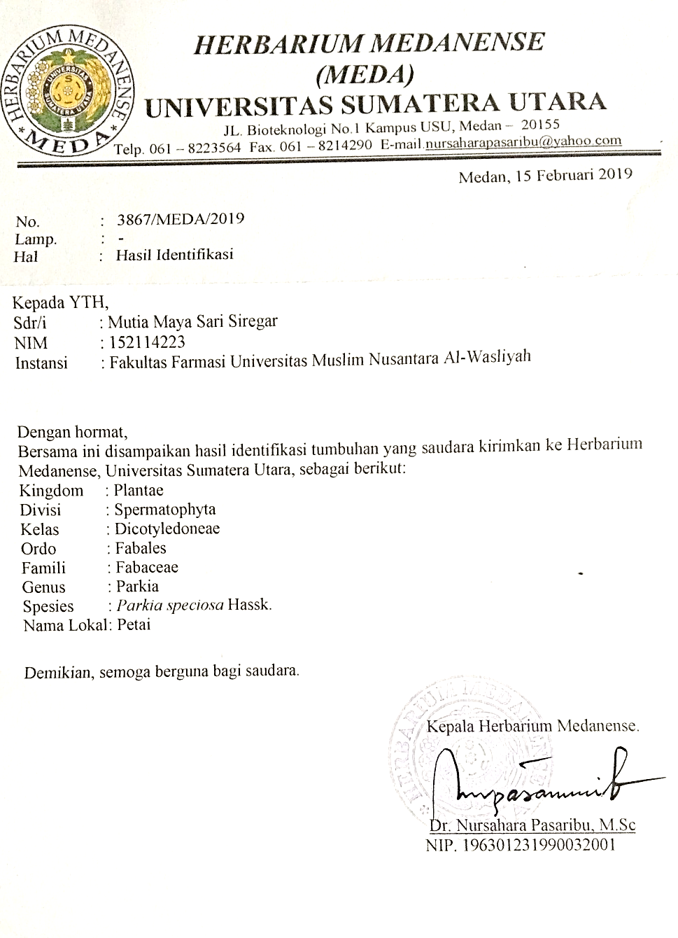LAMPIRAN
Lampiran 2. Surat ethical clearance
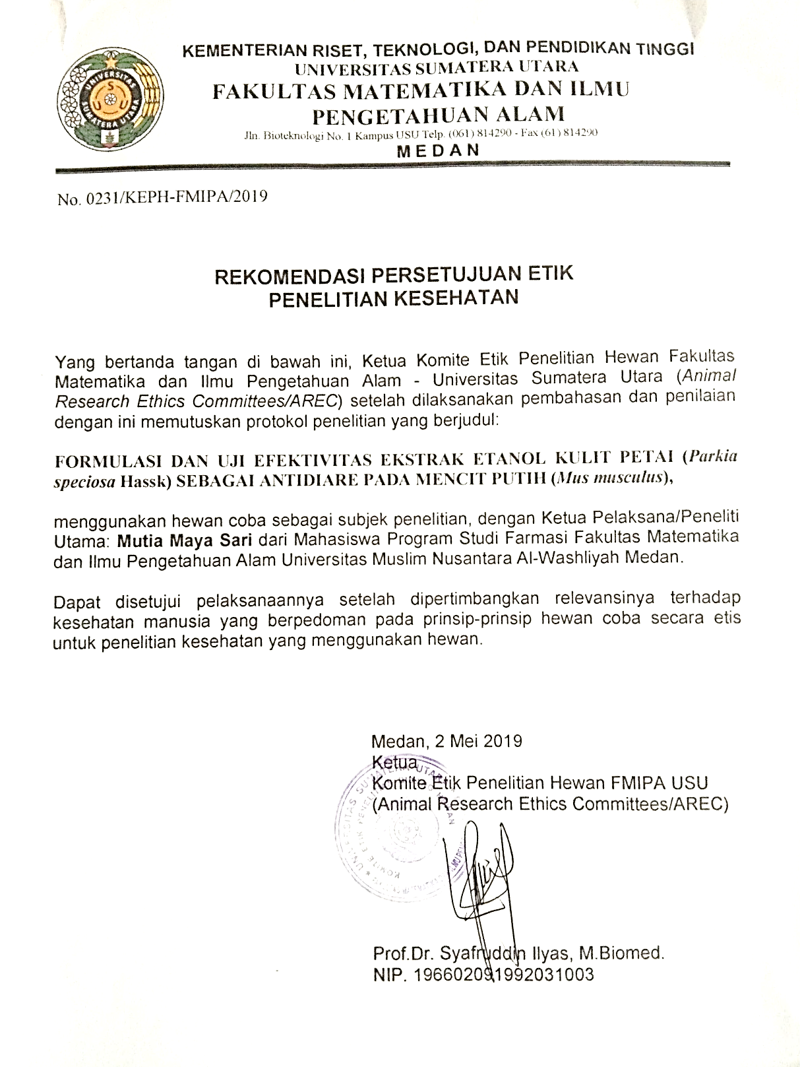
Lampiran 3. Gambar tanaman petai

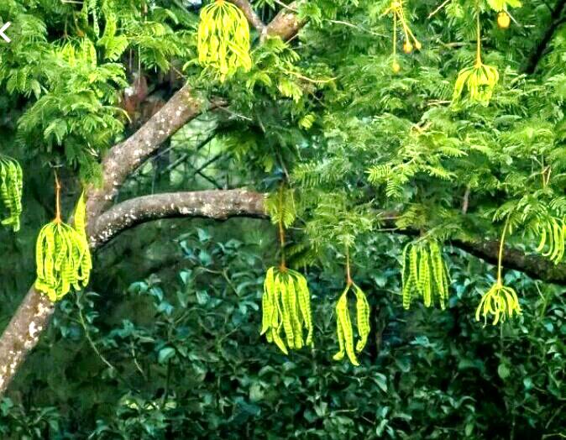
Lampiran 4. Makroskopik kulit petai
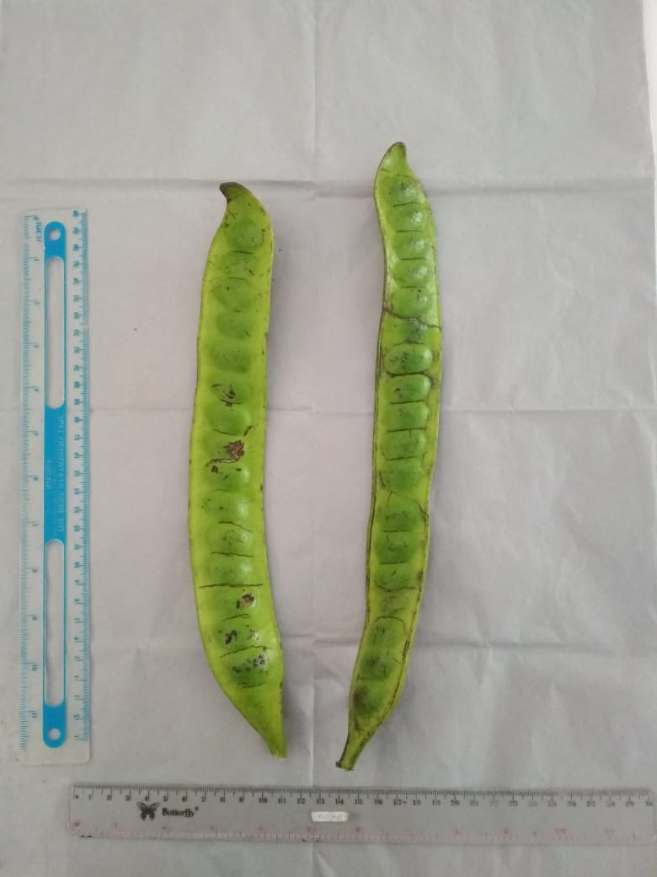

Kulit petai
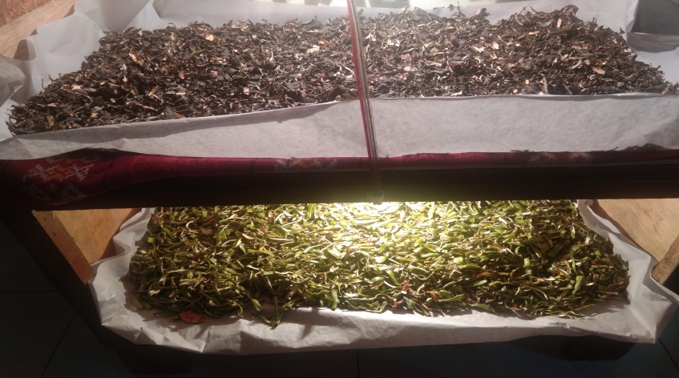
Proses pengeringan kulit petai
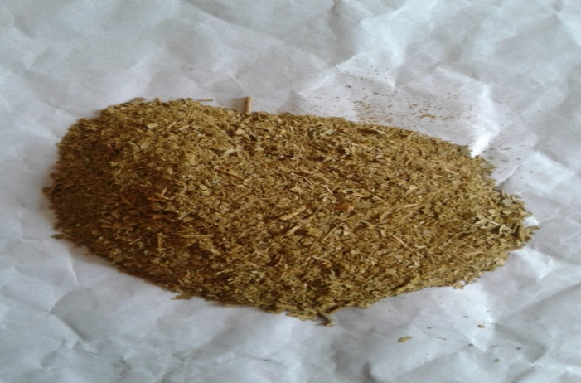

Serbuk kulit petai
Lampiran 5. Gambar alat
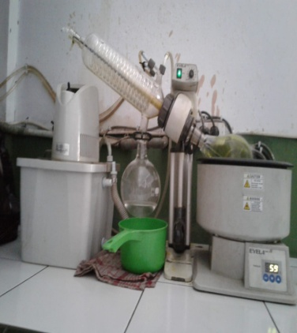

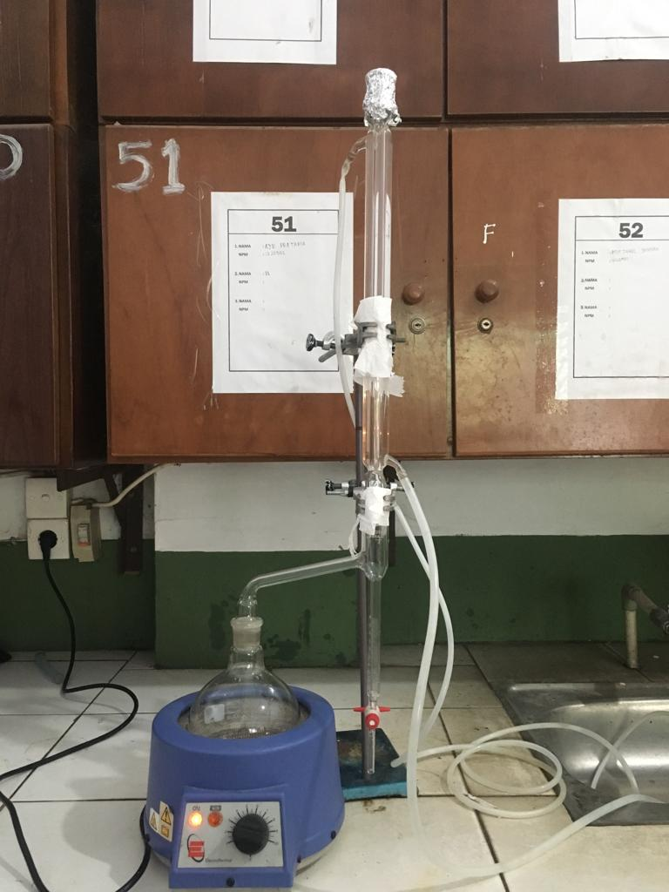
Alat Rotary Evaporator

Gambar Destilasis

Lampiran 6. Bagan Alir Skrining Fitokimia dan Karakterisasi
Simplisia Kulit Petai 12 kg

Dibersihkan dari pengotor kemudian
Dicuci bersih dan di tiriskan
Ditimbang
Simplisia Kulit Petai 11,5 kg

kemudian di keringkan di lemari pengering suhu 40ºC
Di timbang
Simplisia Kering Kulit Petai 8,2 kg

Di haluskan
Di timbang
Serbuk Simplisia Kulit Petai 4,5 kg

Skrining Fitokimia
Karakterisasi
Dibuat Ekstrak
- Makroskospik
- Mikroskospik
- PenetapanKadar Air
- Penetapan Kadar Sari Larut Dalam Air
- Penetapan Kadar Sari Larut Dalam Etanol
- Penetapan Kadar Abu Total
- Penetapan Kadar Abu Tidak Larut Dalam asam
Dimeserasi dengan Etanol 96 %
- Pemeriksaan alkaloid
- Pemeriksaan flavonoid
- Pemeriksaan Glikosida
- Pemeriksaan Glikosida Antrakuinon
- Pemeriksaan Saponin
- Pemeriksaan Tanin
- Pemeriksaan Steroid
Meserasi
Diuapkan dengan rotary evavorator
Ekstrak kental

Uji anti diare
SkriningFitokimia

Hasil

Lampiran 7. Bagan alir uji efektivitas antidiare pada mencit
Diadaptasi 2 minggu

Mencit 20 -30 g

Diinduksi oleh Oleum ricini
Diamati selama 1 jam

Semua mencit diuji dalam keadaan diare

Kelompok V
Suspensi EEKP 600 mg/kg BB
Kelompok IV suspensi EEKP 400 mg/kg BB
Kelompok III
suspensi EEKP 200 mg/kg BB
Kelompok 1
CMC 0,5 %
Kelompok II
Loperamid HCL 0.05%

Pengamatan
- Saat terjadinya diare
- Berat feses
- Diameter feses
- Frekuensi diare
- Lama terjadi diare

Lampiran 8. Gambar hasil uji mikroskopik kulit petai segar
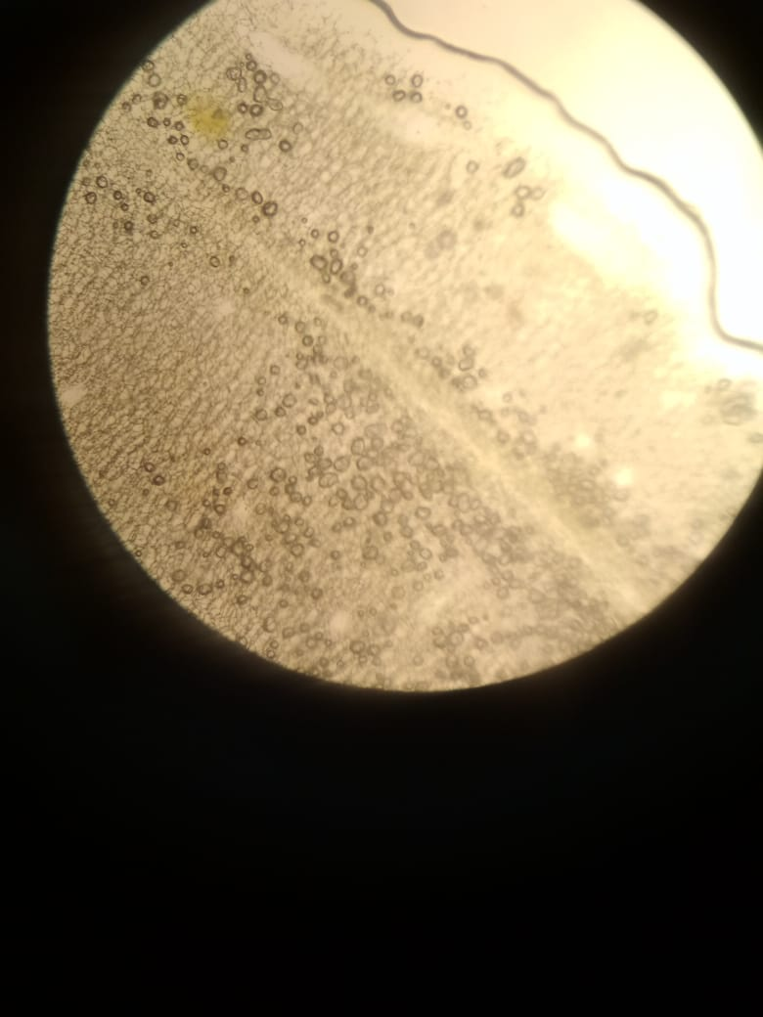
1 3
2

Mikroskopik kulit petai perbesaran 10 x 40
Keterangan:
1. Minyak atsiri
2. Sel pipih
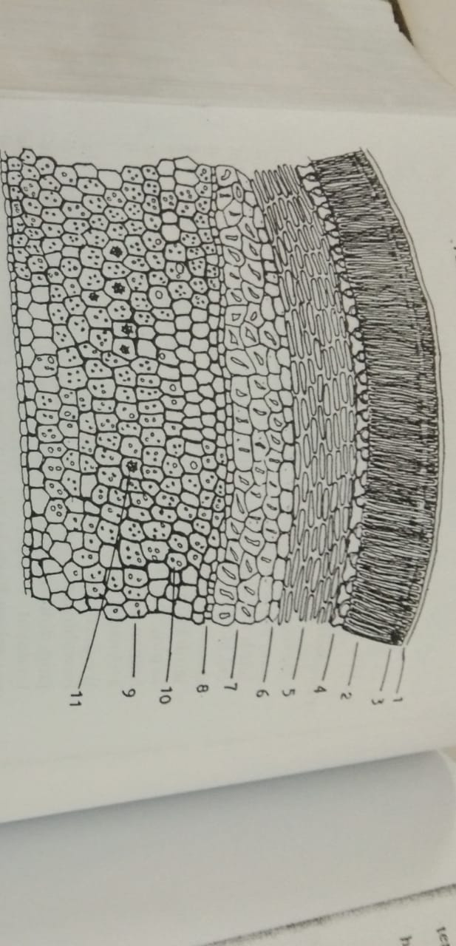
3. Hablur kalsium oksalat
4
3
2
1
Mikroskopik Petai Cina
Keterangan :
      - sel pipih
      - Minyak Asiri
      - Hablur kalsium oksalat
      - Sel Bentuk Piala

Lampiran 9. Perhitungan Hasil Pemeriksaan Karakterisasi Serbuk Simplisia Kuli Petai
1. Hasil Perhitungan Penetapan Kadar Air
$\% kadar air=\frac{V_{2-}V_{1}}{Berat sampel}×100\%$
Keterangan : V₁= Volume awal dari penjenuhan toluen
V₂= Volume akhir air dari simplisia
- Sampel pengulangan I
V₁ = 1.8 mL
V₂ = 1.5mL
Berat simplisia = 5 g
$\% kadar air = \frac{1.8 mL-1.5 mL}{5 g}×100\%$ = 6 %
- Sampel pengulangan II
V₁ = 2.1 mL
V₂ = 1.7 mL
Berat simplisia = 5 g
$\% kadar air =\frac{2.1 mL-1.7 mL}{5 g}×100\%$ = 8 %
- Sampel pengulangan III
V₁ = 2,2 mL
V₂ = 2.0 mL
Berat simplisia = 5 g
$\% kadar air =\frac{2.2 mL-2.0 mL}{5 g}×100\%$ = 4 %
Kadar air rata-rata =$\frac{6 \% + 8 \%+ 4 \% }{3}$ = 6 %
Lampiran 9. (Lanjutan)
2. Hasil Perhitungan Penetapan Kadar Sari Larut Air
Kadar sari larut air $=\frac{\left\{\left(berat cawan +sampel\right)-berat cawan kosong\right\}x5}{berat sampel} x 100\%$
- Sampel pengulangan I
Berat sampel : 5 g
Berat Cawan Kosong : 34,96 g
Berat Cawan + sampel : 34.96 g
Kadar sari larut air $=\frac{(34.96 -34,96 )x 5 }{5 g} x 100\%$ = 25 %

- Sampel pengulangan II
Beratsampel :5 g
Berat Cawan Kosong : 28,70 g
Berat Cawan + sampel :28.90 g
Kadar sari larut air $=\frac{(28,90-28,70 )x 5}{5 g} x 100\%$ = 20%

- Sampel pengulangan III
Berat sampel :5 g
Berat Cawan Kosong : 35.15 g
Berat Cawan + sampel : 35. 35 g
Kadar sari larut air $=\frac{(35,35 -35.15)x 5}{5 g} x 100\%$ = 20%
Kadar sari larut air rata-rata = $\frac{25\% + 20 \% +20 \% }{3}$ = 21.666 %

Lampiran 9. (Lanjutan)
3. Hasil Perhitungan Penetapan Kadar Sari Larut Etanol
Kadar sari larut etanol $=\frac{\left\{\left(berat cawan +sampel\right)-berat cawan kosong\right\}x5}{berat sampel} x 100\%$
a. Sampel pengulangan I
Berat sampel : 5 g
Berat Cawan Kosong : 53.25 g
Berat Cawan + sampel :53.30 g
Kadar sari larut air $=\frac{(53.30 -53.25)x 5 }{5 g} x 100\%$ = 5%
b. Sampel pengulangan II
Berat sampel :5 g
Berat Cawan Kosong : 64.40 g
Berat Cawan + sampel : 64.48 g
Kadar sari larut air $=\frac{(64.48-64.40 )x 5}{5 g} x 100\%$ = 8%
c. Sampel pengulangan III
Berat sampel :5 g
Berat Cawan Kosong : 64.20 g
Berat Cawan + sampel : 64.25 g
Kadar sari larut air $=\frac{(64.48-64.40 )x 5}{5 g} x 100\%$ = 5%
Kadar sari larut etanol rata-rata = $\frac{5\% + 8 \% +5 \% }{3}$ = 6 %

Lampiran 9. (Lanjutan)
4.Hasil Perhitungan Penetapan Kadar Abu Total
Kadar abu total $=\frac{Berat abu}{Berat sampel} x 100\%$
- Sampel pengulangan I
Berat sampel : 5 g
Berat Krus Kosong : 63 g
Berat Krus Isi : 63,12 g
Kadar abu total $=\frac{(63,12-63) }{5 g} x 100\%$ = 2.4 %

b. Sampel pengulangan II
Berat sampel : 5 g
Berat Krus Kosong : 59.35 g
Berat Krus Isi : 59.50 g
Kadar abu total $=\frac{(59,50-59,35 ) }{5 g} x 100\%$ = 3 %

c. Sampel pengulangan III
Berat sampel : 5 g
Berat Krus Kosong : 60.25 g
Berat Krus Isi : 60,45 g
Kadar abu total $=\frac{(60,45-60.25, ) }{5 g} x 100\%$ = 4%
Kadar abu total rata-rata = $\frac{2.4 \% + 3 \% + 4\% }{3}$ = 3,13%
Lampiran 9. (Lanjutan)
5. Hasil Perhitungan Penetapan Kadar Abu Tidak Larut Dalam Asam
Kadar abu tidak larut asam$=\frac{Berat abu }{Berat sampel} x 100\%$
a. Sampel pengulangan I
Berat sampel : 2,0005 gram
Berat Krus Kosong : 34,48 gram
Berat Krus Isi : 34,52 gram
Kadar abu tidak larut asam$=\frac{(34,52-34,48) }{2,0005} x 100\%$ = 1,99 %

b. Sampel pengulangan II
Berat sampel : 2,0001 gram
Berat Krus Kosong : 34,48 gram
Berat Krus Isi : 34,51 gram
Kadar abu tidak larut asam$=\frac{(34,511-34,48) }{2,0001} x 100\%$ = 1,49%

c. Sampel pengulangan III
Berat sampel : 2,0001 gram
Berat Krus Kosong : 34,48 gram
Berat Krus Isi : 34,50 gram
Kadar abu tidak larut asam$=\frac{(34,50-34,48) }{2,0001} x 100\%$ = 0,99%
Kadar abu tidak larut asam rata-rata = $\frac{1,99 \% + 1,49 \% + 0,99\% }{3}$ = 1,49%

Lampiran 10. Gambar feses mencit
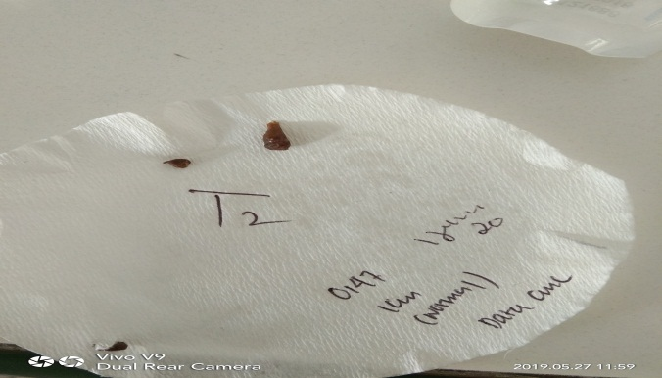

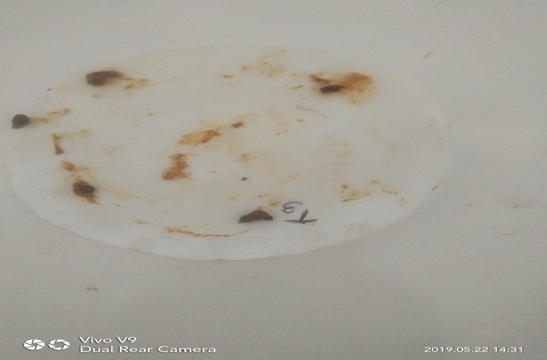
feses normal

feses lembek
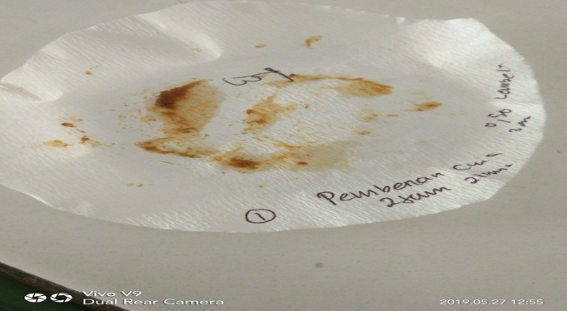

feses berlemdir

Lampiran 11. Volume Maksimum Sediaan Uji Yang Diberikan Pada Hewan Uji
Jenis Hewan Uji | Volume maksimum (ml) sesuai jalur pemberian
 | i.v |  | i.p | s.c | p.o
Mencit  (20-30 g) | 0,5 | 0,05 | 1,0 | 0,5-1,0 | 1,0
Tikus  (200 g) | 1,0 | 0,1 | 2-5 | 2-5 | 5,0
Hamster  (50 g) | - | 0,1 | 1-2 | 2-5 | 2,5
Marmut  (300 g) | - | 0,25 | 2-5 | 5,0 | 10,0
Kelinci  (2,5 kg) | 5-10 | 0,5 | 10-20 | 5-10 | 20,0
Kucing  (3 kg) | 5-10 | 1,0 | 10-20 | 5-10 | 50,0
Anjing  (5 kg) | 10-20 | 5,0 | 20-50 | 10,0 | 100,0

Keterangan :
i.v = intravena
i.m = intramuskular
i.p = intraperitonial
s.c = subcutan
p.o = peroral

Lampiran 12. Tabel Konversi Antara Jenis Hewan Dengan Manusia.

 | Mencit  20 g | Tikus  200 g | Marmut  400 g | Kelinci  1,5 kg | Kera  4 kg | Anjing  12 kg | Manusia  70 kg
Mencit  20 g | 1,0 | 7,0 | 12,25 | 27,8 | 64,1 | 124,3 | 387,9
Tikus  200 g | 0,14 | 1,0 | 1,74 | 3,0 | 9,2 | 17,8 | 56,0
Marmut  400 g | 0,008 | 0,57 | 1,0 | 2,25 | 5,2 | 10,2 | 31,5
Kelinci  1,5 kg | 0,04 | 0,25 | 0,44 | 1,0 | 2,4 | 4,5 | 14,2
Kera  4 kg | 0,016 | 0,11 | 0,19 | 0,42 | 1,0 | 1,9 | 6,1
Anjing  12 kg | 0,008 | 0,06 | 0,10 | 0,22 | 0,52 | 1,0 | 3,1
Manusia  70 kg | 0,0026 | 0,018 | 0,031 | 0,07 | 0,16 | 0,32 | 1,0

Lampiran 13. Perhitungan Konversi Dosis Loperamid HCl
      - Perhitungan konversi dosis loperamid HCl dari manusia ke mencit:
Dosis loperamid pada manusia (berat 70 kg) = 2-8 mg, tidak melebihi 16 mg/hari
Maka dosis loperamid untuk mencit (20 g) = 0,0026 X 2 mg
= 0,0052 mg / 0,02 kg BB
=0,26 mg/kg BB
ii. Perhitungan pembuatan loperamid HCl 0,05%
kosentrasi loperamid yang digunakan dalam penelitian adalah 0,05% maka untuk membuat suspensi loperamid HCl dengan konsentrasi 0,05% sebanyak 10 ml diperlukan loperamid HCl sebanyak
$$\frac{10 ml}{100 ml} x 0,05 g=0,005 g=5 mg$$
Dosis mencit setelah dikonversikan 0,26 mg/kg BB
Volume pemberian suspensi loperamid HCl 0,26 mg/kg BB (0.05%)
Kosentrasi $0,05\%=\frac{0,05 g}{100 ml} =0,0005 g/ml$ => 0,5 mg/ml
Jika berat badan mencit 20 g, maka loperamid yang diberikan tiap mencit sebanyak
Dosis mencit (20g) = $\frac{20 g}{1000 g}X 0,26 mg/kg =0,0052 mg$
Maka, volume yang diberikan
$$\frac{0,0052 mg}{0,5 mg/ml} =0,01 ml$$
Loperamid HCl 0,05% yaitu 50 mg dalam 100 ml, jika untuk 10 mg dalam 10 ml. maka loperamid HCl yang digunakan aebanyak 10 mg dalam 10 ml = 2,5 tablet dalam 10 ml
Lampiran 14. Perhitungan Dosis EEKP 2% Dengan dosis 200 mg/kg BB, 400 mg/kg BB dan 600 mg/kg BB
1. Perhitungan dosis, volume pemberian suspensi EEKP
Konsentrasi EEKP = 2 % $=\frac{2000 mg}{100 ml} =20 mg/ml$
2. EEKP dosis 200 mg/kg BB
Maka untuk membuat suspensi EEKP dengan konsentrasi 2 % sebanyak 10 ml, EEKP yang diambil sebanyak $=\frac{10 ml}{100 ml} x 2 g=200 mg$
Volume pemberian suspensi EEKP 10 mg/kg BB
Jika berat bedan mencit 30 g, maka EEKP yang diberikan tiap mencit sebanyak
$=\frac{30 g}{1000 ml}x 200 mg =6 mg$
Maka, volume yang diberikan $=\frac{6 mg}{20 mg/ml} =0,3 ml$
3. EEKP dosis 400 mg/kg BB
Maka untuk membuat suspensi EEKP dengan konsentrasi 2 % sebanyak 10 ml, EEKP yang diambil sebanyak $=\frac{10 ml}{100 ml} x 2 g=200 mg$
Volume pemberian suspensi EEKP 10 mg/kg BB
Jika berat bedan mencit 30 g, maka EEKP yang diberikan tiap mencit sebanyak $=\frac{30 g}{1000 ml}x 400 mg =12 mg$
Maka, volume yang diberikan $=\frac{12 mg}{20 mg/ml} =0,6 ml$
4. EEKP dosis 600 mg/kg BB
Maka untuk membuat suspensi EEKP dengan konsentrasi 2 % sebanyak 10 ml, EEKP yang diambil sebanyak $=\frac{10 ml}{100 ml} x 2 g=200 mg$
Lampiran 14. (Lanjutan)
Volume pemberian suspensi EEKP 10 mg/kg BB
Jika berat bedan mencit 30 g, maka EEKP yang diberikan tiap mencit sebanyak
$=\frac{30 g}{1000 ml}x 600 mg =18 mg$
Maka, volume yang diberikan $=\frac{18 mg}{20 mg/ml} =0,9 ml$

Lampiran 15. Hasil pengamatan saat mulai terjadinya diare yang diinduksi oleum ricini setelah pemberian suspensi CMC Na 0,5 %, suspensi loperamid HCl dan suspensi ekstrak etanol kulit petai (EEKP)
Perlakuan | Hewan |  |  |  |  |  | Jumlah | Rata-rata (menit)
 | 1 | 2 | 3 | 4 | 5 | 6
OR + CMC Na 0,5 % | 69 | 75 | 82 | 63 | 62 | 73 | 424 | 70.6
OR + Loperamid HCl | 117 | 103 | 112 | 93 | 95 | 92 | 612 | 102
OR + EEKP 200 mg/kg BB | 84 | 87 | 110 | 93 | 75 | 85 | 534 | 89
OR + EEKP 400 mg/kg BB | 79 | 85 | 83 | 63 | 65 | 84 | 459 | 76.5
OR + EEKP 600 mg/ kg BB | 97 | 80 | 104 | 70 | 84 | 90 | 525 | 87.5

Keterangan :
OR : Oleum Ricini
EEKP : Ekstrak Etanol Kulit Petai
Lampiran 16. Hasil pengamatan konsistensi feses (berlendir, lembek, normal) meliputi diameter feses dan berat feses setelah pemberian suspensi CMC Na 0,5% b/v, loperamid HCl dan ekstrak etanol kulit petai (EEKP)
      - feses berlendir
Perlakuan | Diameter feses (cm) | Berat feses  (g)
OR+CMC Na 0,5% b/v | 1,51 | 0,52
OR+Loperamid HCl | 1,19 | 0,46
OR+EEKP 200 mg/kg BB | 1,49 | 0,65
OR+ EEKP 400 mg/kg BB | 0,96 | 0,55
OR+EEKP 600 mg/kg BB | 0,96 | 0,51

      - feses lembek
Perlakuan | Diameter feses (cm) | Berat feses  (g)
OR+CMC Na 0,5% b/v | 0,11 | 0,47
OR+Loperamid HCl | 0,94 | 0,54
OR+EEKP 200 mg/kg BB | 1,09 | 0,42
OR+ EEKP 400 mg/kg BB | 1,36 | 0,47
OR+EEKP 600 mg/kg BB | 0,96 | 0,44

      - feses normal
Perlakuan | Diameter feses (cm) | Berat feses  (g)
OR+CMC Na 0,5% b/v | 0,31 | 0,31
OR+Loperamid | 0,57 | 0,52
OR+EEDA 200 mg/kg BB | 0,85 | 0,44
OR+ EEDA 400 mg/kg BB | 0,81 | 0,41
OR+EEDA 600 mg/kg BB | 0,88 | 0,42
Keterangan :
OR : Oleum Ricini
EEKP : Ekstrak Etanol Kulit Petai
Lampiran 17. Hasil pengamatan mengenai frekuensi diare dan lama terjadinya diare pada mencit yang telah diinduksi oleum ricini setelah pemberian suspensi CMC Na 0,5 % b/v, suspensi loperamid HCl dan suspensi ekstrak etanol kulit petai (EEKP)
- Pengamatan frekuensi diare
Perlakuan | Hewan |  |  |  |  |  | Jumlah | Rata-rata
 | 1 | 2 | 3 | 4 | 5 | 6
OR + CMC Na 0,5% b/v | 6 | 6 | 7 | 6 | 8 | 5 | 38 | 6,3
OR + Loperamid HCl | 6 | 7 | 5 | 4 | 5 | 4 | 31 | 3,5
OR + EKKP 200 mg/kg BB | 7 | 7 | 4 | 5 | 5 | 4 | 32 | 5,3
OR + EEKP 400 mg/kg BB | 4 | 5 | 5 | 7 | 7 | 4 | 32 | 5,3
OR + EEKP 600 mg/kg BB | 5 | 4 | 7 | 7 | 4 | 5 | 32 | 5,3

- Pengamatan lama terjadinya diare setelah pemberian oleum ricini
Perlakuan | Hewan |  |  |  |  |  | Jumlah | Rata-rata
 | 1 | 2 | 3 | 4 | 5 | 6
 | T₂₋T₁ | T₂₋T₁ | T₂₋T₁ | T₂₋T₁ | T₂₋T₁ | T₂₋T₁
OR+ CMC Na 0,5% b/v | 246 | 234 | 270 | 271 | 260 | 242 | 1,522 | 253,8
OR+ Loperamid | 198 | 125 | 140 | 182 | 179 | 172 | 996 | 166,1
OR+ EEKP 200 mg/kg BB | 258 | 193 | 143 | 235 | 304 | 109 | 1242 | 207
OR+ EEKP 400 mg/kg BB | 197 | 126 | 138 | 180 | 175 | 174 | 989 | 165
OR+ EEKP 600 mg/kg BB | 118 | 140 | 111 | 142 | 118 | 121 | 751 | 125,3

Keterangan :
OR : Oleum Ricini
EEKP : Ekstrak Etanol Kulit Petai
T₁ : Waktu pertama
T₂ : Waktu kedua

Lampiran 18. Hasil statistik ANOVA (Analysis Of Variance)

ANOVA
 |  | Sum of Squares | df | Mean Square | F | Sig.
saat terjadinya diare | Between Groups | .353 | 4 | .088 | 7.948 | .000
 | Within Groups | .278 | 25 | .011
 | Total | .631 | 29
berat feses berlendir | Between Groups | 1.775 | 4 | .444 | 3.395 | .004
 | Within Groups | 3.267 | 25 | .131
 | Total | 5.042 | 29
berat feses lembek | Between Groups | 5.245 | 4 | 1.311 | 15.688 | .000
 | Within Groups | 2.089 | 25 | .084
 | Total | 7.334 | 29
berat feses normal | Between Groups | 1.394 | 4 | .349 | 1.763 | .006
 | Within Groups | 4.944 | 25 | .198
 | Total | 6.338 | 29
diameter berlendir | Between Groups | .124 | 4 | .031 | 2.365 | .000
 | Within Groups | .328 | 25 | .013
 | Total | .452 | 29
diameter lembek | Between Groups | .051 | 4 | .013 | .265 | .005
 | Within Groups | 1.199 | 25 | .048
 | Total | 1.250 | 29
diameter normal | Between Groups | .140 | 4 | .035 | 2.471 | .007
 | Within Groups | .354 | 25 | .014
 | Total | .494 | 29
frekuensi diare | Between Groups | 5.133 | 4 | 1.283 | 5.066 | .004
 | Within Groups | 6.333 | 25 | .253
 | Total | 11.467 | 29
lama terjadinya diare | Between Groups | 57150.467 | 4 | 14287.617 | 9.740 | .000
 | Within Groups | 36673.000 | 25 | 1466.920
 | Total | 93823.467 | 29

Lampiran 19. Hasil deskriptif data

Descriptives
 |  | N | Mean | Std. Deviation | Std. Error | 95% Confidence Interval for Mean |  | Min | Max
 |  |  |  |  |  | Lower Bound | Upper Bound
1 | 2 | 3 | 5 | 6 | 7 | 8 | 9 | 10 | 11
saat terjadinya diare | CMC Na 0.5% | 6 | 70.6 | .07607 | .03106 | .6268 | .7865 | .62 | .82
 | Loperamid HCL 0.05 % | 6 | 1.02 | .10545 | .04305 | .9093 | 1.1307 | .92 | 1.17
 | Dosis 200 mg/kg BB | 6 | 89 | .11815 | .04824 | .7660 | 1.0140 | .75 | 1.10
 | Dosis 400 mg/kg BB | 6 | 76.5 | .09915 | .04048 | .6610 | .8690 | .63 | .85
 | Dosis 600 mg/kg BB | 6 | 87.5 | .12194 | .04978 | .7470 | 1.0030 | .70 | 1.04
 | Total | 30 | 1.061 | .14753 | .02693 | .7962 | .9064 | .62 | 1.17
berat feses berlendir | CMC Na 0.5% | 6 | .5250 | .06473 | .02643 | .4571 | .5929 | .44 | .61
 | Loperamid HCL | 6 | .4617 | .06676 | .02725 | .3916 | .5317 | .37 | .54
 | Dosis 200 mg/kg BB | 6 | .6567 | .15971 | .06520 | .4891 | .8243 | .51 | .88
 | Dosis 400 mg/kg BB | 6 | .5583 | .09827 | .04012 | .4552 | .6615 | .47 | .74
 | Dosis mg/kg BB sis 600 | 6 | .5183 | .14770 | .06030 | .3633 | .6733 | .38 | .80
 | Total | 30 | .5440 | .12489 | .02280 | .4974 | .5906 | .37 | .88
berat feses lembek | CMC Na 0.5% | 6 | .4717 | .07653 | .03124 | .3914 | .5520 | .39 | .61
 | Loperamid HCL | 6 | .5433 | .09993 | .04080 | .4385 | .6482 | .43 | .70
 | Dosis 200 mg/kg BB | 6 | .4200 | .45865 | .18724 | .0613 | .9013 | .42 | .94
 | Dosis 400 mg/kg BB | 6 | .4783 | .07305 | .02982 | .4017 | .5550 | .38 | .57
 | Dosis 600 mg/kg BB | 6 | .4467 | .09070 | .03703 | .3515 | .5419 | .38 | .60
 | Total | 30 |  | .20759 | .03790 | .3945 | .5495 | .42 | .94
1 | 2 | 3 | 5 | 6 | 7 | 8 | 9 | 10 | 11
berat feses normal | CMC Na 0.5% | 6 | .3100 | .16923 | .06909 | .1324 | .4876 | .00 | .49
 | Loperamid HCL | 6 | .5233 | .16801 | .06859 | .3470 | .6996 | .35 | .80
 | Dosis 200 mg/kg BB | 6 | .4417 | .09239 | .03772 | .3447 | .5386 | .35 | .58
 | Dosis 400 mg/kg BB | 6 | .4117 | .04579 | .01869 | .3636 | .4597 | .35 | .47
 | Dosis 600 mg/kg BB | 6 | .4267 | .05750 | .02348 | .3663 | .4870 | .35 | .52
 | Total | 30 | .4227 | .13051 | .02383 | .3739 | .4714 | .00 | .80
diameter berlendir | CMC Na 0.5% | 6 | 1.5133 | .66075 | .26975 | .8199 | 2.2067 | .93 | 2.36
 | Loperamid HCL | 6 | 1.1933 | .15718 | .06417 | 1.0284 | 1.3583 | 1.00 | 1.33
 | Dosis 200 mg/kg BB | 6 | 1.4967 | .22142 | .09039 | 1.2643 | 1.7290 | 1.20 | 1.87
 | dosis 400 mg/kg BB | 6 | .9650 | .17649 | .07205 | .7798 | 1.1502 | .66 | 1.20
 | Dosis 600 mg/kg BB | 6 | .9600 | .33454 | .13658 | .6089 | 1.3111 | .51 | 1.431
 | Total | 30 | 1.2257 | .41695 | .07612 | 1.0700 | 1.3814 | .51 | 2.36
diameter lembek | CMC Na 0.5% | 6 | .1167 | .28577 | .11667 | -.1832 | .4166 | .00 | .70
 | Loperamid HCL | 6 | .9400 | .20367 | .08315 | .7263 | 1.1537 | .65 | 1.23
 | Dosis 200 mg/kg BB | 6 | 1.0917 | .24983 | .10199 | .8295 | 1.3539 | .70 | 1.30
 | dosis 400 mg/kg BB | 6 | 1.3667 | .40208 | .16415 | .9447 | 1.7886 | .70 | 1.95
 | Dosis 600 mg/kg BB | 6 | .9667 | .26583 | .10853 | .6877 | 1.2456 | .60 | 1.20
 | Total | 30 | .8963 | .50289 | .09182 | .7086 | 1.0841 | .00 | 1.95
diameter normal | CMC Na 0.5% | 6 | .3167 | .77567 | .31667 | -.4974 | 1.1307 | .00 | 1.90
 | Loperamid HCL | 6 | .5717 | .31752 | .12963 | .2385 | .9049 | .30 | 1.20
 | Dosis 200 mg/kg BB | 6 | .8500 | .31464 | .12845 | .5198 | 1.1802 | .50 | 1.30
 | dosis 400 mg/kg BB | 6 | .8167 | .40702 | .16617 | .3895 | 1.2438 | .30 | 1.30
 | Dosis 600 mg/kg BB | 6 | .8833 | .14720 | .06009 | .7289 | 1.0378 | .70 | 1.00
 | Total | 30 | .6877 | .46751 | .08535 | .5131 | .8622 | .00 | 1.90

1 | 2 | 3 | 5 | 6 | 7 | 8 | 9 | 10 | 11
frekuensi diare | CMC Na 0,5% | 6 | 6.33 | .516 | .211 | 5.79 | 6.88 | 6 | 7
 | Loperamid HCL | 6 | 5.17 | .408 | .167 | 4.74 | 5.60 | 5 | 6
 | Dosis 200 | 6 | 5.50 | .548 | .224 | 4.93 | 6.07 | 5 | 6
 | Dosis 400 | 6 | 5.33 | .516 | .211 | 4.79 | 5.88 | 5 | 6
 | Dosis 600 | 6 | 5.33 | .516 | .211 | 4.79 | 5.88 | 5 | 6
 | Total | 30 | 5.53 | .629 | .115 | 5.30 | 5.77 | 5 | 7
lama terjadinya diare | CMC Na 0,5% | 6 | 253.83 | 26.339 | 10.753 | 226.19 | 281.47 | 204 | 272
 | Loperamid HCL | 6 | 166.17 | 56.333 | 22.998 | 107.05 | 225.28 | 107 | 264
 | Dosis 200 | 6 | 207.00 | 56.232 | 22.956 | 147.99 | 266.01 | 143 | 304
 | Dosis 400 | 6 | 165.00 | 11.967 | 4.885 | 152.44 | 177.56 | 148 | 182
 | Dosis 600 | 6 | 125.33 | 12.738 | 5.200 | 111.97 | 138.70 | 111 | 142
 | Total | 30 | 183.47 | 56.880 | 10.385 | 162.23 | 204.71 | 107 | 304

Lampiran 20 Hasil analisis statistik uji beda rata-rata Duncan
1. Saat mulai terjadinya diare
Saat terjadinya diare
Duncan
Kelompok | N | Subset for alpha = 0.05
 |  | 1 | 2 | 3
CMC Na 0.5% | 6 | 70.67
EEKP dosis 400 mg/kg BB | 6 | 87.50 | 87.50
EEKP dosis 600 mg/kg BB | 6 |  | 89.00
EEKP dosis 200 mg/kg BB | 6 |  | 76.00
Loperamid HCL 0.05% | 6 |  |  | 102.00
Sig. |  | .347 | .062 | 1.000
Means for groups in homogeneous subsets are displayed.
2. Feses berat dan diameter feses

- Berat feses
- berat berlendir
Berat feses berlendir
Duncanª
Kelompok | N | Subset for alpha = 0.05
 |  | 1 | 2
Loperamid HCL 0.05% | 6 | .4617
Dosis 600 mg/kg BB | 6 | .5183 | .5183
CMC Na 0.5% | 6 | .5250 | .5250
Dosis 400 mg/kg BB | 6 | .5583 | .5583
Dosis 200 mg/kg BB | 6 |  | .6567
Sig. |  | .193 | .065
Means for groups in homogeneous subsets are displayed.
a. Uses Harmonic Mean Sample Size = 6.000.

Lampiran 20. (lanjutan)

- berat lembek
Berat feses lembek
Duncanª
Kelompok | N | Subset for alpha = 0.05
 |  | 1
Dosis 200 mg/kg BB | 6 | .4200
Dosis 600 mg/kg BB | 6 | .4467
CMC Na 0.5% | 6 | .4717
Dosis 400 mg/kg BB | 6 | .4783
Loperamid HCL 0.05% | 6 | .5433
Sig. |  | .392
Means for groups in homogeneous subsets are displayed.
a. Uses Harmonic Mean Sample Size = 6.000.

- berat normal
Berat feses normal
Duncanª
Kelompok | N | Subset for alpha = 0.05
 |  | 1 | 2
CMC Na 0.5% | 6 | .3100
Dosis 400 mg/kg BB | 6 | .4117 | .4117
Dosis 600 mg/kg BB | 6 | .4267 | .4267
Dosis 200 mg/kg BB | 6 | .4417 | .4417
Loperamid HCL 0.05% | 6 |  | .5233
Sig. |  | .090 | .149
Means for groups in homogeneous subsets are displayed.
a. Uses Harmonic Mean Sample Size = 6.000.

- diameter feses
- diameter berlendir
Diameter berlendir
Duncanª
Kelompok | N | Subset for alpha = 0.05
 |  | 1 | 2
Dosis 600 mg/kg BB | 6 | .9600
dosis 400 mg/kg BB | 6 | .9650
Loperamid HCL 0.05 % | 6 | 1.1933 | 1.1933
Dosis 200 mg/kg BB | 6 |  | 1.4967
CMC Na 0.5% | 6 |  | 1.5133
Sig. |  | .302 | .159
Lampiran 20. (lanjutan)
- diameter lembek

Diameter lembek
Duncanª
Kelompok | N | Subset for alpha = 0.05
 |  | 1 | 2 | 3
CMC Na 0.5% | 6 | .1167
Loperamid HCL 0.05% | 6 |  | .9400
Dosis 600 mg/kg BB | 6 |  | .9667
Dosis 200 mg/kg BB | 6 |  | 1.0917 | 1.0917
dosis 400 mg/kg BB | 6 |  |  | 1.3667
Sig. |  | 1.000 | .400 | .112
Means for groups in homogeneous subsets are displayed.
a. Uses Harmonic Mean Sample Size = 6.000.

- diameter normal
Diameter normal
Duncanª
Kelompok | N | Subset for alpha = 0.05
 |  | 1
CMC Na 0.5% | 6 | .3167
Loperamid HCL 0.05% | 6 | .5717
dosis 400 mg/kg BB | 6 | .8167
Dosis 200 mg/kg BB | 6 | .8500
Dosis 600 mg/kg BB | 6 | .8833
Sig. |  | .057
Means for groups in homogeneous subsets are displayed.
a. Uses Harmonic Mean Sample Size = 6.000.

Lampiran 20. (lanjutan)

- Frekuensi diare
Duncan | Frekuensi diare
Kelompok | N | Subset for alpha = 0.05
 |  | 1 | 2 | 3
EEKP dosis 600 mg/kg BB | 6 | 4.6667
Loperamid HCL 0.05% | 6 | 5.1667 | 5.1667
EEKP dosis 400 mg/kg BB | 6 |  | 5.3333
EEKP dosis 200 mg/kg BB | 6 |  | 5.6667
CMC Na 0.5% | 6 |  |  | 7.3333
Sig. |  | .093 | .111 | 1.000
Means for groups in homogeneous subsets are displayed.

- Lama terjadinya diare

lama terjadinya diare
Duncanª
Kelompok | N | Subset for alpha = 0.05
 |  | 1 | 2 | 3
5. Dosis 600 mg/kg BB | 6 | 125.33
4. Dosis 400 mg/kg BB | 6 | 165.00 | 165.00
2.Loperamid HCL | 6 | 166.17 | 166.17
3.Dosis 200 mg/kg BB | 6 |  | 207.00
1.CMC Na 0.5% | 6 |  |  | 253.83
Sig. |  | .092 | .083 | 1.000
Means for groups in homogeneous subsets are displayed.

