Lampiran 01.

Data Perusahaan Consumer Goods

Sektor Makanan dan Minuman yang Terdaftar di Bursa Efek Indonesia

No. | Kode | Nama Emiten | Saham Perdana
1 | ADES | Akasha Wira International Tbk | 13/06/1994
2 | AISA | Tiga Pilar Sejahtera Food Tbk | 11/06/1997
3 | ALTO | Tri Banyan Tirta Tbk | 10/07/2012
4 | BTEK | Bumi Teknokultura Unggul Tbk | 14/05/2004
5 | BUDI | Budi Starch & Sweetener Tbk | 08/05/1995
6 | CAMP | Campina Ice Cream Industry Tbk | 19/12/2017
7 | CEKA | Wilmar Cahaya Indonesia Tbk | 09/07/1996
8 | CLEO | Sariguna Primatirta Tbk | 05/05/2017
9 | DLTA | Delta Djakarta Tbk | 12/02/1984
10 | FOOD | Sentra Food Indonesia Tbk | 08/01/2019
11 | GOOD | Garudafood Putra Putri Jaya Tbk | 10/10/2018
12 | HOKI | Buyung Poetra Sembada Tbk | 22/06/2017
13 | ICBP | Indofood CBP Sukses Makmur Tbk | 07/10/2010
14 | IIKP | Inti Agri Resources Tbk | 20/10/2002
15 | INDF | Indofood Sukses Makmur Tbk | 14/07/1994
16 | MGNA | Magna Investama Mandiri Tbk | 07/07/2014
17 | MLBI | Multi Bintang Indonesia Tbk | 17/01/1994
18 | MYOR | Mayora Indah Tbk | 04/07/1990
19 | PANI | Pratama Abadi Nusa Industri Tbk | 18/09/2018
20 | PCAR | Prima Cakrawala Abadi Tbk | 29/12/2017
21 | PSDN | Prasidha Aneka Niaga Tbk | 18/10/1994
22 | ROTI | Nippon Indosari Corpindo Tbk | 28/06/2010
23 | SKBM | Sekar Bumi Tbk | 05/01/1993
24 | SKLT | Sekar Laut Tbk | 08/09/1993
25 | STTP | Siantar Top Tbk | 16/12/1996
26 | ULTJ | Ultra Jaya Milk Industry & Trading  Company Tbk. | 02/07/1990

Lampiran 02.

Data Leverage

No. | Kode | 2019 | 2018 | 2017 | RATA  RATA
1 | ADES | 0,31 | 0,45 | 0,50 | 0,42
2 | AISA | 0,57 | 0,55 | 0,38 | 0,50
3 | ALTO | 0,68 | 0,65 | 0,62 | 0,65
4 | BTEK | 0,57 | 0,56 | 0,63 | 0,59
5 | BUDI | 0,57 | 0,64 | 0,59 | 0,60
6 | CAMP | 0,12 | 0,12 | 0,31 | 0,18
7 | CEKA | 0,19 | 0,16 | 0,35 | 0,23
8 | CLEO | 0,38 | 0,24 | 0,55 | 0,39
9 | DLTA | 0,15 | 0,17 | 0,15 | 0,15
10 | FOOD | 0,38 | 0,57 | 0,91 | 0,62
11 | GOOD | 0,45 | 0,41 | 0,65 | 0,50
12 | HOKI | 0,24 | 0,26 | 0,18 | 0,23
13 | ICBP | 0,31 | 0,34 | 0,36 | 0,34
14 | IIKP | 0,07 | 0,08 | 0,08 | 0,07
15 | INDF | 0,46 | 0,48 | 0,47 | 0,47
16 | MGNA | 0,73 | 0,79 | 0,79 | 0,77
17 | MLBI | 0,60 | 0,60 | 0,60 | 0,60
18 | MYOR | 0,48 | 0,51 | 0,51 | 0,50
19 | PANI | 0,47 | 0,54 | 0,49 | 0,50
20 | PCAR | 0,29 | 0,25 | 0,31 | 0,28
21 | PSDN | 0,77 | 0,65 | 0,57 | 0,66
22 | ROTI | 0,34 | 0,34 | 0,38 | 0,35
23 | SKBM | 0,39 | 0,41 | 0,37 | 0,39
24 | SKLT | 0,52 | 0,55 | 0,52 | 0,53
25 | STTP | 0,37 | 0,41 | 0,39 | 0,39
26 | ULTJ | 0,14 | 0,19 | 0,16 | 0,16
Total |  |  |  |  | 11,08
Mean |  |  |  |  | 0,4263
Std Dev |  |  |  |  | 0,18132134
Min |  |  |  |  | 0,07
Max |  |  |  |  | 0,77

Lampiran 03.

Data Ukuran Perusaahaan

No. | Kode | 2019 | 2018 | 2017 | RATA  RATA
1 | ADES | 13,62 | 13,69 | 13,64 | 13,65
2 | AISA | 15,64 | 15,86 | 15,64 | 15,71
3 | ALTO | 14,00 | 13,92 | 13,92 | 13,95
4 | BTEK | 15,42 | 15,46 | 15,48 | 15,45
5 | BUDI | 14,91 | 15,04 | 14,89 | 14,95
6 | CAMP | 13,87 | 13,82 | 14,01 | 13,90
7 | CEKA | 14,15 | 13,97 | 14,15 | 14,09
8 | CLEO | 14,03 | 13,63 | 13,40 | 13,69
9 | DLTA | 14,17 | 14,17 | 14,11 | 14,15
10 | FOOD | 11,68 | 11,75 | 11,75 | 11,73
11 | GOOD | 15,44 | 15,25 | 15,09 | 15,26
12 | HOKI | 13,65 | 13,54 | 13,27 | 13,49
13 | ICBP | 17,47 | 17,35 | 17,27 | 17,36
14 | IIKP | 12,86 | 12,61 | 12,66 | 12,71
15 | INDF | 18,34 | 18,39 | 18,30 | 18,34
16 | MGNA | 12,37 | 12,38 | 12,41 | 12,39
17 | MLBI | 14,88 | 14,88 | 14,88 | 14,88
18 | MYOR | 16,76 | 16,68 | 16,52 | 16,65
19 | PANI | 12,04 | 11,77 | 11,24 | 11,69
20 | PCAR | 11,86 | 11,67 | 11,87 | 11,80
21 | PSDN | 13,55 | 13,46 | 13,45 | 13,48
22 | ROTI | 15,36 | 15,30 | 15,33 | 15,33
23 | SKBM | 14,36 | 14,39 | 14,30 | 14,35
24 | SKLT | 13,58 | 13,52 | 13,36 | 13,49
25 | STTP | 14,87 | 14,78 | 14,67 | 14,77
26 | ULTJ | 15,70 | 15,53 | 15,46 | 15,56
Total |  |  |  |  | 372,82
Mean |  |  |  |  | 14,3391
Std Dev |  |  |  |  | 1,650770363
Min |  |  |  |  | 11,69
Max |  |  |  |  | 18,34

Lampiran 04.

Data Profitabilitas

No. | Kode | 2019 | 2018 | 2017 | RATA RATA
1 | ADES | 0,10 | 0,06 | 0,05 | 0,07
2 | AISA | 0,18 | 0,13 | 0,15 | 0,16
3 | ALTO | 0,01 | 0,03 | 0,06 | 0,03
4 | BTEK | 0,02 | 0,02 | 0,01 | 0,02
5 | BUDI | 0,02 | 0,01 | 0,02 | 0,02
6 | CAMP | 0,07 | 0,06 | 0,04 | 0,06
7 | CEKA | 0,15 | 0,08 | 0,08 | 0,10
8 | CLEO | 0,11 | 0,08 | 0,08 | 0,09
9 | DLTA | 0,24 | 0,24 | 0,21 | 0,23
10 | FOOD | 0,02 | 0,01 | 0,02 | 0,01
11 | GOOD | 0,08 | 0,10 | 0,09 | 0,09
12 | HOKI | 0,12 | 0,12 | 0,08 | 0,11
13 | ICBP | 0,14 | 0,14 | 0,11 | 0,13
14 | IIKP | 0,22 | 0,05 | 0,04 | 0,10
15 | INDF | 0,06 | 0,05 | 0,05 | 0,06
16 | MGNA | 0,39 | 0,15 | 0,13 | 0,23
17 | MLBI | 0,42 | 0,38 | 0,35 | 0,38
18 | MYOR | 0,11 | 0,10 | 0,11 | 0,11
19 | PANI | 0,01 | 0,01 | 0,01 | 0,01
20 | PCAR | 0,07 | 0,07 | 0,00 | 0,05
21 | PSDN | 0,03 | 0,07 | 0,05 | 0,05
22 | ROTI | 0,05 | 0,03 | 0,03 | 0,04
23 | SKBM | 0,01 | 0,01 | 0,02 | 0,01
24 | SKLT | 0,06 | 0,04 | 0,04 | 0,05
25 | STTP | 0,17 | 0,10 | 0,09 | 0,12
26 | ULTJ | 0,16 | 0,13 | 0,14 | 0,14
Total |  |  |  |  | 2,45
Mean |  |  |  |  | 0,0941
Std Dev |  |  |  |  | 0,083971094
Min |  |  |  |  | 0,01
Max |  |  |  |  | 0,38

Lampiran 05.

Data Perataan Laba

No | Kode | Rata-Rata
 |  | Income Smoothing
1 | ADES | 0,05
2 | AISA | 00.04
3 | ALTO | -0.02
4 | BTEK | -0.92
5 | BUDI | 00.21
6 | CAMP | 00.07
7 | CEKA | 00.13
8 | CLEO | 00.06
9 | DLTA | -0.66
10 | FOOD | 0,13125
11 | GOOD | -0.34
12 | HOKI | 00.00
13 | ICBP | 00.04
14 | IIKP | 04.16
15 | INDF | 00.00
16 | MGNA | -0.82
17 | MLBI | -3.42
18 | MYOR | -0.20
19 | PANI | -0.20
20 | PCAR | -1.31
21 | PSDN | 01.39
22 | ROTI | 00.40
23 | SKBM | 02.32
24 | SKLT | 00.05
25 | STTP | 0,048611111
26 | ULTJ | 00.14
Total |  | 05.24
Rata-Rata |  | 1,398611111
Std.Dev |  | 1.3807
Minimum |  | -3.42
Maximum |  | 4.16

Lampiran 06.

Data Hasil Olahan SPSS

Tabel 4.1 Deskriptif Statistik

Descriptive Statistics
 | N | Minimum | Maximum | Mean | Std. Deviation
X1_Leverage | 26 | .07 | .77 | .4242 | .18296
X2_UkuranPerusahaan | 26 | 11.69 | 18.34 | 14.3392 | 1.64927
X3_Profitabilitas | 26 | .01 | .38 | .0958 | .08329
Y_PerataanLaba | 26 | -3.40 | 4.20 | .2060 | 1.38086
Valid N (listwise) | 26
Sumber : Data hasil olahan Peneliti 2020

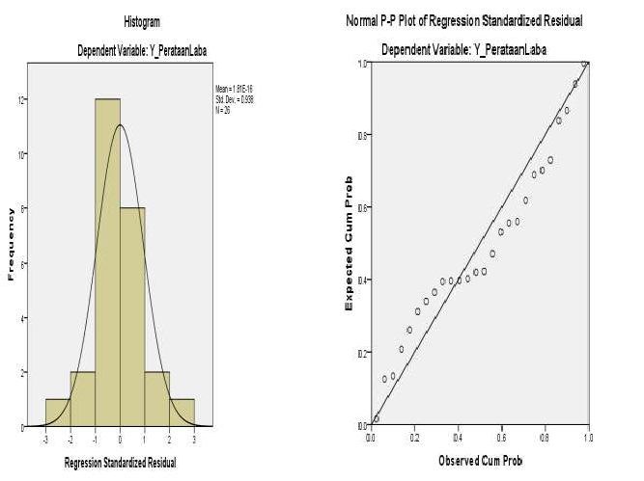

Gambar 4.1 Uji Normalitas

Sumber : Data hasil olahan Peneliti 2020

Tabel 4.2 Kolmogorof Smirnov
One-Sample Kolmogorov-Smirnov Test
 |  | Unstandardize d Residual
N |  | 26  0E-7  1.09230206  .129  .129  -.108  .656  .783
Normal Parameters^{a,b} | Mean
 | Std. Deviation
 | Absolute
Most Extreme
 | Positive
Differences
 | Negative
Kolmogorov-Smirnov Z
Asymp. Sig. (2-tailed)
      - Test distribution is Normal.
      - Calculated from data.

Sumber : Data hasil olahan Peneliti 2020

Tabel 4.3
Uji Multikilinieritas
Coefficientsª

Coefficientsª
Model | Unstandardized Coefficients |  | Standardized Coefficients | t | Sig. | Collinearity Statistics
 | B | Std. Error | Beta |  |  | Tolerance | VIF
(Constant) | 3.709 | 2.122 |  | 1.748 | .094
X1_Leverage  1 | -1.956 | 1.274 | -.259 | -1.535 | .139 | .999 | 1.001
X2_UkuranPerusahaan | -.129 | .143 | -.154 | -.903 | .376 | .978 | 1.022
X3_Profitabilitas | -8.606 | 2.827 | -.519 | -3.044 | .006 | .978 | 1.022
a. Dependent Variable: Y_PerataanLaba
Sumber : Data hasil olahan Peneliti 2020

Tabel 4.4 Uji Autokorelasi
Durbin-Watson

Model Summary^{b}
Model | R | R Square | Adjusted R Square | Std. Error of the Estimate | Durbin-Watson
1 | .612ª | .374 | .289 | 1.16440 | 2.003
- Predictors: (Constant), X3_Profitabilitas, X1_Leverage, X2_UkuranPerusahaan
- Dependent Variable: Y_PerataanLaba

Sumber : Data hasil olahan Peneliti 2020

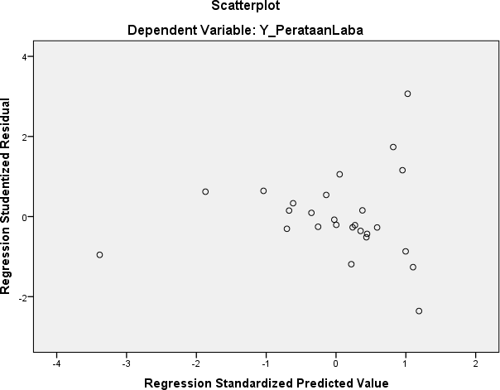

Gambar 4.2 Scatterplot

Tabel 4.5
Analisis Regresi Linier Berganda

Model | Unstandardized Coefficients |  | Standardized Coefficients | t | Sig.
 | B | Std. Error | Beta
(Constant)  X1_Leverage  1  X2_UkuranPerusahaan  X3_Profitabilitas | 3.709  -1.956  -.129  -8.606 | 2.122  1.274  .143  2.827 | -.259  -.154  -.519 | 1.748  -1.535  -.903  -3.044 | .094  .139  .376  .006

Sumber : Data hasil olahan Peneliti 2020

Tabel 4.7
Uji Simultan (Uji f)

ANOVAª
Model |  | Sum of Squares | df | Mean Square | F | Sig.
 | Regression | 17.842 | 3 | 5.947 | 4.386 | .015^{b}
1 | Residual | 29.828 | 22 | 1.356
 | Total | 47.670 | 25
- Dependent Variable: Y_PerataanLaba
- Predictors: (Constant), X3_Profitabilitas, X1_Leverage, X2_UkuranPerusahaan

Sumber : Data hasil olahan Peneliti 2020

Tabel 4.8
Uji Koefisien Determinasi

Model Summary^{b}
Model | R | R Square | Adjusted R Square | Std. Error of the Estimate
1 | .612ª | .374 | .289 | 1.16440
  - Predictors: (Constant), X3_Profitabilitas, X1_Leverage,
X2_UkuranPerusahaan
  - Dependent Variable: Y_PerataanLaba

Sumber : Data hasil olahan Peneliti 2020

