Lampiran 1. Kuesioner
DAFTAR KUESIONER
Pengaruh Persepsi Kualitas Layanan Dan Kepuasan Konsumen Terhadap Keputusan Pembeli Ulang di Minimarket Alfamart cab SM Raja Medan”
Dengan hormat,
Guna menyusun proposal dalam rangka memenuhi syarat untuk dapat menyelesaikan program pendidikan S1 pada Fakultas Ekonomi Universitas Muslim Nusantara Al-Washliyah Medan, jadi diperukan data-data dan informasi – informasi yang mendukung kelancaran penelitian ini .
Demi tercapainya tujuan penelitian ini, maka penyusun memohon kesedian dari saudara/I untuk membantu mengisi kuesioner atau daftar penyataan yang telah disediakan.
Kemudian atas kesedian saudara/i yang telah meluangkan waktunya untuk mengisi kuesioner penelitian ini, penyusun mengucapkan banyak terima kasih.
Hormat saya,

Zulfahmi Siregar

KUESIONER
NO.
    - Identitas Reponden
Berilah tanda silang (X) pada pertanyaan tentang karakteristik responden dibawah ini :
- Jenis kelamin :
  - Laki-Laki
  - Perempuan
- Usia :……… tahun
- Tingkat pendidikan
  - SMA/SMK
  - D1/D3
  - S1
  - S2
- Pekerjaan
  - Karyawan Swasta
  - PNS / TNI
  - Wiraswasta
  - IRT (Ibu rumah tangga)
    - Petunjuk Pengisian Kuesioner
Berilah tanda check list (√) pada jawaban yang paling sesuai pendapat anda pada kolom yang tersedia. Setiap responden hanya diperbolehkan memilih satu jawaban.

Penilaian dapat anda lakukan berdasarkan skala berikut :
Keterangan | Nilai
Sangat Setuju (SS) | 5
Setuju (S) | 4
Kurang Setuju (KS) | 3
Tidak Setuju (TS) | 2
Sangat Tidak Setuju (STS) | 1

Apakah Bapak / Ibu Sudah Mempunyai Kartu Member Alfa Mart ?
YA
TIDAK

    - Daftar Pertanyaan
Variabel X₁ (Kualitas Layanan)
No. | Pertanyaan | SS | S | KS | TS | STS
Keandalan
1. | Menurut saya alfamart memberikan layanan sesuai dengan segera dan memuaskan
Daya tanggap
2. | Staff pegawai alfamart membantu para pelanggan dengan sigap
Jaminan
3. | Pengetahuan para staff karyawan alfamart memiliki pengetahuan dan kompetensi yang baik
Perhatian
4. | Para karyawan alfamart tulus melayani pelanggan dengan baik

Variabel X₂ (Kepuasan Konsumen)
No. | Pertanyaan | SS | S | KS | TS | STS
Perasaan puas
1. | Saya Merasa Puas Berbelanja Di Alfamart
Terpenuhinya Harapan Pelanggan Setelah Membeli Produk
2. | Alfamart Memenuhi Harapan Saya Ketika Berbelanja
Selalu Membeli Produk
3. | Saya Selalu Membeli Produk Kebutuhan Saya Di Alfamart
Kesesuaian Harapan
4. | Keinginan Yang Saya Harapkan Ketika Berbelanja Di Alfamrt Sesuai Dengan Yang Saya Harapkan
Minat Berkunjung Kembali
5. | Saya Akan Terus Berbelanja Kebutuhan Saya Di Alfamart
Kesedian Merekomendasi
 | Saya Akan Mengajak Teman Dan Kerabat Untuk Berbelanja Di Alfamart

Variabel Y ( Keputusan Pembelian Ulang )
No. | Pertanyaan | ST | S | KS | TS | STS
Pilihan pertama membeli
1. | Saya akan memutuskan berbelanja di alfamart
Akan tetap membeli
2. | Saya akan tetap berbelanja di alfamart walau ada godaan potongan di tempat lain
Pemecahan masalah berulang
3. | Apabila ada kebutuhan yang saya perlukan saya akan selalu kembali berbelanja di alfamart
Perilaku karena kebiasaan
4. | Berbelanja di alfamart sudah menjadi kebiasaan saya

Lampiran 2. Hasil Jawaban Validitas Dan Reliabilitas Kuesioner
NO | KUALITAS LAYANAN (X1) |  |  |  | TOTAL X1 | KEPUASAN KONSUMEN (X2) |  |  |  |  |  | TOTAL  X2
 | X1.1 | X1.2 | X1.3 | X1.4 |  | X2.1 | X2.2 | X2.3 | X2.4 | X2.5 | X2.6
1 | 5 | 5 | 5 | 5 | 20 | 4 | 4 | 5 | 5 | 5 | 4 | 27
2 | 5 | 5 | 5 | 4 | 19 | 4 | 4 | 4 | 3 | 4 | 4 | 23
3 | 5 | 5 | 5 | 5 | 20 | 5 | 5 | 5 | 4 | 5 | 5 | 29
4 | 4 | 5 | 4 | 4 | 17 | 5 | 5 | 5 | 5 | 5 | 5 | 30
5 | 4 | 5 | 4 | 4 | 17 | 5 | 5 | 5 | 5 | 5 | 5 | 30
6 | 5 | 5 | 5 | 5 | 20 | 5 | 5 | 5 | 5 | 5 | 5 | 30
7 | 4 | 5 | 5 | 5 | 19 | 5 | 4 | 5 | 4 | 5 | 4 | 27
8 | 5 | 5 | 5 | 5 | 20 | 5 | 5 | 5 | 5 | 5 | 5 | 30
9 | 4 | 5 | 5 | 4 | 18 | 5 | 5 | 5 | 5 | 5 | 4 | 29
10 | 4 | 5 | 5 | 4 | 18 | 5 | 5 | 5 | 5 | 5 | 4 | 29
11 | 4 | 5 | 5 | 5 | 19 | 4 | 4 | 5 | 5 | 5 | 4 | 27
12 | 4 | 5 | 5 | 5 | 19 | 5 | 5 | 5 | 4 | 5 | 5 | 29
13 | 5 | 5 | 5 | 5 | 20 | 5 | 4 | 5 | 5 | 5 | 4 | 28
14 | 5 | 5 | 5 | 5 | 20 | 5 | 5 | 5 | 5 | 5 | 5 | 30
15 | 5 | 5 | 5 | 5 | 20 | 4 | 4 | 5 | 5 | 5 | 4 | 27
16 | 4 | 4 | 5 | 5 | 18 | 4 | 4 | 5 | 5 | 4 | 4 | 26
17 | 5 | 5 | 5 | 5 | 20 | 5 | 4 | 5 | 5 | 4 | 4 | 27
18 | 4 | 4 | 5 | 5 | 18 | 5 | 4 | 5 | 5 | 5 | 4 | 28
19 | 5 | 5 | 5 | 5 | 20 | 5 | 5 | 5 | 5 | 5 | 5 | 30
20 | 4 | 4 | 5 | 5 | 18 | 3 | 3 | 4 | 4 | 4 | 3 | 21
21 | 5 | 5 | 5 | 5 | 20 | 5 | 5 | 5 | 5 | 5 | 5 | 30
22 | 5 | 4 | 5 | 5 | 19 | 5 | 4 | 5 | 5 | 5 | 5 | 29
23 | 4 | 4 | 5 | 5 | 18 | 4 | 3 | 5 | 5 | 5 | 4 | 26
24 | 4 | 4 | 4 | 4 | 16 | 4 | 3 | 5 | 4 | 5 | 4 | 25
25 | 4 | 4 | 4 | 4 | 16 | 4 | 4 | 5 | 5 | 5 | 4 | 27
26 | 5 | 5 | 5 | 5 | 20 | 5 | 4 | 5 | 5 | 5 | 5 | 29
27 | 5 | 5 | 5 | 5 | 20 | 4 | 4 | 5 | 5 | 5 | 4 | 27
28 | 5 | 5 | 5 | 5 | 20 | 5 | 5 | 5 | 5 | 5 | 5 | 30
29 | 4 | 4 | 5 | 5 | 18 | 4 | 4 | 4 | 5 | 4 | 4 | 25
30 | 4 | 4 | 4 | 4 | 16 | 4 | 4 | 5 | 5 | 5 | 4 | 27

No | KEPUTUSAN PEMBELIAN ULANG (Y)
 | Y.1 | Y.2 | Y.3 | Y.4 | TOTAL Y
1 | 5 | 5 | 5 | 5 | 20
2 | 5 | 5 | 5 | 5 | 20
3 | 4 | 5 | 5 | 5 | 19
4 | 4 | 5 | 5 | 5 | 19
5 | 5 | 5 | 5 | 5 | 20
6 | 4 | 5 | 5 | 5 | 19
7 | 5 | 5 | 5 | 5 | 20
8 | 5 | 5 | 5 | 5 | 20
9 | 5 | 5 | 5 | 5 | 20
10 | 5 | 5 | 5 | 5 | 20
11 | 4 | 4 | 4 | 4 | 16
12 | 5 | 5 | 5 | 5 | 20
13 | 4 | 4 | 5 | 5 | 18
14 | 4 | 4 | 5 | 5 | 18
15 | 5 | 5 | 5 | 5 | 20
16 | 5 | 5 | 5 | 5 | 20
17 | 5 | 5 | 5 | 5 | 20
18 | 4 | 5 | 4 | 4 | 17
19 | 4 | 5 | 4 | 4 | 17
20 | 5 | 5 | 5 | 5 | 20
21 | 4 | 4 | 4 | 4 | 16
22 | 5 | 5 | 5 | 5 | 20
23 | 3 | 5 | 5 | 5 | 18
24 | 3 | 5 | 4 | 4 | 16
25 | 3 | 5 | 5 | 5 | 18
26 | 3 | 4 | 4 | 4 | 15
27 | 4 | 5 | 4 | 5 | 18
28 | 5 | 3 | 4 | 5 | 17
29 | 5 | 4 | 4 | 5 | 18
30 | 5 | 4 | 4 | 4 | 17

Lampiran 2 : Hasil Jawaban Kuesioner

Tabulasi (X1)

NO RESPONDEN | KUALITAS LAYANAN (X1) |  |  |  | TOTAL X1
 | X1.1 | X1.2 | X1.3 | X1.4
1 | 5 | 5 | 5 | 5 | 20
2 | 5 | 4 | 5 | 5 | 19
3 | 5 | 5 | 5 | 5 | 20
4 | 5 | 5 | 5 | 4 | 19
5 | 4 | 4 | 5 | 5 | 18
6 | 3 | 3 | 3 | 3 | 12
7 | 5 | 5 | 5 | 3 | 18
8 | 4 | 4 | 4 | 4 | 16
9 | 4 | 4 | 3 | 4 | 15
10 | 4 | 3 | 3 | 2 | 12
11 | 5 | 5 | 5 | 4 | 19
12 | 5 | 5 | 4 | 4 | 18
13 | 5 | 5 | 5 | 5 | 20
14 | 4 | 5 | 5 | 5 | 19
15 | 4 | 5 | 4 | 4 | 17
16 | 5 | 5 | 5 | 5 | 20
17 | 4 | 3 | 3 | 2 | 12
18 | 5 | 5 | 5 | 4 | 19
19 | 5 | 5 | 4 | 4 | 18
20 | 5 | 5 | 5 | 4 | 19
21 | 5 | 5 | 4 | 5 | 19
22 | 5 | 5 | 5 | 3 | 18
23 | 4 | 5 | 5 | 5 | 19
24 | 5 | 5 | 4 | 4 | 18
25 | 4 | 5 | 5 | 4 | 18
26 | 4 | 5 | 5 | 5 | 19
27 | 5 | 4 | 4 | 5 | 18
28 | 5 | 5 | 5 | 5 | 20
29 | 5 | 5 | 4 | 5 | 19
30 | 5 | 5 | 5 | 5 | 20
31 | 5 | 5 | 5 | 5 | 20
32 | 5 | 4 | 5 | 5 | 19
33 | 2 | 5 | 4 | 5 | 16
34 | 5 | 4 | 5 | 3 | 17
35 | 4 | 5 | 5 | 5 | 19
36 | 5 | 5 | 5 | 5 | 20
37 | 4 | 5 | 4 | 4 | 17
38 | 4 | 5 | 4 | 4 | 17
39 | 4 | 4 | 4 | 4 | 16
40 | 4 | 5 | 3 | 5 | 17
41 | 5 | 5 | 4 | 5 | 19
42 | 5 | 5 | 3 | 3 | 16
43 | 5 | 3 | 4 | 5 | 17
44 | 5 | 4 | 5 | 5 | 19
45 | 4 | 3 | 4 | 3 | 14
46 | 3 | 3 | 4 | 5 | 15
47 | 5 | 5 | 5 | 4 | 19
48 | 3 | 5 | 4 | 5 | 17
49 | 5 | 5 | 5 | 5 | 20
50 | 5 | 5 | 4 | 5 | 19
51 | 5 | 5 | 4 | 4 | 18
52 | 3 | 2 | 3 | 5 | 13
53 | 5 | 5 | 5 | 2 | 17
54 | 4 | 5 | 5 | 5 | 19
55 | 5 | 5 | 5 | 4 | 19
56 | 5 | 4 | 4 | 4 | 17
57 | 5 | 5 | 5 | 5 | 20
58 | 5 | 3 | 4 | 5 | 17
59 | 5 | 4 | 5 | 5 | 19
60 | 4 | 5 | 5 | 5 | 19
61 | 5 | 5 | 5 | 5 | 20
62 | 5 | 3 | 4 | 5 | 17
63 | 5 | 5 | 5 | 4 | 19
64 | 3 | 5 | 4 | 5 | 17
65 | 3 | 3 | 3 | 3 | 12
66 | 5 | 5 | 5 | 4 | 19
67 | 5 | 5 | 4 | 5 | 19
68 | 5 | 5 | 4 | 4 | 18
69 | 4 | 5 | 5 | 5 | 19
70 | 5 | 5 | 5 | 5 | 20
71 | 5 | 5 | 5 | 5 | 20
72 | 5 | 3 | 4 | 4 | 16
73 | 3 | 5 | 5 | 4 | 17
74 | 4 | 5 | 4 | 3 | 16
75 | 2 | 3 | 4 | 5 | 14
76 | 5 | 5 | 5 | 5 | 20
77 | 3 | 3 | 5 | 5 | 16
78 | 4 | 4 | 4 | 3 | 15
79 | 4 | 4 | 4 | 4 | 16
80 | 5 | 5 | 5 | 3 | 18
81 | 3 | 5 | 4 | 5 | 17
82 | 3 | 4 | 5 | 5 | 17
83 | 2 | 4 | 5 | 5 | 16
84 | 5 | 5 | 5 | 5 | 20
85 | 5 | 5 | 4 | 5 | 19
86 | 5 | 5 | 5 | 5 | 20
87 | 5 | 3 | 4 | 5 | 17
88 | 5 | 2 | 3 | 4 | 14
89 | 4 | 4 | 5 | 5 | 18
90 | 5 | 5 | 5 | 5 | 20
91 | 5 | 4 | 5 | 5 | 19
92 | 5 | 3 | 5 | 4 | 17
93 | 5 | 3 | 4 | 5 | 17
94 | 5 | 5 | 3 | 2 | 15
95 | 5 | 3 | 4 | 5 | 17
96 | 5 | 4 | 3 | 4 | 16
97 | 4 | 5 | 3 | 4 | 16

Tabulasi (X2)
NO RESPONDEN | KEPUASAN KONSUMEN (X2) |  |  |  |  |  | TOTAL X2
 | X2.1 | X2.2 | X2.3 | X2.4 | X2.5 | X2.6
1 | 5 | 4 | 5 | 4 | 5 | 5 | 28
2 | 5 | 5 | 5 | 5 | 5 | 5 | 30
3 | 5 | 5 | 5 | 5 | 4 | 5 | 29
4 | 5 | 5 | 5 | 5 | 4 | 3 | 27
5 | 4 | 5 | 4 | 5 | 5 | 5 | 28
6 | 5 | 5 | 5 | 4 | 3 | 4 | 26
7 | 5 | 5 | 5 | 5 | 5 | 5 | 30
8 | 5 | 4 | 5 | 4 | 5 | 2 | 25
9 | 3 | 3 | 4 | 3 | 3 | 4 | 20
10 | 5 | 5 | 5 | 5 | 4 | 5 | 29
11 | 5 | 5 | 5 | 5 | 5 | 5 | 30
12 | 5 | 5 | 5 | 5 | 5 | 5 | 30
13 | 5 | 5 | 5 | 5 | 4 | 5 | 29
14 | 5 | 5 | 3 | 5 | 4 | 5 | 27
15 | 5 | 5 | 5 | 4 | 5 | 5 | 29
16 | 5 | 5 | 5 | 4 | 4 | 5 | 28
17 | 2 | 3 | 3 | 2 | 3 | 2 | 15
18 | 4 | 3 | 3 | 2 | 3 | 3 | 18
19 | 5 | 5 | 5 | 5 | 4 | 4 | 28
20 | 5 | 5 | 5 | 5 | 5 | 5 | 30
21 | 4 | 5 | 5 | 4 | 5 | 4 | 27
22 | 4 | 5 | 4 | 5 | 5 | 5 | 28
23 | 5 | 5 | 5 | 5 | 5 | 5 | 30
24 | 5 | 5 | 4 | 5 | 4 | 5 | 28
25 | 5 | 4 | 5 | 4 | 5 | 5 | 28
26 | 3 | 5 | 3 | 2 | 2 | 3 | 18
27 | 3 | 4 | 3 | 3 | 3 | 2 | 18
28 | 5 | 5 | 5 | 5 | 5 | 5 | 30
29 | 5 | 5 | 5 | 5 |  | 5 | 25
30 | 5 | 4 | 5 | 5 | 5 | 5 | 29
31 | 5 | 5 | 5 | 4 | 3 | 3 | 25
32 | 5 | 5 | 5 | 5 | 5 | 5 | 30
33 | 3 | 2 | 3 | 2 | 1 | 3 | 14
34 | 2 | 2 | 3 | 4 | 4 | 5 | 20
35 | 2 | 2 | 2 | 2 | 2 | 2 | 12
36 | 4 | 2 | 3 | 2 | 2 | 2 | 15
37 | 2 | 2 | 3 | 4 | 3 | 3 | 17
38 | 3 | 4 | 2 | 2 | 3 | 3 | 17
39 | 3 | 3 | 2 | 2 | 3 | 2 | 15
40 | 2 | 3 | 3 | 3 | 3 | 2 | 16
41 | 4 | 5 | 5 | 4 | 5 | 5 | 28
42 | 3 | 3 | 4 | 5 | 5 | 5 | 25
43 | 5 | 4 | 2 | 3 | 3 | 2 | 19
44 | 5 | 2 | 3 | 4 | 2 | 3 | 19
45 | 4 | 3 | 3 | 3 | 4 | 3 | 20
46 | 4 | 5 | 5 | 5 | 5 | 5 | 29
47 | 3 | 3 | 4 | 5 | 5 | 5 | 25
48 | 4 | 3 | 2 | 4 | 5 | 5 | 23
49 | 5 | 5 | 5 | 5 | 5 | 5 | 30
50 | 5 | 5 | 5 | 5 | 5 | 5 | 30
51 | 5 | 5 | 5 | 5 | 5 | 5 | 30
52 | 5 | 5 | 5 | 5 | 5 | 5 | 30
53 | 5 | 5 | 5 | 5 | 5 | 5 | 30
54 | 5 | 5 | 4 | 5 | 5 | 5 | 29
55 | 5 | 5 | 5 | 4 | 4 | 5 | 28
56 | 5 | 5 | 3 | 5 | 4 | 5 | 27
57 | 5 | 3 | 3 | 4 | 2 | 2 | 19
58 | 3 | 3 | 3 | 4 | 2 | 2 | 17
59 | 4 | 5 | 5 | 5 | 5 | 5 | 29
60 | 5 | 4 | 4 | 5 | 5 | 5 | 28
61 | 5 | 5 | 5 | 5 | 4 | 5 | 29
62 | 3 | 2 | 2 | 3 | 4 | 5 | 19
63 | 4 | 5 | 5 | 4 | 5 | 5 | 28
64 | 5 | 4 | 5 | 5 | 5 | 5 | 29
65 | 2 | 3 | 5 | 3 | 4 | 2 | 19
66 | 4 | 3 | 3 | 3 | 4 | 3 | 20
67 | 4 | 5 | 5 | 5 | 5 | 5 | 29
68 | 4 | 4 | 5 | 5 | 5 | 5 | 28
69 | 4 | 4 | 5 | 3 | 5 | 5 | 26
70 | 5 | 5 | 5 | 5 | 5 | 5 | 30
71 | 5 | 5 | 5 | 5 | 5 | 5 | 30
72 | 1 | 2 | 2 | 2 | 3 | 5 | 15
73 | 5 | 5 | 5 | 5 | 5 | 5 | 30
74 | 5 | 3 | 5 | 5 | 5 | 5 | 28
75 | 4 | 3 | 3 | 3 | 3 | 4 | 20
76 | 4 | 4 | 5 | 5 | 5 | 5 | 28
77 | 3 | 3 | 2 | 2 | 2 | 2 | 14
78 | 4 | 5 | 4 | 2 | 2 | 2 | 19
79 | 2 | 3 | 1 | 2 | 3 | 4 | 15
80 | 5 | 5 | 5 | 5 | 4 | 4 | 28
81 | 4 | 5 | 5 | 5 | 5 | 4 | 28
82 | 5 | 5 | 5 | 3 | 4 | 4 | 26
83 | 2 | 3 | 3 | 4 | 3 | 4 | 19
84 | 5 | 5 | 5 | 5 | 5 | 5 | 30
85 | 2 | 3 | 5 | 5 | 5 | 5 | 25
86 | 2 | 3 | 2 | 4 | 2 | 5 | 18
87 | 5 | 5 | 5 | 5 | 4 | 4 | 28
88 | 4 | 5 | 5 | 5 | 4 | 5 | 28
89 | 4 | 4 | 4 | 4 | 4 | 4 | 24
90 | 4 | 3 | 2 | 2 | 2 | 2 | 15
91 | 2 | 3 | 3 | 3 | 3 | 3 | 17
92 | 5 | 5 | 5 | 5 | 5 | 5 | 30
93 | 5 | 5 | 5 | 5 | 5 | 4 | 29
94 | 5 | 5 | 5 | 5 | 4 | 4 | 28
95 | 5 | 5 | 5 | 4 | 4 | 5 | 28
96 | 4 | 5 |  | 5 | 5 | 5 | 24
97 | 3 | 3 | 2 | 3 | 2 | 2 | 15

Tabulasi (Y)
NO RESPONDEN | KEPUTUSAN PEMBELIAN ULANG (Y) |  |  |  | TOTAL Y
 | Y.1 | Y.2 | Y.3 | Y.4
1 | 5 | 5 | 5 | 5 | 20
2 | 5 | 5 | 5 | 5 | 20
3 | 3 | 5 | 5 | 5 | 18
4 | 5 | 5 | 3 | 4 | 17
5 | 4 | 5 | 4 | 5 | 18
6 | 3 | 2 | 3 | 2 | 10
7 | 4 | 5 | 5 | 5 | 19
8 | 2 | 3 | 3 | 4 | 12
9 | 4 | 2 | 4 | 4 | 14
10 | 4 | 3 | 5 | 5 | 17
11 | 5 | 5 | 5 | 5 | 20
12 | 4 | 5 | 5 | 5 | 19
13 | 5 | 5 | 4 | 4 | 18
14 | 5 | 5 | 5 | 4 | 19
15 | 5 | 5 | 5 | 4 | 19
16 | 4 | 5 | 5 | 5 | 19
17 | 2 | 5 | 3 | 3 | 13
18 | 5 | 5 | 5 | 5 | 20
19 | 4 | 5 | 5 | 4 | 18
20 | 5 | 5 | 5 | 5 | 20
21 | 4 | 4 | 4 | 4 | 16
22 | 4 | 5 | 4 | 5 | 18
23 | 5 | 5 | 5 | 5 | 20
24 | 5 | 3 | 4 | 5 | 17
25 | 5 | 5 | 5 | 3 | 18
26 | 2 | 2 | 3 | 4 | 11
27 | 3 | 4 | 5 | 5 | 17
28 | 3 | 4 | 5 | 5 | 18
29 | 5 | 5 | 5 | 5 | 20
30 | 5 | 4 | 4 | 5 | 18
31 | 5 | 5 | 4 | 4 | 18
32 | 4 | 5 | 5 | 5 | 19
33 | 3 | 3 | 3 | 2 | 11
34 | 4 | 3 | 3 | 5 | 15
35 | 5 | 5 | 4 | 5 | 19
36 | 5 | 3 | 4 | 5 | 17
37 | 3 | 3 | 4 | 5 | 15
38 | 3 | 3 | 3 | 3 | 12
39 | 3 | 3 | 3 | 2 | 11
40 | 5 | 5 | 5 | 5 | 20
41 | 5 | 5 | 5 | 5 | 20
42 | 4 | 4 | 4 | 5 | 17
43 | 2 | 3 | 5 | 5 | 15
44 | 2 | 3 | 4 | 4 | 13
45 | 2 | 2 | 2 | 3 | 9
46 | 5 | 5 | 5 | 5 | 20
47 | 5 | 5 | 5 | 5 | 20
48 | 5 | 5 | 5 | 5 | 20
49 | 5 | 4 | 5 | 5 | 19
50 | 5 | 4 | 4 | 5 | 18
51 | 5 | 5 | 3 | 3 | 16
52 | 5 | 5 | 5 | 5 | 20
53 | 3 | 5 | 5 | 5 | 18
54 | 3 | 5 | 5 | 5 | 18
55 | 5 | 5 | 5 | 5 | 20
56 | 3 | 3 | 4 | 5 | 15
57 | 3 | 4 | 4 | 3 | 14
58 | 3 | 4 | 4 | 4 | 15
59 | 4 | 4 | 5 | 5 | 18
60 | 5 | 5 | 5 | 5 | 20
61 | 5 | 5 | 5 | 2 | 17
62 | 5 | 3 | 3 | 4 | 15
63 | 5 | 5 | 5 | 5 | 20
64 | 4 | 4 | 5 | 5 | 18
65 | 4 | 3 | 3 | 3 | 13
66 | 5 | 5 | 5 | 3 | 18
67 | 5 | 5 | 5 | 4 | 17
68 | 5 | 5 | 4 | 4 | 18
69 | 5 | 4 | 5 | 5 | 19
70 | 4 | 5 | 5 | 5 | 19
71 | 5 | 5 | 5 | 5 | 20
72 | 2 | 3 | 2 | 4 | 11
73 | 5 | 5 | 5 | 2 | 17
74 | 3 | 2 | 5 | 5 | 15
75 | 2 | 3 | 3 | 3 | 13
76 | 5 | 5 | 5 | 5 | 20
77 | 4 | 2 | 2 | 2 | 10
78 | 4 | 4 | 3 | 4 | 15
79 | 4 | 3 | 2 | 2 | 11
80 | 4 | 3 | 5 | 5 | 17
81 | 4 | 5 | 5 | 5 | 19
82 | 4 | 4 | 3 | 4 | 15
83 | 2 | 3 | 3 | 4 | 12
84 | 5 | 5 | 5 | 5 | 20
85 | 5 | 4 | 4 | 4 | 17
86 | 3 | 4 | 3 | 3 | 13
87 | 5 | 5 | 5 | 5 | 20
88 | 5 | 5 | 5 | 5 | 20
89 | 3 | 3 | 5 | 5 | 16
90 | 3 | 4 | 3 | 5 | 15
91 | 4 | 2 | 2 | 2 | 10
92 | 5 | 5 | 4 | 4 | 18
93 | 5 | 5 | 4 | 4 | 18
94 | 3 | 4 | 3 | 5 | 15
95 | 5 | 5 | 5 | 5 | 20
96 | 5 | 5 | 5 | 4 | 19
97 | 2 | 2 | 3 | 3 | 10

Lampiran 4. Uji Validitas Dan Reliabilitas
Uji Validitas
Correlations
Notes
Output Created |  |  |  |  | 26-JUL-2021 18:17:01
Comments
Input |  | Data |  |  | E:\DATA SPSS\VALIDITAS.sav
 |  | Active Dataset |  |  | DataSet1
 |  | Filter |  |  | <none>
 |  | Weight |  |  | <none>
 |  | Split File |  |  | <none>
 |  | N of Rows in Working Data File |  |  | 30
Missing Value Handling |  | Definition of Missing |  |  | User-defined missing values are treated as missing.
 |  | Cases Used |  |  | Statistics for each pair of variables are based on all the cases with valid data for that pair.
Syntax |  |  |  |  | CORRELATIONS  /VARIABLES=P1 P2 P3 P4 TOTAL  /PRINT=TWOTAIL NOSIG  /MISSING=PAIRWISE.
Resources |  | Processor Time |  |  | 00:00:00,03
 |  | Elapsed Time |  |  | 00:00:00,11
Correlations
 |  |  | P1 | P2 |  | P3 | P4 | TOTAL
P1 | Pearson Correlation |  | 1 | ,509** |  | ,447* | ,452* | ,825**
 | Sig. (2-tailed) |  |  | ,004 |  | ,013 | ,012 | ,000
 | N |  | 30 | 30 |  | 30 | 30 | 30
P2 | Pearson Correlation |  | ,509** | 1 |  | ,293 | ,099 | ,649**
 | Sig. (2-tailed) |  | ,004 |  |  | ,116 | ,604 | ,000
 | N |  | 30 | 30 |  | 30 | 30 | 30
P3 | Pearson Correlation |  | ,447* | ,293 |  | 1 | ,742** | ,794**
 | Sig. (2-tailed) |  | ,013 | ,116 |  |  | ,000 | ,000
 | N |  | 30 | 30 |  | 30 | 30 | 30
P4 | Pearson Correlation |  | ,452* | ,099 |  | ,742** | 1 | ,742**
 | Sig. (2-tailed) |  | ,012 | ,604 |  | ,000 |  | ,000
 | N |  | 30 | 30 |  | 30 | 30 | 30
TOTAL | Pearson Correlation |  | ,825** | ,649** |  | ,794** | ,742** | 1
 | Sig. (2-tailed) |  | ,000 | ,000 |  | ,000 | ,000
 | N |  | 30 | 30 |  | 30 | 30 | 30
**. Correlation is significant at the 0.01 level (2-tailed).
*. Correlation is significant at the 0.05 level (2-tailed).
Correlations
 |  |  | P1 | P2 |  | P3 | P4 | P5 |  | P6
P1 | Pearson Correlation |  | 1 | ,736** |  | ,537** | ,237 | ,454* |  | ,738**
 | Sig. (2-tailed) |  |  | ,000 |  | ,002 | ,208 | ,012 |  | ,000
 | N |  | 30 | 30 |  | 30 | 30 | 30 |  | 30
P2 | Pearson Correlation |  | ,736** | 1 |  | ,330 | ,221 | ,349 |  | ,733**
 | Sig. (2-tailed) |  | ,000 |  |  | ,075 | ,241 | ,059 |  | ,000
 | N |  | 30 | 30 |  | 30 | 30 | 30 |  | 30
P3 | Pearson Correlation |  | ,537** | ,330 |  | 1 | ,516** | ,745** |  | ,427*
 | Sig. (2-tailed) |  | ,002 | ,075 |  |  | ,004 | ,000 |  | ,019
 | N |  | 30 | 30 |  | 30 | 30 | 30 |  | 30
P4 | Pearson Correlation |  | ,237 | ,221 |  | ,516** | 1 | ,331 |  | ,193
 | Sig. (2-tailed) |  | ,208 | ,241 |  | ,004 |  | ,074 |  | ,307
 | N |  | 30 | 30 |  | 30 | 30 | 30 |  | 30
P5 | Pearson Correlation |  | ,454* | ,349 |  | ,745** | ,331 | 1 |  | ,464**
 | Sig. (2-tailed) |  | ,012 | ,059 |  | ,000 | ,074 |  |  | ,010
 | N |  | 30 | 30 |  | 30 | 30 | 30 |  | 30
P6 | Pearson Correlation |  | ,738** | ,733** |  | ,427* | ,193 | ,464** |  | 1
 | Sig. (2-tailed) |  | ,000 | ,000 |  | ,019 | ,307 | ,010
 | N |  | 30 | 30 |  | 30 | 30 | 30 |  | 30
TOTAL | Pearson Correlation |  | ,859** | ,818** |  | ,720** | ,526** | ,681** |  | ,833**
 | Sig. (2-tailed) |  | ,000 | ,000 |  | ,000 | ,003 | ,000 |  | ,000
 | N |  | 30 | 30 |  | 30 | 30 | 30 |  | 30
**. Correlation is significant at the 0.01 level (2-tailed).
*. Correlation is significant at the 0.05 level (2-tailed).

Correlations
 |  |  | P1 | P2 |  | P3 | P4 | TOTAL
P1 | Pearson Correlation |  | 1 | ,053 |  | ,298 | ,421* | ,686**
 | Sig. (2-tailed) |  |  | ,779 |  | ,110 | ,021 | ,000
 | N |  | 30 | 30 |  | 30 | 30 | 30
P2 | Pearson Correlation |  | ,053 | 1 |  | ,538** | ,285 | ,608**
 | Sig. (2-tailed) |  | ,779 |  |  | ,002 | ,127 | ,000
 | N |  | 30 | 30 |  | 30 | 30 | 30
P3 | Pearson Correlation |  | ,298 | ,538** |  | 1 | ,780** | ,840**
 | Sig. (2-tailed) |  | ,110 | ,002 |  |  | ,000 | ,000
 | N |  | 30 | 30 |  | 30 | 30 | 30
P4 | Pearson Correlation |  | ,421* | ,285 |  | ,780** | 1 | ,803**
 | Sig. (2-tailed) |  | ,021 | ,127 |  | ,000 |  | ,000
 | N |  | 30 | 30 |  | 30 | 30 | 30
TOTAL | Pearson Correlation |  | ,686** | ,608** |  | ,840** | ,803** | 1
 | Sig. (2-tailed) |  | ,000 | ,000 |  | ,000 | ,000
 | N |  | 30 | 30 |  | 30 | 30 | 30
*. Correlation is significant at the 0.05 level (2-tailed).
**. Correlation is significant at the 0.01 level (2-tailed).

Uji Reliabilitas
Reliability
Notes
Output Created |  | 26-JUL-2021 18:26:45
Comments
Input | Data | E:\DATA SPSS\RELIABILITAS.sav
 | Active Dataset | DataSet1
 | Filter | <none>
 | Weight | <none>
 | Split File | <none>
 | N of Rows in Working Data File | 30
 | Matrix Input
Missing Value Handling | Definition of Missing | User-defined missing values are treated as missing.
 | Cases Used | Statistics are based on all cases with valid data for all variables in the procedure.
Syntax |  | RELIABILITY  /VARIABLES=P1 P2 P3 P4 TOTAL  /SCALE('ALL VARIABLES') ALL  /MODEL=ALPHA.
Resources | Processor Time | 00:00:00,02
 | Elapsed Time | 00:00:00,02

Scale: ALL VARIABLES
Case Processing Summary
 |  |  | N |  | %
Cases | Valid |  | 30 |  | 100,0
 | Excludedª |  | 0 |  | ,0
 | Total |  | 30 |  | 100,0
a. Listwise deletion based on all variables in the procedure.
Reliability Statistics
Cronbach's Alpha |  | N of Items
,798 |  | 5

Scale: ALL VARIABLES
Case Processing Summary
 |  |  | N |  | %
Cases | Valid |  | 30 |  | 100,0
 | Excludedª |  | 0 |  | ,0
 | Total |  | 30 |  | 100,0
a. Listwise deletion based on all variables in the procedure.
Reliability Statistics
Cronbach's Alpha |  | N of Items
,784 |  | 7

Scale: ALL VARIABLES
Case Processing Summary
 |  |  | N |  | %
Cases | Valid |  | 30 |  | 100,0
 | Excludedª |  | 0 |  | ,0
 | Total |  | 30 |  | 100,0
a. Listwise deletion based on all variables in the procedure.
Reliability Statistics
Cronbach's Alpha |  | N of Items
,782 |  | 5

Lampiran 5. Output Tanggapan Responden
Tanggapan Responden (X1)
X1.1
 |  | Frequency | Percent | Valid Percent | Cumulative Percent
Valid | Tidak Setuju | 3 | 3,1 | 3,1 | 3,1
 | Kurang Setuju | 10 | 10,3 | 10,3 | 13,4
 | Setuju | 24 | 24,7 | 24,7 | 38,1
 | Sangat Setuju | 60 | 61,9 | 61,9 | 100,0
 | Total | 97 | 100,0 | 100,0
X1.2
 |  | Frequency | Percent | Valid Percent | Cumulative Percent
Valid | Tidak Setuju | 2 | 2,1 | 2,1 | 2,1
 | Kurang Setuju | 16 | 16,5 | 16,5 | 18,6
 | Setuju | 18 | 18,6 | 18,6 | 37,1
 | Sangat Setuju | 61 | 62,9 | 62,9 | 100,0
 | Total | 97 | 100,0 | 100,0
X1.3
 |  | Frequency | Percent | Valid Percent | Cumulative Percent
Valid | Kurang Setuju | 12 | 12,4 | 12,4 | 12,4
 | Setuju | 35 | 36,1 | 36,1 | 48,5
 | Sangat Setuju | 50 | 51,5 | 51,5 | 100,0
 | Total | 97 | 100,0 | 100,0
X1.4
 |  | Frequency | Percent | Valid Percent | Cumulative Percent
Valid | Tidak Setuju | 4 | 4,1 | 4,1 | 4,1
 | Kurang Setuju | 10 | 10,3 | 10,3 | 14,4
 | Setuju | 28 | 28,9 | 28,9 | 43,3
 | Sangat Setuju | 55 | 56,7 | 56,7 | 100,0
 | Total | 97 | 100,0 | 100,0

Tanggapan Responden (X2)
X2.1
 |  | Frequency | Percent | Valid Percent | Cumulative Percent
Valid | Sangat Tidak Setuju | 1 | 1,0 | 1,0 | 1,0
 | Tidak Setuju | 11 | 11,3 | 11,3 | 12,4
 | Kurang Setuju | 12 | 12,4 | 12,4 | 24,7
 | Setuju | 23 | 23,7 | 23,7 | 48,5
 | Sangat Setuju | 50 | 51,5 | 51,5 | 100,0
 | Total | 97 | 100,0 | 100,0

X2.2
 |  |  | Frequency |  | Percent |  | Valid Percent |  | Cumulative Percent
Valid | Tidak Setuju |  | 8 |  | 8,2 |  | 8,2 |  | 8,2
 | Kurang Setuju |  | 23 |  | 23,7 |  | 23,7 |  | 32,0
 | Setuju |  | 13 |  | 13,4 |  | 13,4 |  | 45,4
 | Sangat Setuju |  | 53 |  | 54,6 |  | 54,6 |  | 100,0
 | Total |  | 97 |  | 100,0 |  | 100,0
X2.3
 |  |  |  | Frequency |  | Percent |  | Valid Percent |  | Cumulative Percent
Valid |  | Sangat Tidak Setuju |  | 1 |  | 1,0 |  | 1,0 |  | 1,0
 |  | Tidak Setuju |  | 11 |  | 11,3 |  | 11,5 |  | 12,5
 |  | Kurang Setuju |  | 19 |  | 19,6 |  | 19,8 |  | 32,3
 |  | Setuju |  | 10 |  | 10,3 |  | 10,4 |  | 42,7
 |  | Sangat Setuju |  | 55 |  | 56,7 |  | 57,3 |  | 100,0
 |  | Total |  | 96 |  | 99,0 |  | 100,0
Missing |  | System |  | 1 |  | 1,0
Total |  |  |  | 97 |  | 100,0
X2.4
 |  |  | Frequency |  | Percent |  | Valid Percent |  | Cumulative Percent
Valid | Tidak Setuju |  | 13 |  | 13,4 |  | 13,4 |  | 13,4
 | Kurang Setuju |  | 13 |  | 13,4 |  | 13,4 |  | 26,8
 | Setuju |  | 21 |  | 21,6 |  | 21,6 |  | 48,5
 | Sangat Setuju |  | 50 |  | 51,5 |  | 51,5 |  | 100,0
 | Total |  | 97 |  | 100,0 |  | 100,0
X2.5
 |  |  |  | Frequency |  | Percent |  | Valid Percent |  | Cumulative Percent
Valid |  | Sangat Tidak Setuju |  | 1 |  | 1,0 |  | 1,0 |  | 1,0
 |  | Tidak Setuju |  | 11 |  | 11,3 |  | 11,5 |  | 12,5
 |  | Kurang Setuju |  | 16 |  | 16,5 |  | 16,7 |  | 29,2
 |  | Setuju |  | 23 |  | 23,7 |  | 24,0 |  | 53,1
 |  | Sangat Setuju |  | 45 |  | 46,4 |  | 46,9 |  | 100,0
 |  | Total |  | 96 |  | 99,0 |  | 100,0
Missing |  | System |  | 1 |  | 1,0
Total |  |  |  | 97 |  | 100,0
X2.6
 |  |  | Frequency |  | Percent |  | Valid Percent |  | Cumulative Percent
Valid | Tidak Setuju |  | 15 |  | 15,5 |  | 15,5 |  | 15,5
 | Kurang Setuju |  | 11 |  | 11,3 |  | 11,3 |  | 26,8
 | Setuju |  | 14 |  | 14,4 |  | 14,4 |  | 41,2
 | Sangat Setuju |  | 57 |  | 58,8 |  | 58,8 |  | 100,0
 | Total |  | 97 |  | 100,0 |  | 100,0
Tanggapan Responden (Y)
Y.1
 |  |  | Frequency |  | Percent |  | Valid Percent |  | Cumulative Percent
Valid | Tidak Setuju |  | 10 |  | 10,3 |  | 10,3 |  | 10,3
 | Kurang Setuju |  | 18 |  | 18,6 |  | 18,6 |  | 28,9
 | Setuju |  | 23 |  | 23,7 |  | 23,7 |  | 52,6
 | Sangat Setuju |  | 46 |  | 47,4 |  | 47,4 |  | 100,0
 | Total |  | 97 |  | 100,0 |  | 100,0
Y.2
 |  |  | Frequency |  | Percent |  | Valid Percent |  | Cumulative Percent
Valid | Tidak Setuju |  | 8 |  | 8,2 |  | 8,2 |  | 8,2
 | Kurang Setuju |  | 20 |  | 20,6 |  | 20,6 |  | 28,9
 | Setuju |  | 18 |  | 18,6 |  | 18,6 |  | 47,4
 | Sangat Setuju |  | 51 |  | 52,6 |  | 52,6 |  | 100,0
 | Total |  | 97 |  | 100,0 |  | 100,0
Y.3
 |  |  | Frequency |  | Percent |  | Valid Percent |  | Cumulative Percent
Valid | Tidak Setuju |  | 5 |  | 5,2 |  | 5,2 |  | 5,2
 | Kurang Setuju |  | 20 |  | 20,6 |  | 20,6 |  | 25,8
 | Setuju |  | 21 |  | 21,6 |  | 21,6 |  | 47,4
 | Sangat Setuju |  | 51 |  | 52,6 |  | 52,6 |  | 100,0
 | Total |  | 97 |  | 100,0 |  | 100,0
Y.4
 |  |  | Frequency |  | Percent |  | Valid Percent |  | Cumulative Percent
Valid | Tidak Setuju |  | 8 |  | 8,2 |  | 8,2 |  | 8,2
 | Kurang Setuju |  | 11 |  | 11,3 |  | 11,3 |  | 19,6
 | Setuju |  | 23 |  | 23,7 |  | 23,7 |  | 43,3
 | Sangat Setuju |  | 55 |  | 56,7 |  | 56,7 |  | 100,0
 | Total |  | 97 |  | 100,0 |  | 100,0

Lampiran 6. Hasil Analisis Data
Analisis Data
Regression
Notes
Output Created |  |  |  | 26-JUL-2021 23:44:43
Comments
Input |  | Data |  | E:\SPSS FAHMI\TABULASIKUESIONER.sav
 |  | Active Dataset |  | DataSet11
 |  | Filter |  | <none>
 |  | Weight |  | <none>
 |  | Split File |  | <none>
 |  | N of Rows in Working Data File |  | 97
Missing Value Handling |  | Definition of Missing |  | User-defined missing values are treated as missing.
 |  | Cases Used |  | Statistics are based on cases with no missing values for any variable used.
Syntax |  |  |  | REGRESSION  /MISSING LISTWISE  /STATISTICS COEFF OUTS R ANOVA COLLIN TOL CHANGE  /CRITERIA=PIN(.05) POUT(.10)  /NOORIGIN  /DEPENDENT Y  /METHOD=ENTER X1 X2  /SCATTERPLOT=(*SRESID ,*ZPRED)  /RESIDUALS HISTOGRAM(ZRESID) NORMPROB(ZRESID).
Resources |  | Processor Time |  | 00:00:00,62
 |  | Elapsed Time |  | 00:00:00,65
 |  | Memory Required |  | 2912 bytes
 |  | Additional Memory Required for Residual Plots |  | 664 bytes
Variables Entered/Removedª
Model | Variables Entered | Variables Removed | Method
1 | Kepuasan Konsumen, Kualitas Layanan^{b} | . | Enter
a. Dependent Variable: Keputusan Pembelian Ulang
b. All requested variables entered.

Model Summary^{b}
Model | R |  | R Square | Adjusted R Square |  | Std. Error of the Estimate | Change Statistics
 |  |  |  |  |  |  | R Square Change |  | F Change
1 | ,749ª |  | ,560 | ,551 |  | 2,07230 | ,560 |  | 59,890
Model Summary^{b}
Model |  | Change Statistics
 |  | df1 |  |  | df2 |  |  | Sig. F Change
1 |  | 2 |  |  | 94 |  |  | ,000
a. Predictors: (Constant), Kepuasan Konsumen, Kualitas Layanan
b. Dependent Variable: Keputusan Pembelian Ulang

ANOVAª
Model |  | Sum of Squares |  | df |  | Mean Square |  | F | Sig.
1 | Regression | 514,387 |  | 2 |  | 257,193 |  | 59,890 | ,000^{b}
 | Residual | 403,675 |  | 94 |  | 4,294
 | Total | 918,062 |  | 96
a. Dependent Variable: Keputusan Pembelian Ulang
b. Predictors: (Constant), Kepuasan Konsumen, Kualitas Layanan
Coefficientsª
Model |  |  | Unstandardized Coefficients |  |  |  | Standardized Coefficients |  |  | t |  | Sig.
 |  |  | B |  | Std. Error |  | Beta
1 | (Constant) |  | ,948 |  | 1,953 |  |  |  |  | ,485 |  | ,628
 | Kualitas Layanan |  | ,408 |  | ,113 |  | ,260 |  |  | 3,627 |  | ,000
 | Kepuasan Konsumen |  | ,349 |  | ,040 |  | ,629 |  |  | 8,781 |  | ,000

Coefficientsª
Model |  |  |  |  |  |  |  |  | Collinearity Statistics
 |  |  |  |  |  |  |  |  | Tolerance |  |  |  | VIF
1 |  | (Constant)
 |  | Kualitas Layanan |  |  |  |  |  |  | ,912 |  |  |  | 1,097
 |  | Kepuasan Konsumen |  |  |  |  |  |  | ,912 |  |  |  | 1,097
a. Dependent Variable: Keputusan Pembelian Ulang
Collinearity Diagnosticsª
Model | Dimension |  | Eigenvalue |  | Condition Index |  |  | Variance Proportions
 |  |  |  |  |  |  |  | (Constant) |  |  | Kualitas Layanan |  |  | Kepuasan Konsumen
1 | 1 |  | 2,964 |  | 1,000 |  |  | ,00 |  |  | ,00 |  |  | ,00
 | 2 |  | ,030 |  | 9,968 |  |  | ,07 |  |  | ,05 |  |  | ,99
 | 3 |  | ,006 |  | 22,166 |  |  | ,93 |  |  | ,94 |  |  | ,00
a. Dependent Variable: Keputusan Pembelian Ulang
Residuals Statisticsª
 |  |  |  | Minimum |  | Maximum | Mean |  |  | Std. Deviation |  | N
Predicted Value |  |  |  | 11,0798 |  | 19,5788 | 16,7526 |  |  | 2,31478 |  | 97
Std. Predicted Value |  |  |  | -2,451 |  | 1,221 | ,000 |  |  | 1,000 |  | 97
Standard Error of Predicted Value |  |  |  | ,215 |  | ,745 | ,349 |  |  | ,104 |  | 97
Adjusted Predicted Value |  |  |  | 10,8512 |  | 19,6257 | 16,7466 |  |  | 2,32281 |  | 97
Residual |  |  |  | -5,04882 |  | 6,53048 | ,00000 |  |  | 2,05060 |  | 97
Std. Residual |  |  |  | -2,436 |  | 3,151 | ,000 |  |  | ,990 |  | 97
Stud. Residual |  |  |  | -2,476 |  | 3,208 | ,001 |  |  | 1,009 |  | 97
Deleted Residual |  |  |  | -5,21578 |  | 6,76784 | ,00600 |  |  | 2,13398 |  | 97
Stud. Deleted Residual |  |  |  | -2,548 |  | 3,381 | ,004 |  |  | 1,028 |  | 97
Mahal. Distance |  |  |  | ,045 |  | 11,428 | 1,979 |  |  | 2,063 |  | 97
Cook's Distance |  |  |  | ,000 |  | ,288 | ,014 |  |  | ,035 |  | 97
Centered Leverage Value |  |  |  | ,000 |  | ,119 | ,021 |  |  | ,021 |  | 97
a. Dependent Variable: Keputusan Pembelian Ulang

Charts
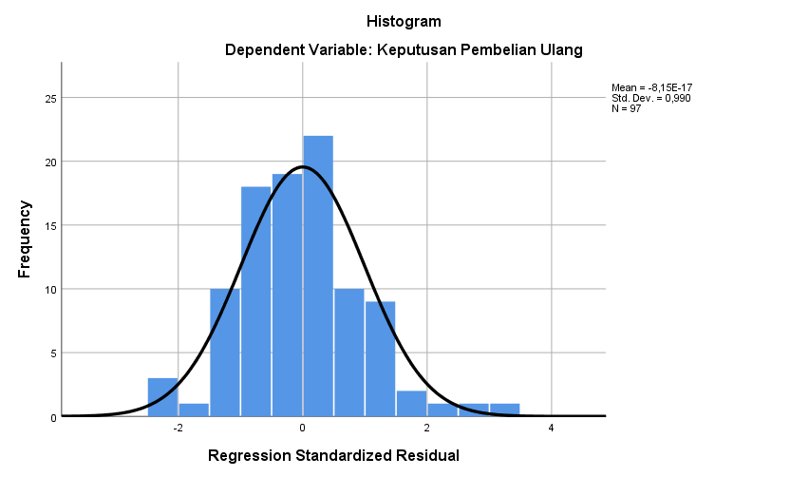
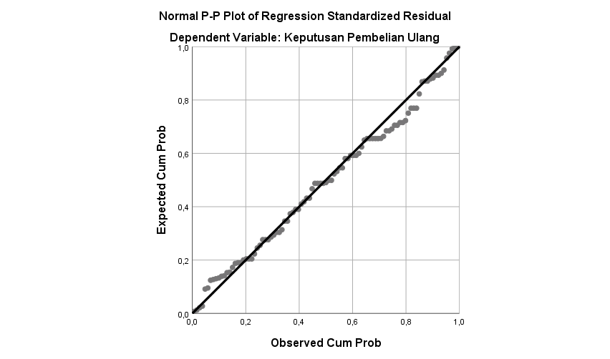

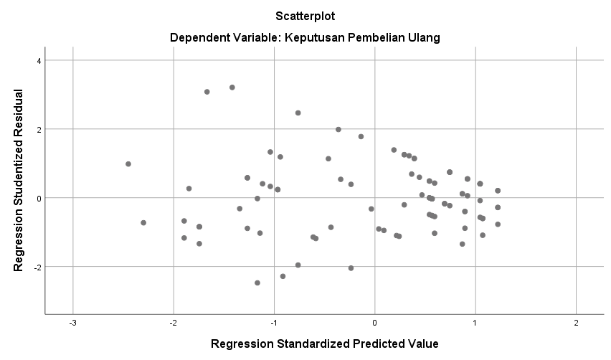
One-Sample Kolmogorov-Smirnov Test
 |  | Unstandardized Residual
N |  | 97
Normal Parameters^{a,b} | Mean | ,0000000
 | Std. Deviation | 1,48921359
Most Extreme Differences | Absolute | ,086
 | Positive | ,061
 | Negative | -,086
Test Statistic |  | ,086
Asymp. Sig. (2-tailed) |  | ,102^{c}
a. Test distribution is Normal.
b. Calculated from data.
c. Lilliefors Significance Correction.

Uji Glejser
Coefficientsª

Model |  | Unstandardized Coefficients |  | Standardized Coefficients | t | Sig.
 |  | B | Std. Error | Beta
1 | (Constant) | 5,376 | 1,558 |  | 3,450 | ,001
 | Kualitas Layanan | -,119 | ,091 | -,140 | -1,310 | ,194
 | Kepuasan Konsumen | -,053 | ,036 | -,155 | -1,449 | ,151

Lampiran 7. Foto – Foto Saat Pengambilan Sampel Untuk Kuisioner

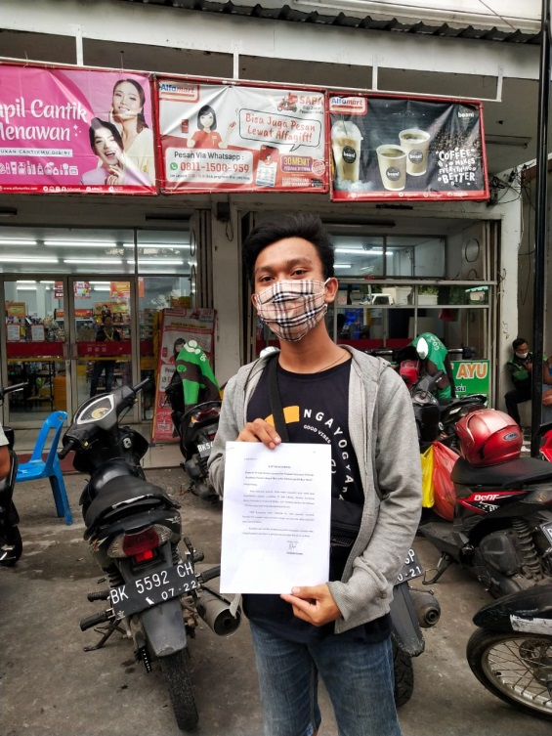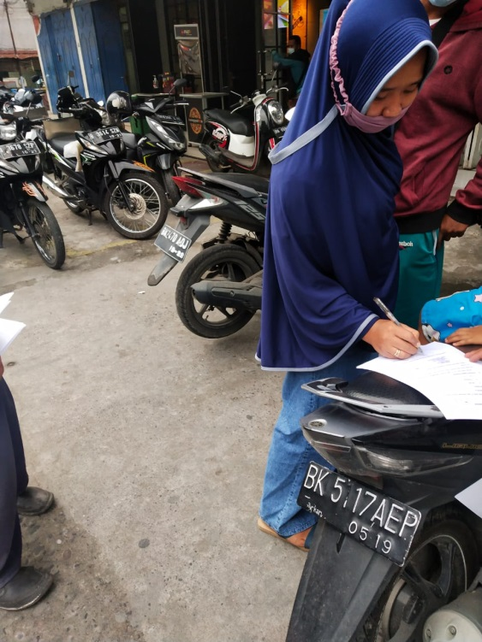

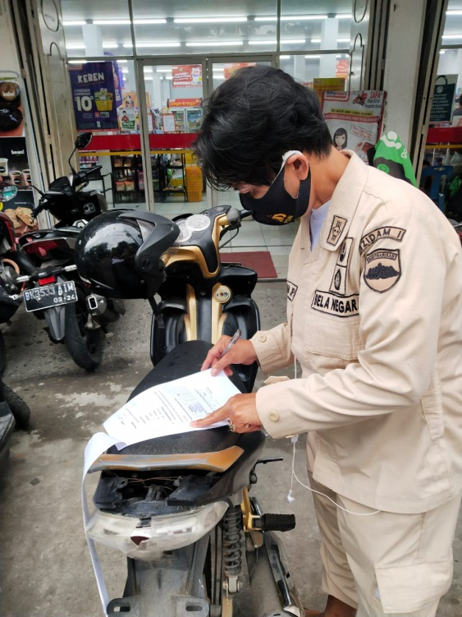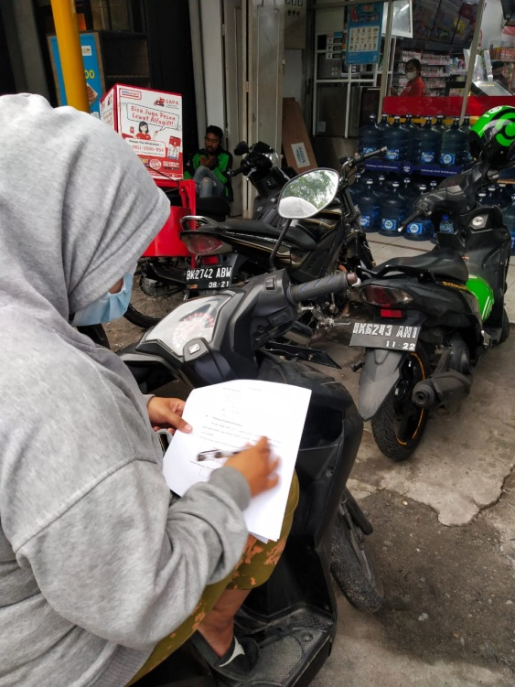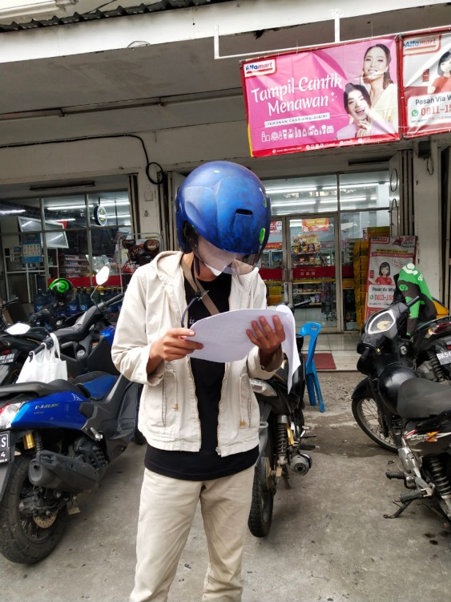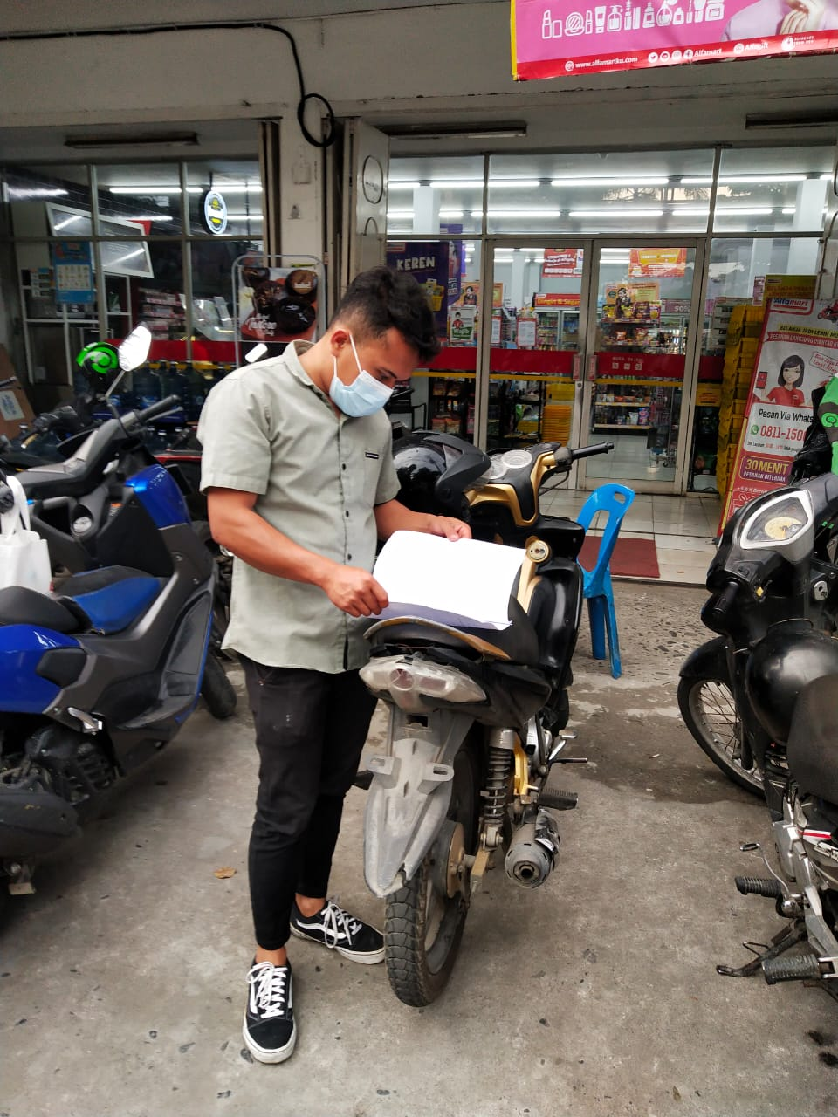

Lampiran 8
t Tabel
Pr | 0.25 | 0.10 | 0.05 | 0.025 | 0.01 | 0.005 | 0.001
df | 0.50 | 0.20 | 0.10 | 0.050 | 0.02 | 0.010 | 0.002
1 | 1.00000 | 3.07768 | 6.31375 | 12.70620 | 31.82052 | 63.65674 | 318.30884
2 | 0.81650 | 1.88562 | 2.91999 | 4.30265 | 6.96456 | 9.92484 | 22.32712
3 | 0.76489 | 1.63774 | 2.35336 | 3.18245 | 4.54070 | 5.84091 | 10.21453
4 | 0.74070 | 1.53321 | 2.13185 | 2.77645 | 3.74695 | 4.60409 | 7.17318
5 | 0.72669 | 1.47588 | 2.01505 | 2.57058 | 3.36493 | 4.03214 | 5.89343
6 | 0.71756 | 1.43976 | 1.94318 | 2.44691 | 3.14267 | 3.70743 | 5.20763
7 | 0.71114 | 1.41492 | 1.89458 | 2.36462 | 2.99795 | 3.49948 | 4.78529
8 | 0.70639 | 1.39682 | 1.85955 | 2.30600 | 2.89646 | 3.35539 | 4.50079
9 | 0.70272 | 1.38303 | 1.83311 | 2.26216 | 2.82144 | 3.24984 | 4.29681
10 | 0.69981 | 1.37218 | 1.81246 | 2.22814 | 2.76377 | 3.16927 | 4.14370
11 | 0.69745 | 1.36343 | 1.79588 | 2.20099 | 2.71808 | 3.10581 | 4.02470
12 | 0.69548 | 1.35622 | 1.78229 | 2.17881 | 2.68100 | 3.05454 | 3.92963
13 | 0.69383 | 1.35017 | 1.77093 | 2.16037 | 2.65031 | 3.01228 | 3.85198
14 | 0.69242 | 1.34503 | 1.76131 | 2.14479 | 2.62449 | 2.97684 | 3.78739
15 | 0.69120 | 1.34061 | 1.75305 | 2.13145 | 2.60248 | 2.94671 | 3.73283
16 | 0.69013 | 1.33676 | 1.74588 | 2.11991 | 2.58349 | 2.92078 | 3.68615
17 | 0.68920 | 1.33338 | 1.73961 | 2.10982 | 2.56693 | 2.89823 | 3.64577
18 | 0.68836 | 1.33039 | 1.73406 | 2.10092 | 2.55238 | 2.87844 | 3.61048
19 | 0.68762 | 1.32773 | 1.72913 | 2.09302 | 2.53948 | 2.86093 | 3.57940
20 | 0.68695 | 1.32534 | 1.72472 | 2.08596 | 2.52798 | 2.84534 | 3.55181
21 | 0.68635 | 1.32319 | 1.72074 | 2.07961 | 2.51765 | 2.83136 | 3.52715
22 | 0.68581 | 1.32124 | 1.71714 | 2.07387 | 2.50832 | 2.81876 | 3.50499
23 | 0.68531 | 1.31946 | 1.71387 | 2.06866 | 2.49987 | 2.80734 | 3.48496
24 | 0.68485 | 1.31784 | 1.71088 | 2.06390 | 2.49216 | 2.79694 | 3.46678
25 | 0.68443 | 1.31635 | 1.70814 | 2.05954 | 2.48511 | 2.78744 | 3.45019
26 | 0.68404 | 1.31497 | 1.70562 | 2.05553 | 2.47863 | 2.77871 | 3.43500
27 | 0.68368 | 1.31370 | 1.70329 | 2.05183 | 2.47266 | 2.77068 | 3.42103
28 | 0.68335 | 1.31253 | 1.70113 | 2.04841 | 2.46714 | 2.76326 | 3.40816
29 | 0.68304 | 1.31143 | 1.69913 | 2.04523 | 2.46202 | 2.75639 | 3.39624
30 | 0.68276 | 1.31042 | 1.69726 | 2.04227 | 2.45726 | 2.75000 | 3.38518
31 | 0.68249 | 1.30946 | 1.69552 | 2.03951 | 2.45282 | 2.74404 | 3.37490
32 | 0.68223 | 1.30857 | 1.69389 | 2.03693 | 2.44868 | 2.73848 | 3.36531
33 | 0.68200 | 1.30774 | 1.69236 | 2.03452 | 2.44479 | 2.73328 | 3.35634
34 | 0.68177 | 1.30695 | 1.69092 | 2.03224 | 2.44115 | 2.72839 | 3.34793
35 | 0.68156 | 1.30621 | 1.68957 | 2.03011 | 2.43772 | 2.72381 | 3.34005
36 | 0.68137 | 1.30551 | 1.68830 | 2.02809 | 2.43449 | 2.71948 | 3.33262
37 | 0.68118 | 1.30485 | 1.68709 | 2.02619 | 2.43145 | 2.71541 | 3.32563
38 | 0.68100 | 1.30423 | 1.68595 | 2.02439 | 2.42857 | 2.71156 | 3.31903
39 | 0.68083 | 1.30364 | 1.68488 | 2.02269 | 2.42584 | 2.70791 | 3.31279
40 | 0.68067 | 1.30308 | 1.68385 | 2.02108 | 2.42326 | 2.70446 | 3.30688
Pr | 0.25 | 0.10 | 0.05 | 0.025 | 0.01 | 0.005 | 0.001
df | 0.50 | 0.20 | 0.10 | 0.050 | 0.02 | 0.010 | 0.002
41 | 0.68052 | 1.30254 | 1.68288 | 2.01954 | 2.42080 | 2.70118 | 3.30127
42 | 0.68038 | 1.30204 | 1.68195 | 2.01808 | 2.41847 | 2.69807 | 3.29595
43 | 0.68024 | 1.30155 | 1.68107 | 2.01669 | 2.41625 | 2.69510 | 3.29089
44 | 0.68011 | 1.30109 | 1.68023 | 2.01537 | 2.41413 | 2.69228 | 3.28607
45 | 0.67998 | 1.30065 | 1.67943 | 2.01410 | 2.41212 | 2.68959 | 3.28148
46 | 0.67986 | 1.30023 | 1.67866 | 2.01290 | 2.41019 | 2.68701 | 3.27710
47 | 0.67975 | 1.29982 | 1.67793 | 2.01174 | 2.40835 | 2.68456 | 3.27291
48 | 0.67964 | 1.29944 | 1.67722 | 2.01063 | 2.40658 | 2.68220 | 3.26891
49 | 0.67953 | 1.29907 | 1.67655 | 2.00958 | 2.40489 | 2.67995 | 3.26508
50 | 0.67943 | 1.29871 | 1.67591 | 2.00856 | 2.40327 | 2.67779 | 3.26141
51 | 0.67933 | 1.29837 | 1.67528 | 2.00758 | 2.40172 | 2.67572 | 3.25789
52 | 0.67924 | 1.29805 | 1.67469 | 2.00665 | 2.40022 | 2.67373 | 3.25451
53 | 0.67915 | 1.29773 | 1.67412 | 2.00575 | 2.39879 | 2.67182 | 3.25127
54 | 0.67906 | 1.29743 | 1.67356 | 2.00488 | 2.39741 | 2.66998 | 3.24815
55 | 0.67898 | 1.29713 | 1.67303 | 2.00404 | 2.39608 | 2.66822 | 3.24515
56 | 0.67890 | 1.29685 | 1.67252 | 2.00324 | 2.39480 | 2.66651 | 3.24226
57 | 0.67882 | 1.29658 | 1.67203 | 2.00247 | 2.39357 | 2.66487 | 3.23948
58 | 0.67874 | 1.29632 | 1.67155 | 2.00172 | 2.39238 | 2.66329 | 3.23680
59 | 0.67867 | 1.29607 | 1.67109 | 2.00100 | 2.39123 | 2.66176 | 3.23421
60 | 0.67860 | 1.29582 | 1.67065 | 2.00030 | 2.39012 | 2.66028 | 3.23171
61 | 0.67853 | 1.29558 | 1.67022 | 1.99962 | 2.38905 | 2.65886 | 3.22930
62 | 0.67847 | 1.29536 | 1.66980 | 1.99897 | 2.38801 | 2.65748 | 3.22696
63 | 0.67840 | 1.29513 | 1.66940 | 1.99834 | 2.38701 | 2.65615 | 3.22471
64 | 0.67834 | 1.29492 | 1.66901 | 1.99773 | 2.38604 | 2.65485 | 3.22253
65 | 0.67828 | 1.29471 | 1.66864 | 1.99714 | 2.38510 | 2.65360 | 3.22041
66 | 0.67823 | 1.29451 | 1.66827 | 1.99656 | 2.38419 | 2.65239 | 3.21837
67 | 0.67817 | 1.29432 | 1.66792 | 1.99601 | 2.38330 | 2.65122 | 3.21639
68 | 0.67811 | 1.29413 | 1.66757 | 1.99547 | 2.38245 | 2.65008 | 3.21446
69 | 0.67806 | 1.29394 | 1.66724 | 1.99495 | 2.38161 | 2.64898 | 3.21260
70 | 0.67801 | 1.29376 | 1.66691 | 1.99444 | 2.38081 | 2.64790 | 3.21079
71 | 0.67796 | 1.29359 | 1.66660 | 1.99394 | 2.38002 | 2.64686 | 3.20903
72 | 0.67791 | 1.29342 | 1.66629 | 1.99346 | 2.37926 | 2.64585 | 3.20733
73 | 0.67787 | 1.29326 | 1.66600 | 1.99300 | 2.37852 | 2.64487 | 3.20567
74 | 0.67782 | 1.29310 | 1.66571 | 1.99254 | 2.37780 | 2.64391 | 3.20406
75 | 0.67778 | 1.29294 | 1.66543 | 1.99210 | 2.37710 | 2.64298 | 3.20249
77 | 0.67769 | 1.29264 | 1.66488 | 1.99125 | 2.37576 | 2.64120 | 3.19948
78 | 0.67765 | 1.29250 | 1.66462 | 1.99085 | 2.37511 | 2.64034 | 3.19804
79 | 0.67761 | 1.29236 | 1.66437 | 1.99045 | 2.37448 | 2.63950 | 3.19663
80 | 0.67757 | 1.29222 | 1.66412 | 1.99006 | 2.37387 | 2.63869 | 3.19526
Pr | 0.25 | 0.10 | 0.05 | 0.025 | 0.01 | 0.005 | 0.001
df | 0.50 | 0.20 | 0.10 | 0.050 | 0.02 | 0.010 | 0.002
81 | 0.67753 | 1.29209 | 1.66388 | 1.98969 | 2.37327 | 2.63790 | 3.19392
82 | 0.67749 | 1.29196 | 1.66365 | 1.98932 | 2.37269 | 2.63712 | 3.19262
83 | 0.67746 | 1.29183 | 1.66342 | 1.98896 | 2.37212 | 2.63637 | 3.19135
84 | 0.67742 | 1.29171 | 1.66320 | 1.98861 | 2.37156 | 2.63563 | 3.19011
85 | 0.67739 | 1.29159 | 1.66298 | 1.98827 | 2.37102 | 2.63491 | 3.18890
86 | 0.67735 | 1.29147 | 1.66277 | 1.98793 | 2.37049 | 2.63421 | 3.18772
87 | 0.67732 | 1.29136 | 1.66256 | 1.98761 | 2.36998 | 2.63353 | 3.18657
88 | 0.67729 | 1.29125 | 1.66235 | 1.98729 | 2.36947 | 2.63286 | 3.18544
89 | 0.67726 | 1.29114 | 1.66216 | 1.98698 | 2.36898 | 2.63220 | 3.18434
90 | 0.67723 | 1.29103 | 1.66196 | 1.98667 | 2.36850 | 2.63157 | 3.18327
91 | 0.67720 | 1.29092 | 1.66177 | 1.98638 | 2.36803 | 2.63094 | 3.18222
92 | 0.67717 | 1.29082 | 1.66159 | 1.98609 | 2.36757 | 2.63033 | 3.18119
93 | 0.67714 | 1.29072 | 1.66140 | 1.98580 | 2.36712 | 2.62973 | 3.18019
94 | 0.67711 | 1.29062 | 1.66123 | 1.98552 | 2.36667 | 2.62915 | 3.17921
95 | 0.67708 | 1.29053 | 1.66105 | 1.98525 | 2.36624 | 2.62858 | 3.17825
96 | 0.67705 | 1.29043 | 1.66088 | 1.98498 | 2.36582 | 2.62802 | 3.17731
97 | 0.67703 | 1.29034 | 1.66071 | 1.98472 | 2.36541 | 2.62747 | 3.17639
98 | 0.67700 | 1.29025 | 1.66055 | 1.98447 | 2.36500 | 2.62693 | 3.17549
99 | 0.67698 | 1.29016 | 1.66039 | 1.98422 | 2.36461 | 2.62641 | 3.17460
100 | 0.67695 | 1.29007 | 1.66023 | 1.98397 | 2.36422 | 2.62589 | 3.17374
101 | 0.67693 | 1.28999 | 1.66008 | 1.98373 | 2.36384 | 2.62539 | 3.17289
102 | 0.67690 | 1.28991 | 1.65993 | 1.98350 | 2.36346 | 2.62489 | 3.17206
103 | 0.67688 | 1.28982 | 1.65978 | 1.98326 | 2.36310 | 2.62441 | 3.17125
104 | 0.67686 | 1.28974 | 1.65964 | 1.98304 | 2.36274 | 2.62393 | 3.17045
105 | 0.67683 | 1.28967 | 1.65950 | 1.98282 | 2.36239 | 2.62347 | 3.16967
106 | 0.67681 | 1.28959 | 1.65936 | 1.98260 | 2.36204 | 2.62301 | 3.16890
107 | 0.67679 | 1.28951 | 1.65922 | 1.98238 | 2.36170 | 2.62256 | 3.16815
108 | 0.67677 | 1.28944 | 1.65909 | 1.98217 | 2.36137 | 2.62212 | 3.16741
109 | 0.67675 | 1.28937 | 1.65895 | 1.98197 | 2.36105 | 2.62169 | 3.16669
110 | 0.67673 | 1.28930 | 1.65882 | 1.98177 | 2.36073 | 2.62126 | 3.16598

Lampiran 9
F Table
Titik Persentase Distribusi F untuk Probabilita = 0,05
df untuk  penyebut (N2) | Df untuk pembanding (N1)
 | 1 | 2 | 3 | 4 | 5 | 6 | 7 | 8
1 | 161 | 199 | 216 | 225 | 230 | 234 | 237 | 239
2 | 18.51 | 19.00 | 19.16 | 19.25 | 19.30 | 19.33 | 19.35 | 19.37
3 | 10.13 | 9.55 | 9.28 | 9.12 | 9.01 | 8.94 | 8.89 | 8.85
4 | 7.71 | 6.94 | 6.59 | 6.39 | 6.26 | 6.16 | 6.09 | 6.04
5 | 6.61 | 5.79 | 5.41 | 5.19 | 5.05 | 4.95 | 4.88 | 4.82
6 | 5.99 | 5.14 | 4.76 | 4.53 | 4.39 | 4.28 | 4.21 | 4.15
7 | 5.59 | 4.74 | 4.35 | 4.12 | 3.97 | 3.87 | 3.79 | 3.73
8 | 5.32 | 4.46 | 4.07 | 3.84 | 3.69 | 3.58 | 3.50 | 3.44
9 | 5.12 | 4.26 | 3.86 | 3.63 | 3.48 | 3.37 | 3.29 | 3.23
10 | 4.96 | 4.10 | 3.71 | 3.48 | 3.33 | 3.22 | 3.14 | 3.07
11 | 4.84 | 3.98 | 3.59 | 3.36 | 3.20 | 3.09 | 3.01 | 2.95
12 | 4.75 | 3.89 | 3.49 | 3.26 | 3.11 | 3.00 | 2.91 | 2.85
13 | 4.67 | 3.81 | 3.41 | 3.18 | 3.03 | 2.92 | 2.83 | 2.77
14 | 4.60 | 3.74 | 3.34 | 3.11 | 2.96 | 2.85 | 2.76 | 2.70
15 | 4.54 | 3.68 | 3.29 | 3.06 | 2.90 | 2.79 | 2.71 | 2.64
16 | 4.49 | 3.63 | 3.24 | 3.01 | 2.85 | 2.74 | 2.66 | 2.59
17 | 4.45 | 3.59 | 3.20 | 2.96 | 2.81 | 2.70 | 2.61 | 2.55
18 | 4.41 | 3.55 | 3.16 | 2.93 | 2.77 | 2.66 | 2.58 | 2.51
19 | 4.38 | 3.52 | 3.13 | 2.90 | 2.74 | 2.63 | 2.54 | 2.48
20 | 4.35 | 3.49 | 3.10 | 2.87 | 2.71 | 2.60 | 2.51 | 2.45
21 | 4.32 | 3.47 | 3.07 | 2.84 | 2.68 | 2.57 | 2.49 | 2.42
22 | 4.30 | 3.44 | 3.05 | 2.82 | 2.66 | 2.55 | 2.46 | 2.40
23 | 4.28 | 3.42 | 3.03 | 2.80 | 2.64 | 2.53 | 2.44 | 2.37
24 | 4.26 | 3.40 | 3.01 | 2.78 | 2.62 | 2.51 | 2.42 | 2.36
25 | 4.24 | 3.39 | 2.99 | 2.76 | 2.60 | 2.49 | 2.40 | 2.34
26 | 4.23 | 3.37 | 2.98 | 2.74 | 2.59 | 2.47 | 2.39 | 2.32
27 | 4.21 | 3.35 | 2.96 | 2.73 | 2.57 | 2.46 | 2.37 | 2.31
28 | 4.20 | 3.34 | 2.95 | 2.71 | 2.56 | 2.45 | 2.36 | 2.29
29 | 4.18 | 3.33 | 2.93 | 2.70 | 2.55 | 2.43 | 2.35 | 2.28
30 | 4.17 | 3.32 | 2.92 | 2.69 | 2.53 | 2.42 | 2.33 | 2.27
31 | 4.16 | 3.30 | 2.91 | 2.68 | 2.52 | 2.41 | 2.32 | 2.25
32 | 4.15 | 3.29 | 2.90 | 2.67 | 2.51 | 2.40 | 2.31 | 2.24
33 | 4.14 | 3.28 | 2.89 | 2.66 | 2.50 | 2.39 | 2.30 | 2.23
34 | 4.13 | 3.28 | 2.88 | 2.65 | 2.49 | 2.38 | 2.29 | 2.23
35 | 4.12 | 3.27 | 2.87 | 2.64 | 2.49 | 2.37 | 2.29 | 2.22
36 | 4.11 | 3.26 | 2.87 | 2.63 | 2.48 | 2.36 | 2.28 | 2.21
df untuk  penyebut (N2) | df untuk pembilang (N1)
 | 1 | 2 | 3 | 4 | 5 | 6 | 7 | 8
37  38  39  40  41  42  43  44  45  46 | 4.11  4.10  4.09  4.08  4.08  4.07  4.07  4.06  4.06  4.05 | 3.25  3.24  3.24  3.23  3.23  3.33  3.21  3.21  3.20  3.20 | 2.86  2.85  2.85  2.84  2.83  2.83  2.83  2.82  2.82  2.81 | 2.63  2.62  2.61  2.61  2.60  2.59  2.59  2.58  2.58  2.57 | 2.47  2.46  2.46  2.45  2.44  2.44  2.43  2.43  2.42  2.42 | 2.36  2.35  2.34  2.34  2.33  2.32  2.32  2.31  2.31  2.30 | 2.27  2.26  2.26  2.25  2.24  2.24  2.23  2.23  2.22  2.22 | 2.20  2.19  2.19  2.18  2.17  2.17  2.16  2.16  2.15  2.15
47 | 4.05 | 3.20 | 2.80 | 2.57 | 2.41 | 2.30 | 2.21 | 2.14
48 | 4.04 | 3.19 | 2.80 | 2.57 | 2.41 | 2.29 | 2.21 | 2.14
49 | 4.04 | 3.19 | 2.79 | 2.56 | 2.40 | 2.29 | 2.20 | 2.13
50 | 4.03 | 3.18 | 2.79 | 2.56 | 2.40 | 2.29 | 2.20 | 2.13
51 | 4.03 | 3.18 | 2.79 | 2.55 | 2.40 | 2.28 | 2.20 | 2.13
52 | 4.03 | 3.18 | 2.78 | 2.55 | 2.39 | 2.28 | 2.19 | 2.12
53 | 4.02 | 3.17 | 2.78 | 2.55 | 2.39 | 2.28 | 2.19 | 2.12
54 | 4.02 | 3.17 | 2.78 | 2.54 | 2.39 | 2.27 | 2.18 | 2.12
55 | 4.02 | 3.16 | 2.77 | 2.54 | 2.38 | 2.27 | 2.18 | 2.11
56 | 4.01 | 3.16 | 2.77 | 2.54 | 2.38 | 2.27 | 2.18 | 2.11
57 | 4.01 | 3.16 | 2.77 | 2.53 | 2.38 | 2.26 | 2.18 | 2.11
58 | 4.01 | 3.16 | 2.76 | 2.53 | 2.37 | 2.26 | 2.17 | 2.10
59 | 4.00 | 3.15 | 2.76 | 2.53 | 2.37 | 2.26 | 2.17 | 2.10
60 | 4.00 | 3.15 | 2.76 | 2.53 | 2.37 | 2.25 | 2.17 | 2.10
61 | 4.00 | 3.15 | 2.76 | 2.52 | 2.37 | 2.25 | 2.16 | 2.09
62 | 4.00 | 3.15 | 2.75 | 2.52 | 2.36 | 2.25 | 2.16 | 2.09
63 | 3.99 | 3.14 | 2.75 | 2.52 | 2.36 | 2.25 | 2.16 | 2.09
64 | 3.99 | 3.14 | 2.75 | 2.52 | 2.36 | 2.24 | 2.16 | 2.09
65 | 3.99 | 3.14 | 2.75 | 2.51 | 2.36 | 2.24 | 2.15 | 2.08
66 | 3.99 | 3.14 | 2.74 | 2.51 | 2.35 | 2.24 | 2.15 | 2.08
67 | 3.98 | 3.13 | 2.74 | 2.51 | 2.35 | 2.24 | 2.15 | 2.08
68 | 3.98 | 3.13 | 2.74 | 2.51 | 2.35 | 2.24 | 2.15 | 2.08
69 | 3.98 | 3.13 | 2.74 | 2.50 | 2.35 | 2.23 | 2.15 | 2.08
70 | 3.98 | 3.13 | 2.74 | 2.50 | 2.35 | 2.23 | 2.14 | 2.07
71 | 3.98 | 3.13 | 2.73 | 2.50 | 2.34 | 2.23 | 2.14 | 2.07
72 | 3.97 | 3.12 | 2.73 | 2.50 | 2.34 | 2.23 | 2.14 | 2.07
73 | 3.97 | 3.12 | 2.73 | 2.50 | 2.34 | 2.23 | 2.14 | 2.07
74 | 3.97 | 3.12 | 2.73 | 2.50 | 2.34 | 2.22 | 2.14 | 2.07
75 | 3.97 | 3.12 | 2.73 | 2.49 | 2.34 | 2.22 | 2.13 | 2.06
76 | 3.97 | 3.12 | 2.72 | 2.49 | 2.33 | 2.22 | 2.13 | 2.06
77 | 3.97 | 3.12 | 2.72 | 2.49 | 2.33 | 2.22 | 2.13 | 2.06
78 | 3.96 | 3.11 | 2.72 | 2.49 | 2.33 | 2.22 | 2.13 | 2.06
79 | 3.96 | 3.11 | 2.72 | 2.49 | 2.33 | 2.22 | 2.13 | 2.06
80 | 3.96 | 3.11 | 2.72 | 2.49 | 2.33 | 2.21 | 2.13 | 2.06
Df untuk penyebut (N2) | Df untuk pembilang (N1)
 | 1 | 2 | 3 | 4 | 5 | 6 | 7 | 8
81 | 3.96 | 3.11 | 2.72 | 2.48 | 2.33 | 2.21 | 2.12 | 2.05
82 | 3.96 | 3.11 | 2.72 | 2.48 | 2.33 | 2.21 | 2.12 | 2.05
83 | 3.96 | 3.11 | 2.71 | 2.48 | 2.32 | 2.21 | 2.12 | 2.05
84 | 3.95 | 3.11 | 2.71 | 2.48 | 2.32 | 2.21 | 2.12 | 2.05
85 | 3.95 | 3.10 | 2.71 | 2.48 | 2.32 | 2.21 | 2.12 | 2.05
86 | 3.95 | 3.10 | 2.71 | 2.48 | 2.32 | 2.21 | 2.12 | 2.05
87 | 3.95 | 3.10 | 2.71 | 2.48 | 2.32 | 2.20 | 2.12 | 2.05
88 | 3.95 | 3.10 | 2.71 | 2.48 | 2.32 | 2.20 | 2.12 | 2.05
89 | 3.95 | 3.10 | 2.71 | 2.47 | 2.32 | 2.20 | 2.11 | 2.04
90 | 3.95 | 3.10 | 2.71 | 2.47 | 2.32 | 2.20 | 2.11 | 2.04
91 | 3.95 | 3.10 | 2.70 | 2.47 | 2.31 | 2.20 | 2.11 | 2.04
92 | 3.94 | 3.10 | 2.70 | 2.47 | 2.31 | 2.20 | 2.11 | 2.04
93 | 3.94 | 3.09 | 2.70 | 2.47 | 2.31 | 2.20 | 2.11 | 2.04
94 | 3.94 | 3.09 | 2.70 | 2.47 | 2.31 | 2.20 | 2.11 | 2.04
95 | 3.94 | 3.09 | 2.70 | 2.47 | 2.31 | 2.20 | 2.11 | 2.04
96 | 3.94 | 3.09 | 2.70 | 2.47 | 2.31 | 2.19 | 2.11 | 2.04
97 | 3.94 | 3.09 | 2.70 | 2.47 | 2.31 | 2.19 | 2.11 | 2.04
98 | 3.94 | 3.09 | 2.70 | 2.46 | 2.31 | 2.19 | 2.10 | 2.03
99 | 3.94 | 3.09 | 2.70 | 2.46 | 2.31 | 2.19 | 2.10 | 2.03
100 | 3.94 | 3.09 | 2.70 | 2.46 | 2.31 | 2.19 | 2.10 | 2.03
101 | 3.94 | 3.09 | 2.69 | 2.46 | 2.30 | 2.19 | 2.10 | 2.03
102 | 3.93 | 3.09 | 2.69 | 2.46 | 2.30 | 2.19 | 2.10 | 2.03
103 | 3.93 | 3.08 | 2.69 | 2.46 | 2.30 | 2.19 | 2.10 | 2.03
104 | 3.93 | 3.08 | 2.69 | 2.46 | 2.30 | 2.19 | 2.10 | 2.03
105 | 3.93 | 3.08 | 2.69 | 2.46 | 2.30 | 2.19 | 2.10 | 2.03
106 | 3.93 | 3.08 | 2.69 | 2.46 | 2.30 | 2.19 | 2.10 | 2.03
107 | 3.93 | 3.08 | 2.69 | 2.46 | 2.30 | 2.18 | 2.10 | 2.03
108 | 3.93 | 3.08 | 2.69 | 2.46 | 2.30 | 2.18 | 2.10 | 2.03
109 | 3.93 | 3.08 | 2.69 | 2.45 | 2.30 | 2.18 | 2.09 | 2.02
110 | 3.93 | 3.08 | 2.69 | 2.45 | 2.30 | 2.18 | 2.09 | 2.02
111 | 3.93 | 3.08 | 2.69 | 2.45 | 2.30 | 2.18 | 2.09 | 2.02
112 | 3.93 | 3.08 | 2.69 | 2.45 | 2.30 | 2.18 | 2.09 | 2.02
113 | 3.93 | 3.08 | 2.68 | 2.45 | 2.29 | 2.18 | 2.09 | 2.02
114 | 3.92 | 3.08 | 2.68 | 2.45 | 2.29 | 2.18 | 2.09 | 2.02
115 | 3.92 | 3.08 | 2.68 | 2.45 | 2.29 | 2.18 | 2.09 | 2.02
116 | 3.92 | 3.07 | 2.68 | 2.45 | 2.29 | 2.18 | 2.09 | 2.02
117 | 3.92 | 3.07 | 2.68 | 2.45 | 2.29 | 2.18 | 2.09 | 2.02
118 | 3.92 | 3.07 | 2.68 | 2.45 | 2.29 | 2.18 | 2.09 | 2.02
119 | 3.92 | 3.07 | 2.68 | 2.45 | 2.29 | 2.18 | 2.09 | 2.02
120 | 3.92 | 3.07 | 2.68 | 2.45 | 2.29 | 2.18 | 2.09 | 2.02

