# **APPENDIX**

**Appendix 1**

**Lesson Plan**

**Experimental Group**

School : MTS Al Washliyah Kolam

Subject : English

Class/Semester : VII

Time : 2 x 40 minutes

**Standard competence :**

1. Understanding the form of vocabulary of narrative text
2. Expressing the meaning and functions of vocabulary of narrative text

**Basic competence :**

1. Responding the forms of vocabulary of narrative text
2. Intensive Reading to find out the adjective in narrative text

**Indicators :**

1. Doing the intensive reading in narrative text and underline the vocabulary of adjective
2. Doing the writing in narrative text and underline the vocabulary of adjective
3. Objectives

Students are able to recognise the narrative text which is using simple past tense.

Students are able to know the meaning of word which is in adjective word.

1. Materials

The Lazy Bear

It’s spring in the forest. The snow has gone, leaves are growing and the animals are waking up. Bruno the bear is still asleep. He doesn’t know that it’s spring.

“Listen! Bruno is snoring!”

Now it’s summer. It’s warm and the animals are having lots of fun. But where’s Bruno?

Bruno is still asleep. He doesn’t know that it’s summer.

Now it’s autumn. The leaves are turning red, yellow and orange. The animals are getting ready for winter. But where’s Bruno?

Bruno is still asleep. He doesn’t know that it’s autumn.

Now it’s winter. You can’t see the animals. They’re all asleep in their warm homes. But where’s Bruno? “What a nice, long sleep. Snow! It’s winter! I’m all alone.”

It’s spring again. The animals are very happy. They’re having a party. But where’s Bruno?

“Bruno!”

Bruno is awake at last. Now he knows that it’s spring.

1. **Method/Technique**

Discourse (*ceramah*)

1. **Steps**

|  |  |
| --- | --- |
| Kegiatan | Deskripsi |
| Pendahuluan | * Memberikan salam * Menanyakan kepada siswa mengenai kesiapan dan kenyamanan untuk belajar * Mempersilahkan salah satu siswa memimpin doa. * Menanyakan kehadiran siswa. * Guru menyampaikan informasi mengenai tujuan pembelajaran dan indicator yang akan dicapai. |
| Inti | **Mengamati**   * Siswa membaca teks khusus dalam bentuk fable story yang menjelaskan vocabulary adjective   **Mempertanyakan**   * Siswa mempertanyakan kepada guru kata-kata yang mengandung unsur adjective.   **Mengeksplorasi**   * Siswa mencoba mengeksplorasi tentang adjective words |
| Penutup | * Evaluasi untuk mengukur ketercapaian tujuan pembelajaran * Siswa melakukan refleksi tentang pelaksanaan pembelajaran * Mengucapkan salam |

Source/ media

* Story source by internet
* Buku LKS Bahasa Inggris Kelas VII

**Penilaian**

* Teknik : Performance Assessment (responding)
* Bentuk : Written answer

Medan, 30 July 2021

Headmaster of MTS AL Teacher, Nur Hasanah

AL Washliyah Kolam

( ) ( )

**Appendix 2**

**Lesson Plan**

**Control Group**

School : MTS Al Washliyah Kolam

Subject : English

Class/Semester : VII

Time : 2 x 40 minutes

**Standard competence :**

1. Understanding the form of vocabulary of narrative text
2. Expressing the meaning and functions of vocabulary of narrative text

**Basic competence :**

1. Responding the forms of vocabulary of narrative text
2. Reading to find out the adjective in narrative text

**Indicators :**

1. Doing the reading in narrative text and underline the vocabulary of adjective
2. Doing the writing in narrative text and underline the vocabulary of adjective
3. **Objectives**

Students are able to recognise the narrative text which is using simple past tense.

Students are able to know the meaning of word which is in adjective word.

1. **Materials**

The Lazy Bear

It’s spring in the forest. The snow has gone, leaves are growing and the animals are waking up. Bruno the bear is still asleep. He doesn’t know that it’s spring.

“Listen! Bruno is snoring!”

Now it’s summer. It’s warm and the animals are having lots of fun. But where’s Bruno?

Bruno is still asleep. He doesn’t know that it’s summer.

Now it’s autumn. The leaves are turning red, yellow and orange. The animals are getting ready for winter. But where’s Bruno?

Bruno is still asleep. He doesn’t know that it’s autumn.

Now it’s winter. You can’t see the animals. They’re all asleep in their warm homes. But where’s Bruno? “What a nice, long sleep. Snow! It’s winter! I’m all alone.”

It’s spring again. The animals are very happy. They’re having a party. But where’s Bruno?

“Bruno!”

Bruno is awake at last. Now he knows that it’s spring.

1. **Method/Technique :**

Discourse (*ceramah*)

1. **Steps**

|  |  |
| --- | --- |
| **Kegiatan** | **Deskripsi** |
| **Pendahuluan** | * Memberikan salam * Menanyakan kepada siswa mengenai kesiapan dan kenyamanan untuk belajar * Mempersilahkan salah satu siswa memimpin doa. * Menanyakan kehadiran siswa. * Guru menyampaikan informasi mengenai tujuan pembelajaran dan indicator yang akan dicapai. |
| **Inti** | **Mengamati**   * Siswa membaca teks khusus dalam bentuk fable story yang menjelaskan vocabulary adjective   **Mempertanyakan**   * Siswa mempertanyakan kepada guru kata-kata yang mengandung unsur adjective.   **Mengeksplorasi**   * Siswa mencoba mengeksplorasi tentang adjective words |
| **Penutup** | * Evaluasi untuk mengukur ketercapaian tujuan pembelajaran * Siswa melakukan refleksi tentang pelaksanaan pembelajaran * Mengucapkan salam |

**Source/ media**

* Story source by internet
* Buku LKS Bahasa Inggris Kelas VII

**Penilaian**

* Teknik : Performance Assessment (responding)
* Bentuk : Written answer

Medan, 2 August 2021

Headmaster of MTS Teacher, Nur Hasanah

Al Washliyah Kolam

( ) ( )

**THE INSTRUMENT**

**OF THE TEST**

1. What is the weather mention above except?
2. Sping
3. Summer
4. Autumn
5. Rainy
6. How are the animals feels during the spring?
7. Sad
8. Happy
9. Angry
10. Lazy
11. Where you can see the animals during the winter?
12. In the jungle
13. In the market
14. In the house
15. In the bathroom
16. What colours of the leaveas when autumns and comes?
17. Green and purple
18. Black and brown
19. Blue and red
20. Red,yellow and orange
21. How are the animals doing in the spring
22. Sleeping
23. Weaking up
24. Shooting
25. Crying

**Appendix 3**

**Lesson Plan**

**Experimental Group**

School : MTS Al Washliyah Kolam

Subject : English

Class/Semester : VII

Time : 2 x 40 minutes

**Standard competence :**

1. Understanding the form of vocabulary of narrative text
2. Expressing the meaning and functions of vocabulary of narrative text

**Basic competence :**

1. Responding the forms of vocabulary of narrative text
2. Intensive Reading to find out the verb in narrative text

**Indicators :**

1. Doing the intensive reading in narrative text and underline the vocabulary of adjective
2. Doing the writing in narrative text and underline the vocabulary of adjective
3. **Objectives**

Students are able to recognize the narrative text which is using simple present tense.

Students are able to know the meaning of word which is in adjective word.

1. **Materials**

My Backpack

I have a new backpack. Its color is light green. I always take it when I go to school. It is made of strong fabric. My backpack has several parts. The first part is the pocket where I put my money and library card. The second part is the main part. I always put my books and pencil case in it. The third part is a small pocket on the left side of the backpack. I keep a bottle of water in this pocket.

1. **Method/Technique**

Discourse (*ceramah*)

1. **Steps**

|  |  |
| --- | --- |
| **Kegiatan** | **Deskripsi** |
| **Pendahuluan** | * Memberikan salam * Menanyakan kepada siswa mengenai kesiapan dan kenyamanan untuk belajar * Mempersilahkan salah satu siswa memimpin doa. * Menanyakan kehadiran siswa. * Guru menyampaikan informasi mengenai tujuan pembelajaran dan indicator yang akan dicapai. |
| **Inti** | **Mengamati**   * Siswa membaca teks khusus dalam bentuk fable story yang menjelaskan vocabulary adjective   **Mempertanyakan**   * Siswa mempertanyakan kepada guru kata-kata yang mengandung unsur adjective.   **Mengeksplorasi**   * Siswa mencoba mengeksplorasi tentang adjective words |
| **Penutup** | * Evaluasi untuk mengukur ketercapaian tujuan pembelajaran * Siswa melakukan refleksi tentang pelaksanaan pembelajaran * Mengucapkan salam |

**Source/ media**

* Story source by internet
* Buku LKS Bahasa Inggris Kelas VII

**Penilaian**

* Teknik : Performance Assessment (responding)
* Bentuk : Written answer

Medan, 6 August 2021

Headmaster of MTS Teacher, Nur Hasanah

Al Washliyah Kolam

( ) ( )

**Appendix 4**

**Lesson Plan**

**Control Group**

School : MTS Al Washliyah Kolam

Subject : English

Class/Semester : VII

Time : 2 x 40 minutes

**Standard competence :**

1. Understanding the form of vocabulary of narrative text
2. Expressing the meaning and functions of vocabulary of narrative text

**Basic competence :**

1. Responding the forms of vocabulary of narrative text
2. Reading to find out the adjective in narrative text

**Indicators :**

1. Doing the reading in narrative text and underline the vocabulary of adjective
2. Doing the writing in narrative text and underline the vocabulary of adjective
3. **Objectives**

Students are able to recognize the narrative text which is using simple present tense.

Students are able to know the meaning of word which is in adjective word.

1. **Materials**

My Backpack

I have a new backpack. Its color is light green. I always take it when I go to school. It is made of strong fabric. My backpack has several parts. The first part is the pocket where I put my money and library card. The second part is the main part. I always put my books and pencil case in it. The third part is a small pocket on the left side of the backpack. I keep a bottle of water in this pocket.

1. **Method/Technique :**

Discourse (*ceramah*)

1. **Steps**

|  |  |
| --- | --- |
| **Kegiatan** | **Deskripsi** |
| **Pendahuluan** | * Memberikan salam * Menanyakan kepada siswa mengenai kesiapan dan kenyamanan untuk belajar * Mempersilahkan salah satu siswa memimpin doa. * Menanyakan kehadiran siswa. * Guru menyampaikan informasi mengenai tujuan pembelajaran dan indicator yang akan dicapai. |
| **Inti** | **Mengamati**   * Siswa membaca teks khusus dalam bentuk fable story yang menjelaskan vocabulary adjective   **Mempertanyakan**   * Siswa mempertanyakan kepada guru kata-kata yang mengandung unsur adjective.   **Mengeksplorasi**   * Siswa mencoba mengeksplorasi tentang adjective words |
| **Penutup** | * Evaluasi untuk mengukur ketercapaian tujuan pembelajaran * Siswa melakukan refleksi tentang pelaksanaan pembelajaran * Mengucapkan salam |

**Source/ media**

* Story source by internet
* Buku LKS Bahasa Inggris Kelas VII

**Penilaian**

* Teknik : Performance Assessment (responding)
* Bentuk : Written answer

Medan,16 August 2021

Headmaster of MTS Teacher, Nur Hasanah

Al Washliyah Kolam

( ) ( )

1.     What does the text tell us about?

A.    the backpack's material

B.    the parts of the backpack

C.    the writer's new backpack

D.    the writer's favorite color

2.     How many parts does the backpack have?

A.    one part

B.    two parts

C.    four parts

D.    three parts

3.     Where does the writer put his water bottle? In the...part of the backpack.

A.    first

B.    third

C.    fourth

D.    second

4. What is the color of the write’s backpack?

A. pink

B. green

C. red

D. light green

5. Where does the writer’s always take the backpack?

A. hometown

B. school

C. library

D. mall

**Appendix 5**

**Test (Pre Test)**

**Redfeathers the Hen**

Redfeathers, the hen, was so-called use all her feathers were red. One day, the fox caught sight of her in the armyard and his mouth began to water.

He ran home and told his wife to put and water for boiling a chicken, and he rushed back, and before Redfeathers knew what was happening, she found herself snapped up and inside a sack, not even able to call for help.  
Luckily for her, her friend the dove saw what had happened. She fluttered on the path in the woods, and lay there, pretending to have a broken wing. The fox was delighted to find that he now had a first course as well as a main dish. He put down the sack with the hen in it, and chased off after the dove, who began cleverly to hop futher and futher away.

Redfeathers slipped out of the sack and put a stone in her place, then she too ran off. When the dove saw that her friend was safe, she flew up into a tree. The fox then went back and picked up the sack, thinking that the hen was still it. When he got home, the fox tipped -the sack into the pot of boiling water, but the stone splashed it all over him, and he burned his greedy paws.

Choose either a, b, c, or d for the correct answer.

1. What did the fox do, after he caught sight of Redfeathers?  
a. He ran over to her.  
b. He ran home.  
c. He boiled water.  
d. He called her.

2. She fluttered on to the path in the woods, and lay there  
She refers to ….  
a. The hen  
b. The duck  
c. The dove  
d. The swan

3. What did the fox think when he found the dove?  
a. The fox thought that he had to  
b. The fox thought that he had better go back.  
c. The fox thought he had a first course.  
d. The fox thought that he had to boil water.

4. What happened to the dove?  
a. she flew up into tree.  
b. she was cooked by the fox.  
c. she was chased by the fox.  
d. she was put into the sack.

5. What did Redfeathers do to trick the fox?  
a. she slipped out of the sack.  
b. she yelled for help.  
c. she flew away to the tree.  
d. she put a stone in her place.

**Young Giraffes**

You and I learnt to walk when we were a few months old, but baby giraffes can walk after only twenty minutes. Baby giraffes live in a dangerous world. Lions and other animals like to eat them, so the babies must learn quickly. They learn to run fast and to stay on their feet almost all of the time. Even at night, giraffes do not lie down. They stand by a tree and sleep. Big giraffes have long legs and they can run at fifty kilometres per hour. The English word giraffe comes from the Arabic word xirapha. The word means ‘runs fast’.

Giraffe’s also have very long tongues. All giraffes tongue can be fifty centimetres long! Giraffes use their tongues for cleaning them selves! Their tongues are important for other things too. A giraffe’s favourite food is green leaves from acacia trees. These trees have sharp thorns, but the giraffe’s tongue can go between the thorns. The giraffe’s long neck is important because the best leaves are at the tops of the trees. Giraffes love these leaves, and they eat for about eighteen hours every day.

Choose either a, b, c, or d for the correct answer.

6. Baby giraffes must learn quickly because  
a. other animals want to kill them  
b. they are dangerous  
c. they eat lions  
d. they are scary

7. Giraffes do not often  
a. run  
b. lie down  
c. sleep  
d. eat

8. There was an Arabic word for giraffes there was an English word.  
a. xirapha  
b. because  
c. before  
d. after

9. …. giraffes have fifty—centimetre tongues.  
a. All  
b. Some  
c. Young  
d. Several

10. Giraffes love to eat  
a. acacia leaves  
b. trees  
c. thorns  
d. all leaves

11. Their tongues get  
a. thorns  
b. wood  
c. food  
d. drink

12. The best food is  
a. high up  
b. on the ground  
c. Between the trees  
d. on the trees

**Little Brother, Little Sister**

Maltreated by their stepmother, who Was a witch, a little brother and sister fled into the woods. After running for a while. the brother said: ‘I’m so thirsty. Let’s find a spring and have a drink.’

However, as the young boy bent down to drink, his sister heard a voice which said: ‘Who drinks from me will turn into a fawn.’ it was the witch! Too late, the sister tried to prevent her brother from drinking. The young boy changed at once into a fawn. In tears, the little girl made a lead and collar out of her belt, and led the fawn off into the woods. There they found an abandoned cottage and lived together, far from any danger.

One day, however, the king was hunting in the woods, and he spied the fawn, which could not resist the urge to wander away from the cottage. The king and his hunters chased the fawn all the way back home. There, the king followed it into the cottage, where he found a young girl stroking the frightened animal. She was so beautiful and gentle that the king fell in love with her at once.

He asked her to be his wife, and his words caused the maiden to cry for joy. When one of her tears fell on the fawn, it changed back to her brother once more. Their goodness and love had overcome the witch’s evil spell, and they lived safely and happily with the king for ever after.

13. Why did the brother and sister flee into the woods?  
a. Because they felt very happy.  
b. Because they had been maltreated by their stepmother.  
c. Because they had been treated well their stepmother  
d. Because they wanted to leak Home

14. The young boy changed at once into a  
a. dog  
b. cat  
c. fawn  
d. cow

15. What caused the young boy to changed into a fawn?  
a. He was drinking something.  
b. He was eating something.  
c. He was saying something bad.  
d. He was having cursed by someone.

**The Answer of Pre Test**

1.B

2.A

3.C

4.A

5.D

6.A

7.B

8.A

9.A

10.A

11.C

12.D

13.B

14.C

15.A

**Appendix 6**

**Test Post Test**

**Snow White**

Once upon a time there lived a little girl named Snow White. She lived with her aunt and uncle because her parents were dead.

One day she heard her uncle and aunt talking about leaving Snow White in the castle because they both wanted to go to America and they didn’t have enough money to take Snow White.

Snow White didn’t want her uncle and aunt to do that so she decided that it would be best if she ran away. The next morning she ran away into the woods. She was very tired and hungry. Then she saw a little cottage. She knocked but no one answered so she went inside and fell asleep.

Meanwhile, the seven dwarfs were coming home from work. There they found Snow White sleeping. Then Snow White woke up. She saw the dwarfs.

The dwarfs said, “What is your name?”

Snow White said, “My name is Snow White.”

Then, Snow White told the dwarfs the whole story.

The dwarfs said, “If you want, you may live here with us.”

Snow White answered, “Oh, could I? Thank you.”

Finally, Snow White and the seven dwarfs lived happily ever after.

1. What type of the text is used by the witer?  
a. narrative  
b. report  
c. anecdote  
d. comparative

2. To tell the plot, the writers uses…………..  
a. a rhetorical question and an exclamation  
b. time sequences  
c. contrastive evidences  
d. past tense

3. Why Snow White ran away to the woods?  
a. Her parents passed away  
b. Her uncle was angry with her  
c. Her uncle and aunt would go to America  
d. Snow White was happy to run away

4. When did Snow White run away to the woods?  
a. In the afternoon  
b. In the morning  
c. In the evening  
d. In the full moon

5 Where did Snow White live after she ran away to the woods?  
a. She lived in the cave  
b. She lived in the lion nest  
c. She lived everywhere in the woods  
d. She lived in the dwarfs’ cottage

6. According to the text, before she ran away into the woods, why did Snow White live with her uncle and aunt?  
a. because she loved them very much  
b. as a result of forcing attitude from them  
c. because her parents were dead  
d. because she were afraid of the dwarfs

7. The communicative purpose of this text is…………..  
a. to inform the readers about important and newsworthy events  
b. to entertain readers with fairy tale  
c. to share an account of an unusual event  
d. to persuade readers to accept his/her opinions

8. The organization of the text above is………….  
a. abstract, orientatin, crisis, incident,coda  
b. thesis, argument: plot-elaboration, argument: plot-elaboration, argument: plot-elaboration, conclusion  
c. orientation, major complication, resolution, complication, resolution, complication, major complication  
d. description, background events, sources

**Legend**  
A long time ago, very few people lived in the New Territories.  There were only a few villages.  If the people wanted to go from one village to another, they often had to pass through wild and unsafe forest.  
One day, a farmer’s young wife went to the next village to visit her own mother and brother.  She brought along her baby son.  When it was time for her to leave, her brother said “it is getting dark.  Let my son, Ah Tim go with you though the forest.”  
So Ah Tim led the way and the young woman followed behind, carrying her baby.  When they were in the forest, suddenly they saw a group of wolves.  They began to run to avoid the danger, but Ah Tim kicked against a stone and fell down.  At once the wolves caught him.  The young woman cried to the wolves, “please eat my own son instead.” Then, she put her baby son on the ground in front of the wolves and took her nephew away.  Everyone understood that this was because the woman was very good and kind.  She had offered her own son’s life to save her nephew.  
They ran back to the house and called for help.  All men in the village fetched thick sticks and went back with her into the forest.  When they got there, they saw something very strange.  Instead of eating the woman’s baby the wolves were playing with him.

9. What separated between one village to another a long time ago in the New Territories ?  
A.  Another village  
B.  Mountains  
**C.  Forests**  
D.  Hills

10. Who was Ah Tim ?  
A.  The young woman’s brother  
B.  The young woman’s son  
C.  The young woman’s brother and nephew  
**D.  The young woman’s brother’s son**

11. Who walked in front when they were in the forest ?  
**A.  Ah Tm**B.  The woman  
C.  The woman’s son  
D.  Her brother’s nephew

12. How could the wolves catch Ah Tim ?  
A.  He was afraid  
**B.  He was stumbled by a stone**  
C.  He ran slowly  
D.  The woman cried

13. The woman gave her son to the wolves because  
A.  She loved her nephew than her son.  
**B.  She thought about how her brother would be**  
C.  She wanted her son was eaten by the wolves  
D.  She was crazy

14. What did the villagers bring sticks for ?  
**A.  For the weapon to beat the wolves**  
B.  To bring the woman’s nephew  
C.  For the fire woods.  
D.  For play

15. “ all men in the village fetched thick stick … “ The word “ fetched” has a similar meaning to :  
A.  Received  
B.  Caught  
**C.  Got**  
D.  Hit

**The Answer of Post Test**

1.A  
2.D  
3.C  
4.B  
5.D  
6.C  
7.B  
8.C

9.C

10.D

11.A

12.B

13.B

14.A

15.C

**Appendix 7**

**Documentation of Research**

**Experimental Group**

**Pre Test**

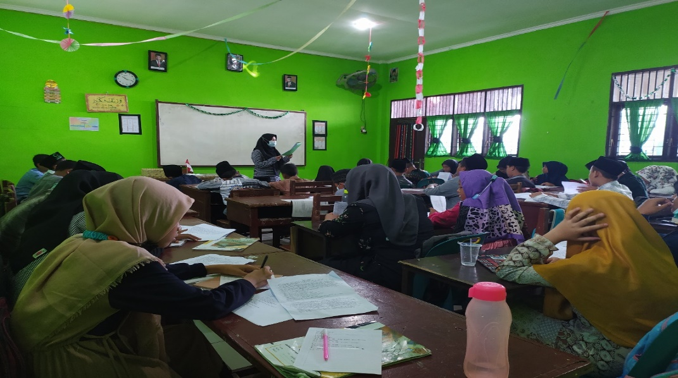

**Post Test Experimental Group**

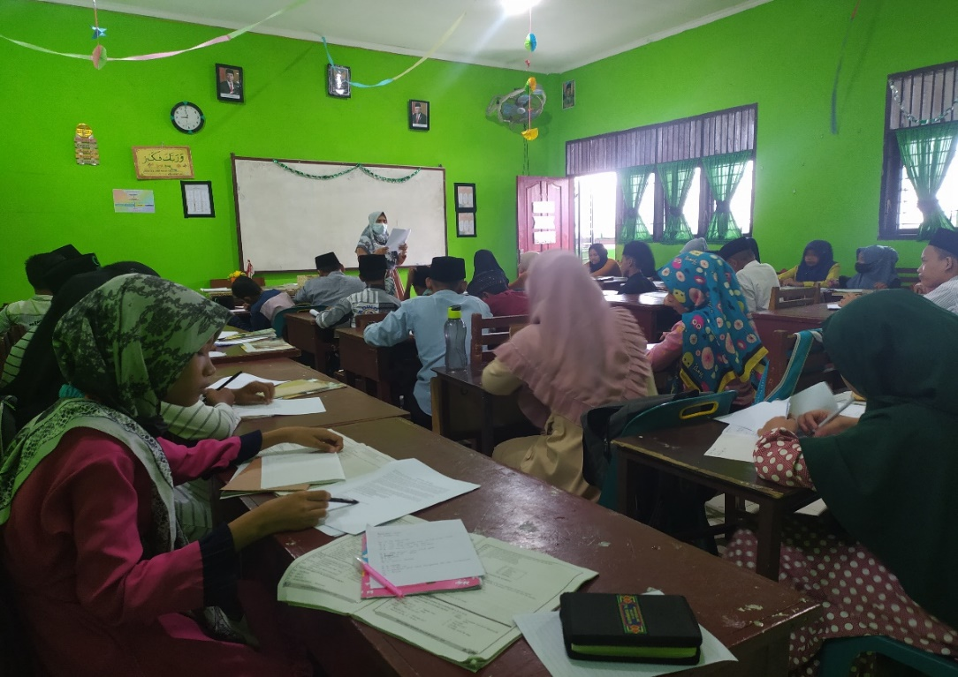

**Experimental Group**

**Pre Test Control Group**

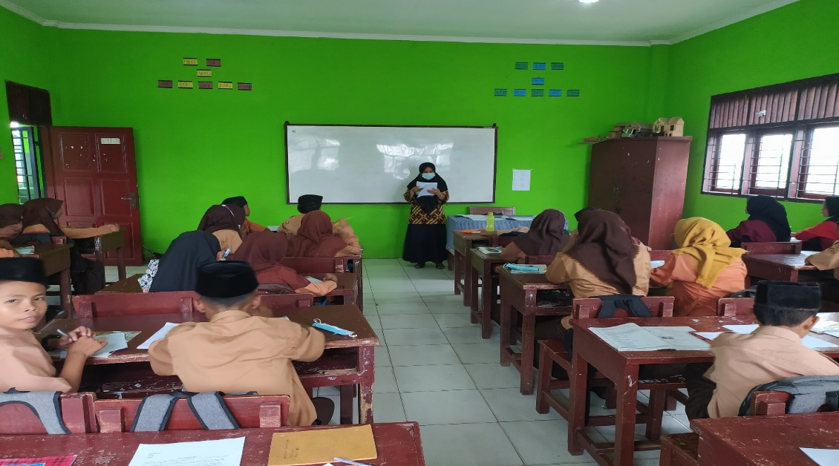

**Post Test Control Group**