# **ACKNOWLEDGEMENTS**

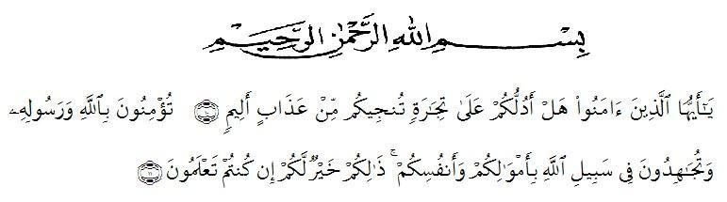

*Meaning: "Hai orang-orang yang beriman, maukah kamu aku tujukkan Suatu perniagaan yang dapat menyelamatkan kamu dari azab yang pedih? (10) (Yaitu) kamu beriman kepada Allah dan Rasulnya dan berjihad dijalan Allah dengan harta dan jiwamu. Itulah yang lebih baik jika kamu mengetahui’’. (11) (As-Shaf Ayat 10-11).*

Assalamualaikum wr.wb

Alhamdulillah, all praises belong to Allah STW who had bestowed mercy, health, blessing, knowledge to the Researcher. Secondly, peace and salutation always be given prophet Muhammad SAW who has guided us from the darknes to the lightness. In accomplising this thesis, a lot of people have provided motivation, action, advice and support for the researcher. The researcher some how relize that an appropriate moment for her deepest gratitude for:

1. Mr. Dr. KRT. Hardi Mulyono K. Surbakti as a Rector of the Universitas Muslim Nusantara Al Washliyah who has given the researcher the opportunity to study at the institution he leads.
2. Mr. Drs. Samsul Bahri, M,Pd as the Dean of FKIP UMN Al Washliyah who has given this research permission.
3. Mrs. Zulfitri S.S.,M.A the head of English Language Education Department which has provide invaluable guidance and ssistance for researcher.
4. Dahlia Sirait, S.Pd, M.Hum as adviser who has given a bunch of reliance, guidance, supports, suggestions and corrections in order to finish this thesis.
5. All of the lectures in FKIP UMN Al Washliyah for their kind andd valuable suggestions to enrich the researcher’s knowledge.
6. Mrs. Supiah. S.Pd as the headmaster of MTs. Al-Washliyah Kolam and all the teachers for the facilities and who has allowed her to conduct research at the school she is leading and assist her in conducting research.
7. To her special beloved parents of the Research Partomuan Batubara, Yusrona Siregar who always love the researcher unconditionally, support, facilitate the researcher to finished study.
8. To her beloved Afandy Batubara, Asril Batubara, Rahma Hayati, who have provide supports researchers to finished study.
9. To her special person Munandar who always pick up her, give the motivations and support her to finish this research.
10. To her beloved friends in Executive Class-O, Raisa Maulia Abdul, Indah Eka Destry, Siti Rohana, Risma Yanti.
11. All of classmate of English Department 2017 who had given her a lot of life experiences in this college life even they are conscious or unconscious.
12. To her friends at home, Juwita Anggraini, Nur Azizah, Nadia Azzahra.
13. For everyone whom she has not mention yet, thank you very much for all your support.

The last but not least, researcher would like to say thanks to anyone whom cannot be mentioned one by one, it does not mean the researcher forget about you, but reseacher deepest appreciation is dedicated for all of you.

The researcher realized that this thesis is still far from being perfect. Therefore, the researcher hopes constructive critics and suggestion will be highly appreciated much. May Allah SWT always give guidance and blessing to us. *Aamiin Ya Rabbal Alaamiin.*

Medan, 19 November 2021

 Researcher

**Nur Hasanah Batubara**