### ACKNOWLEDGEMENTS

Bismillahirrahmanirrahim,

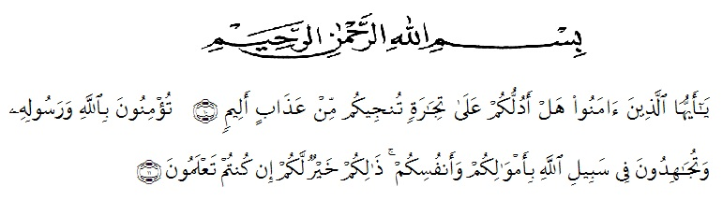

Meaning: O ye who believe! Shall I lead you to a bargain that will save you from a grievous Penalty? That ye believe in Allah and His Messenger, and that ye strive (your utmost) in the Cause of Allah, with your property and your persons: That will be best for you, if ye but knew!

Proudly, The writer would like to express her deepest gratitude to Allah SWT for all His blessing and mercies because finally she can complete this thesis. It is only for Him, she gives all her hopes and wishes. Sholawat and salam are always given upon the noble Prophet Muhammad SAW who has guided people to the right way of life.

This thesis entitled *An Analysis On Pessimism Of Obama Era As Reflected In Green’s The Fault In Our Stars”* byis intended to fulfill the requirement for achieving the degree of Sarjana Sastra (S.S) in English Literature, at The University of Muslim Nusantara Alwashliyah Medan.

Furthermore, the writer would like to dedicate the best thank to:

1. The Rector of University of Muslim Nusantara Alwashliyah Medan, H. Hardi Mulyono Surbakti, SE, MAP.
2. The Dean of Faculty of Letters, Dr. Hj. Risnawaty, M.Hum, providing tool and infrastructure which support the smoothness of learning and studying in this faculty.
3. The Head of English Letters, Dewi Nurmala, S.S, M.Hum and all the lecturers of English Letters of The University of Muslim Nusantara, for being so kind, patient and generous in leading her to the world, which never she knew before with, the loves, valuable knowledge and experiences.
4. Dewi Nurmala, S.S, M.Hum and Dr. Yulia Arfanti, M.Hum as their advisor who leads and inspires her to get a better critical thoughts and ideas in completing this thesis.
5. Her lovely parents, Zulhelmi Munir and Suyatmi, for support, prays, love, cares, and affection, and her Sisters, Jenny Cantika, Vina Andriyani, Adelin Nazalia and Queensha Almahyra for their endless love and prayer her sister.
6. All of her friends, Nadila cayank, Imaniar, Maike, Arfa, Opy, Weni, Indah, Yeni, Ratih kibo and Tiwileng for accompanying her in her days during in Medan.

Last but the least, she expect the readers’ suggestions and criticism responding to the presence of her thesis. Hopefully, this research will give many advantages to all of people who much concern in English language.

Alhamdulillahirobbil’alamin.

Medan, July 2020

The writer