Lampiran 1. Surat Determinasi Sampel
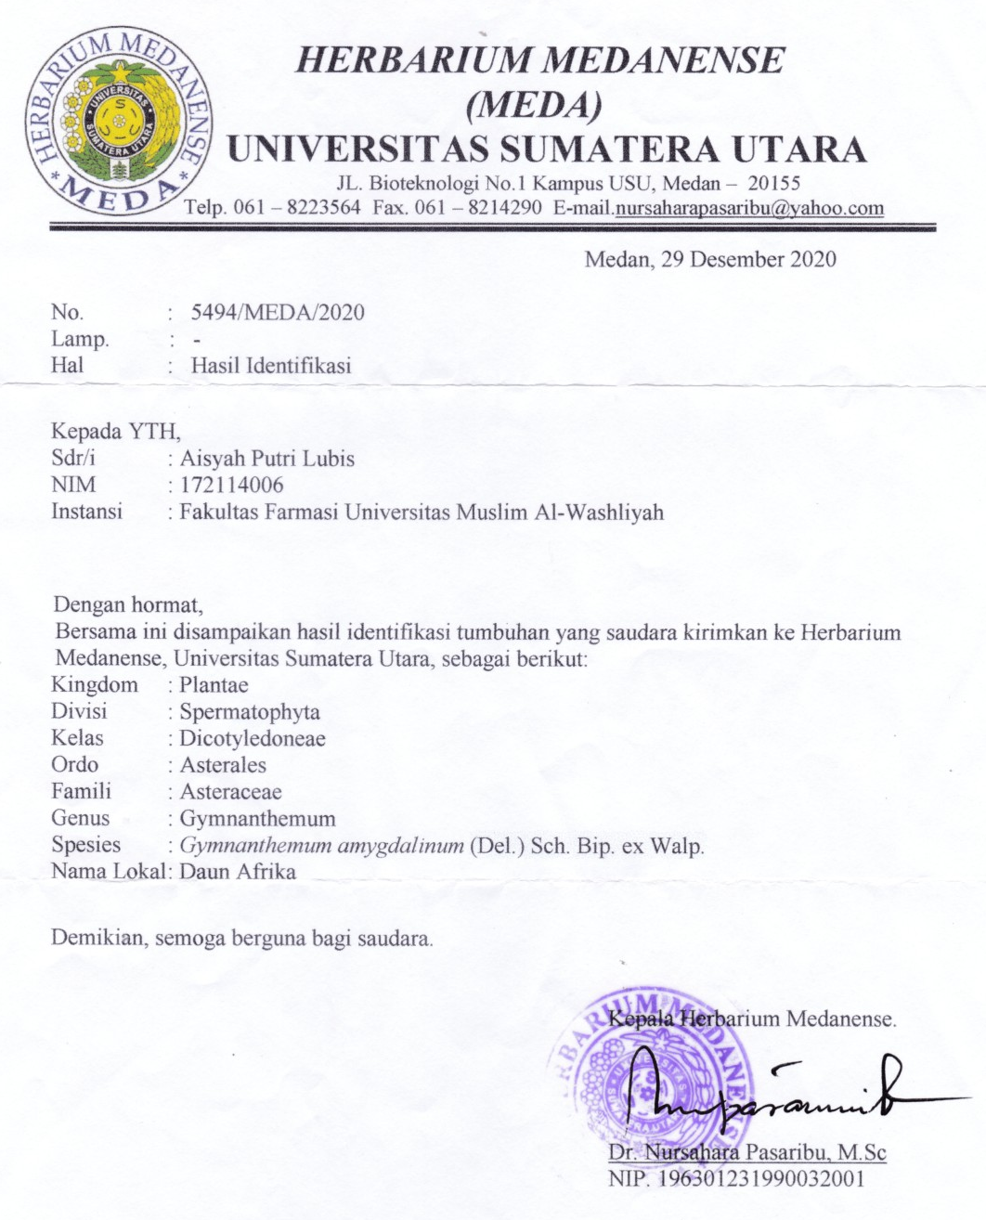

Lampiran 2. Surat Etical Clearens
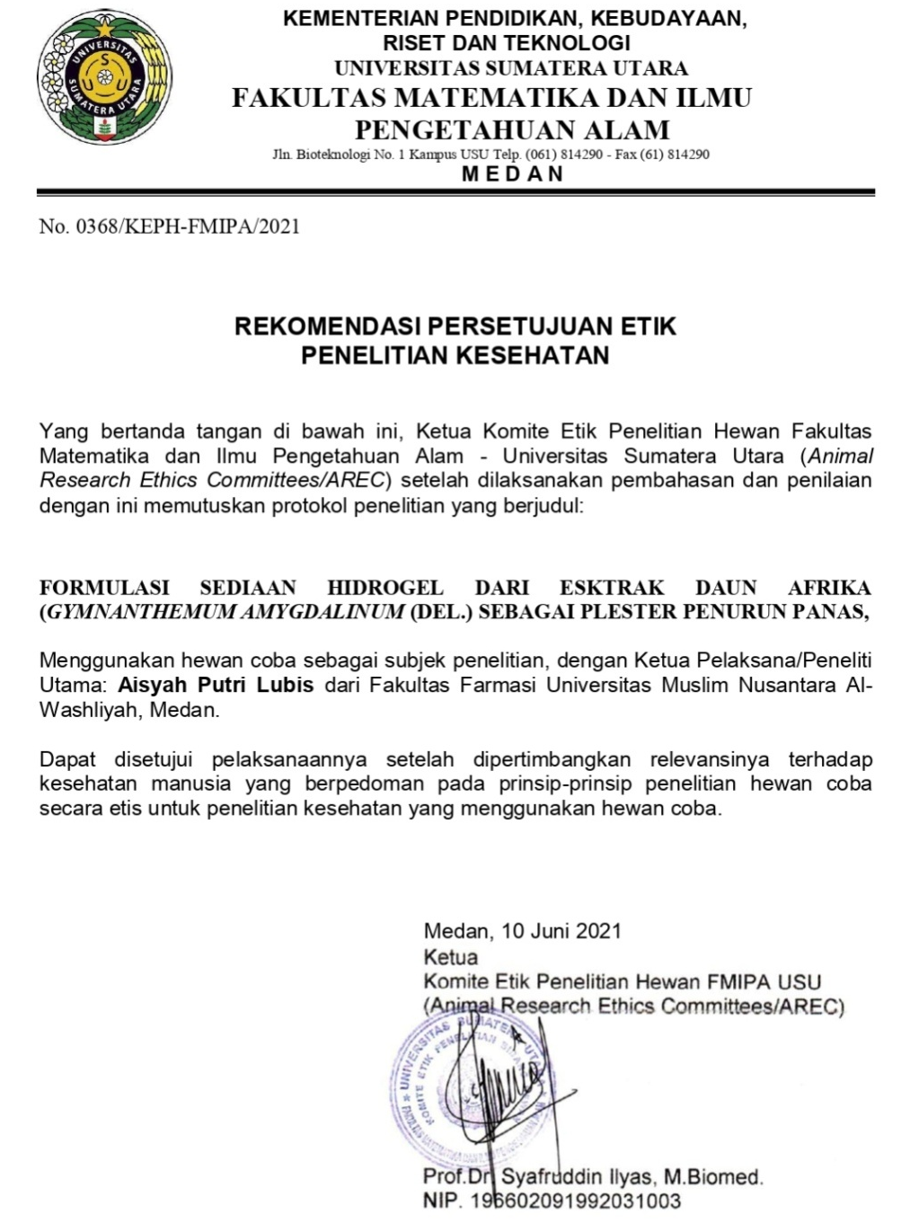

Lampiran 3. Bagan Alir Penelitian
Daun Afrika

Uji efek antipiretik pada mencit yang di induksi vaksin DPT-HB

Makroskopis Mikroskopis Kadar Air Kadar Sari Larut Air Kadar Sari Larut Etanol Kadar Abu Total Kadar Abu Tidak Larut Asam

Uji organoleptis Uji pH Uji Homogenitas Uji viskositas

Sediaan Plester Demam

Serbuk

m1 dan m2 digabungkan, uapkan dengan Vacum
Ampas direndam lagi dalam 25 bagian etanol 96% selama 2 hari, saring (m2)
Serbuk dalam bejana direndam dalam 75 bagian etanol 96% dibiarkan selama 5 hari, saring (m1)
Pembuatan ekstrak

Alkaloid Flavonoid Tanin Saponin Steroid/Triterpen

Karakterisasi simplisia

Skrining fitokimia
Serbuk

dihaluskan dengan blender, disimpan dalam wadah tertutup
dikeringkan di lemari pengering, disortasi kering dan ditimbang
Simplisia kering

Lampiran 4. Bagan Alir Pembuatan Hidrogel
HPMC

Nipagin

Plester demam ekstrak daun afrika

lapisi dengan plastik wrapping
didiamkan hingga terbentuk konstituen padat
oleskan pada plester micropore yang sudah dipotong
ditambahkan ekstrak sedikit demi sedikit gerus sampai homogen
Massa 3

Massa 2

gerus sampai homogen
tambahkan gliserin dan propilen glikol
membentuk basis gel tranparan
gerus kuat hingga
mengembang
diaduk sampai homogen
ditambahkan aquadest panas
ditambahkan aquadest panas
Massa 1

Lampiran 5. Bagan Alir Penurun Suhu Tubuh

25 Ekor Mencit

dicatat suhu rektal mencit setiap 15 menit selama 60 menit
diamati perubahan suhu
menggunakan thermometer
Plester Hidrogel Ekstrak Daun Afrika 10g

Plester Hidrogel Ekstrak Daun Afrika 7g

Plester Hidrogel Ekstrak Daun Afrika 3g
Kontrol Plester Hidrogel Tanpa Ekstrak
Kontrol Plester
Bye-bye Fever
diukur suhu tubuh demam
diinduksi dengan vaksin DPT-HB 0,2ml
secara im
diukur suhu tubuh demam
diukur suhu tubuh normal denganthermometer
dicukur bulu bagian perut hinggapunggung
dipuasakan selama 18 jam
diberi penandaan setiap ekor mencit
diaklimatisasi selama 2 minggu
25 Ekor Mencit

Lampiran 6. Dokumen Penelitian
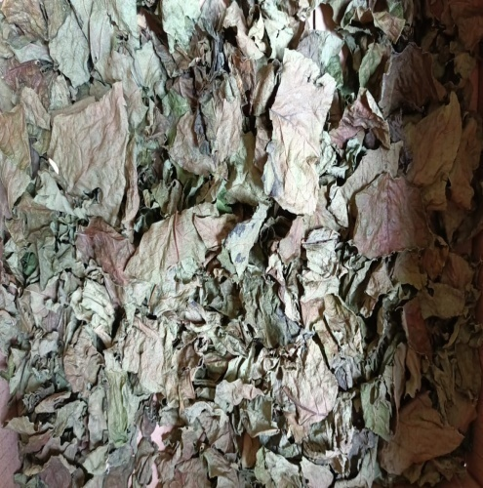
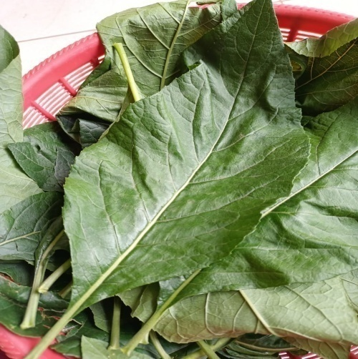

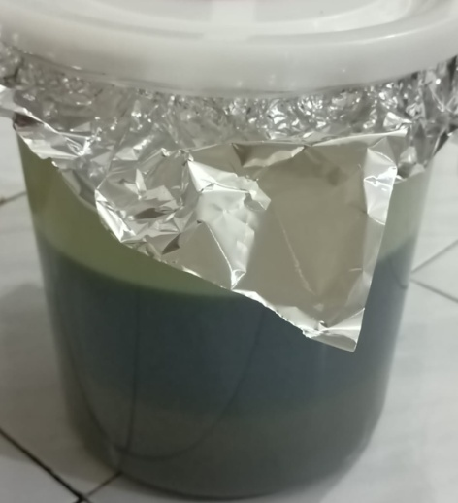
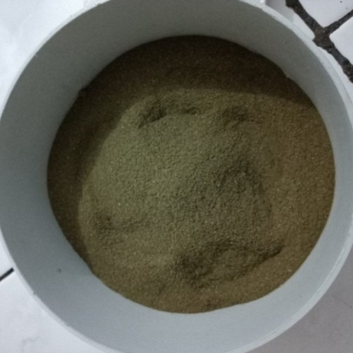
Sampel Segar Daun Afrika Simplisia Daun Afrika

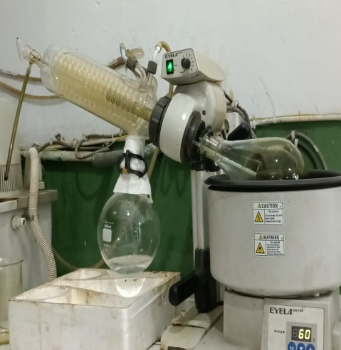
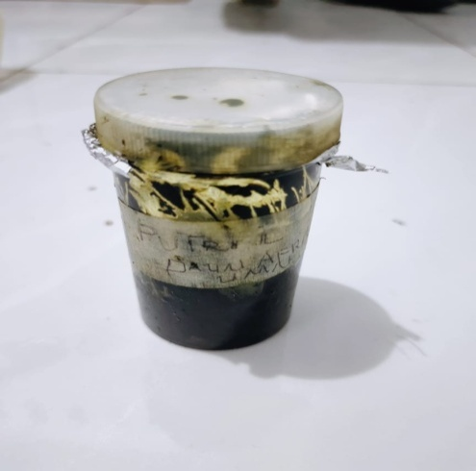
Serbuk Simplisia Ekstraksi Simplisia

Ekstrak Kental Vacuum Rotary Evaporator

Lampiran 6.(Lanjutan)
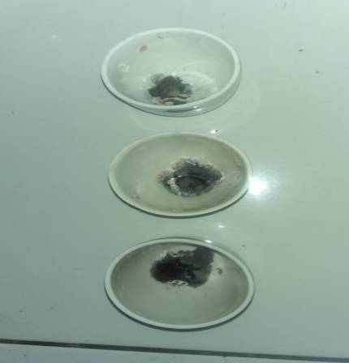
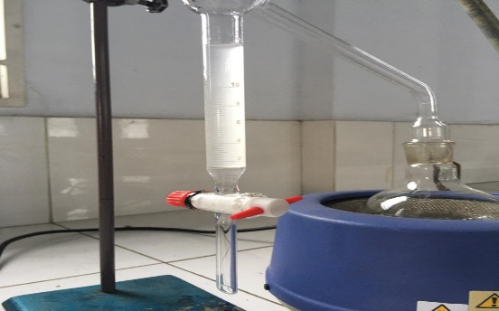

Kadar Abu Total Penetapan Kadar Air
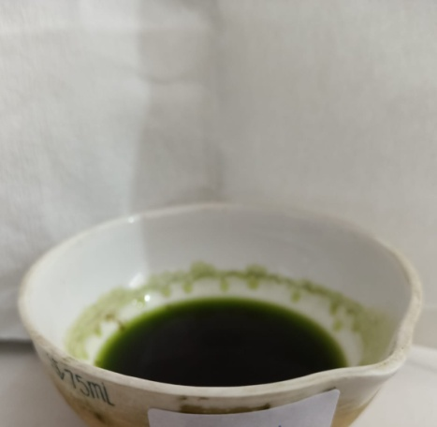
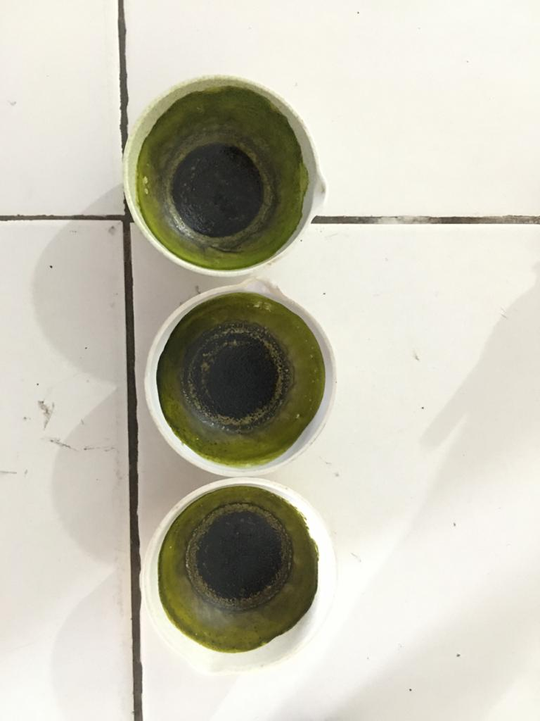

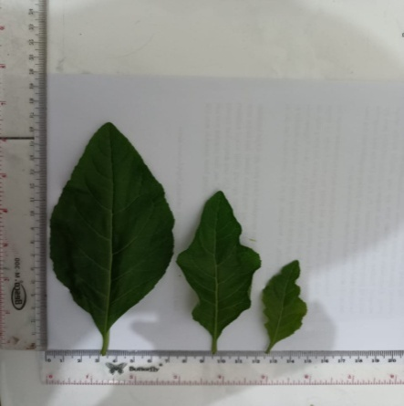
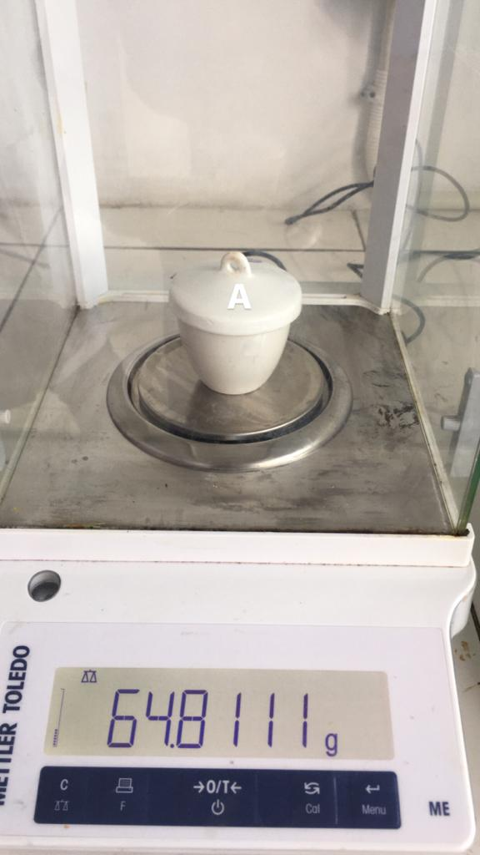
Kadar Sari Larut Air Kadar Sari Larut Etanol

Kadar Abu Tidak Larut Asam Makroskopis

Lampiran 6.(Lanjutan)
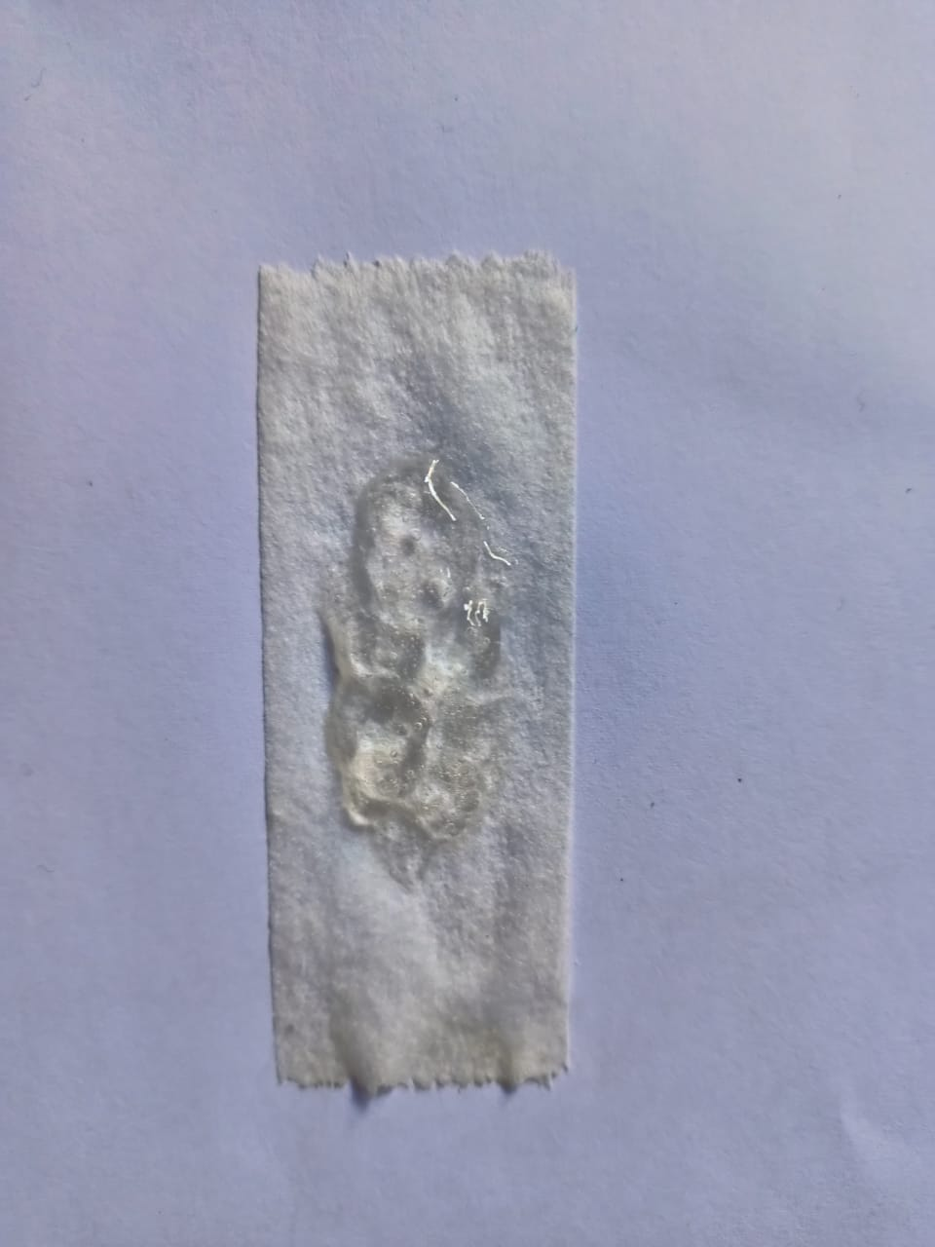
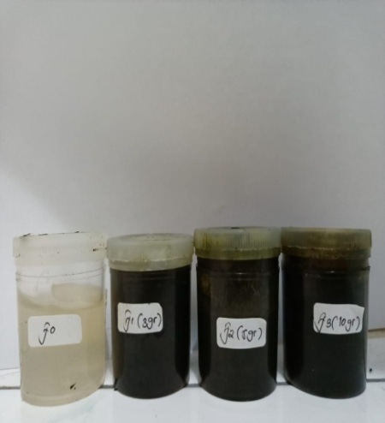

Sediaan Hidrogel Plester Hidrogel Tanpa Ekstrak
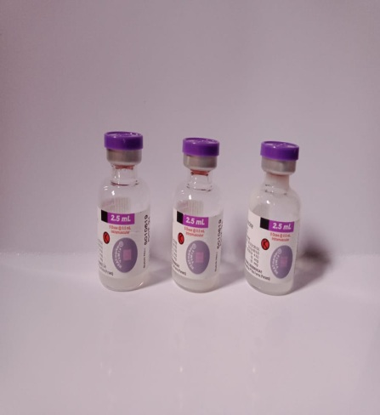
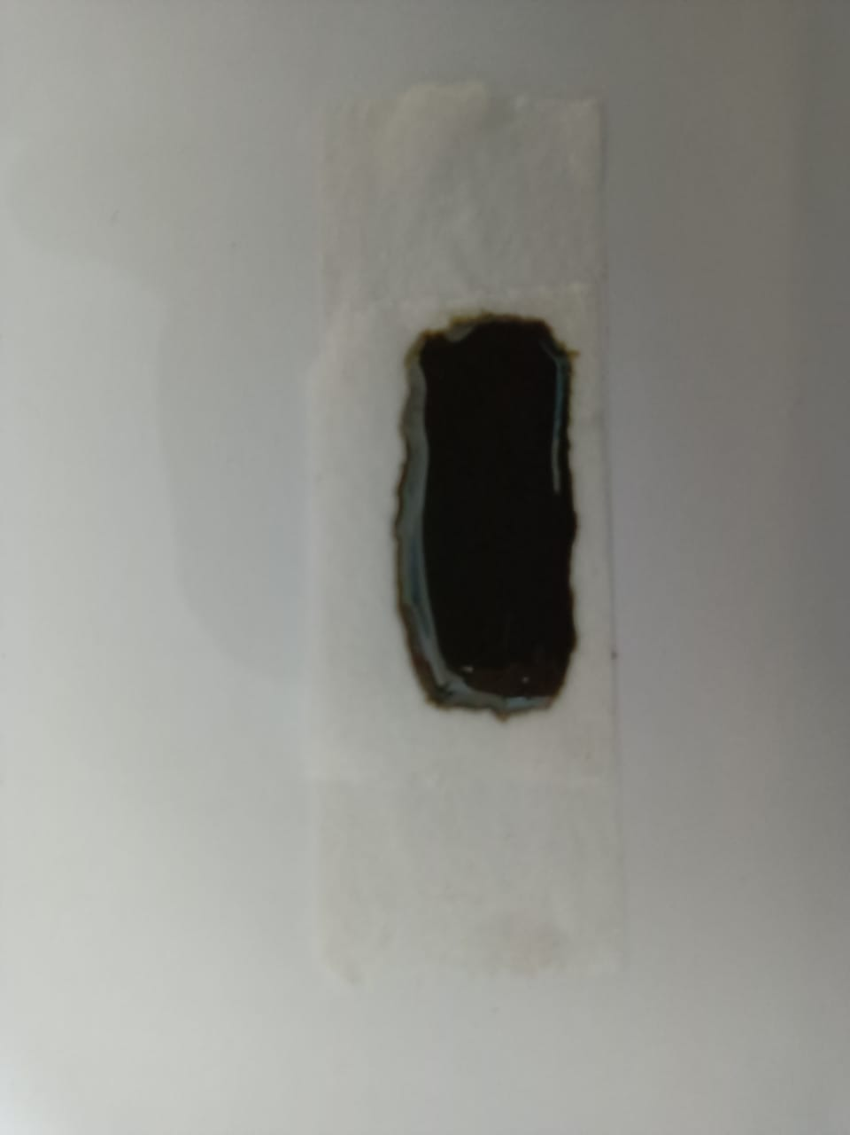

Plester Hidrogel Ekstrak Daun Afrika Vaksin DPT-HB
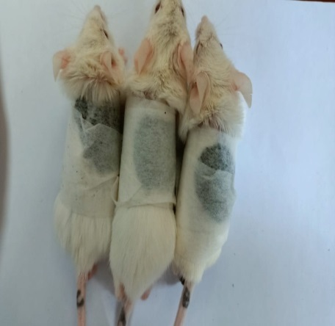
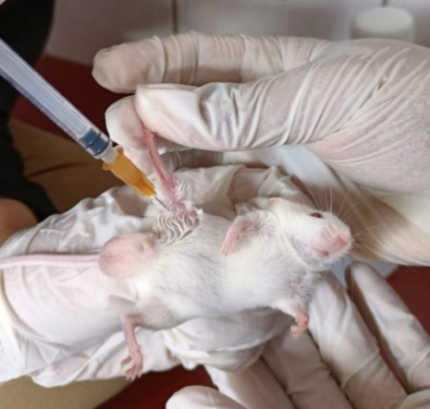

Induksi Vakasin DPT-HB Secara IM Pengujian Plester Terhadap Mencit

Lampiran 6.(Lanjutan)
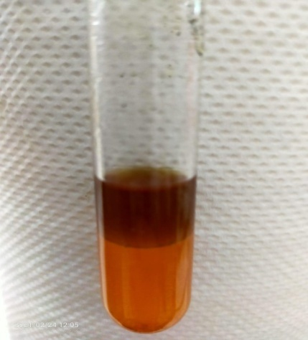
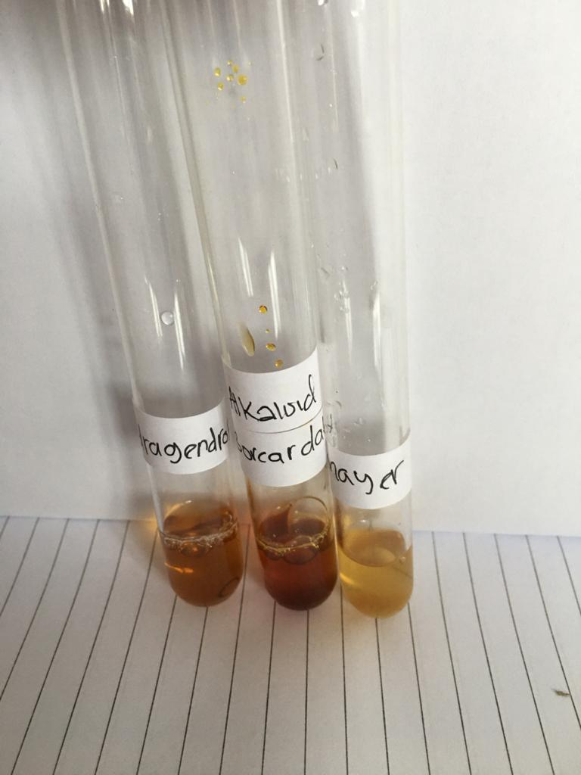

(+) Alkaloid (+) Flavonoid
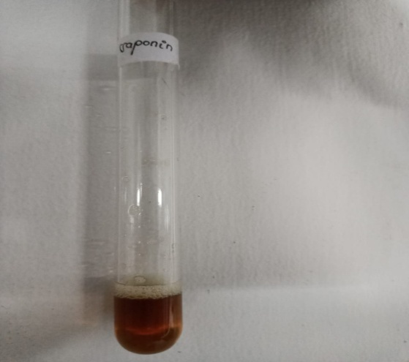
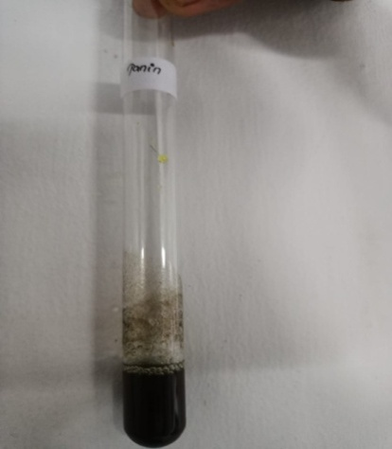

(+) Tanin (+) Saponin
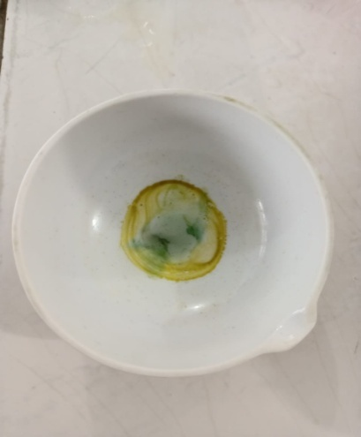

(+) Positif Steroid/Triterpen

Lampiran 6.(Lanjutan)
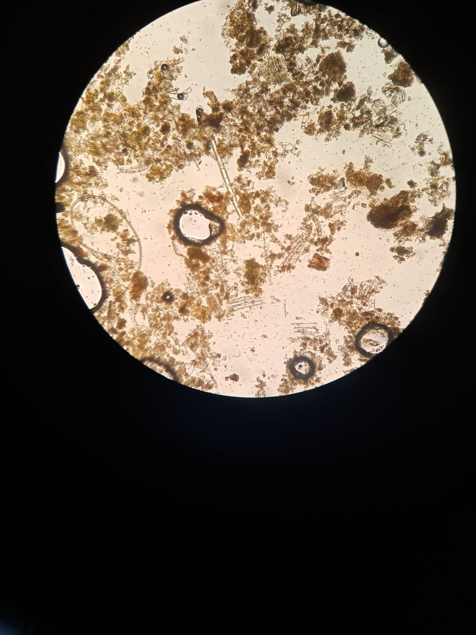
A

C
B

Mikroskopik
Keterangan gambar:
- Jaringan epidermis dan stomata
- Rambut kelenjar
- Mesofil dan berkas pembuluh
Mikroskopik serbuk daun bunga matahari (Heliantus annus L.) family asteraceae sebagai daun pembanding (Ditjen POM, 1995).

Lampiran 7. Perhitungan Hasil Karakterisasi Simplisia Daun Afrika
- Penetapan kadar air
$$Kadar Air =\frac{Volume Akhir-Volume Awal}{Berat Sampel}x 100\%$$
Sampel I
Berat Sampel = 5,0028 g
Volume awal = 1,8 ml
Volume akhir = 1,4 ml
% Kadar Air = $\frac{1,8ml-1,4 ml}{5, 0028 gram}$x 100%
= 7,99%
Sampel II
Berat sampel = 5,0030 g
Volume awal = 1,3 ml
Volume akhir = 1,7 ml
% Kadar Air = $\frac{1,7ml-1,3 ml}{5, 0030 gram}$x 100%
= 7,99%
Sampel III
Berat sampel = 5,0020 g
Volume awal = 1,4 ml
Volume akhir = 1,7 ml
% Kadar Air = $\frac{1,7ml-1,4 ml}{5, 0020 gram}$x 100%
= 5,99%
$$\% Kadar air rata-rata=\frac{7,99\%+7,99\%+5,99\%}{3}= 7,32 \%$$
Lampiran 7. (Lanjutan)
- Penetapan Kadar Abu Total
$$Kadar Abu Total=\frac{Berat Abu}{Berat Sampel}x100\%$$
Sampel I
Berat sampel = 2,0021 g
Berat abu = 0,087 g
% Kadar Abu Total = $\frac{0,087 g}{2, 0021 gram}$ x100%
= 4,34%
Sampel II
Berat sampel = 2,0005 g
Berat abu = 0,3224 g
% Kadar Abu Total = $\frac{0,3224 g}{2,0005 gram}$ x100%
= 16,11 %
Sampel III
Berat sampel = 2,0015 g
Berat abu = 0,0676 g
% Kadar Abu Total = $\frac{0,0676 g}{2,0015 gram}$ x100%
= 3,37%
$$\% Kadar Abu Total rata-rata= \frac{4,34\%+16,11\%+3,37\%}{3}= 7,94 \%$$

Lampiran 7. (Lanjutan)
- Kadar Abu Yang Tidak Larut Dalam Asam
$$Kadar Abu yang tidak larut dalam asam= \frac{Berat Abu}{Berat Simplisia}x100\%$$
Sampel
Berat sampel = 2,0004 g
Berat Abu = 0,0250 g
$$\% Kadar Abu yang tidak larut asam= \frac{0,0250 g}{2,0004 gram} x100\%= 1,24 \%$$
- Kadar Sari Larut dalam Air
$$\% Kadar Sari Larut dalam Air=\frac{Berat Sari}{Berat Simplisia}x \frac{100}{20} x100\%$$
Simplisia I
Berat Simplisia = 5,0300 g
Berat Sari = 0,11883 g
% Kadar Sari Larut dalam Air = $\frac{0,11883 g}{5,0300 g}$ x $\frac{100}{20}$ x100%
= 18,70%
Simplisia II
Berat Simplisia = 5,0255 g
Berat Sari = 0,2089 g
$$\% Kadar Sari Larut dalam Air= \frac{0,2089 g}{5,0255 g}x \frac{100}{20} x100\%$$
= 20,75 %

Lampiran 7. (Lanjutan)
Simplisia III
Berat Simplisia = 5,0412 g
Berat Sari = 0,2186 g
% Kadar Sari Larut dalam Air = $\frac{0,2186 g}{5,0412 g}$ x $\frac{100}{20}$ x100%
= 21,65 %
$$\% Kadar Sari Larut dalam Air rata-rata =\frac{18,70\%+20,75\%+21,65\%}{3}= 20,36 \%$$
- Kadar Sari Larut dalam Etanol
$$\% Kadar Sari Larut dalam Etanol= \frac{BeratSari}{BeratSimplisia}x \frac{100}{20} x100\%$$
Simplisia I
Berat Simplisia = 5,0077 g
Berat Sari = 0,1650 g
% Kadar Sari Larut dalam Etanol = $\frac{0,1650 g}{5,0077 g}$x $\frac{100}{20}$ x100%
= 16,45 %
Simplisia II
Berat Simplisia = 5,0112 g
Berat Sari = 0,1764 g
% Kadar Sari Larut dalam Etanol = $\frac{0,1764 g}{5,0112 g}$ x $\frac{100}{20}$ x100%
= 11,99 %

Lampiran 7. (Lanjutan)
Simplisia III
Berat Simplisia = 5,0216 g
Berat Sari = 0,1961 g
% Kadar Sari Larut dalam Etanol = $\frac{0, 1961g}{5,0216 g}$ x $\frac{100}{20}$ x100%
= 19,50 %
$$\% Kadar Sari Larut Dalam etanol rata-rata= \frac{16,45\%+11,99\%+19,50\%}{3}= 17,85 \%$$

- Rendemen Ekstrak
%Rendemen Ekstrak = $\frac{Berat Ekstrak }{Berat Simplisia}$ x100%
$$\% Rendemen Ekstrak Daun Afrika = \frac{90 gram}{500 gram} x100\%$$
= 18%

Lampiran 8. Uji Penurunan Suhu
Data Hasil Pengukuran Suhu Rektal Mencit Setelah Pemberian Vaksin DPT-HB 0,2/Hewan Secara Intramuscular Dan Penurunan Suhu Pemberian Plaster Hidrogel Ekstrak Daun Afrika.
Pemberian Plester Hidrogel Tanpa Ekstrak (F0)
Kelompok Hewan | Suhu Awal (ºC) | Suhu Demam (ºC) | 15 Menit (ºC) | 30 Menit (ºC) | 45 Menit (ºC) | 60 Menit (ºC)
F0 | 37,5 | 38,6 | 38,4 | 38,4 | 37,9 | 37,8
F1 | 37,0 | 38,7 | 38,5 | 38,4 | 37,9 | 37,5
FII | 36,8 | 38,8 | 38,5 | 38,4 | 38,2 | 37,7
FIII | 36,9 | 38,5 | 38,6 | 38,2 | 38,0 | 37,8
Bye-bye Fever | 36,8 | 38,9 | 38,6 | 38,5 | 38,0 | 37,6
Rata-rata | 37 | 38,7 | 38,5 | 38,3 | 38 | 37,6

Pemberian Plester Hidrogel Ekstrak Daun Afrika 3g (FI)
Kelompok Hewan | Suhu Awal (ºC) | Suhu Demam (ºC) | 15 Menit (ºC) | 30 Menit (ºC) | 45 Menit (ºC) | 60 Menit (ºC)
F0 | 37,0 | 38,0 | 38,7 | 37,4 | 37,3 | 37,0
F1 | 36,5 | 38,7 | 38,7 | 38,3 | 37,7 | 37,5
FII | 37,0 | 38,4 | 38,0 | 37,7 | 37,5 | 37,4
FIII | 37,0 | 38,7 | 37,8 | 37.7 | 37,4 | 36,9
Bye-bye Fever | 36,5 | 38,1 | 38,0 | 37,8 | 37,4 | 37,0
Rata-rata | 36,8 | 38,3 | 38,2 | 37,7 | 37,4 | 37,1

Pemberian Plester Hidrogel Ekstrak Daun Afrika 5g (FII)
Kelompok Hewan | Suhu Awal (ºC) | Suhu Demam (ºC) | 15 Menit (ºC) | 30 Menit (ºC) | 45 Menit (ºC) | 60 Menit (ºC)
F0 | 36,9 | 38,8 | 37,7 | 37,4 | 37,0 | 36,9
F1 | 37,4 | 38,9 | 37,5 | 37,3 | 37,0 | 37,0
FII | 36,6 | 38,7 | 37,8 | 37,7 | 37,4 | 36,9
FIII | 36,7 | 38,8 | 37,9 | 37,8 | 37,7 | 37,7
Bye-bye Fever | 36,8 | 38,7 | 38,3 | 37,7 | 37,5 | 37,3
Rata-rata | 36,8 | 38,2 | 37,8 | 37,5 | 37,3 | 37,0
Lampiran 8.(Lanjutan)

Pemberian Plester Hidrogel Ekstrak Daun Afrika 10g (FIII)
Kelompok Hewan | Suhu Awal (ºC) | Suhu Demam (ºC) | 15 Menit (ºC) | 30 Menit (ºC) | 45 Menit (ºC) | 60 Menit (ºC)
F0 | 36,8 | 38,7 | 37,7 | 37,1 | 36,9 | 36,6
F1 | 37,1 | 38,8 | 37,1 | 36,7 | 36,4 | 36,2
FII | 37,3 | 38,0 | 37,6 | 37,1 | 36,8 | 36,4
FIII | 36,5 | 38,3 | 37,4 | 37,4 | 37,3 | 37,0
Bye-bye Fever | 37,3 | 38,0 | 37,6 | 37,1 | 36,4 | 36,1
Rata-rata | 37 | 38,3 | 37,4 | 37,0 | 36,7 | 36,4

Pemberian Plester Bye-bye Fever
Kelompok Hewan | Suhu Awal (ºC) | Suhu Demam (ºC) | 15 Menit (ºC) | 30 Menit (ºC) | 45 Menit (ºC) | 60 Menit (ºC)
F0 | 37,6 | 38,4 | 38,0 | 37,4 | 37.1 | 36,1
F1 | 37,4 | 38,1 | 37,7 | 37,5 | 37,0 | 37,0
FII | 36,6 | 37,9 | 37,5 | 37,1 | 36,7 | 36,6
FIII | 36,9 | 38,0 | 37,8 | 37,0 | 36.7 | 36,4
Bye-bye Fever | 37,5 | 38,7 | 37,5 | 36,8 | 36,5 | 36,1
Rata-rata | 37,2 | 38,2 | 37,7 | 37,1 | 36,7 | 36,3

Lampiran 9. Hasil Uji Anova
Tests of Normality
 | Perlakuan | Kolmogorov-Smirnovª |  |  | Shapiro-Wilk
 |  | Statistic | Df | Sig. | Statistic | df | Sig.
T0 | BYE-BYE FEVER | ,279 | 5 | ,200* | ,885 | 5 | ,335
 | HPMC | ,300 | 5 | ,161 | ,776 | 5 | ,050
 | FI 3g | ,367 | 5 | ,026 | ,684 | 5 | ,006
 | FII 5g | ,274 | 5 | ,200* | ,867 | 5 | ,254
 | FIII 10g | ,214 | 5 | ,200* | ,887 | 5 | ,341
T1 | BYE-BYE FEVER | ,243 | 5 | ,200* | ,922 | 5 | ,544
 | HPMC | ,136 | 5 | ,200* | ,987 | 5 | ,967
 | FI 3g | ,236 | 5 | ,200* | ,870 | 5 | ,265
 | FII 5g | ,259 | 5 | ,200* | ,888 | 5 | ,345
 | FIII 10g | ,229 | 5 | ,200* | ,858 | 5 | ,222
@15MENIT | BYE-BYE FEVER | ,227 | 5 | ,200* | ,910 | 5 | ,468
 | HPMC | ,231 | 5 | ,200* | ,881 | 5 | ,314
 | FI 3g | ,313 | 5 | ,124 | ,804 | 5 | ,087
 | FII 5g | ,199 | 5 | ,200* | ,941 | 5 | ,670
 | FIII 10g | ,292 | 5 | ,188 | ,877 | 5 | ,294
@30MENIT | BYE-BYE FEVER | ,198 | 5 | ,200* | ,951 | 5 | ,742
 | HPMC | ,372 | 5 | ,022 | ,828 | 5 | ,135
 | FI 3g | ,276 | 5 | ,200* | ,905 | 5 | ,437
 | FII 5g | ,310 | 5 | ,131 | ,871 | 5 | ,272
 | FIII10g | ,332 | 5 | ,075 | ,873 | 5 | ,278
@45MENIT | BYE-BYE FEVER | ,221 | 5 | ,200* | ,953 | 5 | ,758
 | HPMC | ,300 | 5 | ,161 | ,833 | 5 | ,146
 | FI 3g | ,263 | 5 | ,200* | ,951 | 5 | ,747
 | FII 5g | ,248 | 5 | ,200* | ,885 | 5 | ,332
 | FIII 10g | ,229 | 5 | ,200* | ,903 | 5 | ,429
@60MENIT | BYE-BYE FEVER | ,199 | 5 | ,200* | ,941 | 5 | ,670
 | HPMC | ,221 | 5 | ,200* | ,902 | 5 | ,421
 | FI 3g | ,286 | 5 | ,200* | ,813 | 5 | ,103
 | FII 5g | ,259 | 5 | ,200* | ,947 | 5 | ,714
 | FIII 10g | ,167 | 5 | ,200* | ,943 | 5 | ,685
*. This is a lower bound of the true significance.
a. Lilliefors Significance Correction

Oneway
Descriptives
 |  | N | Mean | Std. Deviation | Std. Error | 95% Confidence Interval for Mean |  | Minimum | Maximum
 |  |  |  |  |  | Lower Bound | Upper Bound
T0 | BYE-BYE FEVER | 5 | 37,200 | ,4301 | ,1924 | 36,666 | 37,734 | 36,6 | 37,6
 | HPMC | 5 | 37,000 | ,2915 | ,1304 | 36,638 | 37,362 | 36,8 | 37,5
 | FI3g | 5 | 36,800 | ,2739 | ,1225 | 36,460 | 37,140 | 36,5 | 37,0
 | FII 5g | 5 | 36,880 | ,3114 | ,1393 | 36,493 | 37,267 | 36,6 | 37,4
 | FIII 10g | 5 | 37,000 | ,3464 | ,1549 | 36,570 | 37,430 | 36,5 | 37,3
 | Total | 25 | 36,976 | ,3358 | ,0672 | 36,837 | 37,115 | 36,5 | 37,6
T1 | BYE-BYE FEVER | 5 | 38,220 | ,3271 | ,1463 | 37,814 | 38,626 | 37,9 | 38,7
 | HPMC | 5 | 38,700 | ,1581 | ,0707 | 38,504 | 38,896 | 38,5 | 38,9
 | FI 3g | 5 | 38,380 | ,3271 | ,1463 | 37,974 | 38,786 | 38,0 | 38,7
 | FII 5g | 5 | 38,260 | ,3912 | ,1749 | 37,774 | 38,746 | 37,9 | 38,9
 | FIII 10g | 5 | 38,360 | ,3782 | ,1691 | 37,890 | 38,830 | 38,0 | 38,8
 | Total | 25 | 38,384 | ,3448 | ,0690 | 38,242 | 38,526 | 37,9 | 38,9
@15MENIT | BYE-BYE FEVER | 5 | 37,700 | ,2121 | ,0949 | 37,437 | 37,963 | 37,5 | 38,0
 | HPMC | 5 | 38,520 | ,0837 | ,0374 | 38,416 | 38,624 | 38,4 | 38,6
 | FI 3g | 5 | 38,240 | ,4278 | ,1913 | 37,709 | 38,771 | 37,8 | 38,7
 | FII 5g | 5 | 37,820 | ,3114 | ,1393 | 37,433 | 38,207 | 37,5 | 38,3
 | FIII 10g | 5 | 37,480 | ,2387 | ,1068 | 37,184 | 37,776 | 37,1 | 37,7
 | Total | 25 | 37,952 | ,4611 | ,0922 | 37,762 | 38,142 | 37,1 | 38,7
@30MENIT | BYE-BYE FEVER | 5 | 37,160 | ,2881 | ,1288 | 36,802 | 37,518 | 36,8 | 37,5
 | HPMC | 5 | 38,380 | ,1095 | ,0490 | 38,244 | 38,516 | 38,2 | 38,5
 | FI 3g | 5 | 37,780 | ,3271 | ,1463 | 37,374 | 38,186 | 37,4 | 38,3
 | FII 5g | 5 | 37,580 | ,2168 | ,0970 | 37,311 | 37,849 | 37,3 | 37,8
 | FIII 10g | 5 | 37,080 | ,2490 | ,1114 | 36,771 | 37,389 | 36,7 | 37,4
 | Total | 25 | 37,596 | ,5311 | ,1062 | 37,377 | 37,815 | 36,7 | 38,5
@45MENIT | BYE-BYE FEVER | 5 | 36,760 | ,1949 | ,0872 | 36,518 | 37,002 | 36,5 | 37,0
 | HPMC | 5 | 38,000 | ,1225 | ,0548 | 37,848 | 38,152 | 37,9 | 38,2
 | FI 3g | 5 | 37,420 | ,2168 | ,0970 | 37,151 | 37,689 | 37,1 | 37,7
 | FII 5g | 5 | 37,320 | ,3114 | ,1393 | 36,933 | 37,707 | 37,0 | 37,7
 | FIII 10g | 5 | 36,760 | ,3782 | ,1691 | 36,290 | 37,230 | 36,4 | 37,3
 | Total | 25 | 37,252 | ,5300 | ,1060 | 37,033 | 37,471 | 36,4 | 38,2
@60MENIT | BYE-BYE FEVER | 5 | 36,320 | ,3114 | ,1393 | 35,933 | 36,707 | 36,0 | 36,8
 | HPMC | 5 | 37,680 | ,1304 | ,0583 | 37,518 | 37,842 | 37,5 | 37,8
 | FI 3g | 5 | 37,140 | ,2881 | ,1288 | 36,782 | 37,498 | 36,9 | 37,5
 | FII 5g | 5 | 37,060 | ,3912 | ,1749 | 36,574 | 37,546 | 36,6 | 37,6
 | FIII 10g | 5 | 36,460 | ,3578 | ,1600 | 36,016 | 36,904 | 36,1 | 37,0
 | Total | 25 | 36,932 | ,5771 | ,1154 | 36,694 | 37,170 | 36,0 | 37,8

ANOVA
 |  | Sum of Squares | df | Mean Square | F | Sig.
T0 | Between Groups | ,458 | 4 | ,114 | 1,018 | ,422
 | Within Groups | 2,248 | 20 | ,112
 | Total | 2,706 | 24
T1 | Between Groups | ,714 | 4 | ,178 | 1,667 | ,197
 | Within Groups | 2,140 | 20 | ,107
 | Total | 2,854 | 24
@15MENIT | Between Groups | 3,546 | 4 | ,887 | 11,396 | ,000
 | Within Groups | 1,556 | 20 | ,078
 | Total | 5,102 | 24
@30MENIT | Between Groups | 5,526 | 4 | 1,381 | 22,209 | ,000
 | Within Groups | 1,244 | 20 | ,062
 | Total | 6,770 | 24
@45MENIT | Between Groups | 5,382 | 4 | 1,346 | 19,788 | ,000
 | Within Groups | 1,360 | 20 | ,068
 | Total | 6,742 | 24
@60MENIT | Between Groups | 6,082 | 4 | 1,521 | 15,906 | ,000
 | Within Groups | 1,912 | 20 | ,096
 | Total | 7,994 | 24

Post Hoc Tests
Multiple Comparisons
Tukey HSD
Dependent Variable | (I) Perlakuan | (J) Perlakuan | Mean Difference (I-J) | Std. Error | Sig. | 95% Confidence Interval
 |  |  |  |  |  | Lower Bound | Upper Bound
T0 | BYE-BYE FEVER | HPMC | ,2000 | ,2120 | ,877 | -,434 | ,834
 |  | EEDA 3g | ,4000 | ,2120 | ,356 | -,234 | 1,034
 |  | EEDA 5g | ,3200 | ,2120 | ,569 | -,314 | ,954
 |  | EEDA 10g | ,2000 | ,2120 | ,877 | -,434 | ,834
 | HPMC | BYE-BYE FEVER | -,2000 | ,2120 | ,877 | -,834 | ,434
 |  | EEDA 3g | ,2000 | ,2120 | ,877 | -,434 | ,834
 |  | EEDA 5g | ,1200 | ,2120 | ,979 | -,514 | ,754
 |  | EEDA 10g | ,0000 | ,2120 | 1,000 | -,634 | ,634
 | FI 3g | BYE-BYE FEVER | -,4000 | ,2120 | ,356 | -1,034 | ,234
 |  | HPMC | -,2000 | ,2120 | ,877 | -,834 | ,434
 |  | EEDA 5g | -,0800 | ,2120 | ,995 | -,714 | ,554
 |  | EEDA 10g | -,2000 | ,2120 | ,877 | -,834 | ,434
 | FII 5g | BYE-BYE FEVER | -,3200 | ,2120 | ,569 | -,954 | ,314
 |  | HPMC | -,1200 | ,2120 | ,979 | -,754 | ,514
 |  | EEDA 3g | ,0800 | ,2120 | ,995 | -,554 | ,714
 |  | EEDA 10g | -,1200 | ,2120 | ,979 | -,754 | ,514
 | FIII 10g | BYE-BYE FEVER | -,2000 | ,2120 | ,877 | -,834 | ,434
 |  | HPMC | ,0000 | ,2120 | 1,000 | -,634 | ,634
 |  | EEDA 3g | ,2000 | ,2120 | ,877 | -,434 | ,834
 |  | EEDA 5g | ,1200 | ,2120 | ,979 | -,514 | ,754
T1 | BYE-BYE FEVER | HPMC | -,4800 | ,2069 | ,180 | -1,099 | ,139
 |  | EEDA 3g | -,1600 | ,2069 | ,935 | -,779 | ,459
 |  | EEDA 5g | -,0400 | ,2069 | 1,000 | -,659 | ,579
 |  | EEDA 10g | -,1400 | ,2069 | ,959 | -,759 | ,479
 | HPMC | BYE-BYE FEVER | ,4800 | ,2069 | ,180 | -,139 | 1,099
 |  | EEDA 3g | ,3200 | ,2069 | ,546 | -,299 | ,939
 |  | EEDA 5g | ,4400 | ,2069 | ,248 | -,179 | 1,059
 |  | EEDA 10g | ,3400 | ,2069 | ,489 | -,279 | ,959
 | FI 3g | BYE-BYE FEVER | ,1600 | ,2069 | ,935 | -,459 | ,779
 |  | HPMC | -,3200 | ,2069 | ,546 | -,939 | ,299
 |  | EEDA 5g | ,1200 | ,2069 | ,977 | -,499 | ,739
 |  | EEDA 10g | ,0200 | ,2069 | 1,000 | -,599 | ,639
 | FII 5g | BYE-BYE FEVER | ,0400 | ,2069 | 1,000 | -,579 | ,659
 |  | HPMC | -,4400 | ,2069 | ,248 | -1,059 | ,179
 |  | EEDA 3g | -,1200 | ,2069 | ,977 | -,739 | ,499
 |  | EEDA 10g | -,1000 | ,2069 | ,988 | -,719 | ,519
 | FIII 10g | BYE-BYE FEVER | ,1400 | ,2069 | ,959 | -,479 | ,759
 |  | HPMC | -,3400 | ,2069 | ,489 | -,959 | ,279
 |  | EEDA 3g | -,0200 | ,2069 | 1,000 | -,639 | ,599
 |  | EEDA 5g | ,1000 | ,2069 | ,988 | -,519 | ,719
@15MENIT | BYE-BYE FEVER | HPMC | -,8200* | ,1764 | ,001 | -1,348 | -,292
 |  | EEDA 3g | -,5400* | ,1764 | ,043 | -1,068 | -,012
 |  | EEDA 5g | -,1200 | ,1764 | ,958 | -,648 | ,408
 |  | EEDA 10g | ,2200 | ,1764 | ,725 | -,308 | ,748
 | HPMC | BYE-BYE FEVER | ,8200* | ,1764 | ,001 | ,292 | 1,348
 |  | EEDA 3g | ,2800 | ,1764 | ,522 | -,248 | ,808
 |  | EEDA 5g | ,7000* | ,1764 | ,006 | ,172 | 1,228
 |  | EEDA 10g | 1,0400* | ,1764 | ,000 | ,512 | 1,568
 | FI 3g | BYE-BYE FEVER | ,5400* | ,1764 | ,043 | ,012 | 1,068
 |  | HPMC | -,2800 | ,1764 | ,522 | -,808 | ,248
 |  | EEDA 5g | ,4200 | ,1764 | ,162 | -,108 | ,948
 |  | EEDA 10g | ,7600* | ,1764 | ,003 | ,232 | 1,288
 | FII 5g | BYE-BYE FEVER | ,1200 | ,1764 | ,958 | -,408 | ,648
 |  | HPMC | -,7000* | ,1764 | ,006 | -1,228 | -,172
 |  | EEDA 3g | -,4200 | ,1764 | ,162 | -,948 | ,108
 |  | EEDA 10g | ,3400 | ,1764 | ,336 | -,188 | ,868
 | FIII 10g | BYE-BYE FEVER | -,2200 | ,1764 | ,725 | -,748 | ,308
 |  | HPMC | -1,0400* | ,1764 | ,000 | -1,568 | -,512
 |  | EEDA 3g | -,7600* | ,1764 | ,003 | -1,288 | -,232
 |  | EEDA 5g | -,3400 | ,1764 | ,336 | -,868 | ,188
@30MENIT | BYE-BYE FEVER | HPMC | -1,2200* | ,1577 | ,000 | -1,692 | -,748
 |  | EEDA 3g | -,6200* | ,1577 | ,007 | -1,092 | -,148
 |  | EEDA 5g | -,4200 | ,1577 | ,096 | -,892 | ,052
 |  | EEDA 10g | ,0800 | ,1577 | ,986 | -,392 | ,552
 | HPMC | BYE-BYE FEVER | 1,2200* | ,1577 | ,000 | ,748 | 1,692
 |  | EEDA 3g | ,6000* | ,1577 | ,009 | ,128 | 1,072
 |  | EEDA 5g | ,8000* | ,1577 | ,001 | ,328 | 1,272
 |  | EEDA 10g | 1,3000* | ,1577 | ,000 | ,828 | 1,772
 | FI 3g | BYE-BYE FEVER | ,6200* | ,1577 | ,007 | ,148 | 1,092
 |  | HPMC | -,6000* | ,1577 | ,009 | -1,072 | -,128
 |  | EEDA 5g | ,2000 | ,1577 | ,713 | -,272 | ,672
 |  | EEDA 10g | ,7000* | ,1577 | ,002 | ,228 | 1,172
 | FII 5g | BYE-BYE FEVER | ,4200 | ,1577 | ,096 | -,052 | ,892
 |  | HPMC | -,8000* | ,1577 | ,001 | -1,272 | -,328
 |  | EEDA 3g | -,2000 | ,1577 | ,713 | -,672 | ,272
 |  | EEDA 10g | ,5000* | ,1577 | ,035 | ,028 | ,972
 | FIII 10g | BYE-BYE FEVER | -,0800 | ,1577 | ,986 | -,552 | ,392
 |  | HPMC | -1,3000* | ,1577 | ,000 | -1,772 | -,828
 |  | EEDA 3g | -,7000* | ,1577 | ,002 | -1,172 | -,228
 |  | EEDA 5g | -,5000* | ,1577 | ,035 | -,972 | -,028
@45MENIT | BYE-BYE FEVER | HPMC | -1,2400* | ,1649 | ,000 | -1,734 | -,746
 |  | EEDA 3g | -,6600* | ,1649 | ,006 | -1,154 | -,166
 |  | EEDA 5g | -,5600* | ,1649 | ,021 | -1,054 | -,066
 |  | EEDA 10g | ,0000 | ,1649 | 1,000 | -,494 | ,494
 | HPMC | BYE-BYE FEVER | 1,2400* | ,1649 | ,000 | ,746 | 1,734
 |  | EEDA 3g | ,5800* | ,1649 | ,016 | ,086 | 1,074
 |  | EEDA 5g | ,6800* | ,1649 | ,004 | ,186 | 1,174
 |  | EEDA 10g | 1,2400* | ,1649 | ,000 | ,746 | 1,734
 | FI 3g | BYE-BYE FEVER | ,6600* | ,1649 | ,006 | ,166 | 1,154
 |  | HPMC | -,5800* | ,1649 | ,016 | -1,074 | -,086
 |  | EEDA 5g | ,1000 | ,1649 | ,972 | -,394 | ,594
 |  | EEDA 10g | ,6600* | ,1649 | ,006 | ,166 | 1,154
 | FII 5g | BYE-BYE FEVER | ,5600* | ,1649 | ,021 | ,066 | 1,054
 |  | HPMC | -,6800* | ,1649 | ,004 | -1,174 | -,186
 |  | EEDA 3g | -,1000 | ,1649 | ,972 | -,594 | ,394
 |  | EEDA 10g | ,5600* | ,1649 | ,021 | ,066 | 1,054
 | FIII 10g | BYE-BYE FEVER | ,0000 | ,1649 | 1,000 | -,494 | ,494
 |  | HPMC | -1,2400* | ,1649 | ,000 | -1,734 | -,746
 |  | EEDA 3g | -,6600* | ,1649 | ,006 | -1,154 | -,166
 |  | EEDA 5g | -,5600* | ,1649 | ,021 | -1,054 | -,066
@60MENIT | BYE-BYE FEVER | HPMC | -1,3600* | ,1956 | ,000 | -1,945 | -,775
 |  | EEDA 3g | -,8200* | ,1956 | ,004 | -1,405 | -,235
 |  | EEDA 5g | -,7400* | ,1956 | ,009 | -1,325 | -,155
 |  | EEDA 10g | -,1400 | ,1956 | ,950 | -,725 | ,445
 | HPMC | BYE-BYE FEVER | 1,3600* | ,1956 | ,000 | ,775 | 1,945
 |  | EEDA 3g | ,5400 | ,1956 | ,079 | -,045 | 1,125
 |  | EEDA 5g | ,6200* | ,1956 | ,035 | ,035 | 1,205
 |  | EEDA 10g | 1,2200* | ,1956 | ,000 | ,635 | 1,805
 | FI 3g | BYE-BYE FEVER | ,8200* | ,1956 | ,004 | ,235 | 1,405
 |  | HPMC | -,5400 | ,1956 | ,079 | -1,125 | ,045
 |  | EEDA 5g | ,0800 | ,1956 | ,994 | -,505 | ,665
 |  | EEDA 10g | ,6800* | ,1956 | ,018 | ,095 | 1,265
 | FII 5g | BYE-BYE FEVER | ,7400* | ,1956 | ,009 | ,155 | 1,325
 |  | HPMC | -,6200* | ,1956 | ,035 | -1,205 | -,035
 |  | EEDA 3g | -,0800 | ,1956 | ,994 | -,665 | ,505
 |  | EEDA 10g | ,6000* | ,1956 | ,043 | ,015 | 1,185
 | FIII 10g | BYE-BYE FEVER | ,1400 | ,1956 | ,950 | -,445 | ,725
 |  | HPMC | -1,2200* | ,1956 | ,000 | -1,805 | -,635
 |  | EEDA 3g | -,6800* | ,1956 | ,018 | -1,265 | -,095
 |  | EEDA 5g | -,6000* | ,1956 | ,043 | -1,185 | -,015
*. The mean difference is significant at the 0.05 level.

Homogeneous Subsets
T0
Tukey HSDª
Perlakuan | N | Subset for alpha = 0.05
 |  | 1
FI 3g | 5 | 36,800
FII 5g | 5 | 36,880
HPMC | 5 | 37,000
FIII 10g | 5 | 37,000
BYE-BYE FEVER | 5 | 37,200
Sig. |  | ,356
Means for groups in homogeneous subsets are displayed.
a. Uses Harmonic Mean Sample Size = 5,000.

TInduksi
Tukey HSDª
Perlakuan | N | Subset for alpha = 0.05
 |  | 1
BYE-BYE FEVER | 5 | 38,220
FII 5g | 5 | 38,260
FIII 10g | 5 | 38,360
FI 3g | 5 | 38,380
HPMC | 5 | 38,700
Sig. |  | ,180
Means for groups in homogeneous subsets are displayed.
- Uses Harmonic Mean Sample Size = 5,000.

@15MENIT
Tukey HSDª
Perlakuan | N | Subset for alpha = 0.05
 |  | 1 | 2 | 3
FIII 10g | 5 | 37,480
BYE-BYE FEVER | 5 | 37,700
FII 5g | 5 | 37,820 | 37,820
FI 3g | 5 |  | 38,240 | 38,240
HPMC | 5 |  |  | 38,520
Sig. |  | ,336 | ,162 | ,522
Means for groups in homogeneous subsets are displayed.
a. Uses Harmonic Mean Sample Size = 5,000.

@30MENIT
Tukey HSDª
Perlakuan | N | Subset for alpha = 0.05
 |  | 1 | 2 | 3 | 4
FIII 10g | 5 | 37,080
BYE-BYE FEVER | 5 | 37,160 | 37,160
FII 5g | 5 |  | 37,580 | 37,580
FI 3g | 5 |  |  | 37,780
HPMC | 5 |  |  |  | 38,380
Sig. |  | ,986 | ,096 | ,713 | 1,000
Means for groups in homogeneous subsets are displayed.
a. Uses Harmonic Mean Sample Size = 5,000.

@45MENIT
Tukey HSDª
Perlakuan | N | Subset for alpha = 0.05
 |  | 1 | 2 | 3
FIII 10g | 5 | 36,760
BYE-BYE FEVER | 5 | 36,760
FII 5g | 5 |  | 37,320
FI 3g | 5 |  | 37,420
HPMC | 5 |  |  | 38,000
Sig. |  | 1,000 | ,972 | 1,000
Means for groups in homogeneous subsets are displayed.
a. Uses Harmonic Mean Sample Size = 5,000.
@60MENIT
Tukey HSDª
Perlakuan | N | Subset for alpha = 0.05
 |  | 1 | 2 | 3
BYE-BYE FEVER | 5 | 36,320
FIII 10g | 5 | 36,460
FII 5g | 5 |  | 37,060
FI 3g | 5 |  | 37,140 | 37,140
HPMC | 5 |  |  | 37,680
Sig. |  | ,950 | ,994 | ,079
Means for groups in homogeneous subsets are displayed.
a. Uses Harmonic Mean Sample Size = 5,000.

T0
Duncanª
Perlakuan | N | Subset for alpha = 0.05
 |  | 1
FI 3g | 5 | 36,800
FII 5g | 5 | 36,880
HPMC | 5 | 37,000
FIII 10g | 5 | 37,000
BYE-BYE FEVER | 5 | 37,200
Sig. |  | ,104
Means for groups in homogeneous subsets are displayed.
a. Uses Harmonic Mean Sample Size = 5,000.

TInduksi
Duncanª
Perlakuan | N | Subset for alpha = 0.05
 |  | 1 | 2
BYE-BYE FEVER | 5 | 38,220
FII 5g | 5 | 38,260 | 38,260
FIII 10g | 5 | 38,360 | 38,360
FI 3g | 5 | 38,380 | 38,380
HPMC | 5 |  | 38,700
Sig. |  | ,488 | ,064
Means for groups in homogeneous subsets are displayed.
a. Uses Harmonic Mean Sample Size = 5,000.

@15MENIT
Duncanª
Perlakuan | N | Subset for alpha = 0.05
 |  | 1 | 2
FIII 10g | 5 | 37,480
BYE-BYE FEVER | 5 | 37,700
FII 5g | 5 | 37,820
FI 3g | 5 |  | 38,240
HPMC | 5 |  | 38,520
Sig. |  | ,082 | ,128
Means for groups in homogeneous subsets are displayed.
a. Uses Harmonic Mean Sample Size = 5,000.

@30MENIT
Duncanª
Perlakuan | N | Subset for alpha = 0.05
 |  | 1 | 2 | 3
FIII 10g | 5 | 37,080
BYE-BYE FEVER | 5 | 37,160
FII 5g | 5 |  | 37,580
FI 3g | 5 |  | 37,780
HPMC | 5 |  |  | 38,380
Sig. |  | ,618 | ,219 | 1,000
Means for groups in homogeneous subsets are displayed.
a. Uses Harmonic Mean Sample Size = 5,000.

@45MENIT
Duncanª
Perlakuan | N | Subset for alpha = 0.05
 |  | 1 | 2 | 3
FIII 10g | 5 | 36,760
BYE-BYE FEVER | 5 | 36,760
FII 5g | 5 |  | 37,320
FI 3g | 5 |  | 37,420
HPMC | 5 |  |  | 38,000
Sig. |  | 1,000 | ,551 | 1,000
Means for groups in homogeneous subsets are displayed.
a. Uses Harmonic Mean Sample Size = 5,000.

@60MENIT
Duncanª
Perlakuan | N | Subset for alpha = 0.05
 |  | 1 | 2 | 3
BYE-BYE FEVER | 5 | 36,320
FIII 10g | 5 | 36,460
FII 5g | 5 |  | 37,060
FI 3g | 5 |  | 37,140
HPMC | 5 |  |  | 37,680
Sig. |  | ,482 | ,687 | 1,000
Means for groups in homogeneous subsets are displayed.
a. Uses Harmonic Mean Sample Size = 5,000.

