**IMPROVING STUDENTS’ ADJECTIVE VOCABULARY   
THROUGH ANIMATION VIDEO ON FIFTH GRADE   
OF MIS TERPADU AL-IKHWAN TANJUNG MORAWA**

**A THESIS**

**BY**

**JAMIL ARROHMAN‑171224089**

**Registration Number : 171224089**

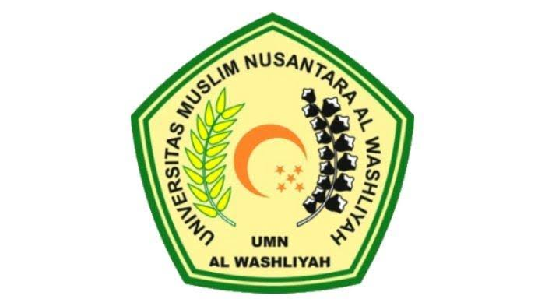

**ENGLISH EDUCATION DEPARTEMENT**

**FACULTY OF TEACHER TRAINING AND EDUCATION**

**UNIVERSITAS MUSLIM NUSANTARA AL WASHLIYAH**

**MEDAN**

**2021**

**IMPROVING STUDENTS’ ADJECTIVE VOCABULARY   
THROUGH ANIMATION VIDEO ON FIFTH GRADE   
OF MIS TERPADU AL-IKHWAN TANJUNG MORAWA**

**A Thesis**

*Submitted to the Department of English Language Education In Partial Fulfillment of the Requirements for the Degree of*

*Sarjana Pendidikan*

**BY**

**JAMIL ARROHMAN**

**Registration Number: 171224089**



**FAKULTAS KEGURUAN DAN ILMU PENDIDIKAN**

**UNIVERSITAS MUSLIM NUSANTARA AL WASHLIYAH**

**MEDAN**

**2021**

**FACULTY OF TEACHER TRAINING AND EDUCATION**

**UNIVERSITAS MUSLIM NUSANTARA AL WASHLIYAH**

**APPROVAL OF THESIS**

NAME : Jamil Arrohman

REG.NUMBER : 171224089

DEPARTMENT : Language Education and Literature

STUDY PROGRAM : English Language Education

QUALIFICATION : Bachelor (S-1)

TITLE : Improving Students’ Adjective Vocabulary Through Animation Video On Fifth Grade Of Mis Terpadu Al-Ikhwan Tanjung Morawa

Adviser

**Teguh Satria Amin M.Hum**NIDN 0113038602

This thesis was examined on :

Judicium :

Chairman Secretary

**Dr. KRT. HardiMuldoon K. Surbakti Dr. Samsul Bahri,M.Si**

NIDN 0111116303 NIDN 0017036702