Lampiran 1. Hasil Identifikasi Tanaman Kecombrang
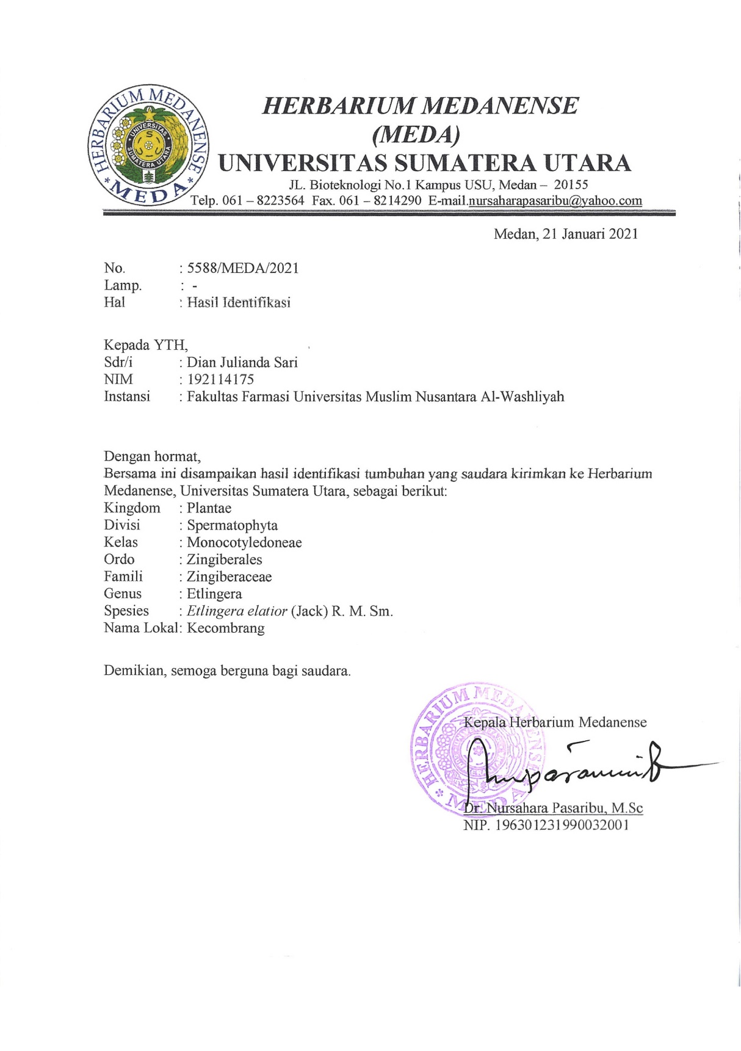

Lampiran 2. Surat Persetujuan Etik Penelitian Kesehatan
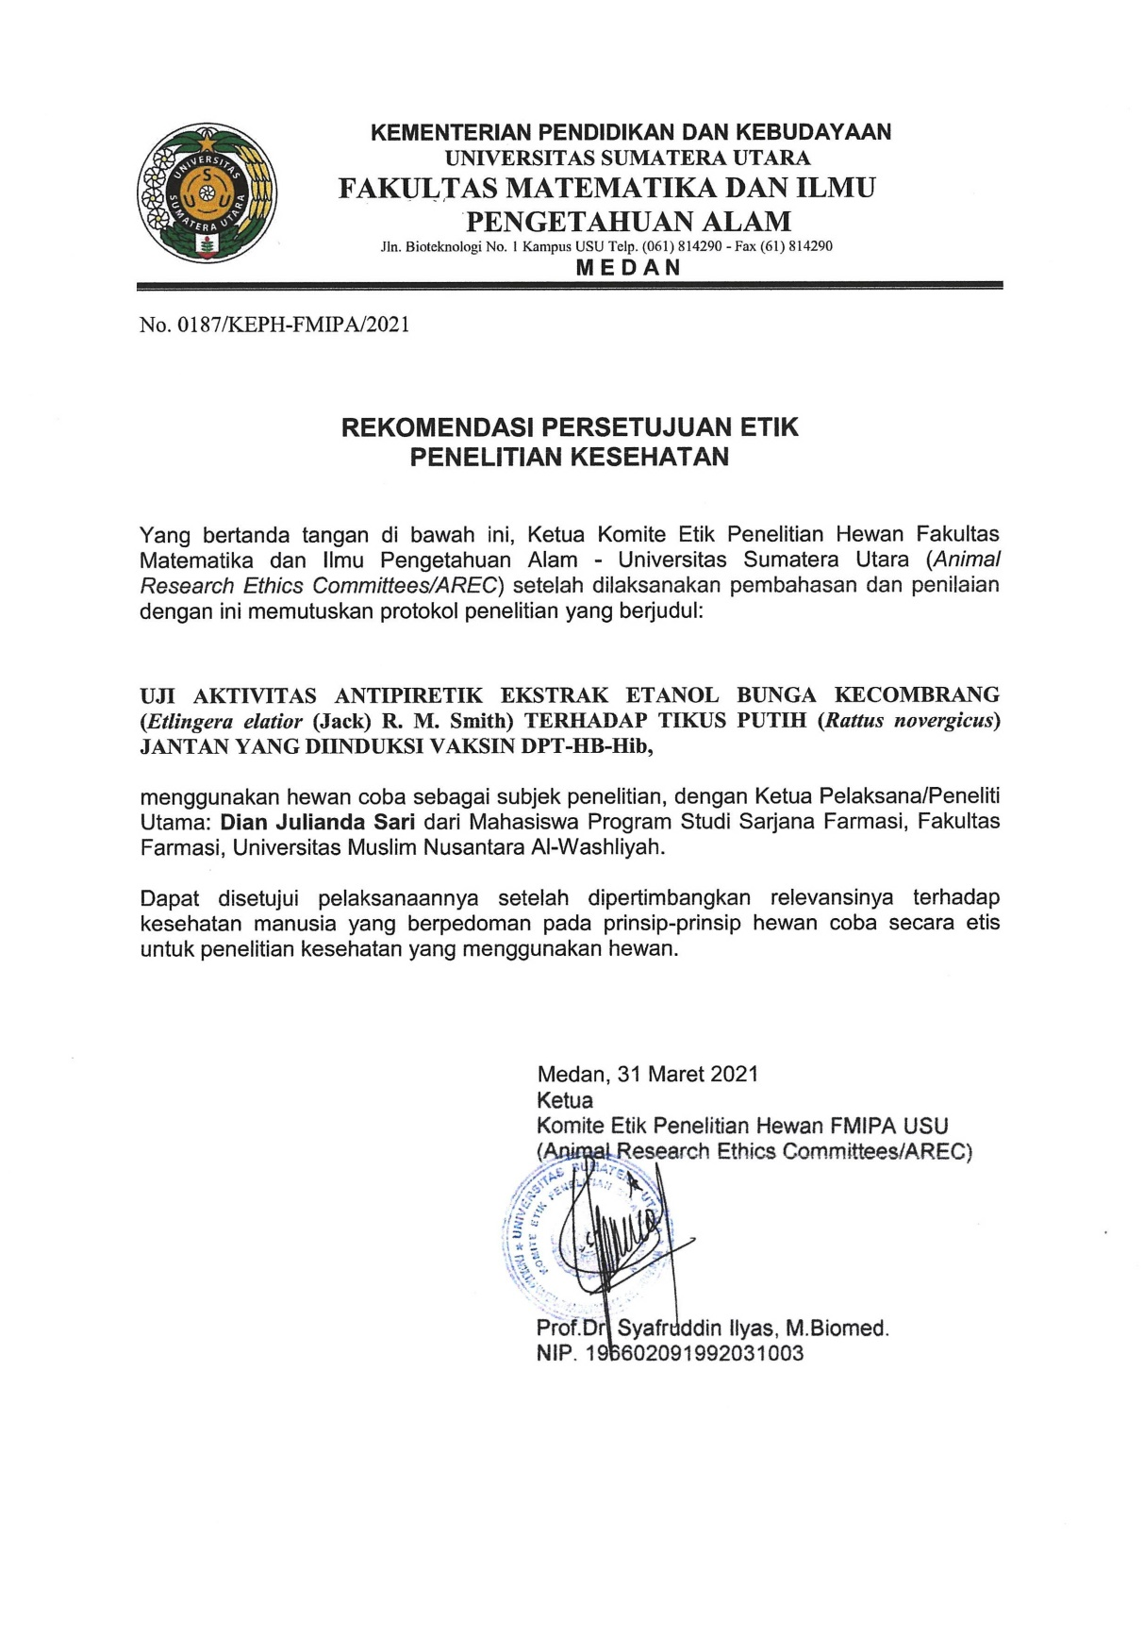
Lampiran 3. Bagan Alir Pembuatan Simplisia
Bunga Kecombrang
disortasi basah
dicuci dan ditiriskan
dikeringkan dalam lemari pengering
disortasi kering
Simplisia Bunga Kecombrang

dihaluskan menggunakan blender
diayak
Serbuk Simplisia Bunga Kecombrang

Lampiran 4. Bagan Alir Pembuatan Ekstrak Etanol Bunga Kecombrang
Serbuk Simplisia
Ditimbang 500 gram
Dimasukkan dalam bejana
Ditambahkan 75 bagian etanol 96% (3750 ml) diamkan selama 5 hari
Diaduk sesekali dan disaring
Ampas
Maserat I
Dibilas 25 bagian etanol 96% (1250 ml)
Maserat I dan II dicampur
Diamkan selama 2 hari
Ekstrak Kental

Di enap tuangkan atau disaring
Maserat
Dipekatkan dengan rotary evaporator

Lampiran 5. Bagan Alir Penelitian
Bunga kecombrang
Dikeringkan pada suhu 40-50˚C
Ditimbang
Simplisia kering
Dihaluskan
Ditimbang
Serbuk simplisia bungkecombrang

Dimaserasi dengan etanol 96%
Karakterisasi simplisia :
- Makroskopik dan Mikroskopik
- Kadar air
- Kadar abu
- Kadar abu tidak larut asam
- Kadar sari larut dalam air
- Kadar sari larut dalam etanol
Ekstrak cair
Skrining fitokimia:
- Alkaloid
- Flavonoid
- Steroid/triterpenoid
- Saponin
- Tanin
- Glikosida
Dipekatkan dengan
rotary evaporator
Ekstrak Etanol Bunga Kecombrang

Uji aktivitas antipiretik

Lampiran 6. Ekstraksi Sampel

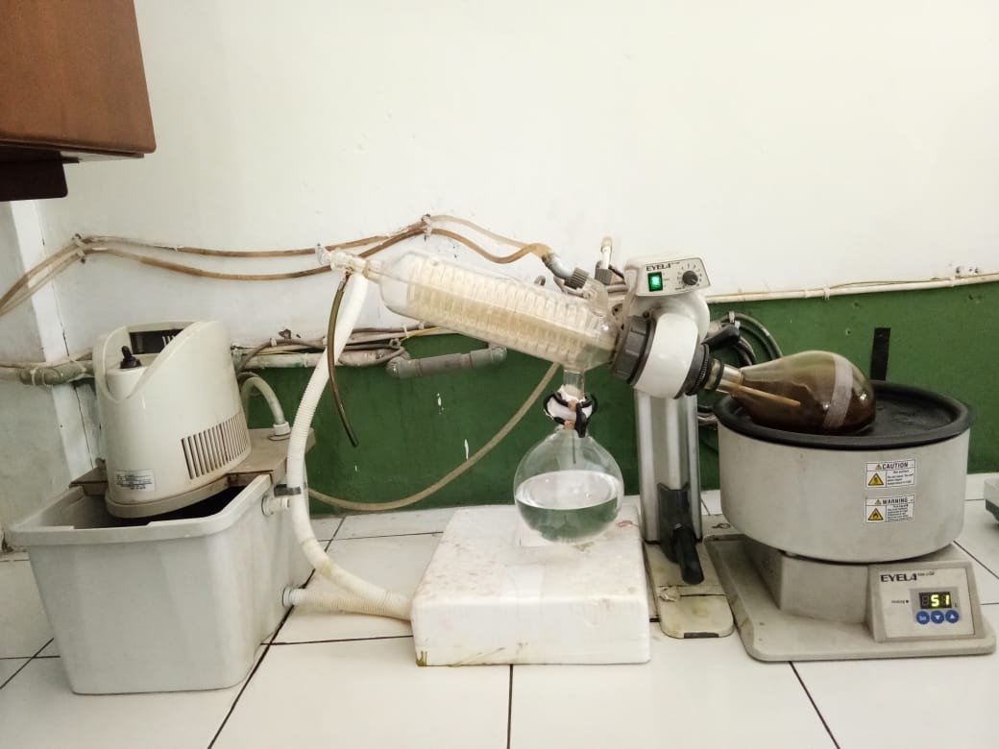
Ekstraksi dengan rotary evaporator

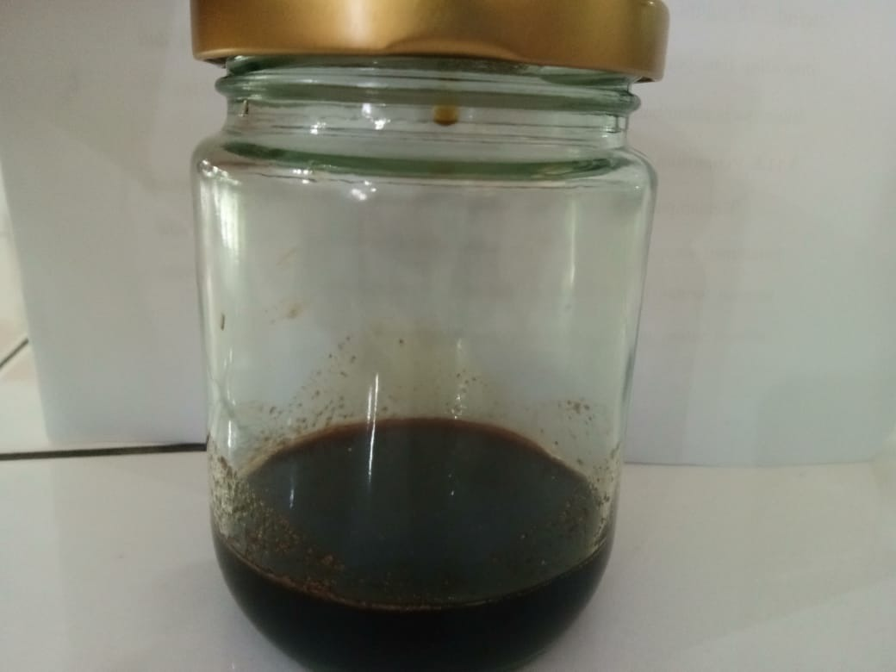
Ekstrak bunga kecombrang

Lampiran 7. Makroskopis Dan Mikroskopis Simplisia

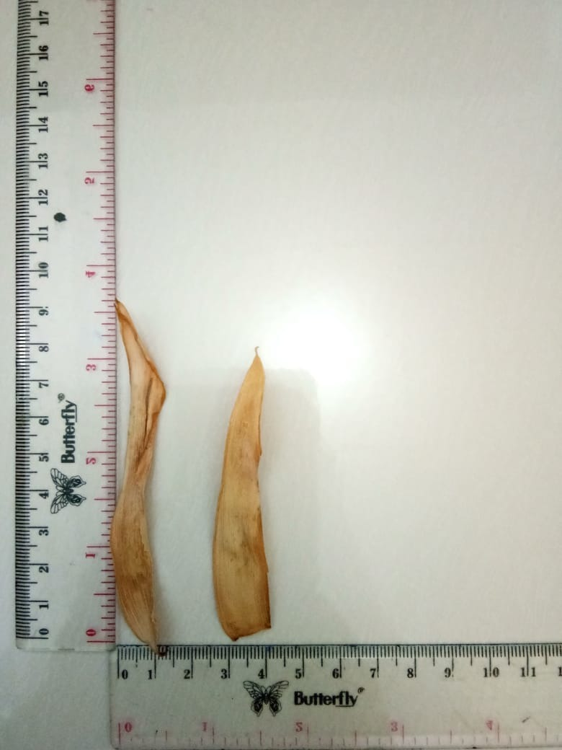
Simplisia bunga kecombrang

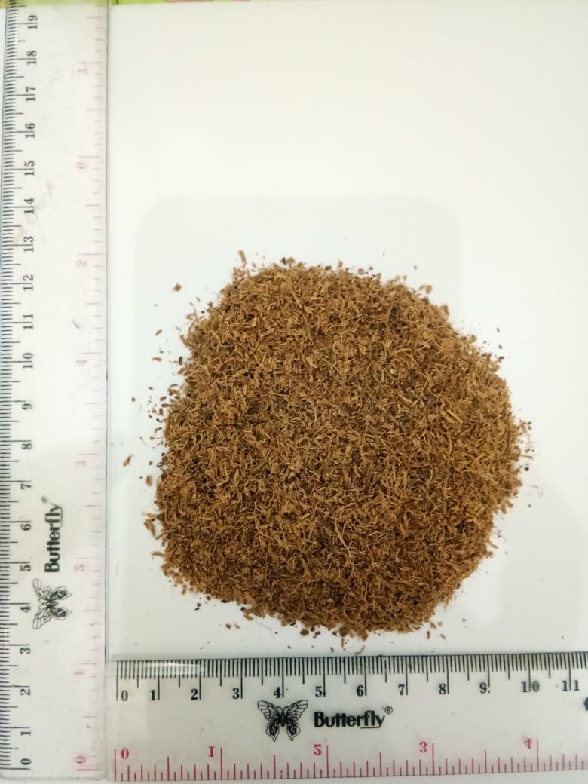
Serbuk bunga kecombrang
Lampiran 7. (Lanjutan)
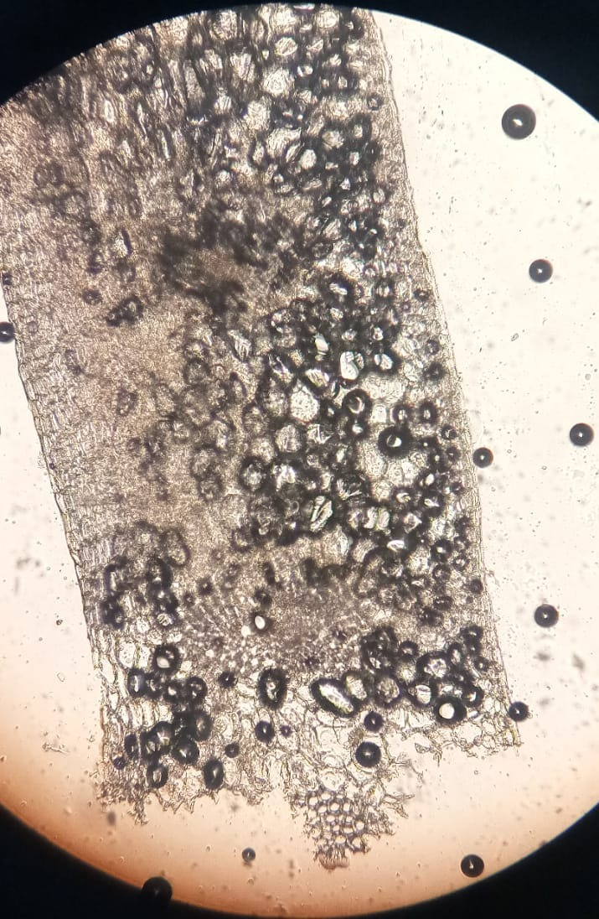

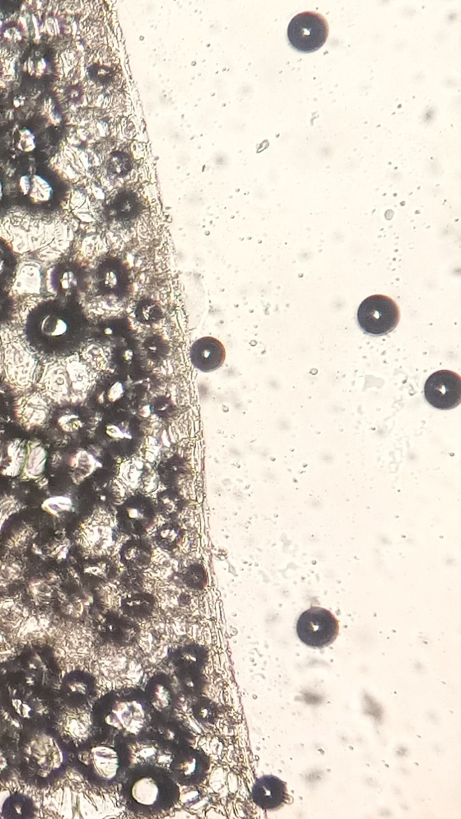
a
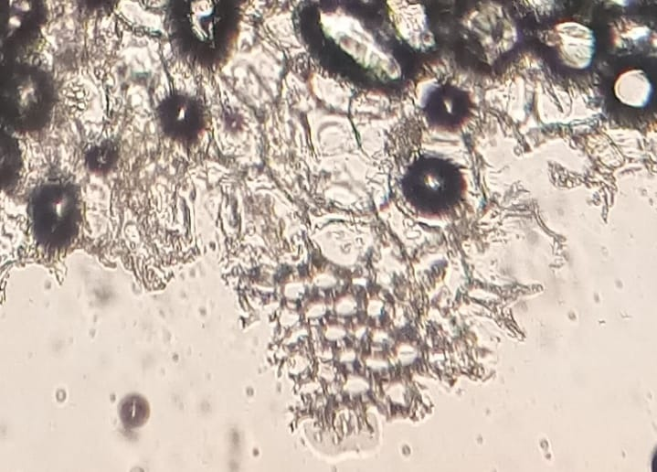
Keterangan gambar :
- Epidermis
- Kolenkim
- Ruang antar sel berisi kalsium oksalat

b
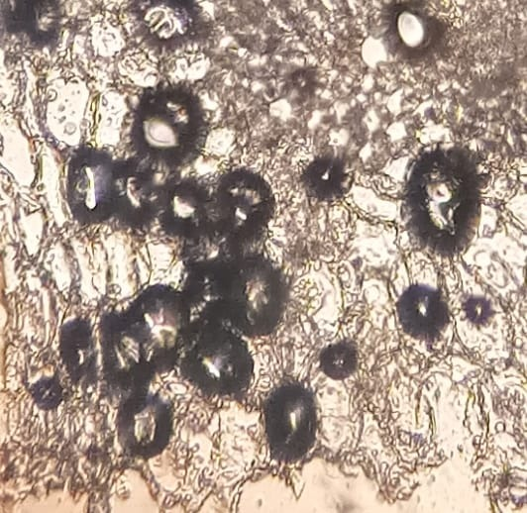
c

Lampiran 8. Tabel Konversi Dosis Hewan Percobaan
Dicari  Diketahui | Mencit 20 g | Tikus 200 g | Marmut 400 g | Kelinci 1,5 kg | Kucing 1,5 kg | Kera  4 kg | Anjing 12 kg | Manusia 70 kg
Mencit  20 g | 1,0 | 7,0 | 12,23 | 27,80 | 29,7 | 64,10 | 124,20 | 387,9
Tikus  200 g | 0,14 | 1,0 | 1,74 | 3,9 | 4,20 | 9,20 | 17,80 | 56,0
Marmut  400 g | 0,08 | 0,57 | 1,0 | 2,25 | 2,40 | 5,20 | 10,20 | 31,50
Kelinci  1,5 kg | 0,04 | 0,25 | 0,44 | 1,0 | 1,08 | 2,40 | 4,50 | 14,20
Kucing  1,5 kg | 0,03 | 0,23 | 0,41 | 0,91 | 1,0 | 2,20 | 4,10 | 13,0
Kera  4 kg | 0,016 | 0,11 | 0,19 | 0,42 | 0,43 | 0,1 | 1,9 | 6,1
Anjing  12 kg | 0,008 | 0,06 | 0,10 | 0,22 | 1,24 | 0,52 | 1,0 | 3,10
Manusia  70 kg | 0,0026 | 0,018 | 0,31 | 0,07 | 0,076 | 0,16 | 0,32 | 1,0

Lampiran 9. Tabel Volume Maksimum Sesuai Jalur Pemberian Pada Hewan
Jenis Hewan Uji | Volume Maksimum (ml) Sesuai Jalur Pemberian
 | i.v | i.m | i.p | s.c | p.o
Mencit (20-30 g) | 0,5 | 0,05 | 1,0 | 0,5-1,0 | 1,0
Tikus (200 g) | 1,0 | 0,1 | 2-5 | 2-5 | 5,0
Hamster (50 g) | - | 0,1 | 1-2 | 2-5 | 2,5
Marmut (250 g) | - | 0,25 | 2-5 | 5,0 | 10,0
Kelinci (2,5 g) | 5-10 | 0,5 | 10-20 | 5-10 | 20,0
Kucing (3 kg) | 5-10 | 1,0 | 10-20 | 5-10 | 50,0
Anjing (5 kg) | 10-20 | 5,0 | 20-50 | 10,0 | 100,0

Keterangan :
  - i.v = intravena
  - i.m = intramuscular
  - i.p = intraperitoneal
  - s.c = subcutan
  - p.o = peroral

Lampiran 10. Bagan Alir Uji Aktivitas Antipiretik Ekstrak Etanol Bunga Kecombrang Pada Tikus Putih Jantan
25 ekor tikus dibagi menjadi 5 kelompok, masing-masing kelompok terdiri dari 5 ekor tikus.
Tikus di aklimatisasi terlebih dahulu selama 14 hari

Tikus dipuasakan selama 18 jam sebelum diberi perlakuan

Berat badan tikus ditimbang dan ukur suhu awal badan tikus melalui rektal

Tikus diberikan vaksin DTP-HB-Hib secara intramuskular untuk menaikan suhu tubuh pada tikus

Suhu rektal diukur setelah 1 jam penyuntikan vaksin hingga mencapai suhu demam ≥ 38°C

Kelompok (III) EEBK dosis 200 mg/KgBB

Kelompok (I) EEBK dosis
50 mg/KgBB

Kelompok kontrol (+) suspensi Parasetamol 2%

Kelompok kontrol (-)
Na CMC 0,5 %
Kelompok (II) EEBK dosis 100 mg/KgBB

Ukur Suhu Badan Tikus setiap 30 menit selama 3 jam
Analisis Data
Lampiran 11. Dokumentasi Pengujian Antipiretik
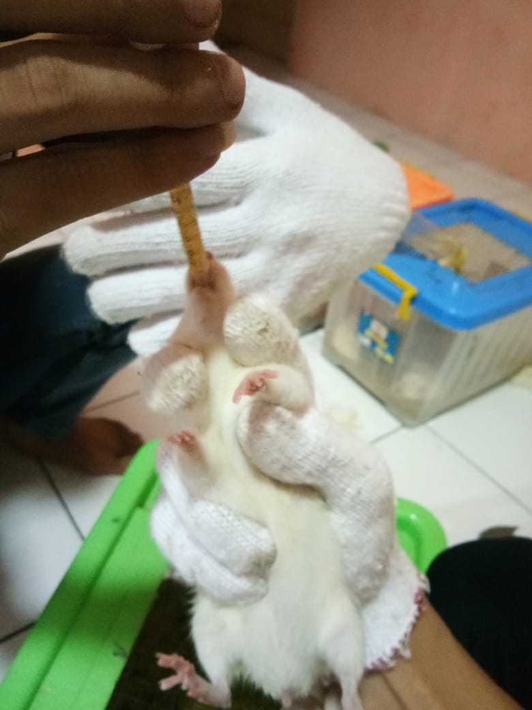
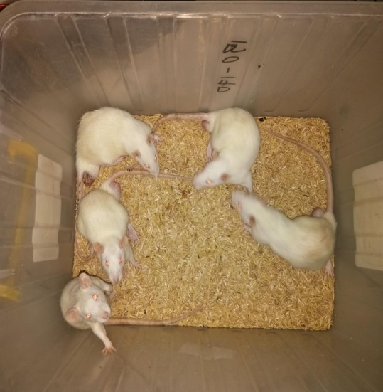
Pengelompokan tikus putih jantan
Pemberian secara oral

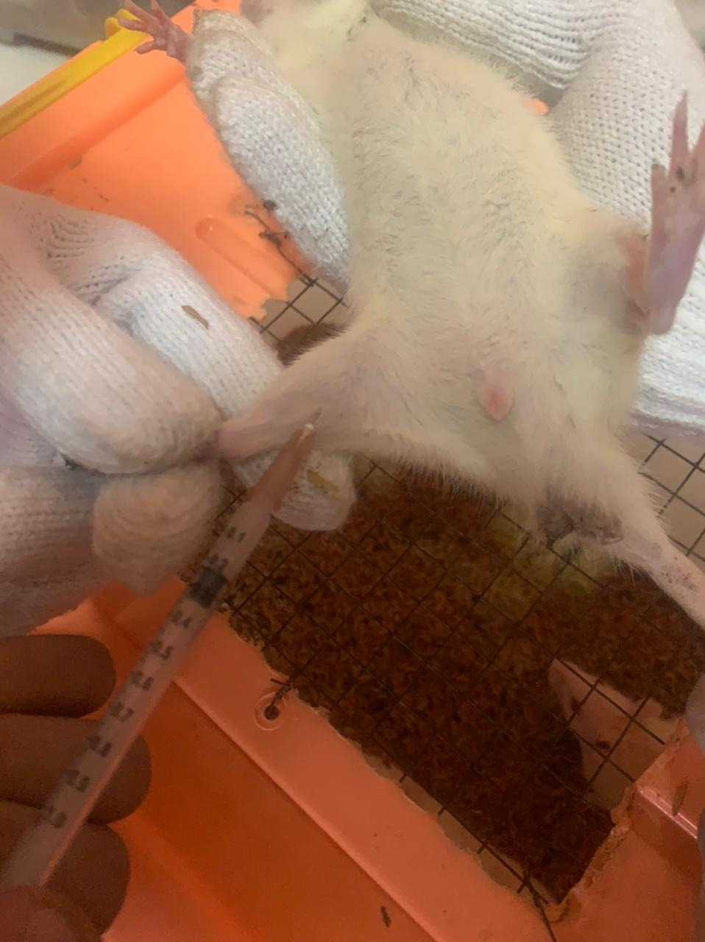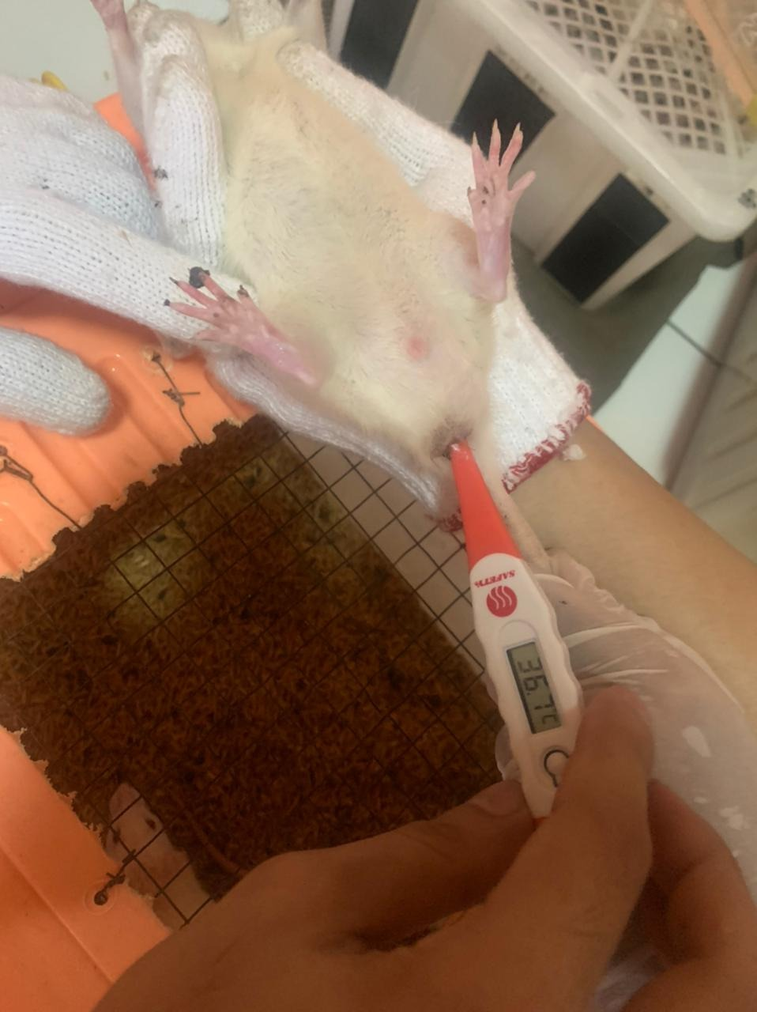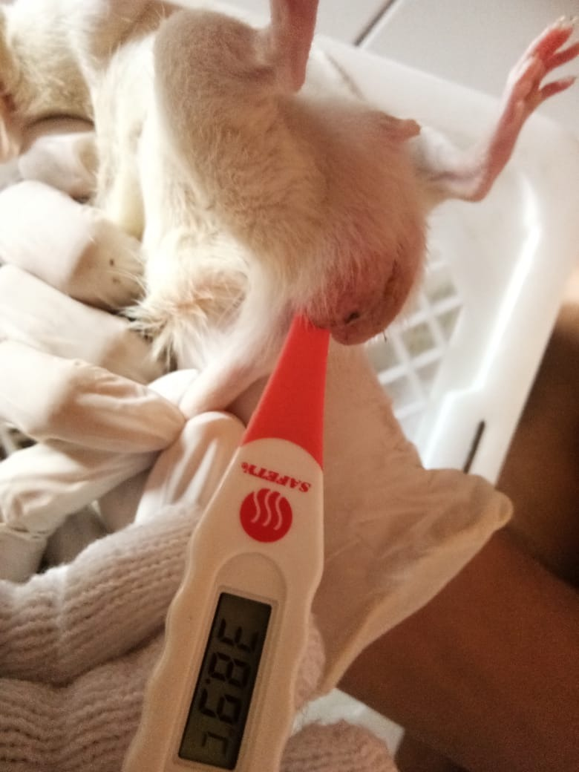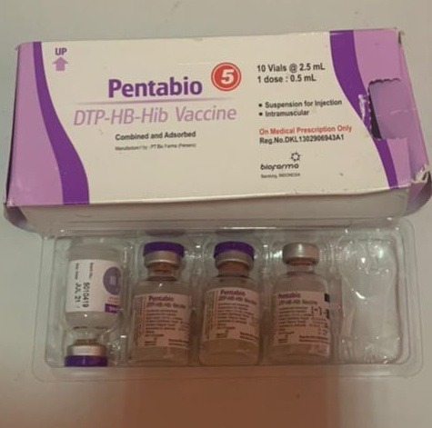
Pengukuran suhu tubuh normal pada tikus
Penyuntikan vaksin secara i.m
Vaksin DTP-HB-Hib
Pengukuran suhu demam pada tikus
Lampiran 12. Perhitungan Dosis
      - Perhitungan Dosis Suspensi Parasetamol
Dosis parasetamol untuk manusia = 500 mg/hari
= 500 mg/70 KgBB
Dosis parasetamol untuk tikus = 500 mg x 0,018
= 9 mg/200 gBB
= 45 mg/ kgBB
Konsentrasi suspensi parasetamol :
Suspensi parasetamol 2% = Jumlah parasetamol / Volume suspensi
= 2 gram / 100 ml
= 2000 mg/ 100 ml
= 20 mg / ml
Dosis untuk tikus = Dosis parasetamol x BB tikus / 1000 gram
= 45 mg/KgBB x 200g BB / 1000 gram
= 9 mg
Volume suspensi parasetamol yang diberikan :
= Dosis parasetamol untuk tikus
Konsentrasi suspensi parasetamol

= 9 mg
20 mg / ml
= 0,45 ml

Lampiran 12. ( Lanjutan )
      - Perhitungan Dosis Na CMC 0,5%
Na CMC 0,5 % = Jumlah Na CMC / Volume suspensi
= 0,5 gram / 100 ml
= 500 mg / 100 ml
= 5 mg / ml
Perhitungan Na CMC 0,5 % pada tikus dengan BB 200 gram
= 0,5 gram X 200 gram BB
100 ml
= 1 ml
      - Perhitungan Dosis EEBK 50 mg/KgBB
Konsentrasi suspensi 2% = Jumlah EEBK / Volume suspensi
= 2 gram / 100 ml
= 2000 mg / 100 ml
= 20 mg / ml
Ket : Setiap 1 ml mengandung 20 mg ekstrak etanol bunga kecombrang
Dosis EEBK untuk tikus 200 gram BB = 50 mg/KgBB
= 50 mg/1000 gram x 200 gram BB
= 10 mg
Volume EEBK yang diberikan = Dosis EEBK
Konsentrasi suspensi

= 10 mg
20 mg / ml
= 0,5 ml

      - Perhitungan Perhitungan Dosis EEBK 100 mg/KgBB
Konsentrasi suspensi 2% = Jumlah EEBK / Volume suspensi
= 2 gram / 100 ml
= 2000 mg / 100 ml
= 20 mg / ml
Dosis EEBK untuk tikus 200 gram BB = 100 mg/KgBB
= 100 mg/1000 gram x 200 gram BB
= 20 mg
Volume EEBK yang diberikan = Dosis EEBK
Konsentrasi suspensi

= 20 mg
20 mg / ml
= 1 ml
      - Perhitungan Dosis EEBK 200 mg/KgBB
Konsentrasi suspensi 2% = Jumlah EEBK / Volume suspensi
= 2 gram / 100 ml
= 2000 mg / 100 ml
= 20 mg / ml
Dosis EEBK untuk tikus 200 gram BB = 200 mg/KgBB
= 200 mg/1000 gram x 200 gram BB
= 40 mg
Volume EEBK yang diberikan = Dosis EEBK
Konsentrasi suspensi

= 40 mg
20 mg / ml
= 2 ml
Lampiran 13. Perhitungan Rendemen Ekstrak Bunga Kecombrang
Berat simplisia bunga kecombrang = 500 gram
Berat ekstrak bunga kecombrang = 32, 6 gram
% Rendemen = $\frac{Berat Ekstrak Kental}{Berat Simplisia Kering}$ x 100%
= $\frac{32, 6 gram}{500 gram }$ x 100%
= 6,52 %

Lampiran 14. Bagan Alir Karakterisasi Simplisia
- Penetapan Kadar Air (Metode Azeotrop)
Toluen : Air
(100 : 1)
Dimasukkan dalam labu alas bulat
Dipasang dan didestilasi selama 2 jam
Didinginkan selama 30 menit, sampai toluen dan air memisah
Dihitung Volume air dalam tabung penerima
Toluen : Air
(100 : 1)
Dimasukkan 5 gram serbuk simplisia dalam labu alas bulat berisi toluen yang telah jenuh
Dipanaskan selama 15 menit sampai toluen mendidik diatur kecepatan tetesan 2 tetes perdetik
Dibiarkan sampai semua air terdestilasi
Dibiarkan tabung penerima dingin sampai air dan toluen memisah sempurna
Dihitung volume air dalam tabung penerima
Volume air akhir

Lampiran 14. (Lanjutan)
- Penetapan Kadar Sari larut dalam air
Serbuk Simplisia
Ditimbang 5 gram
Dimaserasi dengan 100 ml kloroform (2,5 ml kloroform dalam 1000 ml aquadest) selama 24 jam sambil sesekali dikocok
Disaring
Filtrat
Diambil 20 ml diuapkan dalam cawan porselen yang telah ditara pada suhu 105ºC sampai bobot tetap
Ditimbang
Berat Sari

- Penetapan Kadar Sari larut dalam etanol
Serbuk Simplisia
Ditimbang 5 gram
Dimaserasi dengan 100 ml etanol selama 24 jam sambil sesekali dikocok
Disaring
Filtrat
Diambil 20 ml diuapkan dalam cawan porselen yang telah ditara pada suhu 105ºC sampai bobot tetap
Ditimbang
Berat Sari

Lampiran 14. (Lanjutan)
- Penetapan Kadar Abu Total
Serbuk Simplisia
Ditimbang 2 gram
Dimasukkan dalam kurs porselen dalam tanur dipijar dan ditara
Dimasukkan kurs porselen dalam tanur dipijar pada suhu 600ºC selama 3 jam
Dikeluarkan didinginkan
Ditimbang
Berat Abu

- Penetapan Kadar Abu Tidak Larut Asam
Abu
Dimasukkan dalam cawan
Ditambah 25 ml HCL encer
Didihkan selama 15 menit
Disaring dengan kertas saring bebas abu
Dipijar dalam tanur
Berat Abu Tidak Larut Asam
Didinginkan dan ditimbang

Lampiran 15. Perhitungan Karakterisasi Bunga Kecombrang
Perhitungan Hasil Penetapan Kadar Air
$$Kadar air=\frac{Volume akhir air-Volume awal air}{Berat sample mula-mula (g)}x100\%$$

- Kadar Air Bunga Kecombrang
Pegulangan 1.
Volume awal air (V₀) = 1,8 ml
Volume akhir air (V₁) = 2 ml
Berat sampel = 5 gram
Kadar air = $\frac{V1-V0}{Berat sampel}x 100\%$
= $\frac{2 ml – 1,8 ml}{5 gram}x 100\%$
= 4 %
Pengulangan 2.
Volume awal air (V₀) = 2 ml
Volume akhir air (V₁) = 2,1 ml
Berat sampel = 5 gram
Kadar air = $\frac{V1-V0}{Berat sampel}x 100\%$
= $\frac{2,1 ml – 2 ml}{5 gram}x 100\%$
= 4 %
Pengulangan 3.
Volume awal air (V₀) = 1,8 ml
Volume akhir air (V₁) = 2,1 ml
Berat sampel = 5 gram
Kadar air = $\frac{V1-V0}{Berat sampel}x 100\%$
= $\frac{2,1 ml – 1,8 ml}{5 gram}x 100\%$
= 6 %
Rata-rata kadar air = $\frac{4\% + 4\%+6\%}{3}$
= 4,66 %
Lampiran 15. ( Lanjutan)
Perhitungan Hasil Penetapan Kadar Sari Larut Air
$$Kadar sari larut air=\frac{Berat sari setelah dikeringkan \left(g\right) x 100 ml }{Berat sample mula-mula \left(g\right)x 20 ml}x100\%$$

- Penenetapan Kadar Sari Larut Air Bunga Kecombrang
Pengulangan 1.
Berat cawan kosong = 118,2331 gram
Berat cawan + sari = 118,4401 gram
Berat sari kering = (Berat cawan + sari) – (Berat cawan kosong)
= 118,4401 gram – 118,2331 gram
= 0,207 gram
Kadar sari larut air = $\frac{0,207 gram x 100 ml}{5 gram x 20 ml}x 100\%$
= 20,7%
Pengulangan 2.
Berat cawan kosong = 131,9703 gram
Berat cawan + sari = 131,1596 gram
Berat sari kering = (Berat cawan + sari) – (Berat cawan kosong)
= 131,1596 gram – 131, 9703 gram
= 0,1893 gram
Kadar sari larut air = $\frac{0,1893 gram x 100 ml}{5 gram x 20 ml}x 100\%$
= 18,93 %
Pengulangan 3.
Berat cawan kosong = 121,8034 gram
Berat cawan + sari = 121,9501 gram
Berat sari kering = (Berat cawan + sari) – (Berat cawan kosong)
= 121,9501 gram – 121,8034 gram
= 0,1467 gram
Kadar sari larut air = $\frac{0,1467 gram x 100 ml}{5 gram x 20 ml}x 100\%$
= 14,67 %
Rata-rata kadar sari larut air = $\frac{20,7 \% + 18,93 \% + 14,67\%}{3}$
= 18,1 %
Lampiran 15. ( Lanjutan)
Perhitungan Hasil Penetapan Kadar Sari Larut Etanol
$$Kadar sari larut etanol=\frac{Berat sari setelah dikeringkan \left(g\right) x 100 ml }{Berat sample mula-mula \left(g\right)x 20 ml}x100\%$$

- Penenetapan Kadar Sari Larut Etanol Bunga Kecombrang
Pengulangan 1.
Berat cawan kosong = 118,2321 gram
Berat cawan + sari = 118,3353 gram
Berat sari kering = (Berat cawan + sari) – (Berat cawan kosong)
= 118,3353 gram – 118,2331 gram
= 0,1022 gram
Kadar sari larut etanol = $\frac{0,1022 gram x 100 ml}{5 gram x 20 ml}x 100\%$
= 10,22 %
Pengulangan 2.
Berat cawan kosong = 131,9703 gram
Berat cawan + sari = 132, 0789 gram
Berat sari kering = (Berat cawan + sari) – (Berat cawan kosong)
= 132, 0789 gram – 131,9703 gram
= 0,1086 gram
Kadar sari larut etanol = $\frac{0,1086 gram x 100 ml}{5 gram x 20 ml}x 100\%$
= 10,86 %
Pengulangan 3.
Berat cawan kosong = 121,8034 gram
Berat cawan + sari = 122, 0943 gram
Berat sari kering = (Berat cawan + sari) – (Berat cawan kosong)
= 122, 0943 gram – 121, 8034 gram
= 0,2909 gram
Kadar sari larut etanol = $\frac{0,2909 gram x 100 ml}{5 gram x 20 ml}x 100\%$
= 29,09 %
Rata-rata kadar sari larut etanol = $\frac{10,22 \% +10,86 \%+29,09 \%}{3}$
= 16,72 %

Lampiran 15. (Lanjutan)
Perhitungan Hasil Penetapan Kadar Abu Total
$$Kadar Abu Total=\frac{Berat abu yang diperoleh \left(g\right) }{Berat sample mula-mula (g)}x100\%$$

- Penenetapan Kadar Abu Total Bunga Kecombrang
Pengulangan 1.
Berat krus kosong = 63,6497 gram
Berat krus + abu = 63,8523 gram
Berat abu = (Berat krus + abu) – (Berat krus kosong)
= 63,8523 gram – 63,6497 gram
= 0,2026 gram
Kadar Abu total = $\frac{0,2026 gram }{2 gram}x 100\%$
= 10,13 %
Pengulangan 2.
Berat krus kosong = 63,6650 gram
Berat krus + abu = 63,7530 gram
Berat abu = (Berat krus + abu) – (Berat krus kosong)
= 63,7530 gram – 63,6650 gram
= 0,088 gram
Kadar Abu total = $\frac{0,088 gram }{2 gram}x 100\%$
= 4,4 %
Pengulangan 3.
Berat krus kosong = 56,7812 gram
Berat krus + abu = 56,9410 gram
Berat abu = (Berat krus + abu) – (Berat krus kosong)
= 56,9410 gram – 56,7812 gram
= 0,1598 gram
Kadar Abu total = $\frac{0,1598 gram }{2 gram}x 100\%$
= 7,99 %
Rata-rata Kadar Abu total = $\frac{10,13 \% + 4,4 \%+7,99}{3}$
= 7,50 %
Lampiran 15. ( Lanjutan )
Perhitungan Hasil Penetapan Kadar Abu Tidak Larut Asam
$$Kadar Abu Total=\frac{Berat abu sisa dipijar \left(g\right) }{Berat sample abu mula-mula (g)}x100\%$$

- Penenetapan Kadar Abu Total Bunga Kecombrang
Pengulangan 1.
Berat abu mula-mula = 2 gram
Berat krus kosong = 63,6497 gram
Berat krus + abu tidak larut asam = 63,6697 gram
Berat abu = (Berat krus + abu tidak larut asam) – (Berat krus kosong)
= 63,6697 gram – 63,6497 gram
= 0,02 gram
Kadar Abu tidak larut asam = $\frac{0,02 gram }{ 2 gram}x 100\%$
= 1 %
Pengulangan 2.
Berat abu mula-mula = 2 gram
Berat krus kosong = 64,6650 gram
Berat krus + abu tidak larut asam = 63,6880 gram
Berat abu = (Berat krus + abu tidak larut asam) – (Berat krus kosong)
= 63,6880 gram – 63,6650 gram
= 0,023 gram
Kadar Abu tidak larut asam = $\frac{0,023 gram }{ 2 gram}x 100\%$
= 1,15 %
Pengulangan 3.
Berat abu mula-mula = 2 gram
Berat krus kosong = 58,8010 gram
Berat krus + abu tidak larut asam = 58,8320 gram
Berat abu = (Berat krus + abu tidak larut asam) – (Berat krus kosong)
= 58,8010 gram – 58,8320 gram
= 0,031 gram
Kadar Abu tidak larut asam = $\frac{0,031 gram }{ 2 gram}x 100\%$
= 1,55 %
Rata-rata kadar Abu total tidak larut asam = $\frac{1\% +1,15 \% +1,55 \% }{3}$
= 1,23 %

Lampiran 16. Hasil Uji Skrining Fitokimia Bunga Kecombrang (Etlingera elatior (Jack) R. M. Sm)
No | Golongan senyawa | Gambar |  | Hasil Uji | Keterangan
 |  | Serbuk | Ekstrak
1. | Alkaloid | 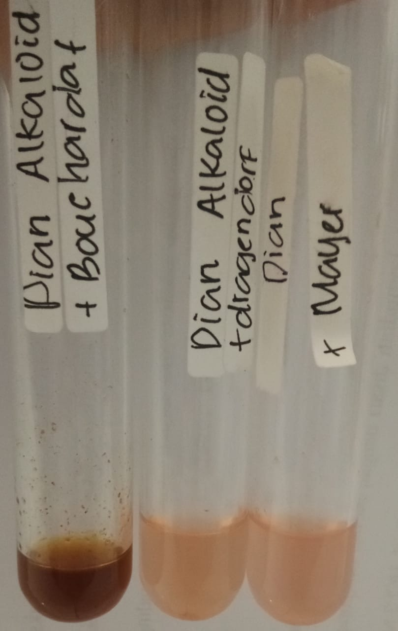 | 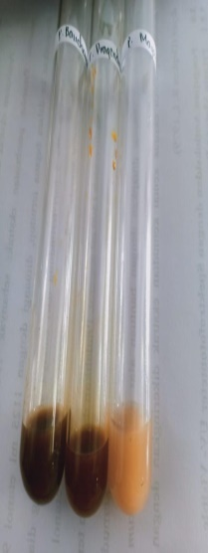 | - | - Mayer  Tidak terbentuk endapan putih  (-)  - Dragendrof  Tidak Terbentuk endapan merah – jingga (-)  - Buochardat  Tidak Terbentuk endapan coklat (-)  (Depkes RI, 1995)
2. | Flavonoid | 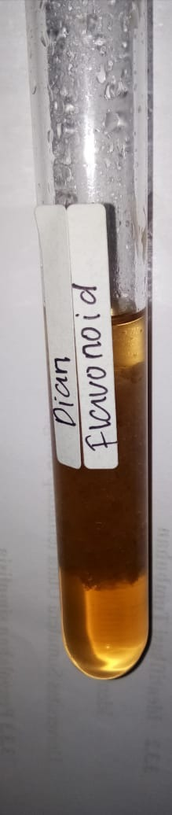 | 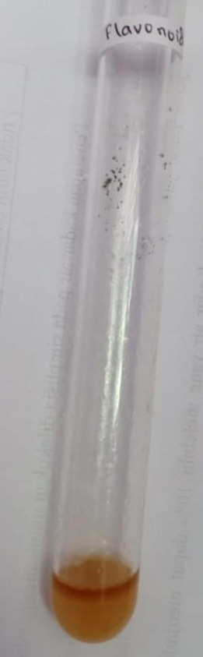 | + | Terbentuk lapisan jingga-merah pada lapisan alkohol  (Franswort, 1966).

3. | Tanin |  |  | 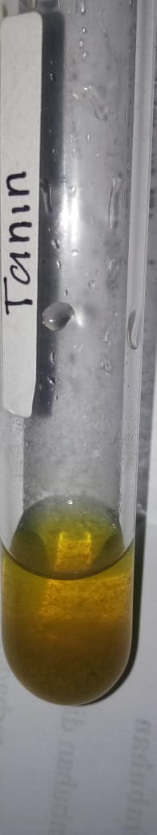 |  | - | Tidak Terbentuk Larutan biru pekat (Franswort, 1966).
4. | saponin | 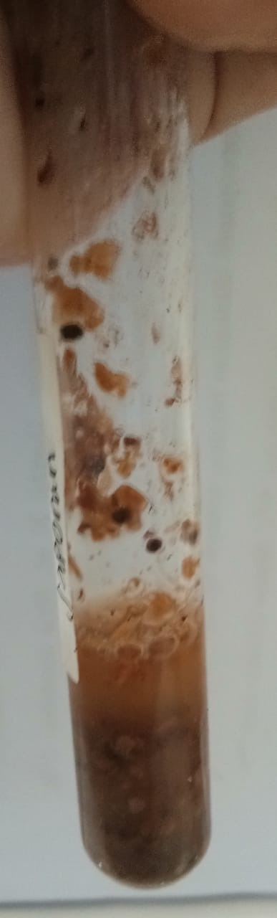 |  | 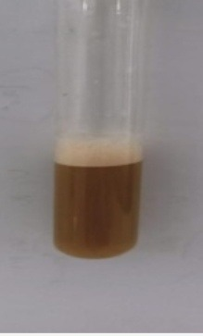 |  | + | Terbentuk busa yang stabil  (Depkes RI, 1995).
5. | Glikosida |  |  |  | + |  | Terbentuk cincin ungu pada lapisan atas dan bawah  (Depkes RI, 1995).
6. | Steroid/Triterpenoid | 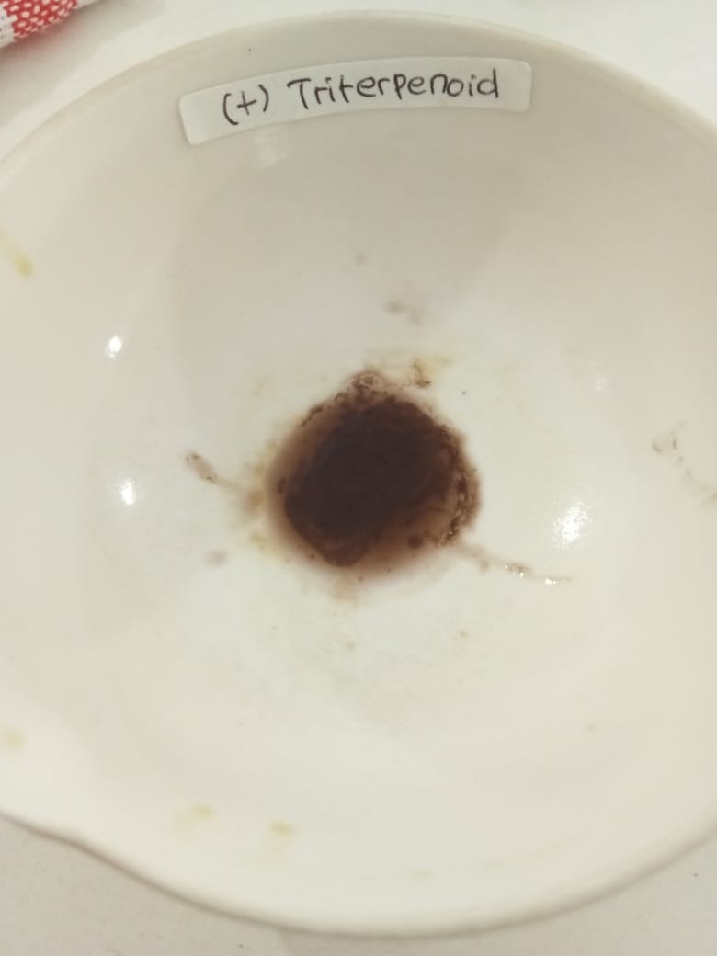 | 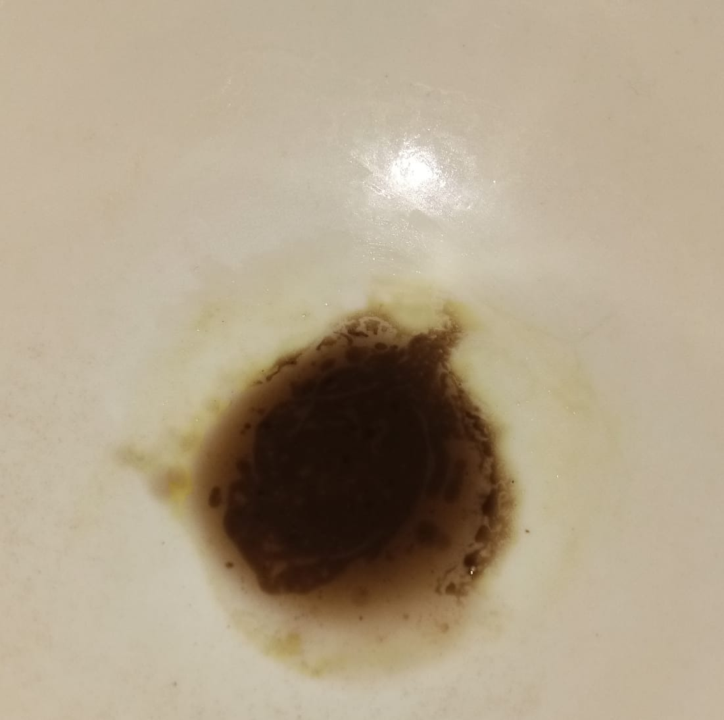 |  | + |  | Terbentuk warna ungu sampai merah (triterpenoid)  (Depkes RI, 1995).

Lampiran 17. Hasil Penurunan Suhu Tubuh Tikus Putih Jantan Pada Kelompok Uji
Kelompok | Hewan | Suhu Tubuh Tikus Pada Menit Ke-
 |  | t₀* | T* | t30 | t60 | t90 | t120 | t150 | t180
Kontrol Negatif | 1 | 37.0 | 38.9 | 39.0 | 38.8 | 39.2 | 39.1 | 39 | 38.9
 | 2 | 36.6 | 38.4 | 38.6 | 38.8 | 39.1 | 38.8 | 38.7 | 38.6
 | 3 | 36.8 | 38.2 | 38.4 | 38.6 | 39.0 | 38.8 | 38.6 | 38.4
 | 4 | 37.2 | 38.8 | 39.0 | 39.3 | 39.2 | 39.0 | 38.6 | 38.1
 | 5 | 37.5 | 39.0 | 39.3 | 39.4 | 39.1 | 38.8 | 38.4 | 38.3
 | Rata-rata | 37.0 | 38.7 | 38.9 | 39.0 | 39.1 | 38.9 | 38.7 | 38.5
kontrol Positif | 1 | 37.1 | 38.2 | 38 | 37.6 | 37.4 | 37.6 | 37.3 | 36.5
 | 2 | 37.0 | 38.6 | 38.1 | 37.8 | 37.5 | 37.3 | 37.0 | 36.8
 | 3 | 37.2 | 38.4 | 38 | 38.3 | 37.8 | 37.4 | 37.1 | 37.0
 | 4 | 36.8 | 38.0 | 37.8 | 37.5 | 37.3 | 37.1 | 37.0 | 36.6
 | 5 | 36.0 | 38.1 | 37.9 | 37.6 | 37.0 | 36.8 | 36.6 | 36.3
 | Rata-rata | 36.8 | 38.3 | 38.0 | 37.8 | 37.4 | 37.2 | 37.0 | 36.6
EEBK 50mg/  KgBB | 1 | 36.6 | 38.2 | 38.1 | 38.0 | 37.4 | 37.4 | 37.4 | 37.0
 | 2 | 36.8 | 39.2 | 38.8 | 38. 9 | 38.7 | 38.5 | 38.3 | 38.1
 | 3 | 36.4 | 38.7 | 38.7 | 38.6 | 38.3 | 38.2 | 37.9 | 37.8
 | 4 | 36.1 | 39.1 | 39.0 | 39.0 | 38.7 | 38.6 | 38.3 | 38.2
 | 5 | 37.1 | 38.5 | 38.5 | 38.4 | 38.3 | 38.1 | 37.8 | 37.7
 | Rata-rata | 36.6 | 38.7 | 38.6 | 38.5 | 38.3 | 38.2 | 37.9 | 37.8
EEBK 100mg/  KgBB | 1 | 37.5 | 38.7 | 38.5 | 38.3 | 38.0 | 37.8 | 37.5 | 37.1
 | 2 | 37.0 | 38.9 | 38.9 | 38.8 | 38.7 | 38.5 | 38.2 | 37.8
 | 3 | 36.8 | 38.0 | 37.8 | 37.6 | 37.5 | 37.3 | 37.1 | 37.2
 | 4 | 37.0 | 38.5 | 38.3 | 38.2 | 38.0 | 37.7 | 37.4 | 37.2
 | 5 | 36.4 | 38.9 | 38.7 | 38.5 | 38.3 | 37.9 | 37.6 | 37.5
 | Rata-rata | 36.9 | 38.6 | 38.4 | 38.3 | 38.1 | 37.8 | 37.6 | 37.4
EEBK 200mg/  KgBB | 1 | 36.1 | 38.6 | 38.3 | 38.1 | 37.8 | 37.4 | 37.3 | 37.0
 | 2 | 37.5 | 39.2 | 38.9 | 38.5 | 38.3 | 38.0 | 37.8 | 37.4
 | 3 | 37.3 | 38.3 | 37.9 | 38.0 | 37.9 | 37.6 | 37.5 | 37.3
 | 4 | 36.5 | 38.4 | 38.0 | 38.2 | 37.8 | 37.5 | 37.3 | 37.0
 | 5 | 36.7 | 39 | 38.6 | 38.4 | 38.0 | 37.7 | 37.5 | 37.2
 | Rata-rata | 36.8 | 38.7 | 38.3 | 38.2 | 38.0 | 37.6 | 37.5 | 37.2
Keterangan :
*t₀ = Suhu Awal Tikus
*T = Suhu Demam Tikus (1 jam setelah diinduksi vaksin DTP-HB-Hib)

Lampiran 18. Hasil Uji Data Statistik
Uji Distribusi Normalitas Terhadap Penurunan Suhu Rektal Masing-Masing Kelompok.
Tujuan : Untuk mengetahui distribusi normalitas penurunan suhu rektal -masing-masing kelompok
Hipotesis :
Ho : Data penurunan suhu rektal terdistribusi normal
Ha : Data penurunan suhu rektal tidak terdistribusi normal
Kriteria Uji :
Ho ditolak bila Sig <0,05
Ho diterima bila Sig >0,05
Hasil :
Tests of Normality

 | Kelompok | Kolmogorov-Smirnovª |  |  | Shapiro-Wilk
 |  | Statistic | df | Sig. | Statistic | df | Sig.
t0 | Kontrol Negatif | ,136 | 5 | ,200* | ,989 | 5 | ,976
 | kontrol Positif | ,283 | 5 | ,200* | ,816 | 5 | ,108
 | EEBK 50mg/KgBB | ,105 | 5 | ,200* | ,999 | 5 | 1,000
 | EEBK 100mg/KgBB | ,240 | 5 | ,200* | ,961 | 5 | ,816
 | EEBK 200mg/KgBB | ,198 | 5 | ,200* | ,951 | 5 | ,742
T | Kontrol Negatif | ,258 | 5 | ,200* | ,902 | 5 | ,419
 | kontrol Positif | ,198 | 5 | ,200* | ,957 | 5 | ,787
 | EEBK 50mg/KgBB | ,207 | 5 | ,200* | ,947 | 5 | ,715
 | EEBK 100mg/KgBB | ,211 | 5 | ,200* | ,862 | 5 | ,235
 | EEBK 200mg/KgBB | ,202 | 5 | ,200* | ,920 | 5 | ,530
t30 | Kontrol Negatif | ,252 | 5 | ,200* | ,943 | 5 | ,685
 | kontrol Positif | ,237 | 5 | ,200* | ,961 | 5 | ,814
 | EEBK 50mg/KgBB | ,192 | 5 | ,200* | ,961 | 5 | ,814
 | EEBK 100mg/KgBB | ,170 | 5 | ,200* | ,962 | 5 | ,822
 | EEBK 200mg/KgBB | ,193 | 5 | ,200* | ,947 | 5 | ,715
t60 | Kontrol Negatif | ,297 | 5 | ,172 | ,872 | 5 | ,275
 | kontrol Positif | ,291 | 5 | ,193 | ,816 | 5 | ,110
 | EEBK 50mg/KgBB | ,187 | 5 | ,200* | ,952 | 5 | ,750
 | EEBK 100mg/KgBB | ,228 | 5 | ,200* | ,960 | 5 | ,811
 | EEBK 200mg/KgBB | ,180 | 5 | ,200* | ,952 | 5 | ,754
t90 | Kontrol Negatif | ,231 | 5 | ,200* | ,881 | 5 | ,314
 | kontrol Positif | ,166 | 5 | ,200* | ,989 | 5 | ,977
 | EEBK 50mg/KgBB | ,315 | 5 | ,117 | ,818 | 5 | ,113
 | EEBK 100mg/KgBB | ,210 | 5 | ,200* | ,970 | 5 | ,877
 | EEBK 200mg/KgBB | ,224 | 5 | ,200* | ,842 | 5 | ,171
t120 | Kontrol Negatif | ,360 | 5 | ,033 | ,767 | 5 | ,042
 | kontrol Positif | ,178 | 5 | ,200* | ,981 | 5 | ,940
 | EEBK 50mg/KgBB | ,249 | 5 | ,200* | ,896 | 5 | ,389
 | EEBK 100mg/KgBB | ,245 | 5 | ,200* | ,951 | 5 | ,747
 | EEBK 200mg/KgBB | ,197 | 5 | ,200* | ,943 | 5 | ,685
t150 | Kontrol Negatif | ,228 | 5 | ,200* | ,932 | 5 | ,607
 | kontrol Positif | ,300 | 5 | ,161 | ,921 | 5 | ,537
 | EEBK 50mg/KgBB | ,229 | 5 | ,200* | ,903 | 5 | ,429
 | EEBK 100mg/KgBB | ,261 | 5 | ,200* | ,932 | 5 | ,608
 | EEBK 200mg/KgBB | ,261 | 5 | ,200* | ,862 | 5 | ,236
t180 | Kontrol Negatif | ,178 | 5 | ,200* | ,981 | 5 | ,940
 | kontrol Positif | ,159 | 5 | ,200* | ,990 | 5 | ,980
 | EEBK 50mg/KgBB | ,249 | 5 | ,200* | ,896 | 5 | ,389
 | EEBK 100mg/KgBB | ,311 | 5 | ,129 | ,871 | 5 | ,269
 | EEBK 200mg/KgBB | ,243 | 5 | ,200* | ,894 | 5 | ,377
*. This is a lower bound of the true significance.
a. Lilliefors Significance Correction

Keterangan: df = degree of freedom/derajat kebebasan adalah jumlah total pengamatan dalam sampel (N) dikurangi banyak kendali (linier) bebas
Sig = Signifikan (p-value) adalah tingkat kepercayaan
Kesimpulan : Ho diterima artinya uji normalitas penurunan suhu rektal seluruh kelompok hewan uji terdistribusi normal

Lampiran 18. (Lanjutan)

Uji Homogenitas Varians Terhadap Penurunan Suhu rektal Masing-masing Kelompok.
Tujuan : Untuk mengetahui distribusi normalitas penurunan suhu rektal masing- masing kelompok
Hipotesis :
Ho : Data penurunan suhu rektal terdistribusi homogen
Ha : Data penurunan suhu rektal tidak terdistribusi homogen
Kriteria Uji :
Ho ditolak bila Sig <0,05
Ho diterima bila Sig >0,05
Hasil :
Test of Homogeneity of Variances
 | Levene Statistic | df1 | df2 | Sig.
t0 | ,581 | 4 | 20 | ,680
T | ,568 | 4 | 20 | ,689
t30 | 1,490 | 4 | 20 | ,243
t60 | ,490 | 4 | 20 | ,743
t90 | 1,447 | 4 | 20 | ,255
t120 | ,827 | 4 | 20 | ,524
t150 | ,699 | 4 | 20 | ,602
t180 | ,705 | 4 | 20 | ,598
Kesimpulan : Ho diterima artinya data bervariasi homogen

Lampiran 18. (Lanjutan)

Uji Analisis Varians Satu Arah One Way ANOVA Masing-Masing Kelompok Perlakuan Terhadap Penurunan Suhu Tubuh Rektal Tikus
Tujuan : Untuk mengetahui ada atau tidaknya perbedaan yang bermakna terhadap penurunan suhu tubuh rektal tikus antar kelompok
Hipotesis :
Ho : Data penurunan suhu rektal tikus antar kelompok perlakuan tidak berbeda secara bermakna
Ha : Data penurunan suhu rektal antar kelompok perlakuan berbeda secara bermakna
Kriteria Uji :
Ho ditolak bila Sig <0,05
Ho diterima bila Sig >0,05
Hasil :
ANOVA

 |  | Sum of Squares | df | Mean Square | F | Sig.
t0 | Between Groups | ,504 | 4 | ,126 | ,637 | ,642
 | Within Groups | 3,956 | 20 | ,198
 | Total | 4,460 | 24
T | Between Groups | ,742 | 4 | ,186 | 1,452 | ,254
 | Within Groups | 2,556 | 20 | ,128
 | Total | 3,298 | 24
t30 | Between Groups | 2,246 | 4 | ,561 | 4,609 | ,008
 | Within Groups | 2,436 | 20 | ,122
 | Total | 4,682 | 24
t60 | Between Groups | 4,066 | 4 | 1,017 | 8,107 | ,000
 | Within Groups | 2,508 | 20 | ,125
 | Total | 6,574 | 24
t90 | Between Groups | 7,782 | 4 | 1,946 | 15,895 | ,000
 | Within Groups | 2,448 | 20 | ,122
 | Total | 10,230 | 24
t120 | Between Groups | 7,794 | 4 | 1,948 | 16,884 | ,000
 | Within Groups | 2,308 | 20 | ,115
 | Total | 10,102 | 24
t150 | Between Groups | 7,666 | 4 | 1,917 | 20,787 | ,000
 | Within Groups | 1,844 | 20 | ,092
 | Total | 9,510 | 24
t180 | Between Groups | 9,244 | 4 | 2,311 | 22,927 | ,000
 | Within Groups | 2,016 | 20 | ,101
 | Total | 11,260 | 24
Kesimpulan : Ho ditolak, artinya penurunan suhu tubuh antar kelompok perlakuan berbeda secara bermakna

Lampiran 18. (Lanjutan)

Hasil Uji Tukey HSD antar kelompok perlakuan
Tujuan : Untuk mengetahui pada kelompok mana terdapat perbedaan penurunan suhu tubuh yang bermakna atau signifikan
Hipotesis :
Ho : Data penurunan suhu rektal tikus antar kelompok perlakuan tidak berbeda secara bermakna
Ha : Data penurunan suhu rektal antar kelompok perlakuan berbeda secara bermakna
Kriteria Uji :
Ho ditolak bila Sig <0,05
Ho diterima bila Sig >0,05
Hasil :

Demam
Tukey HSDª
Kelompok | N | Subset for alpha = 0.05
 |  | 1
kontrol Positif | 5 | 38,260
EEBK 100mg/KgBB | 5 | 38,600
Kontrol Negatif | 5 | 38,660
EEBK 200mg/KgBB | 5 | 38,700
EEBK 50mg/KgBB | 5 | 38,740
Sig. |  | ,249
Means for groups in homogeneous subsets are displayed.
a. Uses Harmonic Mean Sample Size = 5,000.

Menit ke-30
Tukey HSDª
Kelompok | N | Subset for alpha = 0.05
 |  | 1 | 2
kontrol Positif | 5 | 37,960
EEBK 200mg/KgBB | 5 | 38,340 | 38,340
EEBK 100mg/KgBB | 5 | 38,440 | 38,440
EEBK 50mg/KgBB | 5 | 38,620 | 38,620
Kontrol Negatif | 5 |  | 38,860
Sig. |  | ,050 | ,169
Means for groups in homogeneous subsets are displayed.
a. Uses Harmonic Mean Sample Size = 5,000.

Menit ke-60
Tukey HSDª
Kelompok | N | Subset for alpha = 0.05
 |  | 1 | 2 | 3
kontrol Positif | 5 | 37,760
EEBK 200mg/KgBB | 5 | 38,240 | 38,240
EEBK 100mg/KgBB | 5 | 38,280 | 38,280
EEBK 50mg/KgBB | 5 |  | 38,580 | 38,580
Kontrol Negatif | 5 |  |  | 38,980
Sig. |  | ,179 | ,563 | ,408
Means for groups in homogeneous subsets are displayed.
a. Uses Harmonic Mean Sample Size = 5,000.

Menit ke-90
Tukey HSDª
Kelompok | N | Subset for alpha = 0.05
 |  | 1 |  | 2 | 3
kontrol Positif | 5 | 37,400
EEBK 200mg/KgBB | 5 | 37,960 |  | 37,960
EEBK 100mg/KgBB | 5 |  |  | 38,100
EEBK 50mg/KgBB | 5 |  |  | 38,280
Kontrol Negatif | 5 |  |  |  | 39,120
Sig. |  | ,123 |  | ,607 | 1,000
Means for groups in homogeneous subsets are displayed.
a. Uses Harmonic Mean Sample Size = 5,000.
Menit ke-120

Tukey HSDa
Kelompok | N | Subset for alpha = 0.05
 |  | 1 | 2 |  | 3
kontrol Positif | 5 | 37,240
EEBK 200mg/KgBB | 5 | 37,640 | 37,640
EEBK 100mg/KgBB | 5 | 37,840 | 37,840
EEBK 50mg/KgBB | 5 |  | 38,160
Kontrol Negatif | 5 |  |  |  | 38,900
Sig. |  | ,075 | ,151 |  | 1,000
Means for groups in homogeneous subsets are displayed.
a. Uses Harmonic Mean Sample Size = 5,000.

Menit ke-150
Tukey HSDª
Kelompok | N | Subset for alpha = 0.05
 |  | 1 | 2 | 3
kontrol Positif | 5 | 37,000
EEBK 200mg/KgBB | 5 | 37,480 | 37,480
EEBK 100mg/KgBB | 5 | 37,560 | 37,560
EEBK 50mg/KgBB | 5 |  | 37,940
Kontrol Negatif | 5 |  |  | 38,660
Sig. |  | ,058 | ,157 | 1,000
Means for groups in homogeneous subsets are displayed.
a. Uses Harmonic Mean Sample Size = 5,000.

Menit ke-180
Tukey HSDª
Kelompok | N | Subset for alpha = 0.05
 |  | 1 | 2 | 3
kontrol Positif | 5 | 36,640
EEBK 200mg/KgBB | 5 | 37,180 | 37,180
EEBK 100mg/KgBB | 5 |  | 37,360
EEBK 50mg/KgBB | 5 |  | 37,760
Kontrol Negatif | 5 |  |  | 38,460
Sig. |  | ,091 | ,062 | 1,000
Means for groups in homogeneous subsets are displayed.
a. Uses Harmonic Mean Sample Size = 5,000.

