ACKNOWLEDGEMENT
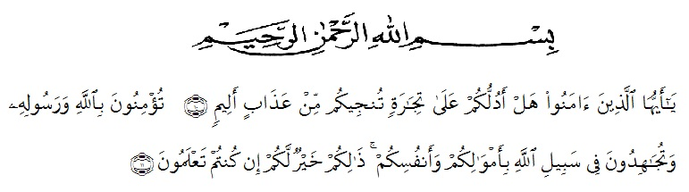

Artinya: “Hai orang-orang yang beriman, sukakah kamu aku tunjukkan suatu perniagaan yang dapat menyelamatkan kamu dari azab yang pedih? (10). (yaitu) kamu beriman kepada Allah dan Rasul-Nya dan berjihad di jalan-Nya dengan harta dan jiwamu, itulah yang lebih baik bagimu jika kamu mengetahuinya. (11) (QS. ash-Shaff: 10-11).

Praise and gratitude the author goes to the presence of Allah SWT who has bestowed His grace and guidance, so that the writer can complete this thesis well. Sholawat and greetings we extend to the last lord of the great Prophet Muhammad SAW.
This thesis is presented as partial fulfillment of the requirements for obtaining an S.S. I am fully aware that this thesis could not be completed without the motivation, support and assistance from various parties. Therefore, on this occasion I would like to express my deepest gratitude to the following parties:
- My beloved parents (Sugiarto and Ariati) who always support, motivate, love, financially, and don't forget to pray for me so that I can complete my undergraduate degree. Thank you very much from the bottom of my heart my father and mother. I am nothing without you.
- My two dear brothers (Teguh Arianto and Tirta Arianto) who always help and accompany me all the time. Thank you very much to my two brothers. I'm lucky to have you guys.
- Dr. KRT. Hardi Mulyono K Surbakti as the rector University of Muslim Nusantara Al Washliyah.
- Dewi Nurmala, S.S., M.hum as the dean of the Faculty of Letters.
- Harianto II, S.S., M.S., P.hD as deputy dean I of the Faculty of Letters and as examiner.
- Ayu Melati Ningsih, S.Pd., M.S as the Head of the English Literature department.
- Diana Shopa, S.S., M.Hum as my mentor who patiently guided me, motivated, corrected, gave advice and provided assistance in completing this thesis.
- Ratna Sari Dewi, S.S., M.S as examiner who have given criticism and suggestions.
- All lecturers of the Faculty of Letters and staff who have helped, provided knowledge, motivation and advice during my studies.
- Beloved friends (Defitri Herlambang and Rizka Fadhillah) from the first semester to the last semester who have provided great support, motivation, helped me in completing this thesis, always there when I needed, joys and sorrows are always together, always continue this, yes. Give love to one another. Thank you very much, I love you guys.
- A friend from childhood (Elvira Nuriza Hrp) who is always there when suddenly asked for help. Thank you so much.
- All my friends and all those who helped me in completing this thesis, whose names cannot be mentioned one by one.
Finally, I pray to the presence of God Almighty, Allah SWT. Later, I realized that this thesis has certain limitations and it is far from perfect. Give respect to all those who have helped me, and I hope that this thesis can be useful and make a positive contribution to readers and others about code mixing.

Medan, 13 Juny 2022
The Researcher

Tiara Arianto
NPM.186114011

