**Lampiran 1.** Bagan Alir Pembuatan Simplisia Bonggol Nanas *(Ananas comosus* (L.)Merr.)

Bonggol nanas

dibersihkan

dicuci dan ditiriskan

dikeringkan dalam lemari pengering

disortasi kering

Simplisia bonggol nanas

dihaluskan menggunakan blender

diayak

Serbuk simplisia bonggol nanas

**Lampiran 2.** Bagan Karakterisasi Simplisia Bonggol Nanas *(Ananas comosus* (L.)Merr.)

1. **Penetapan Kadar Air (Metode Azeotrop)**

Toluen : Air

(100 : 1)

Dimasukkan dalam labu alas bulat

Dipasang dan didestilasi selama 2 jam

Didinginkan selama 30 menit, sampai Toluen dan air memisah

Dihitung Volume air dalam tabung penerima

Toluen : Air

(100 : 1)

Dimasukkan 5 gram serbuk simplisia dalam labu alas bulat berisi toluen yang telah jenuh

Dipanaskan selama 15 menit sampai toluene mendidik diatur kecepatan tetesan 2 tetes perdetik

Dibiarkan sampai semua air terdestilasi

Dibiarkan tabung penerima dingin sampai air dan toluen memisah sempurna

Dihitung volume air dalam tabung penerima

Volume air akhir

**Lampiran 2**. (lanjutan)

1. **Penetapan Kadar Sari larut dalam air**

Serbuk Simplisia

Ditimbang 5 gram

Dimaserasi dengan 100 ml air dan 0,25 ml kloroform selama 24 jam sambil sesekali dikocok

Disaring

Filtrat

Diambil 20 ml diuapkan dalam cawan poselen yang telah ditara pada suhu 105oC sampai bobot tetap

Ditimbang

Berat Sari

1. **Penetapan Kadar Sari larut dalam etanol**

Serbuk Simplisia

Ditimbang 5 gram

Dimaserasi dengan 100 ml etanol selama 24 jam sambil sesekali dikocok

Disaring

Filtrat

Diambil 20 ml diuapkan dalam cawan poselen yang telah ditara pada suhu 105oC sampai bobot tetap

Ditimbang

Berat Sari

**Lampiran 2**. (lanjutan)

1. **Penetapan Kadar Abu Total**

Serbuk Simplisia

Ditimbang 2 gram

Dimasukkan dalam kurs porselen dalam tanur dipijar dan ditara

Dimasukkan kurs porselen dalam tanur dipijar pada suhu 600oC selama 3 jam

Dikeluarkan didinginkan

Ditimbang

Berat Abu

1. **Penetapan Kadar Abu Tidak Larut Asam**

Abu

Dimasukkan dalam cawan

Ditambah 25 ml HCL encer

Didihkan selama 15 menit

Disaring dengan kertas saring bebas abu

Dipijar dalam tanur

Berat Abu Tidak Larut Asam

Didinginkan dan ditimbang

**Lampiran 3.** Bagan Pembuatan Ekstrak Etanol Bonggol Nanas *(Ananas comosus* (L.) Merr.)

Serbuk Simplisia

Ditimbang 500 gram

Dimasukkan dalam bejana

Ditambahkan 75 bagian etanol 80% (3750 ml) diamkan selama 5 hari

Diaduk sesekali dan disaring

Ampas I

Maserat I

Dibilas 25 bagian etanol 80 % (1250 ml)

Maserat I dan II

dicampur

Diamkan selama 2 hari

Lalu di enap tuangkan atau disaring disaring

Maserat

Di pekatkan dengan *rotary evaporator*

Ekstrak Kental

**Lampiran 4.** Skema Kerja Uji Aktivitas Sitotoksisitas dengan Metode *Brine Shrimp Lethality Test (BSLT)*

Timbang 0, 2 g ekstrak

Dilarutkan 100 mL air laut

Larutan induk 2000 ppm

-Tambah 10 ekor larva udang

-Masukkan kedalam vial

-Lalu diambil beberapa mL larutan induk 2000 ppm sesuai yg di butuhkan tiap konsentrasi

-Tambah dengan air laut 10 mL

-masing – masing konsentrasi dibuat 3 kali perlakuan

-mortalitas dihitung setelah 24 jam perlakuan

Hitung LC50

100 ppm, 200 ppm, 300 ppm,400 ppm, 500 ppm, 600 ppm,700 ppm, 800 ppm, 900 ppm, 1000 ppm

Dibuat variasi konsentrasi

**Lampiran 5.** Hasil Identifikasi Tumbuhan

Hasil Identifikasi Tumbuhan Bonggol Nanas *(Ananas comosus* (L.)Merr.)

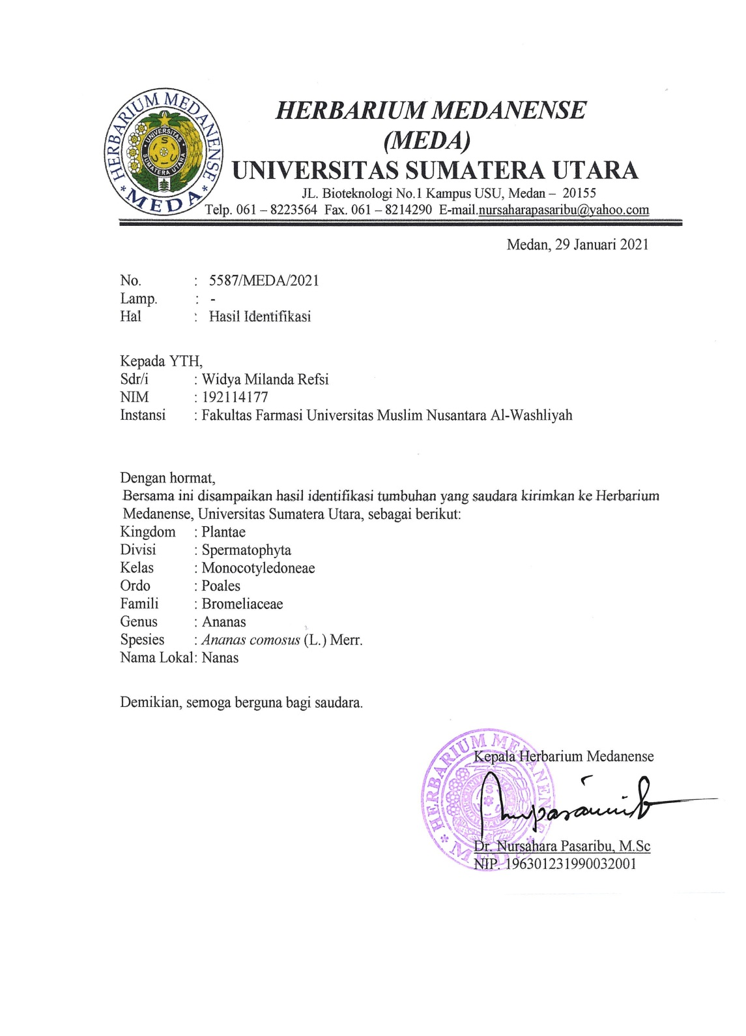

**Lampiran 6.** Tumbuhan Nanas

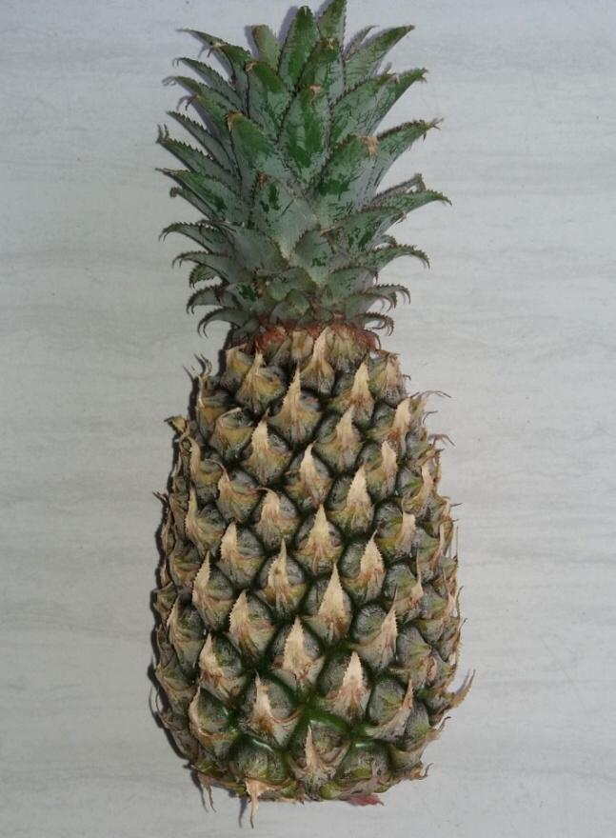

**Lampiran 7.** Pengolahan Sampel Bonggol Nanas

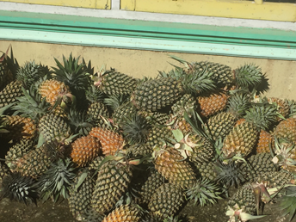

Buah Nanas

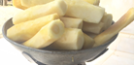 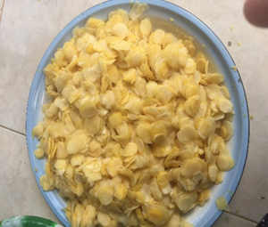

Bonggol Nanas Perajangan Bonggol Nanas

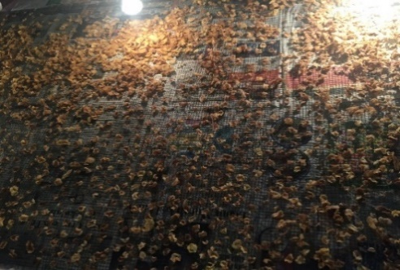 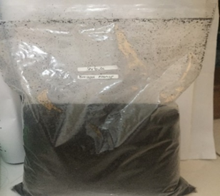

Pengeringan Bonggol Nanas Serbuk bonggol nanas

**Lampiran 8.** Proses Ekstraksi Bonggol Nanas

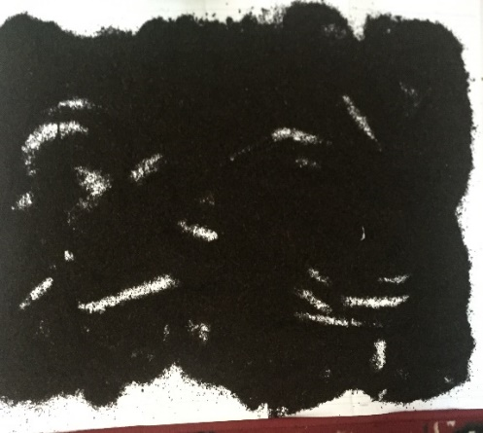 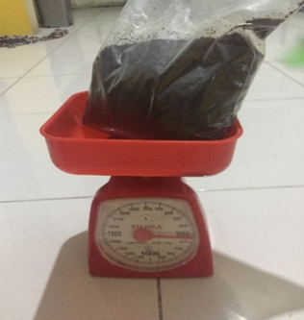

Serbuk Bonggol Nanas 500 g Serbuk Bonggol Nanas

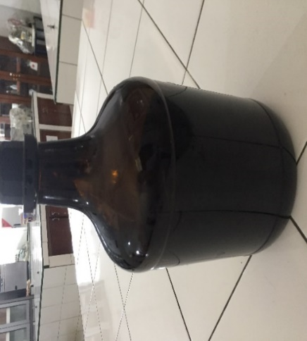 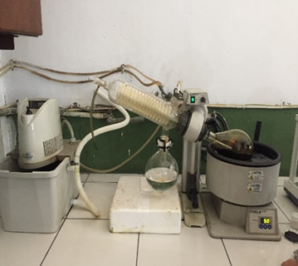

Maserat Bonggol Nanas Rotary Evaporator

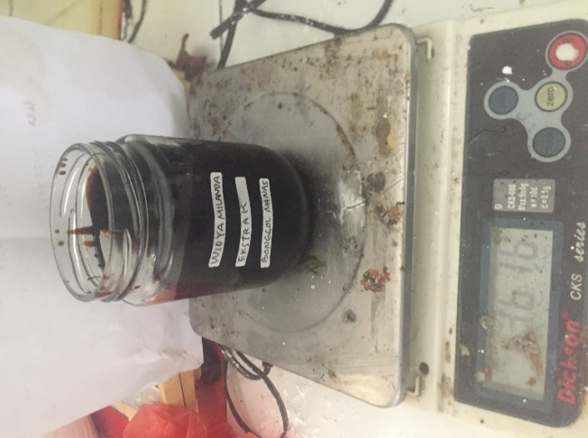

Ekstrak Bonggol Nanas

**Lampiran 9.** Makroskopik dan Mikroskopik Bonggol Nanas

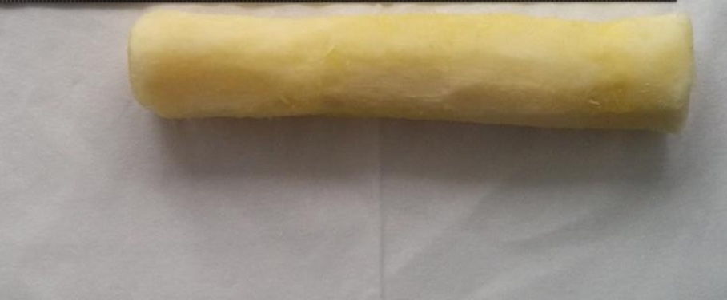

Bonggol nanas

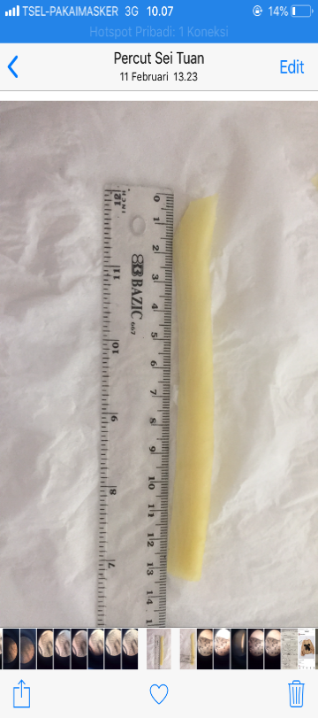 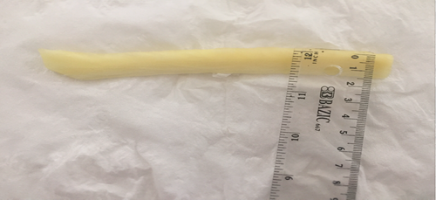

Panjang bonggol nanas 13 cm Lebar bonggol nanas 1,5 cm

Mikroskopik simplisia bonggol nanas

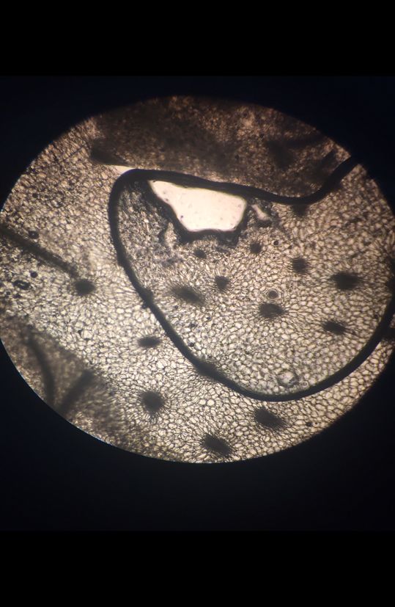

2

3

1

Keterangan : 1. Berkas pembuluh

2.Hablur kalsium oksalat bentuk rafida

3. Epidermis

**Lampiran 10.** Perhitungan Rendemen Ekstrak Bonggol Nanas *(Ananas comosus* (L.) Merr.)

Rendemen Ekstrak Bonggol Nanas *(Ananas comosus (L) Merr)*

Berat simplisia Bonggol Nanas = 1000 gram

Berat ekstrak Bonggol Nanas = 84,62 gram

% Rendemen = $\frac{Berat Ekstrak Kental}{Berat Simplisia kering}$ x 100%

= $\frac{208,8 gram}{500 gram }$ x 100%

= 41,76 %

**Lampiran 11.** Perhitungan Hasil Karakterisasi Bonggol Nanas *(Ananas comosus* (L.)Merr.)

Perhitungan kadar air menurut (Depkes RI, 1989) :

$$Kadar air=\frac{Volume akhir air-Volume awal air}{Berat sample mula-mula (g)}x100\%$$

**Perhitungan Kadar Air**

**Pegulangan 1.**

Volume awal air (V0) = 2 ml

Volime akhir air (V1) = 2,2 ml

Berat sampel = 5 gram

Kadar air = $\frac{V1-V0}{Berat sampel}x 100\%$

= $\frac{2,2 ml – 2 ml}{5 gram}x 100\%$

= 4 %

**Pengulangan 2.**

Volume awal air (V0) = 1,8 ml

Volime akhir air (V1) = 2 ml

Berat sampel = 5 gram

Kadar air = $\frac{V1-V0}{Berat sampel}x 100\%$

= $\frac{2 ml – 1,8ml}{5 gram}x 100\%$

= 4 %

**Pengulangan 3.**

Volume awal air (V0) = 2 ml

Volime akhir air (V1) = 2,4 ml

Berat sampel = 5 gram

**Lampiran 11.** (Lanjutan)

Kadar air = $\frac{V1-V0}{Berat sampel}x 100\%$

= $\frac{2,4 ml – 2 ml}{5 gram}x 100\%$

= 8 %

Rata-rata kadar air = $\frac{4\% + 4\%+8\%}{3}$

= 5,33 %

**Perhitungan Penetapan Kadar Sari Larut Air**

Perhitungan kadar sari larut air menurut (Depkes RI, 1989) :

$$Kadar sari larut air=\frac{Berat sari setelah dikeringkan \left(g\right) x 100 mL }{Berat sample mula-mula \left(g\right)x 20 mL}x100\%$$

**Pengulangan 1**.

Berat cawan kosong = 101,8198 gram

Berat cawan + sari = 102,6293 gram

Berat sari kering = (Berat cawan + sari) – (Berar cawan kosong)

= 102,6293 gram – 101,8198 gram

= 0,8095 gram

Kadar sari larut air = $\frac{0,8095 gram x 100 mL}{5 gram x 20 mL}x 100\%$

= 80,95 %

**Pengulangan 2.**

Berat cawan kosong = 112,6447 gram

Berat cawan + sari = 113,4505 gram

**Lampiran 11.**(Lanjutan)

Berat sari kering = (Berat cawan + sari) – (Berar cawan kosong)

= 113,4505 gram – 112,6447 gram

= 0,8058 gram

Kadar sari larut air = $\frac{0,8058 gram x 100 mL}{5 gram x 20 mL}x 100\%$

= 80,58 %

**Pengulangan 3.**

Berat cawan kosong = 132,4399 gram

Berat cawan + sari = 133,2226 gram

Berat sari kering = (Berat cawan + sari) – (Berar cawan kosong)

= 133,2226 gram – 132,4399 gram

= 0,7827 gram

Kadar sari larut air = $\frac{0,7827 gram x 100 mL}{5 gram x 20 mL}x 100\%$

= 78,27 %

Rata-rata kadar sari larut air = $\frac{80,95 \% +80,58\%+78,27 \%}{3}$

= 79,93 %

**Perhitungan Hasil Penetapan Kadar Sari Larut Etanol**

Perhitungan kadar sari larut etanol menurut (Depkes RI, 1989) :

$$Kadar sari larut etanol=\frac{Berat sari setelah dikeringkan \left(g\right) x 100 mL }{Berat sample mula-mula \left(g\right)x 20 mL}x100\%$$

**Pengulangan 1**.

Berat cawan kosong = 101,8198 gram

**Lampiran 11.**(Lanjutan)

Berat cawan + sari = 102, 5063 gram

Berat sari kering = (Berat cawan + sari) – (Berar cawan kosong)

= 102,5063 gram – 101,8198 gram

= 0,6865 gram

Kadar sari larut etanol = $\frac{0,6865 gram x 100 mL}{5 gram x 20 mL}x 100\%$

= 68,65 %

**Pengulangan 2.**

Berat cawan kosong = 128,1479 gram

Berat cawan + sari = 128,7118 gram

Berat sari kering = (Berat cawan + sari) – (Berar cawan kosong)

= 128,7118 gram – 128,1479 gram

= 0,5639 gram

Kadar sari larut etanol = $\frac{0,5639 gram x 100 mL}{5 gram x 20 mL}x 100\%$

= 56,39 %

**Pengulangan 3.**

Berat cawan kosong = 97,6176 gram

Berat cawan + sari = 98,2411 gram

Berat sari kering = (Berat cawan + sari) – (Berar cawan kosong)

= 98,2411 gram – 97,6176 gram

= 0,6235 gram

Kadar sari larut etanol = $\frac{0,6235 gram x 100 mL}{5 gram x 20 mL}x 100\%$

= 62,35 %

Rata-rata kadar sari larut etanol = $\frac{68,65\% +56,39\%+62,35 \%}{3}$

= 62, 46 %

**Lampiran 11.** (Lanjutan)

Perhitungan Hasil Penetapan Kadar Abu Total

Perhitungan kadar abu total menurut (Depkes RI, 1989) :

$$Kadar Abu Total=\frac{Berat abu yang diperoleh \left(g\right) }{Berat sample mula-mula (g)}x100\%$$

**Perhitungan Hasil Penetapan Kadar Abu Total**

**Pengulangan 1**.

Berat krus kosong = 65,4544 gram

Berat krus + abu = 65,6880 gram

Berat abu = (Berat krus + abu) – (Berat krus kosong)

= 65,6880 gram – 65,4544 gram

= 0,2336 gram

Kadar Abu total = $\frac{0,2336 gram }{2 gram}x 100\%$

= 11,68 %

**Pengulangan 2.**

Berat krus kosong = 64,1930 gram

Berat krus + abu = 64,0731 gram

Berat abu = (Berat krus + abu) – (Berat krus kosong)

= 64,1930 gram – 64,0731 gram

= 0,1199 gram

Kadar Abu total = $\frac{0,1199 gram }{2 gram}x 100\%$

= 5,99 %

**Lampiran 11.** (Lanjutan)

**Pengulangan 3.**

Berat krus kosong = 61,4193 gram

Berat krus + abu = 61,5641 gram

Berat abu = (Berat krus + abu) – (Berat krus kosong)

= 61,5641 gram – 61,4193 gram

= 0,1448 gram

Kadar Abu total = $\frac{0,1448 gram }{2 gram}x 100\%$

= 7,24 %

Rata-rata kadar Abu total = $\frac{11,68 \% +5,99 \%+7,24 \%}{3}$

= 8,30 %

**Perhitungan Hasil Penetapan Kadar Abu Tidak Larut Asam**

Perhitungan kadar abu tidak larut asam menurut (Depkes RI, 1989) :

$$Kadar Abu Total=\frac{Berat abu sisa dipijar \left(g\right) }{Berat sample abu mula-mula (g)}x100\%$$

**Pengulangan 1**.

Berat krus kosong = 65,4544 gram

Berat krus + abu tidak larut asam = 65,5019 gram

Berat abu = (Berat krus + abu tidak larut asam) – (Berat krus kosong)

= 65,5019 gram – 65,4544 gram

= 0,0475 gram

Kadar Abu tidak larut asam = $\frac{0,0475 gram }{2 gram}x 100\%$

= 2,37 %

**Lampiran 11.** (Lanjutan)

**Pengulangan 2.**

Berat krus kosong = 64,0731 gram

Berat krus + abu tidak larut asam = 64,1074 gram

Berat abu = (Berat krus + abu tidak larut asam) – (Berat krus kosong)

= 64,1074 gram – 64,0731 gram

= 0,0316 gram

Kadar Abu tidak larut asam = $\frac{0,0316 gram }{2 gram}x 100\%$

= 1,58 %

**Pengulangan 3.**

Berat krus kosong = 61,4193 gram

Berat krus + abu tidak larut asam = 61,4617 gram

Berat abu = (Berat krus + abu tidak larut asam) – (Berat krus kosong)

= 61,4617 gram – 61,4193 gram

= 0,0424 gram

Kadar Abu tidak larut asam = $\frac{0,0424 gram }{2 gram}x 100\%$

= 2,12 %

Rata-rata kadar Abu total = $\frac{2,37 \% +1,58 \%+2,12\%}{3}$

= 2,02 %

**Lampiran 12.** Hasil Uji Skrining Fitokimia Bonggol Nanas *(Ananas comosus* (L.)Merr.)

|  |  |  |  |  |  |
| --- | --- | --- | --- | --- | --- |
| **No** | **Golongan senyawa** | **Gambar** | | **Hasil Uji** | **Keterangan** |
| **Serbuk** | **Ekstrak** |
| 1. | Alkaloid | IMG-5397 | IMG-6009 | - | 1. Mayer   Tidak terbentuk endapan putih  (-)   1. Dragendrof   Tidak Terbentuk endapan merah – merah kecoklatan (-)  (Depkes RI, 1995)   1. Buochardat   Tidak Terbentuk larutan merah kekuningan (-)  (Depkes RI, 1995) |
| 2. | Flavonoid | IMG-5391 | IMG-6012 | + | Terbentuk lapisan jingga-merah pada lapisan alkohol  (Franswort, 1966). |
| 3. | Tanin |  |  | + | Tidak Terbentuk Larutan biru pekat (Depkes RI, 1995). |

**Lampiran 12.** (Lanjutan)

|  |  |  |  |  |  |
| --- | --- | --- | --- | --- | --- |
| 4. | Saponin |  |  | + | Terbentuk busa yang stabil  (Depkes RI, 1995). |
| 5. | Glikosida |  |  | + | Terbentuk cincin ungu pada lapisan atas dan bawah  (Depkes RI, 1995). |
| 6. | Steroid/Triterpenoid |  |  | + | Terbentuk warna ungu sampai merah (triterpenoid) (Depkes RI, 1995). |

**Lampiran 13.** Pengujian Sitotoksisiitas Ekstrak Bonggol Nanas *(Ananas comosus* (L.) Merr.) dengan Metode BSLT

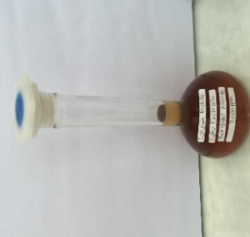 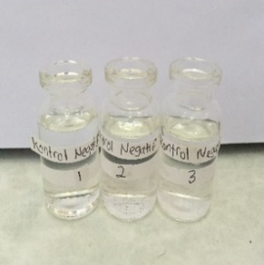 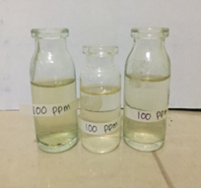

Larutan Induk Baku Kontrol Negatif 100 ppm

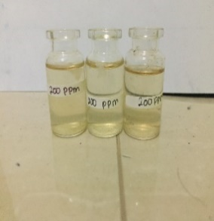 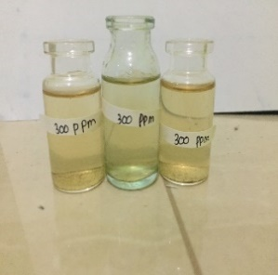 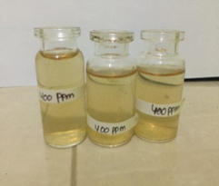

200 ppm 300 ppm 400 ppm

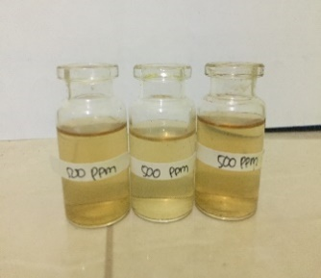 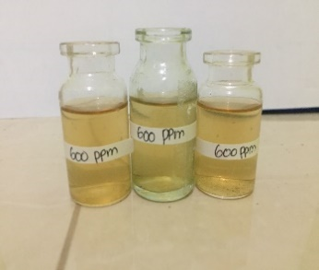 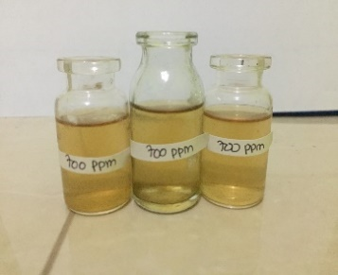

500 ppm 600 ppm 700 ppm

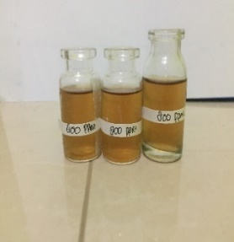 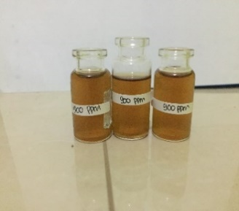 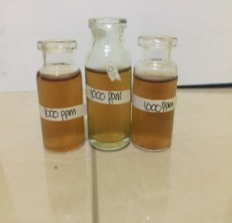

800 ppm 900 ppm 1000 ppm

**Lampiran 14.** Perhitungan Pembuatan Variasi Pengenceran Ekstrak *Etanol Bonggol Nanas* (Ananas comosus (L.) Merr.)

LIB = 200 mg (200,000 µg / 100 mL) = 2000 µg/mL (2000 ppm)

a. 1000 µg/mL = V1.C1 = V2.C2

= x. 2000 µg/mL = 10 ml.1000 µg/mL

x = $\frac{100000 µg }{2000 µg/mL }$ = 5 mL

b. 900 µg/mL = V1.C1 = V2.C2

= x. 2000 µg/mL = 10 ml.900 µg/mL

x = $\frac{9000 µg }{2000 µg/mL }$ = 4,5 mL

c.800 µg/mL = V1.C1 = V2.C2

= x. 2000 µg/mL = 10 ml.800 µg/mL

x = $\frac{8000 µg }{2000 µg/mL }$ = 4 mL

d.700 µg/mL = V1.C1 = V2.C2

= x. 2000 µg/mL = 10 ml.700 µg/mL

x = $\frac{7000 µg }{2000 µg/mL }$ = 3,5 mL

e.600 µg/mL = V1.C1 = V2.C2

= x. 2000 µg/mL = 10 ml.600 µg/mL

x = $\frac{6000 µg }{2000 µg/mL }$ = 3 mL

f. 500 µg/mL = V1.C1 = V2.C2

= x. 2000 µg/mL = 10 ml.500 µg/mL

x = $\frac{5000 µg }{2000 µg/mL }$ = 2,5 mL

g.400 µg/mL = V1.C1 = V2.C2

= x. 2000 µg/mL = 10 ml.400 µg/mL

x = $\frac{4000 µg }{2000 µg/mL }$ = 2 mL

h. 300 µg/mL = V1.C1 = V2.C2

= x. 2000 µg/mL = 10 ml.300 µg/mL

x = $\frac{3000 µg }{2000 µg/mL }$ = 1,5 mL

**Lampiran 14. (**Lanjutan)

i.200 µg/mL = V1.C1 = V2.C2

= x. 2000 µg/mL = 10 ml.200 µg/mL

x = $\frac{2000 µg }{2000 µg/mL }$ = 1 mL

j.100µg/mL = V1.C1 = V2.C2

= x. 2000 µg/mL = 10 ml.100 µg/mL

x = $\frac{1000 µg }{2000 µg/mL }$ = 0,5 mL

**Lampiran 15.** Perhitungan LC50 Ekstrak Etanol Bonggol Nanas *(Ananas comosus* (L.)Merr.) dengan Metode BSLT

% Kematian Larva = $\frac{Jumlah rata-rata larva yang mati }{jumlah larva uji} x 100 \%$

**Hasil Orientasi**

|  |  |  |  |  |  |  |  |
| --- | --- | --- | --- | --- | --- | --- | --- |
| **No** | **Konsentrasi (µg/mL)** | **Jumlah larva yang mati** | | | **Total** | **Rata-rata kematian larva** | **% Mortalitas** |
|
| **P1** | **P2** | **P3** |
| 1 | Blanko | 0 | 0 | 0 | 0 | 0 | 0% |
| 2 | 100 | 2 | 1 | 2 | 5 | 1,67 | 16,7% |
| 3 | 200 | 3 | 2 | 2 | 7 | 2,33 | 23,3% |
| 4 | 300 | 3 | 4 | 2 | 9 | 3 | 30% |
| 5 | 400 | 5 | 4 | 4 | 13 | 4,33 | 43,3% |
| 5 | 500 | 6 | 6 | 5 | 17 | 5,67 | 56,7% |
| 6 | 600 | 9 | 7 | 5 | 21 | 7 | 70% |
| 7 | 700 | 9 | 8 | 8 | 25 | 8,33 | 83,3% |
| 8 | 800 | 10 | 8 | 9 | 27 | 9 | 90% |
| 9 | 900 | 9 | 10 | 10 | 29 | 9,67 | 96,7% |
| 11 | 1000 | 10 | 10 | 10 | 30 | 10 | 100% |

**Lampiran 15.** (Lanjutan)

**Hasil Pengujian**

|  |  |  |  |  |
| --- | --- | --- | --- | --- |
| **NO** | **Konsentrasi (µg/mL)** | **%Mortalitas** | **Log Konsentrasi** | **Nilai probit** |
| 1 | 200 | 23,3% | 2,3010 | 4,2710 |
| 2 | 300 | 30% | 2,4771 | 4,4756 |
| 3 | 400 | 43,3% | 2,6020 | 4,8313 |
| 4 | 500 | 56,7% | 2,6989 | 5,1687 |
| 5 | 600 | 70% | 2,7781 | 5,5244 |
| 6 | 700 | 83,3 % | 2,8450 | 5,9661 |

|  |  |  |  |  |  |  |  |  |
| --- | --- | --- | --- | --- | --- | --- | --- | --- |
| NO | d  (C(µg/mL) | N  (Jumlah Larva) | r (Jumlah yg mati) | P  (%mortalitas) | X (log C) | Y  (Nilai probit) | XY | X2 |
| 1 | 200 | 30 | 7 | 23 % | 2,3010 | 4,2710 | 9,8275 | 5,2946 |
| 2 | 300 | 30 | 9 | 30% | 2,4771 | 4,4756 | 11,0865 | 6,1360 |
| 3 | 400 | 30 | 13 | 43% | 2,602 | 4,8313 | 12,5710 | 6,7704 |
| 4 | 500 | 30 | 17 | 57 % | 2,6989 | 5,1687 | 13,9498 | 7,2840 |
| 5 | 600 | 30 | 21 | 70% | 2,7781 | 5,5244 | 15,3473 | 7,7178 |
| 6 | 700 | 30 | 25 | 83 % | 2,8450 | 5,9661 | 16,9735 | 8,0940 |
|  | **Jumlah** | | | | ∑X = 15,7021 | ∑Y = 30,2371 | ∑XY=  79,7558 | ∑X2=  41,2969 |
|  | **Rata – rata** | | | | 2,6170 | 5,0395 |  |  |

Persamaan garis regresi linear :

Y = a + bX

y = Konsentrasi Kematian

x = Log Konsentrasi

**Lampiran 15.** (Lanjutan)

a = $\frac{ \left(∑xy\right)-(∑x∑y)/n}{ ∑x^{2}-{\left(∑x\right)}^{2}/n}$

a = $\frac{79,7558-\left(15,7021\right)(30,2371/6}{41,2969-(15,7021)/6}$

a = $\frac{0,6249}{0,2043}$

a = 3,0587

b = Y – aX

b = 5,0395 – 3,0587 (2,6170)

b = 5,0395 – 8,0046

b = - 2,9651

Nilai LC50 diperoleh dari antilog x dimana x merupakan logaritma konsentrasi bahan toksik pada Y = 5, yaitu nilai probit 50 % hewan uji. Sehingga persamaan regresi diperoleh: Y = 3,0587 – 2,9651x

5 = 3,0587 -2,9651x

5 + 2,9651 = 3,0587x

7,9651 = 3,0587x

X = $\frac{7,9651}{3,0587}$

X = 2,6040

LC50 = Anti Log x

**=** 401,7908 µg/mL

Maka nilai Lc50 antilog 2,6040 adalah 401,7908 µg/mL

**Lampiran 15.** (Lanjutan)

Kurva Regresi Linier Antara Log Konsentrasi Ekstrak Etanol Bonggol Nanas Dengan Nilai Probit, sebagai berikut :

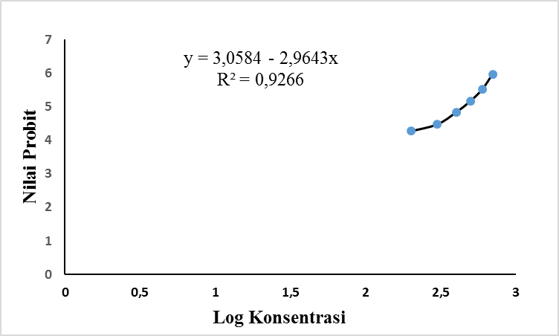

**Lampiran 16.** Nilai Probit Sesuai dengan Besarnya Presentase Kematian (Priyanto, 2009)

|  |  |  |  |  |  |  |  |  |  |  |
| --- | --- | --- | --- | --- | --- | --- | --- | --- | --- | --- |
| Persen |  | | | | | | | | | |
| kematian (%) | **0,0** | **0,1** | **0,2** | **0,3** | **0,4** | **0,5** | **0,6** | **0,7** | **0,8** | **0,9** |
| **0** | - | 1.0098 | 2.1218 | 2.2522 | 2.3479 | 2.4242 | 2.4879 | 2.5427 | 2.5914 | 2.6344 |
| **1** | 2.6737 | 2.7096 | 2.7429 | 2.7738 | 2.8027 | 2.8299 | 2.8556 | 2.8799 | 2.3031 | 2.9251 |
| **2** | 2.9463 | 2.9665 | 2.9859 | 3.0646 | 3.0226 | 3.0400 | 3.0569 | 3.0732 | 3.0896 | 3.1043 |
| **3** | 3.1192 | 3.1337 | 3.1478 | 3.1616 | 3.1750 | 3.1881 | 3.2009 | 3.2134 | 3.2256 | 3.2376 |
| **4** | 3.2493 | 3.2608 | 3.2721 | 3.2831 | 3.2940 | 3.3046 | 3.3151 | 3.3253 | 3.3354 | 3.3454 |
| **5** | 3.3351 | 3.3668 | 3.3742 | 3.3836 | 3.3028 | 3.4018 | 3.4107 | 3.4195 | 3.4282 | 3.4368 |
| **6** | 3.4452 | 3.4536 | 3.4618 | 3.4694 | 3.4780 | 3.4850 | 3.4937 | 3.5015 | 3.5091 | 3.5167 |
| **7** | 3.5242 | 3.5316 | 3.5380 | 3.5462 | 3.5534 | 3.5605 | 3.5675 | 3.5745 | 3.5813 | 3.5882 |
| **8** | 3.5949 | 3.6016 | 3.6083 | 3.6148 | 3.6213 | 3.6278 | 3.6342 | 3.6405 | 3.6408 | 3.6427 |
| **9** | 3.6692 | 3.6654 | 3.6715 | 3.6775 | 3.6835 | 3.6894 | 3.6953 | 3.7012 | 3.7070 | 3.7127 |
| **10** | 3.7182 | 3.7241 | 3.7298 | 3.7354 | 3.7409 | 3.7464 | 3.7519 | 3.7574 | 3.7628 | 3.7681 |
| **11** | 3.7735 | 3.7784 | 3.7840 | 3.7893 | 3.7945 | 3.7996 | 3.8048 | 3.8099 | 3.8150 | 3.8200 |
| **12** | 3.8250 | 3.8300 | 3.8350 | 3.8399 | 3.8848 | 3.8497 | 3.8545 | 3.8503 | 3.8641 | 3.8689 |
| **13** | 3.8736 | 3.8783 | 3.8830 | 3.8877 | 3.8923 | 3.8969 | 3.9015 | 3.9061 | 3.9107 | 3.9152 |
| **14** | 3.9197 | 3.9242 | 3.9286 | 3.9331 | 3.9375 | 3.9419 | 3.9463 | 3.9506 | 3.9550 | 3.9593 |
| **15** | 3.9636 | 3.9678 | 3.9721 | 3.9763 | 3.9800 | 3.9848 | 3.9890 | 3.9931 | 3.9933 | 4.0014 |
| **16** | 4.0055 | 4.0096 | 4.0137 | 4.0178 | 4.0218 | 4.0259 | 4.0299 | 4.0339 | 4.0379 | 4.0410 |
| **17** | 4.0458 | 4.0408 | 4.0537 | 4.0576 | 4.0615 | 4.0693 | 4.0693 | 4.0731 | 4.0770 | 4.0808 |
| **18** | 4.0846 | 4.0884 | 4.0960 | 4.0960 | 4.0998 | 4.1035 | 4.1073 | 4.1110 | 4.1147 | 4.1184 |
| **19** | 4.1221 | 4.1258 | 4.1331 | 4.1331 | 4.1367 | 4.1404 | 4.1440 | 4.1476 | 4.1512 | 4.1548 |
| **20** | 4.1684 | 4.1019 | 4.1035 | 4.1690 | 4.1726 | 4.1761 | 4.1796 | 4.1831 | 4.1866 | 4.1901 |
| **21** | 4.1936 | 4.1970 | 4.2005 | 4.2039 | 4.2074 | 4.2108 | 4.2142 | 4.2176 | 4.2110 | 4.2244 |
| **22** | 4.2278 | 4.2312 | 4.2345 | 4.2379 | 4.2412 | 4.2446 | 4.2479 | 4.2512 | 4.2546 | 4.2579 |
| **23** | 4.2612 | 4.2644 | 4.2677 | **4.2710** | 4.2743 | 4.2275 | 4.2808 | 4.2840 | 4.2872 | 4.2905 |
| **24** | 4.2937 | 4.2969 | 4.3001 | 4.3033 | 4.3065 | 4.3097 | 4.3129 | 4.3160 | 4.3192 | 4.3324 |
| **25** | 4.3255 | 4.3287 | 4.3318 | 4.3349 | 4.3380 | 4.3412 | 4.3443 | 4.3474 | 4.3505 | 4.3536 |
| **26** | 4.3567 | 4.3597 | 4.3628 | 4.3659 | 4.3869 | 4.3720 | 4.3750 | 4.3781 | 4.3811 | 4.3842 |
| **27** | 4.3872 | 4.3902 | 4.3932 | 4.3962 | 4.3992 | 4.4022 | 4.4052 | 4.4082 | 4.4112 | 4.4142 |
| **28** | 4.4172 | 4.4201 | 4.4231 | 4.4260 | 4.4290 | 4.4319 | 4.4349 | 4.4378 | 4.4408 | 4.4437 |
| **29** | 4.4466 | 4.4405 | 4.4524 | 4.4554 | 4.4583 | 4.4612 | 4.4641 | 4.4670 | 4.4698 | 4.4727 |
| **30** | **4.4756** | 4.4785 | 4.4813 | 4.4842 | 4.4871 | 4.4899 | 4.4928 | 4.4956 | 4.4985 | 4.5013 |
| **31** | 4.5041 | 4.5070 | 4.5098 | 4.5126 | 4.5155 | 4.5183 | 4.2511 | 4.5239 | 4.5267 | 4.5295 |
| **32** | 4.5323 | 4.5351 | 4.5370 | 4.5407 | 4.5435 | 4.5462 | 4.5490 | 4.5518 | 4.5546 | 4.5573 |
| **33** | 4.5601 | 4.5628 | 4.5656 | 4.5684 | 4.5711 | 4.5739 | 4.5766 | 4.5793 | 4.5821 | 4.5848 |

**Lampiran 16.** (Lanjutan)

|  |  |  |  |  |  |  |  |  |  |  |
| --- | --- | --- | --- | --- | --- | --- | --- | --- | --- | --- |
| Persen |  |  |  |  |  |  |  |  |  |  |
| kematian | **0,0** | **0,1** | **0,2** | **0,3** | **0,4** | **0,5** | **0,6** | **0,7** | **0,8** | **0,9** |
| (%) | | | | | | | | | | |
| **34** | 4.5875 | 4.5903 | 4.5930 | 4.5957 | 4.5984 | 4.6011 | 4.6039 | 4.6066 | 4.6093 | 4.6120 |
| **35** | 4.6147 | 4.6174 | 4.6201 | 4.6288 | 4.6255 | 4.6281 | 4.6308 | 4.6335 | 4.6362 | 4.6389 |
| **36** | 4.6415 | 4.6442 | 4.6469 | 4.6495 | 4.6522 | 4.6549 | 4.6575 | 4.6602 | 4.6628 | 4.6655 |
| **37** | 4.6681 | 4.6708 | 4.6734 | 4.6761 | 4.6787 | 4.6814 | 4.6840 | 4.6866 | 4.6893 | 4.6919 |
| **38** | 4.6945 | 4.6971 | 4.6998 | 4.7024 | 4.7050 | 4.7078 | 4.7102 | 4.7129 | 4.7155 | 4.7181 |
| **39** | 4.7207 | 4.7233 | 4.7259 | 4.7285 | 4.7311 | 4.7337 | 4.7363 | 4.7389 | 4.7415 | 4.7441 |
| **40** | 4.7467 | 4.7402 | 4.7518 | 4.75f44 | 4.7570 | 4.7595 | 4.7622 | 4.7647 | 4.7673 | 4.7699 |
| **41** | 4.7725 | 4.7750 | 4.7776 | 4.7802 | 4.7827 | 4.7853 | 4.7879 | 4.7902 | 4.7930 | 4.7955 |
| **42** | 4.7981 | 4.8007 | 4.8032 | 4.8058 | 4.8083 | 4.8109 | 4.8134 | 4.8160 | 4.8185 | 4.8211 |
| **43** | 4.8230 | 4.8202 | 4.8278 | **4.8313** | 4.8338 | 4.8363 | 4.8389 | 4.8414 | 4.8440 | 4.8465 |
| **44** | 4.8490 | 4.8516 | 4.8541 | 4.8566 | 4.8592 | 4.8617 | 4.8624 | 4.8668 | 4.8693 | 4.8718 |
| **45** | 4.8743 | 4.8769 | 4.8704 | 4.8819 | 4.8844 | 4.8870 | 4.8895 | 4.8920 | 4.8945 | 4.8970 |
| **46** | 4.8996 | 4.9021 | 4.9046 | 4.9971 | 4.9996 | 4.9122 | 4.9147 | 4.9172 | 4.9197 | 4.9222 |
| **47** | 4.9247 | 4.9272 | 4.9298 | 4.9323 | 4.9348 | 4.9373 | 4.9308 | 4.9423 | 4.9448 | 4.9473 |
| **48** | 4.9408 | 4.9524 | 4.9549 | 4.9574 | 4.9599 | 4.9624 | 4.9649 | 4.9674 | 4.9699 | 4.9724 |
| **49** | 4.9740 | 4.9774 | 4.9799 | 4.9825 | 4.9850 | 4.9876 | 4.9900 | 4.9925 | 4.9950 | 4.9975 |
| **50** | 5.0000 | 5.0025 | 5.0050 | 5.0075 | 5.0100 | 5.0125 | 5.0150 | 5.0175 | 5.0201 | 5.0226 |
| **51** | 5.0251 | 5.0276 | 5.0301 | 5.0326 | 5.0351 | 5.0376 | 5.0401 | 5.0426 | 5.0451 | 5.0476 |
| **52** | 5.0502 | 5.0527 | 5.0552 | 5.0577 | 5.0602 | 5.0627 | 5.0652 | 5.0677 | 5.0702 | 5.0728 |
| **53** | 5.0753 | 5.0778 | 5.0803 | 5.0828 | 5.0853 | 5.0878 | 5.0904 | 5.0929 | 5.0954 | 5.0279 |
| **54** | 5.1004 | 5.1030 | 5.1055 | 5.1080 | 5.1105 | 5.1130 | 5.1156 | 5.1181 | 5.1206 | 5.1231 |
| **55** | 5.1257 | 5.1282 | 5.1307 | 5.1332 | 5.1358 | 5.1383 | 5.1408 | 5.1434 | 5.1459 | 5.1484 |
| **56** | 5.1510 | 5.1535 | 5.1560 | 5.1586 | 5.1614 | 5.1637 | 5.1662 | **5.1687** | 5.1713 | 5.1738 |
| **57** | 5.1764 | 5.1789 | 5.1815 | 5.1840 | 5.1866 | 5.1801 | 5.1917 | 5.1942 | 5.1968 | 5.1993 |
| **58** | 5.2019 | 5.2045 | 5.2070 | 5.2096 | 5.2121 | 5.2147 | 5.2173 | 5.2198 | 5.2224 | 5.2250 |
| **59** | 5.2275 | 5.2301 | 5.2327 | 5.2353 | 5.2378 | 5.2404 | 5.2430 | 5.2468 | 5.2482 | 5.2508 |
| **60** | 5.2533 | 5.2359 | 5.2585 | 5.2611 | 5.2637 | 5.2663 | 5.2689 | 5.2715 | 5.2741 | 5.2767 |
| **61** | 5.2793 | 5.2819 | 5.2845 | 5.2871 | 5.2808 | 5.2024 | 5.2050 | 5.2976 | 5.3002 | 5.3029 |
| **62** | 5.3055 | 5.3081 | 5.3107 | 5.3134 | 5.3160 | 5.3186 | 5.3213 | 5.3239 | 5.3266 | 5.3202 |
| **63** | 5.3319 | 5.3345 | 5.3372 | 5.3398 | 5.3425 | 5.3451 | 5.3478 | 5.3505 | 5.3531 | 5.3658 |
| **64** | 5.3585 | 5.3811 | 5.3638 | 5.3665 | 5.3692 | 5.3719 | 5.3745 | 5.3772 | 5.3799 | 5.3826 |
| **65** | 5.3853 | 5.3380 | 5.8007 | 5.3934 | 5.3961 | 5.3980 | 5.4016 | 5.4043 | 5.4070 | 5.4097 |
| **66** | 5.4125 | 5.4152 | 5.4170 | 5.4207 | 5.4234 | 5.4261 | 5.4289 | 5.4316 | 5.4344 | 5.4372 |
| **67** | 5.4399 | 5.4427 | 5.4454 | 5.4482 | 5.4510 | 5.4638 | 5.4565 | 5.4593 | 5.4621 | 5.4649 |
| **68** | 5.4677 | 5.4705 | 5.4733 | 5.4761 | 5.4780 | 5.4817 | 5.4845 | 5.4874 | 5.4002 | 5.4930 |
| **69** | 5.4959 | 5.4987 | 5.5015 | 5.5044 | 5.5072 | 5.5101 | 5.5129 | 5.5158 | 5.5187 | 5.3215 |

**Lampiran 16.** (Lanjutan)

Persen

kematian

**0,0 0,1 0,2 0,3 0,4 0,5 0,6 0,7 0,8 0,9**

(%)

|  |  |  |  |  |  |  |  |  |  |
| --- | --- | --- | --- | --- | --- | --- | --- | --- | --- |
| **70 5.5244** | 5.5273 | 5.5302 | 5.5330 | 5.5350 | 5.5388 | 5.5417 | 5.5446 | 5.5476 | 5.6505 |
| **71** 5.5534 | 5.5563 | 5.5592 | 5.5622 | 5.5651 | 5.5681 | 5.5710 | 5.5740 | 5.5760 | 5.7990 |
| **72** 5.5828 | 5.5858 | 5.5888 | 5.5918 | 5.5948 | 5.5978 | 5.6008 | 5.6038 | 5.6068 | 5.6098 |
| **73** 5.6128 | 5.6158 | 5.6189 | 5.6219 | 5.6250 | 5.6280 | 5.6311 | 5.6341 | 5.6372 | 5.6403 |
| **74** 5.6435 | 5.6464 | 5.6405 | 5.6526 | 5.6557 | 5.6588 | 5.6620 | 5.6651 | 5.6682 | 5.6713 |
| **75** 5.6745 | 5.6776 | 5.6808 | 5.6840 | 5.6871 | 5.6903 | 5.6935 | 5.6967 | 5.6998 | 5.7031 |
| **76** 5.7083 | 5.7095 | 5.7128 | 5.7160 | 5.7192 | 5.7225 | 5.7257 | 5.7200 | 5.7323 | 5.7356 |
| **77** 5.7388 | 5.7424 | 5.7454 | 5.7488 | 5.7521 | 5.7554 | 5.7588 | 5.7621 | 5.7666 | 5.7688 |
| **78** 5.7722 | 5.7756 | 5.7796 | 5.7824 | 5.7858 | 5.7892 | 5.7926 | 5.7961 | 5.7995 | 5.8030 |
| **79** 5.8834 | 5.8099 | 5.8134 | 5.8169 | 5.8204 | 5.8239 | 5.8274 | 5.8310 | 5.8345 | 5.8381 |
| **80** 5.8416 | 5.8452 | 5.8488 | 5.8524 | 5.8560 | 5.8596 | 5.8633 | 5.8669 | 5.8705 | 5.8742 |
| **81** 5.8779 | 5.8816 | 5.8853 | 5.8890 | 5.8927 | 5.8965 | 5.9002 | 5.9040 | 5.9078 | 5.9116 |
| **82** 5.9154 | 5.9192 | 5.9230 | 5.9269 | 5.9307 | 5.9346 | 5.9386 | 5.9424 | 5.9463 | 5.9502 |
| **83** 5.9540 | 5.9581 | 5.9624 | **5.9661** | 5.9701 | 5.9471 | 5.9782 | 5.9822 | 5.9863 | 5.9904 |
| **84** 5.9945 | 5.9986 | 6.0027 | 6.0069 | 6.0110 | 6.0152 | 5.0194 | 6.0273 | 6.0279 | 6.0322 |
| **85** 6.0364 | 6.0407 | 6.0450 | 6.0494 | 6.0537 | 6.0581 | 6.0625 | 6.0669 | 6.0714 | 6.0758 |
| **86** 6.0803 | 6.0818 | 6.0893 | 6.0939 | 6.0985 | 6.1031 | 6.1077 | 6.1123 | 6.1170 | 6.1217 |
| **87** 6.1264 | 6.1311 | 6.1359 | 6.1407 | 6.1455 | 6.1503 | 6.1552 | 6.1601 | 6.1650 | 6.1700 |
| **88** 6.1750 | 6.1800 | 6.1856 | 6.1901 | 6.1952 | 6.2004 | 6.2055 | 6.2107 | 6.2160 | 6.2212 |
| **89** 6.2205 | 6.2319 | 6.2372 | 6.2426 | 6.2481 | 6.2536 | 6.2591 | 6.2646 | 6.2702 | 6.2750 |
| **90** 6.2816 | 6.2873 | 6.2936 | 6.2988 | 6.3047 | 6.3106 | 6.3165 | 6.3225 | 6.3285 | 6.3346 |
| **91** 6.3408 | 6.3469 | 6.3532 | 6.3595 | 6.3658 | 6.3722 | 6.3787 | 6.3852 | 6.3917 | 6.3984 |
| **92** 6.4031 | 6.4118 | 6.4187 | 6.4255 | 6.4325 | 6.4395 | 6.4466 | 6.4538 | 6.4611 | 6.4684 |
| **93** 6.4758 | 6.4833 | 6.4909 | 6.4985 | 6.5063 | 6.5141 | 6.5220 | 6.5301 | 6.5382 | 6.5464 |
| **94** 6.8548 | 6.5632 | 6.5718 | 6.5805 | 6.5893 | 6.5982 | 6.6078 | 6.6164 | 6.6258 | 6.6352 |
| **95** 6.6449 | 6.6546 | 6.6646 | 6.6747 | 6.6849 | 6.6954 | 6.7060 | 6.7169 | 6.7279 | 6.7302 |
| **96** 6.7507 | 6.7624 | 6.7784 | 6.7806 | 6.7991 | 6.8119 | 6.8260 | 6.8084 | 6.8522 | 6.8663 |
| **97** 6.8808 | 6.8957 | 6.9110 | 6.9268 | 6.9431 | 6.9600 | 6.9774 | 6.9954 | 7.0141 | 7.0335 |
| **98** 7.0537 | 7.0558 | 7.0579 | 7.0660 | 7.0621 | 7.0612 | 7.0663 | 7.0684 | 7.0706 | 7.0727 |
| **98.1** 7.0749 | 7.0770 | 7.0792 | 7.0814 | 7.0836 | 7.0858 | 7.0880 | 7.0902 | 7.0924 | 7.0947 |
| **98.2** 7.0969 | 7.0992 | 7.1015 | 7.1038 | 7.1061 | 7.1084 | 7.1107 | 7.1130 | 7.1154 | 7.1177 |
| **98.3** 7.1204 | 7.1224 | 7.1248 | 7.1272 | 7.1297 | 7.1321 | 7.1345 | 7.1370 | 7.1384 | 7.1419 |
| **98.4** 7.1444 | 7.1469 | 7.1494 | 7.1520 | 7.1545 | 7.1571 | 7.1996 | 7.1622 | 7.1648 | 7.1675 |
| **98.5** 7.1701 | 7.1727 | 7.1754 | 7.1781 | 7.1808 | 7.1835 | 7.1862 | 7.1890 | 7.1917 | 7.1945 |
| **98.6** 7.1973 | 7.2001 | 7.2029 | 7.2058 | 7.2086 | 7.2115 | 7.2144 | 7.2173 | 7.2203 | 7.2232 |
| **98.7** 7.2262 | 7.2292 | 7.2322 | 7.2353 | 7.2383 | 7.2414 | 7.2445 | 7.2476 | 7.2508 | 7.2539 |

**Lampiran 16.** (Lanjutan)

Persen **0,0 0,1 0,2 0,3 0,4 0,5 0,6 0,7 0,8 0,9**

kematian

(%)

|  |  |  |  |  |  |  |  |  |  |
| --- | --- | --- | --- | --- | --- | --- | --- | --- | --- |
| **98.8** 7.2374 | 7.2663 | 7.2636 | 7.2668 | 7.2701 | 7.2734 | 7.2768 | 7.2801 | 7.2835 | 7.2869 |
| **98.9** 7.2904 | 7.2938 | 7.2973 | 7.3009 | 7.3044 | 7.3080 | 7.3116 | 7.3152 | 7.3189 | 7.3226 |
| **98** 7.3263 | 7.3301 | 7.3339 | 7.3378 | 7.3416 | 7.3455 | 7.3495 | 7.3535 | 7.3575 | 7.3615 |
| **99.1** 7.3656 | 7.3698 | 7.3739 | 7.3781 | 7.3824 | 7.3867 | 7.3911 | 7.3954 | 7.3999 | 7.4044 |
| **99.2** 7.4059 | 7.4135 | 7.4181 | 7.4228 | 7.4276 | 7.4324 | 7.4372 | 7.4422 | 7.4474 | 7.4522 |
| **99.3** 7.4373 | 7.4624 | 7.4677 | 7.4730 | 7.4783 | 7.4838 | 7.4893 | 7.4940 | 7.5006 | 7.5063 |
| **99.4** 7.5121 | 7.5181 | 7.5241 | 7.5302 | 7.5364 | 7.5427 | 7.5401 | 7.5550 | 7.5622 | 7.5690 |
| **99.5** 7.5758 | 7.5828 | 7.5890 | 7.5972 | 7.6045 | 7.6121 | 7.6107 | 7.6276 | 7.6356 | 7.6437 |
| **99.6** 7.6521 | 7.6606 | 7.6693 | 7.6783 | 7.6874 | 7.6968 | 7.7065 | 7.7104 | 7.7266 | 7.7370 |
| **99.7** 7.7478 | 7.7589 | 7.7703 | 7.7822 | 7.7944 | 7.8070 | 7.8202 | 7.8338 | 7.8480 | 7.8027 |
| **99.8** 7.8782 | 7.8943 | 7.9112 | 7.9299 | 7.9478 | 7.9677 | 7.9889 | 8.0115 | 8.0357 | 8.0618 |

|  |  |  |  |  |  |  |  |  |  |  |
| --- | --- | --- | --- | --- | --- | --- | --- | --- | --- | --- |
| **99.9** | 8.0902 | 8.1214 | 8.1550 | 8.1847 | 8.2380 | 8.2905 | 8.3528 | 8.4316 | 8.5401 | 8.7190 |