Lampiran 1. Surat Determin asi Tumbuhan 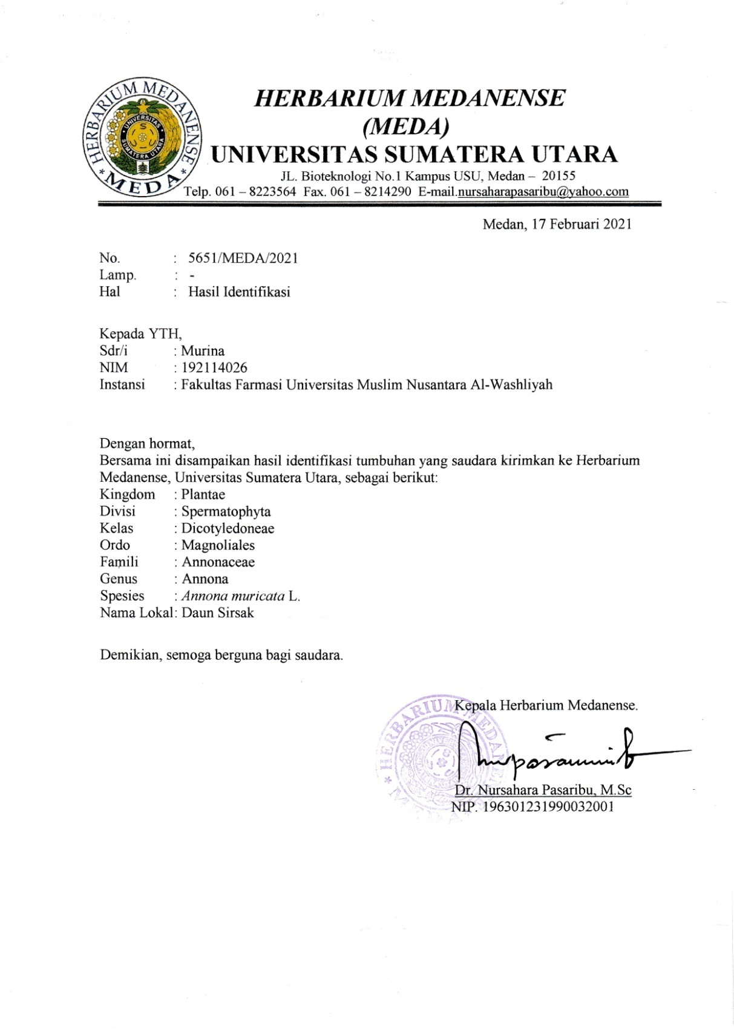

Lampiran 2. Surat Etical Clearens
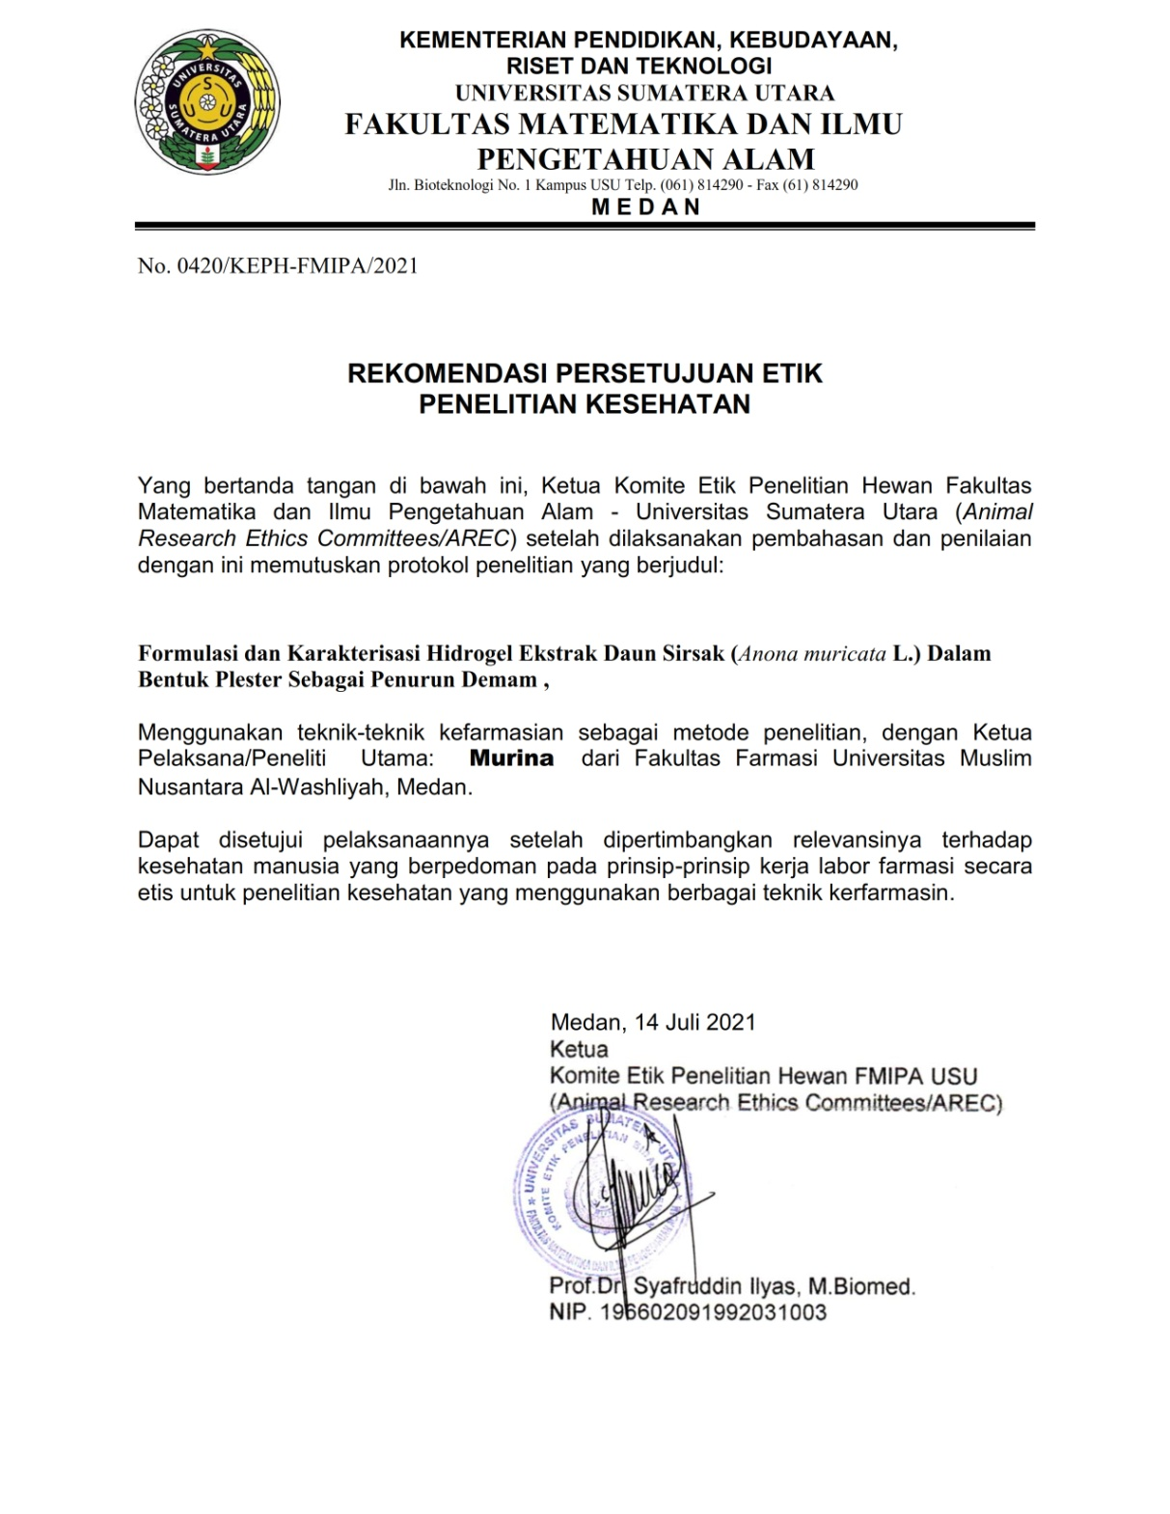
Lampiran 3. Bagan Alir Penelitian Pembuatan Serbuk Simplisia Daun Sirsak (Annona muricata L.)

Daun sirsak segar

Sortasi basah

Dicuci pada air mengalir

Ditiriskan lalu dirajang

Berat basah yang diperoleh ( 3,5 kg )

dikeringkan didalam lemari pengering pada suhu 40

Sortasi kering

Berat simplisia kering 1 kg

Dihaluskan menggunakan blender

Diserkai dengan ayakan

Dimasuka didalam wadah tertutup dan disimpan dalam suhu ruangan

Serbuk simplisia yang diperoleh (700 gram)

Skrining fitokima
Karakterisasi simplisia
Ekstraksi

Lampiran 4. Bagan Alir Pembuatan Ekstrak Etanol Daun Sirsak Annona muricata L.).

500 gram serbuk simplisia daun sirsak

Dimasukan kedalam bejana

Dituangkan dengan 75 bagian caira penyari 70% (3750 ml)

Ditutup dan dibiarkan selama 5 hari sambil di aduk sesekali

Setelah 5 hari campuran diserkai dan peras dengan kain flanel

Ampas
Maserat I

Dicuci dengan 25 bagian etanol 70% (1250 ml)

Maserat II

Maserat I + maserat II

Dimasukan kedalam bejana tertutup dan dibiarkan selama 2 hari lalu disring

Dipekatkan dengan alat Rotary evaporator

Diuapkan diatas Waterbath

Ekstrak etanol

Lampiran 5. Pengolahan Sampel (Daun Sirsak)

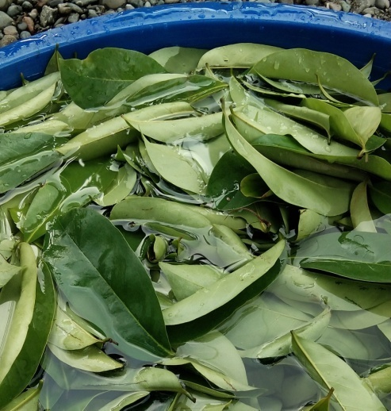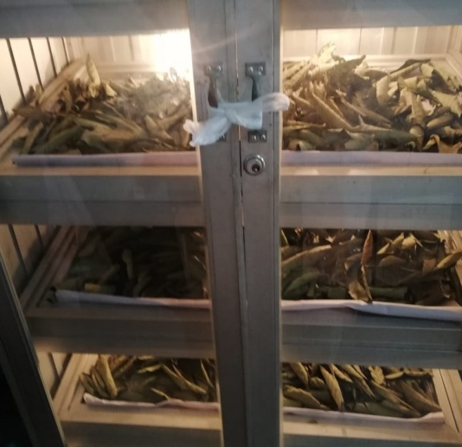
Pengumpulan sampel Pengeringan
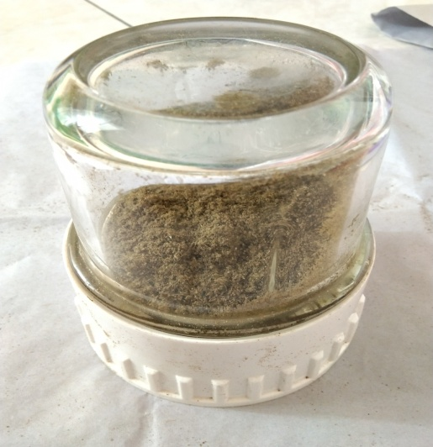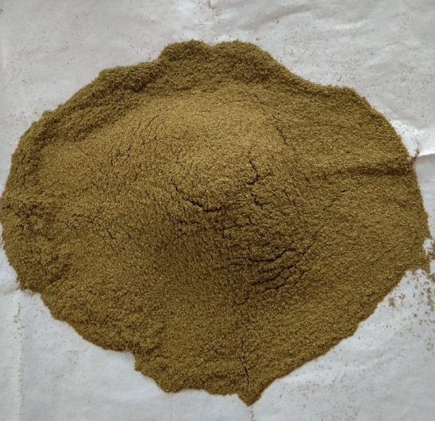
Penghalusan sampel Serbuk simplisia
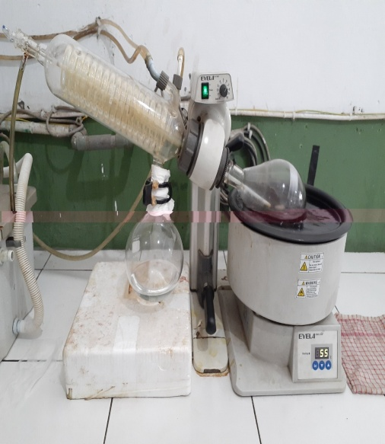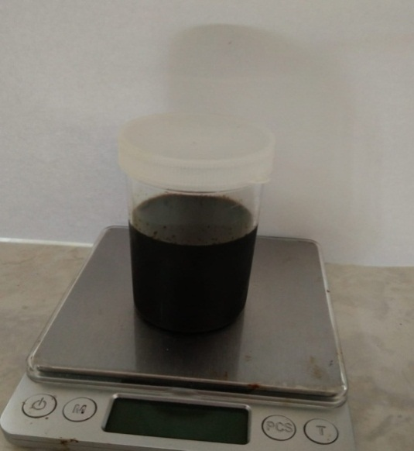
Vacum Rotary Evaporator Ekstrak kental
Lampiran 6. Perhitungan Rendemen Daun Sirsak
% Rendemen Ekstrak $\frac{berat ekstrak yang diperoleh }{berat bahan sebelum diekstrak } x 100\%$

Berat sampel = 500 gram
Berat ekstrak etanol = 80,00 gram
% Rendemen Ekstrak Daun Sirsak$\frac{80.00}{500}×100 \%=16 \%$

Lampiran 7. Makroskopik Daun Sirsak (Annona muricata L.)
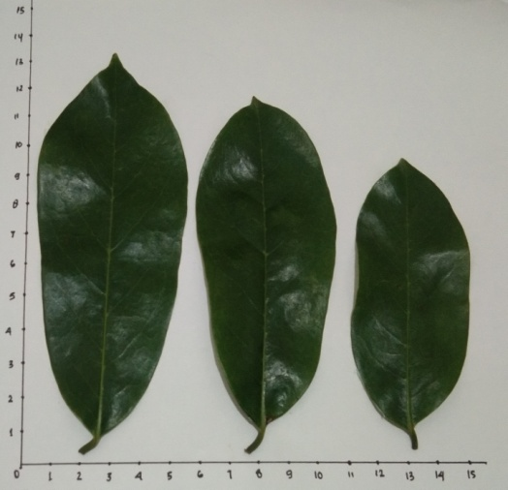
Lampiran 8. Mikroskopik Daun Sirsak ( Annona muricata L.)
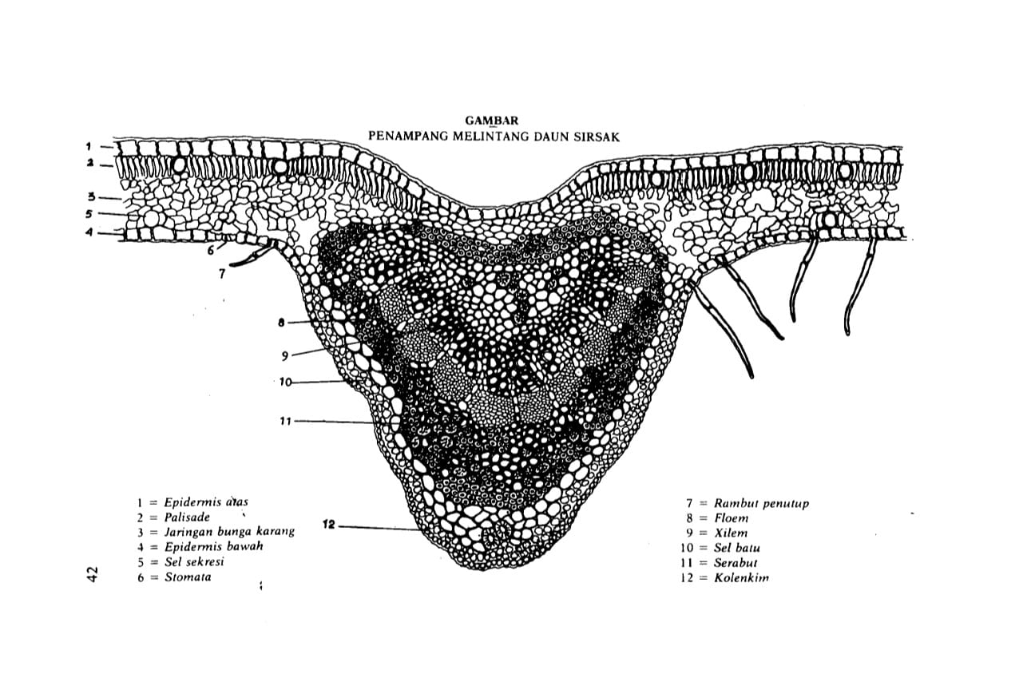
(Materia Medika Indonesia Jilid V,1989)
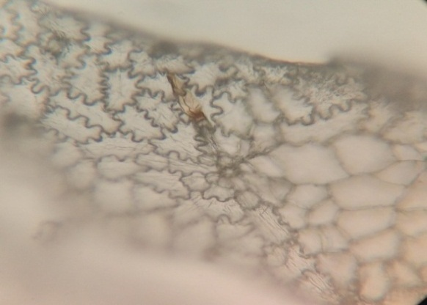
Sel sekresi
Epidermis atas
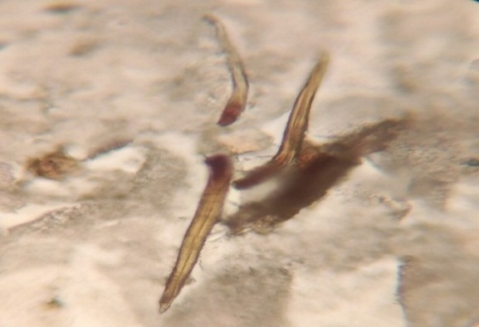
Rambut penutup
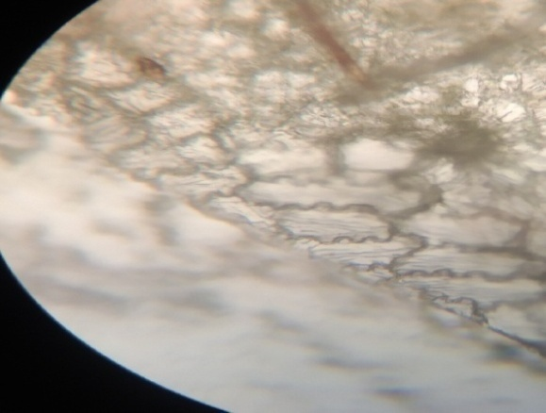
Lampiran 9. Uji Karakterisasi Simplisia Daun Sirsak
Pembuluh kayu
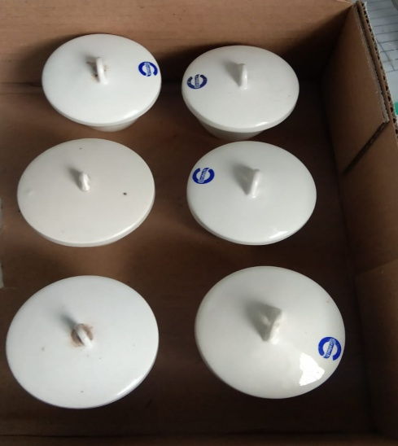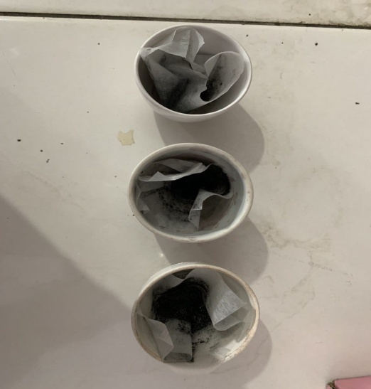
Kadar abu total Kadar abu tidak larut asam
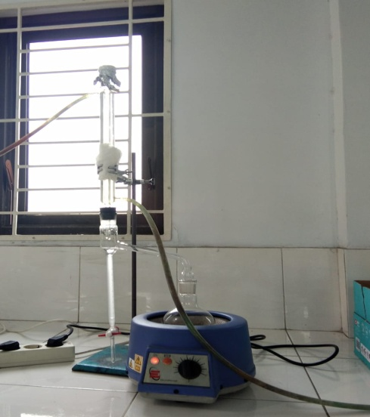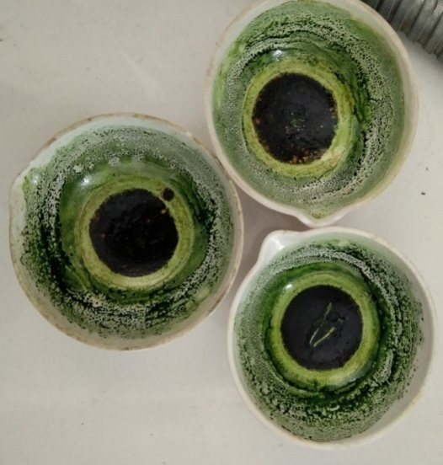
Penetapan kadar air Kadar sari larut etanol
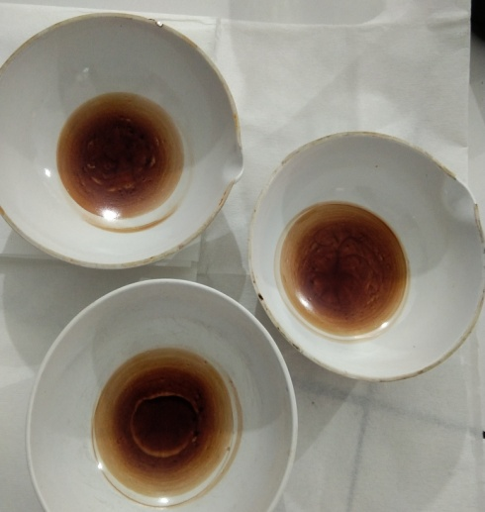
Kadar sari larut dalam air
Lampiran 10. Perhitungan Karakteristik Ekstrak Etanol Daun Sirsak
- Penetapan kadar air ( MMI tidak lebih dari 10 % )
$$kadar air \frac{volume air ( mL ) }{berat sampel }×100\%$$

- Sampel I
Berat sampel = 5 g
Volume I = 1,7 mL
Volume II = 2.1 mL
Kadar air $=\frac{2,1-1,7}{5}×100\%=8\%$
- Sampel II
Berat sampel = 5 g
Volume I = 1,9 ml
Volume II = 2.2 mL
Kadar air $=\frac{2,2-1,9}{5}×100\%=6\%$
- Sampel III
Berat sampel = 5 g
Volume I = 1,7 mL
Volume II = 2.2 mL
Kadar air $=\frac{2,2-1,7}{5}×100\%=10\%$
Kadar air rata-rata$=\frac{8+6+10}{3}=8\%$

- Penetapan kadar sari larut air ( MMI tidak kurang dari 18 % )
$$kadar sari larut dalam air \frac{berat sari }{berat sampel }×5×100\%$$

- Sampel I
Berat sampel = 5 g
Berat sari = 0,2922
Kadar sari larut dalam air $=\frac{0,2922}{5}×5×100\%=29,22\%$
- Sample II
Berat sampel = 5 g
Berat sari = 0,2866
Kadar sari larut dalam air $=\frac{0,2866}{5}×5×100\%=28,66\%$
- Sampel III
Berat sampel = 5 g
Berat sari = 0,2591
Berat sari larut dalam air $=\frac{0.2591}{5}×5×100\%=25,91\%$
Kadar sari larut air rata-rata $=\frac{29.22+28,66+25,91}{3}=27,93\%$

- Kadar sari larut etanol ( MMi tidak kurang dari 12 % )
Kadar sari larut etanol $=\frac{berat sari }{berat sampel}×5×100\%$

- Sampel I
Berat sampel = 5 g
Berat sari = 0,1781
Kadar sari larut dalam etanol $=\frac{0.1781}{5}×5×100\%=17,81$
- Sampel II
Berat sampel = 5 g
Berat sari = 0,1986
Kadar sari larut dalam etanol $=\frac{0,1986}{5}×5×100\%=19,86\%$
- Sampel III
Berat sampel = 5 g
Berat sari = 0.1763
Kadar sari larut dalam etanol $=\frac{0,1763}{5}×5×100\%=17,63\%$
Kadar sari larut etanol rata-rata $=\frac{17,81+19,86+17,63}{3}=18,43\%$

- Kadar abu total ( MMI tidak lebih dari 6% )
Kadar abu total $=\frac{berat abu }{berat sampel}×100\%$

- Sampel I
Berat sampel = 5 g
Berat abu = 0,0928
Kadar abu total$=\frac{0.0928}{2}×100\%=4,64\%$
- Sampel II
Berat sampel = 5 g
Berat abu = 0,1186
Kadar abu total $=\frac{0.1186}{5}×100\%=5,93\%$
- Sampel III
Berat sampel = 5 g
Berat abu = 0,0809
Kadar abu total $=\frac{0,0809}{5}×100\%=4,04\%$
Kadar sari larut etanol rata-rata $=\frac{4,64+5,93+4,04}{3}=4,87\%$

- kadar abu tidak larut asam ( MMI tidak Lebih Dari 1,5 % )
$$kadar abu tidak larut asam=\frac{Berat abu}{Berat sampel}×100\%$$

- Sampel I
Berat sampel = 2
Berat abu = 0.002 g
Kadar abu tidak larut asam$=\frac{0.002}{2}×100\%=0,1\%$
- Sampel II
Berat sampel = 2
Berat abu = 0,050 g
Kadar abu tidak larut asam$=\frac{0,050}{2}×100\%=2,5\%$
- Sampel III
Berat sampel = 2
Berat abu = 0.012 g
Kadar abu tidak larut asam$=\frac{0.012}{2}×100\%=0,6\%$
Kadar a bu tidak larut asam rata-rata $=\frac{0,1+2,5+0,6}{3}=1,06\%$

Lampiran 11 . Hasil Skrining Fitokimia
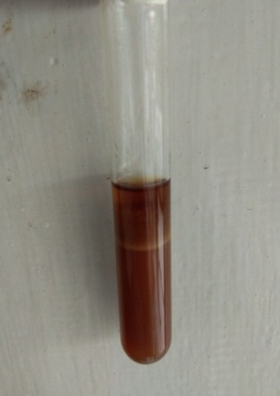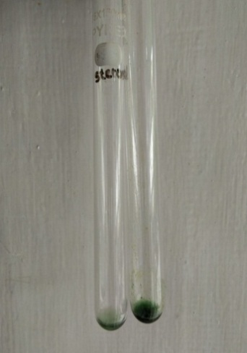
Flavonoid ( + ) Steroid (+)
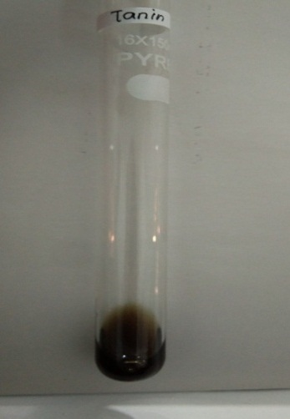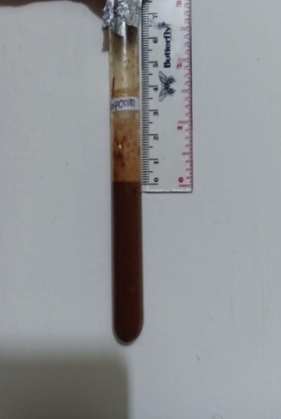
Tanin ( + ) Saponin ( + )
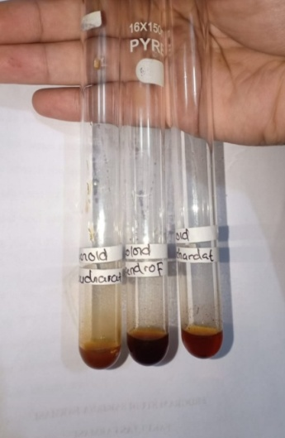
Alkaloid ( - )

Lampiran 12. Bagan Alir Pembuatan Hidrogel
HPMC
Nipagin

ditambahkan aquades panas Ditambahkan aquadest panas
diaduk hingga homogen Gerus hingga mengembang dan membentuk gel transparan
Tambahkan gliserin dan propilenglikol
Gerus sampai homgen.
Massa 2
Massa 1

Massaa 3

Tambahkan ekstrak daun sirsak sedikit-demi sedikit lalu gerus sampai homogen
Oleskan pada plester Miocropore yang telah dipotong
Diamkan hingga membentuk konstituen padat
Lalu dilapisi dengan plastik wrapping
Plseter ekstrak daun sirsak

Lampiran 13. Bagan Alir Penurunan Suhu Tubuh Pada Mencit
25 ekor mencit

diaklimasi selama 2 minggu
diberi penanda pada setiap ekor mencit
dipuasakan selama 18 jam
dicukur bulu padabagian perut
diukur suhu tubuh normal dengan thermometer
diinduksi dengan vaksi DPT-HB sebanyak 0,2 ml
diukur suhu tubuh demam

plester hidrogel ekstrak daun sirsak 10 g

plester hidrogel ekstrak daun sirsak 5 g
plester hidrogel ekstrak daun sirsak 7,5 g

kontrol plester hidrogel tanpa ekstrak

Diamati perubahan suhu tubuh menggunakan thermometer
Dicatat suhu rektal mencit setiap 15 menit selama 60 menit.
Penurunan suhu demam

Lampiran 14. Hewan Uji Mencit (Mus muscullus)
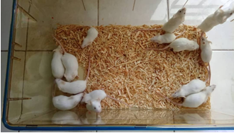
Lampiran 15. Tahapan Pengujian Plester Ekstrak Etanol Daun Sirsak Terhadap Penurunan Suhu Tubuh Pada Mencit
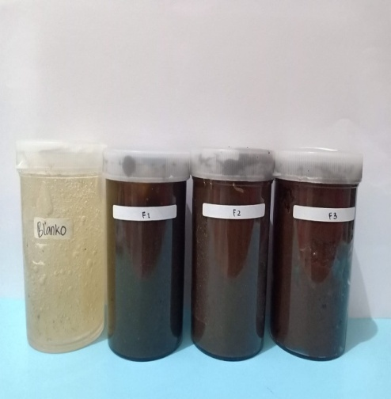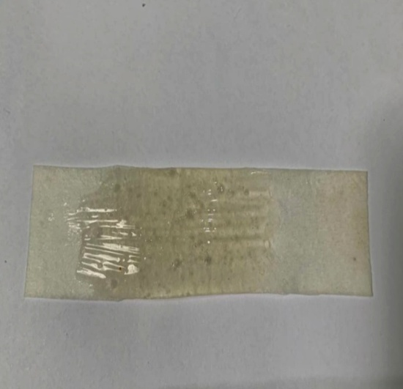
Sediaan Hidrogel Plester hidrogel tanpa ekstrak
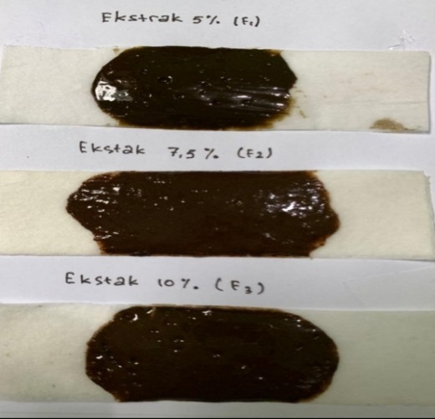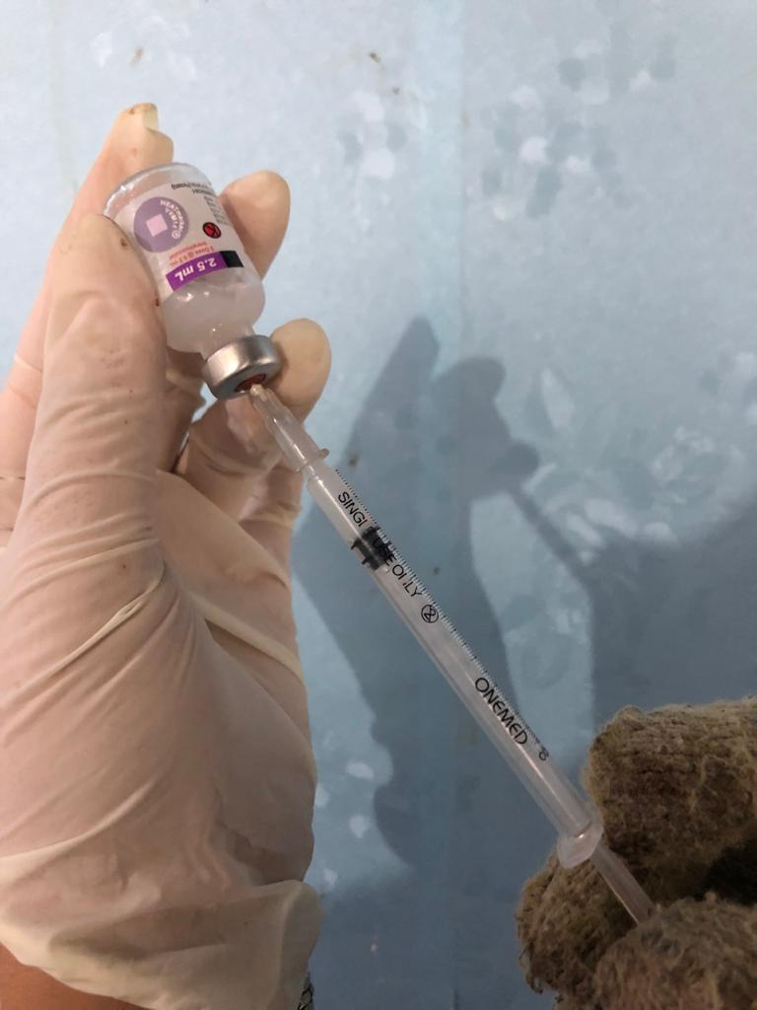
Plester ekstrak daun sirsak Vaksin DPT-HB
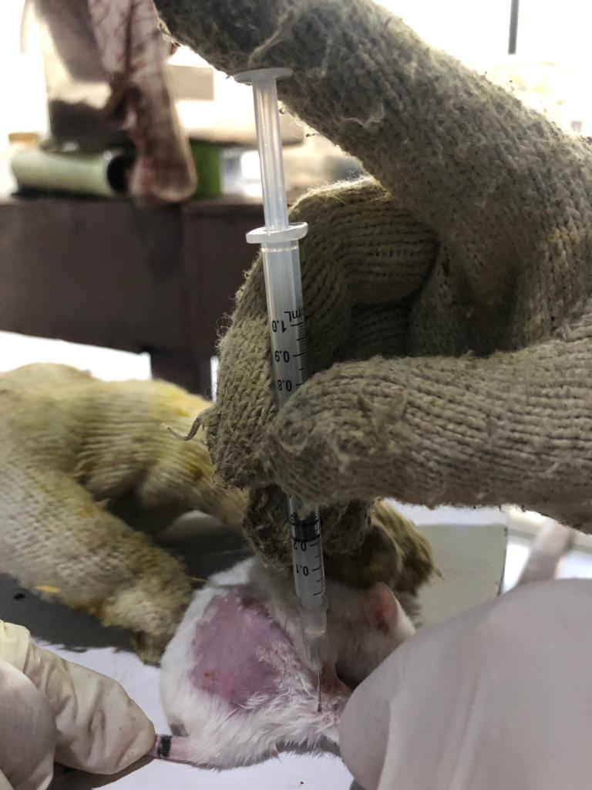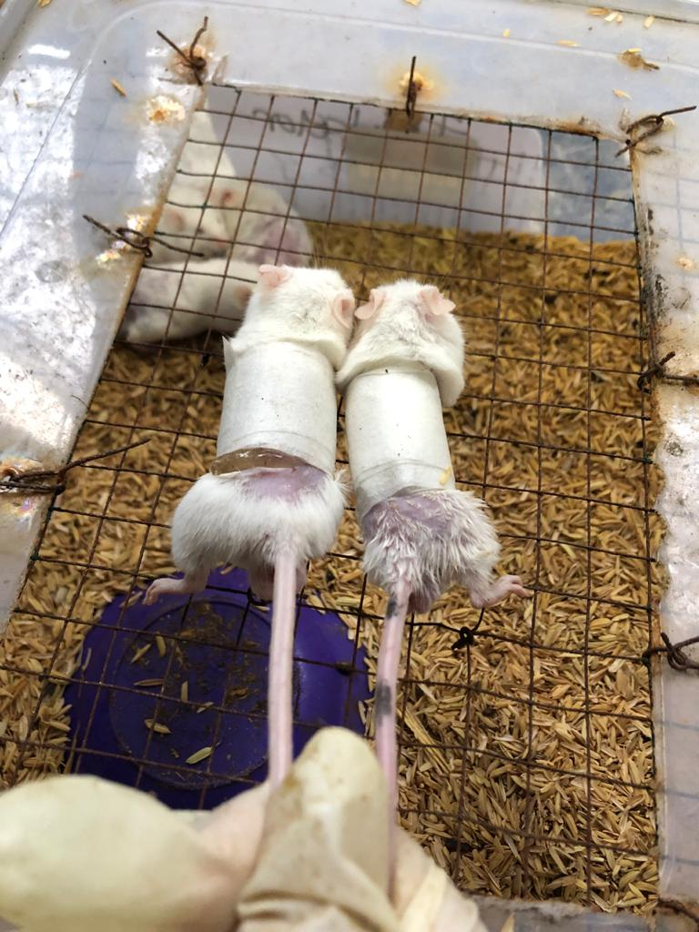
Induksi Vaksin DPT-HB secara IM Pengujian Plester
Lampiran 16. Data Hasil Uji Penurunan Suhu

Data Hasil Pengukuran Suhu Rektal Mencit Setelah Pemberian Vaksin DPT-HB 0,2 ml/Hewan Secara intramuscular dan Penurunan Suhu Pemberian Plester Hidrogel Ekstrak.
Mencit | Suhu awal°C | Suhu demam°C | Penurunan Suhu Rektal Mencit Setelah Pemberia Plester Hidrogel Tanpa Ekstrak Selama 60 Menit
 |  |  | 15 menit | 30 menit | 45 menit | 60 menit
I | 36,6 | 39,5 | 39,1 | 38,8 | 38,5 | 38,0
II | 37,0 | 39,7 | 39,3 | 39,1 | 38,9 | 38,6
III | 36,9 | 40,0 | 39,9 | 39,2 | 39,1 | 39,0
IV | 37,0 | 39,7 | 39,5 | 39,1 | 38,9 | 38,7
V | 36,4 | 39,9 | 39,7 | 39,5 | 39,1 | 38,5°
Rata-rata | 36,7 | 39,1 | 39,5 | 39,1 | 38,9 | 38,5
SD | 0.26 | 0.19 | 0.31 | 0.25 | 0.24 | 0.36

Mencit | Suhu awal  °C | Suhu demam °C | Penurunan Suhu Rektal Mencit Setelah Pemberian Plester Hidrogel Ekstal Daun Sirsak ( 5g ) Selama 60 menit
 |  |  | 15 menit | 30 menit | 45 menit | 60 menit
I | 36,5 | 39,9 | 38,9 | 38,4 | 37,6 | 37,3
II | 37,1 | 39,4 | 38,7 | 38,3 | 37,6 | 37,5
III | 36,7 | 39,8 | 38,8 | 38,2 | 37,8 | 37,4
IV | 36,3 | 40,1 | 39,2 | 38,7 | 37,5 | 37,1
V | 36,8 | 39,7 | 39,1 | 38,5 | 38,2 | 37,8
Rata-rata | 36,6 | 39,7 | 38,9 | 38,4 | 37,7 | 37,4
SD | 0.30 | 0.25 | 0.20 | 0.19 | 0.27 | 0.25

Mencit | Suhu awal °C | Suhu demam °C | Penurunan Suhu Rektal Mencit Setelah Pemberian Plester Hidrogel Ekstal Daun Sirsak ( 7,5g ) Selama 60 menit
 |  |  | 15menit | 30menit | 45menit | 60menit
I | 37,6 | 40,1 | 38,7 | 38,1 | 37,1 | 37,0
II | 36,7 | 39,9 | 38,8 | 38,2 | 37,5 | 36,9
III | 36,9 | 39,8 | 38,7 | 38,4 | 37,7 | 37,1
IV | 36,8 | 39,9 | 38,5 | 38,0 | 37,4 | 36,9
V | 36,4 | 39,5 | 38,4 | 38,1 | 37,6 | 37,0
Rata-rata | 36,8 | 39,8 | 38,6 | 38,1 | 37,4 | 36,9
SD | 0.443 | 0.21 | 0.16 | 0.15 | 0.23 | 0.08

Mencit | Suhu awal °C | Suhu demam °C | Penurunan Suhu Rektal Mencit Setelah Pemberian Plester Hidrogel Ekstal Daun Sirsak ( 10g ) Selama 60 menit
 |  |  | 15menit | 30menit | 45menit | 60menit
I | 37,1 | 40,3 | 38,5 | 37,9 | 37,5 | 37,3
II | 36,5 | 39,1 | 38,2 | 37,8 | 37,1 | 36,9
III | 36,5 | 39,6 | 38,4 | 37,2 | 37,0 | 36,7
IV | 36,7 | 39,9 | 38, 7 | 37,7 | 37,3 | 36,9
V | 36,9 | 39,7 | 38,8 | 37,8 | 37,2 | 36,6
Rata-rata | 36,7 | 39,7 | 38,5 | 37,6 | 37,2 | 36,8
SD | 0.26 | 0.43 | 0.25 | 0.27 | 0.19 | 0.26

Mencit | Suhu awal °C | Suhu demam °C | Penuruanan Suhu Rektal Mencit Setelah Pemberian plester Bye-Bye Fever Selama 60 menit
 |  |  | 15 menit | 30menit | 45menit | 60menit
I | 36,7 | 39,2 | 38,8 | 37,9 | 37,1 | 36,9
II | 36,9 | 39,0 | 38,2 | 37,1 | 36,6 | 36,3
III | 36,1 | 39,1 | 38,5 | 37,5 | 36,9 | 36,5
IV | 36,5 | 39,7 | 38,7 | 37,4 | 36,7 | 36,4
V | 36,8 | 39,3 | 38,7 | 37,7 | 36,5 | 36,4
Rata-rata | 36,6 | 39,2 | 38,4 | 37,5 | 36,7 | 36,4
SD | 0.31 | 0.27 | 0.23 | 0.30 | 0.24 | 0.23

Lampiran 17. Hasil UJI ANNOVA
- Hasil Uji Annova
ANOVA
 |  | Sum of Squares | df | Mean Square | F | Sig.
Suhu awal | Between Groups | .222 | 4 | .055 | .524 | .720
 | Within Groups | 2.116 | 20 | .106
 | Total | 2.338 | 24
Suhu demam | Between Groups | 1.098 | 4 | .275 | 3.285 | .032
 | Within Groups | 1.672 | 20 | .084
 | Total | 2.770 | 24
15 m | Between Groups | 4.244 | 4 | 1.061 | 17.451 | .000
 | Within Groups | 1.216 | 20 | .061
 | Total | 5.460 | 24
30 m | Between Groups | 8.326 | 4 | 2.081 | 35.640 | .000
 | Within Groups | 1.168 | 20 | .058
 | Total | 9.494 | 24
45 m | Between Groups | 12.890 | 4 | 3.222 | 56.336 | .000
 | Within Groups | 1.144 | 20 | .057
 | Total | 14.034 | 24
60 m | Between Groups | 12.414 | 4 | 3.103 | 44.082 | .000
 | Within Groups | 1.408 | 20 | .070
 | Total | 13.822 | 24

- Hasil Uji Homogen
Test of Homogeneity of Variances
 | Levene Statistic | df1 | df2 | Sig.
Suhu awal | .173 | 4 | 20 | .949
Suhu demam | .627 | 4 | 20 | .648
15 m | .646 | 4 | 20 | .636
30 m | .436 | 4 | 20 | .781
45 m | .176 | 4 | 20 | .948
60 m | 1.496 | 4 | 20 | .241

Lampiran 17. ( lanjutan )
- Hasil Uji Normalitas
Tests of Normality
 | Perlakuan | Kolmogorov-Smirnovª |  |  | Shapiro-Wilk
 |  | Statistic | Df | Sig. | Statistic | df | Sig.
Suhu awal | F0 | .273 | 5 | .200* | .852 | 5 | .201
 | F1 | .146 | 5 | .200* | .992 | 5 | .985
 | F2 | .282 | 5 | .200* | .908 | 5 | .455
 | F3 | .221 | 5 | .200* | .902 | 5 | .421
 | Pembanding | .224 | 5 | .200* | .912 | 5 | .482
Suhu demam | F0 | .221 | 5 | .200* | .953 | 5 | .758
 | F1 | .179 | 5 | .200* | .984 | 5 | .955
 | F2 | .228 | 5 | .200* | .932 | 5 | .607
 | F3 | .192 | 5 | .200* | .985 | 5 | .962
 | Pembanding | .241 | 5 | .200* | .903 | 5 | .427
15 m | F0 | .136 | 5 | .200* | .987 | 5 | .967
 | F1 | .180 | 5 | .200* | .952 | 5 | .754
 | F2 | .287 | 5 | .200* | .914 | 5 | .490
 | F3 | .175 | 5 | .200* | .974 | 5 | .899
 | Pembanding | .267 | 5 | .200* | .939 | 5 | .656
30 m | F0 | .237 | 5 | .200* | .950 | 5 | .740
 | F1 | .141 | 5 | .200* | .979 | 5 | .928
 | F2 | .254 | 5 | .200* | .914 | 5 | .492
 | F3 | .329 | 5 | .082 | .778 | 5 | .053
 | Pembanding | .146 | 5 | .200* | .992 | 5 | .985
45 m | F0 | .300 | 5 | .161 | .833 | 5 | .146
 | F1 | .292 | 5 | .190 | .845 | 5 | .180
 | F2 | .197 | 5 | .200* | .943 | 5 | .685
 | F3 | .141 | 5 | .200* | .979 | 5 | .928
 | Pembanding | .198 | 5 | .200* | .957 | 5 | .787
60 m | F0 | .183 | 5 | .200* | .985 | 5 | .961
 | F1 | .197 | 5 | .200* | .943 | 5 | .685
 | F2 | .231 | 5 | .200* | .881 | 5 | .314
 | F3 | .270 | 5 | .200* | .916 | 5 | .502
 | Pembanding | .241 | 5 | .200* | .903 | 5 | .427
*. This is a lower bound of the true significance.
a. Lilliefors Significance Correction

Lampiran 17. (lanjutan)
- Hasil Uji Tukey
Suhu awal
Tukey HSDª
Perlakuan | N | Subset for alpha = 0.05
 |  | 1
Pembanding | 5 | 36.600
F1 | 5 | 36.680
F3 | 5 | 36.740
F0 | 5 | 36.780
F2 | 5 | 36.880
Sig. |  | .658
Means for groups in homogeneous subsets are displayed.
a. Uses Harmonic Mean Sample Size = 5.000.

Suhu demam
Tukey HSDª
Perlakuan | N | Subset for alpha = 0.05
 |  | 1 | 2
Pembanding | 5 | 39.260
F3 | 5 | 39.720 | 39.720
F0 | 5 | 39.760 | 39.760
F1 | 5 | 39.780 | 39.780
F2 | 5 |  | 39.840
Sig. |  | .068 | .963
Means for groups in homogeneous subsets are displayed.
a. Uses Harmonic Mean Sample Size = 5.000.

15 m
Tukey HSDª
Perlakuan | N | Subset for alpha = 0.05
 |  | 1 | 2 | 3
Pembanding | 5 | 38.320
F3 | 5 | 38.520 | 38.520
F2 | 5 | 38.620 | 38.620
F1 | 5 |  | 38.940
F0 | 5 |  |  | 39.500
Sig. |  | .337 | .091 | 1.000
Means for groups in homogeneous subsets are displayed.
a. Uses Harmonic Mean Sample Size = 5.000.

30 m
Tukey HSDª
Perlakuan | N | Subset for alpha = 0.05
 |  | 1 | 2 | 3
Pembanding | 5 | 37.520
F3 | 5 | 37.680
F2 | 5 |  | 38.160
F1 | 5 |  | 38.420
F0 | 5 |  |  | 39.140
Sig. |  | .831 | .455 | 1.000
Means for groups in homogeneous subsets are displayed.
a. Uses Harmonic Mean Sample Size = 5.000.

45 m
Tukey HSDª
Perlakuan | N | Subset for alpha = 0.05
 |  | 1 | 2 | 3 | 4
Pembanding | 5 | 36.760
F3 | 5 |  | 37.220
F2 | 5 |  | 37.460 | 37.460
F1 | 5 |  |  | 37.740
F0 | 5 |  |  |  | 38.900
Sig. |  | 1.000 | .522 | .374 | 1.000
Means for groups in homogeneous subsets are displayed.
a. Uses Harmonic Mean Sample Size = 5.000.

60 m
Tukey HSDª
Perlakuan | N | Subset for alpha = 0.05
 |  | 1 | 2 | 3 | 4
Pembanding | 5 | 36.460
F3 | 5 | 36.880 | 36.880
F2 | 5 |  | 36.980 | 36.980
F1 | 5 |  |  | 37.440
F0 | 5 |  |  |  | 38.520
Sig. |  | .130 | .974 | .083 | 1.000
Means for groups in homogeneous subsets are displayed.
a. Uses Harmonic Mean Sample Size = 5.000.

