Lampiran 1. Surat Permohonan Izin Melaksanakan Penelitian dari Fakultas Kepada Laboratorium Farmasi Terpadu

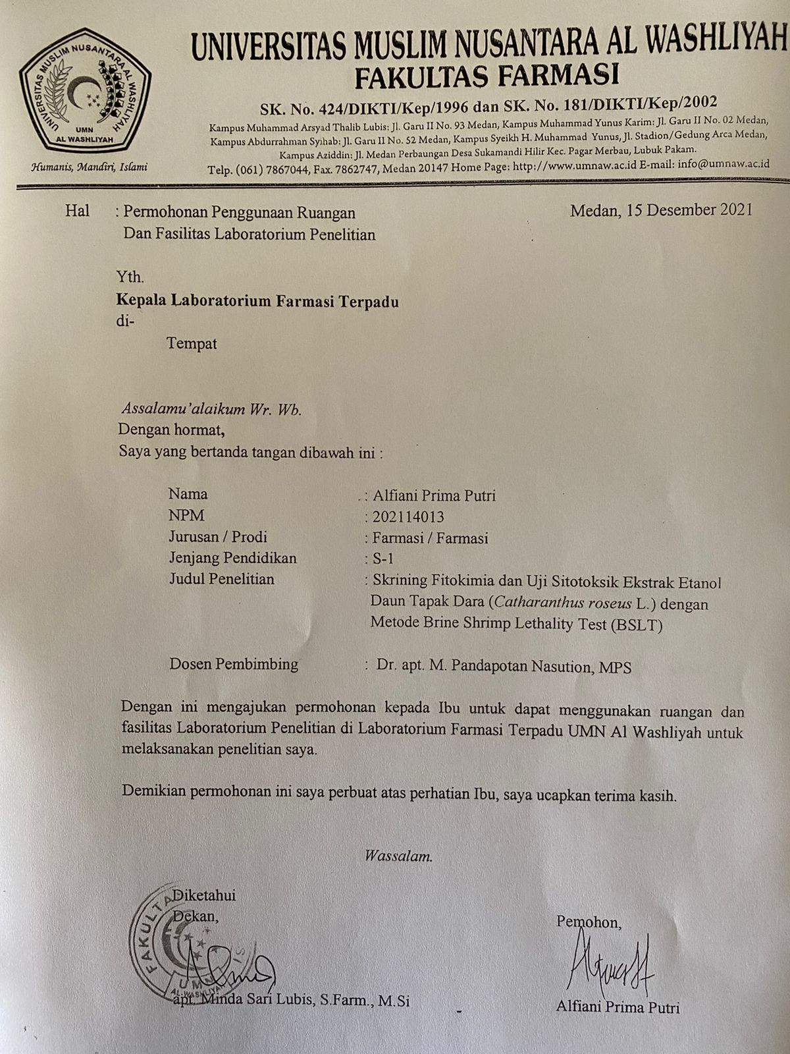

Lampiran 2. Surat Permohonan Determinasi

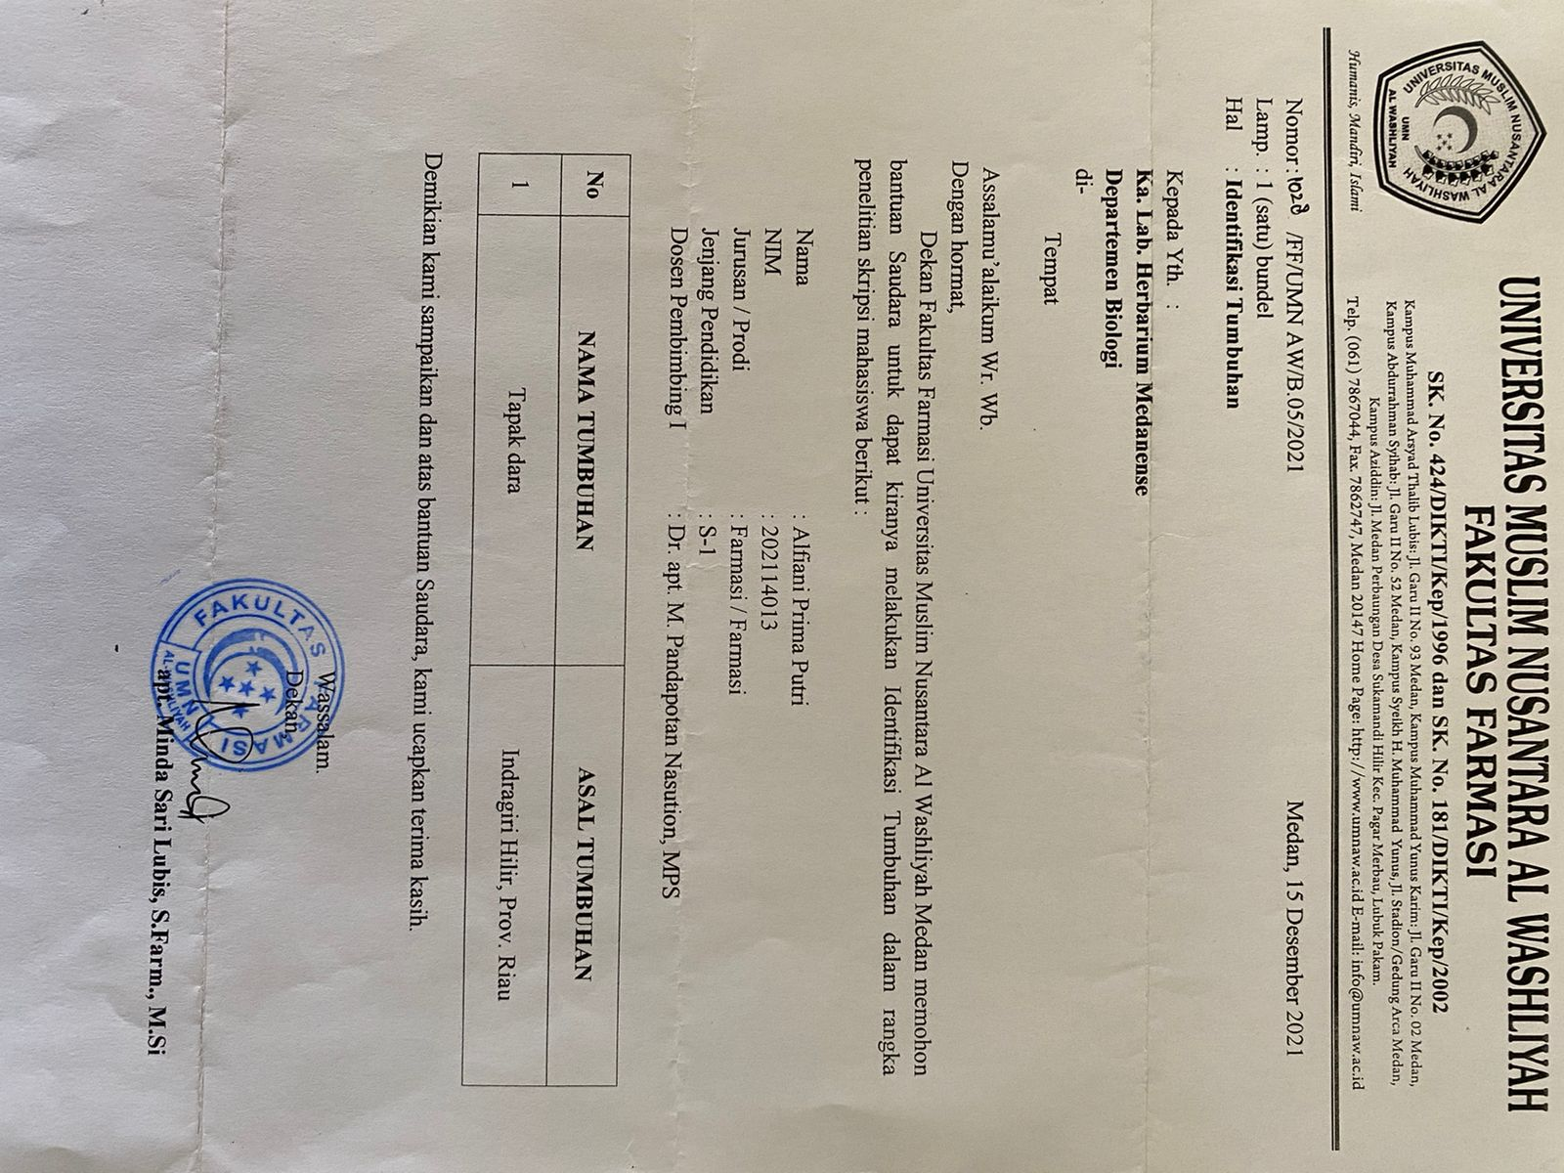

Lampiran 3. Hasil Identifikasi Tumbuhan

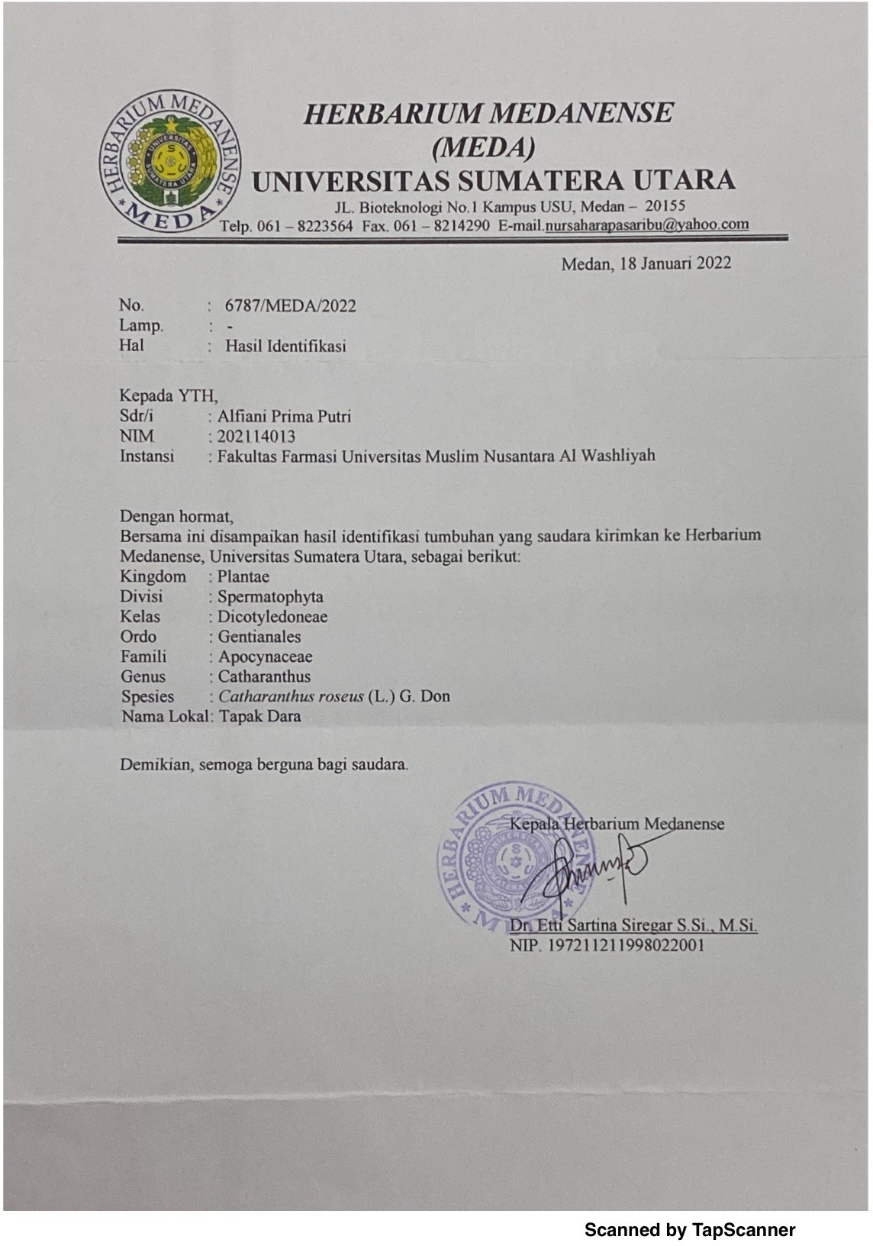

Lampiran 4. Bagan Alir Pembuatan Simplisia Daun Tapak Dara (*Catharanthus roseus* L.)

Daun Tapak Dara

dibersihkan

dicuci dan ditiriskan

dikeringkan dalam lemari pengering

disortasi kering

Simplisia Tapak Dara

dihaluskan menggunakan blender

lalu diayak

Serbuk simplisia daun tapak dara

Lampiran 5. Bagan Karakterisasi Simplisia Daun Tapak Dara (*Catharanthus roseus* L.)

* Kadar air
* Kadar sari larut air
* Kadar sari larut etanol
* Kadar abu total
* Kadar abu tidak larut asam

Pemeriksaan

Mikroskopik

Pemeriksaan

Makroskopik

Simplisia simplisia daun tapak dara

Lampiran 6. Bagan Pembuatan Ekstrak Etanol Daun Tapak Dara (*Catharanthus roseus* L.)

Serbuk Simplisia

ditimbang 500 gram

dimasukkan dalam bejana

ditambahkan 75 bagian etanol 96% (3750 ml) diamkan selama 5 hari

Diaduk sesekali dan disaring

Maserat I

Ampas I

Dibilas dengan 25 bagian

pelarut yaitu 1250 ml etanol

96%

Maserat I dan II

dicampur

Maserat II

Diamkan selama 2 hari

Lalu di enap tuangkan

Maserat

Di pekatkan dengan *rotary evaporator*

Ekstrak Kental

Lampiran 7. Bagan Alir Skrining Fitokimia Simplisia dan Ekstrak Etanol Daun Tapak Dara (*Catharanthus roseus* L.)

Serbuk simplisia dan ekstrak tapak dara

Skrining fitokimia

Golongan saponin

Golongan glikosida

Golongan tanin

Golongan alkaloid

Golongan

Triterpenoid

/steroid

Golongan flavonoid

Lampiran 8. Bagan Alir Uji Aktivitas Sitotoksisitas dengan Metode *Brine Shrimp Lethality Test* (BSLT)

-Tambah 10 ekor larva udang

-Masukkan kedalam vial

-Lalu diambil beberapa mL larutan induk 2000 ppm sesuai yg di butuhkan tiap konsentrasi

-Tambah dengan air laut 10 mL

-masing – masing konsentrasi dibuat 3 kali perlakuan

-mortalitas dihitung setelah 24 jam perlakuan

100 ppm, 200 ppm, 300 ppm,400 ppm, 500 ppm, 600 ppm,700 ppm, 800 ppm, 900 ppm, 1000 ppm

Dibuat variasi konsentrasi

Larutan induk 2000 ppm

Dilarutkan 100 mL air laut

Timbang 0, 2 g ekstrak

Hitung LC50

Lampiran 9. Tumbuhan Daun Tapak Dara

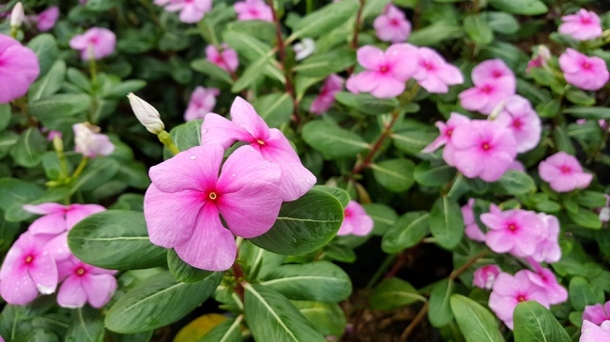

Tumbuhan Daun Tapak Dara (*Catharanthus roseus* L.)

Lampiran 10. Pengolahan Sampel Daun Tapak Dara (*Catharanthus roseus* L.)

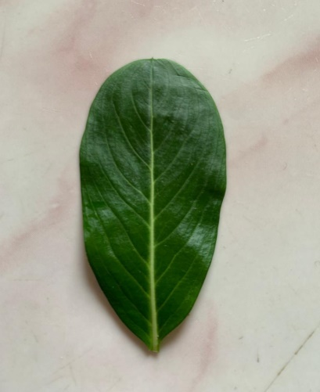 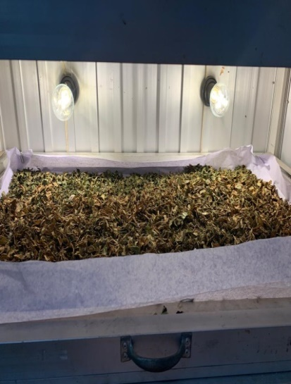

Pengeringan

Daun Tapak Dara

Lampiran 11. Dokumentasi Alur Ekstraksi Sampel Daun Tapak Dara (*Catharanthus roseus* L.)

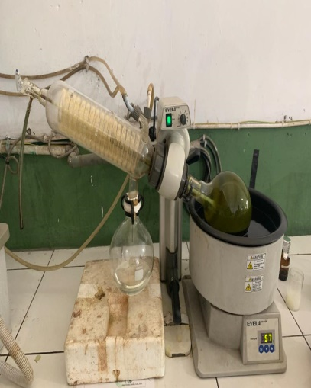 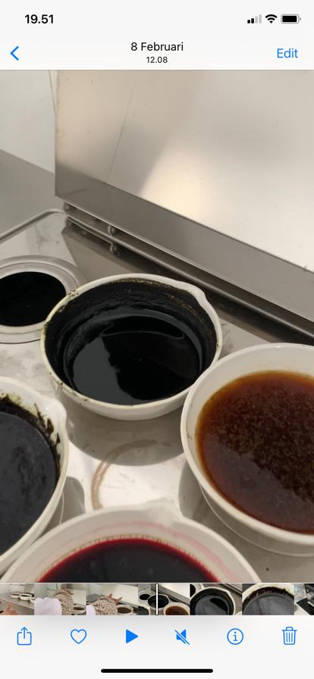

Penguapan

Rotary Evaporator

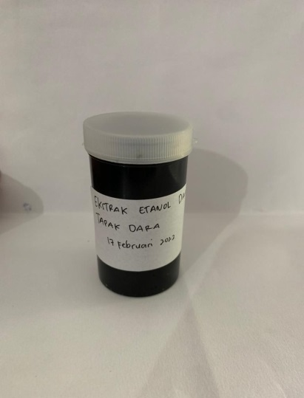

Ekstrak Daun Tapak Dara

Lampiran 12. Makroskopis Daun Tapak Dara (*Catharanthus roseus* L.)

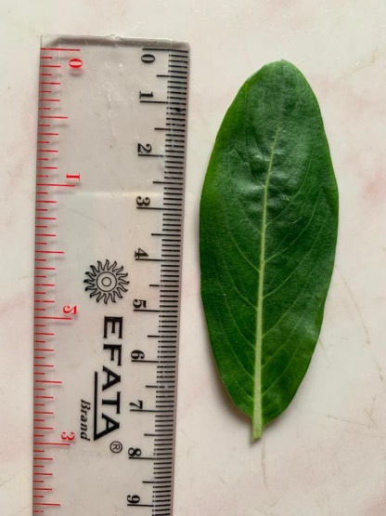

Panjang Daun Tapak Dara 7,5cm

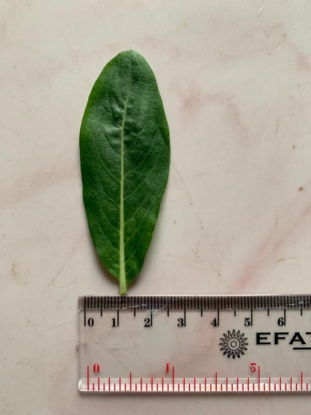

Lebar Daun Tapak Dara 2,5cm

Lampiran 13. Mikroskopis Daun Tapak Dara (*Catharanthus roseus* L.)

|  |  |  |
| --- | --- | --- |
| No | Hasil | Literatur (MMI,1995) |
| 1. | C:\Users\Asus\Downloads\WhatsApp Image 2022-06-14 at 21.59.36.jpeg  1 | C:\Users\Asus\Downloads\WhatsApp Image 2022-06-23 at 17.05.21.jpeg |
| 2. | C:\Users\Scom7\Downloads\PHOTO-2022-03-09-19-48-12.jpg  2 | C:\Users\Asus\Downloads\WhatsApp Image 2022-06-23 at 17.05.54.jpeg |

Keterangan gambar :

1. Rambut penutup
2. Stomata tipe anomositik

Lampiran 14. Perhitungan Susut Pengeringan Daun Tapak Dara (*Catharanthus roseus* L.)

Diketahui :

Bobot tumbuhan segar = 6.000 gram

Bobot simplisia = 656 gram

% susut pengeringan = $\frac{Berat tumbuhan segar-bobot simplisia}{berat tumbuhan segar}$ x 100%

% susut pengeringan = $\frac{6.000 gram-656 gram}{6.000 gram}$ x 100%

= 89 %

Lampiran 15. Perhitungan Rendemen Ekstrak Daun Tapak Dara (*Catharanthus roseus* L.)

Rendemen Ekstrak Daun Tapak Dara (*Catharanthus roseus* L.)

Berat simplisia = 500 gram

Berat ekstrak = 114,2465 gram

% Rendemen = $\frac{Berat Ekstrak Kental}{Berat Simplisia kering}$ x 100%

= $\frac{114,2465 gram}{500 gram }$ x 100%

= 22,84 %

Lampiran 16. Perhitungan Hasil Karakterisasi Daun Tapak Dara (*Catharanthus roseus* L.)

**1. Perhitungan Kadar Air**

$$Kadar air=\frac{Volume akhir air-Volume awal air}{Berat sample mula-mula (g)}x100\%$$

1. Sampel pengulangan I

Volume awal air (V1) = 1,5 ml

Volime akhir air (V2) = 1,8 ml

Berat sampel = 5 gram

Kadar air = $\frac{V2-V1}{Berat sampel}x 100\%$

= $\frac{1,8 ml – 1,5 ml}{5 gram}x 100\%$

= 6 %

1. Sampel pengulangan II

Volume awal air (V1) = 1,7 ml

Volime akhir air (V2) = 2,0 ml

Berat sampel = 5 gram

Kadar air = $\frac{V2-V1}{Berat sampel}x 100\%$

= $\frac{2,0 ml – 1,7 ml}{5 gram}x 100\%$

= 6 %

1. Sampel pengulangan III

Volume awal air (V1) = 1,5 ml

Volime akhir air (V2) = 1,9 ml

Berat sampel = 5 gram

**Lampiran 16.(** Lanjutan)

Kadar air = $\frac{V2-V1}{Berat sampel}x 100\%$

= $\frac{1,9 ml – 1,5 ml}{5 gram}x 100\%$

= 8 %

Rata-rata kadar air = $\frac{6\% + 6\%+8\%}{3}$

= 6,66 %

**2. Perhitungan Penetapan Kadar Sari Larut Air**

$$Kadar sari larut air=\frac{Berat sari setelah dikeringkan \left(g\right) x 100 mL }{Berat sample mula-mula \left(g\right)x 20 mL}x100\%$$

1. Pengulangan I

Berat cawan kosong = 30,4625 gram

Berat cawan + sari = 30,8413 gram

Berat sari kering = (Berat cawan + sari) – (Berat cawan kosong)

= 30,8413 gram –30,4625 gram

= 0,3788 gram

Kadar sari larut air = $\frac{0,3788 gram x 100 mL}{5 gram x 20 mL}x 100\%$

= 37,88 %

1. Pengulangan II

Berat cawan kosong = 38,6728 gram

Berat cawan + sari = 39,0562 gram

Berat sari kering = (Berat cawan + sari) – (Berat cawan kosong)

= 39,0562 gram –38,6728 gram

= 0,3834 gram

**Lampiran 16.(** Lanjutan)

Kadar sari larut air = $\frac{0,3834 gram x 100 mL}{5 gram x 20 mL}x 100\%$

= 38,34 %

1. Pengulangan III

Lampiran 14.( Lanjutan)

Berat cawan kosong = 35,4324 gram

Berat cawan + sari = 35,8172 gram

Berat sari kering = (Berat cawan + sari) – (Berat cawan kosong)

= 35,8172 gram –35,4324 gram

= 0,3849 gram

Kadar sari larut air = $\frac{0,3849 gram x 100 mL}{5 gram x 20 mL}x 100\%$

= 38,49 %

Rata-rata kadar sari larut air = $\frac{37,88 \% +38,34\%+38,49 \%}{3}$

= 38,23 %

**3. Perhitungan Penetapan Kadar Sari Larut Etanol**

$$Kadar sari larut etanol=\frac{Berat sari setelah dikeringkan \left(g\right) x 100 mL }{Berat sample mula-mula \left(g\right)x 20 mL}x100\%$$

1. Pengulangan I

Berat cawan kosong = 28,8876 gram

Berat cawan + sari = 29,1294 gram

Berat sari kering = (Berat cawan + sari) – (Berar cawan kosong)

= 29,1294 gram – 28,8876 gram

= 0,2418 gram

**Lampiran 16.(** Lanjutan)

Kadar sari larut etanol = $\frac{0,2418gram x 100 mL}{5 gram x 20 mL}x 100\%$

= 24,18 %

1. Pengulangan II

Berat cawan kosong = 28,9774 gram

Berat cawan + sari = 29,2268 gram

Berat sari kering = (Berat cawan + sari) – (Berar cawan kosong)

= 29,2268 gram – 28,9774 gram

= 0,2494 gram

Kadar sari larut etanol = $\frac{0,2494gram x 100 mL}{5 gram x 20 mL}x 100\%$

= 24,94 %

1. Pengulangan III

Berat cawan kosong = 33,6655 gram

Berat cawan + sari = 33,9199 gram

Berat sari kering = (Berat cawan + sari) – (Berar cawan kosong)

= 33,9199 gram – 33,6655 gram

= 0,2544 gram

Kadar sari larut etanol = $\frac{0,2494gram x 100 mL}{5 gram x 20 mL}x 100\%$

= 25,44 %

Rata-rata kadar sari larut etanol = $\frac{24,18 \% +24,94\%+25,,44 \%}{3}$

= 24,84 %

**Lampiran 16.(** Lanjutan)

**4. Perhitungan penetapan kadar abu total**

$$Kadar Abu Total=\frac{Berat abu yang diperoleh \left(g\right) }{Berat sample mula-mula (g)}x100\%$$

1. Pengulangan I

Berat krus kosong = 40,2529 gram

Berat krus + abu = 40,3821 gram

**Lampiran 14.** ( Lanjutan)

Berat abu = (Berat krus + abu) – (Berat krus kosong)

= 40,3821 gram – 40,2529 gram

= 0,1292 gram

Kadar Abu total = $\frac{0,1292 gram }{2 gram}x 100\%$

= 6,46 %

1. Pengulangan II

Berat krus kosong = 36,5901 gram

Berat krus + abu = 36,7199 gram

Berat abu = (Berat krus + abu) – (Berat krus kosong)

= 36,7199gram – 36,5901 gram

= 0,1298 gram

Kadar Abu total = $\frac{0,1298 gram }{2 gram}x 100\%$

= 6,49 %

**Lampiran 16.(** Lanjutan)

1. Pengulangan III

Berat krus kosong = 37,9228 gram

Berat krus + abu = 38,0412 gram

Berat abu = (Berat krus + abu) – (Berat krus kosong)

= 38,0412 gram – 37,9228 gram

= 0,1184 gram

Kadar Abu total = $\frac{0,1184 gram }{2 gram}x 100\%$

= 5,92 %

Rata-rata kadar Abu total = $\frac{6,46 \% +6,49 \%+5,92 \%}{3}$

= 6,29 %

**5. Perhitungan penetapan kadar abu tidak larut asam**

$$Kadar Abu Total=\frac{Berat abu sisa dipijar \left(g\right) }{Berat sample abu mula-mula (g)}x100\%$$

1. Pengulangan I

Berat krus kosong = 40,2529 gram

Berat krus + abu tidak larut asam = 40,2658 gram

Berat abu = (Berat krus + abu tidak larut asam) – (Berat krus kosong)

= 40,2658 gram – 40,2529 gram

= 0,0129 gram

Kadar Abu tidak larut asam = $\frac{0,0129 gram }{2 gram}x 100\%$

= 0,645 %

**Lampiran 16.(** Lanjutan)

1. Pengulangan II

Berat krus kosong = 36,5901 gram

Berat krus + abu tidak larut asam = 36,6034 gram

Berat abu = (Berat krus + abu tidak larut asam) – (Berat krus kosong)

= 36,6034 gram – 36,5901 gram

= 0,0133 gram

Kadar Abu tidak larut asam = $\frac{0,0133 gram }{2 gram}x 100\%$

= 0,665 %

**Lampiran 14.** ( Lanjutan)

1. Pengulangan III

Berat krus kosong = 37,9228 gram

Berat krus + abu tidak larut asam = 37,9366 gram

Berat abu = (Berat krus + abu tidak larut asam) – (Berat krus kosong)

= 37,9366 gram – 37,9228 gram

= 0,0138 gram

Kadar Abu tidak larut asam = $\frac{0,0138 gram }{2 gram}x 100\%$

= 0,69 %

Rata-rata kadar Abu tidak larut asam = $\frac{0,645 \% +0,665 \%+0,69\%}{3}$

= 0,66 %

Lampiran 17. Dokumentasi Skrining Fitokimia Ekstrak Dan Simplisia Daun Tapak Dara (*Catharanthus roseus* L.)

|  |  |  |  |  |  |
| --- | --- | --- | --- | --- | --- |
| **No** | **Golongan senyawa** | **Gambar** | | **Hasil Uji** | **Keterangan** |
| **Serbuk** | **Ekstrak** |
| 1. | Alkaloid |  |  | + | 1. Mayer   Terbentuk endapan kuning (+)   1. Buochardat   Terbentuk endapan berwarna coklat (+)   1. Dragendrof   Terbentuk endapan berwarna jingga (+)  (Depkes RI, 1995) |
| 2. | Flavonoid |  |  | + | Terbentuk lapisan jingga-merah pada lapisan alkohol  (Franswort, 1966). |
| 3. | Tanin |  |  | + | Terbentuk warna hijau kehitaman (Depkes RI, 1995). |
| 4. | Saponin |  |  | + | Terbentuk busa yang stabil (Depkes RI, 1995). |
| 5. | Steroid/Triterpenoid |  |  | + | Terbentuk warna biru hijau menunjukan adanya steroid (Depkes RI, 1995). |
| 6. | Glikosida | D:\SKRIPSI\ALFIANI SKRIPSI\foto skrining fitokima\WhatsApp Image 2022-03-30 at 00.05.18 (1).jpeg | D:\SKRIPSI\ALFIANI SKRIPSI\foto skrining fitokima\WhatsApp Image 2022-03-30 at 00.05.18.jpeg | - | Tidak terbentuk cincin berwarna ungu (Depkes RI, 1995). |

**Lampiran 18.** Uji Sitotoksisitas Ekstrak Daun Tapak Dara (Catharanthus roseus L.)

1. Penetasan telur artemia

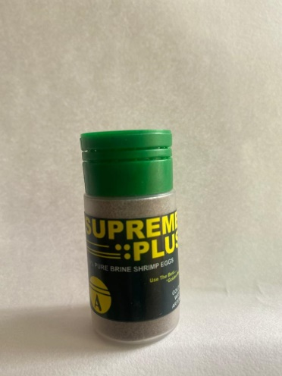

Telur artemia

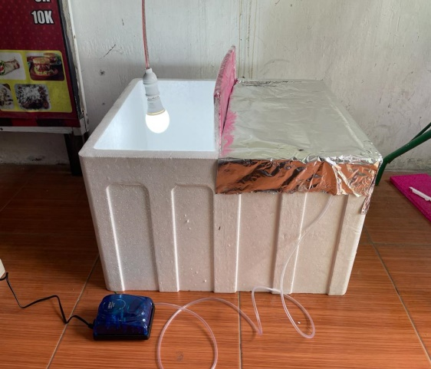

c

b

a

Proses penetasan

Keterangan :

1. Lampu *grow life*
2. Penghasil oksigen
3. Aquarium (Styrofoam)
4. Pengenceran ekstrak daun tapak dara dalam beberapa konsentrasi dan pengujian uji sitotoksisitas

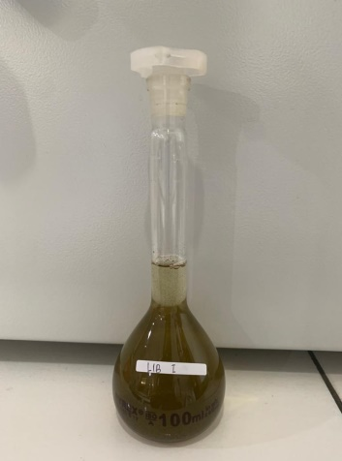 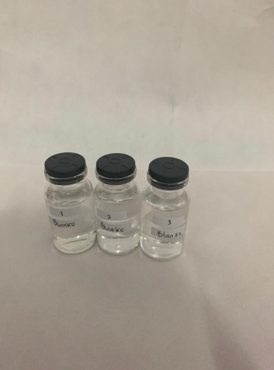 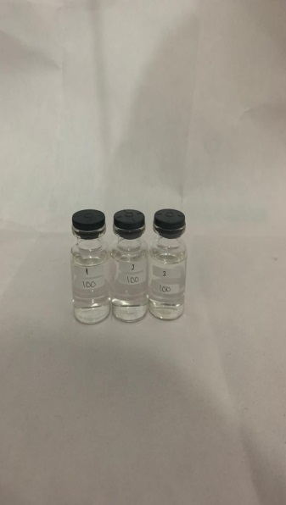

Larutan Induk Baku

Kontrol Negatif

100 ppm

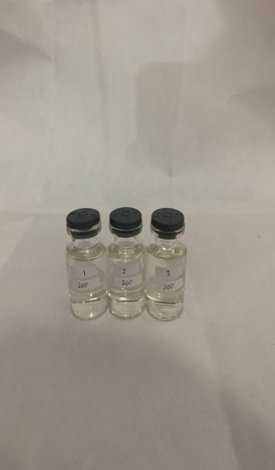 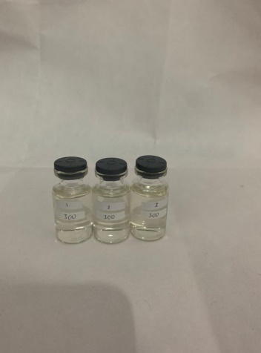 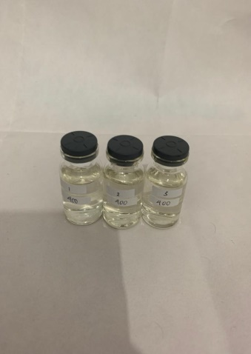

200 ppm

300 ppm

400 ppm

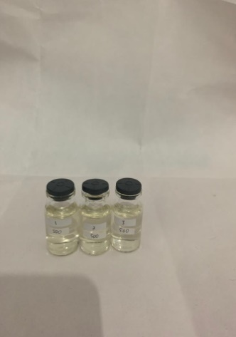 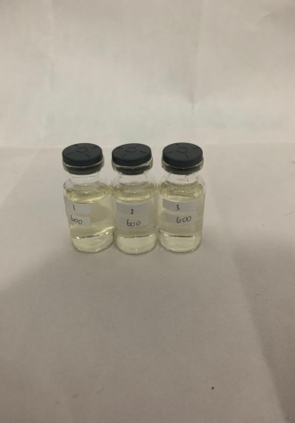 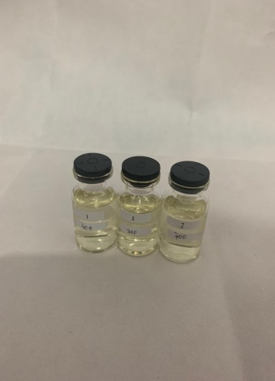

700 ppm

600 ppm

500 ppm

**Lampiran 18.** (Lanjutan)

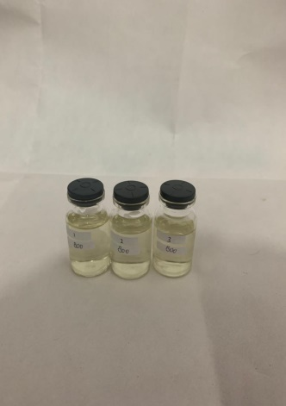 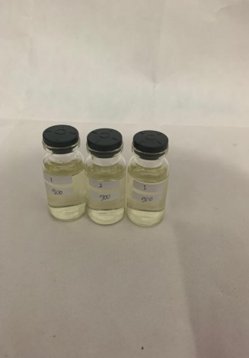 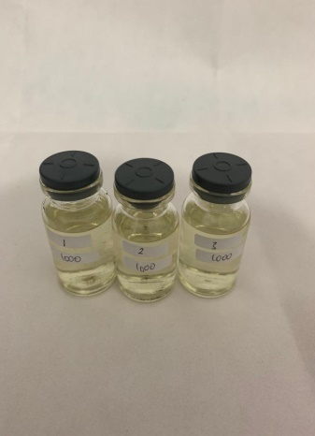

900 ppm

1000 ppm

800 ppm

Lampiran 19. Perhitungan Pembuatan Variasi Pengenceran Ekstrak Daun Tapak Dara (*Catharanthus roseus* L.)

LIB = 200 mg (200,000 µg / 100 mL) = 2000 µg/mL (2000 ppm)

1. 1000 µg/mL

V1.C1 = V2.C2

x. 2000 µg/mL = 10 ml.1000 µg/mL

x = $\frac{10000 µg }{2000 µg/mL }$ = 5 mL

1. 900 µg/mL

V1.C1 = V2.C2

x. 2000 µg/mL = 10 ml.900 µg/mL

x = $\frac{9000 µg }{2000 µg/mL }$ = 4,5 mL

1. 800 µg/mL

V1.C1 = V2.C2

x. 2000 µg/mL = 10 ml.800 µg/mL

x = $\frac{8000 µg }{2000 µg/mL }$ = 4 mL

1. 700 µg/mL

V1.C1 = V2.C2

x. 2000 µg/mL = 10 ml.700 µg/mL

x = $\frac{7000 µg }{2000 µg/mL }$ = 3,5 mL

1. 600 µg/mL

V1.C1 = V2.C2

x. 2000 µg/mL = 10 ml.600 µg/mL

x = $\frac{6000 µg }{2000 µg/mL }$ = 3 mL

**Lampiran 19. (**Lanjutan)

1. 500 µg/mL

V1.C1 = V2.C2

x. 2000 µg/mL = 10 ml.500 µg/mL

x = $\frac{5000 µg }{2000 µg/mL }$ = 2,5 mL

1. 400 µg/mL

V1.C1 = V2.C2

x. 2000 µg/mL = 10 ml.400 µg/mL

x = $\frac{4000 µg }{2000 µg/mL }$ = 2 mL

1. 300 µg/mL

V1.C1 = V2.C2

x. 2000 µg/mL = 10 ml.300 µg/mL

x = $\frac{3000 µg }{2000 µg/mL }$ = 1,5 mL

1. 200 µg/mL

V1.C1 = V2.C2

x. 2000 µg/mL = 10 ml.200 µg/mL

x = $\frac{2000 µg }{2000 µg/mL }$ = 1 mL

1. 100µg/mL

V1.C1 = V2.C2

x. 2000 µg/mL = 10 ml.100 µg/mL

x = $\frac{1000 µg }{2000 µg/mL }$ = 0,5 mL

Lampiran 20. Perhitungan LC50 Ekstrak Daun Tapak Dara (*Catharanthus roseus* L.)

% Kematian Larva = $\frac{Jumlah rata-rata larva yang mati }{jumlah larva uji} x 100 \%$

**Hasil Orientasi**

|  |  |  |  |  |  |  |  |
| --- | --- | --- | --- | --- | --- | --- | --- |
| **No** | **Konsentrasi (µg/mL)** | **Jumlah larva yang mati** | | | **Total** | **Rata-rata kematian larva** | **% Mortalitas** |
|
| **P1** | **P2** | **P3** |
| 1 | Blanko | 0 | 0 | 0 | 0 | 0 | 0% |
| 2 | 100 | 2 | 3 | 2 | 7 | 2,33 | 23,3% |
| 3 | 200 | 3 | 3 | 4 | 10 | 3,33 | 33,3% |
| 4 | 300 | 5 | 4 | 3 | 12 | 4 | 40% |
| 5 | 400 | 6 | 5 | 5 | 16 | 5,33 | 53,3% |
| 6 | 500 | 7 | 6 | 7 | 20 | 6,67 | 66,7% |
| 7 | 600 | 8 | 6 | 7 | 21 | 7 | 70% |
| 8 | 700 | 9 | 8 | 8 | 25 | 8,33 | 83,3% |
| 9 | 800 | 9 | 9 | 9 | 27 | 9 | 90% |
| 10 | 900 | 10 | 10 | 10 | 30 | 10 | 100% |
| 11 | 1000 | 10 | 10 | 10 | 30 | 10 | 100% |

**Lampiran 20**. (Lanjutan)

**Hasil Pengujian**

|  |  |  |  |  |
| --- | --- | --- | --- | --- |
| **No** | **Konsentrasi**  **(µg/mL)** | **% Mortalitas** | **Log Konsentrasi** | **Nilai Probit** |
| 1. | 100 | 23,3% | 2,0000 | 4,2710 |
| 2. | 200 | 33,3% | 2,3010 | 4,5684 |
| 3. | 300 | 40% | 2,4771 | 4,7467 |
| 4. | 400 | 53,5% | 2,6020 | 5,0828 |
| 5. | 500 | 66,7% | 2,6989 | 5,4316 |
| 6. | 600 | 70% | 2,7781 | 5,5244 |
| 7. | 700 | 83,3% | 2,8450 | 5,9661 |

|  |  |  |  |  |  |  |
| --- | --- | --- | --- | --- | --- | --- |
| **No** | **D**  **(C(µg/mL)** | **P**  **(%mortalitas)** | **X (log C)** | **Y**  **(Nilai probit)** | **XY** | **X2** |
| 1. | 100 | 23,3% | 2,0000 | 4,2710 | 8,542 | 4,0000 |
| 2. | 200 | 33,3% | 2,3010 | 4,5684 | 10,5118 | 5,2946 |
| 3. | 300 | 40% | 2,4771 | 4,7467 | 11,7580 | 6,1360 |
| 4. | 400 | 53,3% | 2,6020 | 5,0828 | 13,2254 | 6,7704 |
| 5. | 500 | 66,7% | 2,6989 | 5,4316 | 14,6593 | 7,2840 |
| 6. | 600 | 70% | 2,7781 | 5,5244 | 15,3473 | 7,7178 |
| 7. | 700 | 83% | 2,8450 | 5,9661 | 16,9735 | 8,0940 |
| Jumlah | | | ∑X =  17,7021 | ∑Y =  35,591 | ∑XY=  91,0173 | ∑X2=  45,2968 |
| Rata-rata | | | 2,5288 | 5,0844 |  |  |

Keterangan :

D : Konsentrasi ekstrak

P : % Mortalitas

X : Log konsentrasi ekstrak

Y : Nilai probit

**Lampiran 20**. (Lanjutan)

Persamaan garis regresi linear :

Y = ax + b

Y = Konsentrasi Kematian

x = Log Konsentrasi

a = $\frac{ \left(∑xy\right)-(∑x∑y)/n}{ ∑x^{2}-{\left(∑x\right)}^{2}/n}$

a = $\frac{91,0173-\left(17,7021\right)(35,591/7}{45,2968-(17,7021)/7}$

a = $\frac{1,0123}{0,5305}$

a = 1,9081

b = Y – aX

b = 5,0844 – 1,9081 (2,5288)

b = 5,0844 – 4,8252

b = 0,2592

Nilai LC50 diperoleh dari antilog x dimana x merupakan logaritma konsentrasi bahan toksik pada Y = 5, yaitu nilai probit 50 % hewan uji. Sehingga persamaan regresi diperoleh: Y = 1,9081x + 0,2592

5 = 1,9081x + 0,2592

5 – 0,2592 = 1,9081x

4,7408 = 1,9081x

x = $\frac{4,7408}{1,9081}$

x = 2,4845

LC50 = Anti Log x

**=** 305,1406 µg/mL

**Lampiran 20**. (Lanjutan)

Maka nilai Lc50 antilog 2,4845 adalah 305,1406 µg/mL

Kurva Regresi Linier Antara Log Konsentrasi Ekstrak Etanol Daun Tapak Dara Dengan Nilai Probit, sebagai berikut :

**Lampiran 21.** Nilai Probit Sesuai dengan Besarnya Presentase Kematian (Priyanto, 2009)

|  |  |  |  |  |  |  |  |  |  |  |
| --- | --- | --- | --- | --- | --- | --- | --- | --- | --- | --- |
| Persen kematian (%) | **0,0** | **0,1** | **0,2** | **0,3** | **0,4** | **0,5** | **0,6** | **0,7** | **0,8** | **0,9** |
| **0** | - | 1.0098 | 2.1218 | 2.2522 | 2.3479 | 2.4242 | 2.4879 | 2.5427 | 2.5914 | 2.6344 |
| **1** | 2.6737 | 2.7096 | 2.7429 | 2.7738 | 2.8027 | 2.8299 | 2.8556 | 2.8799 | 2.3031 | 2.9251 |
| **2** | 2.9463 | 2.9665 | 2.9859 | 3.0646 | 3.0226 | 3.0400 | 3.0569 | 3.0732 | 3.0896 | 3.1043 |
| **3** | 3.1192 | 3.1337 | 3.1478 | 3.1616 | 3.1750 | 3.1881 | 3.2009 | 3.2134 | 3.2256 | 3.2376 |
| **4** | 3.2493 | 3.2608 | 3.2721 | 3.2831 | 3.2940 | 3.3046 | 3.3151 | 3.3253 | 3.3354 | 3.3454 |
| **5** | 3.3351 | 3.3668 | 3.3742 | 3.3836 | 3.3028 | 3.4018 | 3.4107 | 3.4195 | 3.4282 | 3.4368 |
| **6** | 3.4452 | 3.4536 | 3.4618 | 3.4694 | 3.4780 | 3.4850 | 3.4937 | 3.5015 | 3.5091 | 3.5167 |
| **7** | 3.5242 | 3.5316 | 3.5380 | 3.5462 | 3.5534 | 3.5605 | 3.5675 | 3.5745 | 3.5813 | 3.5882 |
| **8** | 3.5949 | 3.6016 | 3.6083 | 3.6148 | 3.6213 | 3.6278 | 3.6342 | 3.6405 | 3.6408 | 3.6427 |
| **9** | 3.6692 | 3.6654 | 3.6715 | 3.6775 | 3.6835 | 3.6894 | 3.6953 | 3.7012 | 3.7070 | 3.7127 |
| **10** | 3.7182 | 3.7241 | 3.7298 | 3.7354 | 3.7409 | 3.7464 | 3.7519 | 3.7574 | 3.7628 | 3.7681 |
| **11** | 3.7735 | 3.7784 | 3.7840 | 3.7893 | 3.7945 | 3.7996 | 3.8048 | 3.8099 | 3.8150 | 3.8200 |
| **12** | 3.8250 | 3.8300 | 3.8350 | 3.8399 | 3.8848 | 3.8497 | 3.8545 | 3.8503 | 3.8641 | 3.8689 |
| **13** | 3.8736 | 3.8783 | 3.8830 | 3.8877 | 3.8923 | 3.8969 | 3.9015 | 3.9061 | 3.9107 | 3.9152 |
| **14** | 3.9197 | 3.9242 | 3.9286 | 3.9331 | 3.9375 | 3.9419 | 3.9463 | 3.9506 | 3.9550 | 3.9593 |
| **15** | 3.9636 | 3.9678 | 3.9721 | 3.9763 | 3.9800 | 3.9848 | 3.9890 | 3.9931 | 3.9933 | 4.0014 |
| **16** | 4.0055 | 4.0096 | 4.0137 | 4.0178 | 4.0218 | 4.0259 | 4.0299 | 4.0339 | 4.0379 | 4.0410 |
| **17** | 4.0458 | 4.0408 | 4.0537 | 4.0576 | 4.0615 | 4.0693 | 4.0693 | 4.0731 | 4.0770 | 4.0808 |
| **18** | 4.0846 | 4.0884 | 4.0960 | 4.0960 | 4.0998 | 4.1035 | 4.1073 | 4.1110 | 4.1147 | 4.1184 |
| **19** | 4.1221 | 4.1258 | 4.1331 | 4.1331 | 4.1367 | 4.1404 | 4.1440 | 4.1476 | 4.1512 | 4.1548 |
| **20** | 4.1684 | 4.1019 | 4.1035 | 4.1690 | 4.1726 | 4.1761 | 4.1796 | 4.1831 | 4.1866 | 4.1901 |
| **21** | 4.1936 | 4.1970 | 4.2005 | 4.2039 | 4.2074 | 4.2108 | 4.2142 | 4.2176 | 4.2110 | 4.2244 |
| **22** | 4.2278 | 4.2312 | 4.2345 | 4.2379 | 4.2412 | 4.2446 | 4.2479 | 4.2512 | 4.2546 | 4.2579 |
| **23** | 4.2612 | 4.2644 | 4.2677 | **4.2710** | 4.2743 | 4.2275 | 4.2808 | 4.2840 | 4.2872 | 4.2905 |
| **24** | 4.2937 | 4.2969 | 4.3001 | 4.3033 | 4.3065 | 4.3097 | 4.3129 | 4.3160 | 4.3192 | 4.3324 |
| **25** | 4.3255 | 4.3287 | 4.3318 | 4.3349 | 4.3380 | 4.3412 | 4.3443 | 4.3474 | 4.3505 | 4.3536 |
| **26** | 4.3567 | 4.3597 | 4.3628 | 4.3659 | 4.3869 | 4.3720 | 4.3750 | 4.3781 | 4.3811 | 4.3842 |
| **27** | 4.3872 | 4.3902 | 4.3932 | 4.3962 | 4.3992 | 4.4022 | 4.4052 | 4.4082 | 4.4112 | 4.4142 |
| **28** | 4.4172 | 4.4201 | 4.4231 | 4.4260 | 4.4290 | 4.4319 | 4.4349 | 4.4378 | 4.4408 | 4.4437 |
| **29** | 4.4466 | 4.4405 | 4.4524 | 4.4554 | 4.4583 | 4.4612 | 4.4641 | 4.4670 | 4.4698 | 4.4727 |
| **30** | 4.4756 | 4.4785 | 4.4813 | 4.4842 | 4.4871 | 4.4899 | 4.4928 | 4.4956 | 4.4985 | 4.5013 |
| **31** | 4.5041 | 4.5070 | 4.5098 | 4.5126 | 4.5155 | 4.5183 | 4.2511 | 4.5239 | 4.5267 | 4.5295 |
| **32** | 4.5323 | 4.5351 | 4.5370 | 4.5407 | 4.5435 | 4.5462 | 4.5490 | 4.5518 | 4.5546 | 4.5573 |
| **33** | 4.5601 | 4.5628 | 4.5656 | **4.5684** | 4.5711 | 4.5739 | 4.5766 | 4.5793 | 4.5821 | 4.5848 |

Lampiran 21. (Lanjutan)

|  |  |  |  |  |  |  |  |  |  |  |
| --- | --- | --- | --- | --- | --- | --- | --- | --- | --- | --- |
| Persen kematian (%) | **0,0** | **0,1** | **0,2** | **0,3** | **0,4** | **0,5** | **0,6** | **0,7** | **0,8** | **0,9** |
| **34** | 4.5875 | 4.5903 | 4.5930 | 4.5957 | 4.5984 | 4.6011 | 4.6039 | 4.6066 | 4.6093 | 4.6120 |
| **35** | 4.6147 | 4.6174 | 4.6201 | 4.6288 | 4.6255 | 4.6281 | 4.6308 | 4.6335 | 4.6362 | 4.6389 |
| **36** | 4.6415 | 4.6442 | 4.6469 | 4.6495 | 4.6522 | 4.6549 | 4.6575 | 4.6602 | 4.6628 | 4.6655 |
| **37** | 4.6681 | 4.6708 | 4.6734 | 4.6761 | 4.6787 | 4.6814 | 4.6840 | 4.6866 | 4.6893 | 4.6919 |
| **38** | 4.6945 | 4.6971 | 4.6998 | 4.7024 | 4.7050 | 4.7078 | 4.7102 | 4.7129 | 4.7155 | 4.7181 |
| **39** | 4.7207 | 4.7233 | 4.7259 | 4.7285 | 4.7311 | 4.7337 | 4.7363 | 4.7389 | 4.7415 | 4.7441 |
| **40** | **4.7467** | 4.7402 | 4.7518 | 4.75f44 | 4.7570 | 4.7595 | 4.7622 | 4.7647 | 4.7673 | 4.7699 |
| **41** | 4.7725 | 4.7750 | 4.7776 | 4.7802 | 4.7827 | 4.7853 | 4.7879 | 4.7902 | 4.7930 | 4.7955 |
| **42** | 4.7981 | 4.8007 | 4.8032 | 4.8058 | 4.8083 | 4.8109 | 4.8134 | 4.8160 | 4.8185 | 4.8211 |
| **43** | 4.8230 | 4.8202 | 4.8278 | 4.8313 | 4.8338 | 4.8363 | 4.8389 | 4.8414 | 4.8440 | 4.8465 |
| **44** | 4.8490 | 4.8516 | 4.8541 | 4.8566 | 4.8592 | 4.8617 | 4.8624 | 4.8668 | 4.8693 | 4.8718 |
| **45** | 4.8743 | 4.8769 | 4.8704 | 4.8819 | 4.8844 | 4.8870 | 4.8895 | 4.8920 | 4.8945 | 4.8970 |
| **46** | 4.8996 | 4.9021 | 4.9046 | 4.9971 | 4.9996 | 4.9122 | 4.9147 | 4.9172 | 4.9197 | 4.9222 |
| **47** | 4.9247 | 4.9272 | 4.9298 | 4.9323 | 4.9348 | 4.9373 | 4.9308 | 4.9423 | 4.9448 | 4.9473 |
| **48** | 4.9408 | 4.9524 | 4.9549 | 4.9574 | 4.9599 | 4.9624 | 4.9649 | 4.9674 | 4.9699 | 4.9724 |
| **49** | 4.9740 | 4.9774 | 4.9799 | 4.9825 | 4.9850 | 4.9876 | 4.9900 | 4.9925 | 4.9950 | 4.9975 |
| **50** | 5.0000 | 5.0025 | 5.0050 | 5.0075 | 5.0100 | 5.0125 | 5.0150 | 5.0175 | 5.0201 | 5.0226 |
| **51** | 5.0251 | 5.0276 | 5.0301 | 5.0326 | 5.0351 | 5.0376 | 5.0401 | 5.0426 | 5.0451 | 5.0476 |
| **52** | 5.0502 | 5.0527 | 5.0552 | 5.0577 | 5.0602 | 5.0627 | 5.0652 | 5.0677 | 5.0702 | 5.0728 |
| **53** | 5.0753 | 5.0778 | 5.0803 | **5.0828** | 5.0853 | 5.0878 | 5.0904 | 5.0929 | 5.0954 | 5.0279 |
| **54** | 5.1004 | 5.1030 | 5.1055 | 5.1080 | 5.1105 | 5.1130 | 5.1156 | 5.1181 | 5.1206 | 5.1231 |
| **55** | 5.1257 | 5.1282 | 5.1307 | 5.1332 | 5.1358 | 5.1383 | 5.1408 | 5.1434 | 5.1459 | 5.1484 |
| **56** | 5.1510 | 5.1535 | 5.1560 | 5.1586 | 5.1614 | 5.1637 | 5.1662 | 5.1687 | 5.1713 | 5.1738 |
| **57** | 5.1764 | 5.1789 | 5.1815 | 5.1840 | 5.1866 | 5.1801 | 5.1917 | 5.1942 | 5.1968 | 5.1993 |
| **58** | 5.2019 | 5.2045 | 5.2070 | 5.2096 | 5.2121 | 5.2147 | 5.2173 | 5.2198 | 5.2224 | 5.2250 |
| **59** | 5.2275 | 5.2301 | 5.2327 | 5.2353 | 5.2378 | 5.2404 | 5.2430 | 5.2468 | 5.2482 | 5.2508 |
| **60** | 5.2533 | 5.2359 | 5.2585 | 5.2611 | 5.2637 | 5.2663 | 5.2689 | 5.2715 | 5.2741 | 5.2767 |
| **61** | 5.2793 | 5.2819 | 5.2845 | 5.2871 | 5.2808 | 5.2024 | 5.2050 | 5.2976 | 5.3002 | 5.3029 |
| **62** | 5.3055 | 5.3081 | 5.3107 | 5.3134 | 5.3160 | 5.3186 | 5.3213 | 5.3239 | 5.3266 | 5.3202 |
| **63** | 5.3319 | 5.3345 | 5.3372 | 5.3398 | 5.3425 | 5.3451 | 5.3478 | 5.3505 | 5.3531 | 5.3658 |
| **64** | 5.3585 | 5.3811 | 5.3638 | 5.3665 | 5.3692 | 5.3719 | 5.3745 | 5.3772 | 5.3799 | 5.3826 |
| **65** | 5.3853 | 5.3380 | 5.8007 | 5.3934 | 5.3961 | 5.3980 | 5.4016 | 5.4043 | 5.4070 | 5.4097 |
| **66** | 5.4125 | 5.4152 | 5.4170 | 5.4207 | 5.4234 | 5.4261 | 5.4289 | **5.4316** | 5.4344 | 5.4372 |
| **67** | 5.4399 | 5.4427 | 5.4454 | 5.4482 | 5.4510 | 5.4638 | 5.4565 | 5.4593 | 5.4621 | 5.4649 |
| **68** | 5.4677 | 5.4705 | 5.4733 | 5.4761 | 5.4780 | 5.4817 | 5.4845 | 5.4874 | 5.4002 | 5.4930 |
| **69** | 5.4959 | 5.4987 | 5.5015 | 5.5044 | 5.5072 | 5.5101 | 5.5129 | 5.5158 | 5.5187 | 5.3215 |

Lampiran 21. (Lanjutan)

|  |  |  |  |  |  |  |  |  |  |  |
| --- | --- | --- | --- | --- | --- | --- | --- | --- | --- | --- |
| Persen kematian (%) | **0,0** | **0,1** | **0,2** | **0,3** | **0,4** | **0,5** | **0,6** | **0,7** | **0,8** | **0,9** |
| **70** | 5.5244 | 5.5273 | 5.5302 | 5.5330 | 5.5350 | 5.5388 | 5.5417 | 5.5446 | 5.5476 | 5.6505 |
| **71** | 5.5534 | 5.5563 | 5.5592 | 5.5622 | 5.5651 | 5.5681 | 5.5710 | 5.5740 | 5.5760 | 5.7990 |
| **72** | 5.5828 | 5.5858 | 5.5888 | 5.5918 | 5.5948 | 5.5978 | 5.6008 | 5.6038 | 5.6068 | 5.6098 |
| **73** | 5.6128 | 5.6158 | 5.6189 | 5.6219 | 5.6250 | 5.6280 | 5.6311 | 5.6341 | 5.6372 | 5.6403 |
| **74** | 5.6435 | 5.6464 | 5.6405 | 5.6526 | 5.6557 | 5.6588 | 5.6620 | 5.6651 | 5.6682 | 5.6713 |
| **75** | 5.6745 | 5.6776 | 5.6808 | 5.6840 | 5.6871 | 5.6903 | 5.6935 | 5.6967 | 5.6998 | 5.7031 |
| **76** | 5.7083 | 5.7095 | 5.7128 | 5.7160 | 5.7192 | 5.7225 | 5.7257 | 5.7200 | 5.7323 | 5.7356 |
| **77** | 5.7388 | 5.7424 | 5.7454 | 5.7488 | 5.7521 | 5.7554 | 5.7588 | 5.7621 | 5.7666 | 5.7688 |
| **78** | 5.7722 | 5.7756 | 5.7796 | 5.7824 | 5.7858 | 5.7892 | 5.7926 | 5.7961 | 5.7995 | 5.8030 |
| **79** | 5.8834 | 5.8099 | 5.8134 | 5.8169 | 5.8204 | 5.8239 | 5.8274 | 5.8310 | 5.8345 | 5.8381 |
| **80** | 5.8416 | 5.8452 | 5.8488 | 5.8524 | 5.8560 | 5.8596 | 5.8633 | 5.8669 | 5.8705 | 5.8742 |
| **81** | 5.8779 | 5.8816 | 5.8853 | 5.8890 | 5.8927 | 5.8965 | 5.9002 | 5.9040 | 5.9078 | 5.9116 |
| **82** | 5.9154 | 5.9192 | 5.9230 | 5.9269 | 5.9307 | 5.9346 | 5.9386 | 5.9424 | 5.9463 | 5.9502 |
| **83** | 5.9540 | 5.9581 | 5.9624 | **5.9661** | 5.9701 | 5.9471 | 5.9782 | 5.9822 | 5.9863 | 5.9904 |
| **84** | 5.9945 | 5.9986 | 6.0027 | 6.0069 | 6.0110 | 6.0152 | 5.0194 | 6.0273 | 6.0279 | 6.0322 |
| **85** | 6.0364 | 6.0407 | 6.0450 | 6.0494 | 6.0537 | 6.0581 | 6.0625 | 6.0669 | 6.0714 | 6.0758 |
| **86** | 6.0803 | 6.0818 | 6.0893 | 6.0939 | 6.0985 | 6.1031 | 6.1077 | 6.1123 | 6.1170 | 6.1217 |
| **87** | 6.1264 | 6.1311 | 6.1359 | 6.1407 | 6.1455 | 6.1503 | 6.1552 | 6.1601 | 6.1650 | 6.1700 |
| **88** | 6.1750 | 6.1800 | 6.1856 | 6.1901 | 6.1952 | 6.2004 | 6.2055 | 6.2107 | 6.2160 | 6.2212 |
| **89** | 6.2205 | 6.2319 | 6.2372 | 6.2426 | 6.2481 | 6.2536 | 6.2591 | 6.2646 | 6.2702 | 6.2750 |
| **90** | 6.2816 | 6.2873 | 6.2936 | 6.2988 | 6.3047 | 6.3106 | 6.3165 | 6.3225 | 6.3285 | 6.3346 |
| **91** | 6.3408 | 6.3469 | 6.3532 | 6.3595 | 6.3658 | 6.3722 | 6.3787 | 6.3852 | 6.3917 | 6.3984 |
| **92** | 6.4031 | 6.4118 | 6.4187 | 6.4255 | 6.4325 | 6.4395 | 6.4466 | 6.4538 | 6.4611 | 6.4684 |
| **93** | 6.4758 | 6.4833 | 6.4909 | 6.4985 | 6.5063 | 6.5141 | 6.5220 | 6.5301 | 6.5382 | 6.5464 |
| **94** | 6.8548 | 6.5632 | 6.5718 | 6.5805 | 6.5893 | 6.5982 | 6.6078 | 6.6164 | 6.6258 | 6.6352 |
| **95** | 6.6449 | 6.6546 | 6.6646 | 6.6747 | 6.6849 | 6.6954 | 6.7060 | 6.7169 | 6.7279 | 6.7302 |
| **96** | 6.7507 | 6.7624 | 6.7784 | 6.7806 | 6.7991 | 6.8119 | 6.8260 | 6.8084 | 6.8522 | 6.8663 |
| **97** | 6.8808 | 6.8957 | 6.9110 | 6.9268 | 6.9431 | 6.9600 | 6.9774 | 6.9954 | 7.0141 | 7.0335 |
| **98** | 7.0537 | 7.0558 | 7.0579 | 7.0660 | 7.0621 | 7.0612 | 7.0663 | 7.0684 | 7.0706 | 7.0727 |
| **98.1** | 7.0749 | 7.0770 | 7.0792 | 7.0814 | 7.0836 | 7.0858 | 7.0880 | 7.0902 | 7.0924 | 7.0947 |
| **98.2** | 7.0969 | 7.0992 | 7.1015 | 7.1038 | 7.1061 | 7.1084 | 7.1107 | 7.1130 | 7.1154 | 7.1177 |
| **98.3** | 7.1204 | 7.1224 | 7.1248 | 7.1272 | 7.1297 | 7.1321 | 7.1345 | 7.1370 | 7.1384 | 7.1419 |
| **98.4** | 7.1444 | 7.1469 | 7.1494 | 7.1520 | 7.1545 | 7.1571 | 7.1996 | 7.1622 | 7.1648 | 7.1675 |
| **98.5** | 7.1701 | 7.1727 | 7.1754 | 7.1781 | 7.1808 | 7.1835 | 7.1862 | 7.1890 | 7.1917 | 7.1945 |
| **98.6** | 7.1973 | 7.2001 | 7.2029 | 7.2058 | 7.2086 | 7.2115 | 7.2144 | 7.2173 | 7.2203 | 7.2232 |
| **98.7** | 7.2262 | 7.2292 | 7.2322 | 7.2353 | 7.2383 | 7.2414 | 7.2445 | 7.2476 | 7.2508 | 7.2539 |

Lampiran 21. (Lanjutan)

|  |  |  |  |  |  |  |  |  |  |  |
| --- | --- | --- | --- | --- | --- | --- | --- | --- | --- | --- |
| Persen kematian (%) | **0,0** | **0,1** | **0,2** | **0,3** | **0,4** | **0,5** | **0,6** | **0,7** | **0,8** | **0,9** |
| **98.8** | 7.2374 | 7.2663 | 7.2636 | 7.2668 | 7.2701 | 7.2734 | 7.2768 | 7.2801 | 7.2835 | 7.2869 |
| **98.9** | 7.2904 | 7.2938 | 7.2973 | 7.3009 | 7.3044 | 7.3080 | 7.3116 | 7.3152 | 7.3189 | 7.3226 |
| **99** | 7.3263 | 7.3301 | 7.3339 | 7.3378 | 7.3416 | 7.3455 | 7.3495 | 7.3535 | 7.3575 | 7.3615 |
| **99.1** | 7.3656 | 7.3698 | 7.3739 | 7.3781 | 7.3824 | 7.3867 | 7.3911 | 7.3954 | 7.3999 | 7.4044 |
| **99.2** | 7.4059 | 7.4135 | 7.4181 | 7.4228 | 7.4276 | 7.4324 | 7.4372 | 7.4422 | 7.4474 | 7.4522 |
| **99.3** | 7.4373 | 7.4624 | 7.4677 | 7.4730 | 7.4783 | 7.4838 | 7.4893 | 7.4940 | 7.5006 | 7.5063 |
| **99.4** | 7.5121 | 7.5181 | 7.5241 | 7.5302 | 7.5364 | 7.5427 | 7.5401 | 7.5550 | 7.5622 | 7.5690 |
| **99.5** | 7.5758 | 7.5828 | 7.5890 | 7.5972 | 7.6045 | 7.6121 | 7.6107 | 7.6276 | 7.6356 | 7.6437 |
| **99.6** | 7.6521 | 7.6606 | 7.6693 | 7.6783 | 7.6874 | 7.6968 | 7.7065 | 7.7104 | 7.7266 | 7.7370 |
| **99.7** | 7.7478 | 7.7589 | 7.7703 | 7.7822 | 7.7944 | 7.8070 | 7.8202 | 7.8338 | 7.8480 | 7.8027 |
| **99.8** | 7.8782 | 7.8943 | 7.9112 | 7.9299 | 7.9478 | 7.9677 | 7.9889 | 8.0115 | 8.0357 | 8.0618 |
| **99.9** | 8.0902 | 8.1214 | 8.1550 | 8.1847 | 8.2380 | 8.2905 | 8.3528 | 8.4316 | 8.5401 | 8.7190 |