Lampiran 1. Hasil Identifikasi Daun Timun Tikus (Coccinia grandis (L). Voight)

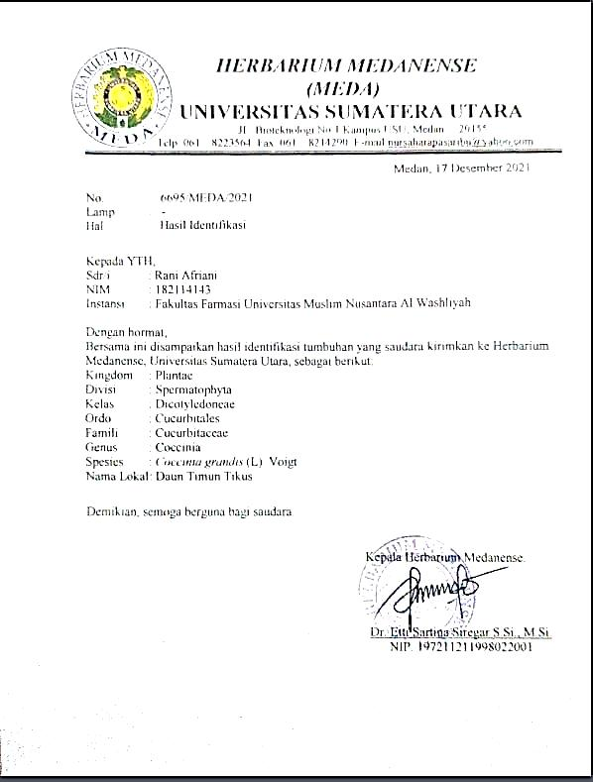

Lampiran 2. Hasil Ethical Clearence

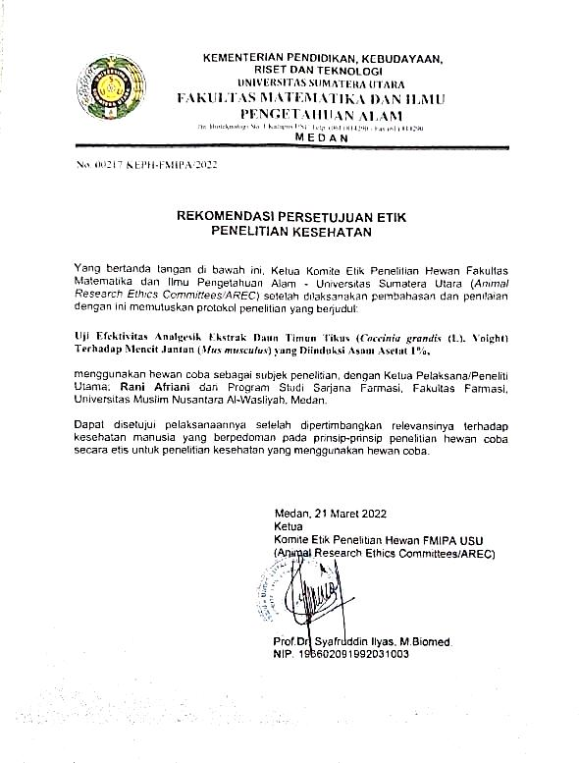

Lampiran 3. Bagan alir Penelitian
Daun Timun Tikus

← Disortasi basah

← Dicuci dengan air mengalir

← Ditiriskan

← Dikeringkan dengan cara diangin-anginkan

← Ditimbang
Berat basah 2 kg

← Dikeringkan di lemari pengering

← Disortasi kering

← Ditimbang
Berat kering 1,34 kg

← Dihaluskan menggunakan blender
Berat serbuk 1,10 kg

Ekstraksi
Skrining Fitokimia
Karakterisasi Simplisia

Ekstrak

Pengujian Farmakologi

Lampiran 4. Bagan Alir Karakterisasi Simplisia Dan Skrining Fitokimia
Serbuk dan Esktrak Daun Timun Tikus
Skrining Fitokimia
Karakterisasi
- Makroskopik
- Mikroskopik
- Penetapan kadar air
- Penetapan kadar sari larut air
- Penetapan kadar sari larut etanol
- Penetapan kadar abu total
- Penetapan kadar abu tidak larut dalam asam
Serbuk Simplisia Daun Timun Tikus

- Pemeriksaan alkaloid
- Pemeriksaan saponin
- Pemeriksaan tanin
- Pemeriksaan flavonoid
- Pemeriksaan steroid

Lampiran 5. Bagan Alir Pembuatan Ekstrak
500 g serbuk simplisia

← Dimasukkan ke dalam bejana

← Ditambahkan 75 bagian etanol 96%

(3750 ml) didiamkan selama 5 hari

Maserat I
Ampas

← Dibilas dengan 25 bagian etanol

96% (1250 ml)

← Disaring dan ampasnya diperas
Maserat II

Maserat I dan II dicampur

← Dimasukkan ke dalam bejana, diamkan

2 hari dan disaring

← Dipekatkan dengan rotary evaporator
Ekstrak kental

Lampiran 6. Bagan alir pengujian farmakologi
Mencit

Mencit dipuasakan 18-24 jam

Dibagi menjadi 5 kelompok, masing-masing kelompok terdiri 5 ekor

Diinduksi dengan asam asetat 1% secara intraperitoneal (IP)

Mencit nyeri

Diberi perlakuan secara peroral :
CMC 0,5%
Metampiron 1%
EDTT 200 mg/kgBB
EDTT 300 mg/kgBB
EDTT 400 mg/kgBB

Dilihat jumlah geliat tiap 5 menit selama 1 jam

Jumlah geliat

Lampiran 7. Tumbuhan Daun Timun Tikus (Coccinia grandis (L). Voight)

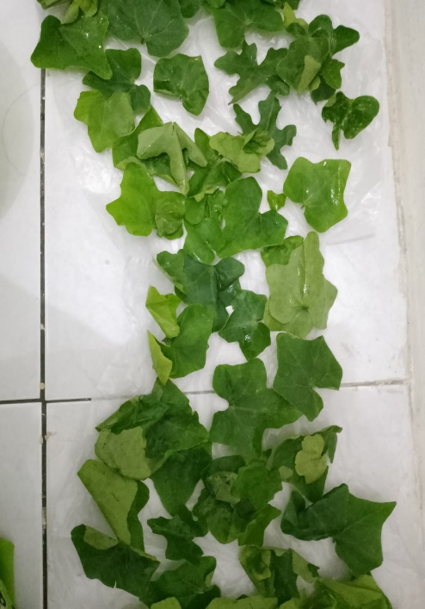

Simplisia Daun Timun Tikus (Coccinia grandis (L). Voight)

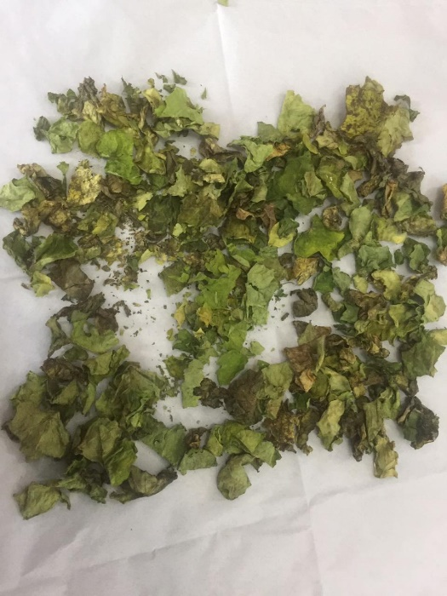

Serbuk Simplisia Daun Timun Tikus (Coccinia grandis (L). Voight)

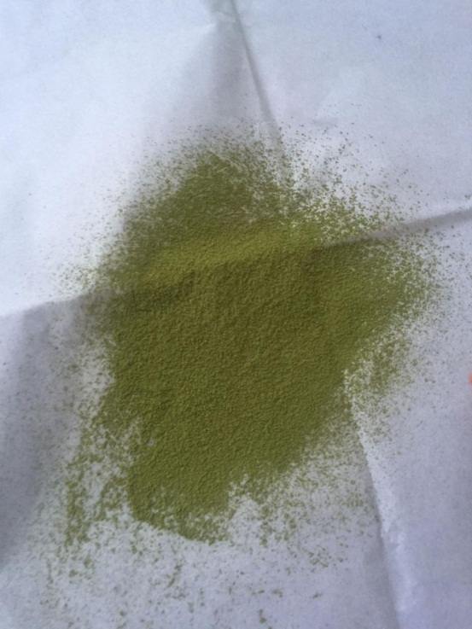

Lampiran 8. Hasil Karakterisasi Simplisia

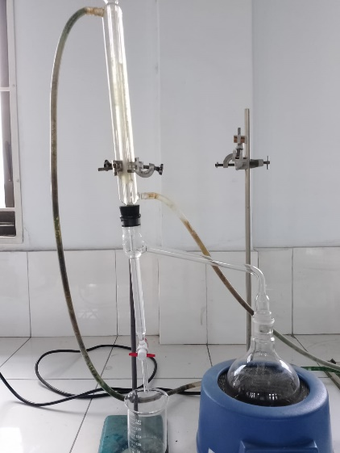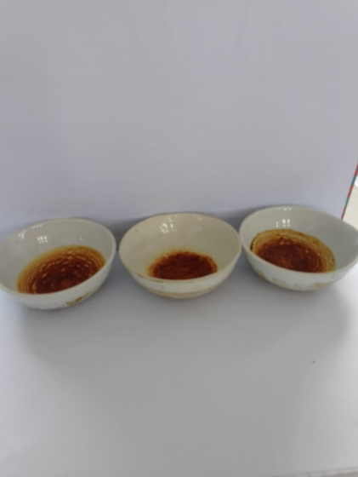

Penetapan Kadar Air Penetapan Kadar Sari Larut dalam Air

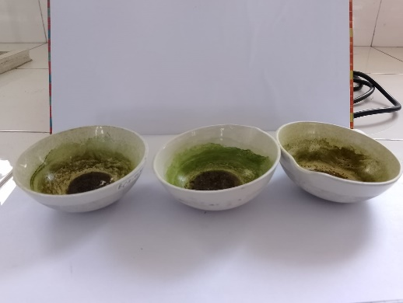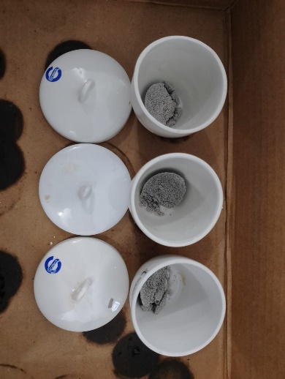

Penetapan Kadar Sari Larut dalam Penetapan Kadar Abu Total Etanol

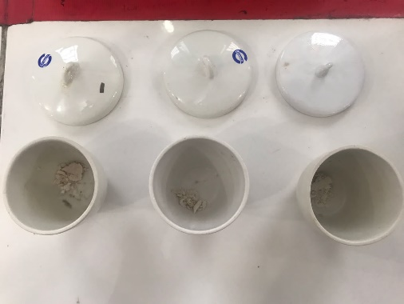

Penetapan Kadar Abu Tidak Larut Asam

Lampiran 9. Perhitungan karakterisasi simplisia
a. Penetapan kadar air
$$Kadar air =\frac{Volume Air (ml)}{Berat sampel (g)}X 100\%$$

• Sampel I
Berat sampel = 5 g
Volume I = 1,8 ml
Volume II = 2,3 ml
Kadar air = $\frac{2,3-2,0}{5}$x 100% = 6 %
• Sampel II
Berat sampel = 5 g
Volume I = 1,8 ml
Volume II = 2,2 ml
Kadar air = $\frac{2,2-1,8}{5}$x 100% = 8 %
• Sampel III
Berat sampel = 5 g
Volume I = 1,9 ml
Volume II = 2,3 ml
Kadar air = $\frac{2,4-2,1}{5}$ x 100% = 8 %
Kadar air rata-rata = $\frac{6+8+8}{3}$ = 7,33 %

Lampiran 9. (lanjutan)
b. Penetapan kadar sari larut dalam air
$$Kadar sari larut dalam air = \frac{Berat sari }{Berat sampel }x FP X 100\%$$

• Sampel I
Berat sampel = 5 g
Berat sari = 0,101 g
$$Kadar sari larut dalam air =\frac{0,101 }{5 }×5x 100 \%= 10,1 \%$$
• Sampel II
Berat sampel = 5 g
Berat sari = 0,117 g
$$Kadar sari larut dalam air=\frac{ 0,117 }{5 }×5 x 100 \%= 11,7 \%$$
• Sampel III
Berat sampel = 5 g
Berat sari = 0,106 g
$$Kadar sari larut dalam air=\frac{ 0,106}{5}×5 x 100 \%=10,6 \%$$
$$\% Kadar sari larut dalam air rata-rata = \frac{10,1+11,7+10,6 }{3}$$
= 10,8 %

Lampiran 9. (lanjutan)
c. Penetapan kadar sari larut dalam etanol
$$Kadar sari larut dalam etanol =\frac{Berat sari }{Berat sampel}X FP X 100\%$$

• Sampel I
Berat sampel = 5 g
Berat sari = 0,112 g
$$Kadar sari larut dalam etanol =\frac{0,112 }{5 }×5 x 100 \%= 11,2 \%$$
• Sampel II
Berat sampel = 5 g
Berat sari = 0,098 g
$$Kadar sari larut dalam etanol= \frac{0,098 }{5 }×5 x 100 \%= 9,8 \%$$
• Sampel III
Berat sampel = 5 g
Berat sari = 0,100 g
$$Kadar sari larut dalam etanol=\frac{0,100 }{5 }×5 x 100 \%= 10 \%$$
$$\%Kadar sari larut dalam etanol rata-rata =\frac{ 11,2+9,8+10}{3}$$
= 10,3 %

Lampiran 9. (lanjutan)
d. Penetapan kadar abu total
$$Kadar abu total =\frac{Berat abu}{Berat sampel}X 100 \%$$

• Sampel I
Berat sampel = 2 g
Berat abu = 0,257 g
$$Kadar abu total =\frac{ 0,257}{2 }×100 \%= 12,85 \%$$

• Sampel II
Berat sampel = 2 g
Berat abu = 0,24 g
$$Kadar abu total =\frac{0,24}{2 }×100 \%= 12 \%$$

• Sampel III
Berat sampel = 2 g
Berat abu = 0,139 g
$$Kadar abu total = \frac{0,139}{2 }×100 \%= 13,9 \%$$
$$\% Kadar abu total rata-rata =\frac{ 12,85+12+13,9}{3}$$
= 12,916 %

Lampiran 9. (lanjutan)
e. Penetapan kadar abu tidak larut asam
$$Kadar abu tidak larut dalam asam = \frac{Berat abu}{Berat sampel}X 100\%$$

• Sampel I
Berat sampel = 2 g
Berat abu = 0,008 g
$$Kadar abu tidak larut dalam asam =\frac{0,008 }{2 }×100 \%= 0,4 \%$$
• Sampel II
Berat sampel = 2 g
Berat abu = 0,016 g
$$Kadar abu tidak larut dalam asam = \frac{0,016 }{2 }×100 \%= 0,8 \%$$
• Sampel III
Berat sampel = 2 g
Berat abu = 0,017 g
$$Kadar abu tidak larut dalam asam = \frac{0,017 }{2 }×100 \% = 0,85 \%$$
$$\% Kadar abu yang tidak larut asam rata-rata =\frac{ 0,4+0,8+0,85}{3}$$
= 0,68%

Lampiran 10. Mikroskopik Daun Timun Tikus (Coccinia grandis (L). Voight)
2
3
4
1
Penampang melintang daun timun tikus
Keterangan :
1. Rambut
2. Stomata anomositik
3. Parenkim
4. Berkas Pembuluh

Lampiran 11. Hasil Skrining Fitokimia
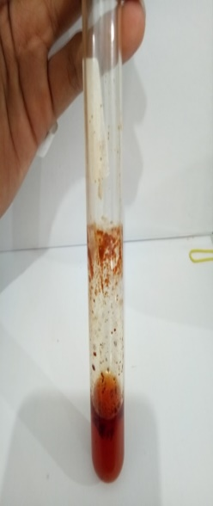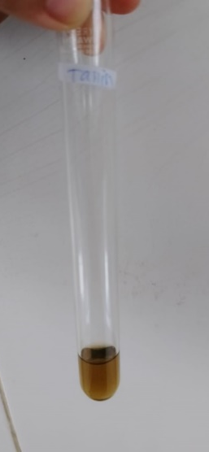
Serbuk Esktrak Serbuk Ekstrak
Flavonoid (+) Tanin (+)
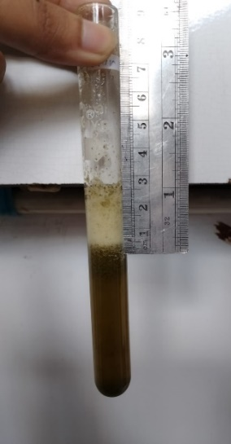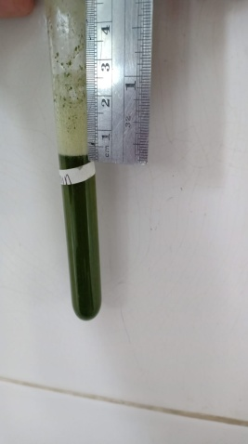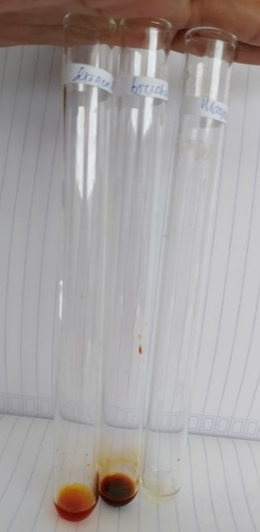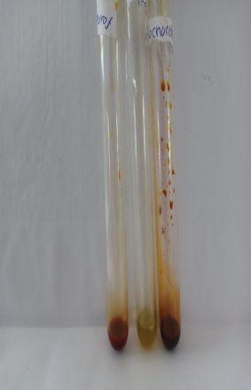
Serbuk Esktrak Serbuk Esktrak
Saponin (+) Alkaloid (+)
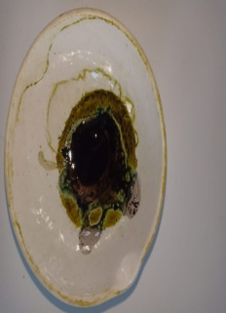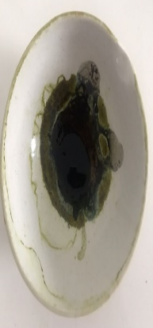
Serbuk Ekstrak
Steroid (+)

Lampiran 12. Proses Pembuatan Ekstrak
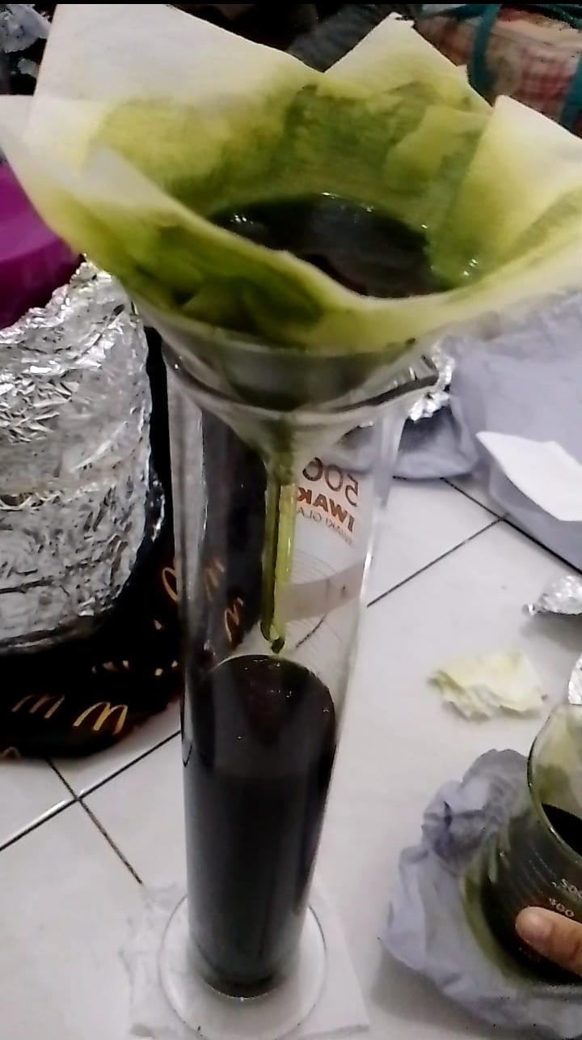
serbuk dimaserasi selama 5 hari Proses penyaringan
dengan sesekali pengadukan

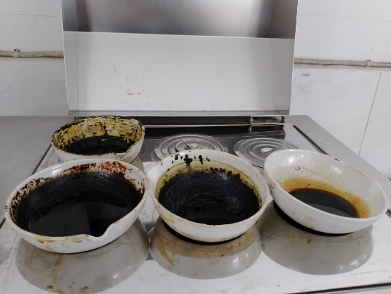
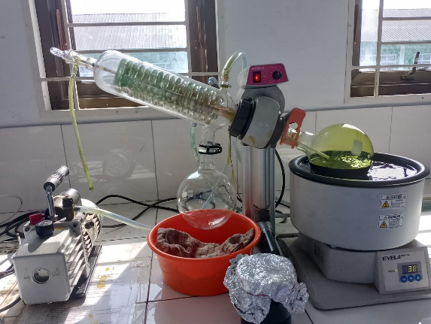
larutan di rotary evaporator Diletakkan dalam water bath

Lampiran 13. Pengujian Farmakologi
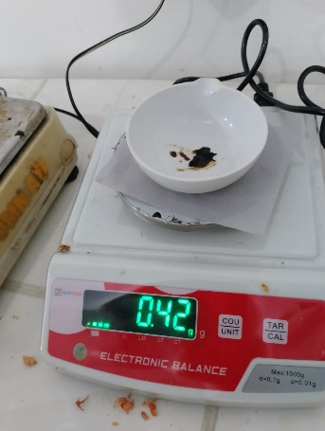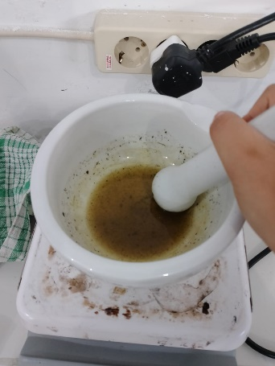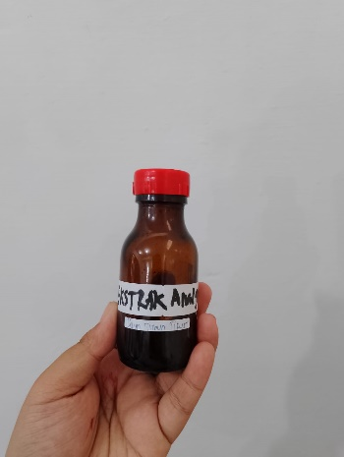
Penimbangan ekstrak Pembuatan Suspensi Suspensi ekstrak
ekstrak

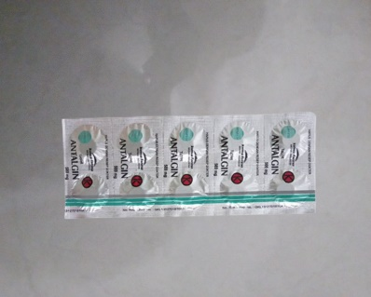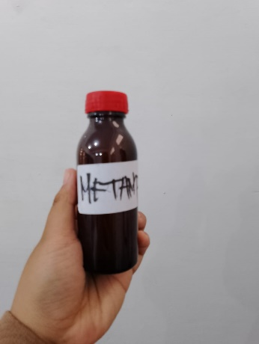
Tablet Metampiron 500 mg Suspensi Metampiron 1%

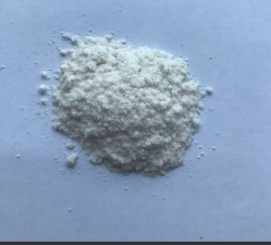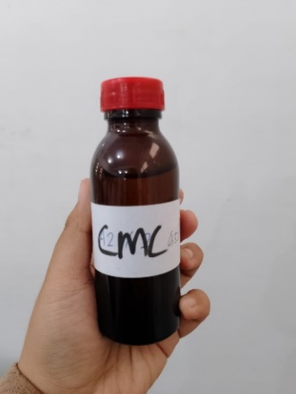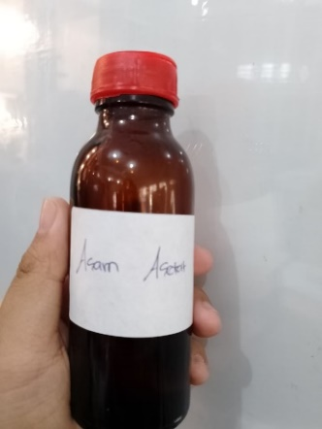
Serbuk CMC Suspensi CMC 0,5% Asam asetat 1%

Lampiran 13. (lanjutan)

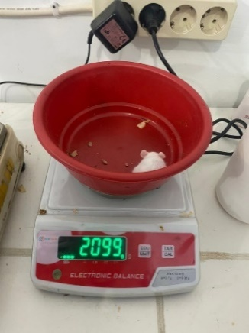
Penimbangan mencit Pemberian Asam Pengambilan Obat
asetat 1% IP

Pemberian Obat Geliat mencit
peroral

Lampiran 14. Tabel Konversi Dosis Hewan Percobaan dengan Manusia
Konvensi | Mencit  20 g | Tikus  200 g | Marmut  400 g | Kelinci  1,5 kg | Kucing  1,5 kg | Kera  4 kg | Anjing  12 kg | Manusia  70 kg
Mencit  20 g | 1,0 | 7,0 | 12,23 | 27,80 | 29,70 | 64,10 | 124,20 | 387,9
Tikus  200 g | 0,14 | 1,0 | 1,74 | 3,90 | 4,20 | 9,20 | 17,80 | 56,0
Marmut  400 g | 0,08 | 0,57 | 1,0 | 2,25 | 2,40 | 5,20 | 10,20 | 31,50
Kelinci  1,5 g | 0,04 | 0,25 | 0,44 | 1,0 | 1,08 | 2,40 | 4,50 | 14,20
Kucing  1,5 g | 0,03 | 0,23 | 0,41 | 0,92 | 1,0 | 2,20 | 4,10 | 13,0
Kera  4 kg | 0,016 | 0,11 | 0,19 | 0,42 | 0,43 | 0,1 | 1,9 | 6,1
Anjing  12 kg | 0,008 | 0,06 | 0,10 | 0,22 | 1,24 | 0,52 | 1,0 | 3,10
Manusia  70 kg | 0,0026 | 0,018 | 0,031 | 0,07 | 0,076 | 0,16 | 0,32 | 1,0

Lampiran 15. Tabel Volume Maksimun Larutan Sediaan Uji Yang Dapat Diberikan Pada Hewan Uji
Hewan Uji | Volume Maksimum (ml) sesuai jalur pemberian
 | i.v | i.m | i.p | s.c | p.o
Mencit (20-30 g) | 0,5 | 0,05 | 1,0 | 0,5-1,0 | 1,0
Tikus (200 g) | 1,0 | 0,1 | 2-5 | 2-5 | 5,0
Hamster (50 g) | - | 0,1 | 2-5 | 2-5 | 2,5
Marmut (250 g) | - | 0,25 | 5,0 | 5,0 | 10,0
Kelinci (2,5 kg) | 5-10 | 0,5 | 5-10 | 5-10 | 20,0
Kucing (3 kg) | 5-10 | 1,0 | 5-10 | 5-10 | 50,0
Anjing (5 kg) | 10-20 | 5,0 | 10,0 | 10,0 | 100,0

Lampiran 16. Perhitungan dosis
Misal berat mencit 20 g
a. CMC 0,5%
CMC 0,5% = 0,5 g / 100 ml
= 500 mg / 100 ml
= 5 mg / 100 ml
CMC 0,5% pada mencit 20 g = 0,5 g / 100 ml x 20 g
= 0,1 ml
b. Metampiron 1%
Konversi dosis manusia (70 kg) ke mencit (20 g) = 0,0026
Dosis manusia Metampiron = 500 mg
Dosis Metampiron mencit = 500 mg x 0,0026
= 1,3 mg / 0,02 kg BB
= 65 mg/kgBB
Metampiron 1% = 1 g / 100 ml
= 1000 mg / 100 ml
= 10 mg/ml
Jumlah Metampiron = 65 mg / 1000 g x 20 g
= 1,3 mg
Volume yang diambil = 1,3 mg / 10 mg/ml
= 0,13 ml
c. Ekstrak daun timun tikus 1%
VAO 1% = 1 g / 100 ml
= 1000 mg / 100 ml
= 10 mg / ml
• Ekstrak daun timun tikus 200 mg/kgBB
Dosis = 200 mg / 1000 g x 20 g
= 4 mg
Volume yang diambil = 4 mg / 10 mg/ml
= 0,4 ml
• Ekstrak daun timun tikus 300 mg/kgBB
Dosis = 300 mg / 1000 g x 20 g
Lampiran 16. (lanjutan)
= 6 mg
Volume yang diambil = 6 mg / 10 mg/ml
= 0,6 ml
• Ekstrak daun timun tikus 400 mg/kgBB
Dosis = 400 mg / 1000 g x 20 g
= 8 mg
Volume yang diambil = 8 mg / 10 mg/ml
= 0,8 ml

Lampiran 17. Perhitungan Dosis Ke Manusia
Misal berat manusia 70 kg
a. CMC 0,5%
CMC 0,5% pada manusia 70 kg = 0,5 g / 100 ml x 70.000 g
= 350 ml
b. Metampiron 1%
Konversi dosis manusia (70 kg) ke manusia (70 kg) = 1,0
Dosis manusia Metampiron = 500 mg
Dosis Metampiron manusia = 500 mg/70 kgBB
c. Ekstrak daun timun tikus 1%
VAO 1% = 1 g / 100 ml
= 1000 mg / 100 ml
= 10 mg / ml
• Ekstrak daun timun tikus 200 mg/kgBB
Dosis = 200 mg / 1000 g x 70.000 g
= 14.000 mg
Volume yang diambil = 14.000 mg / 10 mg/ml
= 1.400 ml
• Ekstrak daun timun tikus 300 mg/kgBB
Dosis = 300 mg / 1000 g x 70.000 g
= 21.000 mg
Volume yang diambil = 21.000 mg / 10 mg/ml
= 2.100 ml
• Ekstrak daun timun tikus 400 mg/kgBB
Dosis = 400 mg / 1000 g x 70.000 g
= 28.000 mg
Volume yang diambil = 28.000 mg / 10 mg/ml
= 2.800 ml

Lampiran 18. Tabel Konversi Dosis Mencit dan Manusia
N0 | Dosis | Tikus (200 g) | Manusia (70 Kg)
1. | Metampiron | 9 mg ( 0,9 ml ) | 500 mg
2. | EDTT 200 mg/Kg BB | 40 mg ( 2 ml ) | 14.000mg (700 ml)
3. | EDTT 300 mg/Kg BB | 60 mg ( 3 ml ) | 21.000mg ( 1050 ml
4. | EDTT 400 mg/ Kg BB | 80 mg ( 6 ml ) | 28.000mg (1400 ml)

Lampiran 19. Data hasil jumlah geliat mencit jantan yang diamati tiap 5 menit selama 1 jam
Perlakuan | Hewan | Waktu (menit)
 |  | 5 | 10 | 15 | 20 | 25 | 30 | 35 | 40 | 45 | 50 | 55 | 60
CMC 1% | 1 | 17 | 33 | 28 | 25 | 22 | 16 | 15 | 15 | 13 | 11 | 10 | 8
 | 2 | 20 | 36 | 31 | 27 | 25 | 18 | 17 | 17 | 16 | 14 | 12 | 9
 | 3 | 20 | 36 | 30 | 28 | 26 | 17 | 16 | 15 | 14 | 14 | 11 | 9
 | 4 | 18 | 34 | 29 | 26 | 24 | 18 | 17 | 16 | 15 | 15 | 13 | 10
 | 5 | 19 | 37 | 31 | 28 | 25 | 16 | 15 | 14 | 13 | 12 | 10 | 8
 | Rata-rata | 18.8 | 35.2 | 29.8 | 26.8 | 24.4 | 17 | 16 | 15.4 | 14.2 | 13.2 | 11.2 | 8.8
Metampiron 1% | 1 | 19 | 24 | 19 | 16 | 11 | 7 | 5 | 3 | 1 | 0 | 0 | 0
 | 2 | 18 | 23 | 18 | 14 | 10 | 9 | 7 | 5 | 3 | 2 | 0 | 0
 | 3 | 21 | 25 | 20 | 15 | 12 | 9 | 4 | 3 | 2 | 1 | 0 | 0
 | 4 | 20 | 24 | 19 | 12 | 9 | 7 | 6 | 4 | 2 | 1 | 0 | 0
 | 5 | 21 | 24 | 19 | 14 | 11 | 8 | 5 | 2 | 1 | 0 | 0 | 0
 | Rata-rata | 20 | 24 | 19 | 14 | 10.6 | 8 | 5.4 | 3.4 | 1.8 | 0.8 | 0 | 0
EDTT 200 mg/kg BB | 1 | 18 | 29 | 25 | 18 | 15 | 14 | 11 | 9 | 7 | 5 | 2 | 1
 | 2 | 17 | 27 | 24 | 19 | 16 | 12 | 10 | 7 | 5 | 3 | 1 | 0
 | 3 | 19 | 30 | 25 | 20 | 17 | 13 | 10 | 8 | 4 | 2 | 0 | 0
 | 4 | 18 | 26 | 22 | 19 | 17 | 12 | 13 | 10 | 6 | 4 | 2 | 1
 | 5 | 17 | 28 | 24 | 16 | 13 | 10 | 9 | 7 | 5 | 2 | 1 | 0
 | Rata-rata | 17.8 | 28 | 24 | 18.4 | 15.60 | 12.2 | 10.6 | 8.2 | 5.4 | 3.2 | 1.2 | 0.4

Lampiran 19. (lanjutan)
Perlakuan | Hewan | Waktu (Menit)
 |  | 5 | 10 | 15 | 20 | 25 | 30 | 35 | 40 | 45 | 50 | 55 | 60
EDTT 300 mg/kg BB | 1 | 16 | 24 | 18 | 16 | 15 | 11 | 8 | 6 | 3 | 1 | 0 | 0
 | 2 | 18 | 26 | 22 | 18 | 15 | 10 | 9 | 7 | 4 | 3 | 2 | 1
 | 3 | 17 | 25 | 20 | 18 | 14 | 12 | 7 | 5 | 3 | 2 | 1 | 0
 | 4 | 17 | 23 | 20 | 16 | 14 | 11 | 7 | 5 | 4 | 2 | 1 | 0
 | 5 | 15 | 24 | 21 | 19 | 16 | 12 | 8 | 6 | 5 | 3 | 0 | 0
 | Rata-rata | 16.6 | 24.4 | 20.2 | 17.4 | 14.8 | 11.2 | 7.8 | 5.8 | 3.8 | 2.2 | 0.8 | 0.2
EDTT 400 mg/kg BB | 1 | 14 | 24 | 17 | 15 | 12 | 10 | 6 | 3 | 2 | 1 | 0 | 0
 | 2 | 16 | 26 | 20 | 16 | 13 | 9 | 7 | 5 | 3 | 2 | 1 | 0
 | 3 | 17 | 23 | 20 | 14 | 10 | 8 | 5 | 4 | 2 | 2 | 1 | 0
 | 4 | 15 | 22 | 18 | 15 | 11 | 8 | 7 | 5 | 6 | 3 | 2 | 0
 | 5 | 18 | 25 | 21 | 17 | 11 | 9 | 6 | 6 | 3 | 1 | 0 | 0
 | Rata-rata | 16 | 24 | 19.2 | 15.4 | 11.4 | 8.8 | 6.2 | 4.6 | 3.2 | 1.8 | 0.8 | 0

Lampiran 20. Perhitungan Persentase Daya Analgesik
$$\%Daya analgesik =100-[ \frac{eksperimen}{kontrol-}X 100\%]$$

a. Metampiron 1%
• 5 menit
Rata-rata geliat Metampiron 1% = 19,8
Rata-rata geliat kontrol negatif CMC 0,5% = 18,8
$$\%Daya analgesik =100-[ \frac{19,8}{18,8}X 100\%]$$

= 5,31%
• 10 menit
Rata-rata geliat Metampiron 1% = 24
Rata-rata geliat kontrol negatif CMC 0,5% = 35,2
$$\%Daya analgesik =100-[ \frac{24}{35,2}X 100\%]$$

= 31,81%
• 15 menit
Rata-rata geliat Metampiron 1% = 19
Rata-rata geliat kontrol negatif CMC 0,5% = 29,8
$$\%Daya analgesik =100-[ \frac{19}{29,8}X 100\%]$$

= 36,24%
• 20 menit
Rata-rata geliat Metampiron 1% = 14,2
Rata-rata geliat kontrol negatif CMC 0,5% = 26,8
$$\%Daya analgesik =100-[ \frac{14,2}{26,8}X 100\%]$$

= 47,01%
• 25 menit
Rata-rata geliat Metampiron 1% = 10,6
Rata-rata geliat kontrol negatif CMC 0,5% = 24,4
$$\%Daya analgesik =100-[ \frac{10,6}{24,4}X 100\%]$$

Lampiran 20. (lanjutan)
= 56,56%
• 30 menit
Rata-rata geliat Metampiron 1% = 8
Rata-rata geliat kontrol negatif CMC 0,5% = 17
$$\%Daya analgesik =100-[ \frac{8}{17}X 100\%]$$

= 52,94%
• 35 menit
Rata-rata geliat Metampiron 1% = 5,4
Rata-rata geliat kontrol negatif CMC 0,5% = 16
$$\%Daya analgesik =100-[ \frac{5,4}{16}X 100\%]$$

= 66,25%
• 40 menit
Rata-rata geliat Metampiron 1% = 3,4
Rata-rata geliat kontrol negatif CMC 0,5% = 15,4
$$\%Daya analgesik =100-[ \frac{3,4}{15,4}X 100\%]$$

= 77,92%
• 45 menit
Rata-rata geliat Metampiron 1% = 1,8
Rata-rata geliat kontrol negatif CMC 0,5% = 14,2
$$\%Daya analgesik =100-[ \frac{1,8}{14,2}X 100\%]$$

= 87,32%
• 50 menit
Rata-rata geliat Metampiron 1% = 0,8
Rata-rata geliat kontrol negatif CMC 0,5% = 13,2
$$\%Daya analgesik =100-[ \frac{0,8}{13,2}X 100\%]$$

= 93,94%
Lampiran 20. (lanjutan)
• 55 menit
Rata-rata geliat Metampiron 1% = 0
Rata-rata geliat kontrol negatif CMC 0,5% = 11,2
$$\%Daya analgesik =100-[ \frac{0}{11,2}X 100\%]$$

= 100%
• 60 menit
Rata-rata geliat Metampiron 1% = 0
Rata-rata geliat kontrol negatif CMC 0,5% = 8,8
$$\%Daya analgesik =100-[ \frac{0}{8,8}X 100\%]$$

= 100%
Jadi, rata-rata persentase daya analgesik kontrol positif metampiron 1% adalah 62,94%.
b. EDTT 200 mg/kgBB
• 5 menit
Rata-rata geliat EDTT 200 mg/kgBB = 17,8
Rata-rata geliat kontrol negatif CMC 0,5% = 18,8
$$\%Daya analgesik =100-[ \frac{17,8}{18,8}X 100\%]$$

= 5,31%
• 10 menit
Rata-rata geliat EDTT 200 mg/kgBB = 28
Rata-rata geliat kontrol negatif CMC 0,5% = 35,2
$$\%Daya analgesik =100-[ \frac{28}{35,2}X 100\%]$$

= 20,45%
• 15 menit
Rata-rata geliat EDTT 200 mg/kgBB = 24
Rata-rata geliat kontrol negatif CMC 0,5% = 29,8
$$\%Daya analgesik =100-[ \frac{24}{29,8}X 100\%]$$

Lampiran 20. (lanjutan)
= 19,46%
• 20 menit
Rata-rata geliat EDTT 200 mg/kgBB = 18,4
Rata-rata geliat kontrol negatif CMC 0,5% = 26,8
$$\%Daya analgesik =100-[ \frac{18,4}{26,8}X 100\%]$$

= 31,34%
• 25 menit
Rata-rata geliat EDTT 200 mg/kgBB = 15,6
Rata-rata geliat kontrol negatif CMC 0,5% = 24,4
$$\%Daya analgesik =100-[ \frac{15,6}{24,4}X 100\%]$$

Lampiran 16. (lanjutan)
= 36,06%
• 30 menit
Rata-rata geliat EDTT 200 mg/kgBB = 12,2
Rata-rata geliat kontrol negatif CMC 0,5% = 17
$$\%Daya analgesik =100-[ \frac{12,2}{17}X 100\%]$$

= 28,23%
• 35 menit
Rata-rata geliat EDTT 200 mg/kgBB = 10,6
Rata-rata geliat kontrol negatif CMC 0,5% = 16
$$\%Daya analgesik =100-[ \frac{10,6}{16}X 100\%]$$

= 33,75%
• 40 menit
Rata-rata geliat EDTT 200 mg/kgBB = 8,2
Rata-rata geliat kontrol negatif CMC 0,5% = 15,4
$$\%Daya analgesik =100-[ \frac{8,2}{15,4}X 100\%]$$

= 46,75%
Lampiran 20. (lanjutan)
• 45 menit
Rata-rata geliat EDTT 200 mg/kgBB = 5,4
Rata-rata geliat kontrol negatif CMC 0,5% = 14,2
$$\%Daya analgesik =100-[ \frac{5,4}{14,2}X 100\%]$$

= 61,97%
• 50 menit
Rata-rata geliat EDTT 200 mg/kgBB = 3,2
Rata-rata geliat kontrol negatif CMC 0,5% = 13,2
$$\%Daya analgesik =100-[ \frac{3,2}{13,2}X 100\%]$$

= 75,76%
• 55 menit
Rata-rata geliat EDTT 200 mg/kgBB = 1,2
Rata-rata geliat kontrol negatif CMC 0,5% = 11,2
$$\%Daya analgesik =100-[ \frac{1,2}{11,2}X 100\%]$$

= 88,93%
• 60 menit
Rata-rata geliat EDTT 200 mg/kgBB = 0,4
Rata-rata geliat kontrol negatif CMC 0,5% = 8,8
$$\%Daya analgesik =100-[ \frac{0,4}{8,8}X 100\%]$$

= 95,45%
Jadi, rata-rata persentase daya analgesik EDTT 200 mg/kgBB adalah 45,28%.
c. EDTT 300 mg/kgBB
• 5 menit
Rata-rata geliat EDTT 300 mg/kgBB = 16,6
Rata-rata geliat kontrol negatif CMC 0,5% = 18,8
$$\%Daya analgesik =100-[ \frac{16,6}{18,8}X 100\%]$$

Lampiran 20. (lanjutan)
= 11,7%
• 10 menit
Rata-rata geliat EDTT 300 mg/kgBB = 24,4
Rata-rata geliat kontrol negatif CMC 0,5% = 35,2
$$\%Daya analgesik =100-[ \frac{24,4}{35,2}X 100\%]$$

= 30,68%
• 15 menit
Rata-rata geliat EDTT 300 mg/kgBB = 20,2
Rata-rata geliat kontrol negatif CMC 0,5% = 29,8
$$\%Daya analgesik =100-[ \frac{20,2}{29,8}X 100\%]$$

Lampiran 16. (lanjutan)
= 32,21%
• 20 menit
Rata-rata geliat EDTT 300 mg/kgBB = 17,4
Rata-rata geliat kontrol negatif CMC 0,5% = 26,8
$$\%Daya analgesik =100-[ \frac{17,4}{26,8}X 100\%]$$

= 35,07%
• 25 menit
Rata-rata geliat EDTT 300 mg/kgBB = 14,8
Rata-rata geliat kontrol negatif CMC 0,5% = 24,4
$$\%Daya analgesik =100-[ \frac{14,8}{24,4}X 100\%]$$

Lampiran 16. (lanjutan)
= 39,34%
• 30 menit
Rata-rata geliat EDTT 300 mg/kgBB = 11,2
Rata-rata geliat kontrol negatif CMC 0,5% = 17
$$\%Daya analgesik =100-[ \frac{11,2}{17}X 100\%]$$

= 34,88%
Lampiran 20. (lanjutan)
• 35 menit
Rata-rata geliat EDTT 300 mg/kgBB = 7,8
Rata-rata geliat kontrol negatif CMC 0,5% = 16
$$\%Daya analgesik =100-[ \frac{7,8}{16}X 100\%]$$

= 51,25%
• 40 menit
Rata-rata geliat EDTT 300 mg/kgBB = 5,8
Rata-rata geliat kontrol negatif CMC 0,5% = 15,4
$$\%Daya analgesik =100-[ \frac{5,8}{15,4}X 100\%]$$

= 62,33%
• 45 menit
Rata-rata geliat EDTT 300 mg/kgBB = 3,8
Rata-rata geliat kontrol negatif CMC 0,5% = 14,2
$$\%Daya analgesik =100-[ \frac{3,8}{14,2}X 100\%]$$

= 73,23%
• 50 menit
Rata-rata geliat EDTT 300 mg/kgBB = 2,2
Rata-rata geliat kontrol negatif CMC 0,5% = 13,2
$$\%Daya analgesik =100-[ \frac{2,2}{13,2}X 100\%]$$

= 83,33%
• 55 menit
Rata-rata geliat EDTT 300 mg/kgBB = 0,8
Rata-rata geliat kontrol negatif CMC 0,5% = 11,2
$$\%Daya analgesik =100-[ \frac{0,8}{11,2}X 100\%]$$

= 92,85%

Lampiran 20. (lanjutan)
• 60 menit
Rata-rata geliat EDTT 300 mg/kgBB = 0,2
Rata-rata geliat kontrol negatif CMC 0,5% = 8,8
$$\%Daya analgesik =100-[ \frac{0,2}{8,8}X 100\%]$$

= 97,72%
Jadi, rata-rata persentase daya analgesik EDTT 300 mg/kgBB adalah 53,71%.
d. EDTT 400 mg/kgBB
• 5 menit
Rata-rata geliat EDTT 400 mg/kgBB = 16
Rata-rata geliat kontrol negatif CMC 0,5% = 18,8
$$\%Daya analgesik =100-[ \frac{16}{18,8}X 100\%]$$

Lampiran 16. (lanjutan)
= 14,89%
• 10 menit
Rata-rata geliat EDTT 400 mg/kgBB = 24
Rata-rata geliat kontrol negatif CMC 0,5% = 35,2
$$\%Daya analgesik =100-[ \frac{24}{35,2}X 100\%]$$

= 31,81%
• 15 menit
Rata-rata geliat EDTT 400 mg/kgBB = 19,2
Rata-rata geliat kontrol negatif CMC 0,5% = 29,8
$$\%Daya analgesik =100-[ \frac{19,2}{29,8}X 100\%]$$

Lampiran 16. (lanjutan)
= 35,57%
• 20 menit
Rata-rata geliat EDTT 400 mg/kgBB = 15,4
Rata-rata geliat kontrol negatif CMC 0,5% = 26,8
$$\%Daya analgesik =100-[ \frac{15,4}{26,8}X 100\%]$$

Lampiran 20. (lanjutan)
= 42,53%
• 25 menit
Rata-rata geliat EDTT 400 mg/kgBB = 11,4
Rata-rata geliat kontrol negatif CMC 0,5% = 24,4
$$\%Daya analgesik =100-[ \frac{11,4}{24,4}X 100\%]$$

Lampiran 16. (lanjutan)
= 53,27%
• 30 menit
Rata-rata geliat EDTT 400 mg/kgBB = 8,8
Rata-rata geliat kontrol negatif CMC 0,5% = 17
$$\%Daya analgesik =100-[ \frac{8,8}{17}X 100\%]$$

= 48,23%
• 35 menit
Rata-rata geliat EDTT 400 mg/kgBB = 6,2
Rata-rata geliat kontrol negatif CMC 0,5% = 16
$$\%Daya analgesik =100-[ \frac{6,2}{16}X 100\%]$$

= 61,25%
• 40 menit
Rata-rata geliat EDTT 400 mg/kgBB = 4,6
Rata-rata geliat kontrol negatif CMC 0,5% = 15,4
$$\%Daya analgesik =100-[ \frac{4,6}{15,4}X 100\%]$$

= 70,12%
• 45 menit
Rata-rata geliat EDTT 400 mg/kgBB = 3,2
Rata-rata geliat kontrol negatif CMC 0,5% = 14,2
$$\%Daya analgesik =100-[ \frac{3,2}{14,2}X 100\%]$$

= 77,46%
Lampiran 20. (lanjutan)
• 50 menit
Rata-rata geliat EDTT 400 mg/kgBB = 1,8
Rata-rata geliat kontrol negatif CMC 0,5% = 13,2
$$\%Daya analgesik =100-[ \frac{1,8}{13,2}X 100\%]$$

= 86,36%
• 55 menit
Rata-rata geliat EDTT 400 mg/kgBB = 0,8
Rata-rata geliat kontrol negatif CMC 0,5% = 11,2
$$\%Daya analgesik =100-[ \frac{0,8}{11,2}X 100\%]$$

= 92,85%
• 60 menit
Rata-rata geliat EDTT 400 mg/kgBB = 0
Rata-rata geliat kontrol negatif CMC 0,5% = 8,8
$$\%Daya analgesik =100-[ \frac{0}{8,8}X 100\%]$$

= 100%
Jadi, rata-rata persentase daya analgesik EDTT 400 mg/kgBB adalah 59,53%.

Lampiran 21. Perhitungan Persentase Efektivitas Analgesik
$$\%Efektivitas= \frac{\%Daya analgesik kelompok perlakuan}{\%Daya analgesik kelompok kontrol positif}X 100\%$$

a. Kontrol positif metampiron 1%
%Daya analgesik kontrol positif metampiron 1% = 62,94%
%Daya analgesik kontrol positif metampiron 1% = 62,94%
$$\%Efektivitas= \frac{62,94}{62,94}X 100\%$$

= 100%
b. EDTT 200 mg/kgBB
%Daya analgesik EDTT 200 mg/kgBB = 45,28%
%Daya analgesik kontrol positif metampiron 1% = 62,94%
$$\%Efektivitas= \frac{45,28}{62,94}X 100\%$$

= 71,94%
b. EDTT 300 mg/kgBB
%Daya analgesik EDTT 300 mg/kgBB = 53,71%
%Daya analgesik kontrol positif metampiron 1% = 62,94%
$$\%Efektivitas= \frac{53,71}{62,94}X 100\%$$

= 85,33%
b. EDTT 400 mg/kgBB
%Daya analgesik EDTT 200 mg/kgBB = 59,53%
%Daya analgesik kontrol positif metampiron 1% = 62,94%
$$\%Efektivitas= \frac{59,53}{62,94}X 100\%$$

= 94,58%

Lampiran 22. Hasil Uji Normalitas
Tests of Normality
 |  | Perlakuan | Kolmogorov-Smirnovª |  |  |  |  |  |  |  |  | Shapiro-Wilk
 |  |  | Statistic |  |  |  | df |  |  | Sig. |  | Statistic |  | df |  | Sig.
Menit ke 5 |  | CMC 0,5% | .221 |  |  |  | 5 |  |  | .200* |  | .902 |  | 5 |  | .421
 |  | Metampiron | .221 |  |  |  | 5 |  |  | .200* |  | .902 |  | 5 |  | .421
 |  | EDTT 200mg/kgBB | .231 |  |  |  | 5 |  |  | .200* |  | .881 |  | 5 |  | .314
 |  | EDTT 300mg/kgBB | .237 |  |  |  | 5 |  |  | .200* |  | .961 |  | 5 |  | .814
 |  | EDTT 400mg/kgBB | .136 |  |  |  | 5 |  |  | .200* |  | .987 |  | 5 |  | .967
Menit ke 10 | CMC 0,5% |  |  | .287 |  | 5 |  |  | .200* |  |  | .914 |  | 5 |  |  | .490
 | Metampiron |  |  | .300 |  | 5 |  |  | .161 |  |  | .883 |  | 5 |  |  | .325
 | EDTT 200mg/kgBB |  |  | .136 |  | 5 |  |  | .200* |  |  | .987 |  | 5 |  |  | .967
 | EDTT 300mg/kgBB |  |  | .237 |  | 5 |  |  | .200* |  |  | .961 |  | 5 |  |  | .814
 | EDTT 400mg/kgBB |  |  | .136 |  | 5 |  |  | .200* |  |  | .987 |  | 5 |  |  | .967
Menit ke 15 | CMC 0,5% |  |  | .221 |  | 5 |  |  | .200* |  |  | .902 |  | 5 |  |  | .421
 | Metampiron |  |  | .300 |  | 5 |  |  | .161 |  |  | .883 |  | 5 |  |  | .325
 | EDTT 200mg/kgBB |  |  | .300 |  | 5 |  |  | .161 |  |  | .833 |  | 5 |  |  | .146
 | EDTT 300mg/kgBB |  |  | .246 |  | 5 |  |  | .200* |  |  | .956 |  | 5 |  |  | .777
 | EDTT 400mg/kgBB |  |  | .287 |  | 5 |  |  | .200* |  |  | .914 |  | 5 |  |  | .490
Menit ke 20 | CMC 0,5% |  |  |  | .221 |  |  | 5 |  |  | .200* |  | .902 |  | 5 |  |  | .421
 | Metampiron |  |  |  | .246 |  |  | 5 |  |  | .200* |  | .956 |  | 5 |  |  | .777
 | EDTT 200mg/kgBB |  |  |  | .254 |  |  | 5 |  |  | .200* |  | .914 |  | 5 |  |  | .492
 | EDTT 300mg/kgBB |  |  |  | .273 |  |  | 5 |  |  | .200* |  | .852 |  | 5 |  |  | .201
 | EDTT 400mg/kgBB |  |  |  | .237 |  |  | 5 |  |  | .200* |  | .961 |  | 5 |  |  | .814

Lampiran 22. (lanjutan)
Menit ke 25 | CMC 0,5% | .254 |  | 5 |  | .200* |  | .914 |  | 5 |  | .492
 | Metampiron | .237 |  | 5 |  | .200* |  | .961 |  | 5 |  | .814
 | EDTT 200mg/kgBB | .201 |  | 5 |  | .200* |  | .881 |  | 5 |  | .314
 | EDTT 300mg/kgBB | .231 |  | 5 |  | .200* |  | .881 |  | 5 |  | .314
 | EDTT 400mg/kgBB | .237 |  | 5 |  | .200* |  | .961 |  | 5 |  | .814
Menit ke 30 | CMC 0,5% |  | .241 |  | 5 |  | .200* |  | .821 |  | 5 |  | .119
 | Metampiron |  | .241 |  | 5 |  | .200* |  | .821 |  | 5 |  | .119
 | EDTT 200mg/kgBB |  | .246 |  | 5 |  | .200* |  | .956 |  | 5 |  | .777
 | EDTT 300mg/kgBB |  | .231 |  | 5 |  | .200* |  | .881 |  | 5 |  | .314
 | EDTT 400mg/kgBB |  | .231 |  | 5 |  | .200* |  | .881 |  | 5 |  | .314
Menit ke 35 | CMC 0,5% |  | .241 |  | 5 |  | .200* |  | .821 |  | 5 |  | .119
 | Metampiron |  | .237 |  | 5 |  | .200* |  | .961 |  | 5 |  | .814
 | EDTT 200mg/kgBB |  | .254 |  | 5 |  | .200* |  | .914 |  | 5 |  | .492
 | EDTT 300mg/kgBB |  | .231 |  | 5 |  | .200* |  | .881 |  | 5 |  | .314
 | EDTT 400mg/kgBB |  | .231 |  | 5 |  | .200* |  | .881 |  | 5 |  | .314
Menit ke 40 | CMC 0,5% |  | .237 |  | 5 |  | .200* |  | .961 |  | 5 |  | .814
 | Metampiron |  | .237 |  | 5 |  | .200* |  | .961 |  | 5 |  | .814
 | EDTT 200mg/kgBB |  | .221 |  | 5 |  | .200* |  | .902 |  | 5 |  | .421
 | EDTT 300mg/kgBB |  | .231 |  | 5 |  | .200* |  | .881 |  | 5 |  | .314
 | EDTT 400mg/kgBB |  | .237 |  | 5 |  | .200* |  | .961 |  | 5 |  | .814

Lampiran 22. (lanjutan)
Menit ke 45 | CMC 0,5% | .221 | 5 | .200* | .902 | 5 | .421
 | Metampiron | .231 | 5 | .200* | .881 | 5 | .314
 | EDTT 200mg/kgBB | .237 | 5 | .200* | .961 | 5 | .814
 | EDTT 300mg/kgBB | .231 | 5 | .200* | .881 | 5 | .314
 | EDTT 400mg/kgBB | .348 | 5 | .047 | .779 | 5 | .054
Menit ke 50 | CMC 0,5% | .287 | 5 | .200* | .914 | 5 | .490
 | Metampiron | .231 | 5 | .200* | .881 | 5 | .314
 | EDTT 200mg/kgBB | .221 | 5 | .200* | .902 | 5 | .421
 | EDTT 300mg/kgBB | .231 | 5 | .200* | .881 | 5 | .314
 | EDTT 400mg/kgBB | .231 | 5 | .200* | .881 | 5 | .314
Menit ke 55 | CMC 0,5% | .221 | 5 | .200* | .902 | 5 | .421
 | Metampiron | . | 5 | . | . | 5 | .
 | EDTT 200mg/kgBB | .231 | 5 | .200* | .881 | 5 | .314
 | EDTT 300mg/kgBB | .231 | 5 | .200* | .881 | 5 | .314
 | EDTT 400mg/kgBB | .231 | 5 | .200* | .881 | 5 | .314
Menit ke 60 | CMC 0,5% | .231 | 5 | .200* | .881 | 5 | .314
 | Metampiron | . | 5 | . | . | 5 | .
 | EDTT 200mg/kgBB | .367 | 5 | .026 | .684 | 5 | .006
 | EDTT 300mg/kgBB | .473 | 5 | .001 | .552 | 5 | .000
 | EDTT 400mg/kgBB | . | 5 | . | . | 5 | .

*. This is a lower bound of the true significance.
a. Lilliefors Significance Correction

Lampiran 23. Hasil Uji Homogenitas
Test of Homogeneity of Variances
 |  |  | Levene Statistic |  | df1 |  |  |  | df2 |  |  |  | Sig.
Menit ke 5 |  | Based on Mean | .585 |  | 4 |  |  |  | 20 |  |  |  | .677
 |  | Based on Median | .481 |  | 4 |  |  |  | 20 |  |  |  | .749
 |  | Based on Median and with adjusted df | .481 |  | 4 |  |  |  | 18.573 |  |  |  | .749
 |  | Based on trimmed mean | .559 |  | 4 |  |  |  | 20 |  |  |  | .695
Menit ke 10 | Based on Mean |  |  | 1.507 |  |  |  | 4 |  |  |  | 20 |  |  | .238
 | Based on Median |  |  | .780 |  |  |  | 4 |  |  |  | 20 |  |  | .551
 | Based on Median and with adjusted df |  |  | .780 |  |  |  | 4 |  |  |  | 15.110 |  |  | .555
 | Based on trimmed mean |  |  | 1.488 |  |  |  | 4 |  |  |  | 20 |  |  | .243
Menit ke 15 | Based on Mean |  |  | 1.226 |  | 4 |  |  |  | 20 |  |  | .331
 | Based on Median |  |  | .548 |  | 4 |  |  |  | 20 |  |  | .703
 | Based on Median and with adjusted df |  |  | .548 |  | 4 |  |  |  | 14.949 |  |  | .704
 | Based on trimmed mean |  |  | 1.207 |  | 4 |  |  |  | 20 |  |  | .339
Menit ke 20 | Based on Mean |  |  | .096 |  | 4 |  |  |  | 20 |  |  | .982
 | Based on Median |  |  | .043 |  | 4 |  |  |  | 20 |  |  | .996
 | Based on Median and with adjusted df |  |  | .043 |  | 4 |  |  |  | 17.707 |  |  | .996
 | Based on trimmed mean |  |  | .094 |  | 4 |  |  |  | 20 |  |  | .983
Menit ke 25 | Based on Mean |  |  | .651 |  |  | 4 |  |  |  | 20 |  |  | .633
 | Based on Median |  |  | .295 |  |  | 4 |  |  |  | 20 |  |  | .877
 | Based on Median and with adjusted df |  |  | .295 |  |  | 4 |  |  |  | 16.269 |  |  | .877
 | Based on trimmed mean |  |  | .595 |  |  | 4 |  |  |  | 20 |  |  | .670

Lampiran 23. (lanjutan)
Menit ke 30 | Based on Mean |  | .414 |  |  | 4 |  |  | 20 |  |  | .797
 | Based on Median |  | .350 |  |  | 4 |  |  | 20 |  |  | .841
 | Based on Median and with adjusted df |  | .350 |  |  | 4 |  |  | 12.698 |  |  | .839
 | Based on trimmed mean |  | .419 |  |  | 4 |  |  | 20 |  |  | .793
Menit ke 35 | Based on Mean |  | .605 |  |  | 4 |  |  | 20 |  |  | .664
 | Based on Median |  | .233 |  |  | 4 |  |  | 20 |  |  | .916
 | Based on Median and with adjusted df |  | .233 |  |  | 4 |  |  | 12.162 |  |  | .914
 | Based on trimmed mean |  | .565 |  |  | 4 |  |  | 20 |  |  | .691
Menit ke 40 |  | Based on Mean |  | .334 |  |  | 4 |  |  | 20 |  |  | .852
 |  | Based on Median |  | .172 |  |  | 4 |  |  | 20 |  |  | .950
 |  | Based on Median and with adjusted df |  | .172 |  |  | 4 |  |  | 18.586 |  |  | .950
 |  | Based on trimmed mean |  | .310 |  |  | 4 |  |  | 20 |  |  | .868
Menit ke 45 |  | Based on Mean |  | .563 |  |  | 4 |  |  | 20 |  |  | .692
 |  | Based on Median |  | .303 |  |  | 4 |  |  | 20 |  |  | .872
 |  | Based on Median and with adjusted df |  | .303 |  |  | 4 |  |  | 13.741 |  |  | .871
 |  | Based on trimmed mean |  | .440 |  |  | 4 |  |  | 20 |  |  | .778
Menit ke 50 |  | Based on Mean |  |  | 2.055 |  |  | 4 |  |  | 20 |  |  | .125
 |  | Based on Median |  |  | .645 |  |  | 4 |  |  | 20 |  |  | .637
 |  | Based on Median and with adjusted df |  |  | .645 |  |  | 4 |  |  | 11.273 |  |  | .641
 |  | Based on trimmed mean |  |  | 1.972 |  |  | 4 |  |  | 20 |  |  | .138

Lampiran 23. (lanjutan)
Menit ke 55 | Based on Mean | 3.825 | 4 | 20 | .018
 | Based on Median | 2.286 | 4 | 20 | .096
 | Based on Median and with adjusted df | 2.286 | 4 | 15.077 | .108
 | Based on trimmed mean | 3.797 | 4 | 20 | .019
Menit ke 60 | Based on Mean | 7.529 | 4 | 20 | .001
 | Based on Median | 2.125 | 4 | 20 | .115
 | Based on Median and with adjusted df | 2.125 | 4 | 11.636 | .142
 | Based on trimmed mean | 7.211 | 4 | 20 | .001

Lampiran 24. Hasil Uji One Way ANOVA
ANOVA
Menit ke 5
 | Sum of Squares | Df | Mean Square | F | Sig.
Between Groups | 48.400 | 4 | 12.100 | 7.658 | .001
Within Groups | 31.600 | 20 | 1.580
Total | 80.000 | 24
Menit ke 10
 | Sum of Squares | df | Mean Square | F | Sig.
Between Groups | 464.640 | 4 | 116.160 | 61.137 | .000
Within Groups | 38.000 | 20 | 1.900
Total | 502.640 | 24
Menit ke 15
 | Sum of Squares | df | Mean Square | F | Sig.
Between Groups | 419.760 | 4 | 104.940 | 61.012 | .000
Within Groups | 34.400 | 20 | 1.720
Total | 454.160 | 24
Menit ke 20
 | Sum of Squares | df | Mean Square | F | Sig.
Between Groups | 490.960 | 4 | 122.740 | 65.989 | .000
Within Groups | 37.200 | 20 | 1.860
Total | 528.160 | 24
Menit ke 25
 | Sum of Squares | df | Mean Square | F | Sig.
Between Groups | 602.160 | 4 | 150.540 | 89.607 | .000
Within Groups | 33.600 | 20 | 1.680
Total | 635.760 | 24
Lampiran 24. (lanjutan)
Menit ke 30
 | Sum of Squares | df | Mean Square | F | Sig.
Between Groups | 251.760 | 4 | 62.940 | 56.196 | .000
Within Groups | 22.400 | 20 | 1.120
Total | 274.160 | 24
Menit ke 35
 | Sum of Squares | df | Mean Square | F | Sig.
Between Groups | 368.000 | 4 | 92.000 | 76.667 | .000
Within Groups | 24.000 | 20 | 1.200
Total | 392.000 | 24
Menit ke 40
 | Sum of Squares | df | Mean Square | F | Sig.
Between Groups | 455.040 | 4 | 113.760 | 90.286 | .000
Within Groups | 25.200 | 20 | 1.260
Total | 480.240 | 24
Menit ke 45
 | Sum of Squares | df | Mean Square | F | Sig.
Between Groups | 487.040 | 4 | 121.760 | 85.746 | .000
Within Groups | 28.400 | 20 | 1.420
Total | 515.440 | 24
Menit ke 50
 | Sum of Squares | df | Mean Square | F | Sig.
Between Groups | 516.560 | 4 | 129.140 | 99.338 | .000
Within Groups | 26.000 | 20 | 1.300
Total | 542.560 | 24

Lampiran 24. (lanjutan)
Menit ke 55
 | Sum of Squares | df | Mean Square | F | Sig.
Between Groups | 444.800 | 4 | 111.200 | 146.316 | .000
Within Groups | 15.200 | 20 | .760
Total | 460.000 | 24
Menit ke 60
 | Sum of Squares | df | Mean Square | F | Sig.
Between Groups | 299.840 | 4 | 74.960 | 312.333 | .000
Within Groups | 4.800 | 20 | .240
Total | 304.640 | 24

Lampiran 25. Hasil Uji Tukey HSD
Menit ke 5
Tukey HSDª
Perlakuan | N | Subset for alpha = 0.05
 |  | 1 | 2 | 3
EDTT 400mg/kgBB | 5 | 16.00
EDTT 300mg/kgBB | 5 | 16.60 | 16.60
EDTT 200mg/kgBB | 5 | 17.80 | 17.80 | 17.80
CMC 0,5% | 5 |  | 18.80 | 18.80
Metampiron | 5 |  |  | 19.80
Sig. |  | .198 | .078 | .127
Menit ke 10
Tukey HSDª
Perlakuan | N | Subset for alpha = 0.05
 |  | 1 | 2 | 3
Metampiron | 5 | 24.00
EDTT 400mg/kgBB | 5 | 24.00
EDTT 300mg/kgBB | 5 | 24.40
EDTT 200mg/kgBB | 5 |  | 28.00
CMC 0,5% | 5 |  |  | 35.20
Sig. |  | .990 | 1.000 | 1.000

Lampiran 25. (lanjutan)
Menit ke 15
Tukey HSDª
Perlakuan |  | N |  | Subset for alpha = 0.05
 |  |  |  | 1 |  | 2 |  | 3
Metampiron |  | 5 |  | 19.00
EDTT 400mg/kgBB |  | 5 |  | 19.20
EDTT 300mg/kgBB |  | 5 |  | 20.20
EDTT 200mg/kgBB |  | 5 |  |  |  | 24.00
CMC 0,5% |  | 5 |  |  |  |  |  | 29.80
Sig. |  |  |  | .606 |  | 1.000 |  | 1.000
Menit ke 20
Tukey HSDª
Perlakuan | N |  | Subset for alpha = 0.05
 |  |  | 1 |  | 2 |  | 3 |  | 4
Metampiron | 5 |  | 14.20
EDTT 400mg/kgBB | 5 |  | 15.40 |  | 15.40
EDTT 300mg/kgBB | 5 |  |  |  | 17.40 |  | 17.40
EDTT 200mg/kgBB | 5 |  |  |  |  |  | 18.40
CMC 0,5% | 5 |  |  |  |  |  |  |  | 26.80
Sig. |  |  | .640 |  | .180 |  | .774 |  | 1.000

Lampiran 25. (lanjutan)
Menit ke 25
Tukey HSDª
Perlakuan | N | Subset for alpha = 0.05
 |  | 1 | 2 | 3
Metampiron | 5 | 10.60
EDTT 400mg/kgBB | 5 | 11.40
EDTT 300mg/kgBB | 5 |  | 14.80
EDTT 200mg/kgBB | 5 |  | 15.60
CMC 0,5% | 5 |  |  | 24.40
Sig. |  | .863 | .863 | 1.000
Menit ke 30
Tukey HSDª
Perlakuan | N | Subset for alpha = 0.05
 |  | 1 | 2 | 3
Metampiron | 5 | 8.00
EDTT 400mg/kgBB | 5 | 8.80
EDTT 300mg/kgBB | 5 |  | 11.20
EDTT 200mg/kgBB | 5 |  | 12.20
CMC 0,5% | 5 |  |  | 17.00
Sig. |  | .754 | .578 | 1.000

Lampiran 25. (lanjutan)
Menit ke 35
Tukey HSDª
Perlakuan | N | Subset for alpha = 0.05
 |  | 1 |  | 2 |  | 3 |  | 4
Metampiron | 5 | 5.40
EDTT 400mg/kgBB | 5 | 6.20 |  | 6.20
EDTT 300mg/kgBB | 5 |  |  | 7.80
EDTT 200mg/kgBB | 5 |  |  |  |  | 10.60
CMC 0,5% | 5 |  |  |  |  |  |  | 16.00
Sig. |  | .776 |  | .183 |  | 1.000 |  | 1.000
Menit ke 40
Tukey HSDª
Perlakuan | N |  | Subset for alpha = 0.05
 |  |  | 1 |  | 2 |  | 3 |  | 4
Metampiron | 5 |  | 3.40
EDTT 400mg/kgBB | 5 |  | 4.60 |  | 4.60
EDTT 300mg/kgBB | 5 |  |  |  | 5.80
EDTT 200mg/kgBB | 5 |  |  |  |  |  | 8.20
CMC 0,5% | 5 |  |  |  |  |  |  |  | 15.40
Sig. |  |  | .462 |  | .462 |  | 1.000 |  | 1.000

Lampiran 25. (lanjutan)
Menit ke 45
Tukey HSDª
Perlakuan | N | Subset for alpha = 0.05
 |  | 1 | 2 | 3
Metampiron | 5 | 1.80
EDTT 400mg/kgBB | 5 | 3.20 | 3.20
EDTT 300mg/kgBB | 5 | 3.80 | 3.80
EDTT 200mg/kgBB | 5 |  | 5.40
CMC 0,5% | 5 |  |  | 14.20
Sig. |  | .098 | .058 | 1.000
Menit ke 50
Tukey HSDª
Perlakuan | N | Subset for alpha = 0.05
 |  | 1 | 2 | 3
Metampiron | 5 | .80
EDTT 400mg/kgBB | 5 | 1.80 | 1.80
EDTT 300mg/kgBB | 5 | 2.20 | 2.20
EDTT 200mg/kgBB | 5 |  | 3.20
CMC 0,5% | 5 |  |  | 13.20
Sig. |  | .329 | .329 | 1.000

Lampiran 25. (lanjutan)
Menit ke 55
Tukey HSDª
Perlakuan | N | Subset for alpha = 0.05
 |  | 1 | 2
Metampiron | 5 | .00
EDTT 300mg/kgBB | 5 | .80
EDTT 400mg/kgBB | 5 | .80
EDTT 200mg/kgBB | 5 | 1.20
CMC 0,5% | 5 |  | 11.20
Sig. |  | .229 | 1.000
Menit ke 60
Tukey HSDª
Perlakuan | N | Subset for alpha = 0.05
 |  | 1 | 2
Metampiron | 5 | .00
EDTT 400mg/kgBB | 5 | .00
EDTT 300mg/kgBB | 5 | .20
EDTT 200mg/kgBB | 5 | .40
CMC 0,5% | 5 |  | 8.80
Sig. |  | .699 | 1.000

