Lampiran 1 Hasil Determinasi Tumbuhan

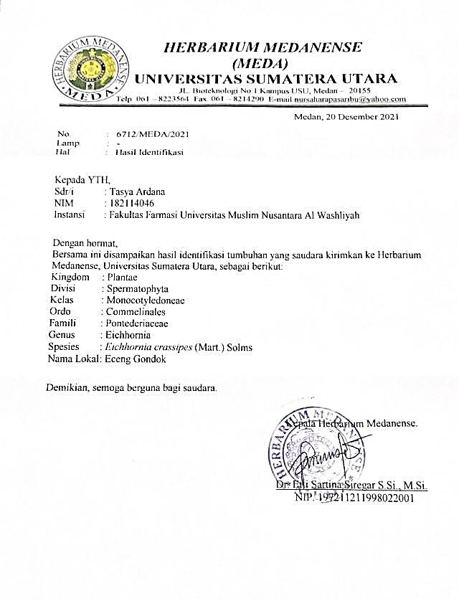

Lampiran 2 Rekomendasi Persetujuan Etik Penelitian

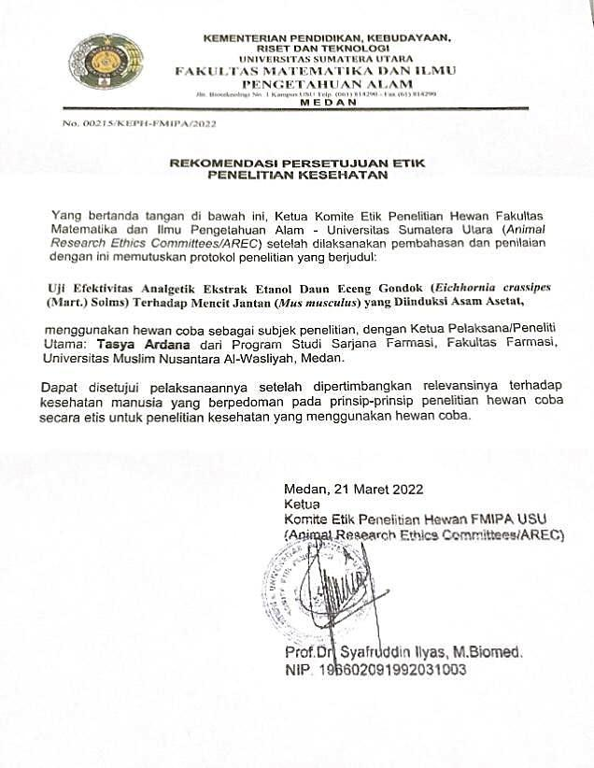

Lampiran 3 Bagan Alir Penelitian

Serbuk
Serbuk Kering
Dicuci bersih, ditiriskan, lalu dikeringkan lalu dihaluskan
Serbuk Kering
Hasil
Skrining fitokimia
karakterisasi
Hasil
Uji efektivitas analgetik
Hasil
Suspensi ekstrak etanol daun eceng gondok
Rotary evaporator
Daun Eceng Gondok
Ekstak kental
Maserat

Masersi dengan pelarut etanol 96%

Lampiran 4 Bagan Alir Pembuatan Simplisia

Tumbuhan daun eceng gondok 8 kg

Disortasi basah

Dicuci

Dirajang/ dipotong

Berat basah 7,8 kg

Dikeringkan dilemari pengering

Disortasi kering
Berat kering 976 g

Dihaluskan dengan menggunalan blender
Serbuk smplisia daun eceng gondok 820 g

Lampiran 5. Bagan alir Pembuatan Ekstrak Daun Eceng Gondok
Serbuk simplisia daun eceng gondok 500 g

Dimasukan dalam bejana

Dimasukan dengan 75 bagian etanol 96%

Ditutup dan dibiarkan selama 5 hari sambil diaduk aduk sekali kali

Setelah 5 hari maserat diserkai dan ampasnya diperas
Maserat 1
Ampas

Dicuci dengan 25 bagian etanol 96%

Dimasukan kedalam bejana tertutup,dibiarkan selama 2 hari dan disaring
Ekstrak kental 95 g
Maserat I + Maserat II
Maserat II

Dipekatkan dengan Rotary Evaporator

Lampiran 6. Bagan Alir Skrining Fitokimia dan Karakterisasi
Ekstrak Etanol Daun Eceng Gondok
Serbuk Simplisia Daun Eceng Gondok
Serbuk Simplisia Daun Eceng Gondok
Serbuk Simplisia Daun Eceng Gondok

Dimaserasi menggunakan pelarut etanol
Uji Farmakologi
1. Pemeriksaan Alkaloida

2. Pemeriksaan Flavonoid

3. Pemeriksaan Tanin

4. Pemeriksaan Saponin

5. Pemeriksaan Steroid/ Triterpenoid

6. Pemeriksaan Glikoksida
Skrining Fitokimia
1. Makroskopik

2. Mikroskopik

3. Penetapan kadar air

4. Penetapan Kadar Sari Larut Air

5. Penetapan Kadar Sari Larut Etanol

6. Penetapan Kadar Abu Total

7. Penetapan Kadar Abu Tidak Larut dalam Asam
Karakterisasi
1. Pemeriksaan Alkaoidaa

2. Pemeriksaan Flavonoid

3.Pemeriksaan Tanin.

4.Pemeriksaan Saponin.

5.Pemeriksaan Steroida/Triterpenoid
96%

Lampiran 7 Bagan Alir Uji Analgetik
Mencit

Dikondisikan selama 2 minggu
Diamati geliatnya dan dihitung jumlah geliat tiap 5 menit sampai ke 60 menit
Mencit Nyeri
Setelah 15 menit diamati, setiap kelompok diberikan perlakukan secara peroral:
Ke I CMC 0,5%

Ke II Methampiron 1%

Ke III EEDEG 300m g/kgBB

Ke VI EEDEG 400 mg/kgBB

Ke V EEDEG 500 mg/kgBB
Dihitung jumlah geliat tiap 5 menit sampe 15 menit
Mencit Nyeri
Diinduksi asam asetat 1% secara intraperitoneal
Dikelompokkan secara acak menjadi 5 kelompok, masing-masing kelompok 5 ekor.
Dipuasakan selama 18-24 jam

Lampiran 8Daun Eceng Gondok Segar, Simplisia dan Serbuk Simplisia Daun Eceng Gondok
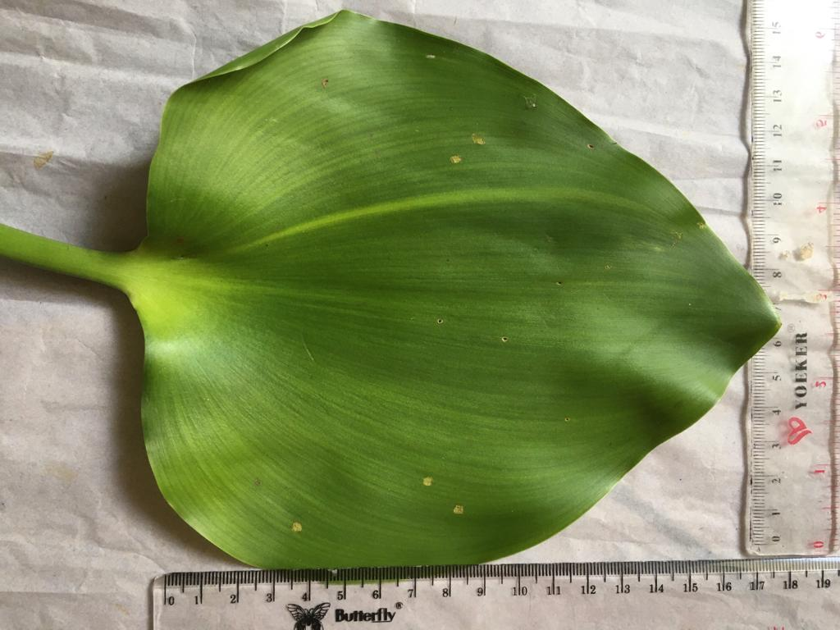

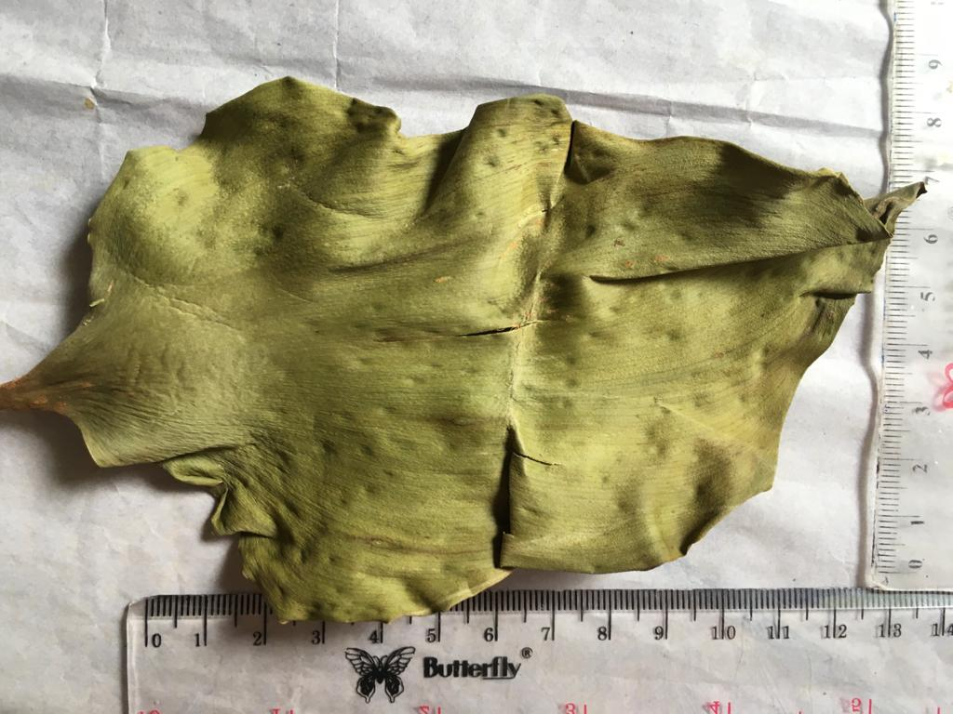
Daun Eceng Gondok Segar

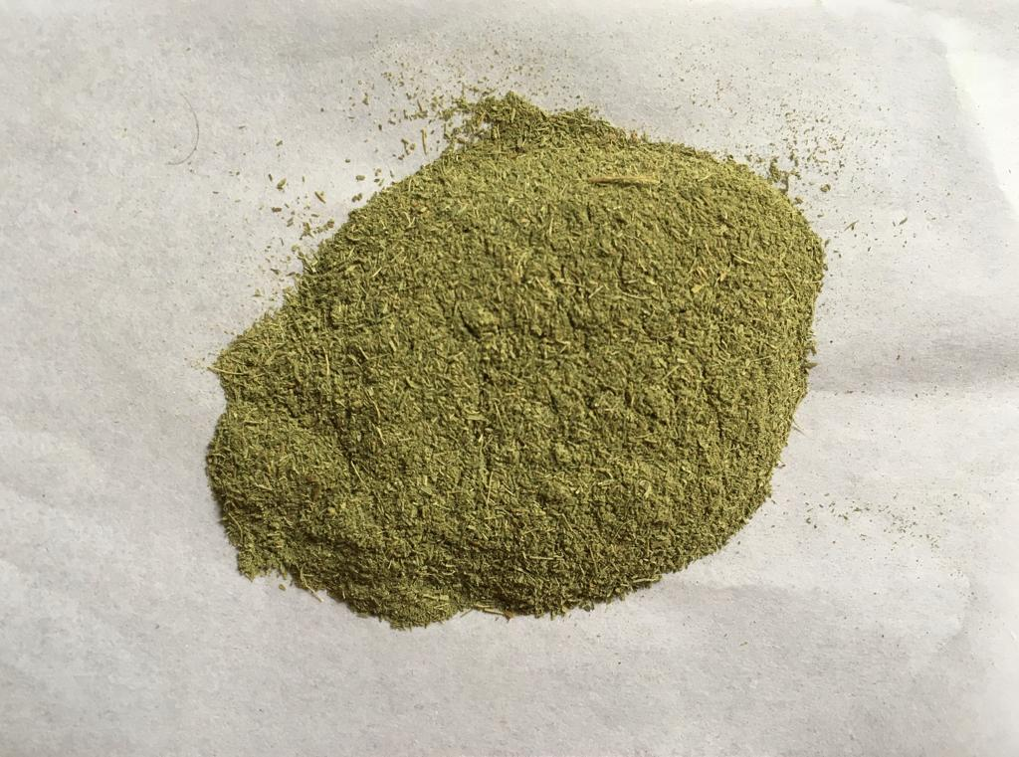
Simplisia Daun Eceng Gondok

Serbuk Simplisia Daun Eceng Gondok

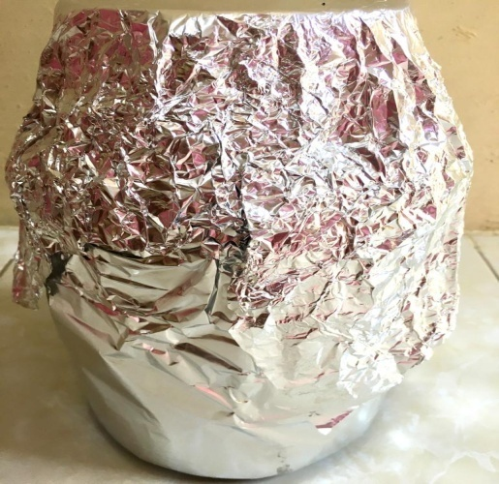
Lampiran 9.Maserasi danEkstrak Daun Eceng Gondok

Maserasi Serbuk Simplisia daun Eceng Gondok
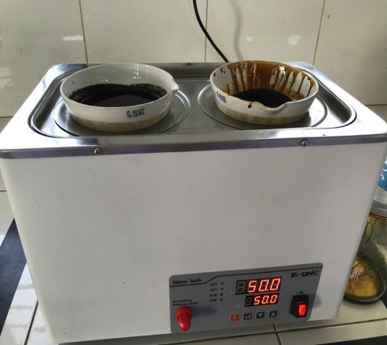
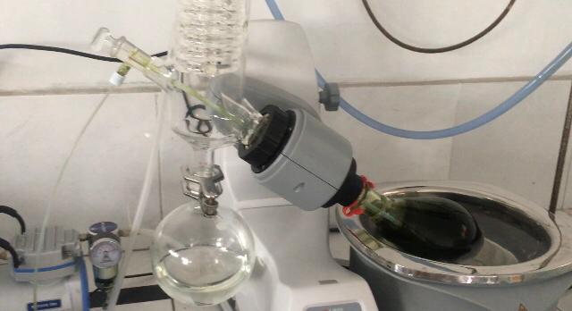

Alat Rotary Evaporator Waterbath

Ekstrak Etanol Daun Eceng Gondok
Lampiran 10. Hasil Mikroskop Daun Eceng Gondok

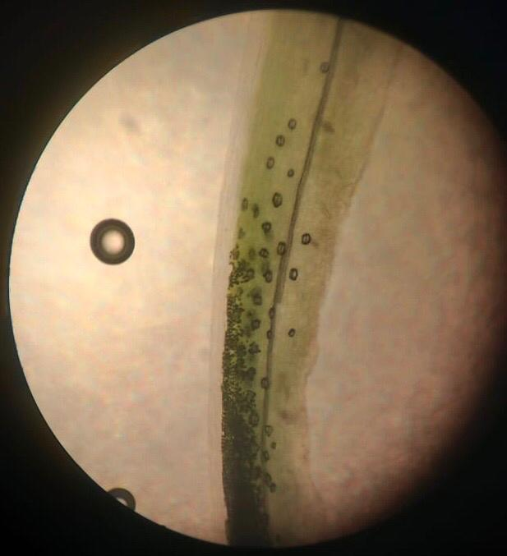
Mikroskopik daun Segar Eceng Gondok pada penapang mebujur

Kutikula
Epidermis atas
stomata

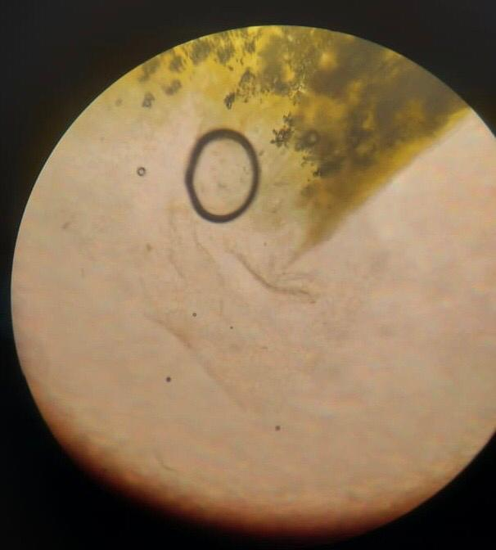
Mikroskopik daun segar eceng gondok pada penampang melintang

Trikoma/rambut pada Penanpang melintang

Lampiran 11.Hasil uji skrining fitokimia simplisia dan ekstrak daun eceng gondok
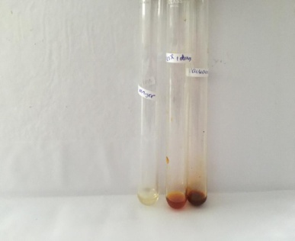
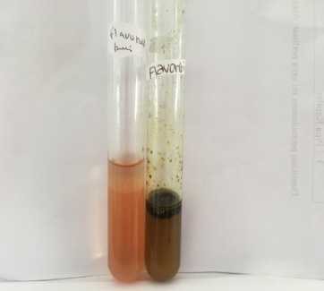
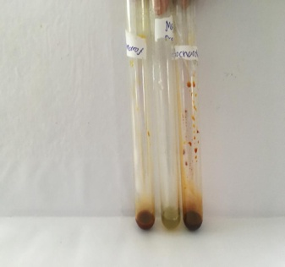

flavonoid pada ekstrak
flavonoid pada serbuk
Alkaoid pada serbuk
Alkaoid pada ekstrak

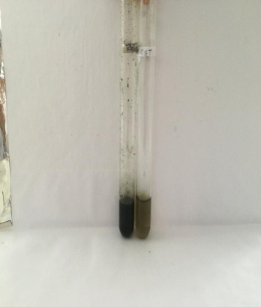
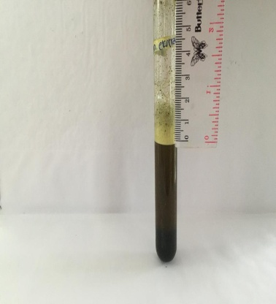
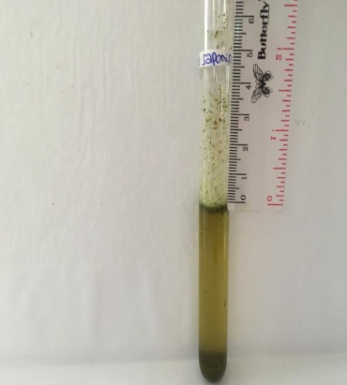

Tanin pada serbuk
Tanin pada ekstrak
Saponin pada serbuk
Saponin pada ekstrak

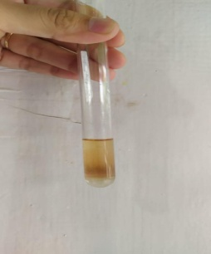
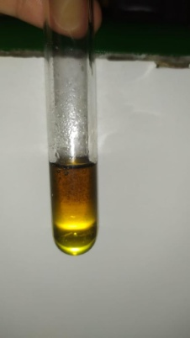
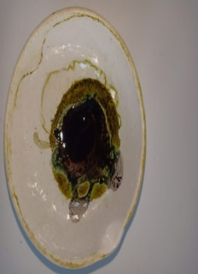
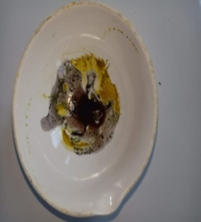

Steroid/Triterpenoid pada ekstrak
Steroid/Triterpenoid pada serbuk
Glikosida pada serbuk
Glikosida pada ekstrak

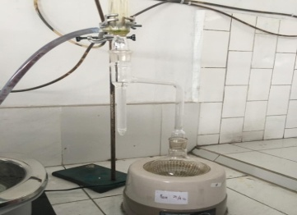
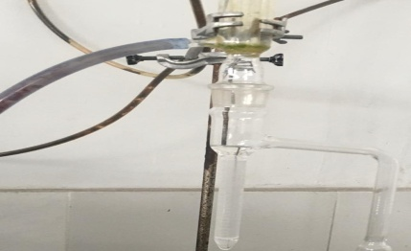
Lampiran 12 Hasil Karakterisasi Simplisia

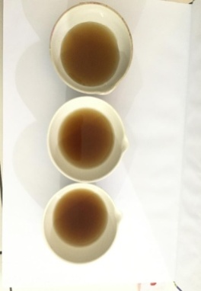
Penetapan Kadar Air Simplisia
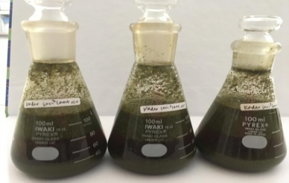

Penetapan Kadar Sari Larut Air
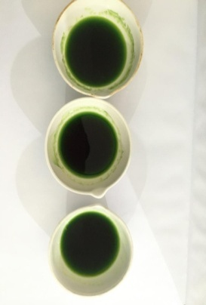
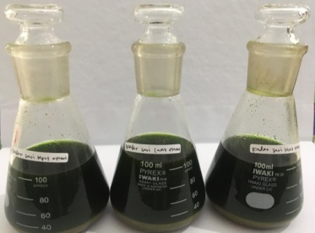

Penetapan Kadar Sari Larut Etanol
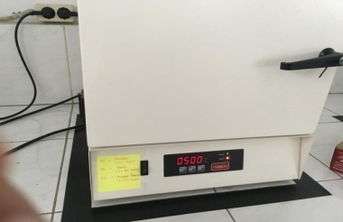
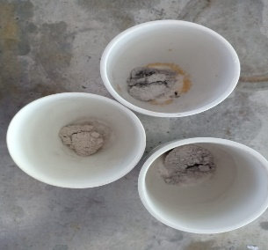

Penetapan Kadar Abu Total
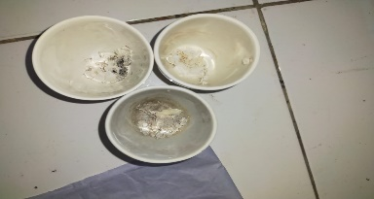
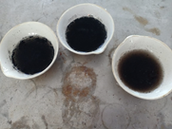

Penetapan Kadar Abu Tidak Larut dalam Asam

Lampiran 13. Hasil Perhitungan Parameter Karakteristik Simplisia
Berat kering = 820 gram
Berat serbuk = 500 gram
Berat ekstrak = 95 gram
X 100 %
Berat ekstrak yang di dapat
Bobot bahan simplisia yang di ekstrak
% Randemen =
95 gram
500 gram
= = 19%
1. Perhitungan Hasil Penetapan Kadar Air (Tidak lebih daro10%)
Berat sampel (g) | Volume awal (ml) | Volume akhir (ml) | Volume air (%)
5 | 1,9 | 2,2 | 6
5 | 1,7 | 2 | 6
5 | 1,8 | 2,1 | 6
Volume akhir – volume awal
Berat sampel
% Kadar air =
X 100

2,2 ml – 1,9 ml
5 g
- % Kadar air = x 100% = 6 %

2 ml – 1,7 ml
5 g
- % Kadar air = x 100% = 6 %

2,1 ml – 1,8 ml
5 g
- % Kadar air = x 100% = 6 %

6% + 6 % + 6 %
3
% rata – rata = = 6 %

Penetapan kadar air pada daun eceng gondok memenuhi syarat yaitu 6% tidak lebih dari 1-10%
2. Penetapan Kadar Sari Larut dalam Air (8-35%)

Berat sampel (g) | Berat cawan berisi | Berat cawan kosong
5 | 51,3269 | 50,9952
5 | 60,9960 | 60,6752
5 | 60,9853 | 60,6669

Lampiran 13. (lanjutan)
(Berat cawan berisi – Berat cawan kosong) x 5
5 g
Kadar sari larut air = x100%
(51,3269 – 50,9952) x 5 g
5 g
- % Kadar sari larut air = x 100 = 33,17 %
(60,9960 – 60,6752) x 5 g
5 g
- % Kadar sari larut air = x 100 = 32,08 %
(60,9852 – 60,6669) x 5 g
5 g
- % Kadar sari larut air = x 100 = 31,84%
33,17 + 32,08 + 31,84
3
Rata – rata kadar sari larut air = = 32,36%

Penetapan kadar sari larut dalam air memenuhi syarat yaitu 32,36% atau tidak leih dari 8-35%.

3. Penetapan Kadar Sari Larut Etanol
Berat sampel (g) | Berat cawan berisi (g) | Berat cawan kosong (g)
5 | 65,5756 | 65,3641
5 | 64,9651 | 64,6885
5 | 60,4234 | 60,2534
(Berat cawan berisi – Berat cawan kosong) x 5
5 g
Kadar sari larut air = x100%
(65,5756 – 65,3641) x 5 g
5 g
- % Kadar sari larut etanol = x 100 = 21,15 %
(64,9651 – 64,6885) x 5 g
5 g
- % Kadar sari larut etanol = x 100 = 27,66%
(60,4234 – 60,2534 ) x 5 g
5 g
- % Kadar sari larut etanol = x 100 = 17%

Lampiran 13. (lanjutan)
21,15 + 27,66 + 17
3
Rata – rata kadar sari larut etanol = = 21,93 %

Penetapan kadarsari larut etanol daun eceng gondok memenuhi syarat yaitu 21,93% atau tidak lebih dari 5-26%.
4. Penetapan Kadar Abu Total (7-14%)
Berat sampel (g) | Berat cawan berisi (g) | Berat cawan kosong (g)
2 | 25,9691 | 25,7952
2 | 26,8650 | 26,6934
2 | 24,9656 | 24,7873
(Berat cawan berisi – Berat cawan kosong)
Berat simplisia (g)
% Kadar abu total = x 100 %
(25,9691 – 25,7952)
2 g
- % Kadar abu total = x 100 = 8,69%
(26,8650 – 26,6934)
2 g
- % Kadar abu total = x 100 = 8,58%
(24,9656 – 24,7873)
2 g
- % Kadar abu total = x 100 = 8,91%
8,69% + 8,58% + 8,91%
3
% Kadar rata-rata abu total = = 8,72%
Penetapan kadar abu total pada daun eceng gondok memenuhi syaratyaitu 8,72% atau tidak lebih dari 7-14%
5. Penetapan Kadar Abu Tidak Larut Dalam Asam (1-10%)
Berat sampel (g) | Berat cawan berisi (g) | Berat cawan kosong (g)
2 | 26,5625 | 26,5620
2 | 25,9865 | 25,9860
2 | 26,4056 | 26,4051
Berat cawan berisi – Berat cawan kosong
Berat simplisia (g)
% Kadar abu tidak larut asam = x 100 %

Lampiran 13. (lanjutan)

26,5625 – 26,5620
2 g
1. % Kadar abu tidak larut asam = x 100%= 0,02%
25,9865 – 25,9860
2 g
2. % Kadar abu tidak larut asam = x 100% = 0,02%
26,4056 – 26,4051
2 g
3. % Kadar abu tidak larut asam = x 100% = 0,02%
0,025% + 0,025% + 0,025%
3
% Kadar rata – rata = = 0,02%
Penetapan kadarabu tidak larut asam pada daun eceng gondok tidak memenuhi syarat yaitu 0,02% atau tidak kurang dari 1-10%.

Lampiran 14.Lampiran Tabel Konversi Perhitungan Dosis antara Jenis Hewan dan Manusia

Tabel. Konversi Perhitungan Dosis antara Jenis Hewan dan Manusia

Hewan dan BB rata-rata | Mencit 20 g | Tikus 200 g | Marmut 400 g | Kelinci 1,5 Kg | Kucing 2 Kg | Kera 4 Kg | Anjing 12 kg | Manusia 70 Kg
Mencit 20 g | 1,0 | 7,0 | 12,29 | 27,8 | 28,7 | 64,1 | 124,2 | 387,9
Tikus 200 g | 0,14 | 1,0 | 1,74 | 3,9 | 4,2 | 9,2 | 17,8 | 60,5
Marmut 400 g | 0,08 | 0,57 | 1,0 | 2,25 | 2,4 | 5,2 | 10,2 | 31,5
Kelinci 1,5 Kg | 0,04 | 0,25 | 0,44 | 1,0 | 1,06 | 2,4 | 4,5 | 14,2
Kucing 2 Kg | 0,03 | 0,23 | 0,41 | 0,92 | 1,0 | 2,2 | 4,1 | 13,0
Kera 4 Kg | 0,016 | 0,11 | 0,19 | 0,42 | 0,45 | 1,0 | 1,9 | 6,1
Anjing 12 Kg | 0,008 | 0,06 | 0,10 | 0,22 | 0,24 | 0,52 | 1,0 | 3,1
Manusia 70 Kg | 0,0026 | 0,018 | 0,031 | 0,07 | 0,76 | 0,16 | 0,32 | 1,0

Lampiran 15.Tabel Volume Maksimum Larutan Sediaan Uji yang Dapat Diberikan Pada Beberapa Hewan Uji

Jenis Hewan Uji | Volume Maksimum (mL) sesuai jalur pemberian
 | i.v | i.m | i.p | s.c | p.o
Mencit (20-30 g) | 0,5 | 0,05 | 1,0 | 0,5-1,0 | 1,0
Tikus (200g) | 1,0 | 0,1 | 2-5 | 2-5 | 5,0
Hamster ( 50g) | - | 0,1 | 2-5 | 2-5 | 2,5
Marmut (250g) | - | 0,25 | 5,0 | 5,0 | 10,0
Kelinci (2,5 kg) | 5-10 | 0,5 | 5-10 | 5-10 | 20,0
Kucing (3Kg) | 5-10 | 1,0 | 5-10 | 5-10 | 50,0
Anjing (5Kg) | 10-20 | 5,0 | 10,0 | 10,0 | 100,0

Lampiran 16.Perhitungan Dosis
1. Dosis Methampiron (Antalgin)
Konversi dosis menusia ke dosis tikus
Dosis lazim methampiron pada manusia : 500 mg
Dosis mencit :0,0026
Berat badan mencit : 20 g
Dosis methampiron = 500 mg x 0,0026 = 1,3 mg/20 g
= 1,3 mg/ 0,02 Kg
= 65 mg/KgBB
Konsentrasi 1% = 1g/100mL = 0,01 g/mL = 10 mg/mL
Dosis mg/kgBB
1000
Dosis= x berat badan mencit (g)
Dosis
Konsentrasi
Volume =

Contoh :
65 mg/kgBB
1000
$Dosis=$x 20 g =1,3 mL
1.3 mg
10 mg/kgBB
Volume = = 0,13 mL

2. Dosis CMC
Volumr suspensi yan diberikan = 0,5 mL
Suspensi CMC 0,5%
0,5% = 0,5 g/100 mL = 500 mg/100 mL = 5 mg/mL

Lampiran 16 . (Lanjutan)
3. EEDEG 300 mg/kgBB
Berat Badan mencit = 20 g
Konsentrasi 2% = 2g/100mL = 2000 mg/100 mL = 20 mg/kgBB
Dosisi (mg)
1000
Dosis = X Berat badan mencit (g)
Dosis
Konsentrasi
Volume =

Contoh :
300 mg
1000
Dosis = x 20 g = 6 mg
6 mg
20 mg/mL
Volume = = 0.3 mL
4. EEDEG 400 mg/kgBB
Berat badan mencit = 20 g
Konsentrasi 2% = 2g/100mL = 2000 mg/100 mL = 20 mg/kgBB
Dosis = x Berat Badan Mencit (g)
Dosis (mg)
1000
Dosis
Konsentrasi
Volume =
Contoh :
400 mg
1000 mg/kgBB
Dosis = x 20 g = 8 mg
8 mg
20 mg/mL
Volume = = 0,4 mL

Lampiran 16 .(Lanjutan)
4. EEDEG 500 mg/kgBB
Dosisi (mg)
1000
Dosis = X Berat badan mencit (g)
Dosis
Konsentrasi
Volume =
Contoh :
500 mg/kgBB
1000
Dosis = x 20 g = 10 mg
10 mg
2020 mg/mL
Volume = = 0,5 mL

Lampiran 17. Hewan Percobaan, Pemberian Induksi Asam Asetat 1%, Pemberian Oral bahan uji, pengamatan Geliat

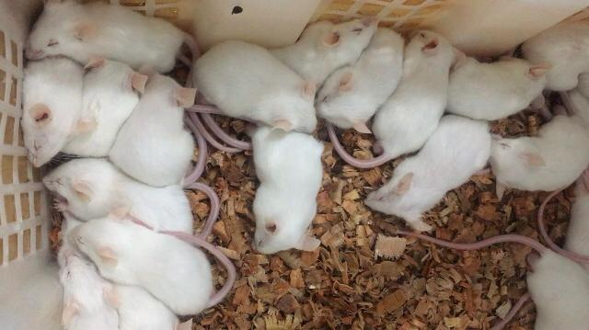
Hewan Percobaan

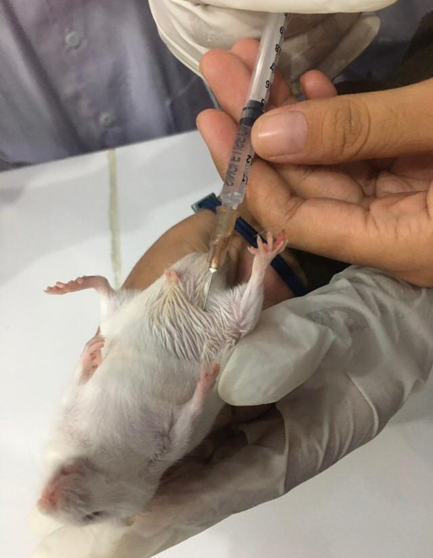

Pemberian Asam Asetat 1%

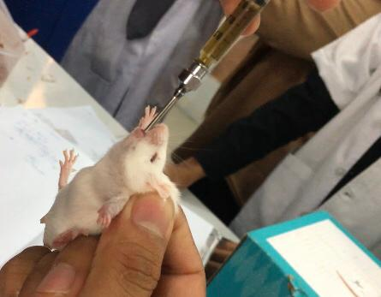
Pemberian Ekstrak Etanol Daun Eceng Gondok

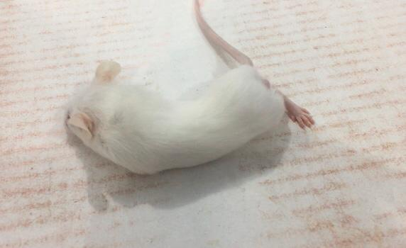
Pengamatan Geliat Mencit

Lampiran 18.Bahan Uji

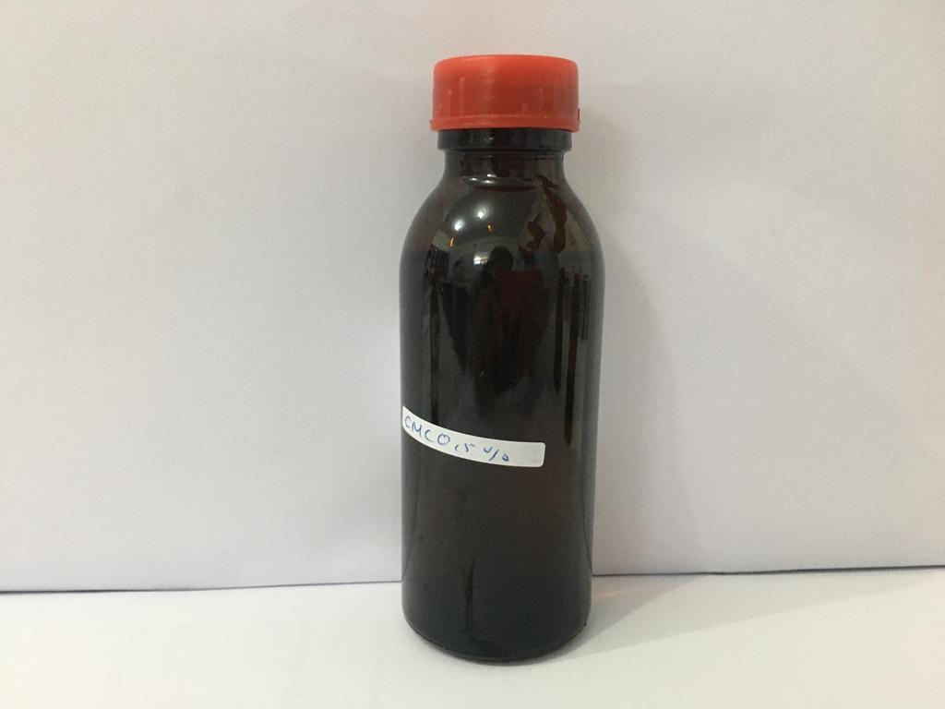

CMC 0,5%

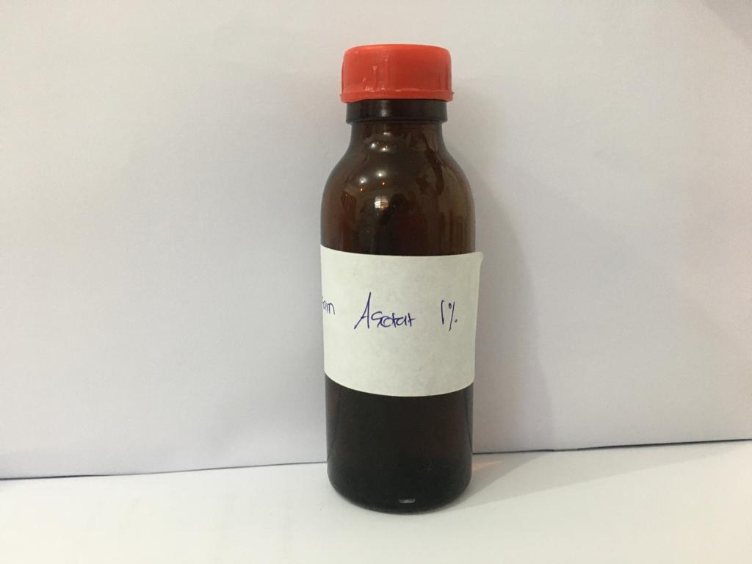

Asam Asetat 1%

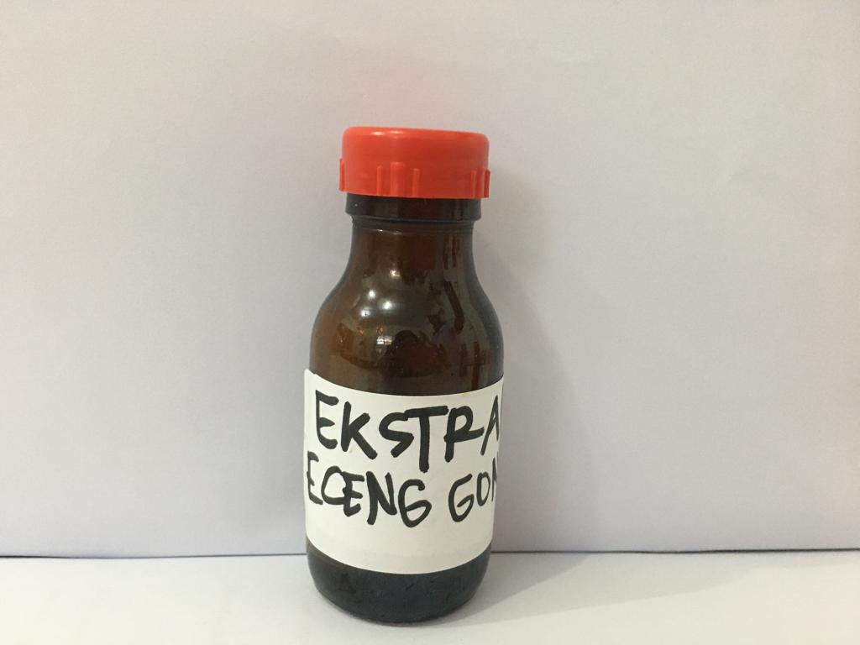

Ekstrak Etanol Daun Eceng Gondok

Lampiran 19. Data jumlah geliat mencit putih jantaan yang diinduksi Asam Asetat 0,5% volume 0,5 mL danAsam Asetat 1% volume 0,2 mL

perlakuan | Menit  Mencit  Ke | 5ʹ | 10ʹ | 15ʹ | 20ʹ | 25ʹ | 30ʹ | 35ʹ | 40ʹ | 45ʹ | 50ʹ | 55ʹ | 60ʹ
Asam Asetat 1% volume 0,2 mL | 1 | 15 | 18 | 22 | 21 | 20 | 19 | 18 | 17 | 15 | 12 | 11 | 7
 | 2 | 18 | 20 | 24 | 23 | 22 | 21 | 19 | 18 | 16 | 15 | 13 | 12
 | 3 | 20 | 21 | 23 | 20 | 19 | 18 | 16 | 14 | 12 | 10 | 9 | 7
 | 4 | 19 | 20 | 24 | 22 | 19 | 17 | 15 | 13 | 13 | 11 | 10 | 7
 | 5 | 14 | 16 | 20 | 17 | 16 | 15 | 13 | 12 | 10 | 8 | 8 | 6
 | Rata-rata | 17,2 | 19 | 22,6 | 20,6 | 19,2 | 18 | 16,2 | 14,8 | 13,2 | 11,2 | 10,2 | 7,8
Asam Asetat 0,5 % volume 0,5 mL | 1 | 14 | 17 | 21 | 20 | 19 | 18 | 17 | 16 | 14 | 11 | 10 | 6
 | 2 | 17 | 19 | 23 | 22 | 21 | 20 | 18 | 17 | 15 | 14 | 12 | 11
 | 3 | 20 | 20 | 22 | 19 | 18 | 17 | 15 | 13 | 11 | 9 | 8 | 6
 | 4 | 19 | 19 | 23 | 21 | 18 | 16 | 14 | 12 | 12 | 10 | 9 | 6
 | 5 | 13 | 16 | 19 | 16 | 15 | 14 | 12 | 11 | 9 | 7 | 7 | 5
 | Rata-rata | 16,6 | 18,2 | 21,6 | 19,6 | 18,2 | 17 | 15,2 | 13,8 | 12,2 | 10,2 | 9,2 | 6,8

Lampiran 20.Data hasil pengamatan geliat mencit putih jantan setelah pemberian suspensi CMC 0,5%, suspensi Methampiron 1%, suspensi Ekstrak Etanol Daun Eceng Gondok 300, 400, dan 500 mg/kgBB selang waktu 5 menit selama 1 jam.
Perlakuan | Menit mencit ke | 5ʹ | 10ʹ | 15ʹ | 20ʹ | 25ʹ | 30ʹ | 35ʹ | 40ʹ | 45ʹ | 50ʹ | 55ʹ | 60ʹ
CMC 0,5% | 1 | 18 | 36 | 30 | 27 | 24 | 22 | 21 | 19 | 17 | 14 | 11 | 9
 | 2 | 17 | 33 | 28 | 25 | 23 | 21 | 22 | 20 | 17 | 15 | 12 | 8
 | 3 | 19 | 35 | 30 | 26 | 24 | 22 | 19 | 17 | 15 | 13 | 11 | 8
 | 4 | 16 | 16 | 27 | 24 | 21 | 18 | 16 | 14 | 12 | 10 | 9 | 7
 | 5 | 19 | 35 | 29 | 27 | 25 | 22 | 19 | 17 | 15 | 13 | 11 | 9
 | Rata-rata | 17,8 | 24,2 | 28,8 | 25,8 | 23,4 | 21 | 19,4 | 17,4 | 15,2 | 13 | 10,8 | 8,2
Methampiron 1% | 1 | 15 | 24 | 17 | 13 | 9 | 6 | 4 | 2 | 0 | 0 | 0 | 0
 | 2 | 16 | 25 | 18 | 15 | 10 | 7 | 4 | 3 | 1 | 0 | 0 | 0
 | 3 | 13 | 22 | 16 | 14 | 10 | 6 | 4 | 2 | 1 | 0 | 0 | 0
 | 4 | 14 | 24 | 17 | 14 | 10 | 7 | 5 | 3 | 2 | 1 | 0 | 0
 | 5 | 16 | 26 | 18 | 13 | 8 | 5 | 3 | 1 | 0 | 0 | 0 | 0
 | Rata-rata | 14,8 | 24,2 | 17,2 | 13,8 | 9,4 | 6,2 | 4 | 2,2 | 0,8 | 0,2 | 0 | 0
EEDEG 300 mg/kgBB | 1 | 19 | 35 | 29 | 26 | 22 | 20 | 18 | 16 | 10 | 8 | 6 | 4
 | 2 | 17 | 33 | 26 | 22 | 19 | 17 | 15 | 13 | 13 | 11 | 9 | 7
 | 3 | 18 | 34 | 27 | 24 | 21 | 18 | 16 | 14 | 12 | 10 | 8 | 6
 | 4 | 18 | 35 | 29 | 25 | 22 | 19 | 17 | 15 | 13 | 11 | 9 | 8
 | 5 | 16 | 32 | 26 | 23 | 20 | 18 | 15 | 13 | 11 | 9 | 6 | 4
 | Rata-rata | 7,6 | 33,8 | 27,2 | 24 | 20,8 | 18,4 | 16,2 | 14,2 | 11,8 | 9,8 | 7,6 | 5,8
EEDEG 400 mg/kgBB | 1 | 17 | 31 | 25 | 20 | 18 | 15 | 13 | 10 | 8 | 7 | 5 | 3
 | 2 | 15 | 29 | 24 | 19 | 16 | 14 | 12 | 9 | 7 | 6 | 4 | 2
 | 3 | 17 | 30 | 26 | 22 | 19 | 16 | 13 | 10 | 7 | 5 | 5 | 2
 | 4 | 18 | 27 | 23 | 23 | 20 | 19 | 14 | 10 | 8 | 6 | 4 | 1
 | 5 | 16 | 24 | 20 | 20 | 17 | 20 | 12 | 11 | 8 | 7 | 4 | 4
 | Rata-rata | 16,6 | 27,6 | 23,6 | 20,8 | 18 | 15,8 | 12,8 | 8,2 | 7,6 | 6,2 | 4,4 | 2,4
EEDEG 500mg/kgBB | 1 | 17 | 31 | 24 | 15 | 13 | 11 | 8 | 5 | 3 | 1 | 0 | 1
 | 2 | 14 | 26 | 20 | 13 | 11 | 8 | 6 | 4 | 2 | 0 | 1 | 0
 | 3 | 16 | 30 | 18 | 12 | 9 | 6 | 4 | 1 | 0 | 0 | 1 | 0
 | 4 | 15 | 27 | 22 | 14 | 11 | 8 | 6 | 2 | 0 | 0 | 0 | 0
 | 5 | 13 | 24 | 18 | 13 | 10 | 7 | 5 | 3 | 1 | 0 | 0 | 0
 | Rata-rata | 15 | 27,6 | 19,6 | 13 | 10,8 | 8 | 5,8 | 3 | 1,2 | 0,2 | 0,4 | 0,2

Lampiran 21. Distribusi Normalitas terhadap Jumlah geliat Masing-Masing Kelompok
Hipotesis :
Ho : Data jumlah geliat terdistribusi normal
Ha : Data jumlah geliat tidak terdistribusi normal
Kriteria uji :
Ho ditolak bila Sig.<0,05
Ha diterima bila Sig.>0,05
Hasil

Tests of Normality
Menit | Perlakuan | Kolmogorov-Smirnovª |  |  | Shapiro-Wilk
 |  | Statistic | df | Sig. | Statistic | df | Sig.
Menit_5 | 1,00 | ,221 | 5 | ,200* | ,902 | 5 | ,421
 | 2,00 | ,221 | 5 | ,200* | ,902 | 5 | ,421
 | 3,00 | ,237 | 5 | ,200* | ,961 | 5 | ,814
 | 4,00 | ,237 | 5 | ,200* | ,961 | 5 | ,814
 | 5,00 | ,136 | 5 | ,200* | ,987 | 5 | ,967
Menit_10 | 1,00 | ,393 | 5 | ,011 | ,664 | 5 | ,004
 | 2,00 | ,246 | 5 | ,200* | ,956 | 5 | ,777
 | 3,00 | ,221 | 5 | ,200* | ,902 | 5 | ,421
 | 4,00 | ,213 | 5 | ,200* | ,939 | 5 | ,656
 | 5,00 | ,198 | 5 | ,200* | ,951 | 5 | ,742
Menit_15 | 1,00 | ,221 | 5 | ,200* | ,902 | 5 | ,421
 | 2,00 | ,231 | 5 | ,200* | ,881 | 5 | ,314
 | 3,00 | ,254 | 5 | ,200* | ,803 | 5 | ,086
 | 4,00 | ,197 | 5 | ,200* | ,943 | 5 | ,685
 | 5,00 | ,221 | 5 | ,200* | ,902 | 5 | ,421
Menit_20 | 1,00 | ,221 | 5 | ,200* | ,902 | 5 | ,421
 | 2,00 | ,231 | 5 | ,200* | ,881 | 5 | ,314
 | 3,00 | ,136 | 5 | ,200* | ,987 | 5 | ,967
 | 4,00 | ,287 | 5 | ,200* | ,914 | 5 | ,490
 | 5,00 | ,237 | 5 | ,200* | ,961 | 5 | ,814
Menit_25 | 1,00 | ,254 | 5 | ,200* | ,914 | 5 | ,492
 | 2,00 | ,349 | 5 | ,046 | ,771 | 5 | ,046
 | 3,00 | ,221 | 5 | ,200* | ,902 | 5 | ,421
 | 4,00 | ,136 | 5 | ,200* | ,987 | 5 | ,967
 | 5,00 | ,246 | 5 | ,200* | ,956 | 5 | ,777
Menit_30 | 1,00 | ,318 | 5 | ,109 | ,701 | 5 | ,010
 | 2,00 | ,231 | 5 | ,200* | ,881 | 5 | ,314
 | 3,00 | ,237 | 5 | ,200* | ,961 | 5 | ,814
 | 4,00 | ,221 | 5 | ,200* | ,915 | 5 | ,501
 | 5,00 | ,300 | 5 | ,161 | ,908 | 5 | ,453
Menit_35 | 1,00 | ,231 | 5 | ,200* | ,943 | 5 | ,685
 | 2,00 | ,300 | 5 | ,161 | ,883 | 5 | ,325
 | 3,00 | ,221 | 5 | ,200* | ,902 | 5 | ,421
 | 4,00 | ,231 | 5 | ,200* | ,881 | 5 | ,314
 | 5,00 | ,246 | 5 | ,200* | ,956 | 5 | ,777
Menit_40 | 1,00 | ,231 | 5 | ,200* | ,943 | 5 | ,685
 | 2,00 | ,231 | 5 | ,200* | ,881 | 5 | ,314
 | 3,00 | ,221 | 5 | ,200* | ,902 | 5 | ,421
 | 4,00 | ,300 | 5 | ,161 | ,883 | 5 | ,325
 | 5,00 | ,136 | 5 | ,200* | ,987 | 5 | ,967
Menit_45 | 1,00 | ,261 | 5 | ,200* | ,862 | 5 | ,236
 | 2,00 | ,231 | 5 | ,200* | ,881 | 5 | ,314
 | 3,00 | ,221 | 5 | ,200* | ,902 | 5 | ,421
 | 4,00 | ,367 | 5 | ,026 | ,684 | 5 | ,006
 | 5,00 | ,221 | 5 | ,200* | ,902 | 5 | ,421
Menit_50 | 1,00 | ,300 | 5 | ,161 | ,908 | 5 | ,453
 | 2,00 | ,473 | 5 | ,001 | ,552 | 5 | ,000
 | 3,00 | ,221 | 5 | ,200* | ,902 | 5 | ,421
 | 4,00 | ,231 | 5 | ,200* | ,881 | 5 | ,314
 | 5,00 | ,473 | 5 | ,001 | ,552 | 5 | ,000
Menit_55 | 1,00 | ,372 | 5 | ,022 | ,828 | 5 | ,135
 | 2,00 | . | 5 | . | . | 5 | .
 | 3,00 | ,254 | 5 | ,200* | ,803 | 5 | ,086
 | 4,00 | ,367 | 5 | ,026 | ,684 | 5 | ,006
 | 5,00 | ,367 | 5 | ,026 | ,684 | 5 | ,006
Menit_60 | 1,00 | ,231 | 5 | ,200* | ,881 | 5 | ,314
 | 2,00 | . | 5 | . | . | 5 | .
 | 3,00 | ,243 | 5 | ,200* | ,894 | 5 | ,377
 | 4,00 | ,237 | 5 | ,200* | ,961 | 5 | ,814
 | 5,00 | ,473 | 5 | ,001 | ,552 | 5 | ,000
*. This is a lower bound of the true significance.
a. Lilliefors Significance Correction

Keterangan ;
Df = degreeof freedom/derajat kebebasan adalah jumlah total pengamatan dalam sampel (N) dikurangi banyaknya kendali (linear) bebas.
Sig = Signifikan (p-value) adalah tingkat kepercayaan
Kesimpulan : Ho diterima artinya uji normalitas jumlah geliat seluruh kelompok hewan uji terdistribusi normal.

Lampiran 22 Uji Homogentitas Varians terhadap JumlahGeliat Masing-masing Kelompok
Tujuan: Untuk mengetahui homogenitas varians jumlah geliat masing-masing kelompok

Test of Homogeneity of Variances
 |  | Levene Statistic | df1 | df2 | Sig.
Menit_5 | Based on Mean | ,217 | 4 | 20 | ,926
 | Based on Median | ,226 | 4 | 20 | ,921
 | Based on Median and with adjusted df | ,226 | 4 | 19,513 | ,921
 | Based on trimmed mean | ,214 | 4 | 20 | ,928
Menit_10 | Based on Mean | 3,344 | 4 | 20 | ,030
 | Based on Median | ,644 | 4 | 20 | ,637
 | Based on Median and with adjusted df | ,644 | 4 | 4,945 | ,655
 | Based on trimmed mean | 2,475 | 4 | 20 | ,077
Menit_15 | Based on Mean | 1,972 | 4 | 20 | ,138
 | Based on Median | 1,259 | 4 | 20 | ,319
 | Based on Median and with adjusted df | 1,259 | 4 | 13,296 | ,334
 | Based on trimmed mean | 1,851 | 4 | 20 | ,159
Menit_20 | Based on Mean | ,998 | 4 | 20 | ,432
 | Based on Median | ,436 | 4 | 20 | ,781
 | Based on Median and with adjusted df | ,436 | 4 | 14,451 | ,781
 | Based on trimmed mean | ,963 | 4 | 20 | ,449
Menit_25 | Based on Mean | ,299 | 4 | 20 | ,875
 | Based on Median | ,267 | 4 | 20 | ,896
 | Based on Median and with adjusted df | ,267 | 4 | 17,495 | ,895
 | Based on trimmed mean | ,302 | 4 | 20 | ,873
Menit_30 | Based on Mean | 1,948 | 4 | 20 | ,142
 | Based on Median | ,890 | 4 | 20 | ,488
 | Based on Median and with adjusted df | ,890 | 4 | 14,368 | ,495
 | Based on trimmed mean | 1,898 | 4 | 20 | ,150
Menit_35 | Based on Mean | 1,713 | 4 | 20 | ,187
 | Based on Median | 1,205 | 4 | 20 | ,340
 | Based on Median and with adjusted df | 1,205 | 4 | 11,524 | ,361
 | Based on trimmed mean | 1,748 | 4 | 20 | ,179
Menit_40 | Based on Mean | 1,877 | 4 | 20 | ,154
 | Based on Median | 1,390 | 4 | 20 | ,273
 | Based on Median and with adjusted df | 1,390 | 4 | 10,828 | ,301
 | Based on trimmed mean | 1,906 | 4 | 20 | ,149
Menit_45 | Based on Mean | 1,425 | 4 | 20 | ,262
 | Based on Median | 1,118 | 4 | 20 | ,376
 | Based on Median and with adjusted df | 1,118 | 4 | 11,796 | ,394
 | Based on trimmed mean | 1,466 | 4 | 20 | ,250
Menit_50 | Based on Mean | 1,728 | 4 | 20 | ,183
 | Based on Median | 1,793 | 4 | 20 | ,170
 | Based on Median and with adjusted df | 1,793 | 4 | 10,163 | ,206
 | Based on trimmed mean | 1,814 | 4 | 20 | ,166
Menit_55 | Based on Mean | 6,531 | 4 | 20 | ,002
 | Based on Median | 2,286 | 4 | 20 | ,096
 | Based on Median and with adjusted df | 2,286 | 4 | 13,466 | ,114
 | Based on trimmed mean | 6,112 | 4 | 20 | ,002
Menit_60 | Based on Mean | 6,293 | 4 | 20 | ,002
 | Based on Median | 3,750 | 4 | 20 | ,020
 | Based on Median and with adjusted df | 3,750 | 4 | 12,698 | ,031
 | Based on trimmed mean | 6,396 | 4 | 20 | ,002

Lampiran 23Analisis Varian Satu Arah Maing-Maing Kelompok Perlakuan Terhadap Jumlah Geliat

ANOVA
 |  | Sum of Squares | Df | Mean Square | F | Sig.
Menit_5 | Between Groups | 39,760 | 4 | 9,940 | 5,847 | ,003
 | Within Groups | 34,000 | 20 | 1,700
 | Total | 73,760 | 24
Menit_10 | Between Groups | 263,360 | 4 | 65,840 | 3,602 | ,023
 | Within Groups | 365,600 | 20 | 18,280
 | Total | 628,960 | 24
Menit_15 | Between Groups | 463,040 | 4 | 115,760 | 34,452 | ,000
 | Within Groups | 67,200 | 20 | 3,360
 | Total | 530,240 | 24
Menit_20 | Between Groups | 656,560 | 4 | 164,140 | 92,213 | ,000
 | Within Groups | 35,600 | 20 | 1,780
 | Total | 692,160 | 24
Menit_25 | Between Groups | 756,240 | 4 | 189,060 | 99,505 | ,000
 | Within Groups | 38,000 | 20 | 1,900
 | Total | 794,240 | 24
Menit_30 | Between Groups | 865,040 | 4 | 216,260 | 71,138 | ,000
 | Within Groups | 60,800 | 20 | 3,040
 | Total | 925,840 | 24
Menit_35 | Between Groups | 874,160 | 4 | 218,540 | 105,067 | ,000
 | Within Groups | 41,600 | 20 | 2,080
 | Total | 915,760 | 24
Menit_40 | Between Groups | 900,960 | 4 | 225,240 | 105,252 | ,000
 | Within Groups | 42,800 | 20 | 2,140
 | Total | 943,760 | 24
Menit_45 | Between Groups | 811,040 | 4 | 202,760 | 117,884 | ,000
 | Within Groups | 34,400 | 20 | 1,720
 | Total | 845,440 | 24
Menit_50 | Between Groups | 653,440 | 4 | 163,360 | 129,651 | ,000
 | Within Groups | 25,200 | 20 | 1,260
 | Total | 678,640 | 24
Menit_55 | Between Groups | 431,360 | 4 | 107,840 | 131,512 | ,000
 | Within Groups | 16,400 | 20 | ,820
 | Total | 447,760 | 24
Menit_60 | Between Groups | 257,840 | 4 | 64,460 | 59,685 | ,000
 | Within Groups | 21,600 | 20 | 1,080
 | Total | 279,440 | 24

Lampiran 24Uji Turkey /Uji Beda Nyata Antar kelompok Perlakuan
Tujuan: Untuk mengetahui pada kelompok mana terdapatperbedaan jumlah geliat yang bermakna
Hipotesis:
Ho : Datajumlah geliat antar kelompok perlakuan tidak berbeda secara bermakna
Ha : Data jumlah geliat anatar kelompok perlakuan berbeda secara bermakna
Kriteria hasiluji :
Ho ditolak bila Sig.<0,05
Ha diterima bila Sig.>0,05
Hasil
Menit_5
Tukey HSDª
X | N | Subset for alpha = 0.05
 |  | 1 | 2
Methamiron 1% | 5 | 14,8000
EEDEG 500 mg/kgBB | 5 | 15,0000
EEDEG 400 mg/kgBB | 5 | 16,6000 | 16,6000
EEDEG 300mg/kg BB | 5 |  | 17,6000
CMC 0,5% | 5 |  | 17,8000
Sig. |  | ,226 | ,601
Means for groups in homogeneous subsets are displayed.
a. Uses Harmonic Mean Sample Size = 5,000.

Menit_10
Tukey HSDª
X | N | Subset for alpha = 0.05
 |  | 1 | 2
Methamiron 1% | 5 | 24,2000
EEDEG 500 mg/kgBB | 5 | 27,6000 | 27,6000
EEDEG 400 mg/kgBB | 5 | 28,2000 | 28,2000
CMC 0,5% | 5 | 31,0000 | 31,0000
EEDEG 300mg/kg BB | 5 |  | 33,8000
Sig. |  | ,127 | ,188
Means for groups in homogeneous subsets are displayed.
a. Uses Harmonic Mean Sample Size = 5,000.

Menit_15
Tukey HSDª
X | N | Subset for alpha = 0.05
 |  | 1 | 2 | 3
Methamiron 1% | 5 | 17,2000
EEDEG 500 mg/kgBB | 5 | 20,4000 | 20,4000
EEDEG 400 mg/kgBB | 5 |  | 23,6000
EEDEG 300mg/kg BB | 5 |  |  | 27,4000
CMC 0,5% | 5 |  |  | 28,8000
Sig. |  | ,080 | ,080 | ,747
Means for groups in homogeneous subsets are displayed.
a. Uses Harmonic Mean Sample Size = 5,000.

Menit_20
Tukey HSDª
X | N | Subset for alpha = 0.05
 |  | 1 | 2 | 3
EEDEG 500 mg/kgBB | 5 | 13,4000
Methamiron 1% | 5 | 13,8000
EEDEG 400 mg/kgBB | 5 |  | 20,8000
EEDEG 300mg/kg BB | 5 |  |  | 24,0000
CMC 0,5% | 5 |  |  | 25,8000
Sig. |  | ,989 | 1,000 | ,245
Means for groups in homogeneous subsets are displayed.
a. Uses Harmonic Mean Sample Size = 5,000.

Menit_25
Tukey HSDª
X | N | Subset for alpha = 0.05
 |  | 1 | 2 | 3
Methamiron 1% | 5 | 9,4000
EEDEG 500 mg/kgBB | 5 | 10,8000
EEDEG 400 mg/kgBB | 5 |  | 18,0000
EEDEG 300mg/kg BB | 5 |  |  | 20,8000
CMC 0,5% | 5 |  |  | 23,4000
Sig. |  | ,511 | 1,000 | ,051
Means for groups in homogeneous subsets are displayed.
a. Uses Harmonic Mean Sample Size = 5,000.

Menit_30
Tukey HSDª
X | N | Subset for alpha = 0.05
 |  | 1 | 2 | 3
Methamiron 1% | 5 | 6,2000
EEDEG 500 mg/kgBB | 5 | 8,0000
EEDEG 400 mg/kgBB | 5 |  | 16,8000
EEDEG 300mg/kg BB | 5 |  | 18,4000 | 18,4000
CMC 0,5% | 5 |  |  | 21,0000
Sig. |  | ,495 | ,604 | ,168
Means for groups in homogeneous subsets are displayed.
a. Uses Harmonic Mean Sample Size = 5,000.

Menit_35
Tukey HSDª
X | N | Subset for alpha = 0.05
 |  | 1 | 2 | 3 | 4
Methamiron 1% | 5 | 4,0000
EEDEG 500 mg/kgBB | 5 | 5,8000
EEDEG 400 mg/kgBB | 5 |  | 12,8000
EEDEG 300mg/kg BB | 5 |  |  | 16,2000
CMC 0,5% | 5 |  |  |  | 19,4000
Sig. |  | ,314 | 1,000 | 1,000 | 1,000
Means for groups in homogeneous subsets are displayed.
a. Uses Harmonic Mean Sample Size = 5,000.

Menit_40
Tukey HSDª
X | N | Subset for alpha = 0.05
 |  | 1 | 2 | 3 | 4
Methamiron 1% | 5 | 2,2000
EEDEG 500 mg/kgBB | 5 | 3,0000
EEDEG 400 mg/kgBB | 5 |  | 10,0000
EEDEG 300mg/kg BB | 5 |  |  | 14,2000
CMC 0,5% | 5 |  |  |  | 17,4000
Sig. |  | ,906 | 1,000 | 1,000 | 1,000
Means for groups in homogeneous subsets are displayed.
a. Uses Harmonic Mean Sample Size = 5,000.

Menit_45
Tukey HSDª
X | N | Subset for alpha = 0.05
 |  | 1 | 2 | 3 | 4
Methamiron 1% | 5 | ,8000
EEDEG 500 mg/kgBB | 5 | 1,2000
EEDEG 400 mg/kgBB | 5 |  | 7,6000
EEDEG 300mg/kg BB | 5 |  |  | 11,8000
CMC 0,5% | 5 |  |  |  | 15,2000
Sig. |  | ,988 | 1,000 | 1,000 | 1,000
Means for groups in homogeneous subsets are displayed.
a. Uses Harmonic Mean Sample Size = 5,000.

Menit_50
Tukey HSDª
X | N | Subset for alpha = 0.05
 |  | 1 | 2 | 3 | 4
Methamiron 1% | 5 | ,2000
EEDEG 500 mg/kgBB | 5 | ,2000
EEDEG 400 mg/kgBB | 5 |  | 6,2000
EEDEG 300mg/kg BB | 5 |  |  | 9,8000
CMC 0,5% | 5 |  |  |  | 13,0000
Sig. |  | 1,000 | 1,000 | 1,000 | 1,000
Means for groups in homogeneous subsets are displayed.
a. Uses Harmonic Mean Sample Size = 5,000.

Menit_55
Tukey HSDª
X | N | Subset for alpha = 0.05
 |  | 1 | 2 | 3 | 4
Methamiron 1% | 5 | ,0000
EEDEG 500 mg/kgBB | 5 | ,4000
EEDEG 400 mg/kgBB | 5 |  | 4,4000
EEDEG 300mg/kg BB | 5 |  |  | 7,6000
CMC 0,5% | 5 |  |  |  | 10,8000
Sig. |  | ,954 | 1,000 | 1,000 | 1,000
Means for groups in homogeneous subsets are displayed.
a. Uses Harmonic Mean Sample Size = 5,000.

Menit_60
Tukey HSDª
X | N | Subset for alpha = 0.05
 |  | 1 | 2 | 3 | 4
Methamiron 1% | 5 | ,0000
EEDEG 500 mg/kgBB | 5 | ,2000
EEDEG 400 mg/kgBB | 5 |  | 2,4000
EEDEG 300mg/kg BB | 5 |  |  | 5,8000
CMC 0,5% | 5 |  |  |  | 8,2000
Sig. |  | ,998 | 1,000 | 1,000 | 1,000
Means for groups in homogeneous subsets are displayed.
a. Uses Harmonic Mean Sample Size = 5,000.
Kesimpulan :
1. Kontrol positif (suspensi methampiron 1%) dansuspensi EEDEG 300, 400, dan 500 mg/kgBB menunjukka efek analgetik yang berbeda bermakna terhadap kelompok negatif.
2. Kontrol positif (suspensi methampiron 1%) menunjukkan efek analgetik yang berbeda bermakna terhadap kelompok negatif (CMC 0,5%).

Lampiran 25. Perhitungan Persentase Daya Analgetik
Rumus % Daya Analgetik
Jumlah rata-rata geliat kelompok bahan uji
Jumlah rata-rata kelompok kontrol negatif
% daya Analgetik = { 100 - x 100% }
1. Kontrol Positif (Metampiron 1%)
14,3
17,8
Menit ke 5 = x 100%
= 100 – 83,15
= 16,85%
Dengan cara yang sama dihitung menit selanjutnya sampai menit ke-60.
Diperoleh :
Menit ke 10 = 29,24%
Menit ke 15 = 40,28%
Menit ke 20 = 46,51%
Menit ke 25 = 59,83%
Menit ke 30 = 70,48%
Menit ke 35 = 79,38%
Menit ke 40 = 87,36%
Menit ke 45 = 94,74%
Menit ke 50 = 98,46%
Menit ke 55 = 100%
Menit ke 60 = 100%
2. Ekstrak Etanol Daun Eceng Gondok (EEDEG) 300 mg/kgBB
17,6
17,8
Menit ke 5 = 100 – ( x 100%)
= 100 – 98,88 = 1,12%

(lanjutan)
Dengan cara yang sama dihitung menit selajutnya sampai menit ke-60, diiperoleh:
Menit ke 10 = 1,17%
Menit ke 15 = 6,25%
Menit ke 15 = 6,25%
Menit ke 20 = 6,98%
Menit ke 25 = 11,11%
Menit ke 30 = 12,38%
Menit ke 35 = 16,5%
Menit ke 40 = 18,39%
Menit ke 45 = 28,95%
Menit ke 50 = 24,62%
Menit ke 55 = 26,93%
Menit ke 60 = 29,27%
3. Ekstrak Etanol Daun Eceng Gondok (EEDEG) 400 mg/kgBB
16,6
17,8
Menit ke 5 = 100 – ( x 100%)
= 100 – 93,26
= 6,74%
Dengan cara yag sama dihitung menit selanjutnya sampai menit ke-60,diperoleh:
Menit ke 10 = 12,8%
Menit ke 15 = 18,06%
Menit ke 20 =19,38%
Menit ke 25 = 23,08%
Menit ke 30 = 24,76%
Lampiran (lanjutan)
Menit ke 35 = 34,02%
Menit ke 40 =52,87%
Menit ke 45 = 50,33%
Menitke 50 = 52,3%
Menit ke 55 = 57,7%
Menit ke 60 = 70,735 %
4. Ekstrak Etanol Daun Eceng Gondok (EEDEG) 500 mg/kgBB
15
17,8
Menit ke 5 = 100 - ( x 100 %)
= 100 – 84,27
= 15,73 %
Dengan cara yang sama dihitung menit selanjutnya sampai menit ke-60,diperoleh:
Menit ke10 = 19,39%
Menitke 15 = 31,95%
Menit ke 20 = 48,06%
Menit ke 25 =53,85%
Menit ke 30 = 61,91%
Menit ke 35 = 70,1%
Menit ke 40 = 82,76%
Menit ke 45 = 92,19%
Menit ke 50 = 98,46%
Menit ke 55 = 96,3%
Menit ke 60 =97,57%

