Lampiran 1. Hasil Identifikasi Tumbuhan

Lampiran 2. Bagan Alir Pembuatan Simplisia Daun Matoa
Daun Matoa Segar
`
Disortasi basah
Dicuci dengan air kran mengalir
Ditiriskan
Dirajang tipis-tipis
Ditimbang

Berat basah daun matoa

Dikeringkan dalam lemari pengering dengan suhu ±40ºC
Disortasi kering
Ditimbang kembali

Berat kering simplisia daun matoa

Dihaluskan menggunakan blender
Disimpan dalam wadah tertutup

Serbuk simplisia daun matoa

Lampiran 3. Bagan Alir Karakterisasi Simplisia Daun Matoa

Serbuk simplisia daun matoa

Kadar sari larut etanol
Kadar abu tidak larut asam
Kadar Air
Pemeriksaan Makroskopik

Kadar abu total
Pemeriksaan Mikroskopik
Kadar sari larut air

Lampiran 4. Bagan Alir Pembuatan Ekstrak Etanol Daun Matoa
Serbuk Simplisia

Ditimbang 500 gram
Dimasukkan dalam bejana
Ditambahkan 75 bagian etanol 96% (3750 ml) diamkan selama 5 hari
Diaduk sesekali dan disaring

Ampas 1
Maserat 1

Dibilas dengan 25 bagian etanol 96% (1250 ml)

Maserat I dan II dicampur

Diamkan selama 2 hari, lalu di enap tuangkan

Maserat

Di pekatkan dengan Rotary evaporator

Ekstrak Kental Daun Matoa

Lampiran 5. Bagan Alir Skrining Fitokimia Simplisia dan Ekstrak Daun Matoa (Pometia pinnata J.R. Forst & G. Forst)
Golongan Steroid/Triter-penoid
Golongan Tanin
Golongan Saponin
Golongan Flavonoid
Golongan Alkaloid
Skrining fitokimia
Ekstrak daun matoa

Serbuk simplisia daun matoa

Golongan Glikosida

Lampiran 6. Bagan Alir Uji Sitotoksisitas Ekstrak Daun Matoa
Timbang 0,2 g ekstrak daun matoa

Dilarutkan dengan 100 ml air laut

Larutan induk 2000 ppm
Dibuat dalam beberapa variasi konsentrasi

100 μg/ml, 200 μg/ml, 300 μg/ml, 400 μg/ml, 500 μg/ml, 600 μg/ml, 700 μg/ml, 800 μg/ml, 900 μg/ml, 1000 μg/ml

Dimasukkan 10 ekor larva udang ke dalam masing masing vial
Lalu diambil beberapa ml LIB 2000 ppm sesuai yang dibutuhkan tiap konsentrasi, lalu ditambahkan dengan air laut 10 ml
Masing-masing konsentrasi dibuat dengan 3 kali pengulangan
Mortalitas dihitung setelah 24 jam

Hitung LC₅₀

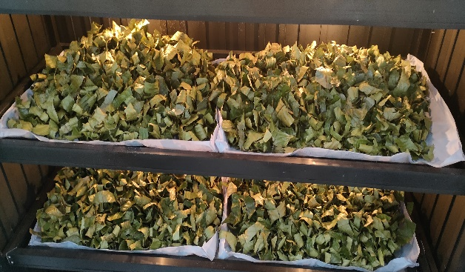
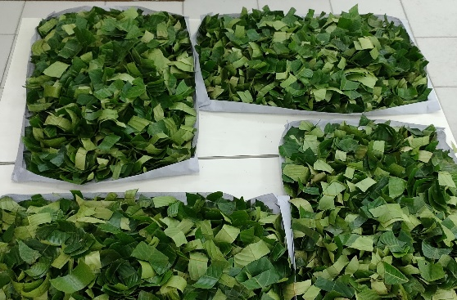
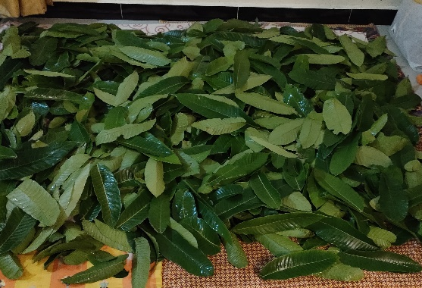
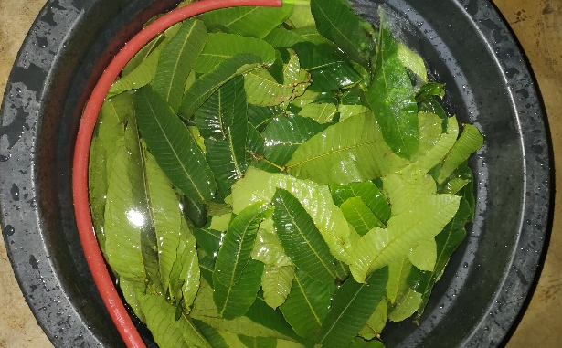
Lampiran 7. Pengolahan Sampel Daun Matoa
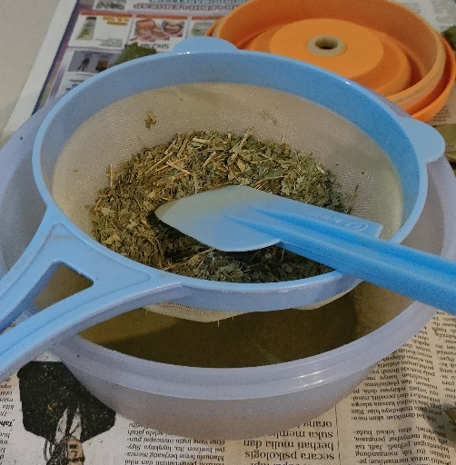
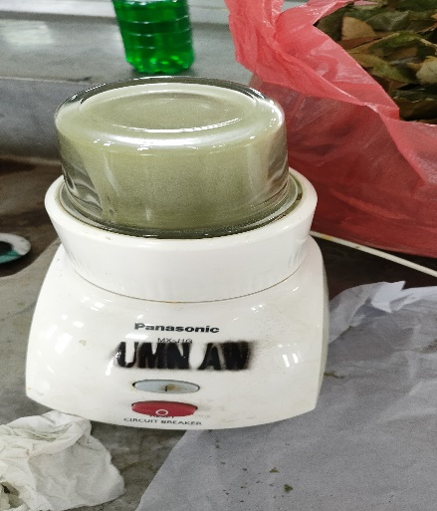
Pencucian
Sortasi basah

Pengeringan
Perajangan

Pengayakan
Penghalusan

Lampiran 8. Proses Ekstraksi Daun Matoa
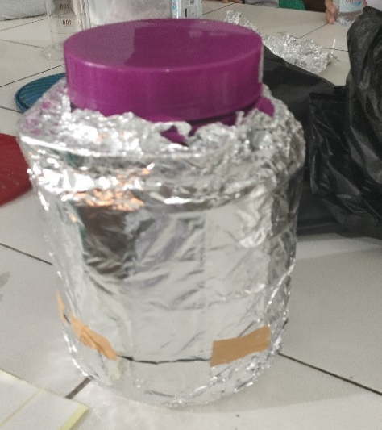
Serbuk simplisia daun matoa
Hasil maserat daun matoa

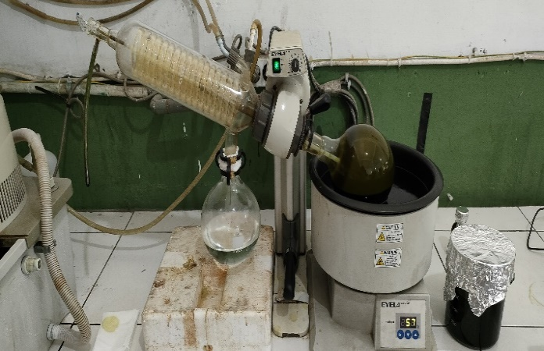
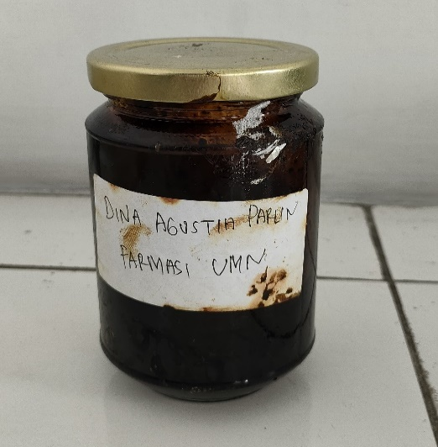
Ekstrak kental daun matoa
Pengentalan ekstrak daun matoa

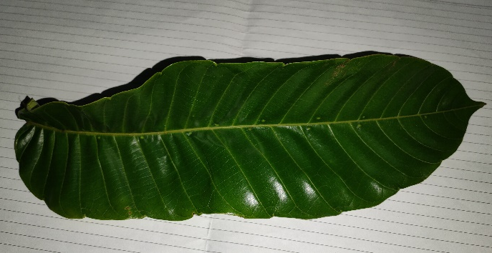
Lampiran 9. Makroskopik Daun Matoa
Daun Matoa

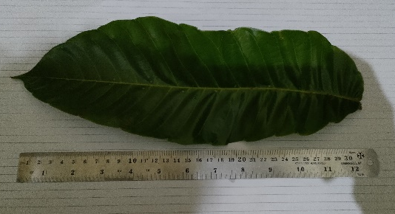
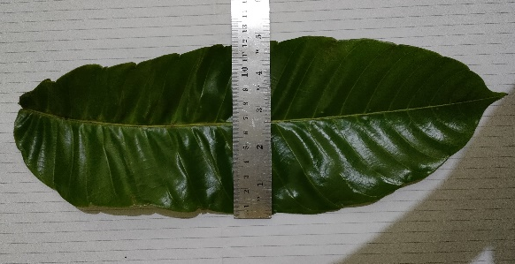
Lebar daun matoa ± 12 cm
Panjang daun matoa ± 30 cm
Lampiran 10. Pemeriksaan Mikroskopik Serbuk Daun Matoa
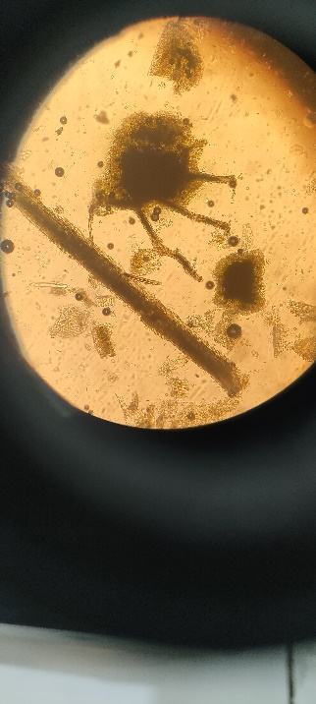
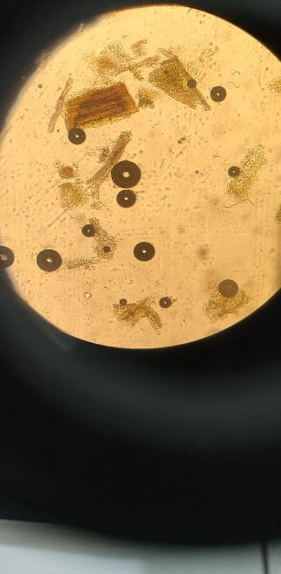
2
1

Keterangan Gambar :
            - Sel Parenkim
            - Epidermis

Lampiran 11. Perhitungan Susut Pengeringan Daun Matoa

Diketahui :
Bobot tumbuhan segar = 3000 gram
Bobot simplisia = 800 gram
$$\% Susut Pengeringan=\frac{berat tumbuhan segar-bobot simplisia}{berat tumbuhan segar }x 100\%$$
$$\% Susut Pengeringan=\frac{3000-800}{3000 }x 100\%$$
= 73, 3 %

Lampiran 12. Perhitungan Rendemen Ekstrak Etanol Daun Matoa

Rendemen Ekstrak Etanol Daun Matoa (Pometia pinnata)
Berat simplisia Daun Matoa = 500 gram
Berat ekstrak Daun matoa = 96,9530 gram
$$\% Rendemen=\frac{berat ekstrak kental}{berat simplisia kering }x 100\%$$
$$=\frac{96,9530 gram}{500 gram }x 100\%$$
$=$ 19,3 %

Lampiran 13. Perhitungan Hasil Karakterisasi simplisia Daun Matoa

Perhitungan Kadar Air
Perhitungan Kadar Air menurut (Depkes RI, 1989):

$$kadar air=\frac{volume akhir air-volume awal air}{berat sampel mula-mula (g)}x 100\%$$
Pengulangan 1
Volume awal air (V_{o}) = 1,9 ml
Volume akhir air (V₁) = 2,3 ml
Berat sampel = 5 gram
$$kadar air=\frac{V1-Vo}{berat sampel }x 100\%$$
$$kadar air=\frac{2,3 ml-1,9 ml}{5 gram}x 100\%$$
= 8 %
Pengulangan 2
Volume awal air (V_{o}) = 2,0 ml
Volume akhir air (V₁) = 2,4 ml
Berat sampel = 5 gram
$$kadar air=\frac{V1-Vo}{berat sampel }x 100\%$$
$$kadar air=\frac{2,4 ml-2,0 ml}{5 gram}x 100\%$$
= 8 %
Pengulangan 3
Volume awal air (V_{o}) = 1,9 ml
Volume akhir air (V₁) = 2,2 ml
Berat sampel = 5 gram
$$kadar air=\frac{V1-Vo}{berat sampel }x 100\%$$
Lampiran 13. (Lanjutan)
$$kadar air=\frac{2,2 ml-1,9 ml}{5 gram}x 100\%$$
= 6 %
$$Rata-rata kadar air=\frac{8\%+8\%+6\%}{3}$$
= 7,33 %

Perhitungan Penetapan Kadar Sari Larut Air
Perhitungan Penetapan Kadar Sari Larut Air menurut (Depkes RI, 1989):
$$kadar sari larut air=\frac{berat sari setelah dikeringkan \left(g\right) x 100ml}{berat sampel mula-mula \left(g\right)x 20 ml}x 100\%$$
Pengulangan 1
Berat cawan kosong = 28,8785 gram
Berat cawan + sari = 29,0205 gram
Berat sari kering = (Berat cawan + sari) – (berat cawan kosong)
= 29,0205 gram – 28,8785 gram
=0,142 gram
$$kadar sari larut air=\frac{0,142 g x 100ml}{5 g x 20 ml}x 100\%$$
= 14,2 %
Pengulangan 2
Berat cawan kosong = 33, 0506 gram
Berat cawan + sari = 33,2046 gram
Berat sari kering = (Berat cawan + sari) – (berat cawan kosong)
= 33,2046 gram – 33,0506 gram
=0,154 gram
$$kadar sari larut air=\frac{0,154 g x 100ml}{5 g x 20 ml}x 100\%$$
= 15,4 %

Lampiran 13. (Lanjutan)
Pengulangan 3
Berat cawan kosong = 26,8652 gram
Berat cawan + sari = 26,9902 gram
Berat sari kering = (Berat cawan + sari) – (berat cawan kosong)
= 26,9902 gram – 26,8652 gram
=0,125 gram
$$kadar sari larut air=\frac{0,125 g x 100ml}{5 g x 20 ml}x 100\%$$
= 12,5 %
$$rata-rata kadar sari larut air=\frac{14,2\%+15,4\%+12,5\%}{3}$$
= 14,03 %

Perhitungan Hasil Penetapan Kadar Sari Larut Etanol
Perhitungan Kadar Sari Larut Etanol menurut (Depkes RI, 1989):
$$kadar sari larut etanol=\frac{berat sari setelah dikeringkan \left(g\right) x 100ml}{berat sampel mula-mula \left(g\right)x 20 ml}x 100\%$$
Pengulangan 1
Berat cawan kosong = 27,7592 gram
Berat cawan + sari = 27,8222 gram
Berat sari kering = (Berat cawan + sari) – (berat cawan kosong)
= 27,8222 gram – 27,7592 gram
=0,063 gram
$$kadar sari larut air=\frac{0,063 g x 100ml}{5 g x 20 ml}x 100\%$$
= 6,3 %
Pengulangan 2
Berat cawan kosong = 34,3543 gram
Berat cawan + sari = 34,4216 gram
Berat sari kering = (Berat cawan + sari) – (berat cawan kosong)
Lampiran 13. (Lanjutan)
= 34,4216 gram – 34,3543 gram
=0,0673 gram
$$kadar sari larut air=\frac{0,0673 g x 100ml}{5 g x 20 ml}x 100\%$$
= 6,73 %
Pengulangan 3
Berat cawan kosong = 27,5891 gram
Berat cawan + sari = 27,6551 gram
Berat sari kering = (Berat cawan + sari) – (berat cawan kosong)
= 27,6551 gram – 27,5891 gram
=0,066 gram
$$kadar sari larut air=\frac{0,066 g x 100ml}{5 g x 20 ml}x 100\%$$
= 6,6 %
$$rata-rata kadar sari larut air=\frac{6,3\%+6,73\%+6,6\%}{3}$$
= 6,54 %

Perhitungan Hasil Penetapan Kadar Abu Total
Perhitungan kadar abu total menurut (Depkes RI, 1989):
$$kadar abu total=\frac{berat abu yang diperoleh \left(g\right)}{berat sampel mula-mula \left(g\right)}x 100\%$$
Pengulangan 1
Berat krus kosong = 64, 8753 gram
Berat krus + abu = 65,0053 gram
Berat abu = (berat krus + abu) – (berat krus kosong)
= 65,0053 gram – 64,8753 gram
= 0,13 gram
$$kadar abu total=\frac{0,13 g}{2 g}x 100\%$$
Lampiran 13. (Lanjutan)
= 6,5 %
Pengulangan 2
Berat krus kosong = 60,4664 gram
Berat krus + abu = 60,5971 gram
Berat abu = (berat krus + abu) – (berat krus kosong)
= 60,5971 gram – 60,4664 gram
= 0,1307 gram
$$kadar abu total=\frac{0,1307 g}{2 g}x 100\%$$
= 6,53 %
Pengulangan 3
Berat krus kosong = 60,1733 gram
Berat krus + abu = 60,3054 gram
Berat abu = (berat krus + abu) – (berat krus kosong)
= 60,3054 gram – 60,1733 gram
= 0,1321 gram
$$kadar abu total=\frac{0,1321 g}{2 g}x 100\%$$
= 6,60 %
$$rata-rata kadar abu total=\frac{6,5\%+6,53\%+6,60\%}{3}$$
= 6,54 %
Perhitungan Hasil Penetapan Kadar Abu Tidak Larut Asam
Perhitungan kadar abu tidak larut asam menurut (Depkes RI, 1989):
$$kadar abu tidak larut asam=\frac{berat abu sisa pijar \left(g\right)}{berat sampel mula-mula \left(g\right)}x 100\%$$
Pengulangan 1
Berat krus kosong = 64,8753 gram
Berat krus + abu tidak larut asam = 64,8884 gram
Berat abu = (berat krus + abu tidak larut asam) – (berat krus kosong)
Lampiran 13. (Lanjutan)
= 64,8884 gram – 64,8753 gram
= 0,0131 gram
$$kadar abu tidak larut asam=\frac{0,0131 g}{2 g}x 100\%$$
= 0,655 %
Pengulangan 2
Berat krus kosong = 60,4664 gram
Berat krus + abu tidak larut asam = 60,4831 gram
Berat abu = (berat krus + abu tidak larut asam) – (berat krus kosong)
= 60,4831 gram – 60,4664 gram
= 0,0167 gram
$$kadar abu tidak larut asam=\frac{0,0167 g}{2 g}x 100\%$$
= 0,835 %
Pengulangan 3
Berat krus kosong = 60,1733 gram
Berat krus + abu tidak larut asam = 60,1880 gram
Berat abu = (berat krus + abu tidak larut asam) – (berat krus kosong)
= 60,1880 gram – 60,1733 gram
= 0,0147 gram
$$kadar abu tidak larut asam=\frac{0,0147 g}{2 g}x 100\%$$
= 0,735 %
$$rata-rata kadar abu tidak larut asam=\frac{0,655\%+0,835\%+0,735\%}{3}$$
= 0,741 %

Lampiran 14. Hasil Uji Skrining Fitokimia Daun Matoa (Pometia pinnata J.R. Forst & G. Forst)
No. | Golongan Senyawa | Gambar |  | Hasil uji |  | Keterangan
 |  | Serbuk | Ekstrak | Serbuk | Ekstrak
1. | Alkaloid |  | 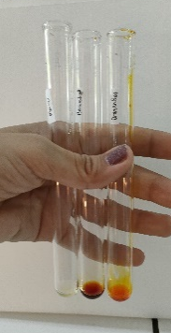 | + | + | a. Mayer  Terbentuk endapan putih  b. Dragendorff  Terbentuk endapan merah, merah kecoklatan  c. Bouchardat  Terbentuk larutan merah kekuningan
2. | Flavonoid | 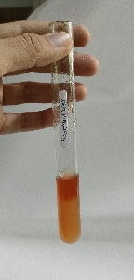 | 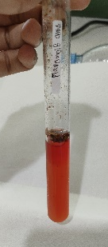 | + | + | Terbentuk lapisan merah-kuning pada lapisan alkohol
3. | Saponin | 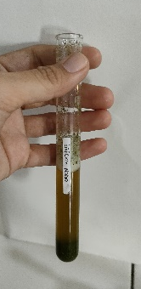 | 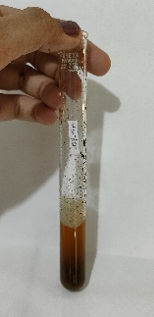 | + | + | Terbentuk busa yang stabil, dan tidak hilang
4. | Tanin | 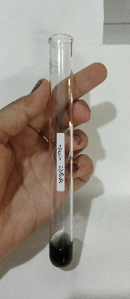 | 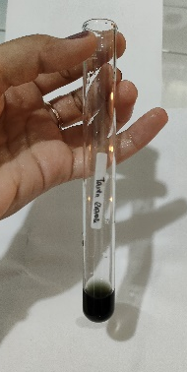 | + | + | Terbentuk larutan hijau kehitaman
5. | Steroid/ Triterpenoid | 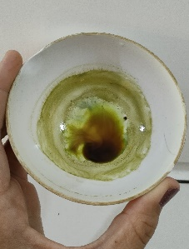 | 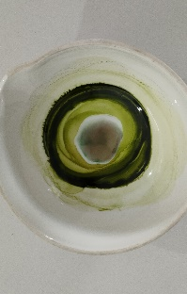 | + | + | Terbentuk warna biru kehijauan  (steroid)
6. | Glikosida |  | 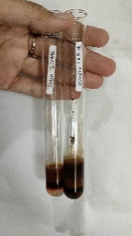 | + | + | Terbentuk cincin ungu pada lapisan atas dan bawah

Lampiran 15. Pengujian Sitotoksisitas Ekstrak Etanol Daun Matoa (Pometia pinnata J.R. Forst & G. Forst) Dengan Metode BSLT
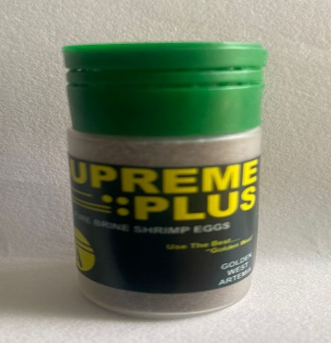
Penetasan Telur Artemia
Proses penetasan
Telur artemia

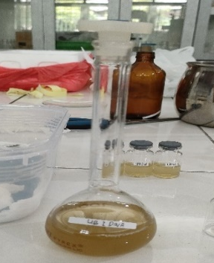
Pengenceran ekstrak daun matoa dalam beberapa konsentrasi dan pengujian sitotoksisitas
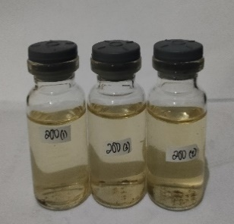
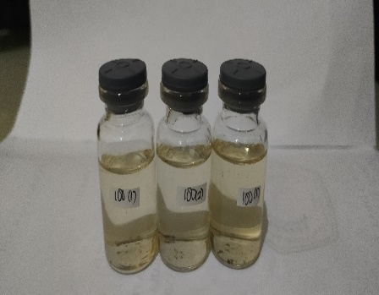
Larutan induk baku
200 ppm
100 ppm
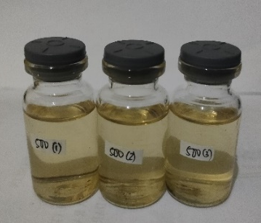
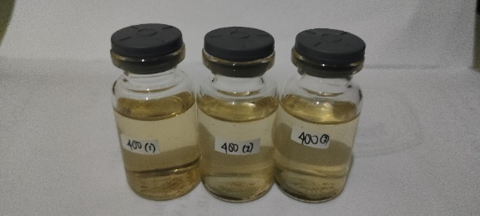
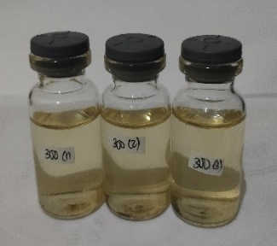
500 ppm
400 ppm
300 ppm
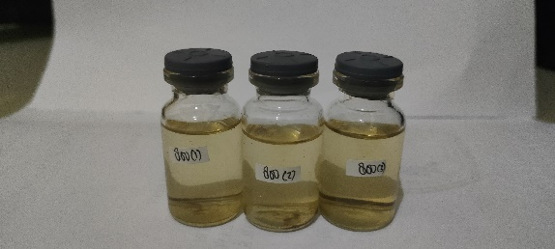
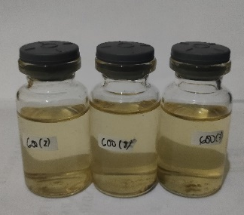
Lampiran 15. (Lanjutan)
800 ppm
700 ppm
600 ppm
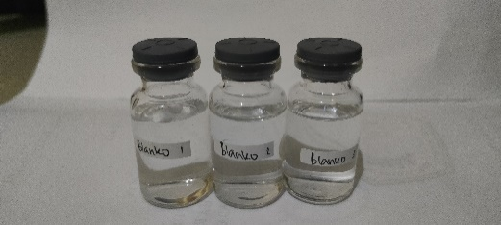
Kontrol Negatif
1000 ppm
900 ppm

Lampiran 16. Perhitungan Pembuatan Variasi Pengenceran Ekstrak Etanol Daun Matoa
LIB = 200 mg (200,000 μg / 100 ml) = 2000 μg/ml (2000 ppm)
        - 1000 μg/ml = V1.C1 = V2.C2
= x . 2000 μg/ml = 10 ml . 1000 μg/ml
$x=\frac{10000 μg}{2000 μg/ml}=5 ml$

        - 900 μg/ml = V1.C1 = V2.C2
= x . 2000 μg/ml = 10 ml . 900 μg/ml
$x=\frac{9000 μg}{2000 μg/ml}=4,5 ml$

        - 800 μg/ml = V1.C1 = V2.C2
= x . 2000 μg/ml = 10 ml . 800 μg/ml
$x=\frac{8000 μg}{2000 μg/ml}=4 ml$
        - 700 μg/ml = V1.C1 = V2.C2
= x . 2000 μg/ml = 10 ml . 700 μg/ml
$x=\frac{7000 μg}{2000 μg/ml}=3,5 ml$
        - 600 μg/ml = V1.C1 = V2.C2
= x . 2000 μg/ml = 10 ml . 600 μg/ml
$x=\frac{6000 μg}{2000 μg/ml}=3 ml$
        - 500 μg/ml = V1.C1 = V2.C2
= x . 2000 μg/ml = 10 ml . 500 μg/ml
$x=\frac{5000 μg}{2000 μg/ml}=2,5 ml$
        - 400 μg/ml = V1.C1 = V2.C2
= x . 2000 μg/ml = 10 ml . 400 μg/ml
$x=\frac{4000 μg}{2000 μg/ml}=2 ml$
        - 300 μg/ml = V1.C1 = V2.C2
= x . 2000 μg/ml = 10 ml . 300 μg/ml
$x=\frac{3000 μg}{2000 μg/ml}=1,5 ml$
        - 200 μg/ml = V1.C1 = V2.C2
= x . 2000 μg/ml = 10 ml . 200 μg/ml
$x=\frac{2000 μg}{2000 μg/ml}=1 ml$
Lampiran 16. (Lanjutan)
        - 100 μg/ml = V1.C1 = V2.C2
= x . 2000 μg/ml = 10 ml . 100 μg/ml
$x=\frac{1000 μg}{2000 μg/ml}=0,5 ml$

Lampiran 17. Perhitungan LC₅₀ Ekstrak Daun Matoa
$$\% Kematian larva=\frac{Jumlah rata-rata larva yang mati}{jumlah larva uji}x 100\%$$
Hasil Orientasi
No | Konsentrasi  (μg/mL) | Jumlah larva yang mati |  |  | Total | Rata-rata kematian larva | % Mortalitas
 |  | P1 | P2 | P3
1 | Blanko | 0 | 0 | 0 | 0 | 0 | 0%
2 | 100 | 3 | 3 | 2 | 8 | 2,66 | 26,6%
3 | 200 | 3 | 4 | 3 | 10 | 3,33 | 33,3%
4 | 300 | 4 | 4 | 3 | 11 | 3,66 | 36,6%
5 | 400 | 5 | 4 | 5 | 14 | 4,66 | 46,6%
6 | 500 | 6 | 5 | 5 | 16 | 5,33 | 53,3%
7 | 600 | 7 | 7 | 6 | 20 | 6,66 | 66,6%
8 | 700 | 8 | 7 | 8 | 23 | 7,66 | 76,6%
9 | 800 | 9 | 9 | 9 | 27 | 9 | 90%
10 | 900 | 10 | 10 | 10 | 30 | 10 | 100%
11 | 1000 | 10 | 10 | 10 | 30 | 10 | 100%

Hasil Pengujian
No. | Konsentrasi (μg/mL) | % Mortalitas | Log Konsentrasi | Nilai Probit
1 | 100 | 26,6% | 2,0000 | 4,3750
2 | 200 | 33,3% | 2,3010 | 4,5684
3 | 300 | 36,6% | 2,4771 | 4,6575
4 | 400 | 46,6% | 2,6020 | 4,9147
5 | 500 | 53,3% | 2,6989 | 5,0828
6 | 600 | 66,6% | 2,7781 | 5,4289
7 | 700 | 76,6% | 2,8450 | 5,7257
Lampiran 17. (Lanjutan)
No. | D (C(μg/mL) | P (%Mortalitas) | X (Log C) | Y (Nilai Probit) | XY | X²
1 | 100 | 26,6% | 2,0000 | 4,3750 | 8,750 | 4,0000
2 | 200 | 33,3% | 2,3010 | 4,5684 | 10,5118 | 5,2946
3 | 300 | 36,6% | 2,4771 | 4,6575 | 11,5370 | 6,1360
4 | 400 | 46,6% | 2,6020 | 4,9147 | 12,7880 | 6,7704
5 | 500 | 53,3% | 2,6989 | 5,0828 | 13,7179 | 7,2840
6 | 600 | 66,6% | 2,7781 | 5,4289 | 15,0820 | 7,7178
7 | 700 | 76,6% | 2,8450 | 5,7257 | 16,2896 | 8,0940
Jumlah |  |  | ∑X= 17,7021 | ∑Y= 34,753 | ∑XY= 88,6763 | ∑X²=  45,2968
Rata-rata |  |  | 2,5288 | 4,9647

Keterangan :
D = Konsentrasi ekstrak
P = % Mortalitas
X = Log konsentrasi ekstrak
Y = Nilai probit

Persamaan garis regresi linear :
Y = a + bx

Keterangan :
Y = konsentrasi kematian
X = log konsentrasi

Lampiran 17. (Lanjutan)
$$a=\frac{\left(∑xy\right)-(∑x.∑y)/n}{∑X2-\left(∑x\right)2/n}$$
$$a=\frac{88,6763-(17,7021)(34,753)/7}{45,2968-\left(17,7021\right)2/7}$$
$$a=\frac{0,7907}{0,5305}$$
a = 1,4904

b = y - ax
= 4,9647-1,4904 (2,5288)
= 4,9647 – 3,7689
= 1,1958

Nilai LC₅₀ diperoleh dari analog x dimana x merupakan logaritma konsentrasi bahan toksik pada y = 5, yaitu nilai probit 50% hewan uji sehingga persamaan regresi diperoleh y = 1, 4904 + 1,1958
5 = 1,4904 x + 1,1958
5– 1,1958 = 1, 4904 x
3,8042 = 1,4904 x
$$x=\frac{3,8042}{1,4904}$$
= 2,5524
Maka nilai LC₅₀ antilog 2,5524 adalah 356,7795 μg/ml
Lampiran 17. (Lanjutan)
Kurva Regresi Linier Antara Log Konsentrasi Ekstrak Etanol Daun Matoa dengan Nilai Probit, sebagai berikut :

Lampiran 18. Nilai Probit Sesuai dengan Besarnya Persentase Kematian
Tabel 1.Tabel Tranformasi Persen-Probit (Priyanto, 2009)
Persen kematian (%) | 0,0 | 0,1 | 0,2 | 0,3 | 0,4 | 0,5 | 0,6 | 0,7 | 0,8 | 0,9
0 | - | 1.0098 | 2.1218 | 2.2522 | 2.3479 | 2.4242 | 2.4879 | 2.5427 | 2.5914 | 2.6344
1 | 2.6737 | 2.7096 | 2.7429 | 2.7738 | 2.8027 | 2.8299 | 2.8556 | 2.8799 | 2.3031 | 2.9251
2 | 2.9463 | 2.9665 | 2.9859 | 3.0646 | 3.0226 | 3.0400 | 3.0569 | 3.0732 | 3.0896 | 3.1043
3 | 3.1192 | 3.1337 | 3.1478 | 3.1616 | 3.1750 | 3.1881 | 3.2009 | 3.2134 | 3.2256 | 3.2376
4 | 3.2493 | 3.2608 | 3.2721 | 3.2831 | 3.2940 | 3.3046 | 3.3151 | 3.3253 | 3.3354 | 3.3454
5 | 3.3351 | 3.3668 | 3.3742 | 3.3836 | 3.3028 | 3.4018 | 3.4107 | 3.4195 | 3.4282 | 3.4368
6 | 3.4452 | 3.4536 | 3.4618 | 3.4694 | 3.4780 | 3.4850 | 3.4937 | 3.5015 | 3.5091 | 3.5167
7 | 3.5242 | 3.5316 | 3.5380 | 3.5462 | 3.5534 | 3.5605 | 3.5675 | 3.5745 | 3.5813 | 3.5882
8 | 3.5949 | 3.6016 | 3.6083 | 3.6148 | 3.6213 | 3.6278 | 3.6342 | 3.6405 | 3.6408 | 3.6427
9 | 3.6692 | 3.6654 | 3.6715 | 3.6775 | 3.6835 | 3.6894 | 3.6953 | 3.7012 | 3.7070 | 3.7127
10 | 3.7182 | 3.7241 | 3.7298 | 3.7354 | 3.7409 | 3.7464 | 3.7519 | 3.7574 | 3.7628 | 3.7681
11 | 3.7735 | 3.7784 | 3.7840 | 3.7893 | 3.7945 | 3.7996 | 3.8048 | 3.8099 | 3.8150 | 3.8200
12 | 3.8250 | 3.8300 | 3.8350 | 3.8399 | 3.8848 | 3.8497 | 3.8545 | 3.8503 | 3.8641 | 3.8689
13 | 3.8736 | 3.8783 | 3.8830 | 3.8877 | 3.8923 | 3.8969 | 3.9015 | 3.9061 | 3.9107 | 3.9152
14 | 3.9197 | 3.9242 | 3.9286 | 3.9331 | 3.9375 | 3.9419 | 3.9463 | 3.9506 | 3.9550 | 3.9593
15 | 3.9636 | 3.9678 | 3.9721 | 3.9763 | 3.9800 | 3.9848 | 3.9890 | 3.9931 | 3.9933 | 4.0014
16 | 4.0055 | 4.0096 | 4.0137 | 4.0178 | 4.0218 | 4.0259 | 4.0299 | 4.0339 | 4.0379 | 4.0410
17 | 4.0458 | 4.0408 | 4.0537 | 4.0576 | 4.0615 | 4.0693 | 4.0693 | 4.0731 | 4.0770 | 4.0808
18 | 4.0846 | 4.0884 | 4.0960 | 4.0960 | 4.0998 | 4.1035 | 4.1073 | 4.1110 | 4.1147 | 4.1184
19 | 4.1221 | 4.1258 | 4.1331 | 4.1331 | 4.1367 | 4.1404 | 4.1440 | 4.1476 | 4.1512 | 4.1548
20 | 4.1684 | 4.1019 | 4.1035 | 4.1690 | 4.1726 | 4.1761 | 4.1796 | 4.1831 | 4.1866 | 4.1901
21 | 4.1936 | 4.1970 | 4.2005 | 4.2039 | 4.2074 | 4.2108 | 4.2142 | 4.2176 | 4.2110 | 4.2244
22 | 4.2278 | 4.2312 | 4.2345 | 4.2379 | 4.2412 | 4.2446 | 4.2479 | 4.2512 | 4.2546 | 4.2579
23 | 4.2612 | 4.2644 | 4.2677 | 4.2710 | 4.2743 | 4.2275 | 4.2808 | 4.2840 | 4.2872 | 4.2905
24 | 4.2937 | 4.2969 | 4.3001 | 4.3033 | 4.3065 | 4.3097 | 4.3129 | 4.3160 | 4.3192 | 4.3324
25 | 4.3255 | 4.3287 | 4.3318 | 4.3349 | 4.3380 | 4.3412 | 4.3443 | 4.3474 | 4.3505 | 4.3536
26 | 4.3567 | 4.3597 | 4.3628 | 4.3659 | 4.3869 | 4.3720 | 4.3750 | 4.3781 | 4.3811 | 4.3842
27 | 4.3872 | 4.3902 | 4.3932 | 4.3962 | 4.3992 | 4.4022 | 4.4052 | 4.4082 | 4.4112 | 4.4142
28 | 4.4172 | 4.4201 | 4.4231 | 4.4260 | 4.4290 | 4.4319 | 4.4349 | 4.4378 | 4.4408 | 4.4437
29 | 4.4466 | 4.4405 | 4.4524 | 4.4554 | 4.4583 | 4.4612 | 4.4641 | 4.4670 | 4.4698 | 4.4727
30 | 4.4756 | 4.4785 | 4.4813 | 4.4842 | 4.4871 | 4.4899 | 4.4928 | 4.4956 | 4.4985 | 4.5013
31 | 4.5041 | 4.5070 | 4.5098 | 4.5126 | 4.5155 | 4.5183 | 4.2511 | 4.5239 | 4.5267 | 4.5295
32 | 4.5323 | 4.5351 | 4.5370 | 4.5407 | 4.5435 | 4.5462 | 4.5490 | 4.5518 | 4.5546 | 4.5573
33 | 4.5601 | 4.5628 | 4.5656 | 4.5684 | 4.5711 | 4.5739 | 4.5766 | 4.5793 | 4.5821 | 4.5848

Persen kematian (%) | 0,0 | 0,1 | 0,2 | 0,3 | 0,4 | 0,5 | 0,6 | 0,7 | 0,8 | 0,9
34 | 4.5875 | 4.5903 | 4.5930 | 4.5957 | 4.5984 | 4.6011 | 4.6039 | 4.6066 | 4.6093 | 4.6120
35 | 4.6147 | 4.6174 | 4.6201 | 4.6288 | 4.6255 | 4.6281 | 4.6308 | 4.6335 | 4.6362 | 4.6389
36 | 4.6415 | 4.6442 | 4.6469 | 4.6495 | 4.6522 | 4.6549 | 4.6575 | 4.6602 | 4.6628 | 4.6655
37 | 4.6681 | 4.6708 | 4.6734 | 4.6761 | 4.6787 | 4.6814 | 4.6840 | 4.6866 | 4.6893 | 4.6919
38 | 4.6945 | 4.6971 | 4.6998 | 4.7024 | 4.7050 | 4.7078 | 4.7102 | 4.7129 | 4.7155 | 4.7181
39 | 4.7207 | 4.7233 | 4.7259 | 4.7285 | 4.7311 | 4.7337 | 4.7363 | 4.7389 | 4.7415 | 4.7441
40 | 4.7467 | 4.7402 | 4.7518 | 4.75f44 | 4.7570 | 4.7595 | 4.7622 | 4.7647 | 4.7673 | 4.7699
41 | 4.7725 | 4.7750 | 4.7776 | 4.7802 | 4.7827 | 4.7853 | 4.7879 | 4.7902 | 4.7930 | 4.7955
42 | 4.7981 | 4.8007 | 4.8032 | 4.8058 | 4.8083 | 4.8109 | 4.8134 | 4.8160 | 4.8185 | 4.8211
43 | 4.8230 | 4.8202 | 4.8278 | 4.8313 | 4.8338 | 4.8363 | 4.8389 | 4.8414 | 4.8440 | 4.8465
44 | 4.8490 | 4.8516 | 4.8541 | 4.8566 | 4.8592 | 4.8617 | 4.8624 | 4.8668 | 4.8693 | 4.8718
45 | 4.8743 | 4.8769 | 4.8704 | 4.8819 | 4.8844 | 4.8870 | 4.8895 | 4.8920 | 4.8945 | 4.8970
46 | 4.8996 | 4.9021 | 4.9046 | 4.9971 | 4.9996 | 4.9122 | 4.9147 | 4.9172 | 4.9197 | 4.9222
47 | 4.9247 | 4.9272 | 4.9298 | 4.9323 | 4.9348 | 4.9373 | 4.9308 | 4.9423 | 4.9448 | 4.9473
48 | 4.9408 | 4.9524 | 4.9549 | 4.9574 | 4.9599 | 4.9624 | 4.9649 | 4.9674 | 4.9699 | 4.9724
49 | 4.9740 | 4.9774 | 4.9799 | 4.9825 | 4.9850 | 4.9876 | 4.9900 | 4.9925 | 4.9950 | 4.9975
50 | 5.0000 | 5.0025 | 5.0050 | 5.0075 | 5.0100 | 5.0125 | 5.0150 | 5.0175 | 5.0201 | 5.0226
51 | 5.0251 | 5.0276 | 5.0301 | 5.0326 | 5.0351 | 5.0376 | 5.0401 | 5.0426 | 5.0451 | 5.0476
52 | 5.0502 | 5.0527 | 5.0552 | 5.0577 | 5.0602 | 5.0627 | 5.0652 | 5.0677 | 5.0702 | 5.0728
53 | 5.0753 | 5.0778 | 5.0803 | 5.0828 | 5.0853 | 5.0878 | 5.0904 | 5.0929 | 5.0954 | 5.0279
54 | 5.1004 | 5.1030 | 5.1055 | 5.1080 | 5.1105 | 5.1130 | 5.1156 | 5.1181 | 5.1206 | 5.1231
55 | 5.1257 | 5.1282 | 5.1307 | 5.1332 | 5.1358 | 5.1383 | 5.1408 | 5.1434 | 5.1459 | 5.1484
56 | 5.1510 | 5.1535 | 5.1560 | 5.1586 | 5.1614 | 5.1637 | 5.1662 | 5.1687 | 5.1713 | 5.1738
57 | 5.1764 | 5.1789 | 5.1815 | 5.1840 | 5.1866 | 5.1801 | 5.1917 | 5.1942 | 5.1968 | 5.1993
58 | 5.2019 | 5.2045 | 5.2070 | 5.2096 | 5.2121 | 5.2147 | 5.2173 | 5.2198 | 5.2224 | 5.2250
59 | 5.2275 | 5.2301 | 5.2327 | 5.2353 | 5.2378 | 5.2404 | 5.2430 | 5.2468 | 5.2482 | 5.2508
60 | 5.2533 | 5.2359 | 5.2585 | 5.2611 | 5.2637 | 5.2663 | 5.2689 | 5.2715 | 5.2741 | 5.2767
61 | 5.2793 | 5.2819 | 5.2845 | 5.2871 | 5.2808 | 5.2024 | 5.2050 | 5.2976 | 5.3002 | 5.3029
62 | 5.3055 | 5.3081 | 5.3107 | 5.3134 | 5.3160 | 5.3186 | 5.3213 | 5.3239 | 5.3266 | 5.3202
63 | 5.3319 | 5.3345 | 5.3372 | 5.3398 | 5.3425 | 5.3451 | 5.3478 | 5.3505 | 5.3531 | 5.3658
64 | 5.3585 | 5.3811 | 5.3638 | 5.3665 | 5.3692 | 5.3719 | 5.3745 | 5.3772 | 5.3799 | 5.3826
65 | 5.3853 | 5.3380 | 5.8007 | 5.3934 | 5.3961 | 5.3980 | 5.4016 | 5.4043 | 5.4070 | 5.4097
66 | 5.4125 | 5.4152 | 5.4170 | 5.4207 | 5.4234 | 5.4261 | 5.4289 | 5.4316 | 5.4344 | 5.4372
67 | 5.4399 | 5.4427 | 5.4454 | 5.4482 | 5.4510 | 5.4638 | 5.4565 | 5.4593 | 5.4621 | 5.4649
68 | 5.4677 | 5.4705 | 5.4733 | 5.4761 | 5.4780 | 5.4817 | 5.4845 | 5.4874 | 5.4002 | 5.4930
69 | 5.4959 | 5.4987 | 5.5015 | 5.5044 | 5.5072 | 5.5101 | 5.5129 | 5.5158 | 5.5187 | 5.3215

Lampiran 18. (Lanjutan)

Lampiran 18. (Lanjutan)

Persen kematian (%) | 0,0 | 0,1 | 0,2 | 0,3 | 0,4 | 0,5 | 0,6 | 0,7 | 0,8 | 0,9
70 | 5.5244 | 5.5273 | 5.5302 | 5.5330 | 5.5350 | 5.5388 | 5.5417 | 5.5446 | 5.5476 | 5.6505
71 | 5.5534 | 5.5563 | 5.5592 | 5.5622 | 5.5651 | 5.5681 | 5.5710 | 5.5740 | 5.5760 | 5.7990
72 | 5.5828 | 5.5858 | 5.5888 | 5.5918 | 5.5948 | 5.5978 | 5.6008 | 5.6038 | 5.6068 | 5.6098
73 | 5.6128 | 5.6158 | 5.6189 | 5.6219 | 5.6250 | 5.6280 | 5.6311 | 5.6341 | 5.6372 | 5.6403
74 | 5.6435 | 5.6464 | 5.6405 | 5.6526 | 5.6557 | 5.6588 | 5.6620 | 5.6651 | 5.6682 | 5.6713
75 | 5.6745 | 5.6776 | 5.6808 | 5.6840 | 5.6871 | 5.6903 | 5.6935 | 5.6967 | 5.6998 | 5.7031
76 | 5.7083 | 5.7095 | 5.7128 | 5.7160 | 5.7192 | 5.7225 | 5.7257 | 5.7200 | 5.7323 | 5.7356
77 | 5.7388 | 5.7424 | 5.7454 | 5.7488 | 5.7521 | 5.7554 | 5.7588 | 5.7621 | 5.7666 | 5.7688
78 | 5.7722 | 5.7756 | 5.7796 | 5.7824 | 5.7858 | 5.7892 | 5.7926 | 5.7961 | 5.7995 | 5.8030
79 | 5.8834 | 5.8099 | 5.8134 | 5.8169 | 5.8204 | 5.8239 | 5.8274 | 5.8310 | 5.8345 | 5.8381
80 | 5.8416 | 5.8452 | 5.8488 | 5.8524 | 5.8560 | 5.8596 | 5.8633 | 5.8669 | 5.8705 | 5.8742
81 | 5.8779 | 5.8816 | 5.8853 | 5.8890 | 5.8927 | 5.8965 | 5.9002 | 5.9040 | 5.9078 | 5.9116
82 | 5.9154 | 5.9192 | 5.9230 | 5.9269 | 5.9307 | 5.9346 | 5.9386 | 5.9424 | 5.9463 | 5.9502
83 | 5.9540 | 5.9581 | 5.9624 | 5.9661 | 5.9701 | 5.9471 | 5.9782 | 5.9822 | 5.9863 | 5.9904
84 | 5.9945 | 5.9986 | 6.0027 | 6.0069 | 6.0110 | 6.0152 | 5.0194 | 6.0273 | 6.0279 | 6.0322
85 | 6.0364 | 6.0407 | 6.0450 | 6.0494 | 6.0537 | 6.0581 | 6.0625 | 6.0669 | 6.0714 | 6.0758
86 | 6.0803 | 6.0818 | 6.0893 | 6.0939 | 6.0985 | 6.1031 | 6.1077 | 6.1123 | 6.1170 | 6.1217
87 | 6.1264 | 6.1311 | 6.1359 | 6.1407 | 6.1455 | 6.1503 | 6.1552 | 6.1601 | 6.1650 | 6.1700
88 | 6.1750 | 6.1800 | 6.1856 | 6.1901 | 6.1952 | 6.2004 | 6.2055 | 6.2107 | 6.2160 | 6.2212
89 | 6.2205 | 6.2319 | 6.2372 | 6.2426 | 6.2481 | 6.2536 | 6.2591 | 6.2646 | 6.2702 | 6.2750
90 | 6.2816 | 6.2873 | 6.2936 | 6.2988 | 6.3047 | 6.3106 | 6.3165 | 6.3225 | 6.3285 | 6.3346
91 | 6.3408 | 6.3469 | 6.3532 | 6.3595 | 6.3658 | 6.3722 | 6.3787 | 6.3852 | 6.3917 | 6.3984
92 | 6.4031 | 6.4118 | 6.4187 | 6.4255 | 6.4325 | 6.4395 | 6.4466 | 6.4538 | 6.4611 | 6.4684
93 | 6.4758 | 6.4833 | 6.4909 | 6.4985 | 6.5063 | 6.5141 | 6.5220 | 6.5301 | 6.5382 | 6.5464
94 | 6.8548 | 6.5632 | 6.5718 | 6.5805 | 6.5893 | 6.5982 | 6.6078 | 6.6164 | 6.6258 | 6.6352
95 | 6.6449 | 6.6546 | 6.6646 | 6.6747 | 6.6849 | 6.6954 | 6.7060 | 6.7169 | 6.7279 | 6.7302
96 | 6.7507 | 6.7624 | 6.7784 | 6.7806 | 6.7991 | 6.8119 | 6.8260 | 6.8084 | 6.8522 | 6.8663
97 | 6.8808 | 6.8957 | 6.9110 | 6.9268 | 6.9431 | 6.9600 | 6.9774 | 6.9954 | 7.0141 | 7.0335
98 | 7.0537 | 7.0558 | 7.0579 | 7.0660 | 7.0621 | 7.0612 | 7.0663 | 7.0684 | 7.0706 | 7.0727
98.1 | 7.0749 | 7.0770 | 7.0792 | 7.0814 | 7.0836 | 7.0858 | 7.0880 | 7.0902 | 7.0924 | 7.0947
98.2 | 7.0969 | 7.0992 | 7.1015 | 7.1038 | 7.1061 | 7.1084 | 7.1107 | 7.1130 | 7.1154 | 7.1177
98.3 | 7.1204 | 7.1224 | 7.1248 | 7.1272 | 7.1297 | 7.1321 | 7.1345 | 7.1370 | 7.1384 | 7.1419
98.4 | 7.1444 | 7.1469 | 7.1494 | 7.1520 | 7.1545 | 7.1571 | 7.1996 | 7.1622 | 7.1648 | 7.1675
98.5 | 7.1701 | 7.1727 | 7.1754 | 7.1781 | 7.1808 | 7.1835 | 7.1862 | 7.1890 | 7.1917 | 7.1945
98.6 | 7.1973 | 7.2001 | 7.2029 | 7.2058 | 7.2086 | 7.2115 | 7.2144 | 7.2173 | 7.2203 | 7.2232
98.7 | 7.2262 | 7.2292 | 7.2322 | 7.2353 | 7.2383 | 7.2414 | 7.2445 | 7.2476 | 7.2508 | 7.2539

Lampiran 18. (Lanjutan)

Persen kematian (%) | 0,0 | 0,1 | 0,2 | 0,3 | 0,4 | 0,5 | 0,6 | 0,7 | 0,8 | 0,9
98.8 | 7.2374 | 7.2663 | 7.2636 | 7.2668 | 7.2701 | 7.2734 | 7.2768 | 7.2801 | 7.2835 | 7.2869
98.9 | 7.2904 | 7.2938 | 7.2973 | 7.3009 | 7.3044 | 7.3080 | 7.3116 | 7.3152 | 7.3189 | 7.3226
98 | 7.3263 | 7.3301 | 7.3339 | 7.3378 | 7.3416 | 7.3455 | 7.3495 | 7.3535 | 7.3575 | 7.3615
99.1 | 7.3656 | 7.3698 | 7.3739 | 7.3781 | 7.3824 | 7.3867 | 7.3911 | 7.3954 | 7.3999 | 7.4044
99.2 | 7.4059 | 7.4135 | 7.4181 | 7.4228 | 7.4276 | 7.4324 | 7.4372 | 7.4422 | 7.4474 | 7.4522
99.3 | 7.4373 | 7.4624 | 7.4677 | 7.4730 | 7.4783 | 7.4838 | 7.4893 | 7.4940 | 7.5006 | 7.5063
99.4 | 7.5121 | 7.5181 | 7.5241 | 7.5302 | 7.5364 | 7.5427 | 7.5401 | 7.5550 | 7.5622 | 7.5690
99.5 | 7.5758 | 7.5828 | 7.5890 | 7.5972 | 7.6045 | 7.6121 | 7.6107 | 7.6276 | 7.6356 | 7.6437
99.6 | 7.6521 | 7.6606 | 7.6693 | 7.6783 | 7.6874 | 7.6968 | 7.7065 | 7.7104 | 7.7266 | 7.7370
99.7 | 7.7478 | 7.7589 | 7.7703 | 7.7822 | 7.7944 | 7.8070 | 7.8202 | 7.8338 | 7.8480 | 7.8027
99.8 | 7.8782 | 7.8943 | 7.9112 | 7.9299 | 7.9478 | 7.9677 | 7.9889 | 8.0115 | 8.0357 | 8.0618
99.9 | 8.0902 | 8.1214 | 8.1550 | 8.1847 | 8.2380 | 8.2905 | 8.3528 | 8.4316 | 8.5401 | 8.7190

